Drew Pulliam – DTP180003

CS 4337.0U2 quiz 2

1. **begin** <assign> **end**

**begin** <id> = <expr> **end**

**begin** A = <expr> **end**

**begin** A = <id> * <expr> **end**

**begin** A = A * <expr> **end**

**begin** A = A * ( <expr> ) **end**

**begin** A = A * (<id> + <expr> ) **end**

**begin** A = A * (B + <expr> ) **end**

**begin** A = A * (B + ( <expr> )) **end**

**begin** A = A * (B + (<id> * <expr>)) **end**

**begin** A = A * (B + (C * <expr>)) **end**

**begin** A = A * (B + (C * <id>)) **end**

**begin** A = A * (B + (C * A)) **end**

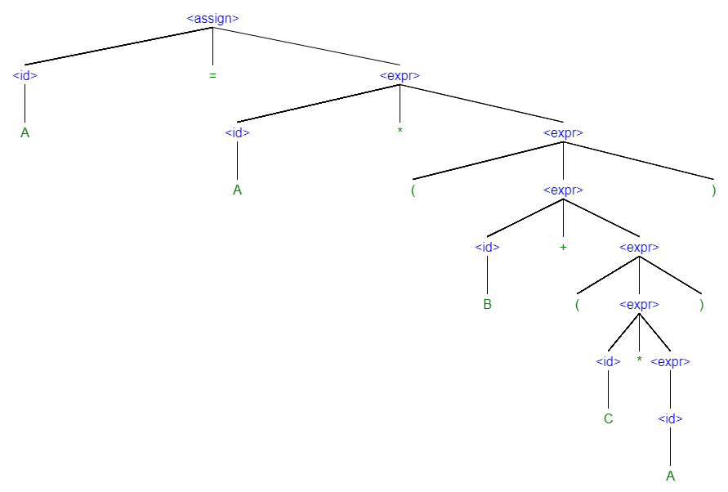

2. <S> **is defined** as <A> , <B> , and <C> (these are all non-terminal and defined later)

<A> , <B> , and <C> **are all defined** recursively as <A> = a <A> or simply just “a”

This means they can be any length. For example <A> = a a a , <B> = b , and <C> = c c c c c c c

Because <A> , <B> , and <C> all have a case where they are just “a”, “b”, or “c”, they are all terminal.