Drew Pulliam – DTP180003

CS 4337.0U2 quiz 2

1. 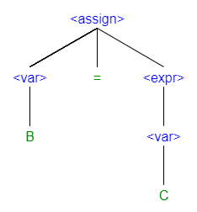

Parse Tree

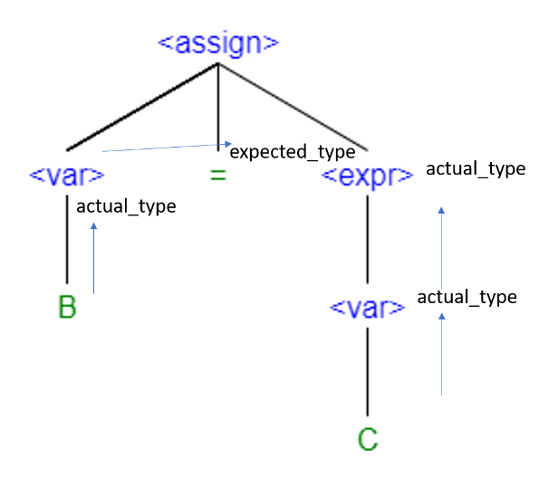

Attribute Flow

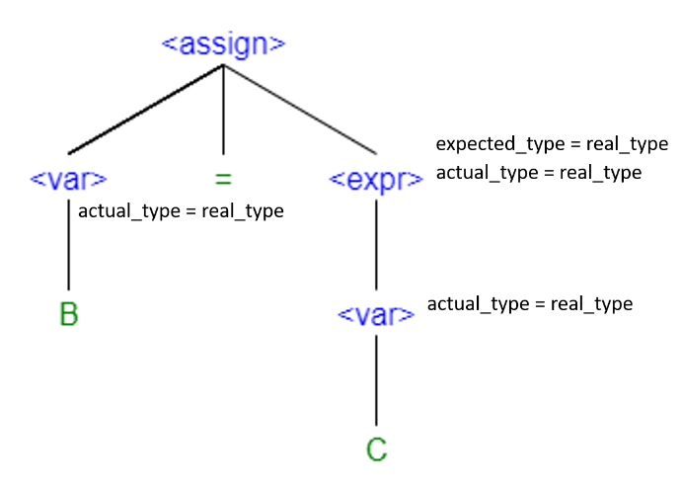

Fully attributed tree (assuming both B and C are real_type)

1. **C++ While Loop**

While (expr1) {

Expr2;

}

**Operational Semantic**

Loop: if expr1 == 0 goto out

Expr2;

Goto loop

Out: …

1. These are two unique parse trees for “a+b+c”, and the fact that there is more than one unique parse tree proves that this grammar is ambiguous

