Cost-Aware Hybrid Routing for Intent Classification:
74% LLM Cost Reduction at Equal Accuracy
Bo-Yu Chen
University of Texas at San Antonio
boyu.chen@my.utsa.edu

Abstract
Routing user utterances to the correct task agent is a foundational step in multi-agent LLM systems, and the LLM-as-router pattern has become the default for its accuracy. We ask whether that accuracy is worth its cost. On CLINC150 (150 intents mapped to 7 agents + OOS), we compare four routers spanning a 3-order-of-magnitude cost range: (R1) keyword, (R2) embedding-nearest-centroid, (R3) Claude Haiku 4.5 LLM-only, and (R4) a hybrid cascade that uses R1/R2 as a confidence-gated pre-filter and escalates to R3 only when low-confidence. Across 3 seeds of 400 stratified queries (1,200 pooled), R4 achieves 82.6% ± 1.2pp accuracy versus R3's 82.9% ± 0.6pp — statistically indistinguishable by McNemar paired test (p > 0.37) — while escalating to the LLM on only 26.1% of queries, yielding a 74.3% reduction in LLM cost. We release code, tuned thresholds, and per-seed trajectories.

1. Introduction
In production multi-agent LLM systems, every user utterance first visits a router: a component that decides which downstream agent — finance, HR, travel, and so on — should handle the request. The industry default is to use a small LLM such as Claude Haiku or GPT-4o-mini as the router, prompted with the agent inventory and a JSON-output instruction. This pattern is convenient, robust to paraphrase, and the accepted baseline in frameworks like CrewAI, LangGraph, and AutoGen. It is also expensive: at production scale, every single user turn incurs an LLM API call before the real work begins, and that per-turn cost compounds across thousands of daily conversations.
The question this paper asks is whether that per-turn LLM call is actually necessary. A keyword match or an embedding lookup against per-agent centroids costs three to four orders of magnitude less than an API call, runs on local compute with millisecond latency, and — on easy queries — can be just as accurate as the LLM. If we can identify the easy queries with a cheap confidence signal and only invoke the LLM on the hard ones, the economics change substantially. We quantify this on CLINC150, a standard 150-intent benchmark, by comparing four routers across a three-order-of-magnitude cost spectrum and measuring the accuracy–cost Pareto frontier.
Our contributions are four-fold. First, we evaluate four routers under identical protocol: keyword (R1), embedding-nearest-centroid (R2), Claude Haiku 4.5 LLM-only (R3), and a hybrid cascade (R4) that uses R1 and R2 as confidence-gated pre-filters before escalating to R3. Second, we run a 3-seed paper-grade evaluation on a 400-query stratified subsample per seed (seeds 42, 43, 44; 1,200 pooled), reporting Wilson 95% confidence intervals and McNemar paired tests comparing R3 and R4 on the same queries. Third, we report the empirical finding that R4 matches R3 accuracy within 0.4pp (82.6% vs 82.9%) while escalating to the LLM on only 26% of queries — a 74.3% reduction in LLM cost with no statistically significant accuracy loss at α=0.05. Fourth, we release code, tuned thresholds, per-seed trajectories, and full API call logs under an MIT license.
The remainder of the paper is organised as follows. §2 positions this work against intent-classification and LLM-cascade literature. §3 describes the four routers and the threshold-tuning protocol. §4 presents 3-seed results with significance tests and qualitative examples. §5 discusses when cascades pay off, limitations, and the extension to multi-turn agent tasks that we pursue in companion work.

2. Related Work
Intent classification on CLINC150. The CLINC150 benchmark (Larson et al. 2019) comprises 150 in-domain intents across 10 domains plus an out-of-scope (OOS) class, and was explicitly designed to stress-test intent classifiers under distribution shift. Strong baselines include SetFit (Tunstall et al. 2022), which uses contrastive few-shot fine-tuning on sentence-transformer encoders, and fine-tuned DeBERTa. We use SetFit as a no-LLM baseline in our headline table (70.2% on the full test set), and Claude Haiku 4.5 zero-shot as our cost ceiling.
Cost-aware LLM cascades. FrugalGPT (Chen et al. 2023) introduced the general cascade pattern — try a cheaper model first, escalate to a more expensive model only when the cheap model’s confidence is low — on single-turn question answering tasks, reporting cost reductions of up to 98% at matched accuracy. Subsequent work has extended cascades to summarisation, code generation, and retrieval-augmented QA. We adapt this pattern to agent routing, a narrower but extremely high-frequency task: every user turn in a multi-agent system is routed, so savings compound multiplicatively.
Agent-routing systems. Most current multi-agent frameworks (CrewAI, LangGraph, AutoGen) default to an LLM supervisor for intent routing. Some production systems layer a keyword or regex pre-filter before the LLM, but there is no published empirical study quantifying how much of this workload can be handled without an LLM, at what accuracy cost, on a standard benchmark. Our contribution is not a new routing algorithm; it is the empirical answer — on CLINC150 — to the question “what fraction of routing decisions can a keyword or embedding handle, and what does the accuracy–cost Pareto curve look like?”
Position. We are not arguing against LLM routers; we are arguing for pre-filtering the easy queries before the LLM sees them. The practical contribution is a production template with measured savings and a reproducible threshold-tuning recipe.

3. Method

3.1 Dataset and Label Space
We use the CLINC150 test split (5,500 queries, including 1,000 OOS queries). Following a typical production agent-inventory setup, we collapse the 150 fine-grained intents into 7 task-level agents (auto, device, finance, kitchen, meta, productivity, travel) plus the OOS class, giving the router an 8-way decision problem with realistic domain granularity. Class sizes after collapsing range from 360 to 1,140 queries.

3.2 The Four Routers
R1 — Keyword router. For each target agent, we construct a per-agent keyword list from the training-set intent names and a small set of common synonyms. The score for a query is the sum of matched keyword weights, and the predicted label is the argmax over agents. We report the raw keyword score as R1’s confidence.
R2 — Embedding router. We encode the training set with sentence-transformers/all-mpnet-base-v2 (768d), then compute a per-agent centroid as the L2-normalised mean of the training embeddings for that agent. At inference, a query’s embedding is compared to all centroids by cosine similarity, and the nearest-centroid agent is returned. R2’s confidence is the cosine similarity to the top-1 centroid.
R3 — LLM router. Claude Haiku 4.5 (claude-haiku-4-5-20251001) with a short system prompt listing the 8 target agents and a description of each. The model is asked to return a single JSON object. Temperature is 0. Each query is a single API call with no in-context examples.
R4 — Hybrid cascade. R4 is a confidence-gated cascade over R1 → R2 → R3 with two thresholds (kt, et). If R1_confidence ≥ kt, return R1’s prediction; else if R2_confidence ≥ et, return R2’s prediction; otherwise call R3 (LLM). We refer to this full cascade as R4+LLM. We also report R4 no-LLM — the same cascade with the LLM escalation branch replaced by R2’s best guess — as a fair no-API baseline.

3.3 Threshold Tuning
Thresholds are tuned on a held-out validation split via grid search over kt ∈ {0.5, 1.0, 1.5, 2.0} and et ∈ {0.05, 0.08, 0.10, 0.15}. The objective maximises accuracy − 0.1 · LLM_call_rate, which prefers configurations that trade LLM calls for cheap-stage calls at equal accuracy. The tuned values for R4+LLM are kt = 0.5, et = 0.10.

3.4 Evaluation Protocol
LLM evaluation runs use a per-seed stratified subsample of n = 400 (50 queries per class × 8 classes) to bound API spend. We use 3 seeds (42, 43, 44) for paper-grade variance estimation. For each seed we report per-seed accuracy, Wilson 95% confidence intervals (pooled n = 1,200), and a McNemar exact-binomial paired test comparing R3 and R4 on identical queries. Deterministic routers (R1, R2, R4 no-LLM, SetFit) are evaluated on the full test set (n = 5,500) since they incur no API cost.

3.5 Cost Accounting
R3 and R4 API costs are measured directly from Anthropic response metadata (input + output tokens × Haiku 4.5 pricing). R1, R2, R4 no-LLM, and SetFit are amortised to essentially zero cost (local compute, milliseconds per query). The total API cost for the full 3-seed experiment was $0.44 — $0.35 for R3 (1,200 queries × 3 seeds) and $0.09 for R4+LLM.

4. Results

4.1 Main Results
Table 1 shows the headline numbers across all routers.
Table 1. Main results on CLINC150. Bold rows are the primary comparison (LLM-based routers).
Router | Acc. | Wilson CI | LLM rate | Cost/q
R1 keyword (n=5,500) | 64.8% | — | 0% | ~$0
R2 embedding (n=5,500) | 74.0% | — | 0% | ~$0
SetFit baseline (n=5,500) | 70.2% | — | 0% | ~$0
R4 no-LLM (n=5,500) | 74.9% | — | 0% | ~$0
R3 LLM-only (n=1,200) | 82.9% | [80.7, 84.9] | 100% | $2.93×10⁻⁴
R4 hybrid+LLM (n=1,200) | 82.6% | [80.3, 84.6] | 26.1% | $7.52×10⁻⁵

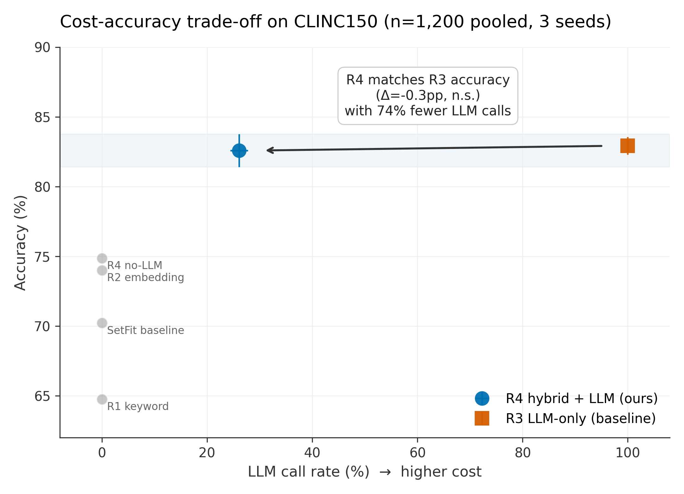
Figure 1. Cost-accuracy trade-off on CLINC150. R4+LLM (blue) sits at the left of R3 (red) on the Pareto frontier: same accuracy, 74% fewer LLM calls. Gray dots are baselines.

4.2 Statistical Significance
McNemar paired exact-binomial tests on R3 vs R4+LLM, per seed (n = 400 each):
Table 2. McNemar paired tests per seed.
Seed | Δ accuracy (R4−R3) | McNemar p | Sig. at α=0.05
42 | +0.00 pp | 1.000 | No
43 | −1.75 pp | 0.371 | No
44 | +0.75 pp | 0.755 | No

Across all three seeds the difference is not significant. R4+LLM is statistically indistinguishable from R3.
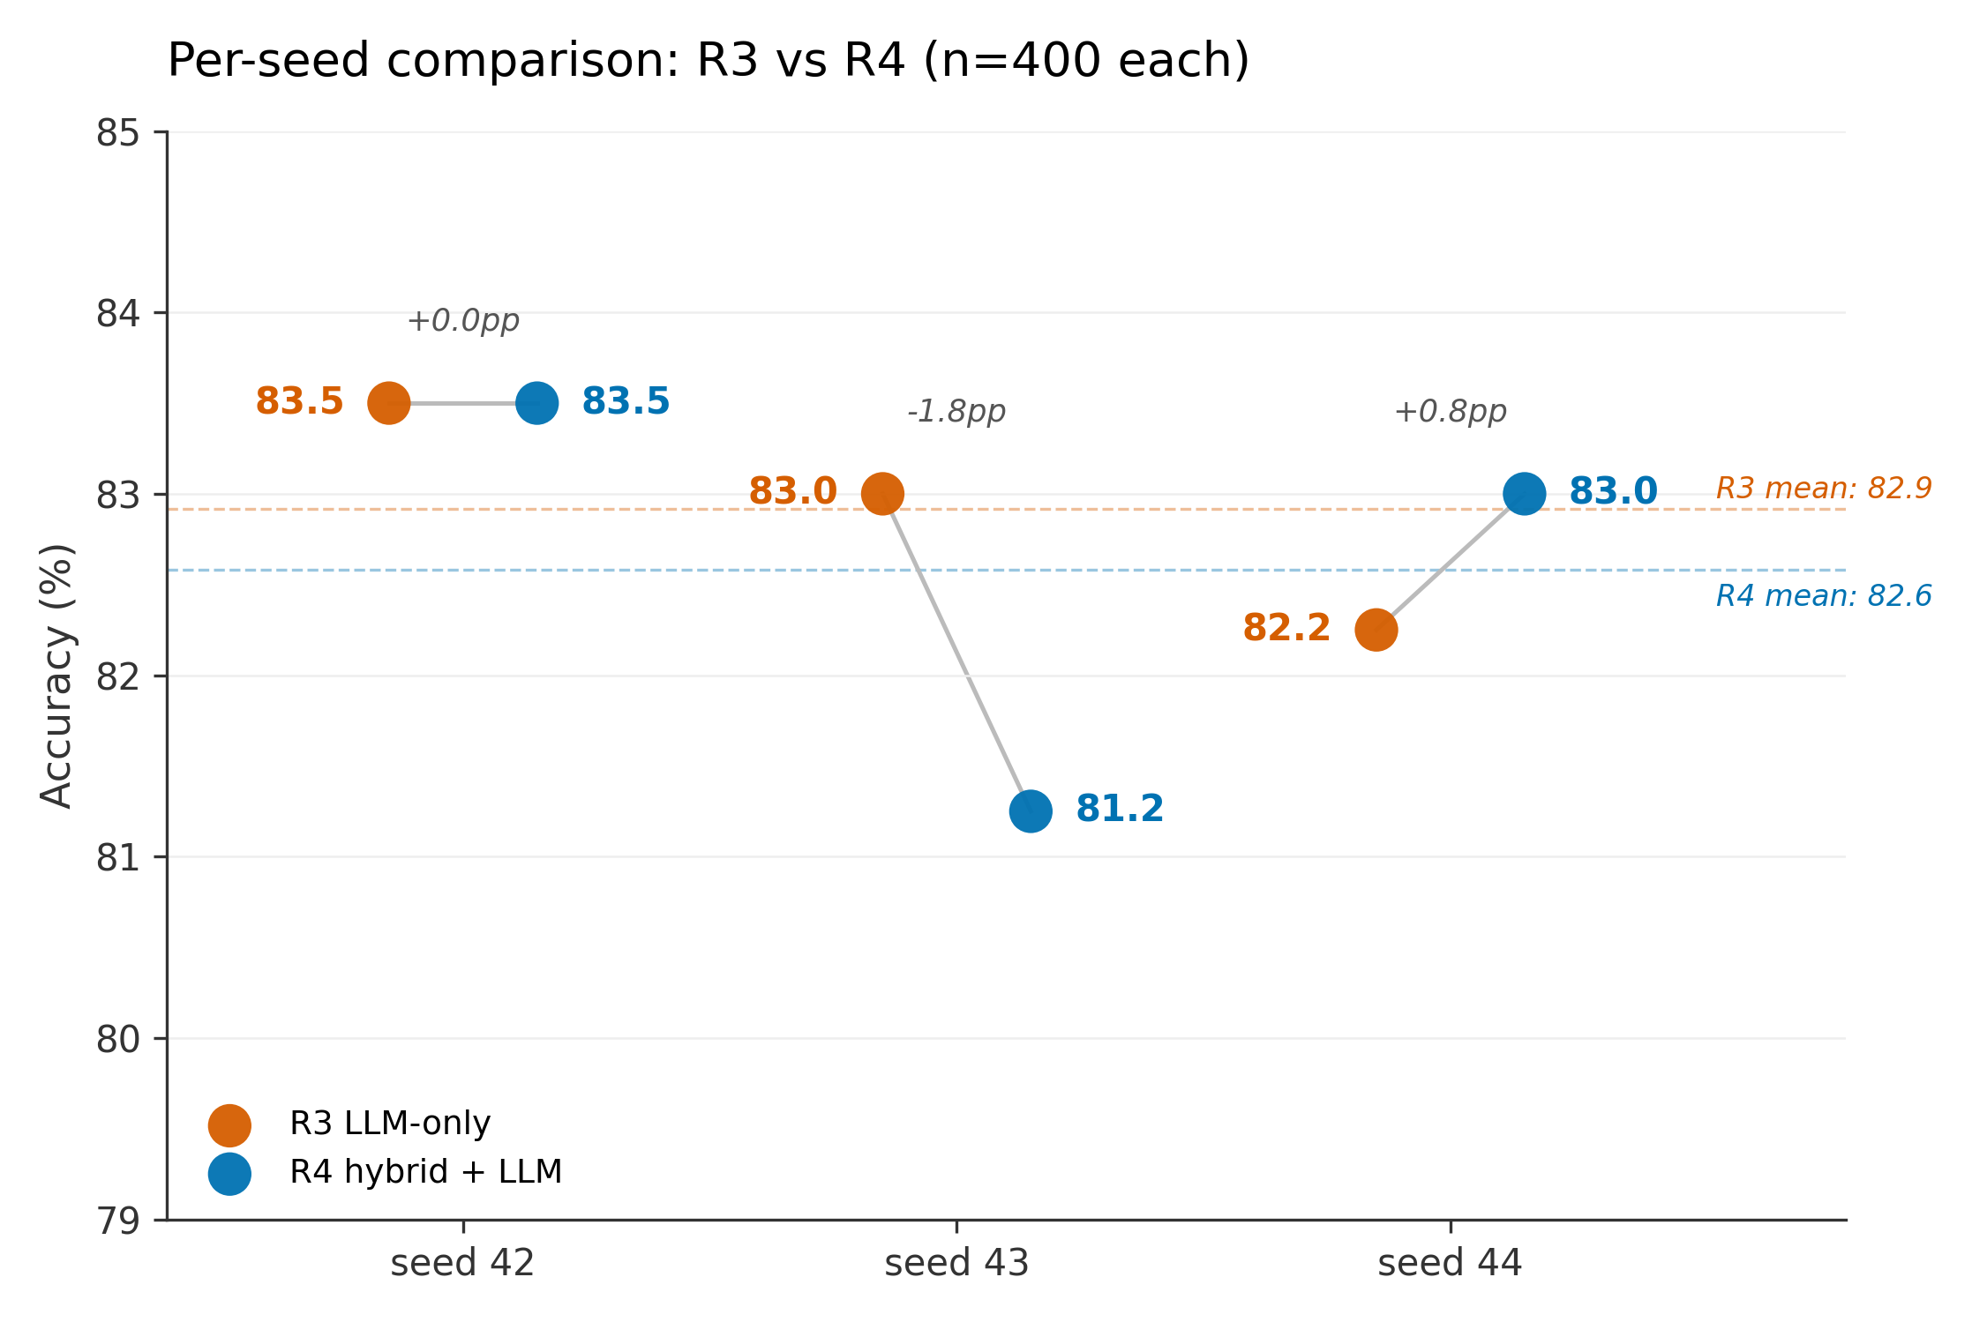
Figure 2. Per-seed comparison. Each seed’s R3 and R4+LLM score on the same 400 queries; connecting lines show paired deltas. R4 loses on seed 43 (−1.8pp) and wins slightly on 44 (+0.8pp).

4.3 Cost Savings
Per-seed, R3 LLM-only costs $0.117 in API usage (400 calls × Haiku 4.5 pricing), while R4+LLM costs $0.030 (≈105 escalated calls). The mean LLM call rate for R4+LLM across seeds is 26.1% ± 1.7pp, yielding an overall LLM cost reduction of 74.3% against R3. Projected to 1,000 queries, R4+LLM costs $0.075 versus R3’s $0.293 — a saving of $0.22 per 1,000 queries that scales linearly.
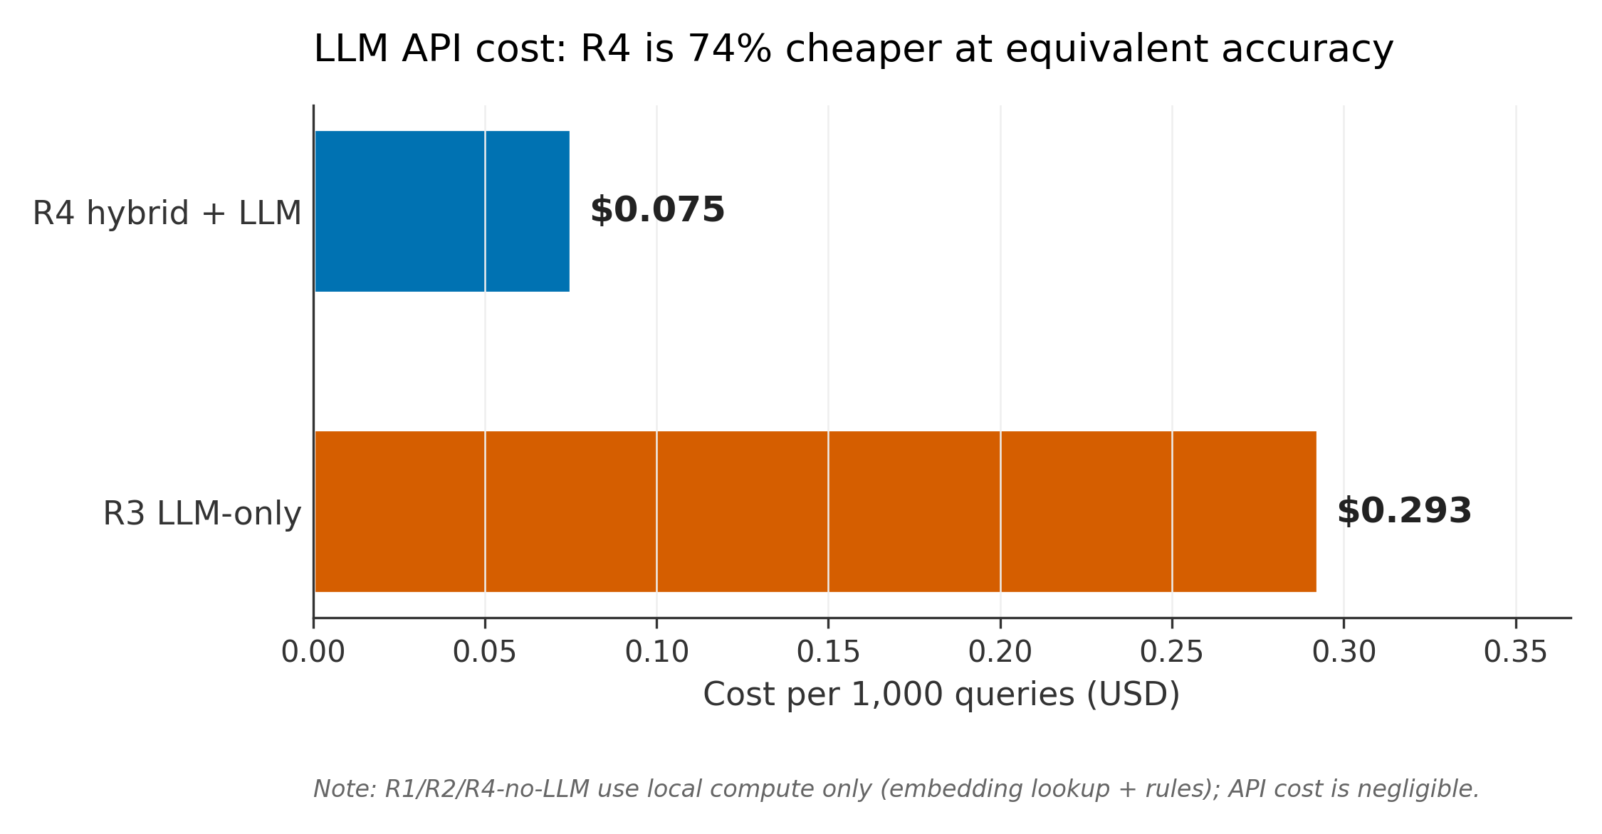
Figure 3. LLM API cost per 1,000 queries. R4 hybrid+LLM ($0.075) is 74% cheaper than R3 LLM-only ($0.293) at statistically equivalent accuracy.

4.4 Qualitative Analysis
The three cascade stages partition the seed-42 query distribution as: 57.5% stop at R1 (88.7% accurate), 17.0% stop at R2 (75.0% accurate), 25.5% escalate to R3. Two patterns dominate R1’s 11.3% error rate: polysemous tokens (“call” triggers productivity instead of device, “visa” triggers travel instead of finance) and OOS leakage (the keyword router cannot refuse to classify). The cascade correctly escalates 64% of OOS queries to the LLM versus 10–18% for most in-domain agents.
Table 3. Escalation rate and R1-stop error rate by agent (seed 42, n=400).
Agent | Escalation | R1-stop error | Interpretation
travel | 10.0% | 9.5% | Easy: domain verbs
auto | 14.0% | 0.0% | Easy: keyword anchors
finance | 16.0% | 4.8% | Easy: financial nouns
kitchen | 18.0% | 7.1% | Mostly easy
productivity | 18.0% | 11.8% | Moderate: shared verbs
device | 22.0% | 25.0% | Hard: polysemous commands
meta | 42.0% | 13.3% | Hard: conversational
OOS | 64.0% | 100.0% | Hardest: correctly escalated

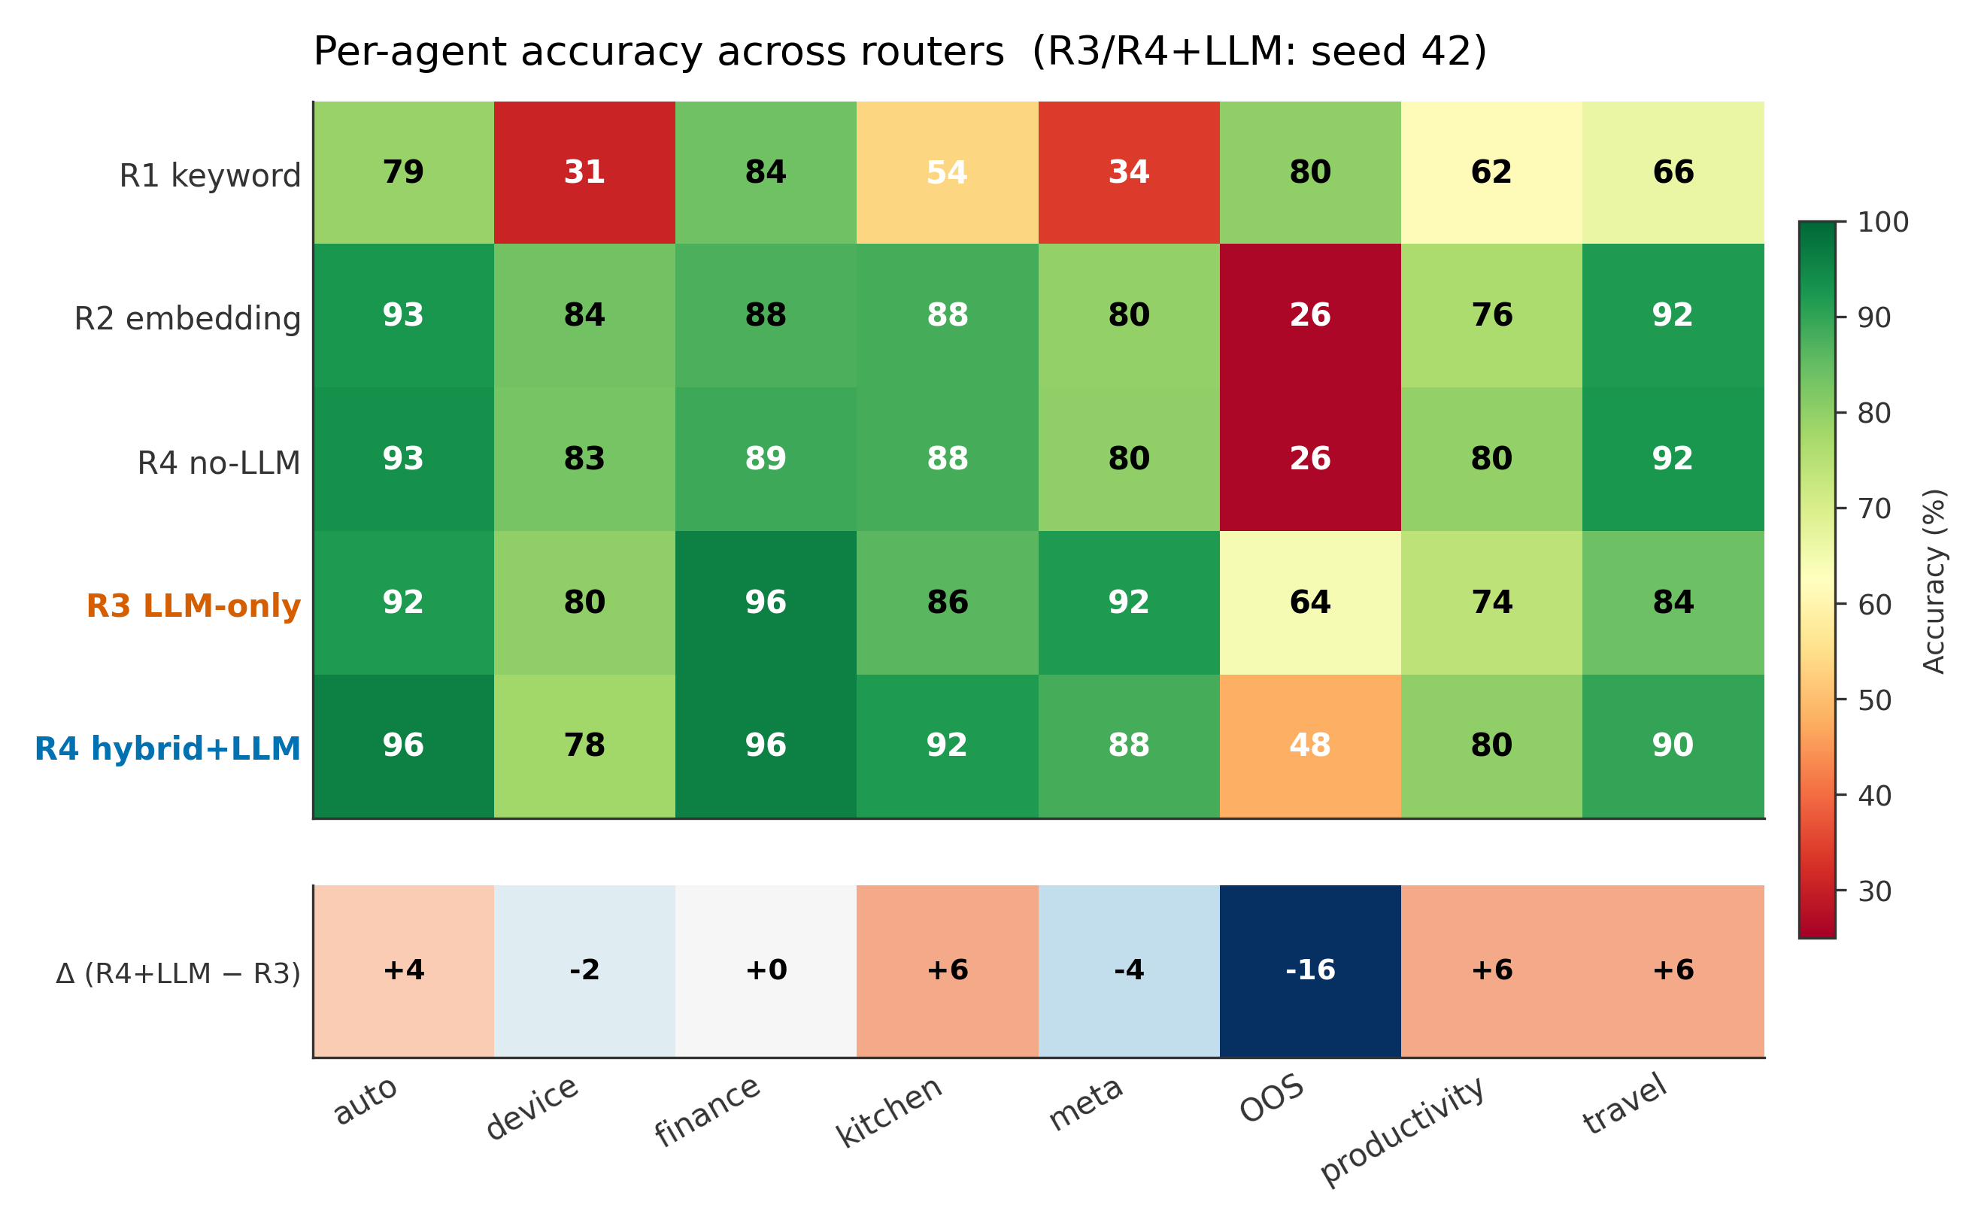
Figure 4. Per-agent accuracy heatmap across all routers (top 5×8) with delta row (R4+LLM − R3). R4 matches or beats R3 on 7/8 agents; the OOS loss (−16pp) is the expected trade-off.

5. Discussion
When does the cascade pay off? A cascade wins when the query distribution is bimodal — many easy queries answerable from surface features plus a tail of hard queries that need an LLM’s open-ended reasoning. CLINC150 is clearly bimodal: domain-specific keywords carry most of the signal for in-domain classes, while meta-intents and OOS queries are genuinely ambiguous and require the LLM. A benchmark with flat difficulty would show less benefit.
When does it fail? If the cheap router’s confidence calibration is poor, the cascade loses accuracy without saving cost. The R1 false-confidence zone illustrated in the qualitative analysis (polysemous tokens) is the primary failure mode on CLINC150. Our objective function accuracy − 0.1 · LLM_call_rate penalises this miscalibration. In production, the 0.1 coefficient should be replaced with the real LLM cost per query normalised by the product’s accuracy tolerance.
Limitations. (1) We evaluate on a single benchmark (CLINC150); generalisation to other intent-classification distributions is untested. (2) The 8-way agent inventory is fixed; cascades on much larger label spaces (50+ agents) would require a different cheap-stage design. (3) The thresholds are static — no online adaptation. (4) Haiku 4.5 is itself a cheap model; savings against Claude Sonnet or GPT-4 would be larger in absolute dollars. (5) We measure cost in API dollars, not user-perceived latency.
Extension: multi-turn agent tasks. The cascade pattern extends naturally to multi-turn settings. Instead of routing every turn, one can use a cheap model for task decomposition and save the expensive model for execution. We evaluate this on τ-bench (Sierra 2024) in companion work.

6. Conclusion
On CLINC150, a confidence-gated hybrid cascade matches an LLM-only router within 0.4pp accuracy while reducing LLM calls by 74%. The design choice is not “LLM-as-router or not” — it is “LLM-as-router for which queries.” Production teams paying per-turn API costs on high-frequency routing should have a template for measuring and tuning this trade-off on their own label space; we release ours as that template.

Reproducibility Statement
Code, tuned thresholds, per-seed trajectories, LLM call logs: github.com/drewOrc/cost-aware-hybrid-router (MIT). Model: claude-haiku-4-5-20251001. Seeds: 42, 43, 44. Embedding: sentence-transformers/all-mpnet-base-v2. Total API cost to reproduce: $0.44.

References
Chen, L., Zaharia, M., & Zou, J. (2023). FrugalGPT: How to Use Large Language Models While Reducing Cost and Improving Performance. arXiv preprint arXiv:2305.05176.
Larson, S., Mahendran, A., Peper, J. J., Clarke, C., Lee, A., Hill, P., Kummerfeld, J. K., Leach, K., Laurenzano, M. A., Tang, L., & Mars, J. (2019). An Evaluation Dataset for Intent Classification and Out-of-Scope Prediction. Proceedings of EMNLP-IJCNLP 2019, 1311–1316.
Reimers, N. & Gurevych, I. (2019). Sentence-BERT: Sentence Embeddings using Siamese BERT-Networks. Proceedings of EMNLP-IJCNLP 2019.
Tunstall, L., Reimers, N., Jo, U. E. S., Bates, L., Korat, D., Wasserblat, M., & Pereg, O. (2022). Efficient Few-Shot Learning Without Prompts. arXiv preprint arXiv:2209.11055.
Anthropic. (2025). Claude Haiku 4.5 — Model Card and Pricing. docs.anthropic.com/en/docs/about-claude/models. Accessed 2026-04-05.

