Software Requirements and Design Document

For

Group 2

Version 1.1

Authors:
Andrew Bradley
Jake Serwe
Luke Gilmore
Kameryn Gartrell
Gabriel Manzo

Overview (5 points)
Give a general overview of the system in 1-2 paragraphs (similar to the one in the project proposal).
The current project is a replica of the game Flappy Bird, now with customizable backgrounds, pipes, and bird sprites.

Functional Requirements (10 points)
List the functional requirements in sentences identified by numbers and for each requirement state if it is of high, medium, or low priority. Each functional requirement is something that the system shall do. Include all the details required such that there can be no misinterpretations of the requirements when read. Be very specific about what the system needs to do (not how, just what). You may provide a brief design rationale for any requirement which you feel requires explanation for how and/or why the requirement was derived.
- Start with a main menu that has a few options: press space to start, press B to switch out backgrounds, P to switch out pipes, and a bird selector menu.
  - Each of the aforementioned start menu options must work. The bird selector button must bring up a menu with options as buttons.
- When playing,
  - Produce a parallax scrolling effect in the background
  - When space is pressed, the bird must jump
  - When pipes are passed, a score is added
  - When pipes or screen edges are hit, a life is taken away
  - When lives reach 0, the game over menu must show
- The game over menu has two options: restart game, return to start menu.

Non-functional Requirements (10 points)
List the non-functional requirements of the system (any requirement referring to a property of the system, such as security, safety, software quality, performance, reliability, etc.) You may provide a brief rationale for any requirement which you feel requires explanation as to how and/or why the requirement was derived.
- Must be computationally light enough to not fry a motherboard and cause an electrical fire.
  - Rationale: on 11/9, when testing the game in Bellamy 102, we saw smoke and smelled electrical burning. We’re pretty sure it wasn’t my laptop, but we figured this would be a good non-functional requirement just in case.

Use Case Diagram (10 points)
This section presents the use case diagram and the textual descriptions of the use cases for the system under development. The use case diagram should contain all the use cases and relationships between them needed to describe the functionality to be developed. If you discover new use cases between two increments, update the diagram for your future increments.
Textual descriptions of use cases: For the first increment, the textual descriptions for the use cases are not required. However, the textual descriptions for all use cases discovered for your system are required for the second and third iterations.
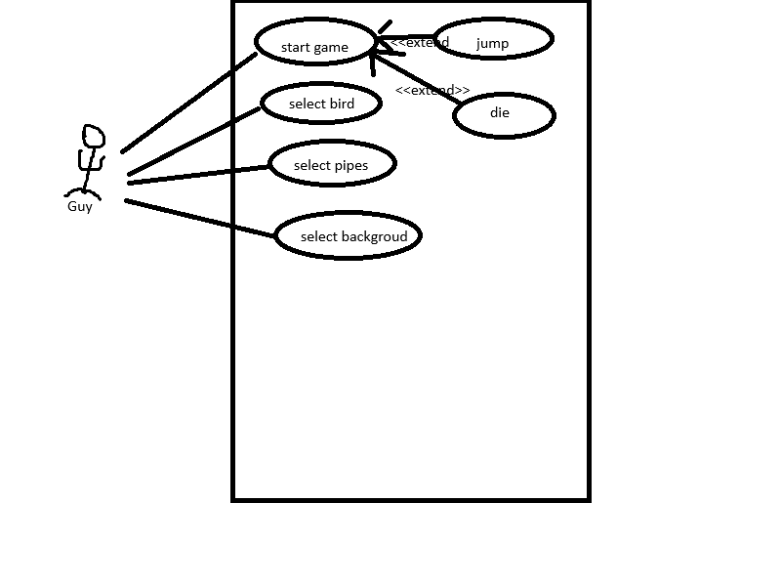
Textual descriptions:
- Start game: player can start playing the game.
- Select bird: player can select a bird sprite from a list of potential bird sprites.
- Select pipes: player can select pipe sprites from a list of potential pipe sprites.
- Select background: player can select backgrounds from a list of potential backgrounds.
- Jump: While playing, player can press space to jump.
- Die: While playing, player can run into screen bounds or pipes enough times to die.

Class Diagram and/or Sequence Diagrams (15 points)
This section presents a high-level overview of the anticipated system architecture using a class diagram and/or sequence diagrams.

If the main paradigm used in your project is Object Oriented (i.e., you have classes or something that acts similar to classes in your system), then draw the Class Diagram of the entire system and Sequence Diagrams for the three (3) most important use cases in your system.

If the main paradigm in your system is not Object Oriented (i.e., you do not have classes or anything similar to classes in your system) then only draw Sequence Diagrams, but for all the use cases of your system. In this case, we will use a modified version of Sequence Diagrams, where instead of objects, the lifelines will represent the functions in the system involved in the action sequence.

Class Diagrams show the fundamental objects/classes that must be modeled with the system to satisfy its requirements and the relationships between them. Each class rectangle on the diagram must also include the attributes and the methods of the class (they can be refined between increments). All the relationships between classes and their multiplicity must be shown on the class diagram.

A Sequence Diagram simply depicts interaction between objects (or functions - in our case - for non-OOP systems) in a sequential order, i.e. the order in which these interactions take place. Sequence diagrams describe how and in what order the objects in a system function.
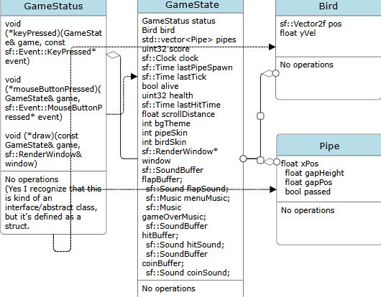
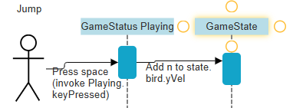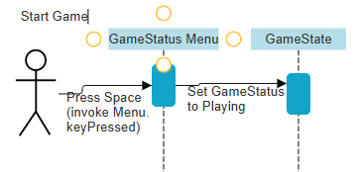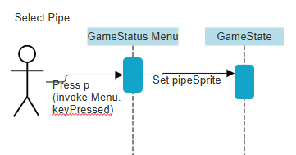

Operating Environment (5 points)
Describe the environment in which the software will operate, including the hardware platform, operating system and versions, and any other software components or applications with which it must peacefully coexist.
Targeted toward PC, Mac, and Linux. Must be compatible with SFML.

Assumptions and Dependencies (5 points)
List any assumed factors (as opposed to known facts) that could affect the requirements stated in this document. These could include third-party or commercial components that you plan to use, issues around the development or operating environment, or constraints. The project could be affected if these assumptions are incorrect, are not shared, or change. Also identify any dependencies the project has on external factors, such as software components that you intend to reuse from another project.
Dependencies:
  - SFML
  - cenui (a UI library written by Andrew solely to support this project lol)

