Reverse Engineering and CFD Analysis of a Two-Stage, Oil-Free, Magnetic-Bearing Centrifugal Compressor
A Danfoss Turbocor TTS350-class compressor as used in the Trane TCAA air-cooled chiller
[TO DO: Your name]
Mechanical Engineering, California Polytechnic State University, San Luis Obispo
[TO DO: Course / advisor, if applicable]
Draft, October 2026
Status: draft. Covers the design basis, CAD model, CFD method, the first stage-1 CFD result and the stage-2 design-point CFD. The design-point stage-1 run, the compressor map and structural analysis are still to come.

Abstract
This report documents the reverse engineering of a two-stage, oil-free, magnetic-bearing centrifugal compressor in the class of the Danfoss Turbocor TTS350, the compressor used in the Trane TCAA air-cooled chiller. With no OEM drawings available, the geometry was derived from a one-dimensional (meanline) design at the chiller's operating point, using R-513A at 3.5 °C saturated suction and 51.5 °C saturated discharge, 110 tons per compressor and 30,000 rpm. The design gives a 103.4 mm impeller tip diameter, 7 main and 7 splitter blades with 40° backsweep, and a stage pressure ratio near 1.98. The full compressor was modelled in SolidWorks: inlet guide vanes, both impellers, crossover and de-swirl vanes, volute, permanent-magnet motor, and radial, axial and touchdown bearings. The stage-1 impeller was then analysed with a single-passage RANS simulation in Ansys TurboGrid and CFX. At the simulated operating point (300 K inlet, 2.70 kg/s, 30,000 rpm, R-134a real-gas properties), CFD predicts a total-to-total pressure ratio of 1.85 and an isentropic efficiency of about 0.89. This agrees with the meanline evaluated at the same conditions within 1 % on pressure ratio, 0.1° on exit flow angle and 2–5 % on specific work. Specific work computed three independent ways (total-temperature rise, blade torque and Euler exit swirl) agrees within 3 %.
[TO DO: Update the abstract once the design-point and stage-2 results are in.]

Contents

Right-click the table of contents in Word and choose Update Field to fill in page numbers.

1 Introduction
Oil-free centrifugal compressors with active magnetic bearings have become a common choice for mid-size chillers. Removing the oil system eliminates oil management, improves heat-transfer surfaces in the heat exchangers, and allows the compressor to run at high, variable speed. The Danfoss Turbocor family is the best-known example. Trane uses Turbocor compressors in its TCAA packaged air-cooled magnetic-bearing chiller.
The aim of this project is to understand how such a compressor works by building one in detail and analysing it, starting from public information only. The specific objectives are:
- Derive a physically consistent compressor geometry from the chiller's published operating conditions, using a meanline design method.
- Build a complete 3D CAD model of the compressor in SolidWorks, including the aerodynamic flow path, rotor, motor and bearings.
- Analyse the impeller aerodynamics with computational fluid dynamics (CFD) in Ansys, and compare the results with the meanline prediction.
- Document the workflow, the problems encountered and how they were resolved.
Important limitation: the geometry in this report is a representative design that does the same job as the real compressor. It is not Danfoss's actual geometry, and the results describe this design, not the commercial product.

2 Background: the Trane TCAA chiller and its compressor
The Trane installation, operation and maintenance manual for the TCAA chiller (TCA-SVX001C-EN, June 2026) does not contain compressor drawings, but it fixes the main facts the design is built on (Table 1).
Table 1. Information taken from the Trane TCAA IOM
IOM information | How it is used in this project
Compressor models TTS300, TTS350, TGS380 | Turbocor TT-class size, envelope and speed range
Refrigerant R-513A | All thermodynamic calculations
TCAA220: 165–240 tons on two compressors | Design capacity of about 110 tons per compressor
Air-cooled condenser | High lift: saturated discharge about 51.5 °C (125 °F)
Two impellers on one high-speed shaft, the only moving part | Two in-line impellers on one overhung rotor
Gas path: IGVs, 1st impeller, de-swirl vanes, 2nd impeller, diffuser, volute | Layout of the aerodynamic flow path
Integrated variable-speed drive with soft start; inverter and SCR heatsinks | Electronics enclosure on top of the compressor
Liquid refrigerant cools the inverter, SCR and stator grooves, then returns to suction through the motor cavity | Helical stator cooling groove; motor cavity vented to suction

The variable-speed drive is central to how the machine works. The chiller is supplied with 60 Hz mains power, which would turn a two-pole motor at only 3,600 rpm. At that speed the impellers would produce a pressure ratio of about 1.01, because pressure rise scales with the square of tip speed. The integrated drive rectifies the mains supply to DC and inverts it at about 500 Hz, which runs the permanent-magnet motor at the design speed of 30,000 rpm. Magnetic bearings make that speed practical, because the rotor never touches its supports and needs no oil.

3 Meanline design

3.1 Method
A meanline (one-dimensional) design sizes each stage from the required mass flow and pressure ratio using velocity triangles and loss correlations at a representative streamline. The calculation was written in Python, with real-gas R-513A properties from CoolProp. R-513A was modelled as a 56/44 % by mass mixture of R-1234yf and R-134a. Both stages share one tip diameter, which was solved so that the two stages together reach condenser pressure. Exit slip was estimated with the Wiesner correlation; the inlet eye was sized to minimise the relative Mach number at the blade tip.
Table 2. Meanline design inputs
Input | Value | Reason
Capacity per compressor | 110 tons (387 kW) | TCAA220 split over two compressors
Saturated suction / discharge | 3.5 °C / 51.5 °C | AHRI 550/590 air-cooled conditions
Superheat / subcooling | 3 K / 5 K | Motor-cooling vapour returns to suction; integral subcooler
Design speed | 30,000 rpm | Mid-high in the Turbocor range; keeps tip relative Mach below 0.9
Impeller / stage efficiency (total-to-total) | 0.90 / 0.80 | Typical for small backswept impellers with vaneless diffusers
Blades | 7 main + 7 splitter, 40° backsweep | Common for refrigerant compressors of this size

3.2 Results
Table 3. Meanline results at the design point (R-513A)
Quantity | Stage 1 | Stage 2
Tip diameter D₂ | 103.4 mm | 103.4 mm
Tip speed U₂ | 162 m/s | 162 m/s
Eye tip / hub diameter | 67.0 / 26.8 mm | 54.0 / 25.9 mm
Exit width b₂ | 8.26 mm | 4.21 mm
Inlet relative Mach number (tip) | 0.88 | 0.73
Flow coefficient φ | 0.102 | 0.053
Work coefficient ψ | 0.63 | 0.63
Exit flow angle α₂ (from radial) | 65.9° | 65.9°
Stage pressure ratio | 1.979 | 1.970

Overall, the compressor lifts the refrigerant from 364 kPa to 1420 kPa (pressure ratio 3.90) at 3.34 kg/s. The estimated shaft power is 113 kW, the electrical input about 119 kW, and the compressor-only efficiency about 1.08 kW/ton. The discharge temperature is 60 °C. These values are in the expected range for an air-cooled oil-free centrifugal chiller.

3.3 Blade geometry
The 3D blade shape was generated from the meanline results. The hub and shroud contours are cubic Bézier curves. The blade angle varies smoothly from the inlet flow angle (plus 2° incidence) to the 40° exit angle. The angle distribution was adjusted so that hub and shroud reach the same wrap angle at the trailing edge, about 80° for stage 1, which keeps the trailing edge a straight radial line. Integrating the blade angle along each contour gives 3D camber lines. These were exported both as point files for SolidWorks and as TurboGrid curve files, so the CAD model and the CFD mesh come from identical geometry.

4 SolidWorks model
The complete compressor was modelled in SolidWorks in a single machine coordinate system: X along the rotor axis, with X = 0 at the suction flange face. Most parts are revolved profiles. The impellers were built from the generated 3D curves: the hub revolved from its meridional curve, each blade made as a boundary surface between hub and shroud camber lines and then thickened, patterned seven times, and trimmed to the shroud contour with a revolved cut.
Table 4. Main components of the model
Component | Key features
Inlet housing and IGVs | DN100 suction flange; 8 NACA 0012 vanes, 40 mm chord, adjustable angle
Stage-1 and stage-2 impellers | Ø103.4 mm, 7 + 7 splitter blades, 7075-T6 aluminium
Compressor casing and diaphragm | Vaneless diffusers, crossover bend, 12 de-swirl vanes
Volute | Circular sections growing from zero to Ø33.1 mm; DN50 discharge cone
Rotor | 547 mm stepped shaft, PM motor section Ø70 mm with carbon-fibre sleeve, thrust disk
Motor | 160 mm stator stack, 24 slots; sleeve with helical refrigerant cooling groove
Bearings | Two 8-pole radial magnetic bearings, double-acting axial bearing, two touchdown bearings
Externals | Electronics enclosure, mains input box, mounting feet; envelope about 790 × 480 × 465 mm
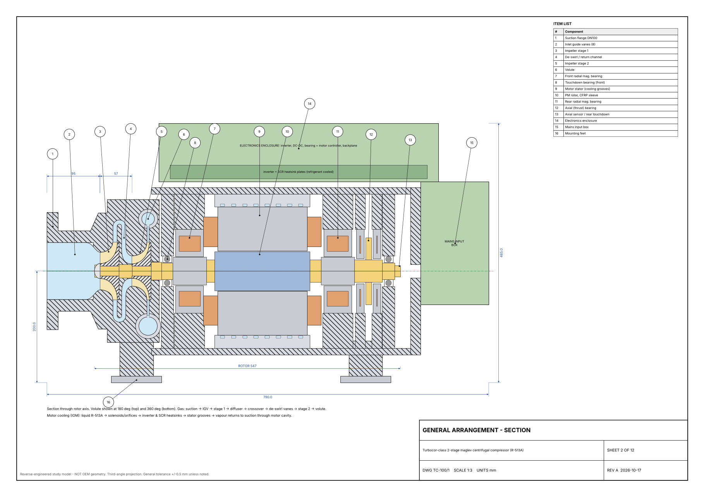
Figure 1. General arrangement section of the compressor (drawing TC-100/1).
[TO DO: Insert a SolidWorks screenshot of the finished assembly (section view)]
Figure 2. SolidWorks assembly, section view.
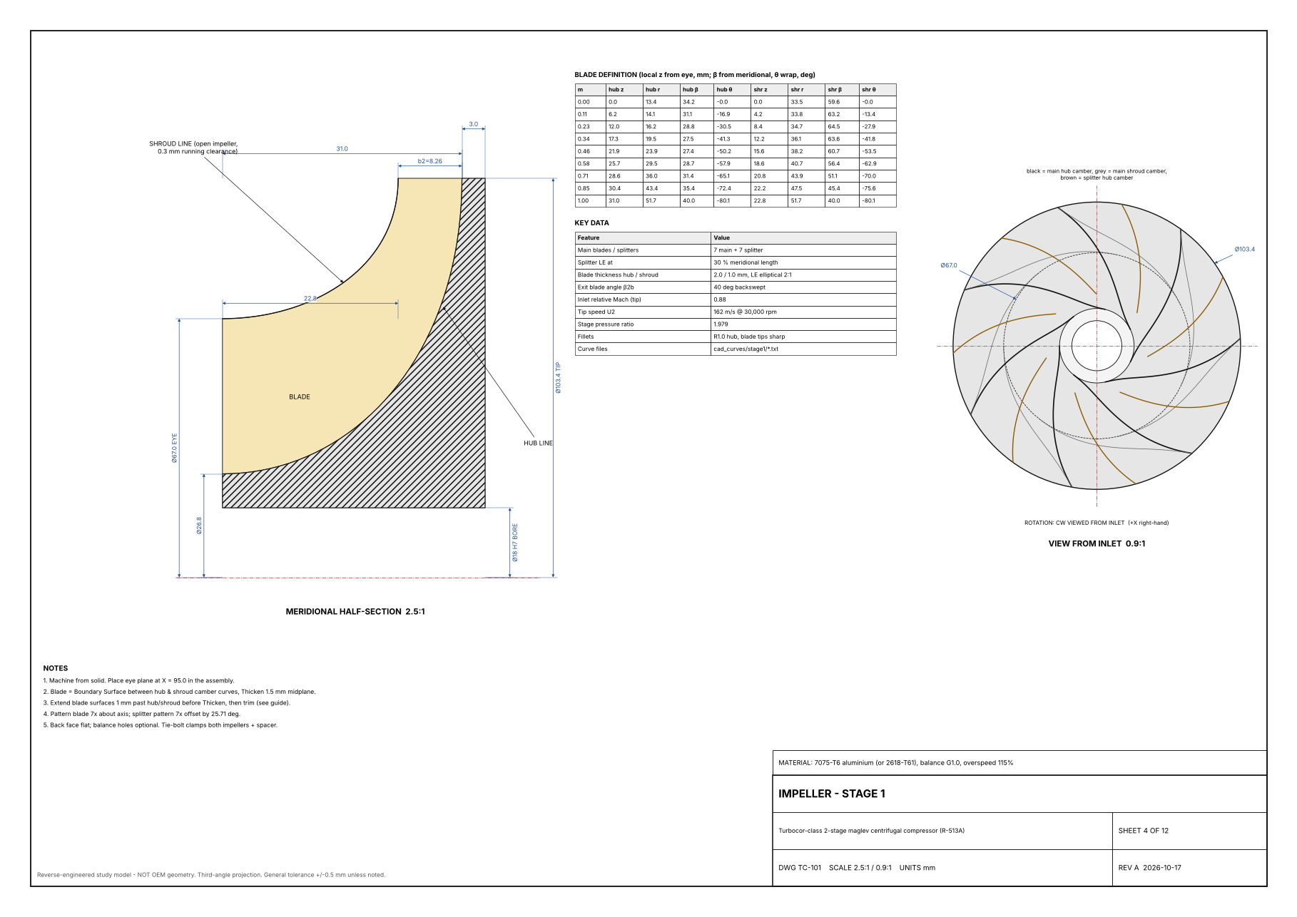
Figure 3. Stage-1 impeller: meridional section, blade definition and view from the inlet (drawing TC-101).
[TO DO: Insert a SolidWorks screenshot of the stage-1 impeller]
Figure 4. Stage-1 impeller in SolidWorks.

5 CFD method (stage 1)

5.1 Computational domain
Because the impeller repeats every 51.4° (seven main blades), only one passage was simulated: one main blade, one splitter and the gas between them. The two cut faces of the slice use rotational periodic boundaries. The domain runs from 20 mm upstream of the eye, through the impeller, to the end of the vaneless diffuser at r = 80.1 mm. The 0.3 mm tip gap between the open blades and the casing is included.
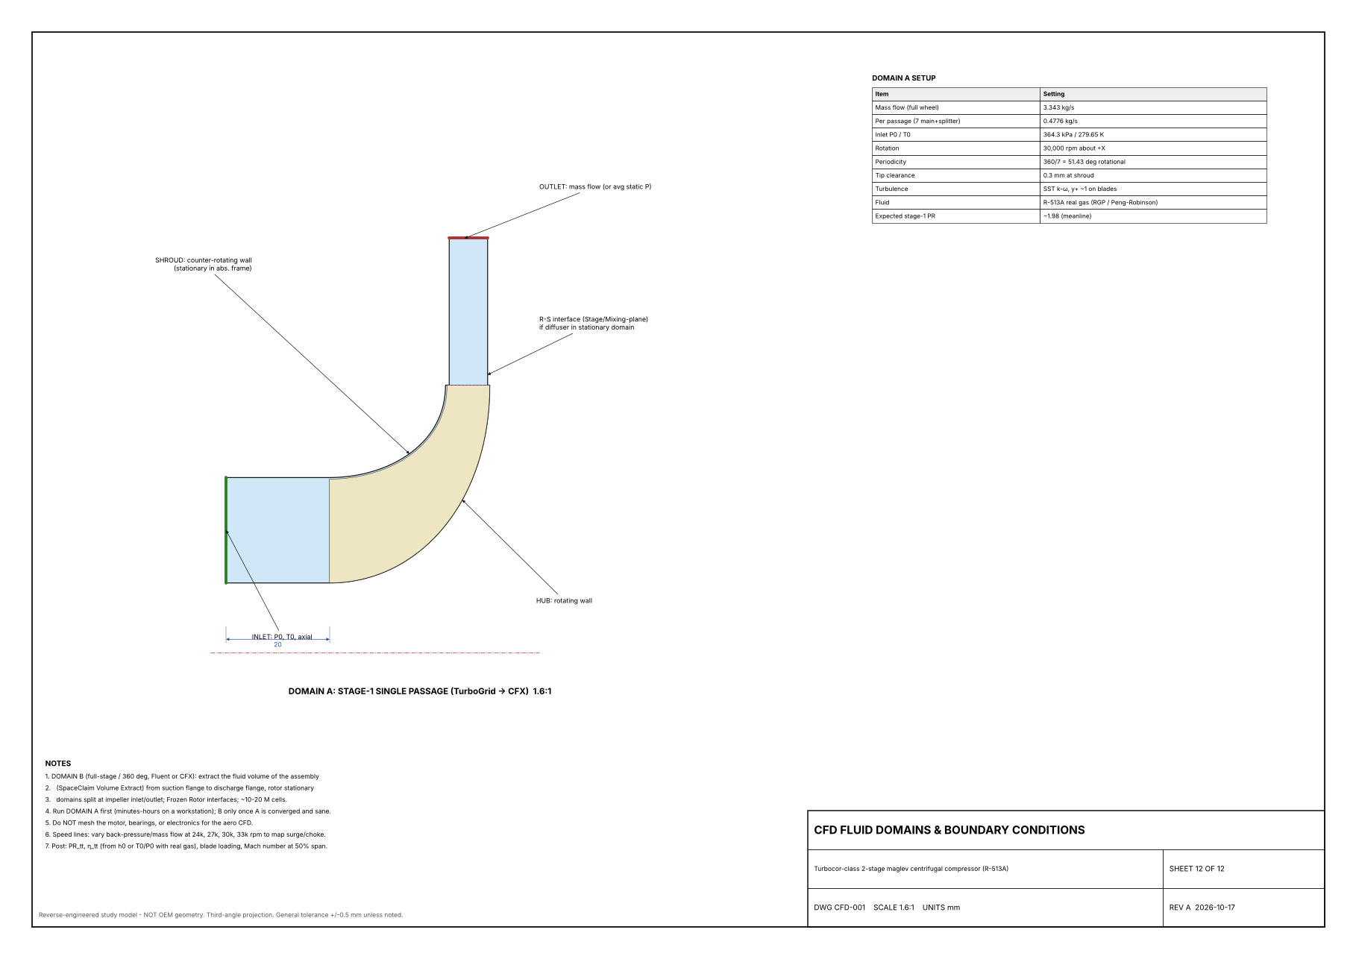
Figure 5. Single-passage domain and boundary conditions (drawing CFD-001).

5.2 Mesh
The mesh was generated in Ansys TurboGrid with the ATM Optimized topology, which wraps a structured hexahedral grid around the main blade and the splitter. Boundary-layer refinement used a factor base of 5, with about 12 cells across the tip gap. Over 99.6 % of cells passed every TurboGrid quality check. Remaining flagged cells (under 0.1 %) were at the blade leading edges. [TO DO: final node count for the run with splitters]

5.3 Physics and boundary conditions
Table 5. CFX setup
Setting | Value
Analysis | Steady state, rotating frame (30,000 rpm about +Z)
Fluid | R-134a, real-gas library material (stand-in for R-513A, which was designed as an R-134a drop-in)
Turbulence model | SST k-ω with automatic wall treatment
Reference pressure | 300 kPa
Inlet | Total pressure 364.3 kPa absolute, total temperature (see 6.1), flow normal to boundary
Outlet | Mass flow (whole machine) or average static pressure
Hub and blades | No-slip walls rotating with the impeller
Casing and diffuser hub | No-slip, counter-rotating (stationary in the absolute frame)
Advection / timescale | High resolution; auto timescale (conservative)

5.4 Setup problems found and fixed
Several problems were found while getting the simulation to run. They are recorded here because each changed the answer significantly.
Table 6. Problems encountered
Problem | Symptom | Fix
Project and solver files stored on a cloud-synced (OneDrive) drive | Setup file could not be written; solver could not write results | Work on the local drive; archive to OneDrive only at the end
Splitter blade missing from the mesh after a project rebuild | Only one blade per passage; slip factor 0.76; work about 7 % low | Re-added the splitter as Blade 2 in TurboGrid and re-meshed
Casing set as a rotating wall | Casing spun with the blades; unstable outlet flow late in the run | Set the shroud to a counter-rotating wall
Diffuser hub rotating with the impeller | Angular momentum rose 5 % through the diffuser, which is not physical | Split the hub after the trailing edge into a separate counter-rotating wall
Missing backups and monitors | A run that collapsed at iteration ~800 could not be recovered | Backups every 100 iterations; monitors for pressure ratio, outlet temperature and mass flow
Inlet total temperature entered as 300 K | Run solved at an off-design point (see section 6) | Use 279.65 K for the design-point run

6 Stage-1 CFD results

6.1 Operating point
The first complete run with the splitter included was solved with an inlet total temperature of 300 K instead of the design value of 279.65 K, and the impeller settled at 2.70 kg/s rather than the design 3.343 kg/s (81 % of design flow). It is therefore an off-design point. To compare like with like, the meanline was re-evaluated at exactly these conditions with the same R-134a properties.
Convergence: the run stopped at 200 iterations. RMS residuals were about 6 × 10⁻⁶ for mass, 4 × 10⁻⁵ for U-momentum and 1.5 × 10⁻⁴ for V- and W-momentum, flat over the last 100 iterations. [TO DO: final mass imbalance from the .out file]

6.2 Overall performance
Table 7. Stage-1 performance: CFD vs meanline at the same operating point
Quantity | CFD | Meanline
Inlet total pressure | 361.3 kPa | —
Outlet total pressure | 668.7 kPa | —
Total pressure ratio | 1.851 | 1.866
Inlet / outlet total temperature | 299.95 / 322.93 K | 299.95 / 323.4 K
Mass flow (whole wheel) | 2.70 kg/s | 2.70 kg/s (input)
Specific work (total-temperature rise) | 15.9 kJ/kg | 16.3 kJ/kg
Isentropic efficiency (total-to-total) | 0.89 | 0.88 (assumed)
Stage-1 shaft power | 41.6 kW | —

The pressure ratio agrees within 1 %, the outlet temperature within 0.5 K and the specific work within about 2 %. The meanline efficiency was an assumption (0.88), so the pressure-ratio agreement partly reflects that choice. The work and temperature comparisons do not depend on it.

6.3 Energy consistency check
The work done on the gas was computed three independent ways. All three agree within 3 %, which shows the simulation is conserving energy correctly.
Table 8. Specific work from three independent methods
Method | How it is computed | Specific work
Total-temperature rise | Real-gas enthalpy change between mass-averaged inlet and outlet total states | 15.9 kJ/kg
Blade torque | Torque on one passage × angular speed ÷ passage mass flow (1.890 N·m × 3141.6 rad/s ÷ 0.386 kg/s) | 15.4 kJ/kg
Euler equation | Tip speed × mass-averaged exit swirl velocity (U₂·Cθ₂) | 15.6 kJ/kg

6.4 Impeller exit flow and slip
Velocities were extracted on a constant-radius surface at r = 52 mm, just downstream of the blade tips, and corrected back to the tip radius (51.7 mm) assuming constant angular momentum and continuity.
Table 9. Impeller exit: CFD vs meanline
Quantity | CFD | Meanline, 14 blades | Meanline, 7 blades | Earlier CFD, no splitter
Swirl velocity Cθ₂ (m/s) | 95.3 | 100.2 | 84.7 | 87.4
Radial velocity Cr₂ (m/s) | 45.3 | 47.3 | 49.2 | 43.1
Exit flow angle α₂ | 64.6° | 64.7° | 59.9° | 64°
Slip factor σ | 0.83 | 0.86 | 0.78 | 0.76

The exit flow angle matches the meanline within 0.1°. The CFD slip factor of 0.83 lies between the Wiesner predictions for 7 and 14 blades, closer to 14. This is the expected trend: splitter blades reduce slip, but less than full-length blades, so treating them as full blades in the Wiesner formula slightly overestimates their benefit. Adding the splitter increased the exit swirl from 87.4 m/s to 95.3 m/s, about 9 % more work, compared with the earlier run in which the splitter was missing from the mesh.

6.5 Flow field
The following observations come from blade-to-blade, meridional and blade-loading plots. They were made on the earlier run without the splitter and are to be confirmed on the current run.
- Blade loading at 50 % span builds smoothly and peaks near 90 % of the blade length. A sharp pressure spike at the leading edge indicates moderate incidence; there is no shock.
- The inlet relative Mach number at 90 % span is about 0.85, against 0.88 predicted. No region reaches Mach 1.
- A large low-momentum region forms near the shroud in the rear half of the passage. Together with the strongly non-uniform exit flow (mass-averaged radial velocity well above the area average), this is the classic jet-wake pattern of centrifugal impellers.
- Entropy rises along the shroud, so the losses are concentrated near the casing, consistent with tip leakage and the wake region.
[TO DO: Insert relative Mach number, blade-to-blade, at 10 %, 50 % and 90 % span]
Figure 6. Relative Mach number in the blade-to-blade view.
[TO DO: Insert blade loading chart at 50 % span]
Figure 7. Blade loading at 50 % span.
[TO DO: Insert meridional entropy (or total pressure) plot]
Figure 8. Circumferentially averaged static entropy.
[TO DO: Insert ImpExit surface coloured by velocity (jet-wake)]
Figure 9. Absolute velocity at the impeller exit (r = 52 mm).

7 Stage-2 CFD results

7.1 Setup changes from stage 1
Stage 2 used the same single-passage approach with the stage-2 TurboGrid mesh (386,472 nodes, 358,685 hexahedra). The inlet was set to the meanline stage-1 exit state: total pressure 720.9 kPa absolute (120.9 kPa relative to a 600 kPa reference) and total temperature 305 K, with the design mass flow of 3.343 kg/s at the outlet. The run went to the 1000-iteration limit.
Two setup problems were found and fixed on the way. Without table generation, the R-134a real-gas property table stops at about 1 MPa absolute; stage 2 reaches about 1.4 MPa, so the first attempt clipped the pressure from the first iteration, ran away and stopped with a floating-point overflow. The final run used a generated table from 1 kPa to 4 MPa and 240 K to 480 K (200 points per axis) and had no property clipping. Second, the post-processing expressions copied from the stage-1 project still added the 300 kPa stage-1 reference pressure instead of 600 kPa.

7.2 Overall performance
Table 10. Stage-2 performance: CFD (mass-averaged) vs meanline
Quantity | CFD | Meanline
Inlet / outlet total pressure (abs) | 720.6 / 1406 kPa | 720.9 / 1420.1 kPa
Total pressure ratio | 1.951 | 1.970
Specific work Δh₀ | 15.54 kJ/kg | 16.53 kJ/kg
Outlet total temperature (real gas, from Δh₀) | 333.2 K | 333.3 K
Isentropic efficiency (total-to-total) | 0.90 | 0.90 (impeller assumption)
Gas power, whole wheel | 51.9 kW | ≈ 55 kW
Outlet static pressure / temperature | 994.8 kPa / 319.7 K | —
Outlet superheat above saturation | 7.4 K | —

The pressure ratio is within 1 % of the meanline and the efficiency matches the impeller assumption. The work is 6 % below the meanline: the impeller produces less exit swirl than the slip model predicted (work coefficient Cθ₂/U₂ = 0.55 against 0.63). CFD-Post's derived total temperature read about 2 K low for this real-gas case and implied an efficiency above 1; the outlet total temperature above is therefore computed from the solver's total-enthalpy rise with real-gas R-134a properties.

7.3 Work and angular-momentum checks
Table 11. Stage-2 specific work from independent methods
Method | How it is computed | Specific work
Total-enthalpy rise | Mass-averaged total enthalpy, outlet minus inlet | 15.54 kJ/kg
Rotor torque | 2.314 N·m per passage (blade + rotating hub) × 3141.6 rad/s ÷ 0.4776 kg/s | 15.23 kJ/kg
Euler + shroud friction | ω·(r·Cθ) at r = 52 mm (14.6 kJ/kg) plus stationary-shroud friction torque × ω ÷ ṁ (0.62 kJ/kg) | 15.2 kJ/kg

The three methods agree within 2 %. About 4 % of the rotor work goes into friction on the stationary shroud rather than into swirl. The mass-averaged angular momentum r·Cθ is 4.66 m²/s at the impeller exit and 4.61 m²/s at the domain outlet: it falls slightly through the vaneless diffuser, as wall friction should make it, which confirms that the diffuser walls are correctly modelled as stationary.
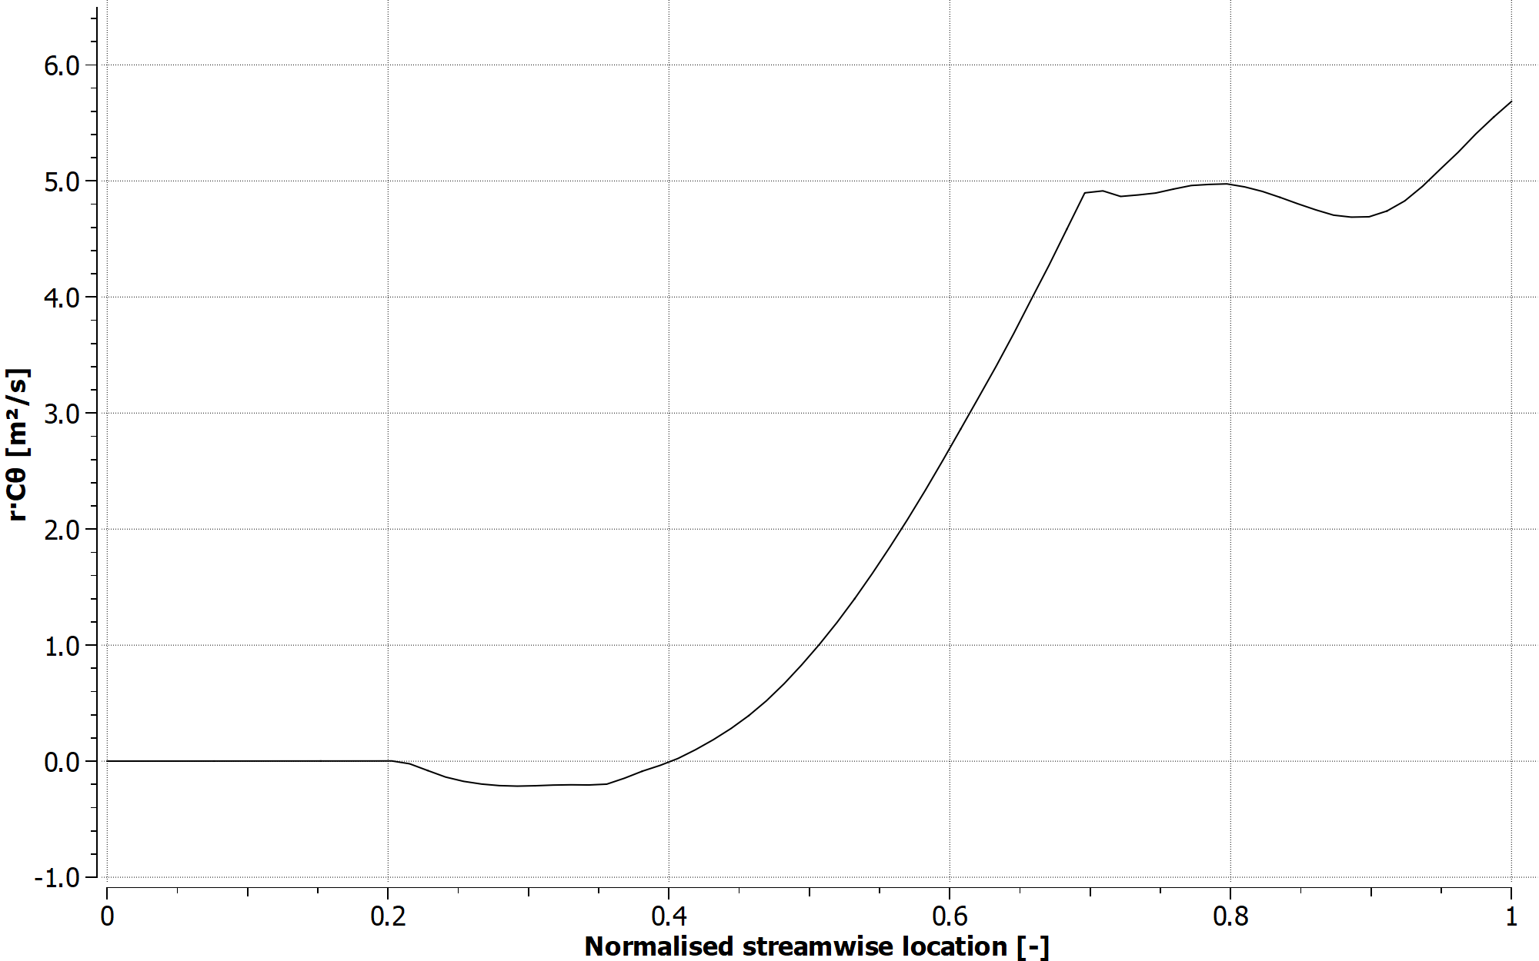
Figure 10. Mass-averaged angular momentum r·Cθ along the flow path (0 = inlet, 1 = outlet; impeller trailing edge at about 0.70). The rise beyond about 0.9 is an averaging artifact from reverse-flow faces at the outlet boundary; plane averages give 4.66 m²/s at the impeller exit and 4.61 m²/s at the outlet.

7.4 Where the losses are
Mass-averaged static entropy rises by 5.1 J/(kg·K) between the inlet and the impeller exit and by a further 10.4 J/(kg·K) through the vaneless diffuser, so most of the stage loss is in the diffuser rather than the impeller. The diffuser exit flow is far from uniform: the mass-averaged absolute Mach number at the outlet is still 0.68, the total-to-static pressure ratio is only 1.38, and reverse flow blocks about 5.5 % of the outlet area. Because of this non-uniformity, single-number averages disagree: mass-averaged total pressure gives a pressure ratio of 1.95, while a uniform state rebuilt from the averaged static pressure, temperature and velocity gives 1.73. The true mixed-out performance lies between the two. The short vaneless diffuser leaves much of the exit kinetic energy unrecovered; in the real machine the return channel or volute does that job.
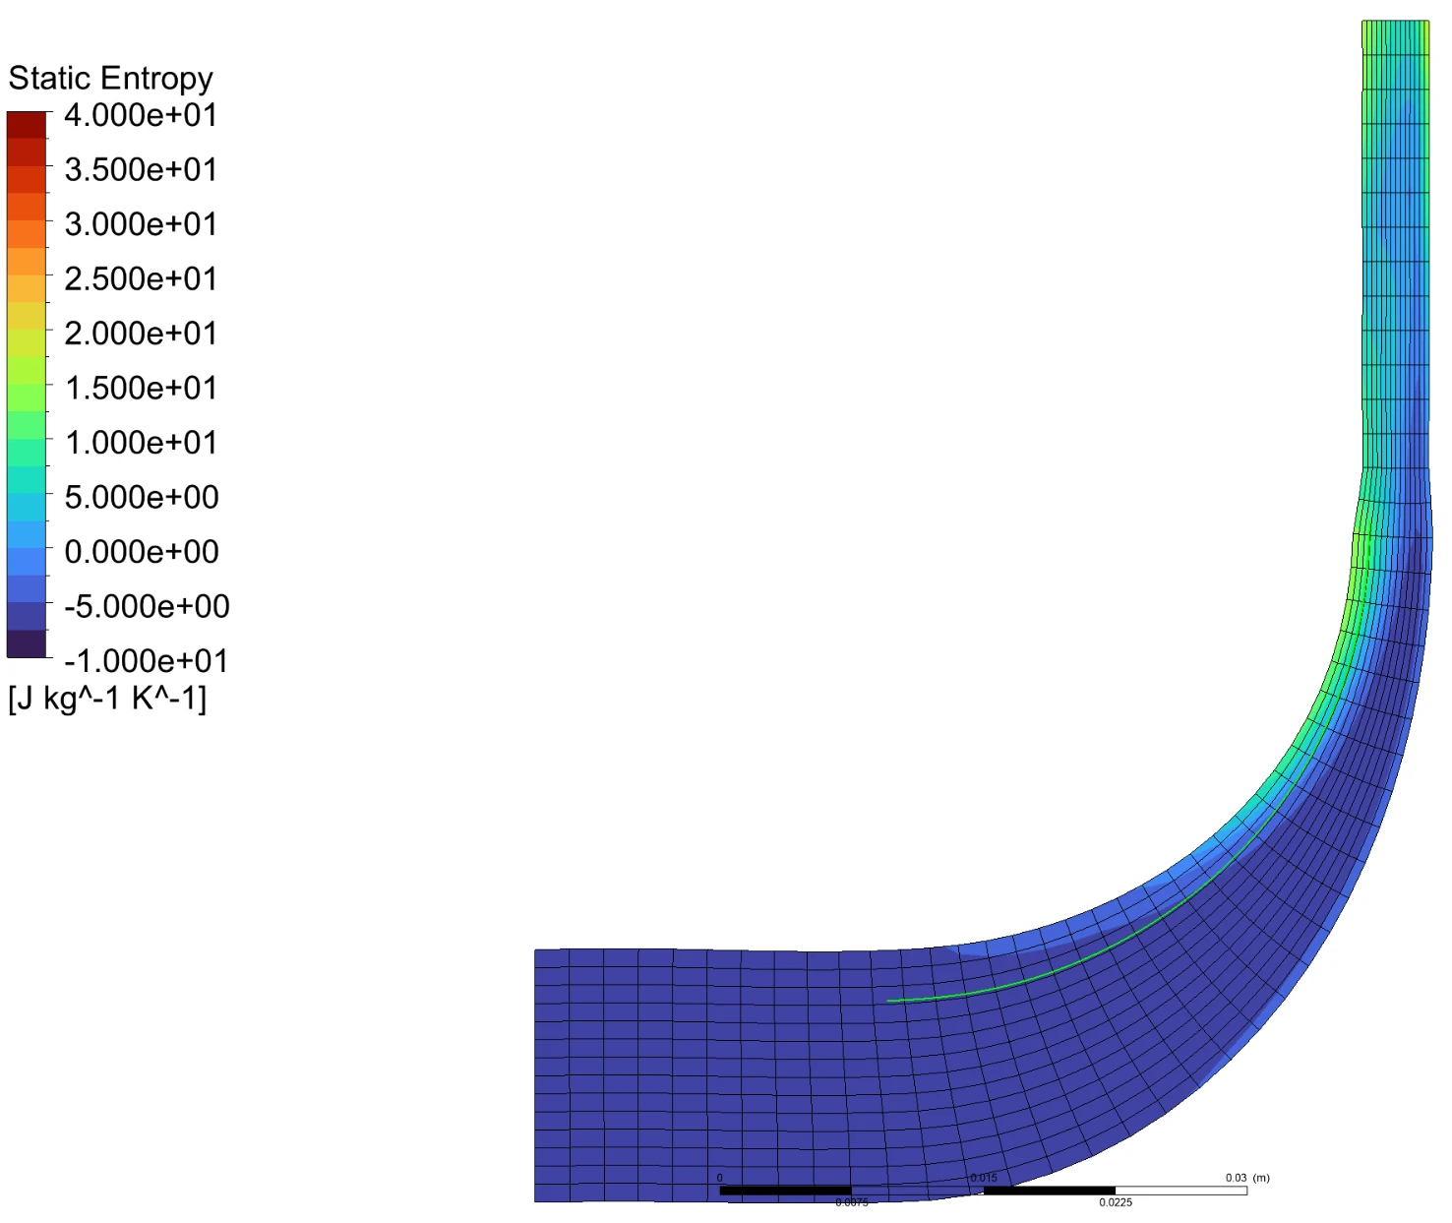
Figure 11. Circumferentially averaged static entropy, stage 2. Entropy rises along the shroud from mid-passage and is carried through the impeller exit and the diffuser.
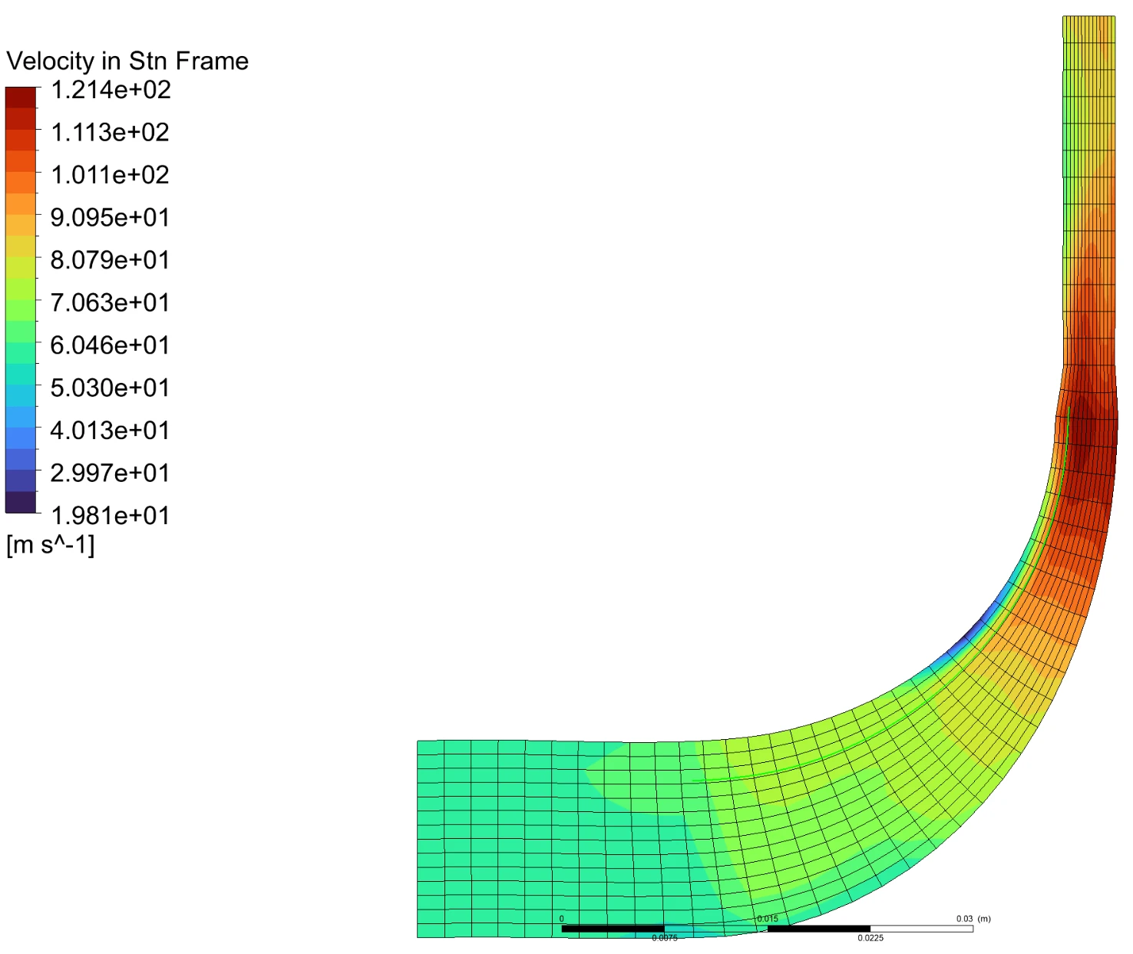
Figure 12. Circumferentially averaged absolute velocity, stage 2. A low-velocity region forms on the shroud side around the bend; the velocity peaks at about 120 m/s at the impeller exit and falls only to about 85–90 m/s by the outlet.

7.5 Flow field
The relative Mach number (Figure 13) shows clean, attached flow near the hub and a growing low-momentum region beside the main blade toward the trailing edge as the span increases. At 90 % span it fills much of the rear passage (relative Mach number 0–0.2), next to a high-velocity jet. This is the jet-wake pattern of centrifugal impellers, driven by tip leakage and secondary flow. The inlet relative Mach number at the tip is about 0.7, against 0.73 from the meanline. Downstream of the trailing edge the relative Mach number reflects the rotating reference frame and has no physical meaning in the stationary diffuser.
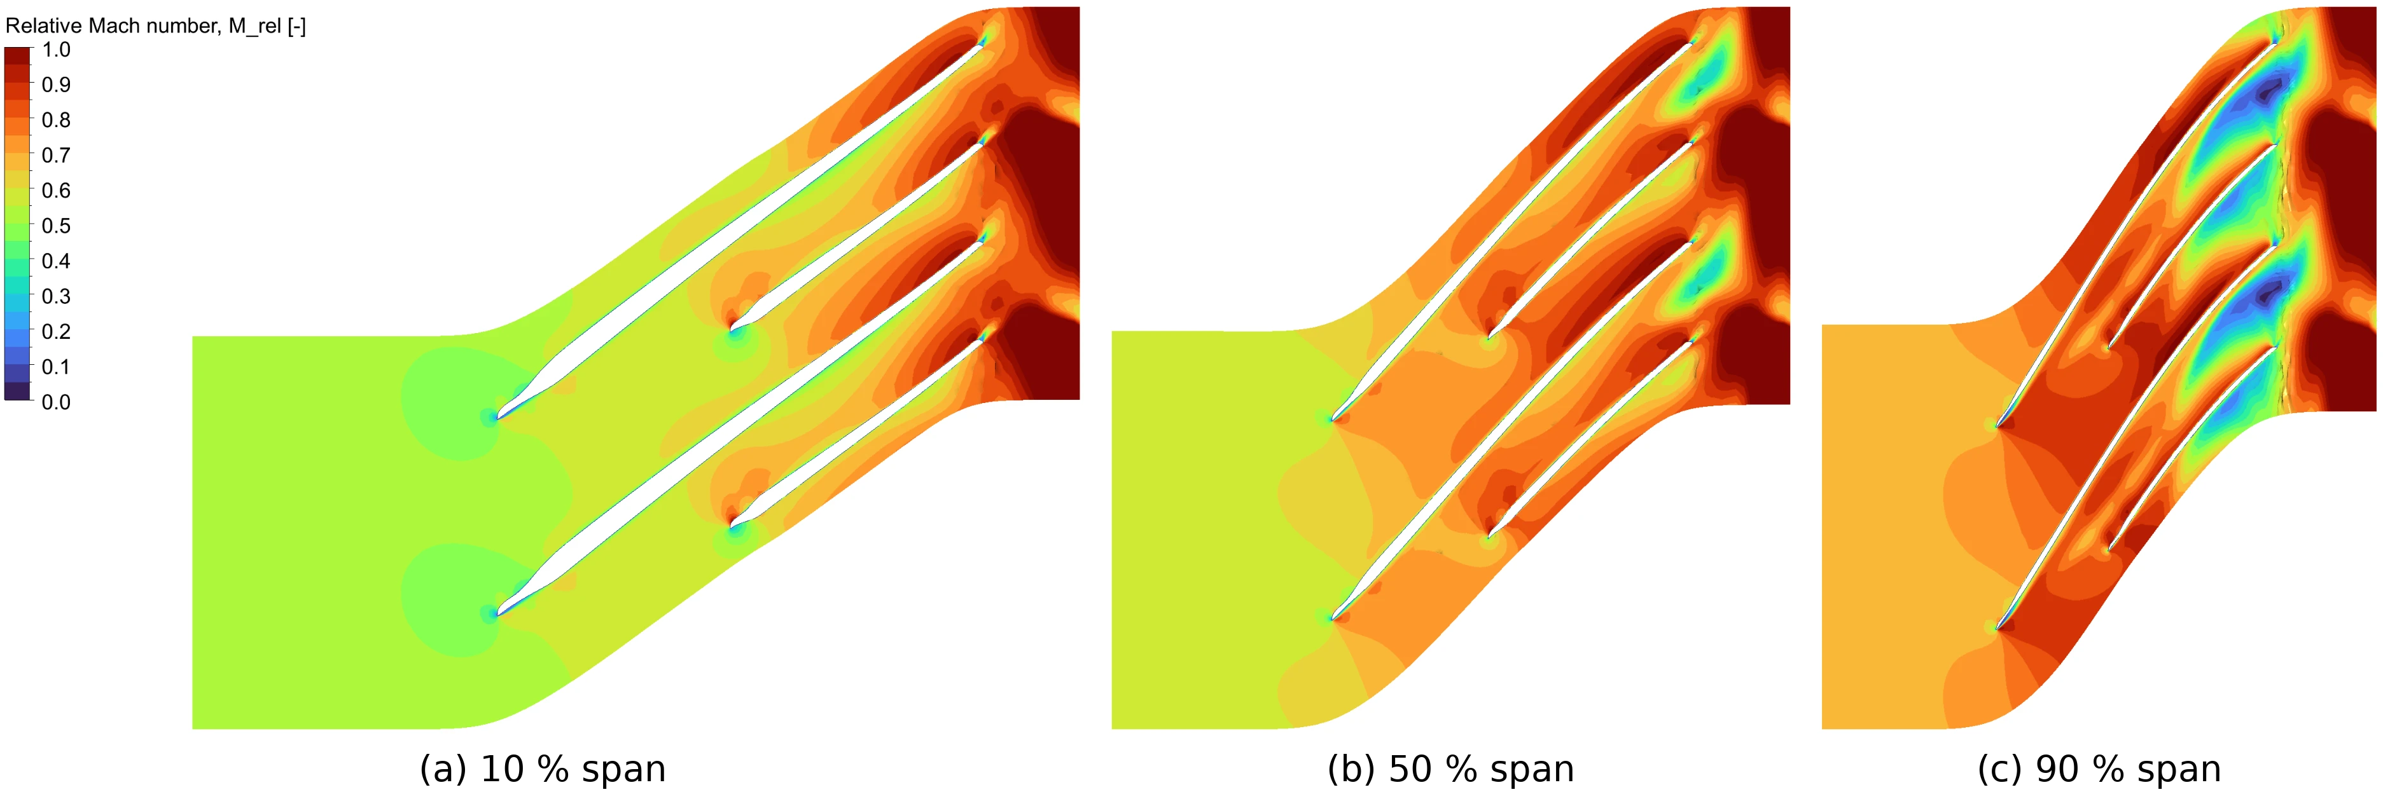
Figure 13. Relative Mach number, blade-to-blade view, stage 2 at the design point. The jagged line just after the trailing edges is a plotting artifact at the mesh-block interface.
In the absolute frame (Figure 14) the flow leaves the blades as a near-sonic jet (absolute Mach number 0.9–1.0 locally) and slows to about 0.5–0.6 at the outlet, with the blade wakes still visible as streaks.
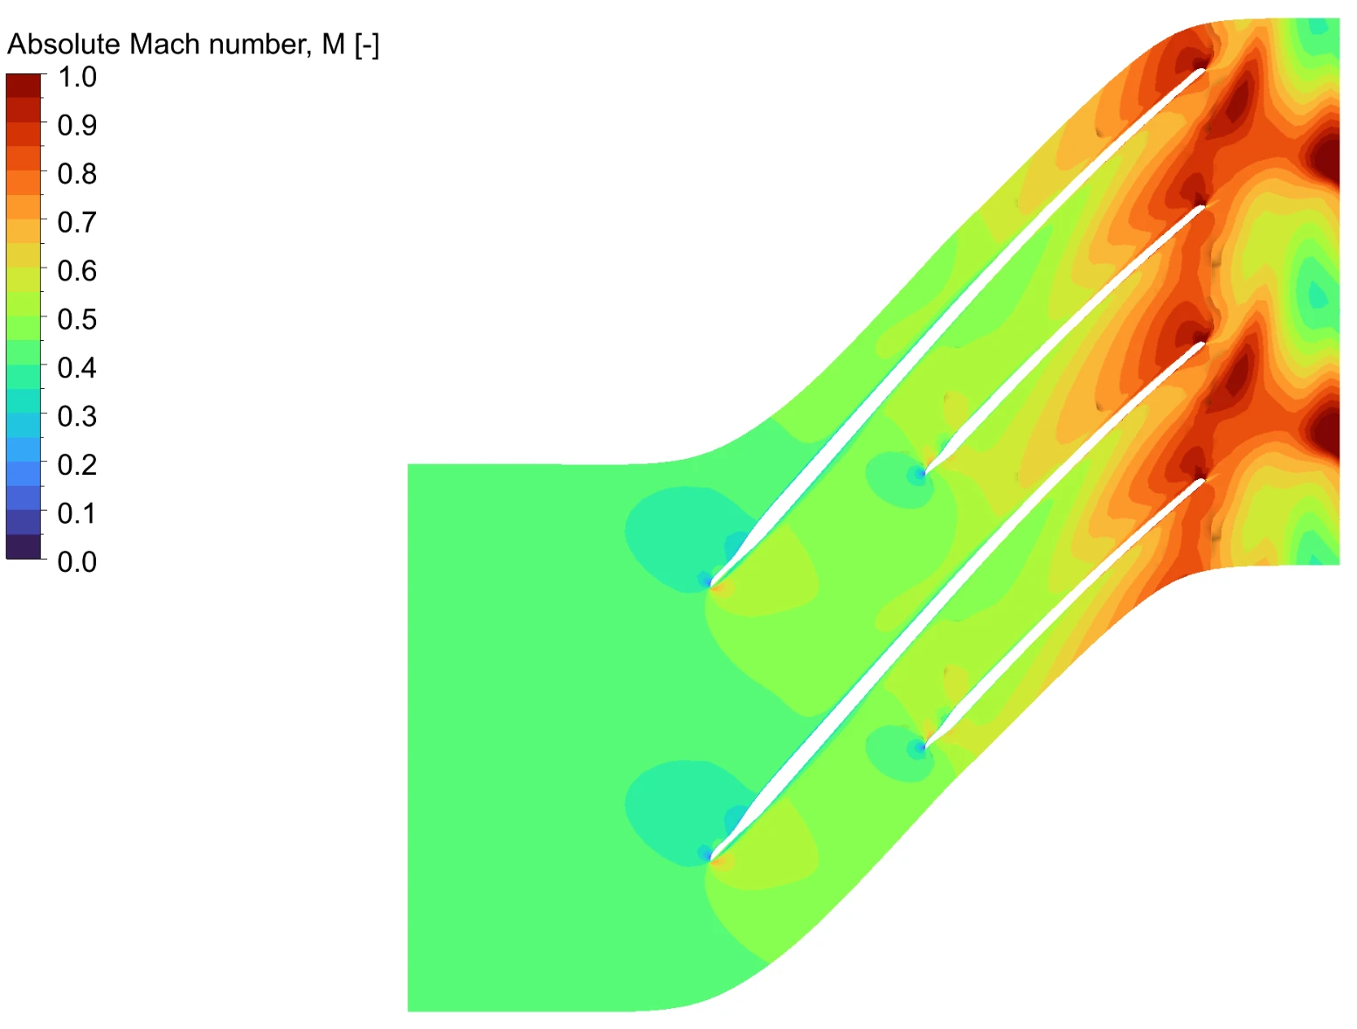
Figure 14. Absolute Mach number at 50 % span, stage 2.
Just downstream of the impeller (Figure 15), a band of negative radial velocity runs along the shroud across most of the passage, with the blade wakes as narrow low-velocity strips and the jet on the hub side. This reverse flow is why the mass-averaged meridional velocity at this plane comes out lower than the mass-averaged radial velocity. Streamlines released in the tip gap (Figure 16) cross the blade tips, mix into the passage and leave as a high-entropy stream along the shroud side of the diffuser, which links the tip leakage to the shroud-side entropy in Figure 11.
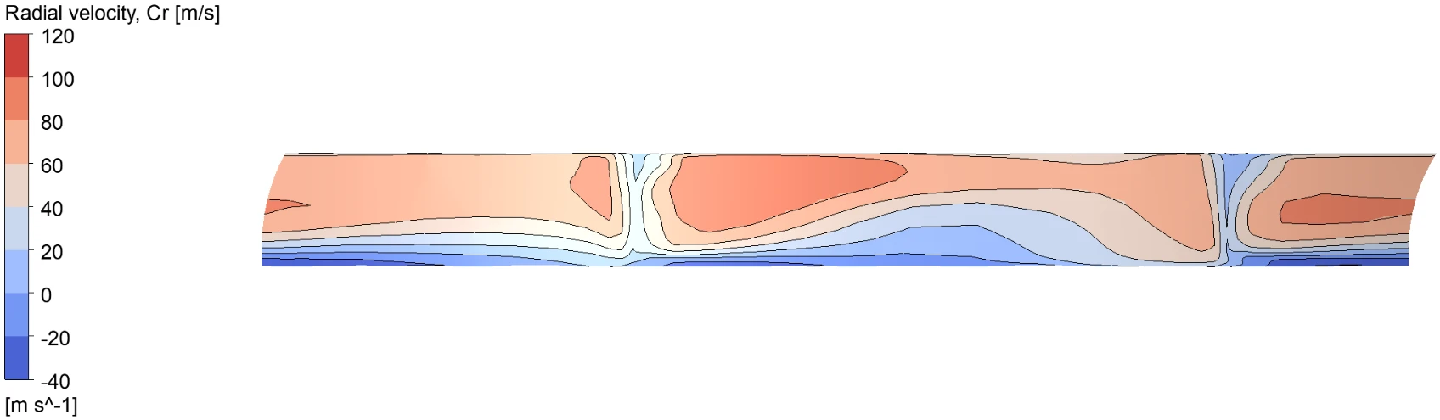
Figure 15. Radial velocity Cr on the r = 52 mm surface just downstream of the impeller trailing edge (one passage, viewed radially inward, shroud at the bottom). Black lines are contours at 20 m/s intervals; negative values are reverse flow.
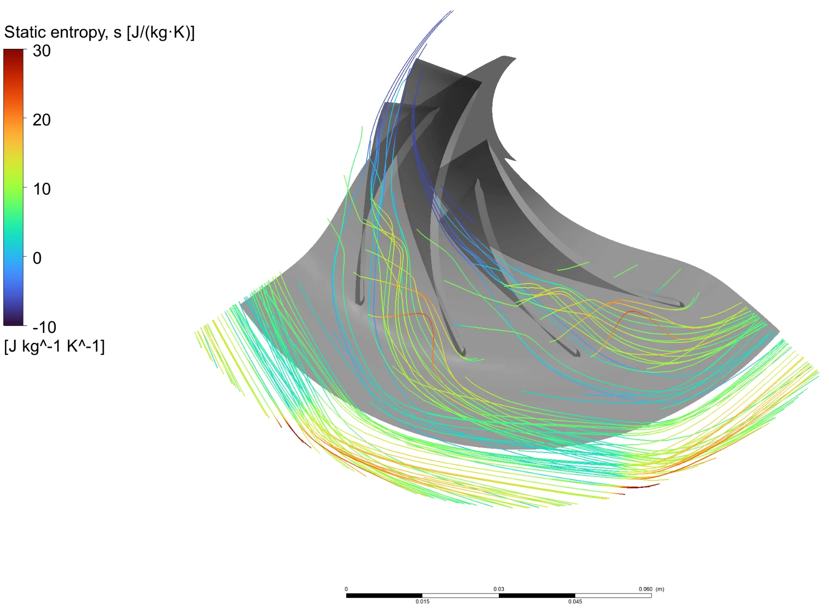
Figure 16. Relative-frame streamlines seeded at 97 % span (tip-clearance region), coloured by static entropy.
[TO DO: Insert blade loading, main blade and splitter, at 20 %, 50 % and 80 % span]
Figure 17. Blade loading, stage 2.

7.6 Mesh and convergence
Average y⁺ is about 3 on the blades (maximum 71) and 27–52 on the hub, shroud and diffuser hub. The SST model's automatic wall treatment switches between resolving the near-wall layer and using wall functions, so both ranges are acceptable; the blades are close to resolved, the end walls use wall functions. RMS residuals flattened at about 10⁻⁴ (mass) and 4 × 10⁻⁴ (momentum) from about iteration 100 onward, without diverging, which points to mild unsteadiness from the tip vortex and the diffuser exit rather than a setup problem. The final mass and energy imbalances were −0.25 % and −0.30 %.
Table 12. Stage-2 limitations
Limitation | Effect
R-134a stand-in instead of R-513A | Small property differences; same trends
Single passage, steady, no volute or return channel | Diffuser exit losses and non-uniformity not resolved downstream
Outlet close to the impeller with 5.5 % reverse-flow area | Averaged outlet totals uncertain; PR between 1.73 and 1.95
No blade or hub fillets | A few % extra blockage in the 4.2 mm exit passage not modelled
Residuals plateaued near 10⁻⁴ | Averaged quantities steady to within about 1 %

8 Remaining work
- Design-point stage-1 run: 279.65 K inlet (or 300 K with R-134a), 3.343 kg/s, with property-table generation and the same post-processing as stage 2.
- Switch the material to a custom R-513A real-gas definition and quantify the difference from R-134a.
- Combined two-stage pressure ratio and power once the design-point stage-1 run is done.
- Longer outlet domain for stage 2, to check whether the outlet reverse flow and the pressure-ratio averaging range shrink.
- Speed lines at 24,000–33,000 rpm to build a compressor map, including surge and choke limits.
- Optional structural checks: impeller stress at 115 % overspeed and rotor critical speed.
- Conclusions.

References
[1] Trane, Installation, Operation, and Maintenance: Packaged Air-Cooled Magnetic Bearing Chiller, Model TCAA, TCA-SVX001C-EN, June 2026.
[2] F. J. Wiesner, "A review of slip factors for centrifugal impellers," Journal of Engineering for Power, vol. 89, no. 4, pp. 558–566, 1967.
[3] S. L. Dixon and C. A. Hall, Fluid Mechanics and Thermodynamics of Turbomachinery, 7th ed. Butterworth-Heinemann, 2014.
[4] R. H. Aungier, Centrifugal Compressors: A Strategy for Aerodynamic Design and Analysis. ASME Press, 2000.
[5] I. H. Bell, J. Wronski, S. Quoilin and V. Lemort, "Pure and pseudo-pure fluid thermophysical property evaluation and the open-source thermophysical property library CoolProp," Industrial & Engineering Chemistry Research, vol. 53, no. 6, pp. 2498–2508, 2014.
[6] Ansys, Inc., Ansys CFX-Solver Theory Guide and TurboGrid User's Guide, Release 2026 R1.

