Hand-Calculation Package
Two-stage magnetic-bearing centrifugal compressor (Turbocor TTS350 class, R-513A)
Free-body diagrams, control volumes and every sizing calculation behind the design
How to use this package: each calculation follows the same pattern used in engineering calc books: Given, Find, Assumptions, Equations, Solution, Result. Values come from the design scripts in this repository (meanline.py and hand_calcs.py), so every number can be reproduced with a calculator and a refrigerant property table. Properties are real-gas R-513A from CoolProp (a 56/44 % by mass R-1234yf/R-134a mixture), except calculation C19, which uses R-134a to match the CFD material.
Calculations C14–C18 (bearing loads, unbalance, axial thrust, disc stress, critical speed) are first-order estimates made for this package. They use simplified models and are labelled as such. Use them to check orders of magnitude, not as final design values.

Contents

Right-click and choose Update Field in Word to fill in the page numbers.

C1 Design requirements and refrigerant state points
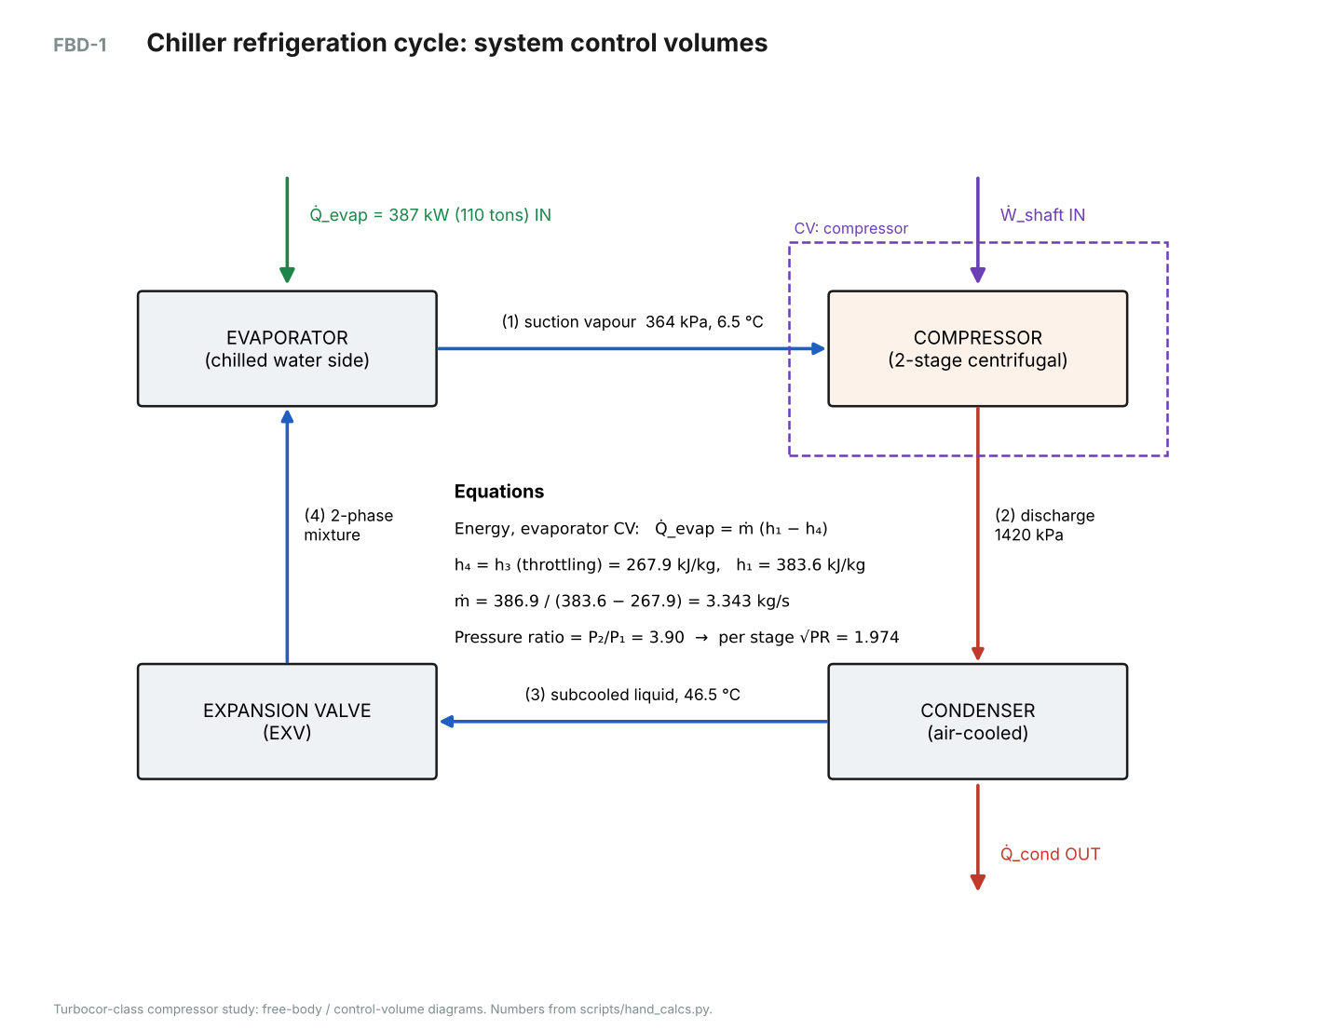
FBD-1. Chiller cycle with the four state points and the compressor control volume.
GIVEN
- Capacity Q̇_evap = 110 tons × 3.51685 kW/ton = 386.9 kW (TCAA220, two compressors)
- Saturated suction 3.5 °C, saturated discharge 51.5 °C (AHRI air-cooled rating)
- Superheat 3 K at compressor inlet, subcooling 5 K leaving the condenser
- Refrigerant R-513A
FIND
- Evaporator and condenser pressures, inlet state (1), liquid enthalpy (3 = 4)
ASSUMPTIONS
- Steady state; no pressure drop in heat exchangers or piping
- Throttling at the expansion valve is isenthalpic (h₄ = h₃)
EQUATIONS
P_evap = P_sat(T_evap), P_cond = P_sat(T_cond)
State 1: (P_evap, T_evap + 3 K) → h₁, s₁, ρ₁, a₁
State 3: (P_cond, T_cond − 5 K) → h₃ = h₄
SOLUTION
P_evap = P_sat(3.5 °C) = 364.3 kPa
P_cond = P_sat(51.5 °C) = 1,420.1 kPa
State 1: T₁ = 6.5 °C → h₁ = 383.57 kJ/kg, s₁ = 1.7126 kJ/kg·K, ρ₁ = 18.92 kg/m³, a₁ = 141.1 m/s
State 3: T₃ = 46.5 °C → h₃ = h₄ = 267.86 kJ/kg

Result: P_evap = 364 kPa, P_cond = 1,420 kPa, h₁ = 383.6 kJ/kg, h₄ = 267.9 kJ/kg

C2 Mass flow and suction volume flow
GIVEN
- Q̇_evap = 386.9 kW, h₁ = 383.57 kJ/kg, h₄ = 267.86 kJ/kg, ρ₁ = 18.92 kg/m³
FIND
- Refrigerant mass flow ṁ and suction volume flow V̇
ASSUMPTIONS
- Evaporator control volume: steady, no work, negligible kinetic/potential energy changes
EQUATIONS
Q̇_evap = ṁ (h₁ − h₄)
V̇ = ṁ / ρ₁
SOLUTION
q_evap = h₁ − h₄ = 383.57 − 267.86 = 115.71 kJ/kg
ṁ = 386.9 / 115.71 = 3.343 kg/s
V̇ = 3.343 / 18.92 = 0.1767 m³/s

Result: ṁ = 3.343 kg/s, V̇ = 0.177 m³/s

C3 Pressure ratio, ideal work and stage split
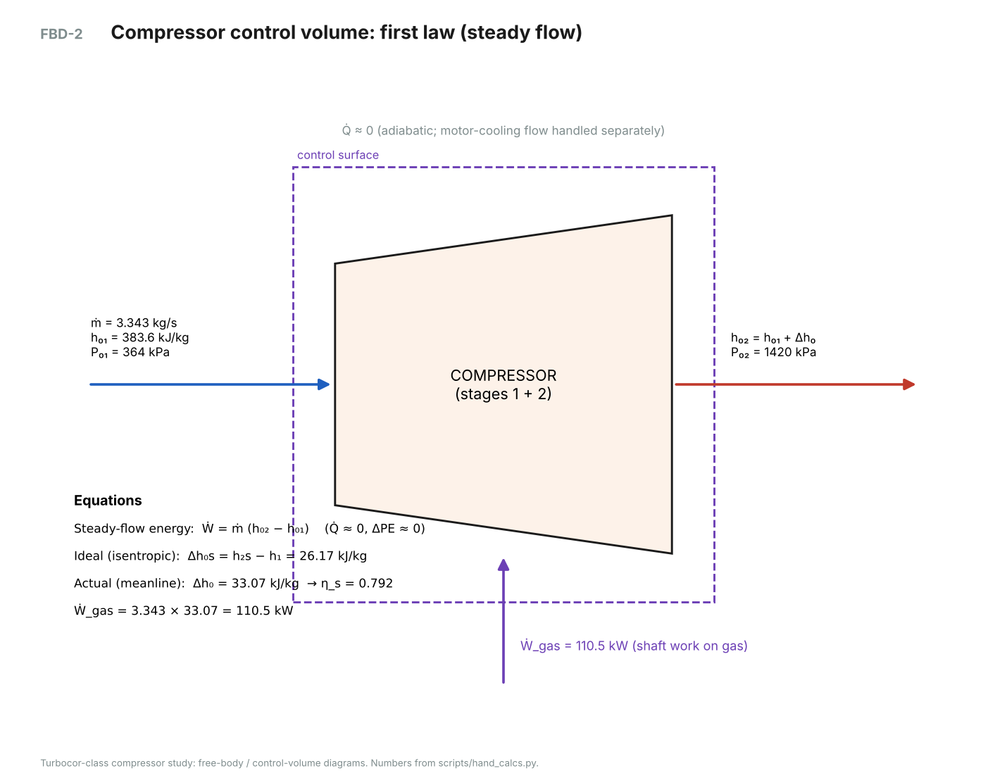
FBD-2. Compressor control volume for the steady-flow energy equation.
GIVEN
- P_evap = 364.3 kPa, P_cond = 1,420.1 kPa, s₁ = 1.7126 kJ/kg·K
FIND
- Overall and per-stage pressure ratio; isentropic work
ASSUMPTIONS
- Two stages with equal pressure ratio (first guess); adiabatic compressor
EQUATIONS
PR = P_cond / P_evap, PR_stage ≈ √PR
Δh₀s = h(P_cond, s₁) − h₁
Ẇ = ṁ (h₀₂ − h₀₁)
SOLUTION
PR = 1,420.1 / 364.3 = 3.899
PR_stage ≈ √3.899 = 1.974
h₂s = h(1,420 kPa, s₁) = 409.74 kJ/kg → Δh₀s = 26.17 kJ/kg
With η_stage = 0.8, stage-1 work ≈ Δh₀s,1/η = 13.23 / 0.8 = 16.53 kJ/kg (iterated: 16.53 kJ/kg)

Result: PR = 3.90 overall, ≈ 1.97 per stage; Δh₀s,total = 26.2 kJ/kg

C4 Slip factor and work coefficient
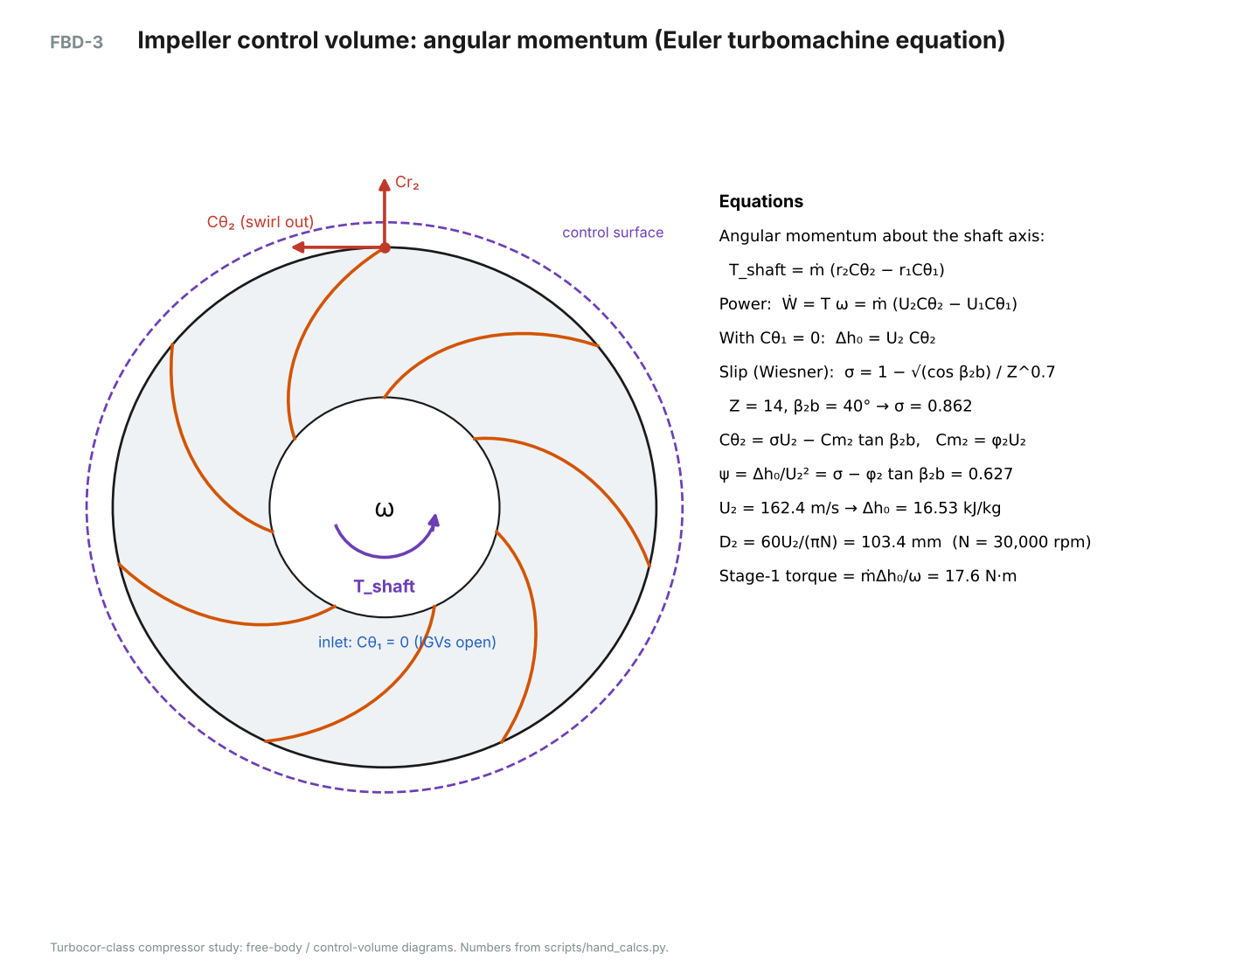
FBD-3. Impeller control volume for angular momentum (Euler equation).
GIVEN
- Z = 14 blades (7 main + 7 splitter), exit blade angle β₂b = 40° (backswept, from radial), φ₂ = Cm₂/U₂ = 0.28
FIND
- Slip factor σ and work coefficient ψ = Δh₀/U₂²
ASSUMPTIONS
- No inlet swirl (IGVs open): Cθ₁ = 0
- Wiesner slip correlation; splitters counted as full blades
EQUATIONS
σ = 1 − √(cos β₂b) / Z^0.7 (Wiesner)
Cθ₂ = σ U₂ − Cm₂ tan β₂b
Δh₀ = U₂ Cθ₂ → ψ = σ − φ₂ tan β₂b
SOLUTION
σ = 1 − √(cos 40°) / 14^0.7 = 1 − 0.8752 / 6.343 = 0.862
(for comparison, 7 blades only: σ = 0.776)
ψ = 0.862 − 0.28 × tan 40° = 0.862 − 0.235 = 0.627

Result: σ = 0.862, ψ = 0.627

C5 Stage-1 tip speed and tip diameter
GIVEN
- Required Δh₀ = 16.53 kJ/kg (from C3, iterated), ψ = 0.627, N = 30,000 rpm
FIND
- Tip speed U₂ and diameter D₂
ASSUMPTIONS
- Both stages use the same D₂ (one shaft, one speed); D₂ iterated until two stages reach P_cond
EQUATIONS
U₂ = √(Δh₀ / ψ)
D₂ = 60 U₂ / (π N)
ω = 2πN/60
SOLUTION
U₂ = √(16,533 / 0.627) = 162.4 m/s
ω = 2π × 30000 / 60 = 3,141.6 rad/s
D₂ = 60 × 162.4 / (π × 30000) = 0.1034 m

Result: U₂ = 162.4 m/s, D₂ = 103.4 mm (r₂ = 51.69 mm)
Note: Check: the tip Mach number U₂/a₁ ≈ 1.15 is typical for refrigerant compressors because refrigerants have low speeds of sound.

C6 Inlet eye sizing
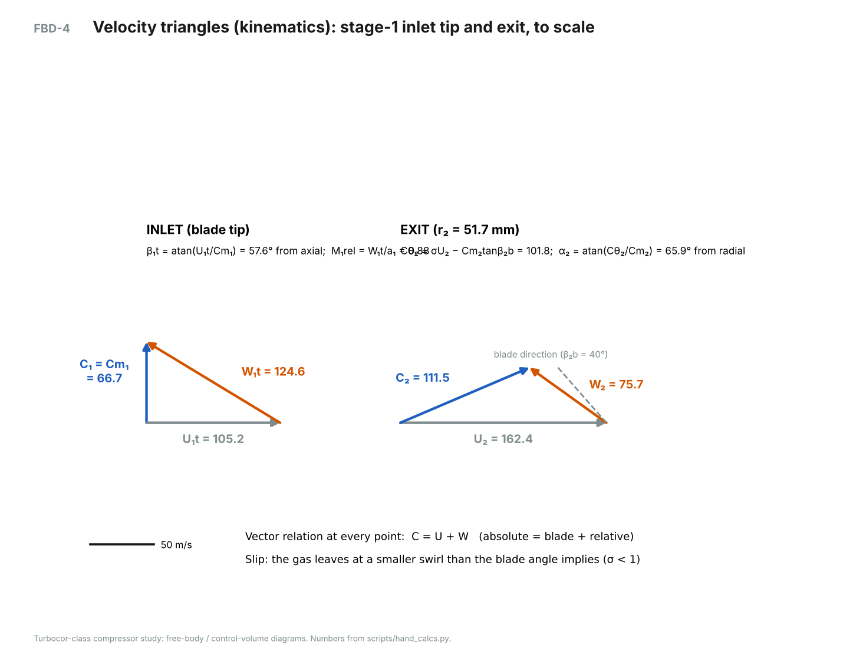
FBD-4. Velocity triangles at the stage-1 inlet tip and exit, to scale.
GIVEN
- ṁ = 3.343 kg/s, hub/tip ratio D₁h/D₁t = 0.4, ω = 3,141.6 rad/s, inlet total state from C1
FIND
- Eye tip diameter D₁t that minimises the relative Mach number at the blade tip
ASSUMPTIONS
- Uniform axial inflow, no swirl; static density from isentropic acceleration (iterated)
EQUATIONS
A₁ = π/4 (D₁t² − D₁h²), Cm₁ = ṁ / (ρ₁ A₁)
U₁t = ω D₁t / 2, W₁t = √(Cm₁² + U₁t²)
M₁rel = W₁t / a₁, β₁t = atan(U₁t / Cm₁)
SOLUTION
Small D₁t → high Cm₁; large D₁t → high U₁t. Scanning D₁t gives a minimum W₁t at:
D₁t = 67.0 mm, D₁h = 26.8 mm → A₁ = 2,962 mm²
ρ₁,static = 16.92 kg/m³ → Cm₁ = 66.7 m/s
U₁t = 3,141.6 × 0.0335 = 105.2 m/s
W₁t = √(66.7² + 105.2²) = 124.6 m/s → M₁rel = 0.882, β₁t = 57.6°

Result: D₁t = 67.0 mm, M₁rel = 0.88 (below 0.9, so no strong shock), blade inlet angle β₁t = 57.6° + 2° incidence

C7 Impeller exit width and exit velocities
GIVEN
- U₂ = 162.4 m/s, φ₂ = 0.28, σ = 0.862, β₂b = 40°, exit static density ρ₂ = 29.17 kg/m³, blockage B = 0.06
FIND
- Exit width b₂, exit velocities, absolute flow angle α₂ and Mach number
ASSUMPTIONS
- Impeller total-to-total efficiency 0.90 to fix the exit state
EQUATIONS
Cm₂ = φ₂ U₂, Cθ₂ = σU₂ − Cm₂ tan β₂b, C₂ = √(Cm₂² + Cθ₂²)
b₂ = ṁ / [ρ₂ π D₂ Cm₂ (1 − B)]
α₂ = atan(Cθ₂ / Cm₂)
SOLUTION
Cm₂ = 0.28 × 162.4 = 45.47 m/s
Cθ₂ = 0.862 × 162.4 − 45.47 × tan 40° = 101.82 m/s
C₂ = 111.5 m/s, α₂ = 65.9°, M₂ = 0.795
b₂ = 3.343 / (29.17 × π × 0.1034 × 45.47 × 0.94) = 0.00826 m

Result: b₂ = 8.26 mm, Cθ₂ = 101.8 m/s, α₂ = 65.9°, stage-1 PR = 1.979

C8 Stage 2 (same method as C4–C7)
Quantity | Stage 1 | Stage 2
Inlet total pressure / temperature | 364 kPa / 6.5 °C | 721 kPa / 31.8 °C
Tip diameter / tip speed | 103.4 mm / 162.4 m/s | 103.4 mm / 162.4 m/s
Eye tip / hub diameter | 67.0 / 26.8 mm | 54.0 / 25.9 mm
Cm₁ / W₁t / M₁rel | 66.7 / 124.6 / 0.88 | 56.4 / 101.9 / 0.73
Exit width b₂ | 8.26 mm | 4.21 mm
Exit density ρ₂ | 29.2 kg/m³ | 57.3 kg/m³
Work Δh₀ | 16.53 kJ/kg | 16.53 kJ/kg
Stage pressure ratio | 1.979 | 1.970
Outlet total pressure / temperature | 721 kPa / 31.8 °C | 1,420 kPa / 60.2 °C

Stage 2 handles the same mass flow at about twice the density, so its eye is smaller and its exit width is about half that of stage 1.

C9 Vaneless diffuser and de-swirl vane inlet angle
GIVEN
- r₂ = 51.69 mm, r₃ = 80.1 mm (r₃/r₂ = 1.55), b₃ = 7.43 mm, Cθ₂ = 101.8 m/s, Cm₂ = 45.5 m/s
FIND
- Velocities at the diffuser exit; inlet metal angle of the de-swirl (return-channel) vanes
ASSUMPTIONS
- Free vortex in the vaneless space (no wall friction): r Cθ = constant
- Density nearly constant across the diffuser (first estimate)
EQUATIONS
Cθ₃ = Cθ₂ r₂ / r₃
Cm₃ = Cm₂ (r₂ b₂) / (r₃ b₃) (continuity)
α₃ = atan(Cθ₃ / Cm₃)
SOLUTION
Cθ₃ = 101.8 × 51.7 / 80.1 = 65.7 m/s
Cm₃ = 45.5 × (51.7 × 8.26) / (80.1 × 7.43) = 32.6 m/s
C₃ = 73.3 m/s (down from 111.5 m/s → static pressure recovery)
De-swirl vane inlet angle (with density correction) = 66.6° from radial

Result: C₃ ≈ 73 m/s; de-swirl vanes: inlet 66.6°, exit 0° (radial, no swirl into stage 2)

C10 Volute cross-sections
GIVEN
- Volume flow at the volute Q = 45.9 L/s, stage-2 exit angular momentum K = Cθ₂ r₂ = 5.263 m²/s, r₃ = 80.1 mm
FIND
- Circular section diameter d(θ) around the volute
ASSUMPTIONS
- Constant angular momentum (free vortex) inside the volute
- Circular, external sections tangent to the diffuser exit (+2 mm lip)
EQUATIONS
Flow through section θ: Q θ/(2π) = ∫ Cθ dA ≈ K · A / R_c
A(θ) = Q θ R_c / (2π K), R_c = r₃ + d/2 + 2 mm, d = √(4A/π) (iterate)
SOLUTION

θ (deg) | d (mm) | R_c (mm) | Area (mm²)
0 | 0.0 | 82.1 | 0
45 | 11.0 | 87.6 | 95
90 | 15.8 | 90.0 | 196
135 | 19.6 | 91.9 | 300
180 | 22.8 | 93.5 | 407
225 | 25.7 | 94.9 | 517
270 | 28.3 | 96.3 | 629
315 | 30.8 | 97.5 | 743
360 | 33.1 | 98.7 | 860
Result: d grows from 0 at the tongue to 33.1 mm at 360° (R_c = 98.7 mm)

C11 Suction and discharge pipe sizing
GIVEN
- V̇_suction = 0.1767 m³/s; discharge density ρ = 72.9 kg/m³ at 1,420 kPa, 60 °C
FIND
- Gas velocity in the DN100 suction and DN50 discharge connections
ASSUMPTIONS
- Target vapour-line velocity about 10–25 m/s (low pressure drop and noise)
EQUATIONS
V = V̇ / (π D² / 4)
SOLUTION
Suction: V = 0.1767 / (π × 0.102² / 4) = 21.6 m/s
Discharge: V̇ = 3.343 / 72.9 = 0.0459 m³/s → V = 21.2 m/s in Ø52.5 mm

Result: Suction DN100: 21.6 m/s; discharge DN50: 21.2 m/s (both within the target range)

C12 Power, torque, efficiency and kW/ton
GIVEN
- ṁ = 3.343 kg/s, Δh₀ = 16.53 + 16.53 kJ/kg, mechanical loss 2 %, motor × drive efficiency 0.95, ω = 3,141.6 rad/s
FIND
- Gas, shaft and electrical power; torque; overall efficiency; kW/ton and COP
EQUATIONS
Ẇ_gas = ṁ Σ Δh₀, Ẇ_shaft = Ẇ_gas (1 + 0.02), Ẇ_in = Ẇ_shaft / 0.95
T = Ẇ_shaft / ω
η_s = Δh₀s / Σ Δh₀, kW/ton = Ẇ_in / tons, COP = Q̇_evap / Ẇ_in
SOLUTION
Ẇ_gas = 3.343 × 33.07 = 110.5 kW
Ẇ_shaft = 112.8 kW, Ẇ_in = 118.7 kW
T = 112,758 / 3,141.6 = 35.89 N·m
η_s = 26.17 / 33.07 = 0.792
kW/ton = 118.7 / 110 = 1.079, COP = 386.9 / 118.7 = 3.26

Result: Shaft 113 kW, input 119 kW, torque 35.9 N·m, 1.08 kW/ton (compressor only)

C13 Motor: electrical frequency and rotor shear stress
GIVEN
- N = 30,000 rpm, 2-pole PM motor, T = 35.9 N·m, rotor Ø70 mm × 170 mm active length
FIND
- Inverter output frequency; air-gap shear stress; rotor surface speed
EQUATIONS
f = N p / 120 (p = number of poles)
τ = T / (2π r² L)
v = ω r
SOLUTION
f = 30000 × 2 / 120 = 500 Hz (mains supply is 60 Hz → 3,600 rpm without the drive)
τ = 35.9 / (2π × 0.035² × 0.170) = 27.4 kPa
v = 3,141.6 × 0.035 = 110 m/s

Result: 500 Hz; τ ≈ 27 kPa (typical 20–40 kPa for liquid-cooled high-speed PM motors); 110 m/s surface speed → carbon-fibre retaining sleeve

C14 Rotor mass, centre of gravity and radial bearing reactions (estimate)
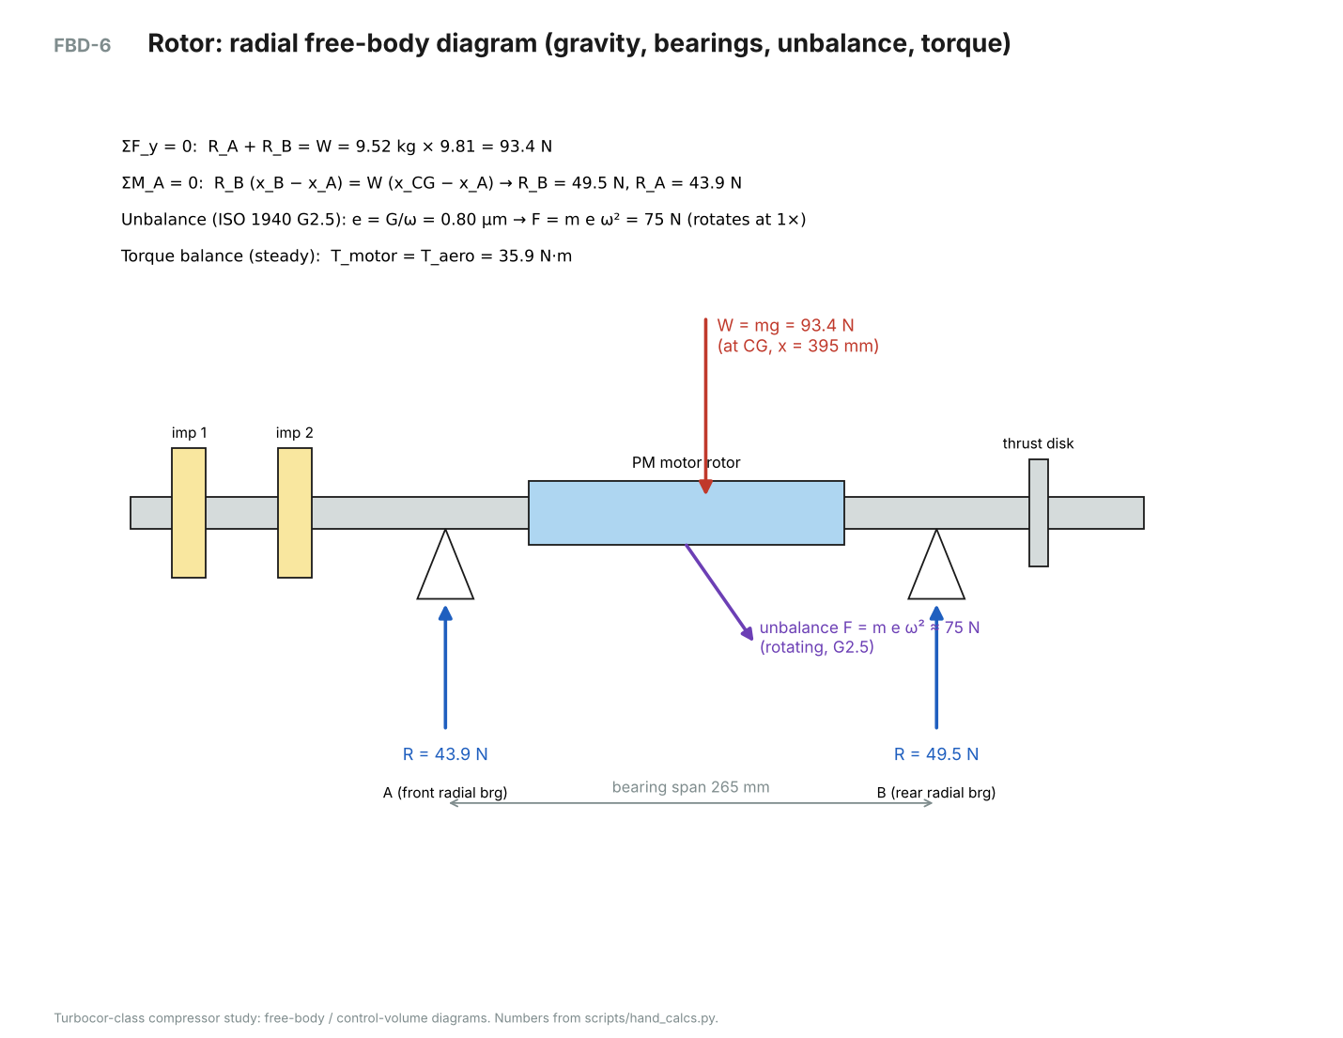
FBD-6. Rotor radial free-body diagram.
GIVEN
- Rotor segment table (drawing TC-103); steel ρ = 7800 kg/m³; aluminium impellers ρ = 2810 kg/m³
- Radial bearing centres x_A = 255 mm, x_B = 520 mm
FIND
- Rotor mass, CG location, static bearing reactions
ASSUMPTIONS
- Shaft segments are solid steel cylinders; impeller mass from a simplified solid of revolution
- Horizontal rotor; gravity only (static)
EQUATIONS
m = Σ mᵢ, x_CG = Σ mᵢxᵢ / Σ mᵢ
ΣF_y = 0: R_A + R_B = m g
ΣM_A = 0: R_B (x_B − x_A) = m g (x_CG − x_A)
SOLUTION
m = 9.52 kg (PM motor section alone ≈ 5.10 kg), x_CG = 395 mm
W = 9.52 × 9.81 = 93.4 N
R_B = 93.4 × (395 − 255) / 265 = 49.5 N
R_A = 93.4 − 49.5 = 43.9 N

Segment | Mass (kg) | x (mm)
impeller nut / nose cone | 0.030 | 90
stage-1 impeller seat | 0.068 | 112
interstage spacer sleeve | 0.081 | 141
stage-2 impeller seat | 0.068 | 169
seal sleeve | 0.119 | 196
front touchdown bearing journal | 0.110 | 215
front radial bearing rotor laminations | 0.919 | 255
shaft | 0.147 | 293
PM motor rotor (magnets + carbon-fibre sleeve) | 5.103 | 385
shaft | 0.196 | 480
rear radial bearing rotor laminations | 0.919 | 520
thrust-disk seat | 0.490 | 575
rear touchdown bearing journal | 0.121 | 611
axial / speed sensor target | 0.025 | 627
thrust disk | 0.784 | 575
impeller 1 | 0.172 | 117
impeller 2 | 0.172 | 174

Result: m ≈ 9.5 kg; R_A ≈ 44 N, R_B ≈ 50 N (static)

C15 Unbalance force at design speed (estimate)
GIVEN
- Rotor mass m = 9.52 kg, ω = 3,141.6 rad/s, balance grade G2.5 (ISO 1940, typical for turbomachinery rotors)
FIND
- Residual unbalance eccentricity and rotating force
EQUATIONS
e = G / ω (G in m/s)
F = m e ω²
SOLUTION
e = 0.0025 / 3,141.6 = 0.80 μm
F = 9.52 × 0.000000796 × 3,141.6² = 75 N

Result: F_unbalance ≈ 75 N rotating at 1× speed, comparable to the rotor weight, so the magnetic bearings are sized for both

C16 Axial thrust on the impellers (simplified estimate)
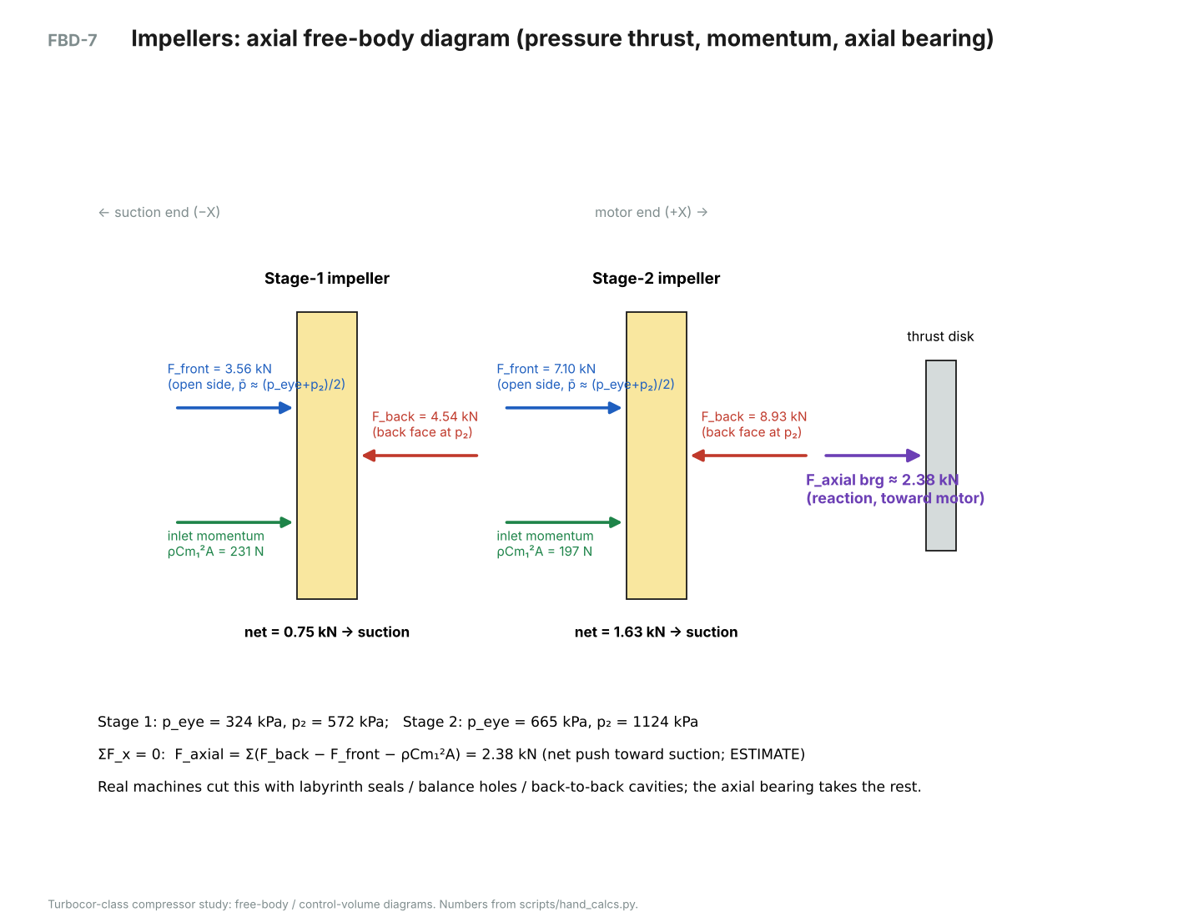
FBD-7. Axial free-body diagram of the two impellers and the thrust disk.
GIVEN
- Static pressures from the meanline: stage 1 eye 324 kPa, exit 572 kPa; stage 2 eye 665 kPa, exit 1,124 kPa
- Face area π(r₂² − r_s²) with r_s = 12 mm → 79.4 cm²
FIND
- Net axial force the axial magnetic bearing must react
ASSUMPTIONS
- Back face sees impeller exit static pressure (no balance holes or seals)
- Open (blade) side sees the average of eye and exit pressure
- Inlet axial momentum ṁCm₁ ≈ ρCm₁²A₁ pushes the impeller toward the motor
EQUATIONS
F_back = p₂ A, F_front = ½(p_eye + p₂) A, F_mom = ρ Cm₁² A₁
F_net,i = F_back − F_front − F_mom (positive = toward suction)
ΣF_x = 0: F_axial bearing = Σ F_net,i
SOLUTION
Stage 1: 4,538 − 3,557 − 231 = 750 N
Stage 2: 8,927 − 7,104 − 197 = 1,626 N

Result: F_axial ≈ 2.38 kN toward the suction end (upper bound; seals and balance cavities reduce it in practice)

C17 Impeller disc stress at overspeed (estimate)
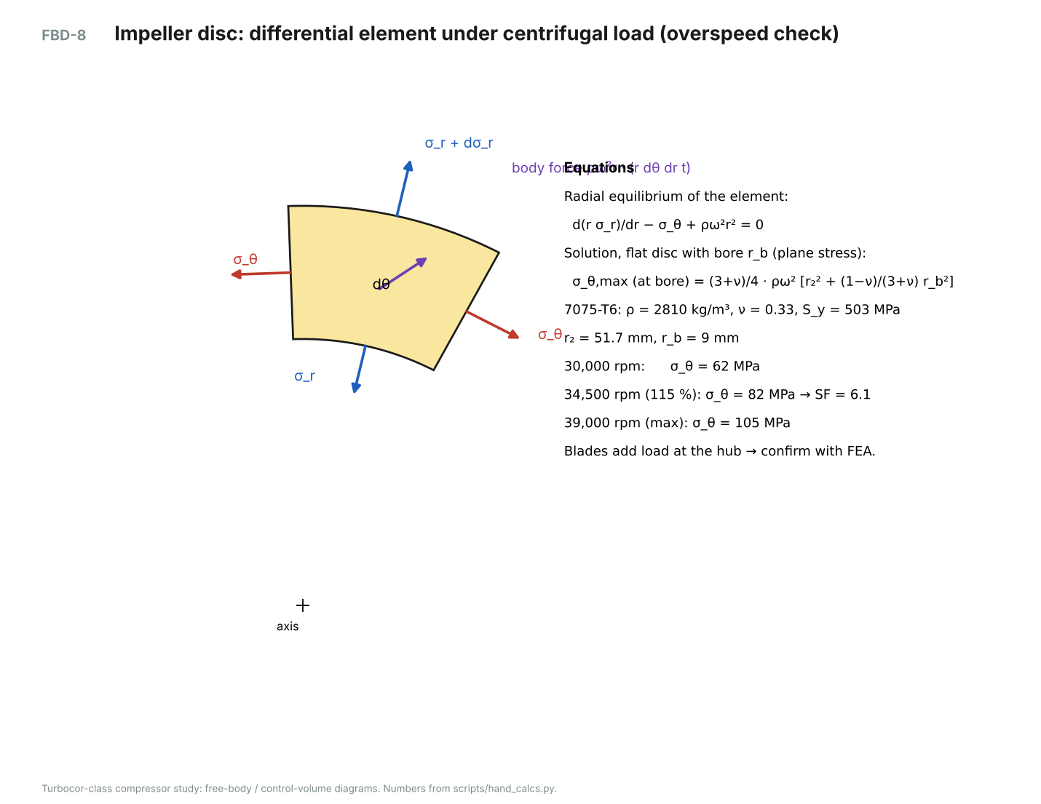
FBD-8. Differential element of a rotating disc.
GIVEN
- 7075-T6: ρ = 2810 kg/m³, ν = 0.33, S_y = 503 MPa; r₂ = 51.7 mm, bore r_b = 9 mm
FIND
- Peak hoop stress at 100 %, 115 % (overspeed test) and maximum speed; safety factor
ASSUMPTIONS
- Flat disc of uniform thickness, plane stress; blades ignored (they add load, so FEA is needed to confirm)
EQUATIONS
d(r σ_r)/dr − σ_θ + ρω²r² = 0
σ_θ,max = (3 + ν)/4 · ρω² [r₂² + (1 − ν)/(3 + ν) r_b²] (at the bore)
SOLUTION
30,000 rpm: σ_θ = 62.1 MPa
34,500 rpm (115 %): σ_θ = 82.1 MPa → SF = 503 / 82.1 = 6.1
39,000 rpm: σ_θ = 104.9 MPa

Result: SF ≈ 6.1 at 115 % overspeed for the disc alone

C18 First bending critical speed (estimate)
GIVEN
- Steel shaft E = 197 GPa, ρ = 7800 kg/m³, Ø50 mm between bearings, span L = 265 mm
FIND
- First bending natural frequency; margin over the 39,000 rpm maximum speed
ASSUMPTIONS
- Uniform simply supported beam (rigid supports); overhung impellers and the motor sleeve ignored, which makes this optimistic
EQUATIONS
ω₁ = (π / L)² √(E I / (ρ A)), I = πd⁴/64, A = πd²/4
SOLUTION
I = 3.068e-7 m⁴, A = 1.963e-3 m²
ω₁ = (π / 0.265)² × √(197e9 × 3.068e-7 / (7800 × 1.963e-3)) = 8,829 rad/s
N₁ = 84,309 rpm → margin = 2.16 × 39,000 rpm

Result: First bending critical ≈ 84k rpm (needs > 1.2 × 39k = 47k rpm). Confirm with a rotordynamics/modal FEA including the impeller and magnet masses.

C19 CFD post-processing calculations (stage-1 run, off-design)
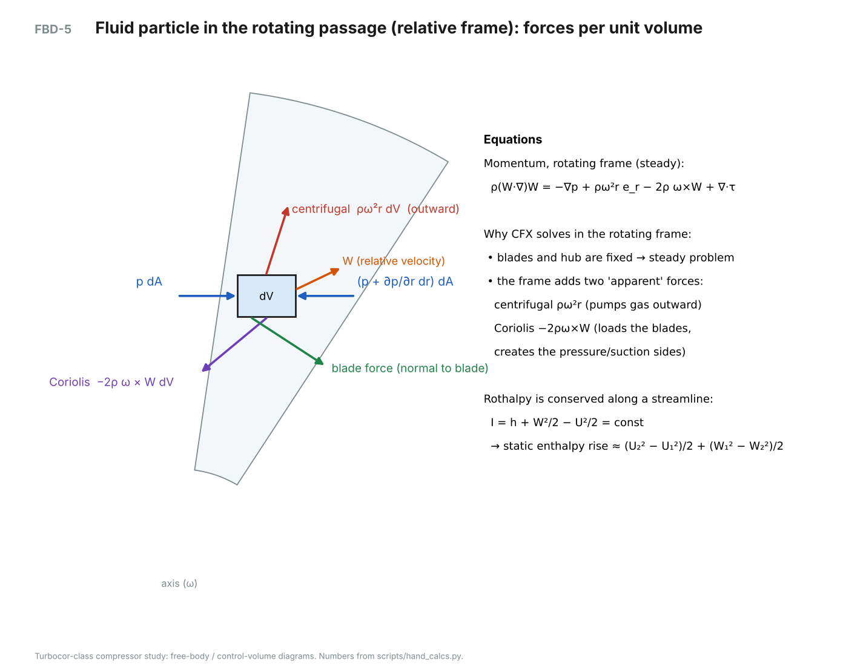
FBD-5. Forces on a fluid particle in the rotating frame, the formulation CFX solves.
GIVEN
- Mass-averaged totals: P₀,in = 361.3 kPa, P₀,out = 668.7 kPa, T₀,in = 299.954 K, T₀,out = 322.93 K (R-134a)
- Per passage: ṁ = 0.385944 kg/s, blade torque 1.89043 N·m; at r = 52 mm: Cθ = 95.2902 m/s, Cr = 45.3262 m/s
FIND
- Pressure ratio, efficiency, specific work three ways, slip factor and exit flow angle
ASSUMPTIONS
- Free vortex and continuity to move the r = 52 mm values to r₂ = 51.69 mm
EQUATIONS
PR = P₀,out/P₀,in; Δh₀ = h(P₀,out, T₀,out) − h(P₀,in, T₀,in); η = [h(P₀,out, s_in) − h_in] / Δh₀
Δh₀,torque = T ω / ṁ; Δh₀,Euler = U₂ Cθ₂
σ = (Cθ₂ + Cr₂ tan β₂b) / U₂; α₂ = atan(Cθ₂/Cr₂)
SOLUTION
PR = 668.7 / 361.3 = 1.851
Δh₀,T = 15.94 kJ/kg; Δh₀s = 14.13 kJ/kg → η = 0.887
Δh₀,torque = 1.89043 × 3,141.6 / 0.385944 = 15.39 kJ/kg
Cθ₂ = 95.2902 × 52.0/51.69 = 95.87 m/s → Δh₀,Euler = 162.4 × 95.87 = 15.57 kJ/kg
σ = (95.87 + 45.60 × tan 40°) / 162.4 = 0.826; α₂ = 64.6°
Stage power = 7 × 1.89043 × 3,141.6 = 41.6 kW at 2.70 kg/s

Result: PR = 1.851, η = 0.89; work: 15.9 / 15.4 / 15.6 kJ/kg (temperature / torque / Euler, within 3 %); σ = 0.83, α₂ = 64.6°

Symbols
Symbol | Meaning | Units
ṁ | mass flow rate | kg/s
h, h₀ | static, total enthalpy | kJ/kg
s | entropy | kJ/kg·K
P, P₀ | static, total pressure | kPa
U | blade speed ωr | m/s
C, W | absolute, relative velocity | m/s
Cm, Cr, Cθ | meridional, radial, swirl (tangential) velocity | m/s
β, α | relative, absolute flow angle | deg
σ | slip factor | —
φ, ψ | flow and work coefficients | —
M | Mach number | —
ω, N | angular speed | rad/s, rpm
T | torque | N·m
σ_r, σ_θ | radial, hoop stress | MPa
Subscripts | 1 inlet/eye, 2 impeller exit, 3 diffuser exit, t tip, h hub, s isentropic

