1. (U & G-required) [20 points] Consider the following algorithm.

**ALGORITHM** *Enigma*(A[0..n − 1])

//Input: An array A[0..n − 1] of integer numbers

for i ← 0 to n − 2 do ……………………………………………………………….. n – 2

for j ← i +1 to n − 1 do ………………………………………………..

if A[i] == A[j] …………………………………………………...

return false ………………………………………...

return true

1. [5 points] What does this algorithm do?

The algorithm **traverses the array of integer numbers and checks if any number in the array has duplicate**/equal number. The algorithm compares the first element with the second, the second with the third and so on.

1. [15 points] Compute the running time of this algorithm.

T(n) =

= = 🡪

2. (U & G-required) [40 points]

(a) [20 points] Implement in C/C++ a divide and conquer algorithm for finding the values of both the largest and the smallest element in an array of n numbers. Show how your algorithm runs on the input A = [1 4 9 3 4 9 5 6 9 3 7].

(b) [10 points] What will be your algorithm’s output for arrays with several elements of the largest value? Indicate the answer on the input given above.

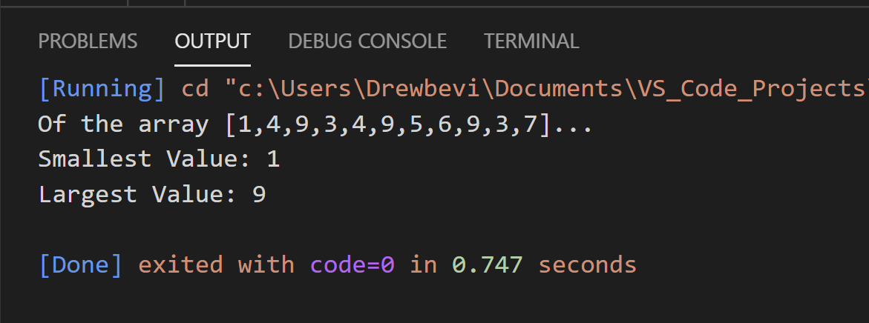 The output of the algorithm with given input above ( [1 4 9 3 4 9 5 6 9 3 7] ) would be:

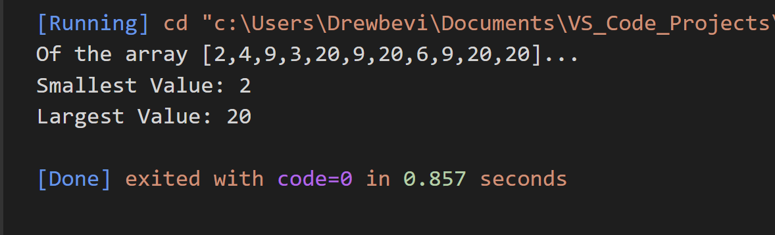 **the question was kind of confused me but here is the out for an array of the same size with several elements of the largest value ( [2,4,9,3,20,9,20,6,9,20,20] )**

(c) [10 points] Set up and solve a recurrence relation for the number of key comparisons made by your algorithm. Note: Name your source file problem2.c or problem2.cpp.

T(n) =

= 🡪 Masters Method

Compare with f(n) = n 🡪 f(n) = O(n) 🡪 case 2

3. (U & G-required) [40 points] We can implement Merge sort without a recursion by starting with merging adjacent elements of a given array, then merging sorted pairs, and so on. Implement this bottom-up version of Merge sort in C/C++ and show how your algorithm runs on the input A = [1 4 9 3 4 9 5 6 9 3 7 2].

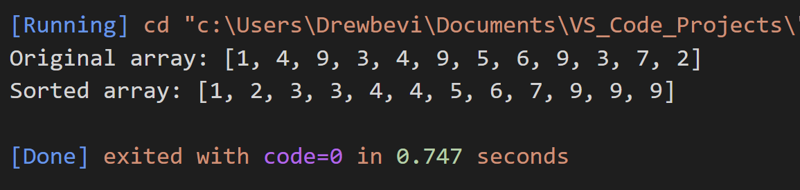

**Note**: Name your source file problem3.c or problem3.cpp.

4. (G-Required) [20 points] Use a loop invariant to prove that the following algorithm computes a raised to the power of n:

Exp(a, n)

{

i ← 1

pow ← 1

while ( i ≤ n )

{

pow ← pow*a

i ← i + 1

}

return pow

}

**Extra credit**

5. [20 points] Consider the following algorithm.

**ALGORITHM** Mystery (A[0..n – 1, 0..n]))

//Input: An n-by-n+1 matrix A[0..n – 1, 0..n] of real numbers

for i ← 0 to n-2 do

for j ← i +1 to n − 1 do

for k ← i to n do

A[j,k] ← A[j,k] – A[i,k] * A[j,i]/A[i,i]

a) [15 points] Compute the running time of this algorithm (make sure to count all the primitive operations separately).

b) [5 points] What obvious inefficiency does this pseudocode contain and how can it be eliminated to speed up the algorithm?