Andrew Burton, Akram Moustafa, Brock Jones

ITC 320 Mini Project Write-Up

We worked on the project by moving from step-to-step together by starting with the wireframe and working together to make decisions on the design of the webpage. Drew worked on the index page primarily while Brock and Akram worked on the To-Do list page. After this, we split up to work on the code with Akram taking on the initial coding of the index page while Brock started working on the To-Do list page. Drew worked on the CSS for the two pages as features were added. After this, Brock added JavaScript functionality to the To-Do list page for adding and deleting To-Do list items, Drew finalized the CSS and took the outline Akram created for the login prompt and made it functional with JavaScript. During the final stage of the project, Drew and Akram split off to work on this write-up, while Brock refactored the JavaScript to represent the To-Do list item as an object rather than the minimum viable product we worked with before. The password we created for the login, specified in the login.js file is “admin”.

We decided to work on the project together during class time while we were online, which helped us better communicate and work together to split up the tasks. We used a GitHub project to manage our version control, and whenever someone would finish a feature, they would push their code up for the rest of the team to pull down and incorporate into what they were working on. We all used VSCode as an editor like we have been using in class which let us run the test server live to see the changes to our application as we were working. This image shows the wireframe we created for this project. We used Miro as the tool for creating this wireframe.

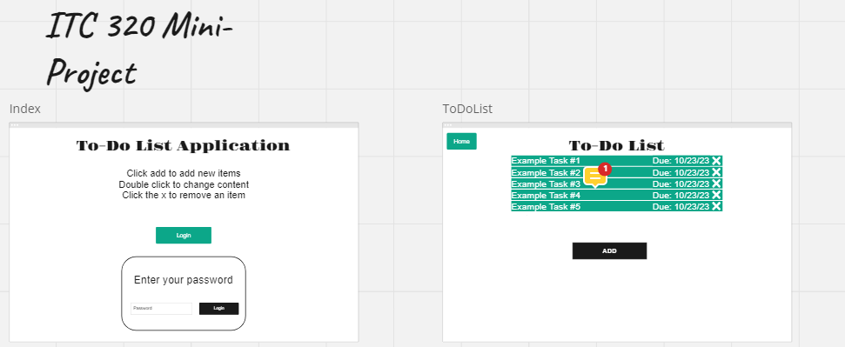

|  |  |  |
| --- | --- | --- |
|  | Time | Tasks |
| Drew | 9/26: 1h 15m  10/3: 1h 15m  10/5: 1h 15m | * Setup github project. * Created index page in wireframe. * Worked on page styling. * Worked on login functionality. * Worked on the write-up |
| Brock | 9/26: 1h 15m  10/3: 1h 15m  10/5: 1h 15m | * Helped with Miro Design for the ToDoList * Worked on to_do_list HTML and JavaScript files. * Implemented most of the To-Do List functionality (add item, modify item, delete item) |
| Akram | 9/26: 1h 15m  10/3: 1h 15m  10/5: 1h 15m | * Worked on the to-do list in the wireframe. * Worked on the index html file. * Worked on the write-up |