**Landing page**: user can search for textiles by name or by a visual characteristic (see page 2) OR just click on an image (see page 3). See page 5 for map to corresponding column in materials data set.

**Material Samples Search:** Search by textile name or modifier or click on an image for more information

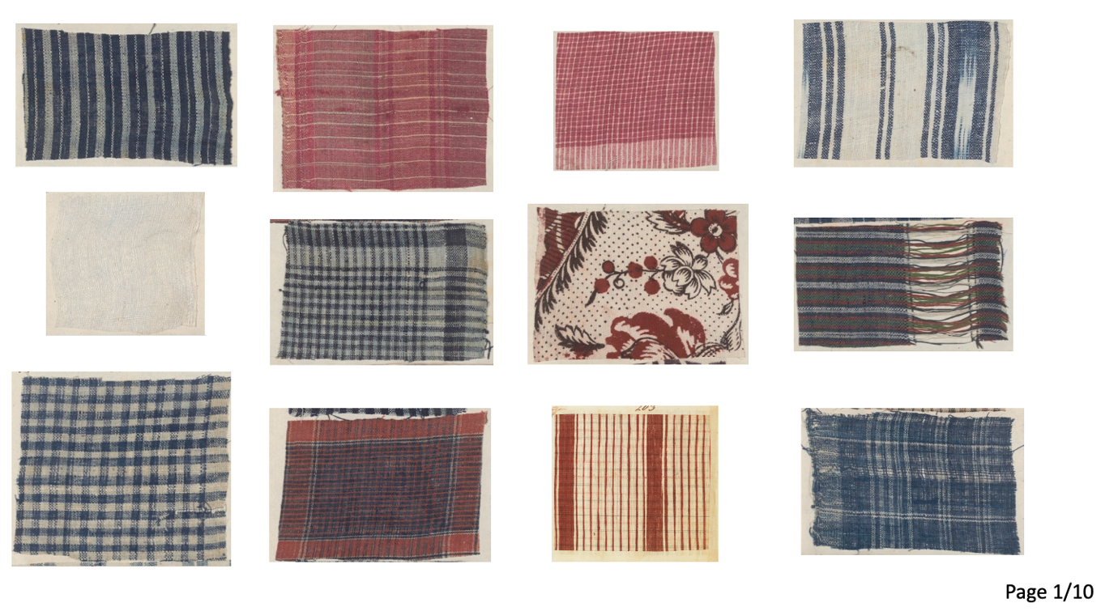

[User **selects** **blue,** returns allblue textiles]—question: can we give users the option to select blue AND striped **or** blue OR striped? Perhaps a radial button?

**Material Samples Search:** Search by textile name or modifier or click on an image for more information

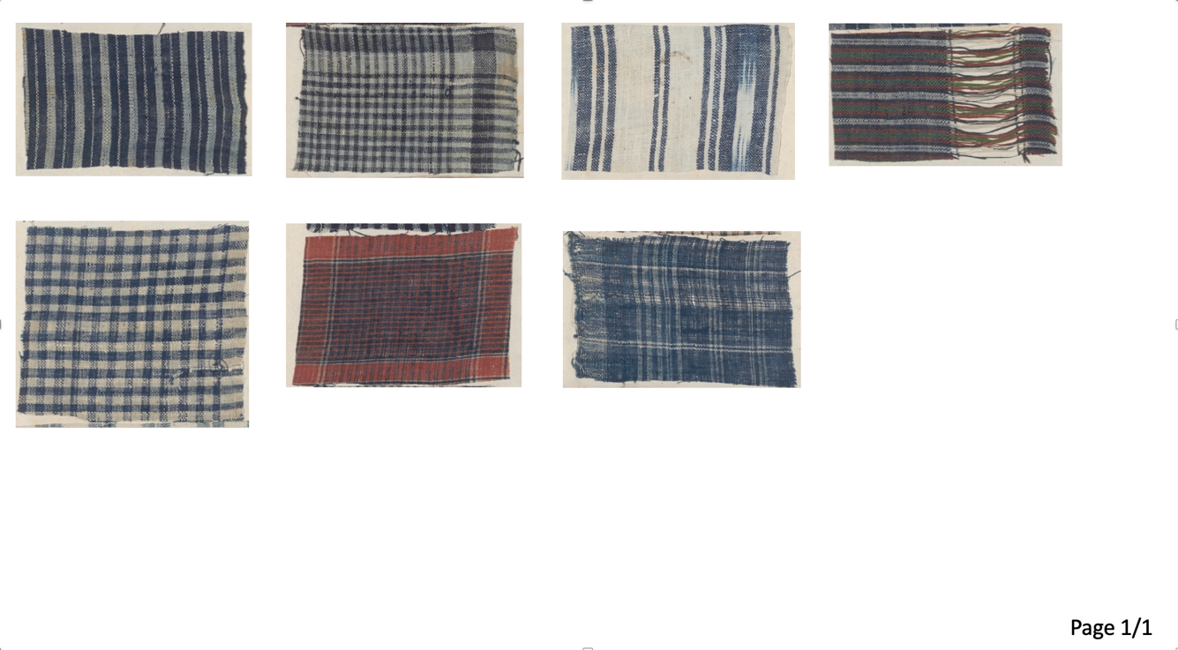

[User **selects a sample,** returns zoomed-in image of selected textile and metadata for image (pulled from data set).

User **clicks image**, returns hi-res zoomed image (or the best we have)

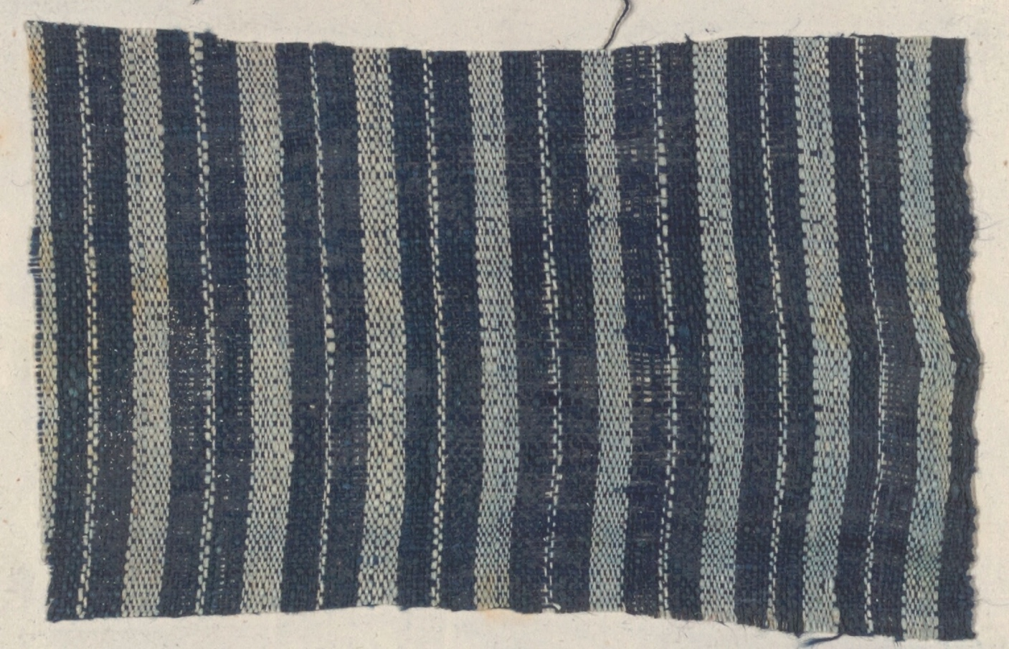

**Page 1/2 - Landing page**

**Search by textile name:**Column B: textile_name

**Search by color:**Column E: textile_color_visual

**Search by pattern:**Column F: textile_pattern_visual

**Search by process:**Column G: textile_process_visual

**Search by weave:**Column H: textile_weave_visual

**Search by textile fiber:**Column I: textile_fiber_visual

**Page 3 - Selected textile metadata**

**Textile Name:**Column B: textile_name

**Source Text:** Column C: text_source

**Color:** Column E: textile_color_visual

**Fiber:**Column I: textile_fiber_visual

**Process:** Column G: textile_process_visual

**Weave:**Column H: textile_weave_visual

**Thread count:**Column L: thread_count

**Date:**Column V: orig_date

**Additional Information:** Column M: addtl_info

**Collection/Location:**Column N: collection [;] Column O: id_narrative

**Image draws from:** Column S: image_url_app (currently the field is empty, need to upload the image files to server; image file names are in Column X: image_filename_app)