ema

Software Requirements Specification

for

E-commerce Store

Version 1.0 approved

Prepared by Group-09

MSU

01/24/2024

# Introduction

## Purpose

The software under specification is an e-commerce platform that functions as a comprehensive marketplace for the exchange of a wide range of goods between customers and sellers. Its main goal is to make online shopping easier and safer by offering a user-friendly design that makes navigating around the site simple, searching and comparing products fast, and completing transactions quickly. Utilizing the scalability of contemporary online technology, the platform hopes to accommodate an expanding user base and inventory.

**Marketplace Facilitation:** To make it easier for people to buy and sell goods, the platform will function as a full e-commerce marketplace. It will enable a range of product categories, including books, technology, etc.

**User Experience:** Creating an intuitive and user-friendly interface that makes it easier for consumers to navigate, find products, and make purchases is a crucial component of the product.

**Multi-Role Capabilities:** The system will accommodate many user roles, each with customized capabilities.

* **Customers** will be able to purchase merchandise, evaluate it, put it in their cart, pay for it, and handle returns.
* **Sellers** will be able to add items to the inventory, receive payment, sell products, remove items from the inventory, and list products.
* **Administrators**: The platform's administrators will supervise its operation, grant or deny access, approve and block new products, and overview user actions.

## Document Conventions

This document uses the following conventions:

* [R] - Indicates a requirement.
* [G] - Indicates a guideline or suggestion.
* Italics - Indicates first use of technical terms or emphasis.
* **Bold** - Indicates definitions or high importance.
* ‘Monospace’ - Indicates code snippets or system outputs.

## Intended Audience and Reading

This SRS is intended for multiple readers, each with a unique focus and area of interest within the project.

**Developers (Team Members of group-09)**: The developers are primarily interested in the particular technical needs of the system, such as its features, interfaces, database architecture, and in-depth specifications for every functional requirement.

* **Suggested Reading Sequence**: Product Functions, System Features, Operating Environment, Design and Implementation Constraints, Detailed System Models, API Specifications.

**Product Managers:** They need an overview of the project’s scope and objective. In the case of this project, Dr. Charan and his TA can be considered as the managers of this product.

* **Suggested Reading Sequence**: Product Scope, Product Perspective, User Classes and Characteristics, Nonfunctional Requirements,

**Users: (Admins, Sellers, and Buyers):** How the technology can be used to suit their needs is what end users are interested in learning.

* **Suggested Reading Sequence:** User Classes and Characteristics, System Features (from the user's perspective), User Interface Design, User Help and Documentation.

**Testers:** Testers are primarily interested in information that will aid in test planning and execution of the product. They concentrate on test cases that are based on performance and functional criteria.

* Suggested Reading Sequence: System Features, Nonfunctional Requirements (especially Performance and Security), Detailed Functional Requirements, Test Cases

**Documentation Writers:** In order to develop manuals, help guides, and usage instructions, documentation writers must have a thorough understanding of the complete system. They have to comprehend the user interface in addition to the technical aspects.

* Suggested Reading Sequence: Sequential reading of the entire document, with special focus on System Features, User Interface Design, and User Help and Documentation.

## Product Scope

[G] Refer to Section 1.1

## References

We used Diagramgpt for drawing out basic ER diagram: <https://www.eraser.io/diagramgpt>

# Overall Description

## Product Perspective

This SRS describes a brand-new, standalone e-commerce platform as the product. It is meant to meet the market's current demand for an all-inclusive, user-friendly, and safe online marketplace; it is neither a direct replacement for an existing system nor a continuation of an existing product family. The goal of this platform is to raise the bar for e-commerce capabilities by emphasizing scalability, performance, and an improved user experience.

The following variables have combined to drive the development of this product:

* Market Demand: E-commerce platforms that offer a smooth, integrated shopping experience across multiple product categories are becoming more and more necessary.
* Technological Progress: The capabilities of mobile devices, cloud computing, and web technologies have advanced recently, making now a good moment to introduce a state-of-the-art e-commerce solution.

**Connection to the Broader System:**

The e-commerce platform will connect with multiple external systems and services even though it is a stand-alone product:

* Payment gateways: To manage payments effectively and safely.
* Services for Shipping and Logistics: To oversee the delivery of tangible products.

**Interfaces and Subsystem Interconnections:**

* Front-end interface: The area where users interact with the product that faces the customer.
* Back-end System: The platform's server side, which is in charge of database administration, business logic, etc.
* Administration Panel: Admins can oversee the platform's operations through the Administration Panel.
* Seller Portal: Product, order, and customer relationship management for sellers.
* Payment Processing Interface: A safe backend for managing transactions and authorizations related to payments.
* External APIs: Interfaces that let external systems communicate with the platform.

**User Interface (Web/Mobile):** The topmost element serves as the user's point of entry. This establishes a direct connection with the E-commerce Platform Server, the central element managing the platform's primary logic and operations.

**E-commerce Platform Server:** Three essential components are connected in both directions by the

* The platform's administration panel: is used for platform management and administrative duties.
* Seller Portal: This is where sellers handle sales, inventory, and correspondence with customers.
* Payment Processing Interface: This securely manages every transaction involving payments.

To oversee the delivery of goods, the Payment Processing Interface establishes a connection with Shipping/Logistics Services.

Figure 1

## Product Functions

The major functions of the e-commerce platform are as follows:

**User Account Management:**

* User registration and login for buyers, sellers, and admins
* Profile creation and management.
* Account recovery and security features.

**Product Management:**

* Sellers can list, update, and remove products.
* Product categorization and inventory management.
* Product detail management, including images, descriptions, and specifications.

**Search and Discovery:**

* Product search with filters and sorting options.
* Recommendations and featured products.
* Product reviews and ratings.

**Shopping Cart and Checkout Process:**

* Adding and removing items from the shopping cart.
* Price calculation with taxes and discounts.
* Address and payment information entry.
* Order confirmation and receipt generation.

**Payment Processing:**

* Integration with multiple payment gateways.
* Secure transaction processing.
* Payment and invoice history.

**Order Fulfillment and Tracking:**

* Order processing and status updates.
* Return and refund processing.

**Administration and Reporting:**

* User and product management by admins.
* Moderation of product listings and user reviews.

## User Classes and Characteristics

**Buyers (Primary User Class)**

* **Frequency of Use**: Regular to occasional, depending on individual shopping needs.
* **Functions Used**: Browsing products, searching, placing orders, making payments.
* **Technical Expertise**: Ranges from low to high; the platform should be user-friendly for all levels.
* **Security Level**: Standard user privileges.
* **Characteristics**: Desire a convenient, secure shopping experience with a variety of choices and competitive prices.

**Sellers (Primary User Class)**

* **Frequency of Use**: Very frequent daily interaction for managing their storefront.
* **Functions Used**: Listing products, managing inventory, sell and receive payment for products.
* **Technical Expertise**: Moderate to high; sellers are expected to manage complex tasks related to e-commerce.
* **Security Level**: Elevated privileges for managing their storefront and accessing sensitive data.
* **Characteristics**: Require efficient tools for managing sales, inventory, and customer interactions.

**Administrators (Secondary User Class)**

* **Frequency of Use**: Frequent; constant monitoring and management of the platform.
* **Functions Used**: Overseeing user activities, accepting and blocking new accounts and products updating content, and maintaining system health.
* **Technical Expertise**: High; understanding of the platform's technical and operational aspects.
* **Security Level**: The highest level of privileges for system-wide control and access to all data.
* **Characteristics**: Focus on maintaining the smooth operation of the platform, ensuring user satisfaction and compliance with policies

## Operating Environment

The operating environment of the e-commerce platform is an essential component of the system requirements. It consists of many software components, operating systems, and hardware. The anticipated operational environment is as follows:

**Hardware Platform:**

* Server-Side: Multi-core CPUs, plenty of RAM (which may grow with the user base and traffic), and SSD storage for best performance are recommended specs.
* Client-Side: Available on a range of gadgets, such as tablets, smartphones, laptops, and desktop computers. The platform ought to be designed with both mid-range and high-end devices in mind.

**System of Operation:**

* Server-Side: Suitable with all major server operating systems, including Windows Server, Linux (favored because of its scalability and stability), and other UNIX-based systems.
* Client-Side: Web browsers on a variety of client operating systems, such as Windows, macOS, iOS, Android, and Linux, should be able to access the platform.

**Web-browsers:**

* Must be compatible with the most recent iterations of all major web browsers, including Microsoft Edge, Opera, Mozilla Firefox, Safari, and Google Chrome. The platform needs to be responsive and tailored to the unique features of various browsers.

**Network Requirements:**

* Needs a reliable internet connection with plenty of bandwidth, particularly for server-side processing of large amounts of data.

**Software Components:**

* Database management: Depending on the size and needs, integration with databases like MongoDB, PostgreSQL, or MySQL is possible. Currently geared towards database using MySQL.
* Backend Frameworks: Python, python Django
* Frontend Technologies: JavaScript, HTML5, CSS3, and frameworks/libraries like React, Angular.
* Payment Gateways: The ability to execute transactions through integration with a variety of payment gateway APIs, including PayPal, Stripe, and others.

## Design and Implementation Constraints

**Corporate or Regulatory Policies:**

* Data Protection and Privacy: It is imperative to comply with data protection legislation. This covers user consent for data gathering, data reduction, and safe management of private data.
* Payment Processing Compliance: When processing credit card transactions, adherence to the Payment Card Industry Data Security Standard (PCI DSS) is required.

**Hardware Limitations:**

* Server Capacity: Considering CPU, RAM, and storage constraints, the platform needs to be optimized for the anticipated server capacity. Scalability has to be taken into account to manage spikes in traffic.
* Client-Side Performance: The software should run smoothly and light on a range of devices, including ones with low RAM or processing capability.

**Specific Technologies, Tools, and Databases:**

* **HTML5, CSS, JavaScript, Python, Python Django, MySQL**

**Parallel Operations:**

* The system must support concurrent user access and transactions without performance degradation.

**Communications Protocols:**

* Use of standard internet protocols (HTTP/HTTPS) and adherence to RESTful API conventions for any external interfaces.

**Security Considerations:**

* Implementation of good security measures including encryption, password hashing, secure coding practices.
* Authentications of user credentials and authorization processes.

**Design Conventions and Programming Standards:**

* Adherence to best practices and coding standards for scalability and maintainability.
* Utilizing a version control system and following a standard development process.

**Documentation and Code Comments:**

* For future maintenance and updates, thorough documentation and in-code commenting in accordance with organizational standards are required.

# System Features

## System Feature 1: USER ACCOUNT MANAGEMENT

3.1.1 Description and Priority

Allows users to reset their passwords, manage their profiles, register, and login. Because it is essential to both guaranteeing security and tailoring the user experience, this function has a high priority.

**Benefit**: 9 (crucial to user involvement)

**Penalty**: 9 (Lack of this feature would make the product far less useful)

**Cost**: 5 (heavy on resources because of security protocols)

**Risk**: 3 (moderate; mostly concerns with data privacy)

3.1.2 Stimulus/Response Sequences

**User Registration**: Sends registration form to the system; account is created; email confirmation is sent.

**Login**: The user enters credentials, the system verifies them, and then access is granted.

**Password Recovery**: The user asks for a password reset, an email is sent by the system, user resets the password.

3.1.3 Functional Requirements

**[R]1.1**: The system shall allow new users to register using email and password.

**[R]1.2**: The system shall authenticate users based on username/password.

**[R]1.4**: The system shall allow users to modify their profile information.

**[R]1.5**: The system shall log out users after periods of inactivity (30 minutes).

## System Feature 2: SHOPPING CART and CHECKOUT PROCESS

3.2.1 Description and Priority

Allows customers to check the products they want to buy, change the quantity, and finish the checkout procedure. High Priority because it's essential to completing transactions.

**Benefit**: 9 (directly affects the production of revenue)

**Penalty**: 8 (Cart abandonment due to inefficient checkout)

**Cost**: 4 (complexity in combining shipping choices and payment methods)

**Risk**: 3 (Moderate; transaction security is a risk)

3.2.2 Stimulus/Response Sequences

**Cart Addition**: Product is added by the user → Cart count is updated by the system.

**Quantity Adjustment:** Changes in quantity are made by the user → system then updates the price total.

**Checkout Initiation:** The user initiates the checkout process. The system then displays the payment and shipping forms.

3.2.3 Functional Requirements

[R]2.1: Users should be able to add, remove, and modify the quantity of items in their shopping carts via the system.

[R]2.2: The system will figure up and show the entire price, including delivery and any necessary taxes.

[R]2.3: The system must accept a variety of payment options, such as digital wallets and credit cards.

[R]2.4: The system will securely finalize transactions and verify payment details.

## System Feature 3: PRODUCT LISTING and MANAGEMENT

3.3.1 Description and Priority

Allows sellers to list, delete, and update product listings. High priority for enabling transactions on the platform.

**Benefit**: 8 (Directly impacts the range of products available)

**Penalty**: 7 (Lack of efficiency and flexibility could deter sellers)

**Cost**: 4 (Requires integration with inventory and order management)

**Risk**: 2 (Low, primarily related to accurate product representation)

3.3.2 Stimulus/Response Sequences

**Listing Creation:** Seller provides product information → Listing is created by the system → Confirmation is displayed.

**Listing Update**: Seller modifies information → System updates listing → Updated confirmation.

**Listing Deletion:** Seller requests deletion → Listing is removed by the system → Deletion confirmation is sent.

3.3.3 Functional Requirements

[R]3.1: The system will allow vendors to add new product listings with the name, price, description, and photos included.

[R]3.2: Sellers will be able to edit or remove current listings through the system.

[R]3.3: The system will verify the accuracy of the product information for completeness and format before submission.

[R]3.4: The system shall display error messages for invalid inputs or actions in product management.

## System Feature 4: SEARCH and FILTERING

3.4.1 Description and Priority

Provides consumers the option to find products using filters and search. **High Priority** because it has an immediate impact on user experience and usability.

**Benefit**: 9 (Important for navigating large inventories)

**Penalty**: 8 (Poor search functionality can significantly degrade user experience)

**Cost**: 3 (Depends on the complexity of the search algorithms)

**Risk**: 2 (Low, with considerations for performance under heavy load)

3.4.2 Stimulus/Response Sequences

**Search Execution**: User types a search query (Trie) → System displays matching results.

**Filter Application**: User applies filters → System updates to show filtered results.

3.4.3 Functional Requirements

[R]4.1: The system must have a text search feature for product descriptions and names.

[R]4.2: The system will provide filters based on ratings, price range, and category.

[R]4.3: As filters are applied, the system will refresh the search results instantly.

[R]4.4: The system will provide an alternate search phrase suggestion and inform when no results are discovered.

## System Feature 5: SECURITY and DATA PROTECTION

3.5.1 Description and Priority

Guarantees that user data is protected in accordance with legal standards and that the platform and its transactions are safe from attacks. High Priority in light of how crucial privacy and security are.

**Benefits**: 9 (essential for legal compliance and trust)

**Penalty**: 9 (Lack of compliance can result in serious legal and reputational ramifications)

**Cost**: 5 (substantial investment in security procedures and infrastructure)

**Risk**: 5 (High, as cybersecurity risks are always changing)

3.5.2 Stimulus/Response Sequences

**Data Encryption**: Every user's data, while it's in transit or at rest, is encrypted.

**Authentication**: The system provides two-factor authentication and demands strong passwords. **Security Breach Detection**: When anomalous behavior is detected, the system notifies administrators.

3.5.3 Functional Requirements

[R]5.1: The system must encrypt all data transfers using SSL.

[R]5.2: The system must safely retain sensitive data, such as passwords and payment details.

[R]5.3: The system must abide by relevant privacy regulations.

# Other Nonfunctional Requirements

## Performance Requirements

The e-commerce platform is constrained only by the services provided by MySQL database system. The response times of this product are likely to be slow because it is hosted off the developer's current machine. If in the future we scale up, we would like to start by hosting our website on AWS which will allow us to increase our response times and increase server limitations. The platform will also be constrained by the speed and reliability of the payment APIs.

## Safety Requirements

**Privacy and Data Protection**

* **Requirement:** To avoid identity theft, data breaches, and unwanted access, the platform must guarantee the security and privacy of user data.
* **Safeguards:** Passwords should be stored in safe, hashed storage. Update software components to avoid vulnerabilities.
* **Preventive Action:** The platform will also avoid storing sensitive personal data or plain-text passwords unless absolutely necessary.

**Financial Transaction Security**

* **Requirement:** In order to avoid fraud, illegal transactions, and financial loss to users or the platform, it is necessary to manage financial transactions securely.
* **Safeguards:** Integrate a two-factor authentication for transactions.
* **Preventive Actions:** Transactions marked as suspicious should be blocked for human inspection. The platform will also limit the number of transaction attempts.

**User Access and Authentication**

* **Requirement:** Prevent unwanted use and preserve user privacy by securing access to user accounts and sensitive portions of the site.
* **Safeguards:** Multi-factor authentication (MFA) should be used as a safeguard while logging in, especially for administrators and sellers.
* **Preventive Actions:** Enforce password strength policies and periodically remind users to update their passwords to avoid the usage of default, weak, or frequently used passwords.

**Software and Infrastructure Security**

* **Requirement:** Prevent vulnerabilities, assaults, and illegal access to the hardware and software infrastructure of the platform.
* **Safeguards:** Perform frequent vulnerability analyses, and testing.
* **Prevention Action:** Stop deploying code that hasn't been tested or reviewed into live environments. Limit who has access to the databases and servers in use.

The e-commerce Platform will be designed with safety in mind. Our website will check user’s browser to ensure compatibility with our service and database.

## Security Requirements

**Data Encryption**:

* **Requirement:** Data must be encrypted during transmission between the client and server.

**Information Storage**:

* **Requirement**: Strong encryption techniques must be used to encrypt sensitive data storage, such as passwords and payment information, while it is at rest.
* **Regulation**: Follow data protection principles regarding data storage.

**Control of Access:**

* **Requirement:** Role-based access control must be implemented in order to guarantee that users can only access information and features pertinent to their roles.
* **Regulations**: Adhere to cybersecurity guidelines' advice and apply the least privilege principle.

**Security Testing:**

* There will be frequent penetration tests conducted to find vulnerabilities.

The e-commerce platform will make use of SSL in transactions. Additionally, no cookies that contain password information or private information will be left on a web browser. Users will be logged out after a period of inactivity of 30 mintues or after a day of being logged in. Only the last 4 digits of a credit card number will be displayed on the client-side and a password will not be displayed, only echoed with special characters representing typed characters. Usernames and passwords will be hidden from other users and authorization will be required to view these details. All usernames and passwords will be hash-encrypted when stored in the database. Additionally, admin users will have sole access to this database.

## Software Quality Attributes

The e-commerce platform will have an easy-to-use UI that will resize automatically to fit the resolution of the screen it is being accessed on. By using AWS, we will be able to achieve a high uptime for our store.

# Other Requirements

# 5.1 Database Requirements

Databases will be updated asynchronously at the end of purchase or when stock is added to, removed from, or taken out of the database.

**5.2 Internalization Requirements**

The system will all be able to locally compile on the system of the current user and be able to be accessed by all Admins.

**5.3 Legal Requirements**

It’s imperative to comply with all legal requirements of Mississippi State University. Our system will also use all free licensing and on open source database for our storage.

**5.4 Reuse Objectives**

All coding will be created from scratch by all members of Group 9.

Appendix A: Glossary

AWS: Amazon Web Services, used to host websites**.**

MySQL: A database service to keep track of users and products.

SSL: Secure Socket Layer.

Appendix B: Analysis Models

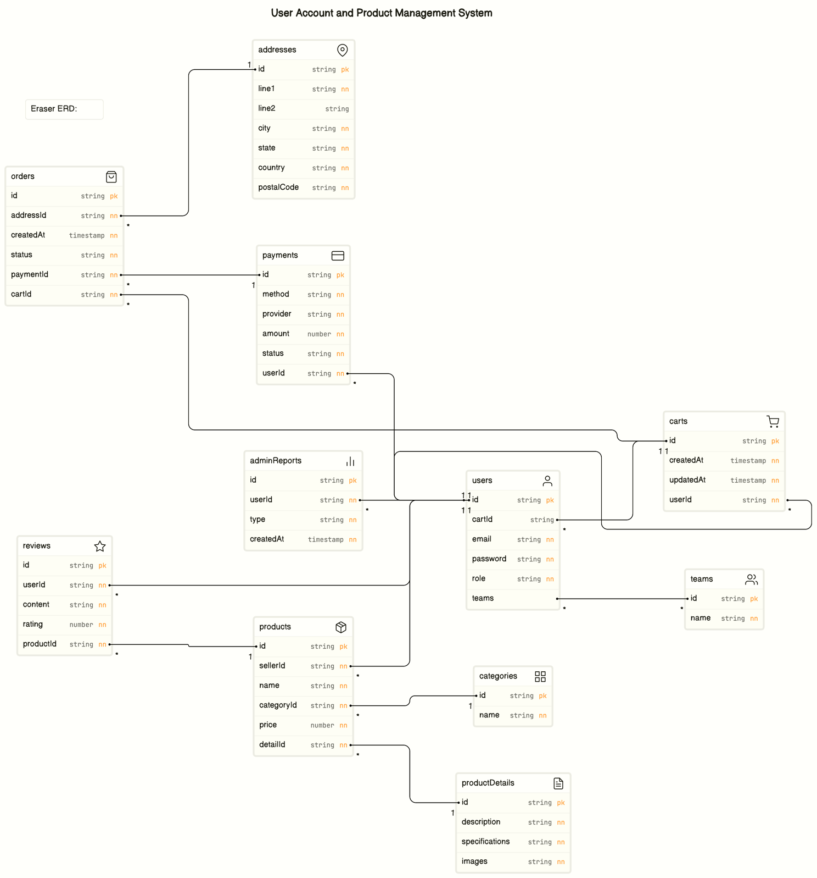Figure 2: From Eraser, DiagramGPT

Appendix C: To Be Determined List