**BabelGlove**



February 14, 2020

ECE Senior Design Spring/Summer 2020

Group 6

Ann Dang - Computer Engineering

Andrew Glisson - Computer Engineering

Madison Manley - Electrical Engineering

Shreya Mistry - Electrical Engineering

## 

## Project Narrative Description

American Sign Language (ASL) has become one of the most popular language classes in North America and is claimed to be the third most commonly used language in the United States. Around 9 out of 10 children who are born deaf are offspring to parents who can hear and have had limited to no experience in sign language and communicating with deaf people. There are many online resources to learn ASL that typically use recorded lessons and videos. Although these methods have proven to be successful, one challenge in learning sign language online is not having immediate interactive feedback to immerse oneself in the language inside and outside of the “classroom.” This can greatly limit how fast or slowly one can gain fluency. Therefore, our project aims to create a sign language tool that can break down the language barrier between the deaf community and people who do not sign while also being a learning tool that is more interactive for non-signers and aspiring learners compared to today’s conventional online methods.

While there have been gloves that have been created in the past to translate Sign Language to speech or text for the deaf or hard-hearing community, our project aims to create a glove that can be used by both signers and non-signers alike. Not only can signers use this glove to communicate with others, it can also be used as an interactive learning tool. Non-signers or people who are new to signing, will be able to get feedback on their gestures. This provides an immersive experience where users can potentially practice anywhere in areas where they don’t have the opportunity to practice with other signers. It is also downright more fun compared to online learning resources that rely on videos.

The goal of the project is to design a glove embedded with sensors that can translate the hand gestures of the wearer to a written and computer voice, using a computer program. A fun, interactive program will be designed for beginning learners to create a more immersive experience. The components that will be needed are a microcontroller to communicate with the computer, software that will take the data and produce an output, and a glove that utilizes flex sensors and an accelerometer. The glove will be lightweight and an average hand size. The entire system will be designed to be user friendly for all learning levels.

## Design Specifications

1. *Flex Sensor*
   1. The flex sensor will be the primary element to collect data from the glove. A flex sensor is a device that relates how much the element bends to a change in resistance. One flex sensor will be placed on each finger component of the glove and as the user bends their fingers, the flex sensor will read the change in resistance and send this data to the microcontroller.
2. *Accelerometer*
   1. The accelerometer is used to help improve the motions that are being sensed. It will be able to detect other motion, such as moving the hand at different angles, by measuring the change in acceleration. For this project, we will use a piezoelectric accelerometer.
3. *Microprocessor*
   1. The microprocessor will be used to read the incoming data from the multiple sensors being used. This processor will be attached to the glove, therefore it is desirable for it to be compact, efficient, and powerful.
4. *Software*
   1. The software will be used to convert the signals generated by the flex sensor into meaningful text. Machine learning will be used to train the software to recognize patterns and convert them into letters or phrases. The software will also be used to create a user-interface so that the user will be able to receive feedback from the gloves.

## Project Constraints

**Language:** The glove is limited to only the ASL alphabet and simple phrases that can be completed with one hand. The system is unable to translate more complicated and complex words and grammar of ASL. ASL also relies heavily on facial expressions that our system is unable to capture, thus greatly limiting what can be translated.

**Wearer’s Comfort**: The glove needs to be lightweight while holding all the sensors. The position of the sensors and hardware needs to be placed so that it is comfortable for the user as well as function properly.

**Interpretation of Data**: The accuracy of the system depends on how accurate it can interpret the user’s movement. Because each person has a different hand size, the same gesture will be slightly different for each person. Therefore, the hardware and software need to work together to make the correct translations.

**Cost**: To increase the performance and accuracy of this system, the costs will have to increase. This can include buying more sensitive sensors and more powerful hardware. Therefore, the cost will limit how accurate the system can be.

## Requirements/Engineering Specifications

* System
  + Must be able to translate 26 letters in the ASL alphabet, including 3 or 4 simple phrases
  + Must be flexible for the user to complete the ASL gestures
* Gloves
  + Must be able to fit the average hand, around 7.3 inches
  + Must be under 3 pounds
* Microcontroller
  + Must be able to sample data every millisecond
  + Must collect the data from the various sensors and send them to a computer to process
* Computer
  + Must process data and produce output through a user interface
  + The Neural Network must have at least 85% accuracy
* Power Source
  + Must have a reasonable battery life of 2 hours from full utilization
* Flex Sensor
  + Flat Resistance of 25K Ohms
  + Resistance Tolerance of +/- 30%
  + Bend Resistance Range of 45K to 125K Ohms
  + Power Rating is continuous at 0.5 Watts with a peak of 1 Watt

## Block Diagrams

Shown below in Figure 1 and Figure 2 are the block diagrams for the hardware and software components, respectively.

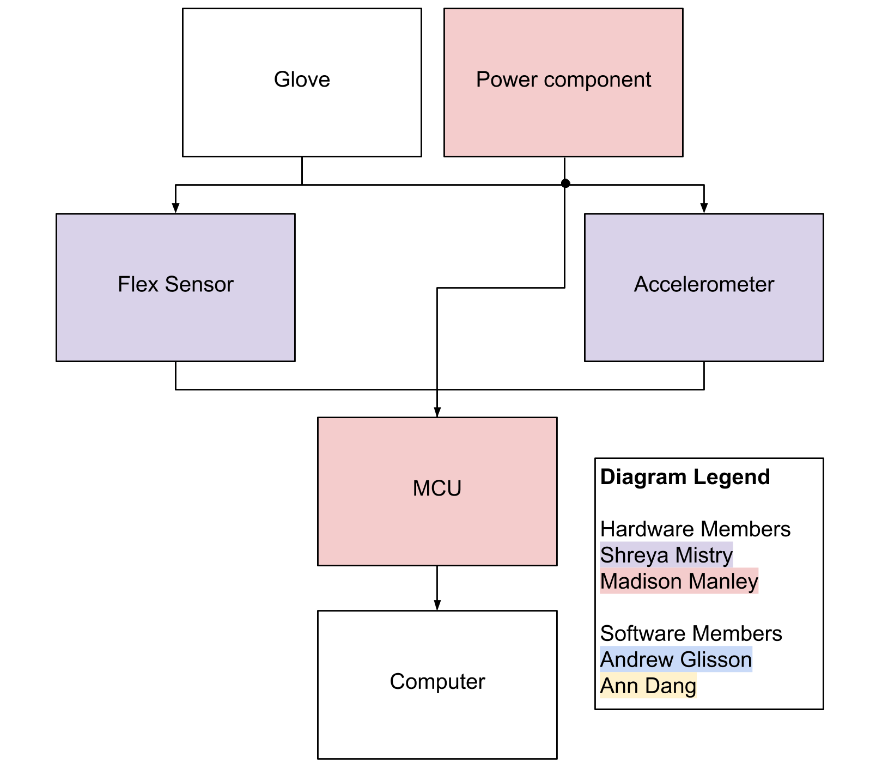  
**Figure 1 - Hardware Block Diagram**

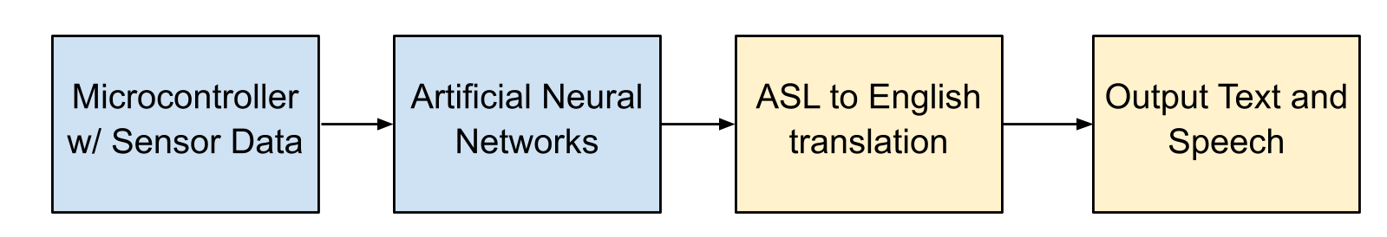

**Figure 2 - Software Block Diagram**

## Budget

The budget shown below in Table 1 outlines the costs associated with the project. Additional costs for replacement parts are also considered. As of right now, there is no sponsor and the cost of the project will be split between the group members.

|  |  |  |  |
| --- | --- | --- | --- |
| **Item** | **Amount Needed** | **Cost** | **Total** |
| Flex sensors | 10 | $13 | $130 |
| MCU | 1 | $25 | $25 |
| Gloves | 1 | $20 | $20 |
| Battery | 1 | $10 | $10 |
| Accelerometer | 1 | $30 | $30 |
| Miscellaneous |  | $140 | $140 |
| Total |  |  | $355 |

**Table 1 - Budget**

## 

## House of Quality

Shown below in Figure 3 is our House of Quality chart which identifies our targeted demographic’s needs and correlates it to an engineering requirement. This chart helps us prioritize certain features of our project.

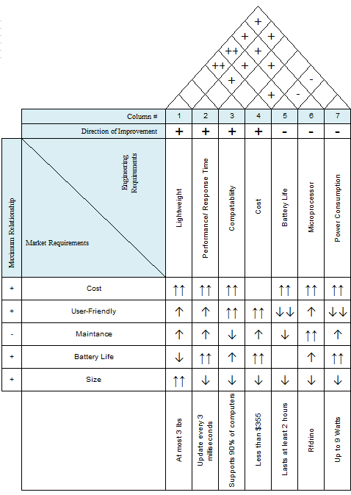

**Figure 3: House of Quality**

## Initial Project Milestones

Listed below in Table 3 are the proposed milestones which show a tentative schedule for the project during the Spring 2020 semester. Each task is assigned a start and end date, as well as who is responsible for each task. Table 4 shows a similar table for the Summer 2020 semester.

|  |  |  |  |
| --- | --- | --- | --- |
| **Task** | **Start** | **End** | **Who** |
| **Research** | | | |
| Group Formed | 1/6/2020 | 1/10/2020 | All of group |
| Divide and Conquer | 1/20/2020 | 1/31/2020 | All |
| Finalize Divide and Conquer | 1/31/2020 | 2/14/2020 | All |
| Microcontroller | 1/31/2020 | 3/6/2020 | Shreya |
| Power System | 1/31/2020 | 3/6/2020 | Madison |
| Communication | 1/31/2020 | 3/6/2020 | Ann |
| Flex or other sensors | 1/31/2020 | 3/6/2020 | Shreya/Madison |
| AI training | 1/31/2020 | 3/6/2020 | Andrew |
| Contact with ASL club | 2/14/2020 | TBD | Madison |
| 60 page SD1 report | 3/9/2020 | 3/20/2020 | All |
| **Design** | | | |
| Microcontroller | 3/6/2020 | 4/10/2020 | Shreya |
| Power System | 3/6/2020 | 4/10/2020 | Madison |
| Communication | 3/6/2020 | 4/10/2020 | Ann |
| Flex or other sensors | 3/6/2020 | 4/10/2020 | Shreya/Madison |
| AI training | 3/6/2020 | 4/10/2020 | Andrew |
| 100 page SD1 report | 3/23/2020 | 4/3/2020 | All |
| Final SD1 report | 4/6/2020 | 4/21/2020 | All |

**Table 3 - Spring 2020 Project Milestones**

|  |  |  |  |
| --- | --- | --- | --- |
| **Task** | **Start** | **End** | **Who** |
| **Implementation** | | | |
| PGB/ MCU | 5/18/2020 | 6/19/2020 | Shreya |
| Power System | 5/18/2020 | 6/19/2020 | Madison |
| Communication | 5/18/2020 | 6/19/2020 | Ann |
| Flex Sensors | 5/18/2020 | 6/19/2020 | Shreya/Madison |
| AI Training | 5/18/2020 | 6/19/2020 | Andrew |
| Test working prototype | 6/22/2020 | TBD | All |
| Final SD Report | 6/22/2020 | TDB | All |

**Table 4 - Summer 2020 Project Milestones**