Drew Gobbi

Maddie Warndorf

Peiyu Wang

03/15/20

**Demographic co-factor analysis of opioid use in cities: preliminary findings**

**Introduction:**

This paper introduces a relational study of demographic co-factors and opioid usage in Cincinnati, Ohio and Tempe, Arizona. We use two main proxies for opioid usage, number of opioid related emergency service (EMS) calls and the wastewater estimated number of opioid users per 1000 or 10,000. EMS call measures of opioid usage are available for both cities, while the experimental wastewater measurements are only available in Tempe.

We utilize a Poisson regression model to determine the relationship between demographic co-factors of interest and our measures of opioid usage. Co-factors that are found to have a statistically significant relationship with opioid usage proxies in both cities and measures of opioid usage exhibit generalizability traits of potentially drug using communities. Uncovering these relationships presents an opportunity for policy makers to target interventions and resources towards recovery.

**Units of Analysis, Independent and Dependent Variables**

We use a spatial-temporal unit of analysis in our study. Emergency service calls are measured at the Census block group level, while wastewater estimated number of users are measured in the wastewater site collection area. These observations are then aggregated by the unique year-month pairs from 2017 to 2019. For example, an EMS unit in our study could be measured in March-2019 in block group 113 in Tempe, while a wastewater estimate could be measured in site collection are 2 in March-2019 in Tempe. Maps of each of these spatial areas are shown below.

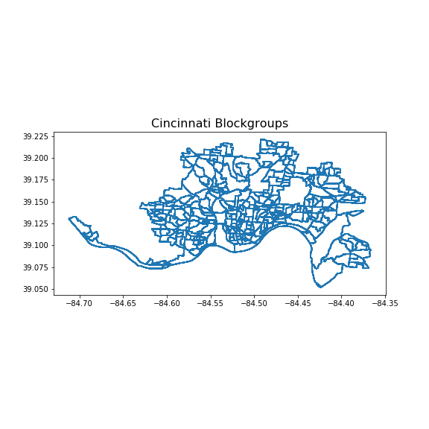

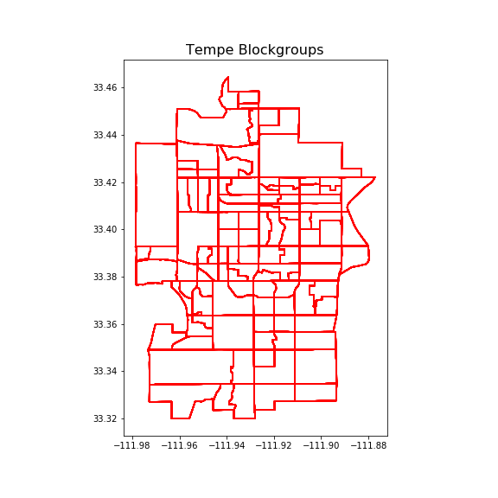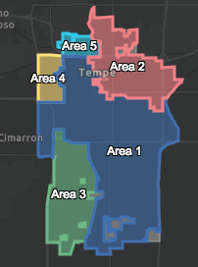

Our first proxy of opioid usage is the EMS call data available for Cincinnati and Tempe from 2017-2019. The EMS data in each city contains basic description information about the call and type of outcome, along with geographic coordinates and a timestamp. We use the coordinates provided to create geographic points for each call in the dataset. We then count the number of EMS call points that occur in each block group. Finally, we further subdivide the block group totals of EMS calls by year-month, using the timestamp on the call data. This gives us count data of EMS calls in each year-month block group pair included in our sample. Histograms of the number of EMS calls in each year-month block group pair for both cities suggest that the EMS call data is Poisson distributed.

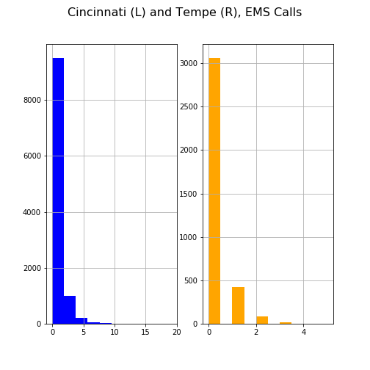

The second opioid usage proxy we use is the wastewater estimated number of opioid users per 1000 in Tempe, Arizona. This measure is calculated by dividing the population normalized mass load (PNML) of an opioid compound by the average daily dose of that compound in mg/day. For example, if the heroin-related PNML reading is 1000 mg/day/1000, and the average heroin user consumes 50 mg/day, then we would estimate that there were 20 users per 1000 in the area where the PNML reading was taken. Histograms of the wastewater estimates vary depending on the type of drug, but generally exhibit a right skew.

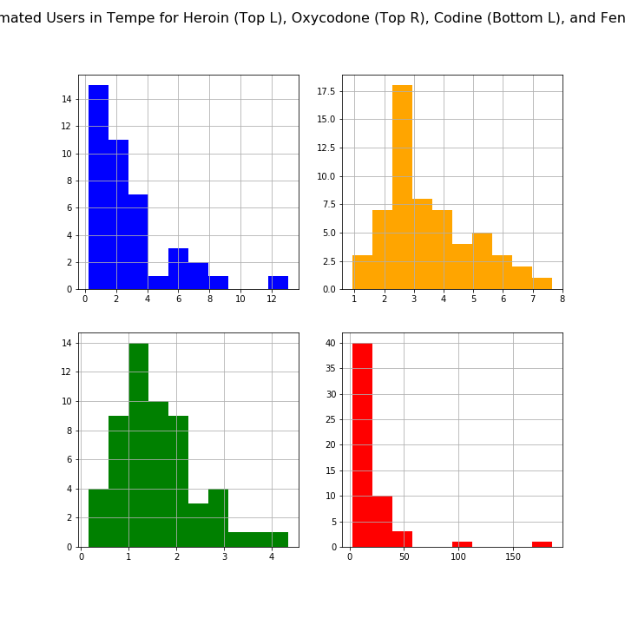

The demographic co-factors that we use as independent variables in our analysis are extracted from the United States Census bureau’s [planning database file](https://www.census.gov/topics/research/guidance/planning-databases.html) (PDB) at the block group level. The PDB data contains measures from both the decennial census and the American Community Survey (ACS) five-year estimates. Because these variables are not available annually, the five-year ACS estimates or decennial Census estimates are held constant across our study. This means that our demographic predictors only vary over out spatial units, not over time. To get demographic measures for the wastewater collection areas, we average the PDB measures of each block group contained in the wastewater collection site.

For our initial analysis, we extract an arbitrary list of covariates that were previously tested in a similar analysis of EMS calls and demographic cofactors in Cincinnati. These are:

* Proportion of males
* Proportion of 18-24 aged individuals
* Proportion of 25-44 aged individuals
* Proportion of 45-64 aged individuals
* Proportion of 65 years or older individuals
* Proportion of Hispanic individuals
* Proportion of households where all individuals are white alone
* Proportion of households where all individuals are black alone
* Proportion of households where all individuals are Asian alone
* Median household income
* Proportion of individuals below poverty
* Median home value
* Proportion of individuals with a college degree or higher
* Natural logarithm of the total population in the spatial unit

**Model**

We use a Poisson regression model following a simplified version of the structure outlined by Li. et al in their paper “Suspected heroin-related overdoses in Cincinnati, Ohio: A spatiotemporal analysis.” We assume that either the number of EMS calls in a block-group year-month pair, or the wastewater estimated number of opioid users per 1000 or 1000 in a site collection area year-month follow a Poisson distribution. We assume that the natural log of the intensity parameter of the Poisson variable of interest is linear for the covariates we include in the model.

$$y_{it} \sim Poisson(λ_{it)}$$

$$Log(λ_{it) }= X_{i}^{T}β$$

We test this model in six different specifications. First, on the number of heroin related EMS calls in Cincinnati. Second, on the number of all opioid related EMS calls in Tempe. And finally, on the wastewater estimated number of heroin, oxycodone, codeine, and fentanyl users in Tempe.

**Preliminary Results**

We find that age-related covariates such as the proportion of individuals who are 25-44 and 45-64 consistently exhibit a positive relationship with our measures of opioid use. Economic status indicators such as median household income, proportion of individuals below poverty, median home value, and the percentage of individuals with a college degree or higher generally have a negative association with the opioid usage measures.

A matrix of results by specification can be viewed [here](https://docs.google.com/spreadsheets/d/1TD17mhV4Q5er3DqZHyjHKonaLT-Wh6jo_WjxrJkzxos/edit?usp=sharing).

**Sources**

<https://tempegov.maps.arcgis.com/apps/opsdashboard/index.html#/69d996bc23dc461f82d01f47a5d70bfe>

<https://tempegov.maps.arcgis.com/apps/opsdashboard/index.html#/374b80b6ab65483e8ea4d30bf0100c23>

<https://insights.cincinnati-oh.gov/stories/s/Heroin/dm3s-ep3u/>

<https://data.cincinnati-oh.gov/Safety/Heroin/7mtn-nnb5>

<https://journals.plos.org/plosmedicine/article?id=10.1371/journal.pmed.1002956#sec015>

<https://www.census.gov/topics/research/guidance/planning-databases.html>