Hi,(yamal)

For learning AWS we need to install Tabby and GitHub software’s….,

Tabby: - It’s an alternate version of PUTTY and more user friendly.

GitHub: - It’s a cloud platform that can be used for multi-tasking various data & also can be used for data storage

Go to Google – type AWS - <https://aws.amazon.com/console/>

Once page open Click Sign in to Console.

Next the page will be open as below

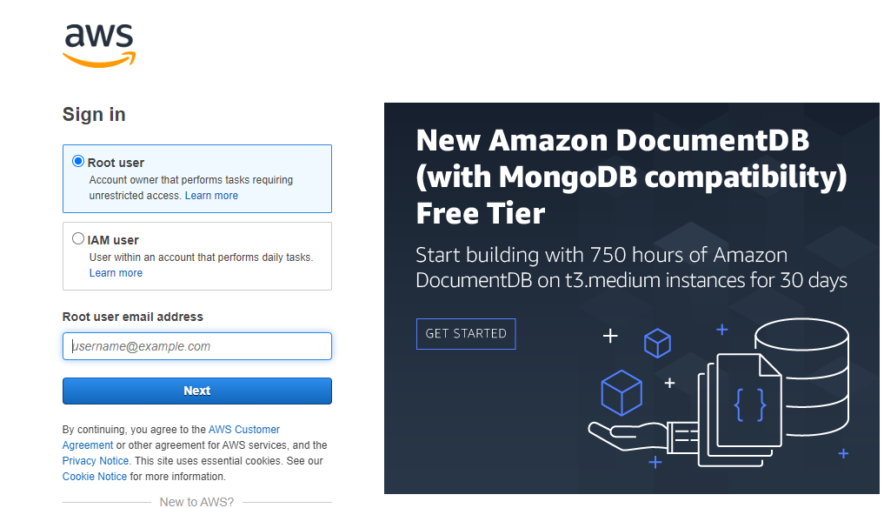

Select Root User & after that provide the mail id used to create AWS portal

Click next and provide the Password.

We’ll enter the page as below

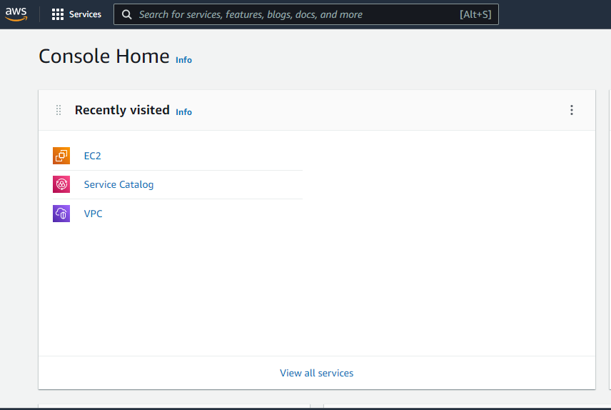

Here we need to select EC2 instance, it opens page as below

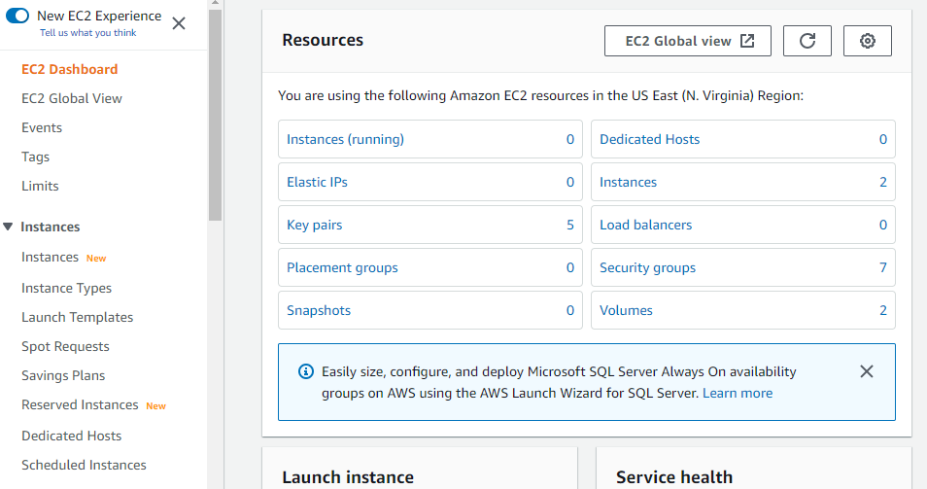

On the right hand scroll down and select Launch Instance & once select it opens new page as below

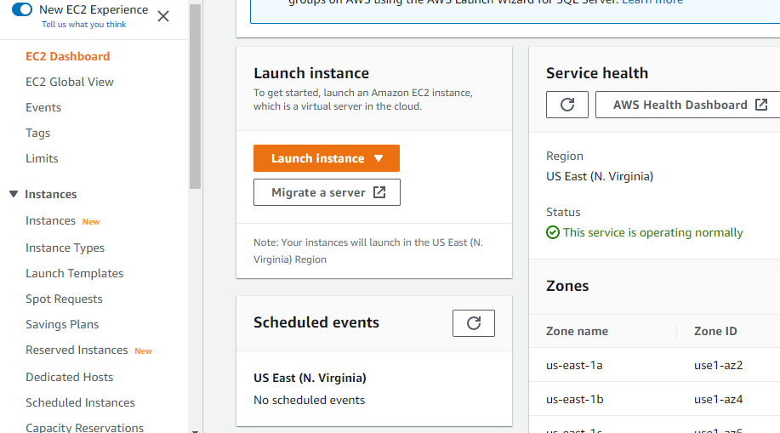

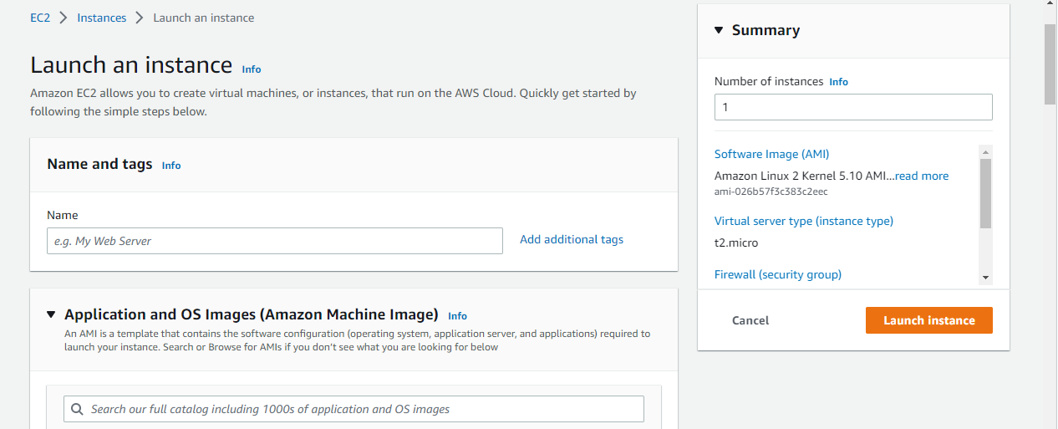

Here we need to keep the No of Instance to 1 which can be seen on right hand top corner (as it’s a free version)

Now for Name and tags.. give the name of your choice.

Below that we can see Application and OS images in that select “Browse more AMI’s

Once selected we can see like below also need to check if it’s free tire only

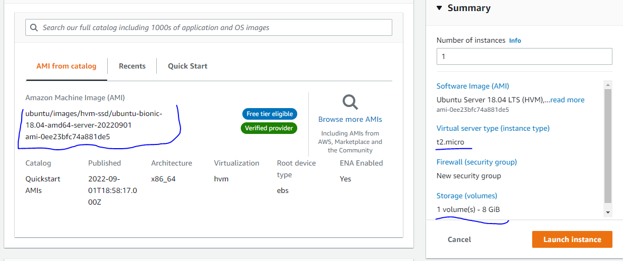

Here instance type must be t2 micro & 1 volume = 8 Gb, as these are free if we change them amount will be debited.

Next key pair name required.

Need to give a Key name

After that select Launch Instance

Once Instance was created it change

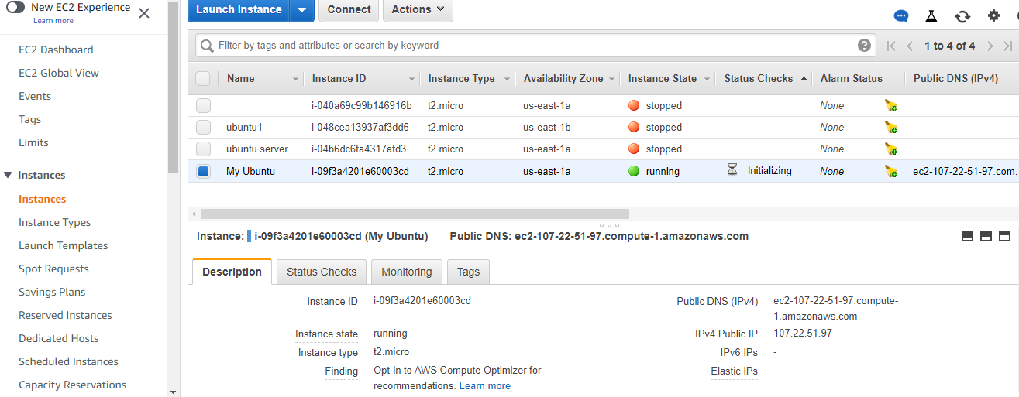

Here in Check statuses initialize has to complete and it should show as below

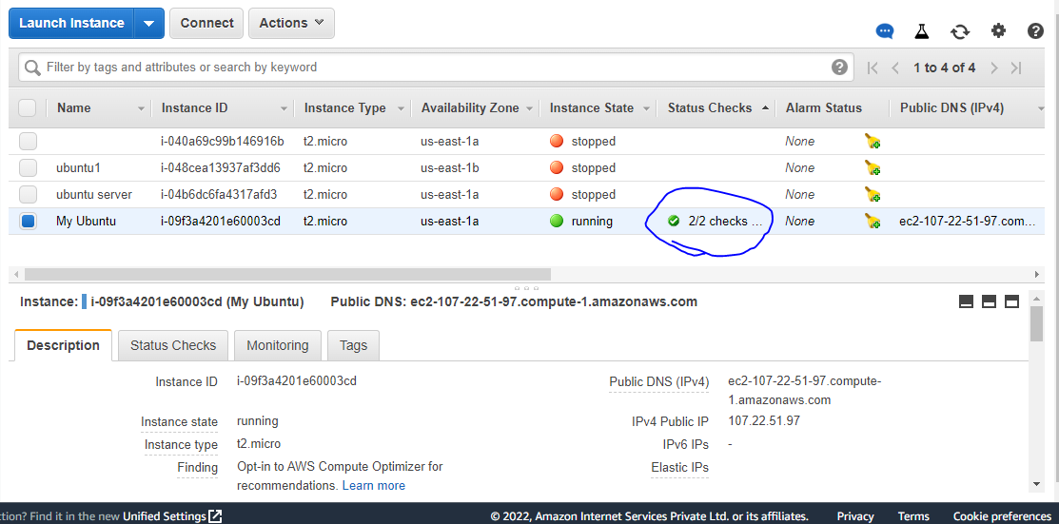

After that copy the Public DNS

Now go to Tabby terminal..

Go to settings

In that Profile & Connections..

Click on New Profile.

Search for SSH connection as shown below

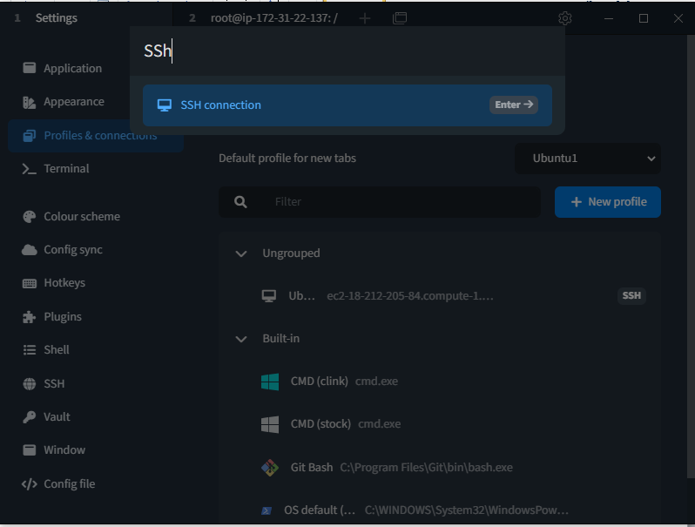

Click on Enter.

Provide the Name.

Scroll down General -- Provide the previously copied Public key

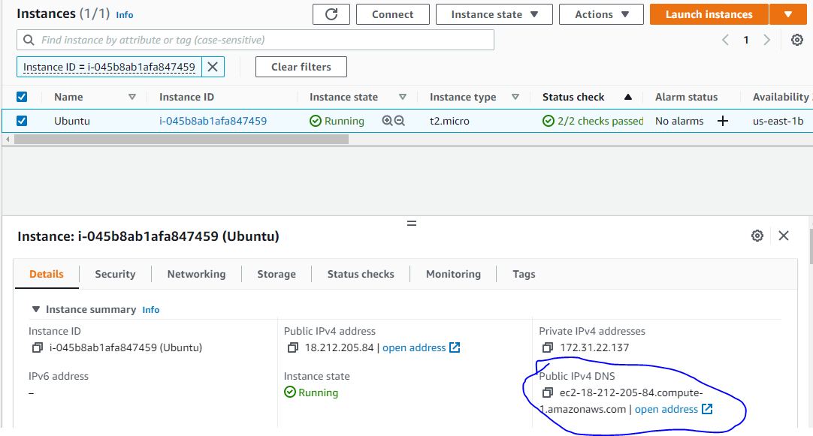

Select the Name & Give the Password as root(Default)

In Key section need to provide the Key that was downloaded from AWS

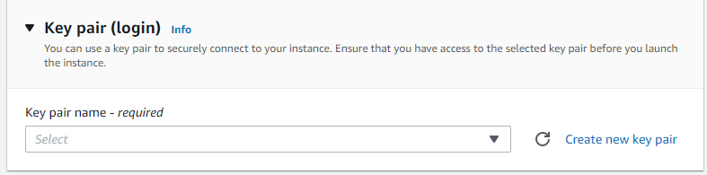

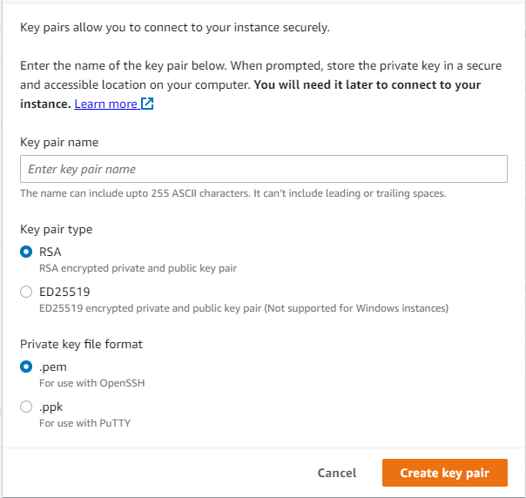

Select create key pair & a key will be generated & Download

We need to select the private key in Tabby & Save

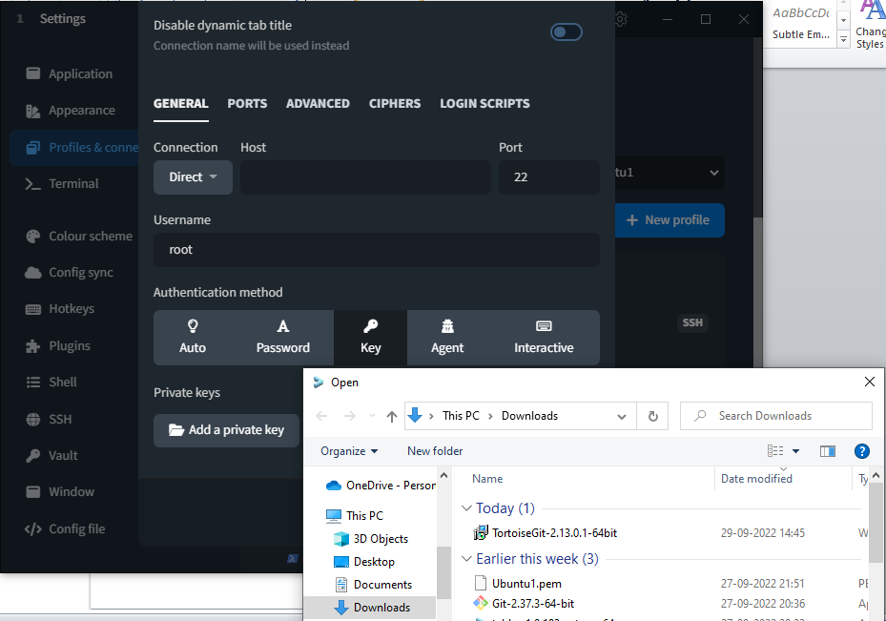

Once you have saved we can see as below & when we keep the curser on it we can see the Play button as shown

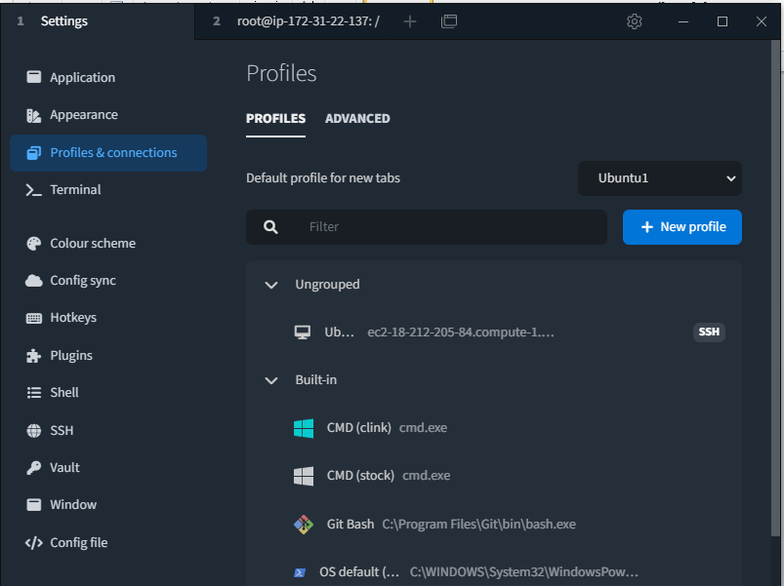

We will get a pop up as below

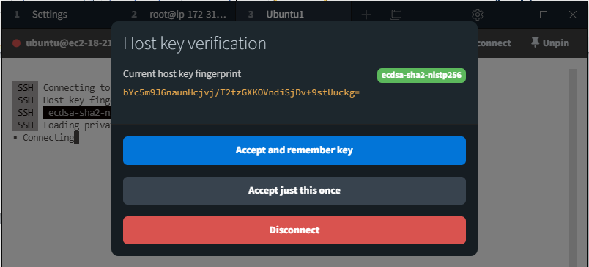

Select Accept & remember (\*as we are using the free version every time instance is stopped a new Public DNS is created. So every time we need to change Connection)

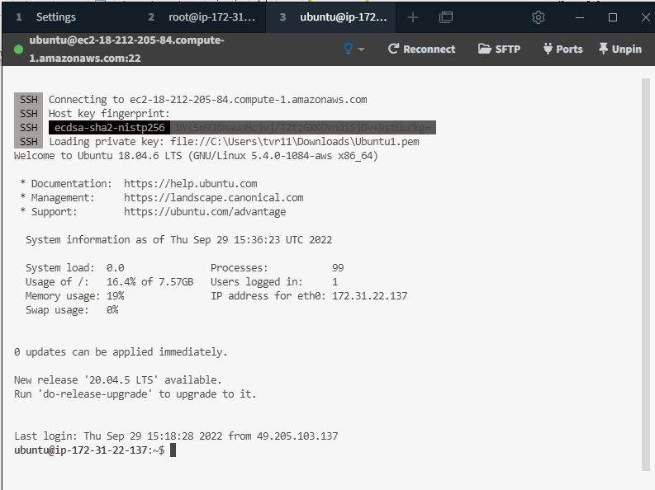

Now we can use the “Linux/Ubuntu Server from tabby in AWS

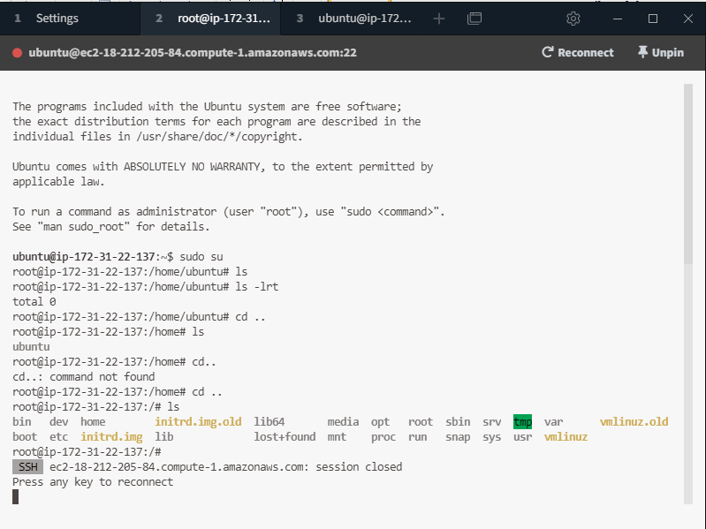

GITHUB:-

Now we need to download & install GitHub

For that we need to create a mail account for the same.

We need to sign in using the created mail id.

Once we Login we can see as below