Article: Methods

Geonomics: forward-time, agent-based, spatially explicit, and arbitrarily complex landscape-genomic simulations
Drew Ellison Hart and Ian J. Wang
Department of Environmental Science, Policy, and Management, College of Natural Resources, University of California, Berkeley, CA, 94720, USA
Corresponding author: Drew Hart (drew.ellison.hart@gmail.com)
TODO
- finalize Yosemite and other figs
- review and rewrite supps
- update and rerun supp figs
- add test of local adaptation/locally adapted loci to Example 2? AT LEAST RUN IT USING EXISTING, ACCEPTED SOFTWARE AND SEE WHAT THE RESULTS ARE, THEN CONSIDER WHETHER OR NOT TO INCLUDE
- write abstract
- shorten/simplify caveats section?
- take care of other yellow-highlighted bits
- Should the second regression in Example 1 include also geo distance, to test whether there is IBE independent of the correlation between geo and env?
- Double-check that there’s nothing in here that is likely to go out of date if I update/change the package (variable names, param names, etc, etc)

Abstract
WRITE ME

Intro/Background
Interest in understanding and predicting the genomic evolution of study systems on complex and changing landscapes continues to grow. These systems might include one or multiple populations or species that are not at demographic equilibrium. Species might inhabit complex, multivariate, and even changing landscapes, and they may be undergoing neutral evolution as well as natural selection, often on multiple traits of variable genetic architecture. The field of landscape genomics studies the ways in which ecological and evolutionary processes playing out on real landscapes generate geographical patterns of genomic variation. Landscape-genomic studies frequently analyze data collected from systems of such genomic and geospatial complexity (Crossley et al. 2017; Harris and Munshi-South 2017; Lind et al. 2017; Mastretta-Yanes et al. 2018). Study of such systems is crucial for developing evolutionary and ecological theory (Barrett et al. 2019; Pelletier 2019), improving our knowledge of the past states and present functionality of ecosystems (Mastretta-Yanes et al. 2018), anticipating ecological futures in the Anthropocene (Bay et al. 2018), and thus informing conservation and management (Crossley et al. 2017; Lind et al. 2017).
The complex genomics of such systems are beyond the reach of analytical population genetics, and their spatial complexity and evolutionary dynamics make them intractable for coalescent simulation (Hoban et al. 2012). This hinders not only our understanding of many empirical systems and our ability to unambiguously interpret analytical results but also our ability to predict those systems’ dynamics and, thus, to manage them appropriately. Thus, in landscape genomics as in many other fields, forward-time simulation is a crucial tool for dissecting the dynamics of complex study systems.
However, the current suite of forward-time genomic simulators, although numerous, is still of limited utility for such work. Most available software is restricted, either genomically or geospatially, in the complexity it can model. Many programs can model systems of considerable genomic complexity (e.g. simuPOP (Peng and Kimmel 2005), NEMO (Guillaume and Rougemont 2006) and QuantiNemo (Neuenschwander et al. 2008)), yet incorporate only rudimentary spatial components or none at all. Other programs are designed specifically for landscape-genetic simulations (e.g. CDPOP (Landguth and Cushman 2010), CDMetaPOP (Landguth et al. 2017), SimAdapt (Rebaudo et al. 2013)), but are limited in their genomic complexity. For instance, many programs are incapable of modeling simultaneous selection on multiple, multigenic traits. To our knowledge, SLiM (Messer 2013; Haller and Messer 2017; Haller and Messer 2019) is the only package currently capable of simulating scenarios that are both as genomically and as geospatially complex as those for which Geonomics is designed (National Cancer Institute, 2019). Its extreme generalizability and complexity allow it to be used for landscape genomics simulation, but it is not explicitly designed for such work.
We developed Geonomics to provide a scriptable framework for building complex landscape-genomic simulations with minimal effort. Geonomics models are parameterized by way of an informatively annotated parameters file that provides the user a straightforward means of building models of arbitrary complexity, yet offers reasonable default settings and ‘off switches’ for parameters and components unrelated to the user’s interest. Models consist of (1.) a landscape of one or more environmental layers, each of which can undergo arbitrarily complex environmental change events during model runs; and (2.) one or more species, with or without genomes and any number of associated phenotypes. Species undergo non-Wright-Fisher evolution in continuous space, with localized mating and mortality, such that species-level phenomena and simulation dynamics are emergent properties of a model’s parameterization. For this reason, Geonomics produces realistic, spatially explicit, landscape-genomic datasets that will be useful for a wide variety of theoretical and empirical purposes.
Geonomics is written and run entirely in Python (Python Software Foundation 2019; van Rossum 1995), a broad-purpose and popular programming language that is already familiar to most researchers with exposure to bioinformatics. This of course makes Geonomics slower than programs written in compiled languages. But what Geonomics sacrifices in performance, it gains in flexibility, extensibility, and accessibility. Users can create and run highly complex models using an edited parameters file and as few as three lines of code; indeed, basic users need not even know the Python language to run such models, as we provide template code in the documentation. Yet advanced users can use custom code to manually access or customize Geonomics data structures, add or extend functionality, or generate special-purpose data. Compared with existing software, Geonomics dramatically reduces the workload associated with landscape-genomic simulation modeling.

Model Overview
The first core component of a Geonomics model is the species. The behavior of a species in the model is determined by a wide variety of demographic and life-history parameters, including an intrinsic growth rate, mate-search radius, mean number of offspring per mating event, reproductive age, and maximum age, among others. Each species can also undergo any number of change events during each model run, including changes to demographic and life history parameters and various types of population-size changes.
A species is composed of individuals. Each individual is described by an x,y location, a sex, and an age or life-history stage that updates at each time step. Each individual also has a diploid genome consisting of any number of diallelic loci. These loci can be thought of as representing either a contiguous haplotype block or a set of distinct loci. (For simplicity’s sake, we refer to the simulated loci herein, and in the software generally, as ‘the genome’.)
At the start of a model run, the first individuals’ genomes are assigned based on the parameterization of the species’ genomic architecture object. Aspects controlled by the genomic architecture include locus-wise starting allele frequencies, locus-wise indicators of dominance, genetic linkage, and the genotype-phenotype mapping for each simulated phenotypic trait. Simpler genomic architectures can be set up within the parameters file, whereas complex, custom genomic architectures can be defined using a CSV file that defines parameter values locus by locus.
Linkage is determined by a genome-length list of inter-locus recombination rates. Recombination rates can be set to a fixed value, drawn from a distribution, or individually defined by the user. Separate chromosomes can be modeled by providing a list of chromosome lengths, defining genomic breakpoints at which the recombination rates will be set to 0.5, to effect independent assortment.
Traits are continuous and quantitative, and can be mono- or multigenic. Each trait is defined by a set of loci that comprise its genetic basis, the effect sizes of those loci, and a selection coefficient (which can be heterogeneous or homogeneous in both space and time). A trait’s phenotype influences an individual’s fitness proportional to its degree of mismatch to the individual’s local environment for the environmental raster layer that is the trait’s selective force.
The genomic architecture can also define separate mutation rates for three types of mutations: neutral mutations, trait mutations, and deleterious mutations. Neutral mutations do not affect fitness. Trait mutations add to the genetic variation affecting a trait, thus generating phenotypic variance upon which natural selection can operate. These mutation rates are defined separately for each trait. Lastly, deleterious mutations do not affect trait phenotypes, but universally decrease each affected individual's fitness.
The other core component of a Geonomics model, the landscape, is a stack of any number of environmental raster layers. Each layer can be used to set any of three different species attributes, which control three different model operations (detailed in the following section): (1.) a resistance raster, which controls individual movement or offspring dispersal; (2.) a carrying-capacity raster, which controls population density; and (3.) a trait’s environmental raster, which controls natural selection. Each layer can also undergo any number of arbitrarily complex environmental change events. As a change event unfolds, it influences the dynamics of any species whose carrying capacity, movement and dispersal, or natural selection depend on the corresponding layer.

Model Operation
A Geonomics model can be used for any number of runs, with each run creating its own separate subdirectory of output data. At the start of each run, a model is burned in by iterating time steps, without genomes or selection, until statistical tests for temporal and spatial stability of population size are passed. These tests include a time-lagged t-test of mean population size, an augmented Dickey-Fuller test of population size, and a STILL NEED TO ADD A SPATIAL TEST. Then, each individual has its genome randomly drawn according to the genomic architecture, so that the main phase of each run begins with no pedigree and thus without population structure.
The main phase can run for any number of time steps. Each time step is a series of four operations, some optional (see Figure 1):
- movement (optional);
- mating (requisite), which includes mate search, mate choice, offspring creation, and offspring dispersal;
- mortality, due to density-dependence (requisite) and natural selection (optional);
- change events, environmental or demographic (optional).
Movement
Movement takes place in continuous space – individuals are assigned x,y coordinates rather than being arbitrarily restricted to grid cells or populations. Each individual moves along a vector, composed from randomly drawn distance-direction pair. Distances are Wald-distributed. Directions can be drawn from a uniform distribution on the unit circle – resulting in isotropic movement, the default behavior. Alternatively, they can be drawn from a ‘movement surface’ – an array of either uni- or multimodal von Mises distributions, derived from a landscape layer that serves as a resistance surface (sensu McRae 2006). On a unimodal surface, each cell is assigned a single von Mises distribution, with mode parameter being set to the direction to the center point of the highest-valued cell in the 8-cell neighborhood (see Figure 2). On a multimodal surface, each cell’s mixture distribution is a weighted sum of eight such unimodal distributions, one pointing toward the center point of each cell in the 8-cell neighborhood, and with weights equal to the neighboring cells’ values, normalized to sum to 1. This is, to our knowledge, a novel approach to simulating movement. It generates realistic, anisotropic movement across an environment of heterogeneous habitat quality, while avoiding time-consuming computations during model runtime, such as repeated searches for minimum-resistance neighboring cells.
Mating
Mating pairs are randomly drawn from among all eligible pairs of individuals within a species’ mate-search radius, with eligibility based on sex and age. The draws are Bernoulli distributed, with probability equal to the species’ intrinsic birth rate. Each mating pair produces some number of offspring, either drawn from a Poisson distribution with equal to the species’ mean number of offspring, or set to a fixed value. Each parent produces a gamete for each of its offspring, using realistic recombination and Mendelian segregation. Gametes are united to create offspring individuals, which are dispersed to a new location. As with movement, dispersal vectors can be drawn isotropically, or anisotropically using a ‘dispersal surface’.
Mortality
Mortality is modeled as a Bernoulli process, with individual-wise death probabilities being a combination of the probabilities of death due to density-dependence (using a logistic-growth model) and of death by natural selection on all simulated phenotypic traits). This is calculated as:
(1)
whereis the probability of death due to density-dependence for individual, is the species’ number of simulated traits, and is the fitness of individualfor trait, which only factors in if natural selection is being used. The probability of density-dependent death at location is calculated as:
(2)
where, for location , is the expected number of deaths,is the population density (expressed as individuals per cell), is the expected number of births, and is the population logistic growth rate. The fitness of individualfor trait is calculated as:
(3)
where is the selection coefficient on trait at location, is the value of the selection layer for traitat location, is the phenotype of individual for trait , and defines the curvature of the fitness function for trait . The phenotype is a result of the additive effects of that individual’s genotypes at all underlying loci, and is calculated as:
(4)
where is the number of loci, is the effect size of locuson trait, is the genotype at locus for individual, and , the baseline genotype, equals 0 for monogenic traits or 0.5 for polygenic traits.
Change Events
Each demographic or environmental change event unfolds as a series of incremental changes that occur at the end of scheduled time steps. Demographic change occurs by way of multiplicative changes to a species’ carrying-capacity raster. A demographic change event can be exponential, random, or cyclic, or can follow a more complex, custom trajectory. Each event is parameterized by defining the time steps at which its changes take place, and by population-sizing parameters that determine the factor by which the carrying-capacity raster is multiplied.
Simple, linearly interpolated environmental change events are defined by a list of time steps for the changes and the terminal raster for the event. More complex, custom events can be simulated by indicating a directory of time step-labeled rasters. The latter option makes it extremely easy to simulate evolution on real-world rasters undergoing realistic, non-linear, spatially heterogeneous change.

Validation
We ran a series of simulations based on classical models from population genetics, including both neutral and non-neutral evolutionary scenarios. Because the classical models are more simplistic than the individual-based, spatially explicit, continuous-movement models built by Geonomics, we parameterized Geonomics so as to accurately emulate these models while minimizing artefacts. We used the results of the simulations to statistically and heuristically validate Geonomics’ full range of functionality.
At the most basic level, multi-generational random mating in any Geonomics model should generate theoretically concordant patterns of genetic drift. We tested this with a series of Wright-Fisher models (Fisher 1923; Wright, Sewall 1930). Neutral allele frequencies drifted from their 0.5 starting values as expected (Figure S1), with mean fixation times increasing as a function of population size and with these times matching theoretical expectations (Figure S2). Because demographic changes should also demonstrate the theoretically predicted effects on genetic drift, we tested for correct evolutionary genetic dynamics under a bottleneck event. This test produced not only the expected shrink and rebound in total population size but also the expected sudden acceleration in the rate of genetic drift (Figure S3). In our spatially explicit framework, individual-based movement should be able to recreate classical patterns of genetic structure between discrete segments of a species. Because Geonomics is not population-based we approximated a one-dimensional island model, using a landscape composed of equal-sized, evenly spaced island patches (Figure S4). We ran the model, manually tracking all between-island migration events, then used that data to calculate actual migration rates for all possible migration trajectories. As expected, we saw that migration rates decreased as a function of inter-island distance (Figure S4), whereas F_{ST} increased as a function of both inter-island distance and time (Figures S4 and S5).
Geonomics should also be able to reproduce the theoretically expected genetic patterns of non-neutral models, such as adaptation to heterogeneous environments. We first tested this using a model of divergent selection on a monogenic trait. Species moved locally and isotropically on a landscape split into opposite-habitat halves. As expected, evolution on this landscape led to local adaptation, producing a visual pattern of phenotype-habitat matching (visible as individual-environment color-matching in Figure S6), with a zone of phenotypic spillover and hybridization along the between-habitat border. Furthermore, over model time, the species reached migration-selection balance – the frequencies of the beneficial alleles in each habitat increasing up to some equilibrium level, with that level increasing as a function of the strength of selection (Figure S7). We next tested Geonomics’ ability to recreate the genetic structure expected under local adaptation along a cline. We used a model very similar to the previous example, but with the landscape being a symmetric environmental gradient rather than two distinct habitats. Geonomics again produced the expected visual pattern associated with local adaptation (Figure S8), and when we fitted sigmoidal tanh clines (such as those as fitted by the ClineFit software package; Porter 2013) for all loci, the locus underlying the monogenic trait was the only one to demonstrate clear, pronounced clinal variation (Figure S9); it was also reliably detected as the most significantly correlated with environmental values in genotype-environment association tests using logistic regression (p < 0.001).
Finally, because Geonomics can simulate genomic data with physical linkage, it should be able to reproduce the genomic patterns associated with selection on loci embedded within linkage blocks. To test this we simulated a selective sweep, in which an initially ill-fitted population had a beneficial mutation purposefully introduced. After the mutation successfully established, we allowed the simulation to run until 2500 time steps after the mutation fixed. Geonomics produced the classic genomic signal of a selective sweep – a pronounced but gradually eroding block of reduced genetic diversity surrounding the selected locus (Figure S10). This happened while the beneficial mutant spread across the landscape from its randomly drawn introduction site (Figure S10), and while the population’s mean fitness increased from 1 - ɸ to a saturating value of 1 (Figure S11).

Applications
After validation, we assembled a series of demonstration simulations. These simulations allowed us to explore the spatial genetic patterns generated under more complex scenarios whose with less well-specified theoretical expectations. They also showcase the power of Geonomics to make previously difficult landscape-genomic simulations easy and tractable.

Example 1: Isolation by distance (IBD) and by isolation by environment (IBE)
Landscape heterogeneity constrains movement, and thus gene flow, whenever the probability of an individual moving across some section of a landscape is conditional on that section’s environment. Ecologists commonly use resistance surfaces to describe such movement (McRae 2006; McRae et al. 2008; Spear et al. 2010; Andrew et al. 2012; Landguth et al. 2012; Zeller et al. 2012; Wang and Bradburd 2014; Ruiz-Gonzalez et al. 2015; Zeller et al. 2016; Milanesi et al. 2017). With gene flow thus spatially constrained, population genetics predicts a pattern of isolation by distance (IBD): A positive correlation between pairwise geographic distances and pairwise genetic distances (Wright 1943). But landscape heterogeneity can also underlie processes such as spatially divergent selection, which should generate a pattern of isolation by environment (IBE): A positive correlation between pairwise environmental distances and pairwise genetic distances, independent of geographic distance (Wang and Bradburd 2014).
To explore the simultaneous generation of both patterns in Geonomics, we built a model that uses a heterogeneous resistance layer to create a movement surface and a heterogeneous environmental variable as the selection layer for a monogenic trait (ɸ = 0.05). The model features a single species at constant population size (roughly 2450 individuals), undergoing both neutral evolution and selection. The movement layer consists of a central, vertical barrier separating equal-area sides, within each of which movement is unconstrained; this layer was also used as the carrying-capacity layer, yielding homogeneous population density on the two sides and zero density within the barrier region. The selection layer consists of two environmental gradients of opposite directionality, one on each side of the barrier (Figure 3).
To compare population structure before and after evolution, we collected two genomic datasets, consisting of all individuals’ genomes at time steps 0 and 1000. We then used Principal Components Analysis (PCA) to calculate pairwise genetic distances between all individuals, for each dataset. To visualize population structure, we extracted the first three principal components (PCs), scaled them to , then used those values as the red, green, and blue (RGB) color values for mapping individuals on top of the landscape. To visualize local adaptation, we produced maps of the same individuals, colored instead by their phenotypes for the trait under selection (using Geonomics’ ‘model.plot_phenotype(...)’ method).
After evolution, we tested for signals of IBD and IBE. We ran logistic regressions of genetic distance, from the post-evolution genetic PCA, on pairwise (Euclidean) geographic and environmental distances. We used a complementary log log, or ClogLog, link function, to allow the regressions to model a non-sigmoidal, saturating functional form. Significant, positive relationships in both models would indicate patterns of both IBD and IBE.
The RGB and phenotype plots of the pre-evolution species, with randomly-assigned genomes, showed a clear lack of both spatial structure and local adaptation (Figure 3, row 1). However, spatial structure developed over evolutionary time (Figure 3, row 2, left), and the species became locally adapted (Figure 3, row 2, right). At the end of the simulation, the species demonstrated significant signals of both IBD and IBE, as evidenced by the highly significant (p < 0.001) positive slopes on both regression models (Figure 3, row 3).

Example 2: Simultaneous selection
One of the powerful features of Geonomics is that it can simulate selection on numerous traits simultaneously, each with a separate selection layer. Thus, a species can experience multiple, distinct, spatial selective regimes. This will prove useful for landscape genomic simulations, given that many natural systems are locally adapted to multiple, distinct environmental gradients (Fournier-Level et al. 2011; Lasky et al. 2012; Manel et al. 2012). However, despite the commonality of such scenarios, theoretical expectations are relatively crude and mostly derive from non-spatial models CITE OR REMOVE.
We simulated a scenario in which a species undergoes natural selection along two, orthogonally aligned environmental gradients, with each gradient serving as the selective force for a separate trait (ɸ = 0.05). Each trait is determined by 10 distinct, unlinked loci, all with effect sizes of 0.1 (i.e. one tenth of the distance between the two opposite, optimal phenotypes). Individuals have a mean movement distance of 0.5 cell widths, on a 50 x 50-cell landscape; this value was chosen to limit gene flow to localized regions, allowing for the development of strong spatial structure and thus providing the potential for local adaptation.
We let the system evolve for 1000 time steps. Then we mapped the species on top of each of its two environmental layers, with individuals colored by their phenotypes. This allowed us to check for the expected visual signal of local adaptation – color-matching between individuals and their environmental backgrounds.
Results showed a pronounced signal of local adaptation to both variables, with a clear overall pattern of color-matching (Figure 4). There are, however, patches of less-clear local adaptation. This is likely a result of model’s movement parameterization; locally restricted movement produces a localized spatial pedigree, and thus leads to location-to-location stochastic variation in the strength of drift for non-neutral loci.

Example 3: Polygenic adaptation to climate change in the Yosemite region
There is growing interest in incorporating evolution into our understanding of species’ responses to climate change (Hoffmann and Sgrò 2011; Franks and Hoffmann 2012; Bay et al. 2018). Much of this interest focuses on species which are locally adapted along an environmental gradient that is expected to shift under climate change. Climatic shifts are expected spatially heterogeneous, for various reasons. In many montane regions, this can happen because many cooler, higher-altitude regions are warming more quickly than warmer, low-altitude regions, and are projected to continue doing so (Rangwala et al. 2013; Mountain Research Initiative EDW Working Group 2015; but see Oyler et al. 2015). Of particular interest in these situations is the ability of species to adapt to changing local conditions. Of the possible species responses to climate change—the others being range shifts, tolerance, plasticity, and local extinction—this is the response about which we know the least (Franks and Hoffmann 2012).
To explore Geonomics’ utility for studying such a system, we simulated the evolutionary response to projected climate change of a continuously distributed, locally adapted species: the montane lizard Sceloporus graciosus ("sagebrush lizard"), in the Yosemite region of California (U.S.A.). We began by preparing the raster layers to be used for the model’s landscape. These include time-series of temperature and precipitation, and a time-series of habitat suitability based on those two variables. All data preparation was done using custom scripts (Supplementary Materials) in the R statistical programming language (R Core Team, 2019).
The first two sets of layers, mean annual temperature and mean annual precipitation, include current data and their projections through 2100. For current data, we used PRISM data (Daly et al. 2008), calculated as normals for the 1981-2010 period, at 800 meter resolution. For future data, we used means at 5-year intervals (2015-2100), downscaled to 6 km resolution using the Localized Constructed Analogs downscaling technique (LOCA; Pierce et al. 2014), from Cal-Adapt (https://cal-adapt.org/help/faq/). We calculated means of both variables from their minima and maxima observed across 32 global climate models, using a conservative Representative Concentration Pathway (RCP 4.5). We developed time-series of future temperature and precipitation layers at 800-m resolution by: (1) calculating the raster difference between the first projected year and the current data, aggregated to the projected data’s resolution; (2) adding that difference to the current data, such that each cell in the current data received the difference of the coarser, projected cell within which it lay; then (3) repeating that process for all remaining years.
The last set of layers represents S. graciosus habitat-suitability, and is derived from a species distribution model (SDM) that used our temperature and precipitation variables to predict species presence. To develop this model, we first downloaded all geo-tagged occurrences of S. graciosus from GBIF (www.gbif.org). For presence data, we clipped those points to the area of California and Nevada, then subsampled to remove multiple points within the same raster cells. We generated pseudoabsence data, by drawing random points from all cells in the California-Nevada region where the species was not observed (following the recommendations of Barbet‐Massin et al. 2012). We extracted the current temperature and precipitation data at these points, which we used as predictor variables of presence-pseudoabsence in a binomial generalized linear model (GLM) with a logit link. We then projected that GLM onto the current and future temperature and precipitation rasters for our study region, producing a time-series of predicted habitat suitability for our simulation landscape (). We did not threshold these rasters at a minimum suitability value, because we wanted spatial variation in habitat suitability to cause spatial variation in population density in our model.
With all raster layers prepared, the construction of the Geonomics model was straightforward. We generated a template Geonomics parameters file (using the Geonomics function ‘gnx.make_parameters_file(…)’), then edited it to match our study system. We needed a parameters file that could parameterize: 3 layers that could be read in from files, two of which would undergo landscape-change; 1 species, with movement, a movement-surface, and genomes with 1 trait (ɸ = 0.3); and data-collection. We created this using the code in Code Sample 1.
We edited the resulting file, setting the appropriate parameter values to indicate the locations of our initial temperature, precipitaiton, and habitat-suitability rasters, and the locations of our directories of change rasters for the temperature and habitat layers. We set other life-history and demographic parameters to reasonable values, based on current knowledge of S. graciosus biology (see parameters file, in Supplements).
Then, in a Python script (Supplementary Materials), we used our parameters file to create a Geonomics model object, run the model, and plot results. We used ‘gnx.make_model(…)’ to create the model and ‘model.walk(…)’ to run the burn-in and main phases of the model, as shown in Code Sample 2. Using ‘mode.walk(...)’ rather than ‘model.run(...)’ allowed us to pause the simulation at desired points, to collect custom data and plot intermediate results (the ‘advanced’ mode referred to in the Introduction). We ran the burn-in, ran the main phase for 500 time steps without climate change (to develop a pattern of local adaptation), then ran the main phase for an additional 100 time steps (i.e. years) of climate change. At time steps 500 (i.e. before climate change) and 600 (after climate change) we plotted the current landscape layers, the current population, and a neighborhood-meaned raster of the population’s phenotypes (using a custom function written in-script).
This produced the results seen in Figure 5 (and viewable in the time-lapse video in the Online Supplements). The model generated a clear and realistic pattern of polygenic adaptation to the elevation-based temperature gradient in the Yosemite region, and that gradient of local adaptation exhibited a slight but noticeable upslope shift in response to the period of climate change. These results are visible both heuristically (from the individuals’ phenotypes plotted before and after climate change) and analytically (from the neighborhood-averaged phenotype rasters plotted at the same time steps). Population size fluctuated around 52,000 before climate change but was reduced to roughly 3,000 by the end of the simulation. This happened as a result of globally declining habitat-suitability values, which led to a concordant global decline in carrying capacity, and thus a concordant decline in total population size. Total population size remained relatively constant throughout the model run, despite a roughly 10,000-individual decrease in the sum of the carrying-capacity raster (from 63435.25 to 53679.625). However, as soon as climate change began, oscillations in population size became about 5 times greater in amplitude (standard deviation changed from about 700 before climate change to about 3900 afterward), and the species displayed what appears to be the beginning of a gradual decrease in population size. Thus, the impact of climate change up to 2100, in this scenario, would likely continue to play out as a legacy effect over future years—indeed, continuing to run the model beyond 2100, without additional climate change, yielded a roughly 10,000-individual reduction in population size by the time the population stabilized around 2125. And although we lack climate-projection data beyond 2100, continued climate change would clearly intensify this effect.

Discussion
Both our validations tests (Supplements) and our three example simulations demonstrate that Geonomics is capable of simulating scenarios of varying complexity, generating accurate and realistic population- and landscape-genomic datasets. Importantly, it does this in a software package that has multiple benefits unavailable in other similar tools. Geonomics is a scripting framework embedded in Python (Python Software Foundation 2019; van Rossum 1995), one of the world’s most popular programming languages and a language already familiar to many researchers who use bioinformatics. It makes the creation of arbitrarily complex models quick and easy, without even requiring much prior Python experience. Yet it provides advanced users with easy access to the core data structures, enabling broad customization and extension.
We believe Geonomics will be useful for many purposes. Many theoretical questions in population genomics necessitate explicitly spatial study methods (Bradburd and Ralph 2019), which Geonomics will make more tractable than ever before. Landscape genomics studies draw conclusions about complex, real-world systems, sometimes with direct implications for conservation and management. Geonomics will not only enable the generation of simulated datasets specific to such study systems—parameterized from field data or from the literature, and simulated under multiple, competing hypothetical scenarios. It will also aid the development and testing of landscape-genomic analytical methods, strengthening our ability to draw accurate and actionable inferences from real-world data.

Runtime and memory
Geonomics models run considerably slower than models written in compiled languages, such as SLiM (Messer 2013; Haller and Messer 2017; Haller and Messer 2019). However, for users whose scenarios are well served by the design and affordances of Geonomics, we believe that what is sacrificed in runtime will be made up for in flexibility, customizability, and ease of use. With a reasonably powerful computer and for reasonably-sized models, most users should not find runtime a major limitation. Indeed, our three examples were run on a modern laptop with 8Gb of RAM and an Intel® Core™ i5-8250U quad-core processor. They ran in an average of 270 s for the IBD-IBE model, 135 s for the simultaneous-selection model, and 5400 s (1.5 hr) for the Yosemite model.
Given the complexity of Geonomics and the number of parameters a user can modify, there are numerous parameters and parameter-combinations that influence a model’s average runtime. We provide a rudimentary runtime analysis (Figure 6), run on the same 8Gb, quad-core laptop as the examples above. This analysis highlights some basic parameters that are likely to influence a model’s average runtime per time step. These are:
- ‘K_factor’. The factor by which a species’ carrying capacity raster is multiplied to determine its local carrying capacities and thus, in sum, its mean total population size.
- ‘n_births_distr_lambda’. The parameter on the Poisson distribution from which the number of offspring per mating event is drawn.
- ‘dim’. The dimensions of the simulated landscape.
- ‘L’. The length of the simulated genome.
Memory usage could likewise pose real limitations for some users modeling some systems. However, we believe it is unlikely to do so for most scenarios within the range of parameterizatons that are also unlikely to pose runtime limitations. There are, however, two potential memory limitations of special concern. These relate to the topics discussed in the following section, so are explained therein.

Caveats
Geonomics uses two unconventional approximations that are worth special consideration. These are used to make complex models tractable within reasonable compute-time in a slower language. The first is the approximation used to model recombination. Precise modeling of recombination between all neighboring loci for each gamete produced would require an extremely large and time-consuming number of Bernoulli draws during a model run. To avoid this, when a model is first created, Geonomics generates and saves (as binary arrays) a large collection of recombination ‘paths’. The number of paths used is set by the user, and directly determines the minimum recombination-rate difference that can be modeled. Each path is just a genome-length array that switches between 0 and 1 at each inter-locus position where a recombination should occur. The path can then quickly be used to subset an individual’s genome, producing a gamete. As a model runs and gametes are continually produced, these paths are repeatedly shuffled and drawn through, like a deck of cards during multiple rounds of a game.
In this way, Geonomics approximates free and potentially heterogeneous recombination. Importantly, memory limitations will occur for models with a large number of paths and a long genome, because the data structure containing the paths is essentially a two-dimensional binary array whose size is the product of these values. To avoid these problems, for genomic architectures with homogeneous recombination rates, Geonomics provides the option to use an alternative recombination mechanism, which precisely simulates recombination but does so at a cost of increased average runtime per time step.
We feel that this is a reasonable approach that poses little risk of generating systematic artefacts. It balances the needs of the system being modeled with the constraints of the interpreted language being used. However, the user should be aware of one concern: The total number of recombination paths generated determines the minimum recombination rate that can be modeled (because all loci with non-zero recombination rates are forced to have at least one recombination event among the set of paths generated) and the precision to which recombination rates are approximated and at which near rates can be differentiated. (For example, the smallest recombination rate that can be modeled when 10000 recombination paths are used is , such that a locus with a nominal recombination rate of would be inaccurately modeled as recombining with a probability of , and any two locations with recombination rates less than different will necessarily be modeled as having identical rates.) When necessary, Geonomics raises relevant warnings about this at the time a model is created.
The other approximation of which users should be aware is that of directional movement across a movement or dispersal surface. Conceptually, a movement or dispersal surface is an array of Von Mises distributions (as explained in the ’Model Operation’ section, above). In practice, each distribution on that surface is represented by a vector of directions (an ‘approximation vector’), drawn from the true, continuous distribution at the time a model is built. During a model run, to draw a movement direction from a cell, a random value is sampled from that cell’s approximation vector. This increases computational efficiency by avoiding large numbers of calls to random number generators during runtime. But it means that movement and dispersal surfaces, rather than being two-dimensional grids of random-number functions, are actually arrays, where and are the landscape dimensions and is the length of the approximation vectors.
Clearly, the accuracy of these approximation vectors is a function of their length, which is set by the user. This length will usually not be so constrained that it significantly impacts the accuracy. But a situation in which such a constraint could arise is a model in which the landscape layer that serves as the basis for a movement or dispersal surface also undergoes environmental change. In this case, the movement surfaces corresponding to each step of this change event will be created and stored when the model is first created. The series of three-dimensional arrays that would need to be stored upfront, for a large landscape with long approximation vectors and a many-step environmental change event, could exhaust memory. One could handle this problem by decreasing the temporal resolution of the environmental change event, decreasing the landscape size, or decreasing the approximation-vector length. If choosing the latter, users may worry that their movement is inaccurately modeled, which could yield artefactual results. Users may check this accuracy by using built-in functions that visualize the composition and behavior of movement and dispersal surfaces.

Conclusion and Software Availability
Geonomics is a Python package designed to make it simple and quick to build and run complex landscape-genomic models. At the same time, it provides a flexible scripting framework that will allow advanced users to customize and extend its functionality. Indeed, the package is designed in anticipation of future extensions. We believe Geonomics will prove highly useful for theoretical, empirical, methodological, and applied research in population and landscape genomics, molecular ecology, global change biology, and conservation.
For those interested in using Geonomics, the simplest way to start is to install via pip or conda. Geonomics only uses common, well-established Python packages as required dependencies: Numpy (Oliphant, 2006; van der Walt et al., 2011), Matplotlib (Hunter, 2007), Pandas (McKinney, 2010), Shapely (Gillies et al., 2007), Scipy (Jones et al., 2001), Scikit-learn (Pedregosa et al., 2011), Statsmodels (Seabold and Perktold, 2010), PyVCF (Dougherty et al., 2011), and Bitarray (Schnell 2011).) The source code is publicly available on GitHub (URL_HERE), where it is actively maintained and developed. We anticipate and welcome user inquiries and input.

Figures
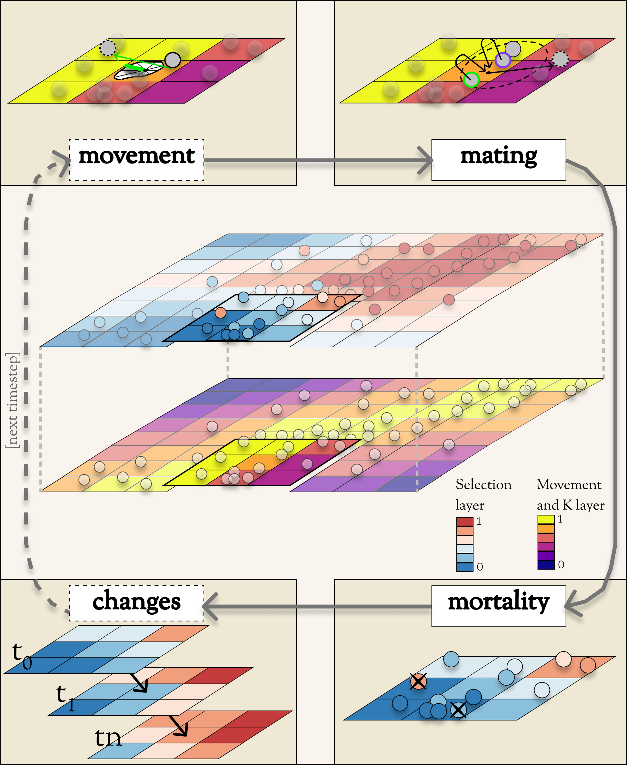
Figure 1: Geonomics conceptual flow diagram: In the center is a species distributed across a multi-layer landscape---in this case, composed of two layers. The upper layer serves as a selection layer for a trait, with both the environmental (i.e. cell) values and individuals' trait-phenotype (i.e. circle) values indicated by the blue-red colormap. The lower layer serves as both a movement layer (which would be the basis for a movement surface) and a carrying-capacity (K) layer. Arranged in series around the landscape is a clockwise flow-diagram of the major operations that occur during each time step. Each operation is depicted in its own labeled box (with dashed-line label-boxes indicating optional operations). Movement: An individual is displaced to a new location along a randomly drawn vector, composed of a random distance (drawn from a Wald distribution, which is not depicted) and a random direction (drawn from a circular distribution, which could be uniform, unimodal, or, in this case, a multimodal Von Mises mixture distribution determined by the relative permeability of the 8-cell neighborhood of the movement layer). Mating: An individual (outlined in purple) randomly chooses a mate (outlined in green) from among all potential mates (solid gray individuals) located within its mating radius (green dashed circle on the landscape). Both mates produce gametes, composing the genome of an offspring individual, which disperses from its parents' midpoint (black dot on the landscape) along a randomly drawn dispersal vector. (Dispersal vectors are drawn akin to, but independently of, movement vectors.) Mortality: Individuals' probabilities of death are a product of density-dependence (determined by the comparison between local density and local carrying capacity, following a spatialized logistic growth model) and selection (with fitness determined by the absolute difference between phenotypic values and environmental values for all pairs of trait and selection-layer). Death events are Bernoulli draws on these probabilities. Changes: Change events are composed of n stepwise changes, which occur at the ends of their scheduled time steps (here depicted as ‘t₁, t₂, …, t_{n}). These can include both environmental changes (i.e. substitutions of the rasters for certain layers, as depicted here) and demographic changes (not depicted).

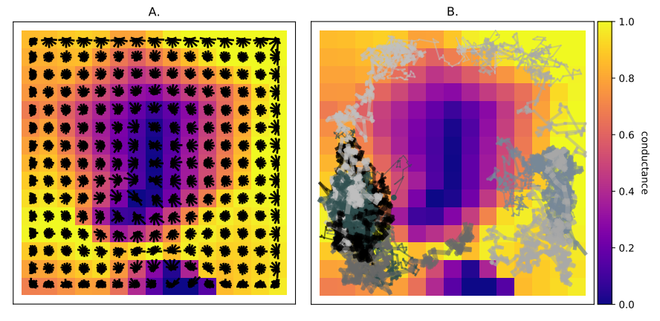
Figure 2: Movement surface structure (A) and function (B): A: Circularized histograms of the VonMises mixture-distribution approximations underlying a movement surface, plotted over a 15x15 landscape layer on which the surface is based. The taller the bar in a histogram (i.e. the further from the histogram’s center), the higher the probability that an individual located on that histogram’s cell would make a random draw that moves it in a direction within the angular neighborhood of that bar. (This plot was produed by the Geonomics method model.plot_movement_surface.) B: Examples of movement tracks for 25 individuals randomly selected from a species, moving across the movement surface depicted in A. Each track is 150 steps long, beginning at the individuals’ starting locations (plotted as dots) and thickening with each increasing time step. Individuals’ preferential movement toward higher-suitability regions of the landscape (values with environmental values nearer 1) is evident. Occasional migrations between relatively isolated portions of the landscape are also visible. (This plot was produced using the Geonomics function gnx.help.param_help.plot_movement.)
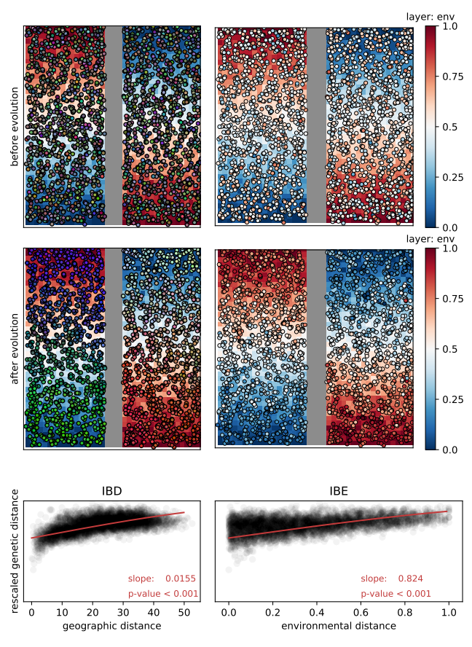
Figure 3: Isolation by distance (IBD) and isolation by environment (IBE): A species evolving on a landscape consisting of 1.) a barrier layer that serves as the species’ movement surface (displayed as a gray band down the landscape’s center), and 2.) an environmental layer that serves as the selective surface for a 10-locus trait (displayed as the red-to-blue cell values of the landscape). Top row: The population before evolution began, colored by genetic distance (right; genetic-distance colors are derived from individuals’ scores on the first three PCs of a genetic PCA, with each score scaled to 0 ≤ score ≤ 255, then used to assign RGB values) and by phenotype (right; the most-fit individuals would be those whose phenotypic colors perfectly match the cells over which they are located). Middle row: Same information as the top row, but plotted after 1000 time steps of evolution. Bottom row: Scatter plots of inter-individual pairwise genetic distance (Euclidean distance in genetic PC space, scaled to 0 ≤ distance ≤ 1) as a function of Euclidean geographic distance (left; IBD) and Euclidean environmental distance (right; IBE); slopes and p-values correspond to the red curves, which were fitted as binomial GLMs with a ClogLog link function (to allow a saturating functional form).

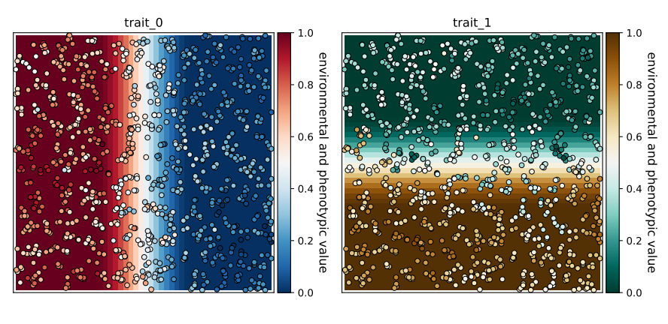
Figure 4: Simultaneous selection: Results of simultaneous selection on two traits with spatially distinct selective regimes. Each trait is controlled by 10 unlinked loci and has a selection coefficient of . Individuals are colored by phenotype, such that fitter individuals for a trait are those whose colors are more similar to the background color for the trait’s selection layer. (Plots were produced by the Geonomics method ‘model.plot_phenotype(…)’.)
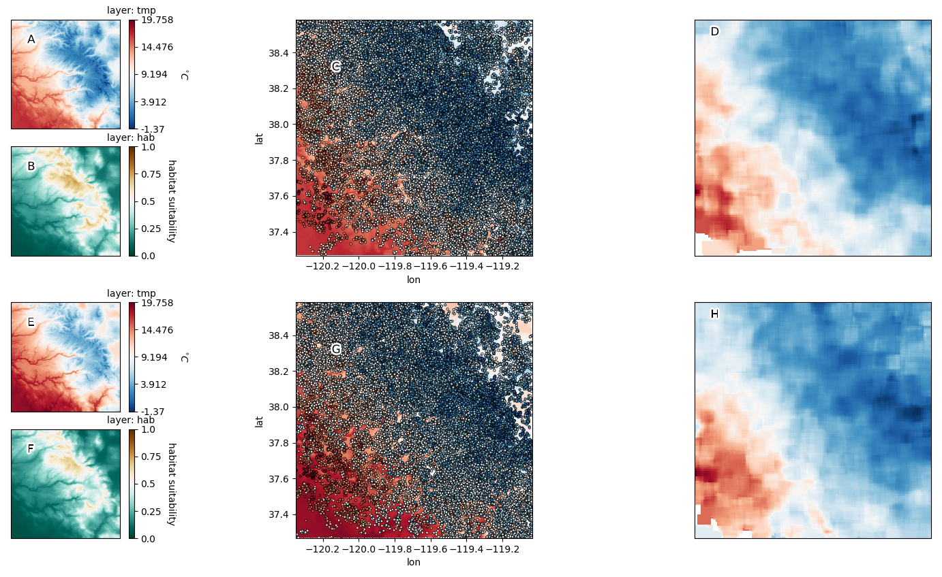
Figure 5: Polygenic adaptation to climate change in the Yosemite region: Shown are the temperature rasters before (A) and after (E) climate change; the habitat-suitability rasters before (B) and after (F); the locally adapted population plotted on top of the temperature raster both before (C) and after (G), and neighborhood-meaned rasters of the population’s phenotypes, both before (D) and after (H). (Plots in the left and middle columns were produced using the Geonomics methods model.plot and model.plot_phenotype respectively.)

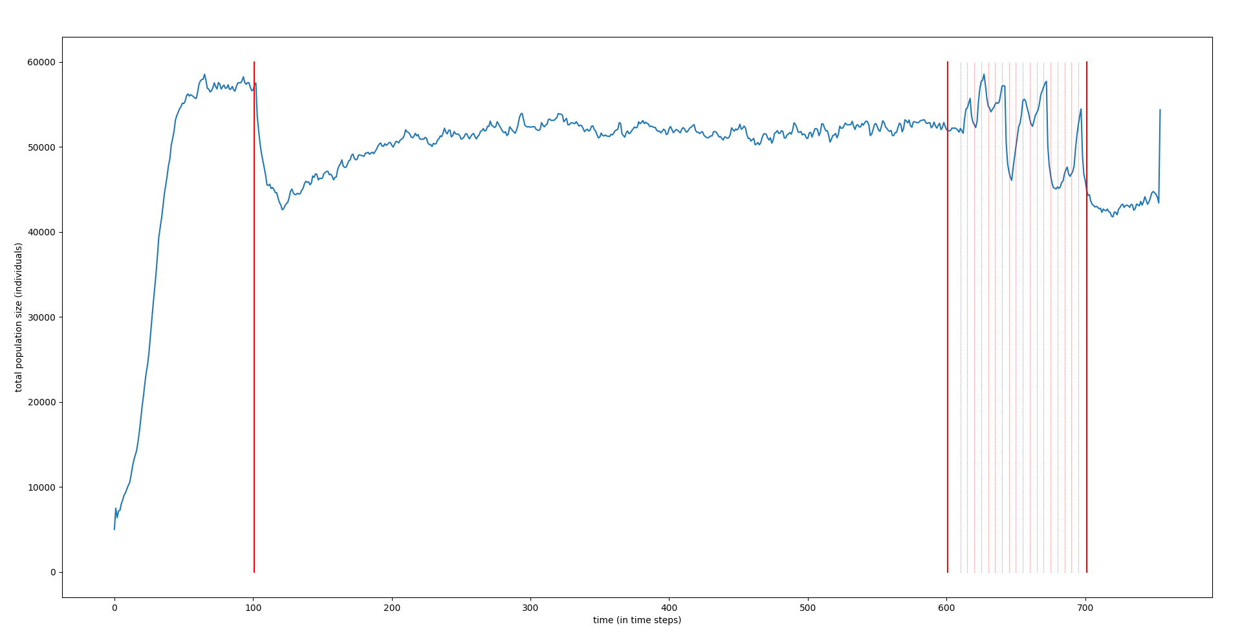
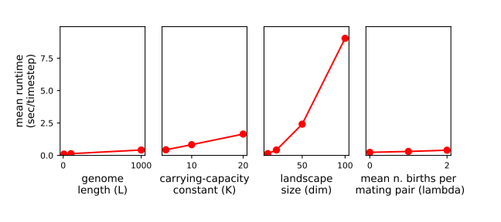
Figure 6: Average runtime per time step (in seconds), as a function of various parameters. Left to right: ‘genome length (L)’: The length of the simulated genome; ‘carrying-capacity constant (K)’: The factor by which a species’ carrying capacity raster is multiplied to determine its local carrying capacities and thus, in sum, its mean total population size; ‘landscape size (dim)’: The dimensions of the simulated landscape; ‘n_births_distr_lambda’: The parameter of the Poisson distribution from which the number of offspring in each mating event is drawn. Note that runtime increases with landscape dimension both because of functions whose runtimes scale with the landscape size directly and because of functions whose runtime scales with total population size. Thus, the difference between the lines for ‘K’ and ‘dim’ can be taken as an indication of the runtime cost of landscape dimension above and beyond population-size effects.

Code Samples
>>> gnx.make_parameters_file(filepath=‘yosemite_params.py’,
layers=[{‘type’: ‘file’, ‘change’: True},
{‘type’: ‘file’, ‘change’: True},
{‘type’: ‘file’, ‘change’: False}],
species=[{‘movement’: True,
‘movement_surface’: True,
‘genomes’: True, ‘n_traits’: 1}],
data=True)
Code Sample 1

>>> model = gnx.make_model(filepath=‘yosemite_params.py’)
>>> model.walk(100000, mode = ‘burn’)
>>> model.walk(500, mode = ‘main’)
Code Sample 2

Works Cited
Andrew RL, Ostevik KL, Ebert DP, Rieseberg LH. 2012. Adaptation with gene flow across the landscape in a dune sunflower. Mol. Ecol. 21:2078–2091.
Barbet‐Massin M, Jiguet F, Albert CH, Thuiller W. 2012. Selecting pseudo-absences for species distribution models: how, where and how many? Methods Ecol. Evol. 3:327–338.
Barrett RDH, Laurent S, Mallarino R, Pfeifer SP, Xu CCY, Foll M, Wakamatsu K, Duke-Cohan JS, Jensen JD, Hoekstra HE. 2019. Linking a mutation to survival in wild mice. Science 363:499–504.
Bay RA, Harrigan RJ, Underwood VL, Gibbs HL, Smith TB, Ruegg K. 2018. Genomic signals of selection predict climate-driven population declines in a migratory bird. Science 359:83–86.
Bradburd GS, Ralph PL. 2019. Spatial Population Genetics: It’s About Time. ArXiv190409847 Q-Bio [Internet]. Available from: http://arxiv.org/abs/1904.09847
Crossley MS, Chen YH, Groves RL, Schoville SD. 2017. Landscape genomics of Colorado potato beetle provides evidence of polygenic adaptation to insecticides. Mol. Ecol. 26:6284–6300.
Daly C, Halbleib M, Smith JI, Gibson WP, Doggett MK, Taylor GH, Curtis J, Pasteris PP. 2008. Physiographically sensitive mapping of climatological temperature and precipitation across the conterminous United States. Int. J. Climatol. 28:2031–2064.
Fisher RA. 1923. XXI.—On the Dominance Ratio. Proc. R. Soc. Edinb. 42:321–341.
Fournier-Level A, Korte A, Cooper MD, Nordborg M, Schmitt J, Wilczek AM. 2011. A Map of Local Adaptation in Arabidopsis thaliana. Science 334:86–89.
Franks SJ, Hoffmann AA. 2012. Genetics of Climate Change Adaptation. Annu. Rev. Genet. 46:185–208.
Guillaume F, Rougemont J. 2006. Nemo: an evolutionary and population genetics programming framework. Bioinformatics 22:2556–2557.
Haller BC, Messer PW. 2017. SLiM 2: Flexible, Interactive Forward Genetic Simulations. Mol. Biol. Evol. 34:230–240.
Haller BC, Messer PW. 2019. SLiM 3: Forward Genetic Simulations Beyond the Wright–Fisher Model.Hernandez R, editor. Mol. Biol. Evol. 36:632–637.
Harris SE, Munshi-South J. 2017. Signatures of positive selection and local adaptation to urbanization in white-footed mice ( Peromyscus leucopus ). Mol. Ecol. 26:6336–6350.
Hoban S, Bertorelle G, Gaggiotti OE. 2012. Computer simulations: tools for population and evolutionary genetics. Nat. Rev. Genet. 13:110–122.
Hoffmann AA, Sgrò CM. 2011. Climate change and evolutionary adaptation. Nature 470:479–485.
Landguth EL, Bearlin A, Day CC, Dunham J. 2017. CDMetaPOP: an individual-based, eco-evolutionary model for spatially explicit simulation of landscape demogenetics.Travis J, editor. Methods Ecol. Evol. 8:4–11.
Landguth EL, Cushman SA. 2010. cdpop: A spatially explicit cost distance population genetics program: COMPUTER PROGRAM NOTE. Mol. Ecol. Resour. 10:156–161.
Landguth EL, Cushman SA, Johnson NA. 2012. Simulating natural selection in landscape genetics. Mol. Ecol. Resour. 12:363–368.
Lasky JR, Des Marais DL, McKAY JK, Richards JH, Juenger TE, Keitt TH. 2012. Characterizing genomic variation of Arabidopsis thaliana : the roles of geography and climate. Mol. Ecol. 21:5512–5529.
Lind BM, Friedline CJ, Wegrzyn JL, Maloney PE, Vogler DR, Neale DB, Eckert AJ. 2017. Water availability drives signatures of local adaptation in whitebark pine ( Pinus albicaulis Engelm.) across fine spatial scales of the Lake Tahoe Basin, USA. Mol. Ecol. 26:3168–3185.
Manel S, Gugerli F, Thuiller W, Alvarez N, Legendre P, Holderegger R, Gielly L, Taberlet P, IntraBioDiv Consortium. 2012. Broad-scale adaptive genetic variation in alpine plants is driven by temperature and precipitation. Mol. Ecol. 21:3729–3738.
Mastretta-Yanes A, Xue AT, Moreno-Letelier A, Jorgensen TH, Alvarez N, Piñero D, Emerson BC. 2018. Long-term in situ persistence of biodiversity in tropical sky islands revealed by landscape genomics. Mol. Ecol. 27:432–448.
McRae BH. 2006. Isolation by Resistance. Evolution 60:1551–1561.
McRae BH, Dickson BG, Keitt TH, Shah VB. 2008. Using circuit theory to model connectivity in ecology, evolution, and conservation. Ecology 89:2712–2724.
Messer PW. 2013. SLiM: Simulating Evolution with Selection and Linkage. Genetics 194:1037–1039.
Milanesi P, Holderegger R, Caniglia R, Fabbri E, Galaverni M, Randi E. 2017. Expert-based versus habitat-suitability models to develop resistance surfaces in landscape genetics. Oecologia 183:67–79.
Mountain Research Initiative EDW Working Group. 2015. Elevation-dependent warming in mountain regions of the world. Nat. Clim. Change 5:424–430.
Neuenschwander S, Hospital F, Guillaume F, Goudet J. 2008. quantiNemo: an individual-based program to simulate quantitative traits with explicit genetic architecture in a dynamic metapopulation. Bioinformatics 24:1552–1553.
Oyler JW, Dobrowski SZ, Ballantyne AP, Klene AE, Running SW. 2015. Artificial amplification of warming trends across the mountains of the western United States. Geophys. Res. Lett. 42:153–161.
Pelletier F. 2019. Testing evolutionary predictions in wild mice. Science 363:452–453.
Peng B, Kimmel M. 2005. simuPOP: a forward-time population genetics simulation environment. Bioinformatics 21:3686–3687.
Pierce DW, Cayan DR, Thrasher BL. 2014. Statistical Downscaling Using Localized Constructed Analogs (LOCA)*. J. Hydrometeorol. 15:2558–2585.
Porter A. 2013. ClineFit v. 2.0, User’s Manual. Available from: http://people.umass.edu/aporter/ClineFit/ClineFit%20Manual.pdf
Python Software Foundation. 2019. Python Language Reference, version 3.7. Available at http://www.python.org.
Rangwala I, Sinsky E, Miller JR. 2013. Amplified warming projections for high altitude regions of the northern hemisphere mid-latitudes from CMIP5 models. Environ. Res. Lett. 8:024040.
Rebaudo F, Le Rouzic A, Dupas S, Silvain J-F, Harry M, Dangles O. 2013. SimAdapt: an individual-based genetic model for simulating landscape management impacts on populations.Spencer M, editor. Methods Ecol. Evol. 4:595–600.
Ruiz-Gonzalez A, Cushman SA, Madeira MJ, Randi E, Gómez-Moliner BJ. 2015. Isolation by distance, resistance and/or clusters? Lessons learned from a forest-dwelling carnivore inhabiting a heterogeneous landscape. Mol. Ecol. 24:5110–5129.
Spear SF, Balkenhol N, Fortin M-J, Mcrae BH, Scribner K. 2010. Use of resistance surfaces for landscape genetic studies: considerations for parameterization and analysis. Mol. Ecol. 19:3576–3591.
van Rossum, G. 1995. Python tutorial, Technical Report CS-R9526, Centrum voor Wiskunde en Informatica (CWI). Amsterdam, the Netherlands.
Wang IJ, Bradburd GS. 2014. Isolation by environment. Mol. Ecol. 23:5649–5662.
Wright S. 1943. Isolation by Distance. Genetics 28:114–138.
Wright, Sewall. 1930. Evolution in Mendelian populations. Genetics 16:97–159.
Zeller KA, Creech TG, Millette KL, Crowhurst RS, Long RA, Wagner HH, Balkenhol N, Landguth EL. 2016. Using simulations to evaluate Mantel-based methods for assessing landscape resistance to gene flow. Ecol. Evol. 6:4115–4128.
Zeller KA, McGarigal K, Whiteley AR. 2012. Estimating landscape resistance to movement: a review. Landsc. Ecol. 27:777–797.

