# Supplemental Materials:

# Geonomics: A Python package for building agent-based, spatially explicit, and arbitrarily complex landscape-genomic simulations

Drew Hart, Ian Wang

**TODO**

* **review all content here, rewrite as needed**
* **figure out how to number equations in Word**
* **fix validations-test plots that need fixing, rerun validations tests, update plots to use new plotting scheme**

## Validations tests

In this section, we briefly review the reasoning and parameterization for each test, then present the results. (We discuss only parameters of key importance to each scenario. Other parameters are set to reasonable values, or left at defaults. For full details, see the parameters file for a given test.)

All results are as expected, demonstrating a robust ability to reproduce population-genetic and population-genomic findings. Some results show minor deviations from theory. These artefacts are primarily a resulting of using a simulation framework designed for complex, spatially explicit models to approximate much simpler and, in some cases, aspatial or spatially implicit models. They artefacts are discussed where applicable. (The code for all tests is available in the ‘./tests/validation’ directory of the package.)

## Wright-Fisher test: genetic drift

The Wright-Fisher model of genetic drift models a fixed-size haploid population that turns over completely at each timestep (i.e. generation). The population can have any number of independent, biallelic genetic loci. For each locus, each generation’s allele frequency is chosen as a binomial random variable, with the number of trials equal to the population size and the probability of success (i.e. of drawing the ‘1’ allele) equal to the previous generation’s ‘1’-allele frequency. The mean persistence time for an allele (i.e. the expected number of generations for which a locus remains segregating) is:

where is the number of alleles in the population (such that can represent the diploid population size) and is the frequency of either allele at the locus (Fisher, 1923; Hartl and Clark, 2007; Wright, Sewall, 1930).

Clearly, the Wright-Fisher model is much simpler than the sorts of models for which Geonomics is designed (as are all of the following validations tests)—it is aspatial, panmictic, features fixed population sizes, models only neutral loci, and so forth. Thus, we parameterized Geonomics so as to approximate the model as closely as possible. To emulate aspatiality and panmixia, we used a population on a homogeneous landscape, with isotropic movement, and with movement and dispersal distributions and a mating radius that broadly encompass the diagonal width of the landscape. To enforce complete generational turnover, we set the maximum-age parameter to 1 (i.e. 1 timestep). While Geonomics does not maintain constant population size, we maintained the carrying-capacity raster at a constant, uniform value, thus maintaining a stationary mean population size. We simulated 100, independent neutral loci (by setting all interlocus recombination rates to 0.5), with starting ’1’-allele frequencies of 0.5 (although the actual starting frequencies vary slightly around this value because of sampling error when all individuals’ genotypes are drawn binomially).

We ran the Wright-Fisher approximation test for three values of the carrying-capacity raster (i.e. three values of ‘K_factor’), hence for three mean population sizes. For each mean population size (calculated as the harmonic mean, to account for stochastic fluctations around the carrying capacity), we compared mean persistence time to that expected by theory, according to equation [eqxn:wf_mean_persist_t] in the previous paragraph. As can be seen in Figures S1 and S2, the results are a close match to theory.

## Bottleneck test: population dynamics

Because drift is a stronger evolutionary force in smaller populations, drift accelerates in shrinking populations. If a population undergoes a bottleneck event, the overall effect of drift on the population during that time is expected to be larger than a constant-size population of equivalent starting size would experience during that time. Thus, mean fixation time should decrease in a bottlenecked population relative to a constant-size comparison population.

As with the Wright-Fisher model, we used a homogeneous landscape with broad distributions for movement and dispersal and with a mating radius that encompasses the full landscape to emulate aspatiality and panmixia. To simulate a bottleneck event, we created a custom change event in which the population’s carrying-capacity raster is reduced to 30% of its initial value for 50 timesteps (from the 200th to 250th), then returned to its initial value for the remainder of the simulation (through the 2500th timestep).

Figure S3 shows a clear signal of drift acceleration during the bottleneck event.

## Stepping-stone test: population subdivision and genetic differentiation

The stepping-stone model, or one-dimensional island model, is a spatially implicit model. It models a series of subpopulations, arranged along a straight line, with migration between all neighboring pairs. As a combined result of divergence by drift and homogenization by effective migration, subpopulations are expected to reach a stationary level of genetic differentiation—migration-drift equilibrium. Theory provides the expected pairwise genetic differentiation between a pair of subpopulations at equilibrium as:

where is the population size and is the per-generation migration rate, such that can be interpreted as the per-generation number of migrant individuals (Hartl and Clark, 2007).

To approximate the stepping-stone model, we created a Landscape Layer with a diagonal of six equally spaced islands (1.0-valued cells) embedded in a ‘sea’ of 0.0-valued cells. We used this layer as the carrying-capacity raster (Figure S4, left). We set the mating radius to encompass an individual’s current island, but no neighboring islands. We parameterized dispersal to be very local to parents’ midpoints, and parameterized movement distance to be strongly right-skewed, such that the long-distance movement events leading to migration are uncommon. We ran the simulation for 5000 timesteps.

Because Geonomics does not model discrete populations, it does not stipulate migration rates between discrete locations on the Landscape. Thus we manually tracked the number of migration events during each timestep, for all possible directional migration events (i.e. for all permutations of island pairs), then used that data to calculate all mean migration rates. With those values, we solved equation [eqxn:F_ST_as_fn_of_mig], then compared the resulting expectations to the observed values (calculated from the simulated data using two common methods; see Figure S4, right, for details).

All island populations were at dynamic equilibria around the same mean size, and results demonstrate that the model approached migration-drift equilibrium, as expected by theory (Figure S5). Estimated migration rates and values qualitatively match theoretical expectations: mean migration rate drops off precipitously at greater than one island’s distance apart, and genetic differentiation increases to approximate saturation. Values of consistently undershoot the values expected based on estimated migration rates, however, because subpopulations have yet to approach fixation at most loci (which is the expectation implied by expected values close to 1).

## Contrasting-habitat test: adaptive divergence

In a population divided between two opposite selective environments, if there is standing genetic variation for a biallelic locus controlling the trait responding to those environments, then theory predicts that the two subpopulations will diverge at that locus as each moves toward its respective adaptive peak. The rate at which divergence should occur depends on the relative strengths of two opposing evolutionary forces: natural selection, which causes divergence, and gene flow from migration, which causes homogenization. The rate of allele frequency change in either subpopulation at timestep t is expressed as:

where and are the frequencies of the deleterious and beneficial alleles in the subpopulation, is the selection coefficient against the homozygous recessive phenotype, is the degree of dominance of the recessive allele, and are the migration rates into and out of the subpopulation being analyzed, and is the frequency of the recessive allele in the alternative subpopulation (Hartl and Clark, 2007).

This model, much like the stepping-stone model, is spatially implicit. To approximate this, we created a landscape with two layers. The first was divided into two equal-sized halves, one valued at 0.0, the other at 1.0; this layer was used as the layer driving natural selection. The second was valued uniformly at 1.0; this was used as the carrying-capacity raster (thus setting uniform population density across the Landscape and determining, in sum, the overall carrying capacity of the landscape). We created one monogenic trait whose position was randomly chosen within a genomic architecture of 100 independent (i.e. unlinked) loci. We ran the model for 1000 timesteps for each of three values of the parameter phi (identical to *s* in equation [eqxn:rate_allele_freq_change]): 0.1, 0.05, and 0.01. Given that Geonomics does not employ express migration rates, we tracked the number of migration events (betwen the two contrasting halves of the first layer) during each timestep, then used that data to solve equation [eqxn:rate_allele_freq_change].

Results depict clear local adaptation to each of the two halves of the landscape, with opposite-phenotype bleedover and heterozygote births occuring along the border between the two habitats (Figure S6). Allele trajectories in each half of the environment follow qualitatively the increasing and saturating trajectories expected by theory, but reach consistently more extreme allele frequencies than expected (Figure S7).

## Cline test: local adaptation

In a clinal model, a population adapts locally across an environmental gradient, which is characterized by the extremes of its environmental values and its steepness (i.e. the instantaneous rate of environmental change along it). Local adaptation across this gradient will generate a cline, i.e. a geographic gradient in allele frequency (though natural selection is not the only way a cline could be produced). The clinal pattern is only expected for loci that underlie the trait underoing selection along the cline (and loci in linkage). Unlinked loci have no long-term clinal expectation (though they could initially be swept along with the selective locus adaptation, and any number could continue to show spurious concordant clinal variation). To detect clinally adapted loci, we can fit cline curves to the allele-frequency variation across the environmental gradient for all loci, with the expectation that the clines fit to adaptive loci will mirror the gradient. Numerous equations have been used to fit clines, but one of the most common is the sigmoidal *tanh* function:

where is the frequency of the reference allele at position along the cline, is the centerpoint of the cline (such that ), and is the ‘width’, which is defined as at centerpoint (Porter, 2013).

To implement the cline model in Geonomics, we created a landscape with two layers. The first layer was an environmental layer—a symmetrical, non-linear gradient between 0-valued and 1-valued halves (see raster in both halves of Figure S8). The second was a uniformly valued habitat-quality layer, used to set a uniform population density and thus determine the global carrying capacity. We created a monogenic trait whose locus was randomly placed within a genomic architecture of 100 independent loci. The trait had a *phi* (i.e. *s*) of 0.01, with the gradient layer serving as its selective force.

We ran the cline model for 2500 timesteps, then used a numerical optimization function (in Python’s scipy package; (Jones *et al.*, 2001)) to fit equation [eqxn:cline] for all loci. We plotted all fitted clines on top of the first landscape layer, with the cline for the one selective locus highlighted. The selective locus consistently and clearly stands out as the only locus with a cline matching the expectation (i.e. mirroring the environmental gradient; Figure S8), and results show an obviously locally adapted population, with a zone of hybridization and phenotypic spillover surrounding the cline’s center (Figure S9). Furthermore, for a family of regression models of environmental value on genotype for all loci, after Bonferroni correction for multiple testing, the selective locus is consistently significant and the most significant (though other loci produce false-positive results, albeit with considerably larger p-values). INCLUDE AND SHOW THESE REGRESSION RESULTS?

## Selective sweep test: genetic hitchhiking

Genomic context and linkage add important complication to models of molecular evolution. The most basic model of selection with linkage is that of the selective sweep: a beneficial mutation occurs in a population, falling on a random genomic background, then rises in frequency because of its selective advantage until it becomes fixed, pulling up the frequency of the surrounding haplotype block in the process. But as the haplotype block increases in frequency it is nevertheless subject to recombination, which gradually erodes it symmetrically around the beneficial mutaiton. Thus the selective-sweep model predicts that once a beneficial mutation occurs —as long as it is not lost early on by chance— it and the haplotype block around it will rise in frequency, the mutation will eventually fix, potentially with some core block around it, but the rest of the block will erode fade over time. The haplotype block should be clearly visible in genomic data, where it will manifest as a genomic region of reduced diversity and heterozygosity, centered on the mutation.

To implement the selective sweep model in Geonomics, we again created a model approximating an aspatial, panmicitic population (see Wright-Fisher test for details). We created a single, monogenic trait with a *phi* (i.e. *s*) of 0.15. The trait’s locus was manually set to position 50, such that it was at the center of the the 101-locus genomic architecture. We manually set the starting ’1’-allele frequency at this locus to 0.0, but set the trait to selected upon by the landscape’s first and only layer (a uniformly 1-valued raster), such that all individuals began the model equally ill-fit (i.e. with a fitness value of ). After burning the model in, we iteratively chose a random individual, introduced a ’1’-mutation in their genome at locus 50, ran the model for 50 timesteps, and checked whether the ’1’ allele had reached a frequency greater than 0.05 by that time. We iterated until that check was passed, at which point we declared the mutant allele ‘established’ and continued to run the model until 2500 timesteps after the mutant reached fixation. At three timepoints during that model we calculated and recorded genome-wide nucleotide diversity using a sliding-window approach.

Geonomics realistically emulated the behavior of a selective sweep. The adaptive phenotype (the ’1’|’1’ genotype, plotted as white on a white environmental background; in Figure S10, top row) clearly emerged in a region surrounding the mutation’s origin, then spread rapidly throughout the population. The population’s mean fitness increased quickly from 0.85 (the universal fitness value before the mutation was introduced) to 1.00 (the universal fitness value after the sweep was complete; Figure S11). The linkage block around the sweeping locus was clearly visible as a region of depressed nucleotide diversity, which became more pronounced as the sweep went to completion, then slowly eroded as a result of recombination of the mutant haplotype’s alleles onto non-mutant backgrounds (Figure S10, bottom row).

# Figures and Captions

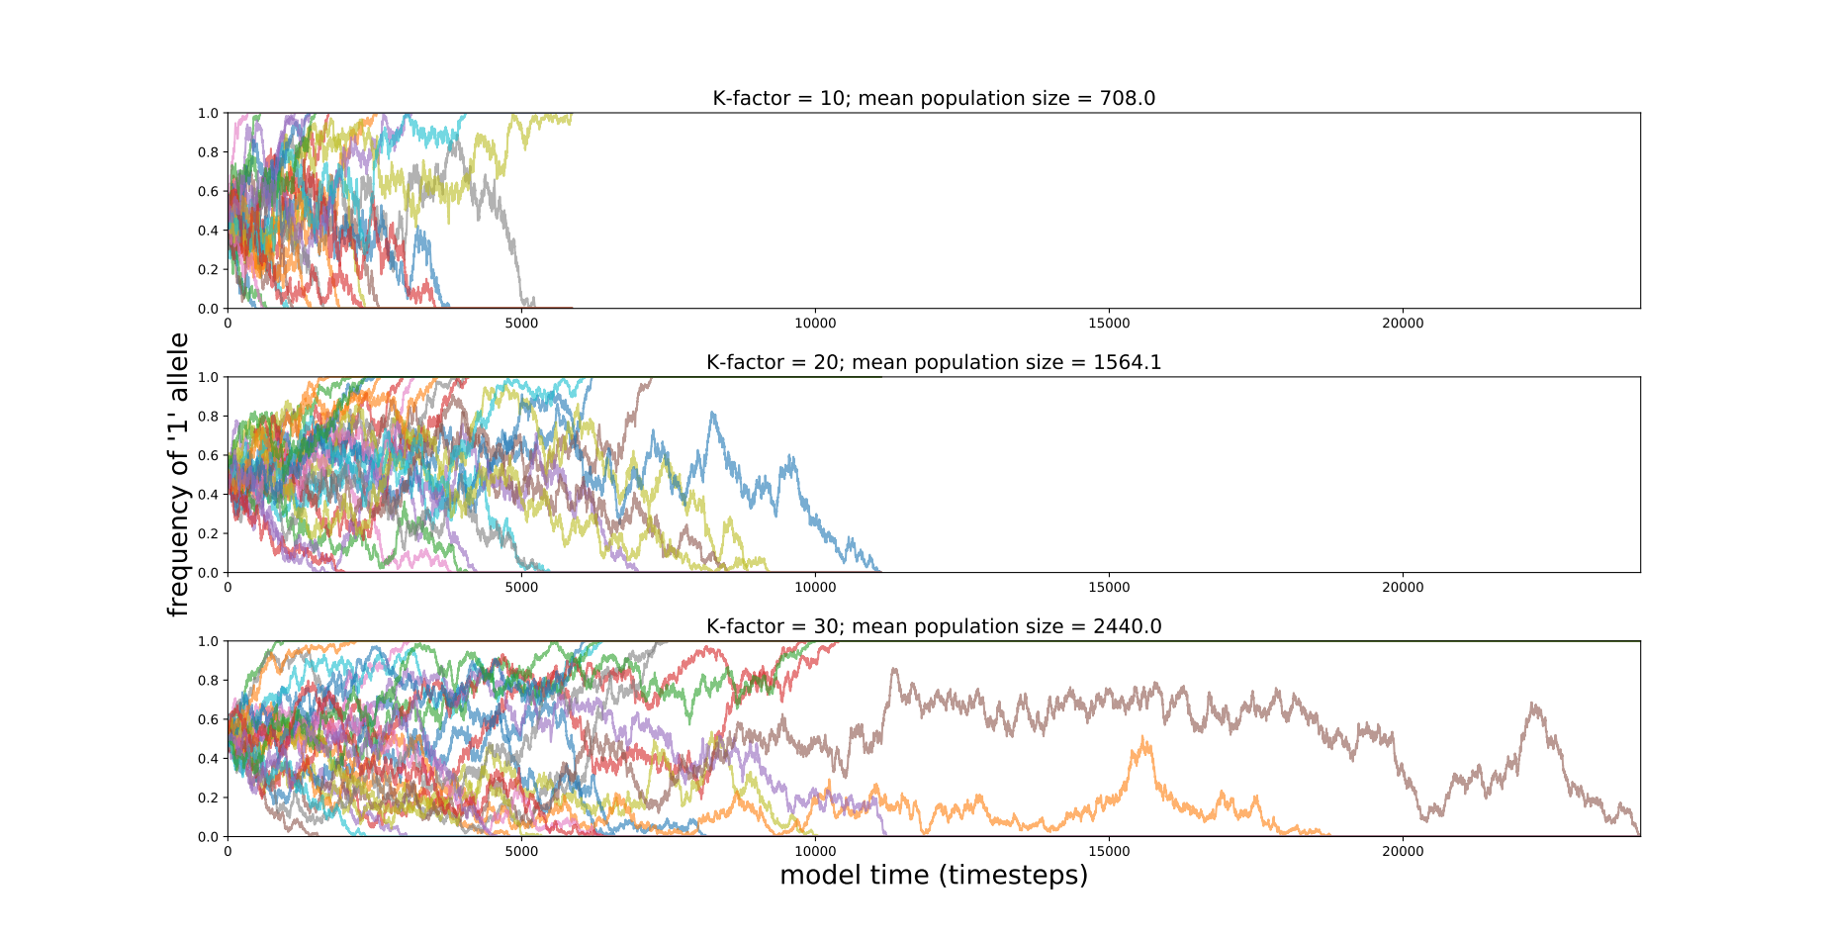

Figure S1: Wright-Fisher test: Trajectories for the frequencies of the ‘1’-alleles at each of 25 loci (one line per locus) in a Wright-Fisher model without mutation. Models were run for each of three mean population sizes (as determined by each of three fixed values for the ‘K_factor’ parameter, the factor by which the 0-1 carrying-capacity raster is multiplied in order to define local carrying capacities and thus total population size). Models were run until all loci fixed.

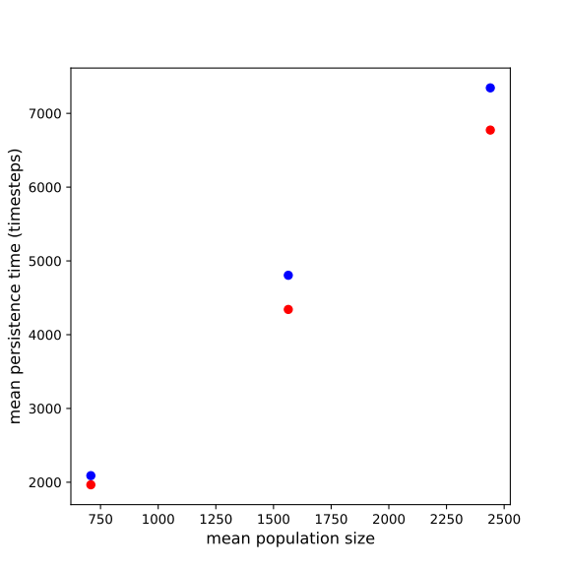

Figure S2: Wright-Fisher test: Mean persistence time across all loci as a function of harmonic mean population size, compared between predictions based on Equation [eqxn:wf_mean_persist_t] (red dots) and observed values (blue).

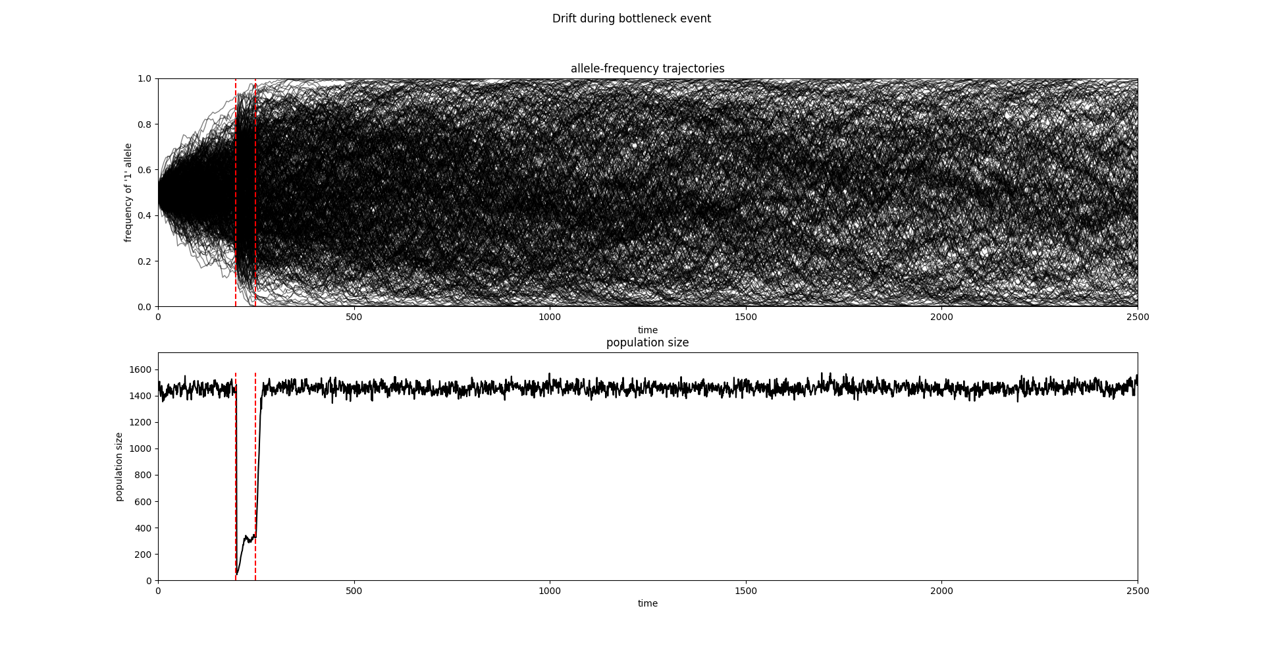

Figure S3: Bottleneck test: 1-allele frequencies (top) and population size (bottom) as a function of time, for a model 2500 timesteps long with a 50-timestep bottleneck

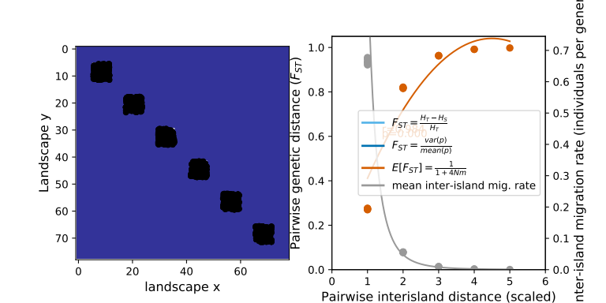

Figure S4: Stepping-stone test: Left: Map of all 6 islands’ populations at the end of the simulation; Right: Pairwise (left y-axis; calculated by 3 different formulae, indicated in legend) and inter-island migration rate (right y-axis) as a function of inter-island distance; values and p-values result from quadratic regressions of values on inter-island distance and log-log regression of mean migration rate on inter-island distance. (Left plot was produced by the Geonomics method model.plot.)

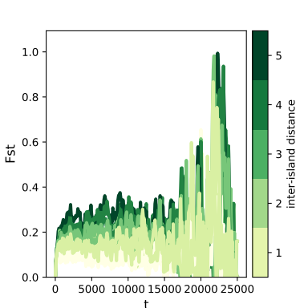

*Figure S5: Stepping-stone test: over model time, plotted across increasing inter-island distances (from yellow to green)*

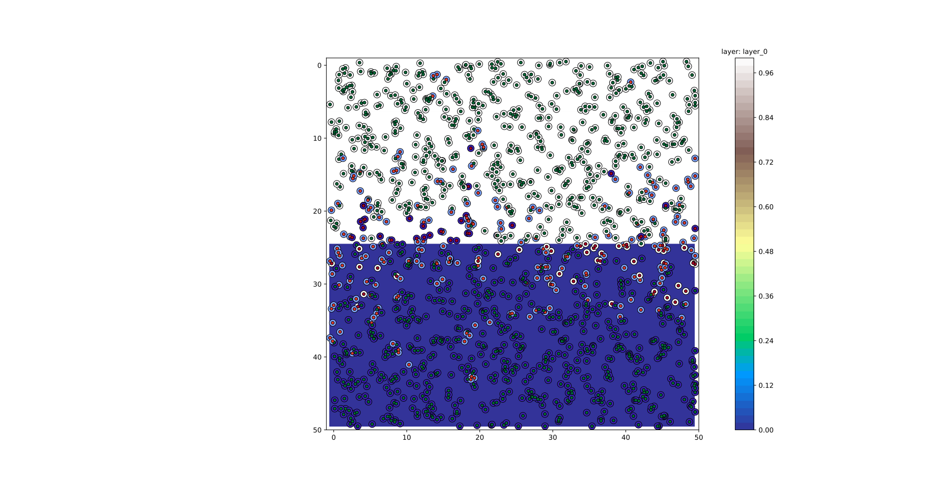

Figure S6: Divergence test: Map of the population after spatially divergent selection at = 0.10. Individuals are plotted on top of the selective landscape layer (vertically divided into white and blue halves). They are colored by phenotype (outer circles; color ranges between dark blue and dark red, representing the optimal phenotypes on their color-matched environmental backgrounds) and by fitness (inner circles; increasing dark gray to white). (Plot was produced by the Geonomics method model.plot_fitness.)

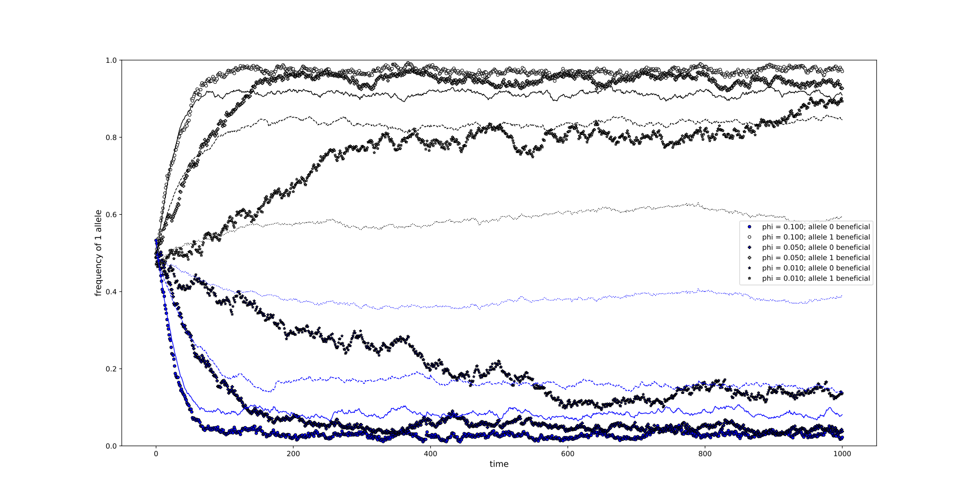Figure S7: Divergence test: Observed (markers) versus predicted (lines) allele-frequency trajectories for two contrasting habitats (blue = 0.0-valued; white = 1.0-valued), across models with three selection coefficients ( = 0.01: stars; 0.05: crosses; 0.10: circles).

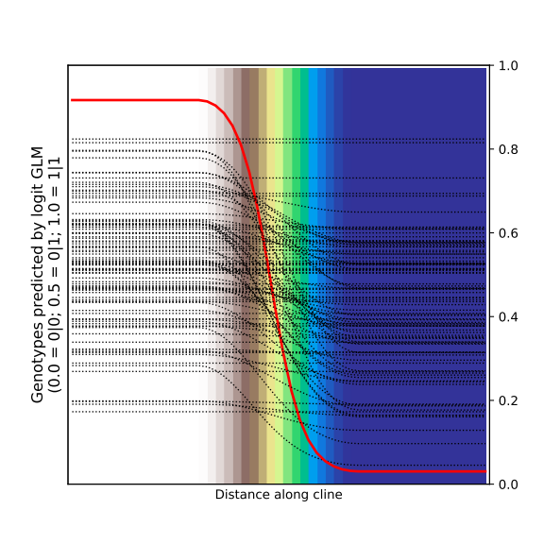

Figure S8: Cline test: Plot of allele-frequency clines (neutral loci in black, selective locus in bold red) against the selective landscape layer (horizontal gradient from blue to white)

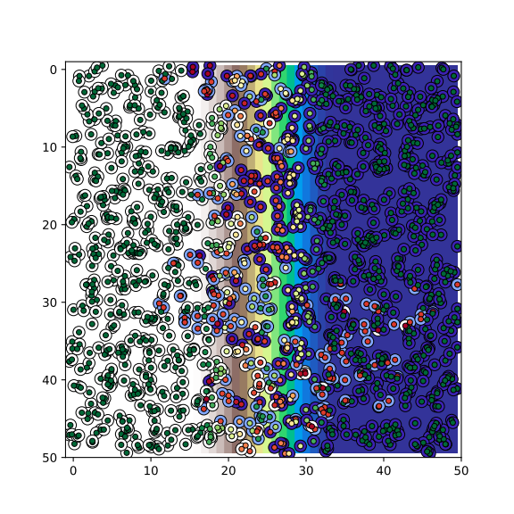

Figure S9: Cline test: Map of the final population on top of the selective landscape layer, with individuals colored by phenotype (outer circles) and fitness (inner circles), as in Figure S7. (Plot was produced by the Geonomics method model.plot_fitness.)

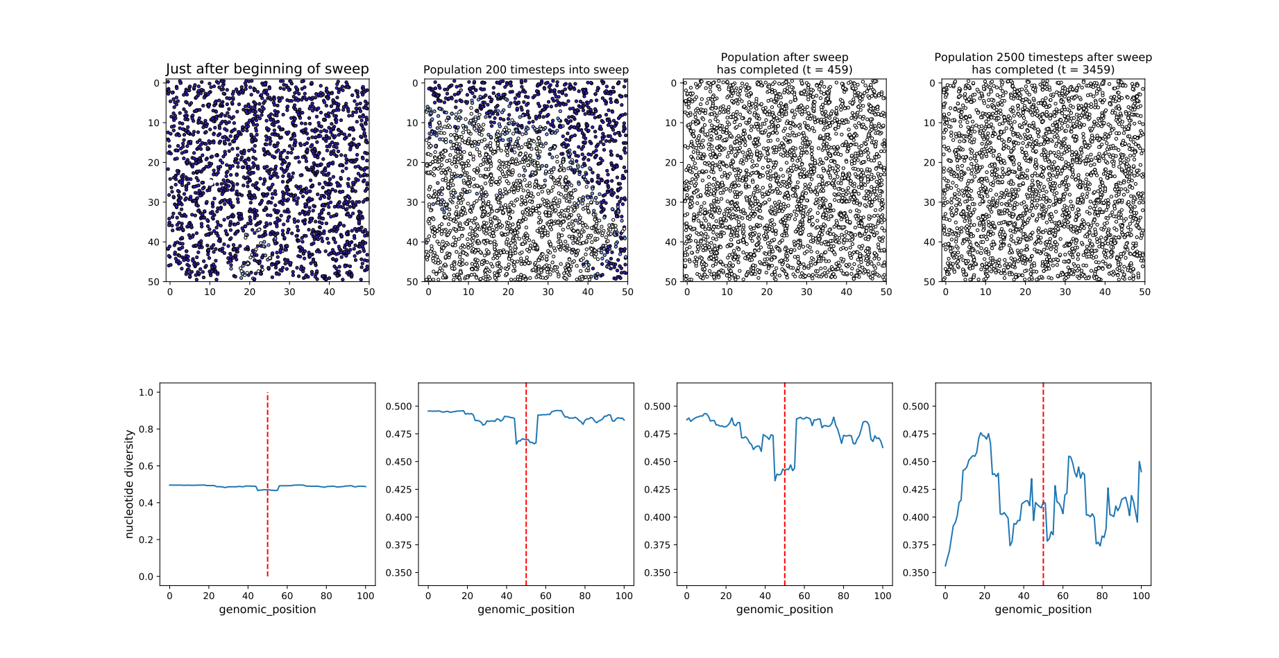

Figure S10: Selective sweep test: Maps of population (top row; colored by phenotype, as in Figure S7) and genome-wide nucleotide diversity (bottom row; calculated in 11-locus windows) at various points in time during the model run (from left to right: timestep 0, timestep 200, just after completion of the sweep, and 2500 timesteps after completion of the sweep). (Top-row plots were produced by the Geonomics method model.plot_phenotype.)

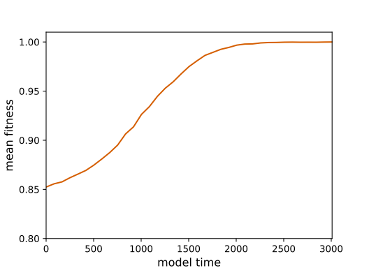

Figure S11: Selective sweep test: Mean fitness of the entire population, over the full run of the model depicted in Figure 10.

# **Works Cited**

Fisher, R.A. (1923). XXI.—On the Dominance Ratio. Proc. R. Soc. Edinb. *42*, 321–341.

Hartl, D.L., and Clark, A.G. (2007). Principles of Population Genetics: Fourth Edition (Sunderland, Massachusetts: Sinauer Associates, Inc. Publishers).

Jones E, Oliphant E, Peterson P, et al. (2001). SciPy: Open Source Scientific Tools for Python, <http://www.scipy.org/>.

Porter, A. (2013). ClineFit v. 2.0, User’s Manual.

Wright, Sewall (1930). Evolution in Mendelian populations. Genetics *16*, 97–159.

Barbet‐Massin, Morgane, Frédéric Jiguet, Cécile Hélène Albert, and Wilfried Thuiller. 2012. “Selecting Pseudo-Absences for Species Distribution Models: How, Where and How Many?” *Methods in Ecology and Evolution* 3 (2): 327–38. <https://doi.org/10.1111/j.2041-210X.2011.00172.x>.

Barrett, Rowan D. H., Stefan Laurent, Ricardo Mallarino, Susanne P. Pfeifer, Charles C. Y. Xu, Matthieu Foll, Kazumasa Wakamatsu, Jonathan S. Duke-Cohan, Jeffrey D. Jensen, and Hopi E. Hoekstra. 2019. “Linking a Mutation to Survival in Wild Mice.” *Science* 363 (6426): 499–504. <https://doi.org/10.1126/science.aav3824>.

Bay, Rachael A., Ryan J. Harrigan, Vinh Le Underwood, H. Lisle Gibbs, Thomas B. Smith, and Kristen Ruegg. 2018. “Genomic Signals of Selection Predict Climate-Driven Population Declines in a Migratory Bird.” *Science* 359 (6371): 83–86. <https://doi.org/10.1126/science.aan4380>.

Crossley, Michael S., Yolanda H. Chen, Russell L. Groves, and Sean D. Schoville. 2017. “Landscape Genomics of Colorado Potato Beetle Provides Evidence of Polygenic Adaptation to Insecticides.” *Molecular Ecology* 26 (22): 6284–6300. <https://doi.org/10.1111/mec.14339>.

Daly, Christopher, Michael Halbleib, Joseph I. Smith, Wayne P. Gibson, Matthew K. Doggett, George H. Taylor, Jan Curtis, and Phillip P. Pasteris. 2008. “Physiographically Sensitive Mapping of Climatological Temperature and Precipitation Across the Conterminous United States.” *International Journal of Climatology* 28 (15): 2031–64. <https://doi.org/10.1002/joc.1688>.

Fisher, R. A. 1923. “XXI.—On the Dominance Ratio.” *Proceedings of the Royal Society of Edinburgh* 42: 321–41. <https://doi.org/10.1017/S0370164600023993>.

Guillaume, F., and J. Rougemont. 2006. “Nemo: An Evolutionary and Population Genetics Programming Framework.” *Bioinformatics* 22 (20): 2556–7. <https://doi.org/10.1093/bioinformatics/btl415>.

Haller, Benjamin C., and Philipp W. Messer. 2017. “SLiM 2: Flexible, Interactive Forward Genetic Simulations.” *Molecular Biology and Evolution* 34 (1): 230–40. <https://doi.org/10.1093/molbev/msw211>.

Haller, Benjamin C, and Philipp W Messer. n.d. “SLiM: An Evolutionary Simulation Framework,” 517.

Harris, Stephen E., and Jason Munshi-South. 2017. “Signatures of Positive Selection and Local Adaptation to Urbanization in White-Footed Mice ( *Peromyscus Leucopus* ).” *Molecular Ecology* 26 (22): 6336–50. <https://doi.org/10.1111/mec.14369>.

Hartl, Daniel L., and Andrew G. Clark. 2007. *Principles of Population Genetics: Fourth Edition*. Fourth. Sunderland, Massachusetts: Sinauer Associates, Inc. Publishers.

Institute, National Cancer. n.d. “Genetic Simulation Resources Home.” Accessed February 23, 2019. <https://popmodels.cancercontrol.cancer.gov/gsr/>.

Landguth, Erin L., Andrew Bearlin, Casey C. Day, and Jason Dunham. 2017. “CDMetaPOP: An Individual-Based, Eco-Evolutionary Model for Spatially Explicit Simulation of Landscape Demogenetics.” Edited by Justin Travis. *Methods in Ecology and Evolution* 8 (1): 4–11. <https://doi.org/10.1111/2041-210X.12608>.

Landguth, Erin L., and S. A. Cushman. 2010. “Cdpop: A Spatially Explicit Cost Distance Population Genetics Program: COMPUTER PROGRAM NOTE.” *Molecular Ecology Resources* 10 (1): 156–61. <https://doi.org/10.1111/j.1755-0998.2009.02719.x>.

Lind, Brandon M., Christopher J. Friedline, Jill L. Wegrzyn, Patricia E. Maloney, Detlev R. Vogler, David B. Neale, and Andrew J. Eckert. 2017. “Water Availability Drives Signatures of Local Adaptation in Whitebark Pine ( *Pinus Albicaulis* Engelm.) Across Fine Spatial Scales of the Lake Tahoe Basin, USA.” *Molecular Ecology* 26 (12): 3168–85. <https://doi.org/10.1111/mec.14106>.

Mastretta-Yanes, Alicia, Alexander T. Xue, Alejandra Moreno-Letelier, Tove H. Jorgensen, Nadir Alvarez, Daniel Piñero, and Brent C. Emerson. 2018. “Long-Term in Situ Persistence of Biodiversity in Tropical Sky Islands Revealed by Landscape Genomics.” *Molecular Ecology* 27 (2): 432–48. <https://doi.org/10.1111/mec.14461>.

McRae, Brad H., Brett G. Dickson, Timothy H. Keitt, and Viral B. Shah. 2008. “USING CIRCUIT THEORY TO MODEL CONNECTIVITY IN ECOLOGY, EVOLUTION, AND CONSERVATION.” *Ecology* 89 (10): 2712–24. <https://doi.org/10.1890/07-1861.1>.

Messer, Philipp W. 2013. “SLiM: Simulating Evolution with Selection and Linkage.” *Genetics* 194 (4): 1037–9. <https://doi.org/10.1534/genetics.113.152181>.

Mountain Research Initiative EDW Working Group. 2015. “Elevation-Dependent Warming in Mountain Regions of the World.” *Nature Climate Change* 5 (5): 424–30. <https://doi.org/10.1038/nclimate2563>.

Neuenschwander, S., F. Hospital, F. Guillaume, and J. Goudet. 2008. “quantiNemo: An Individual-Based Program to Simulate Quantitative Traits with Explicit Genetic Architecture in a Dynamic Metapopulation.” *Bioinformatics* 24 (13): 1552–3. <https://doi.org/10.1093/bioinformatics/btn219>.

Oyler, Jared W., Solomon Z. Dobrowski, Ashley P. Ballantyne, Anna E. Klene, and Steven W. Running. 2015. “Artificial Amplification of Warming Trends Across the Mountains of the Western United States.” *Geophysical Research Letters* 42 (1): 153–61. <https://doi.org/10.1002/2014GL062803>.

Pelletier, Fanie. 2019. “Testing Evolutionary Predictions in Wild Mice.” *Science* 363 (6426): 452–53. <https://doi.org/10.1126/science.aaw3097>.

Peng, B., and M. Kimmel. 2005. “simuPOP: A Forward-Time Population Genetics Simulation Environment.” *Bioinformatics* 21 (18): 3686–7. <https://doi.org/10.1093/bioinformatics/bti584>.

Peterson, A. Townsend, ed. 2011. *Ecological Niches and Geographic Distributions*. Monographs in Population Biology 49. Princeton, N.J: Princeton University Press.

Pierce, David W., Daniel R. Cayan, and Bridget L. Thrasher. 2014. “Statistical Downscaling Using Localized Constructed Analogs (LOCA)*.” *Journal of Hydrometeorology* 15 (6): 2558–85. <https://doi.org/10.1175/JHM-D-14-0082.1>.

Porter, Adam. 2013. “ClineFit V. 2.0-1–Beta Version, User’s Manual,” August. [http://people.umass.edu/aporter/ClineFit/ClineFit%20Manual.pdf](http://people.umass.edu/aporter/ClineFit/ClineFit Manual.pdf).

Rangwala, Imtiaz, Eric Sinsky, and James R Miller. 2013. “Amplified Warming Projections for High Altitude Regions of the Northern Hemisphere Mid-Latitudes from CMIP5 Models.” *Environmental Research Letters* 8 (2): 024040. <https://doi.org/10.1088/1748-9326/8/2/024040>.

R Core Team. 2019. *R: A Language and Environment for Statistical Computing*. Vienna, Austria: R Foundation for Statistical Computing. <https://www.R-project.org/>.

Rebaudo, François, Arnaud Le Rouzic, Stéphane Dupas, Jean-François Silvain, Myriam Harry, and Olivier Dangles. 2013. “SimAdapt: An Individual-Based Genetic Model for Simulating Landscape Management Impacts on Populations.” Edited by Matthew Spencer. *Methods in Ecology and Evolution* 4 (6): 595–600. <https://doi.org/10.1111/2041-210X.12041>.

Wright, Sewall. 1930. “Evolution in Mendelian Populations.” *Genetics* 16 (2): 97–159. <https://www.ncbi.nlm.nih.gov/pmc/articles/PMC1201091/pdf/97.pdf>.