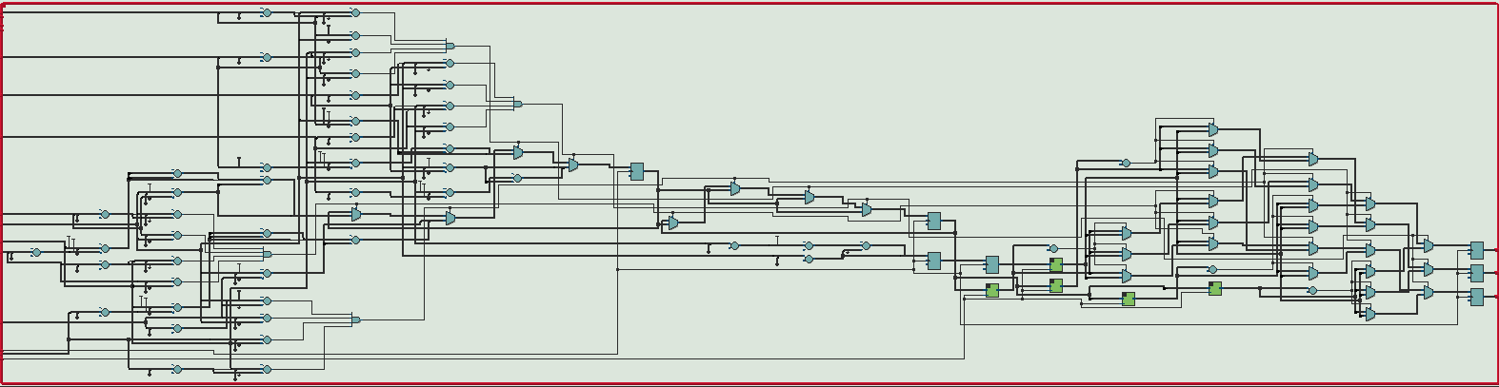

Figure 3: Pixel generator RTL schematic

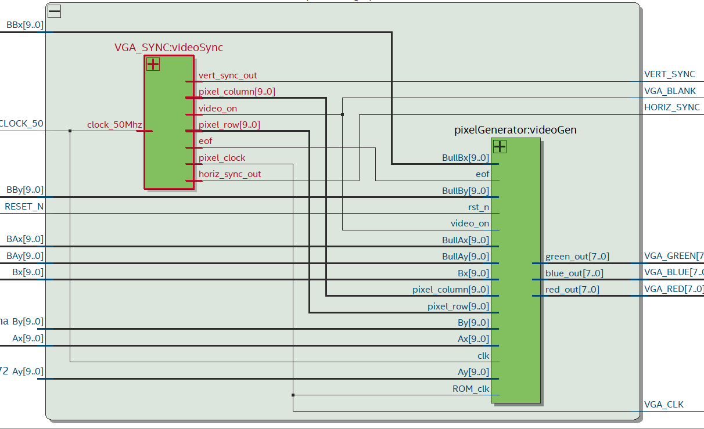

Figure 2: Graphics output RTL schematic

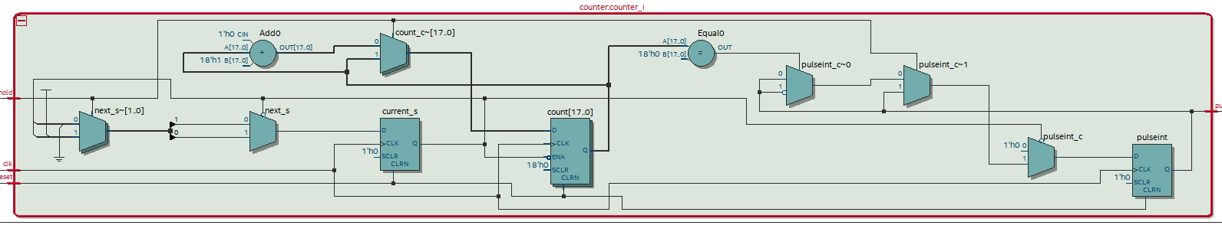

Figure 1: Counter RTL schematic

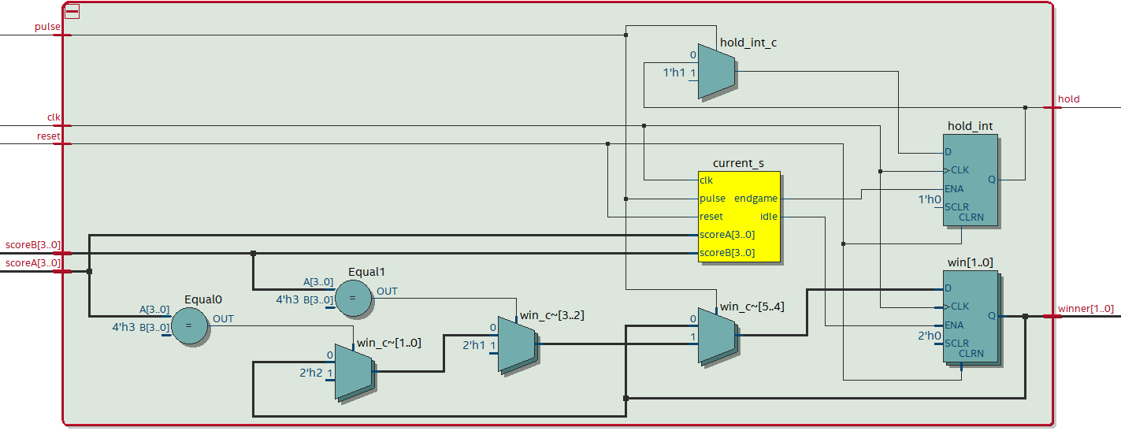

Figure 5: Win logic RTL schematic

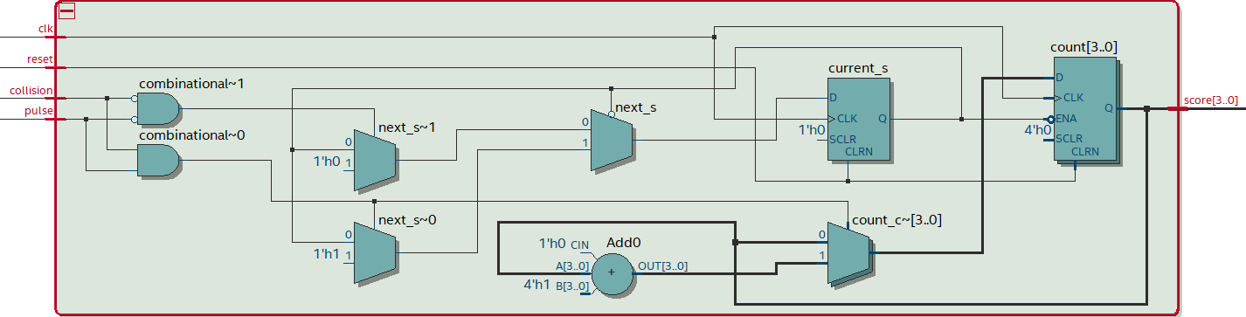

Figure 4: Score component RTL schematic

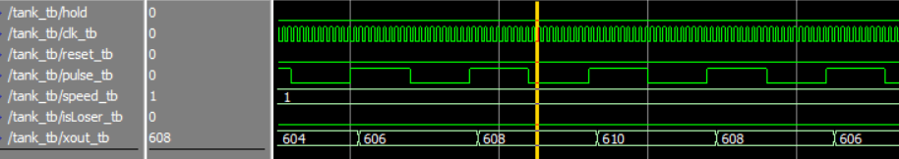

Figure 6: Tank ModelSim wave

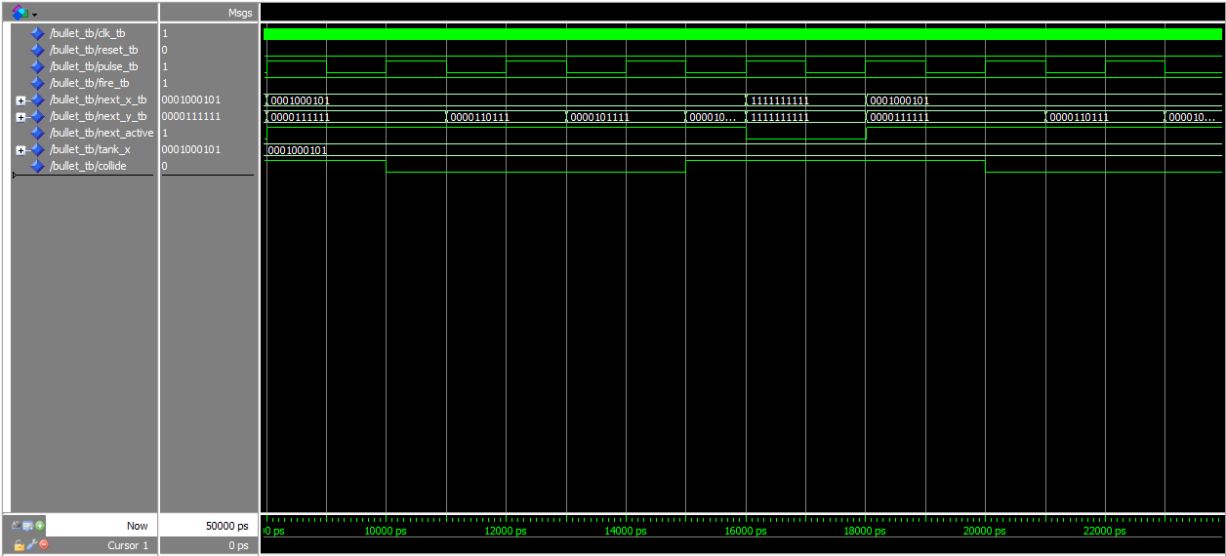

Figure 7: Bullet ModelSim wave

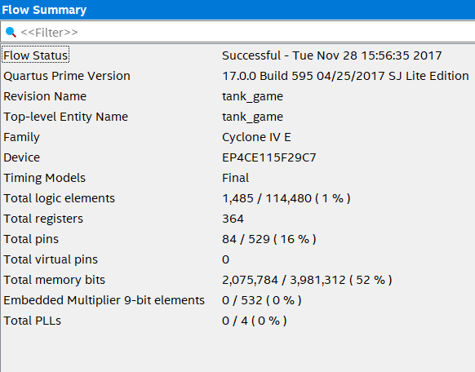

Figure 8: Flow summary showing resource usage