Networking Questions
- How the TCP/IP protocols work.
- Difference between TCP and UDP.
- Understand what the different address classes (A, B, C), know what the private network addresses are used for, what local and broadcast addresses are.
- Understand how DNS works.
- Understand the role of ports in TCP, standard and non-standard port ranges and know common standard ports for commonly used protocols.
- Know the basic difference between IPv4 and IPv6 addressing.
- Understand how a firewall works. Difference between "whitelisting" and "blacklisting", port forwarding, Network Address Translation and basic network security concepts like IP range blocking.
- Have an understanding of how routing works on the Internet.
- Beyond TCP/IP, understanding how SSL work, various telecommunications networks and circuits (i.e. T1, T2, OC-192, etc), different application protocol transports like ATM and MQ-style messaging.

Operating Systems
- What is a process and process table? What are different states of process
- What is a Thread? What are the differences between process and thread?
- What is deadlock?
- What are the necessary conditions for deadlock?
- What is Virtual Memory? How is it implemented?
- What is Thrashing?
- What is Belady’s Anomaly?
- Differences between mutex and semphore?

Basic Language Questions

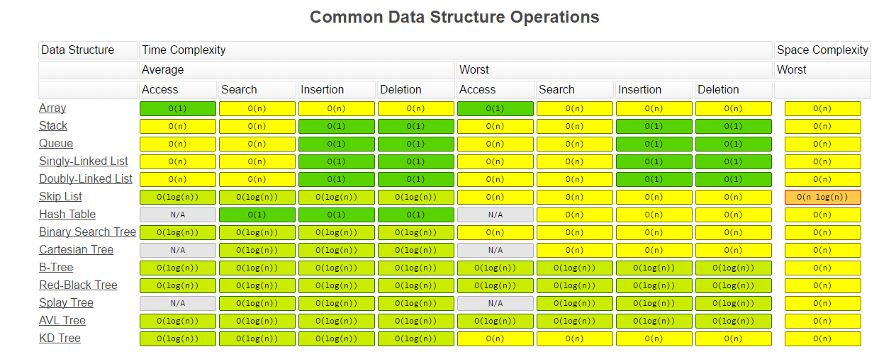
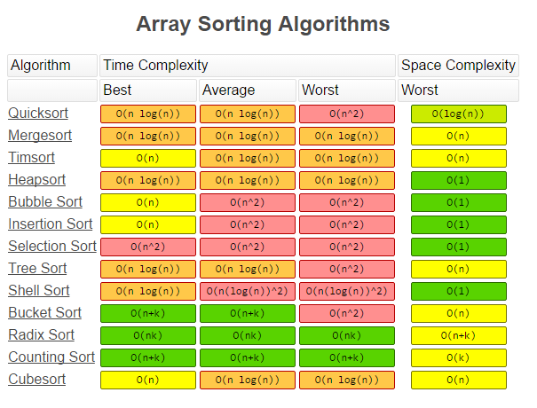
Big O Times

