The Ghost

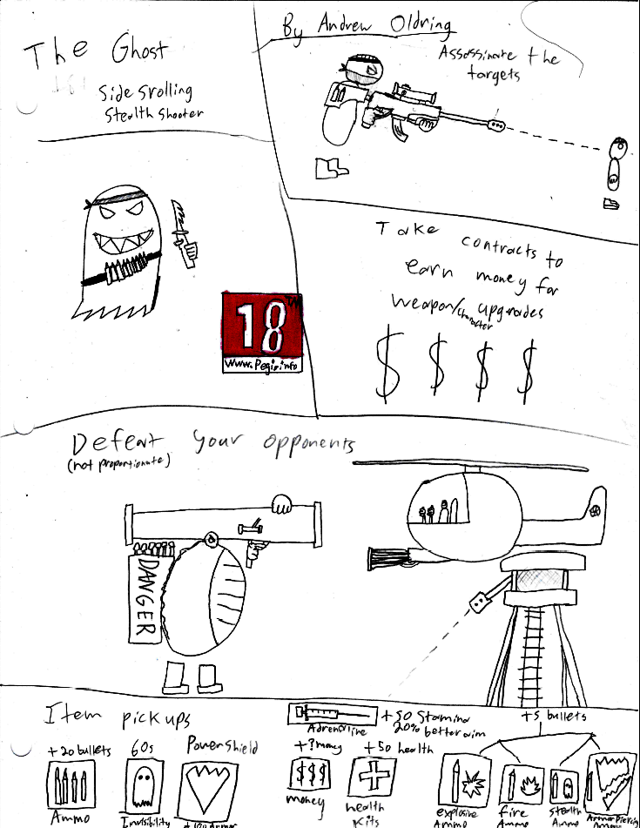

**Launching on Windows on June 13, 2019**

**Gavin Grey, Kelsey Cordray, Andrew Oldring**

**2. Game Story & Flow :**

The character is an ex Army sniper who got a job working at a small IT firm. One day while at work he gets angry at his boss and is tired of the harassment and stress his boss puts him through every day, while browsing the internet he discovers someone has put a contract kill out on your boss (player’s 1st contract, which acts as a tutorial). The player decides to take the contract and assassinate his boss while he’s at home. Afterward becoming a felon he takes on the life of a contract killer. A ghost in society.

The game starts extremely simply, taking out a single target in a fairly isolated environment, but over time the player will breaking into increasingly well-guarded buildings. Missions will have more and more enemies in each level. To compensate for the difficulty the player will have more options available to them.

**3. Character(s) & Controls:**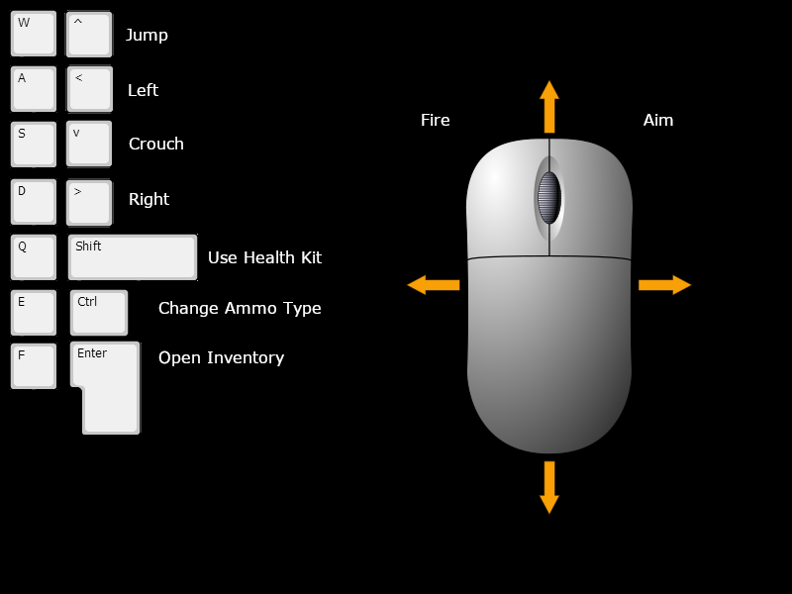

-player controls PC (as shown above)

-w & up arrow jump, a & left arrow left, d & right arrow right, s & down arrow crouch/go down, left click fire, right click zoom, q & shift to use health kits, e & CTRL to swap ammos in the gun, f & enter for open inventory, (ounce in the inventory screen) left click on items to use them.

-Holsters for guns and gear.

-Magazine belts.

-Camo face paint.

-Different outfits for different areas.

-Character concept art

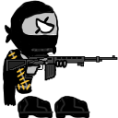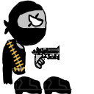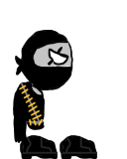

**4. Gameplay:**

-This is a 2d stealth/shooter game

-Each mission is primarily the player scouting out the area; trying to find the objective, explosives, and other useful resources like med kits, armor, special ammo, etc.

-The game progresses by choosing missions from a job board, then completing the missions, with occasional story missions to progress the overarching plot

-The main weapon at the player’s disposal is their sniper rifle.

* When using the sniper rifle the camera zooms out and scrolls somewhat to look at where the mouse is pointing.
* The rifle will also cast a laser beam to a certain distance allowing the player to line up shots better.

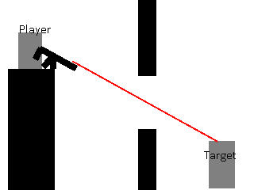

-Cool scenario examples:

* Player could sit outside of the current area, scoping it out before methodically sniping their targets and key guards
* The player can sneak through the base with a silenced pistol, stealthily killing their way to their target
* The player could create a large explosion as a diversion and kill their target in the mayhem.
* Shooting the lone guard rushing to sound the alarm.
* Etc, etc

-Sound:

* Guards will be able to shout to each other for help/backup if they spot the player.
* The player can cause diversions by shooting explosives or (possibly) setting traps (smoke, noise, explosive, etc)

HUD:

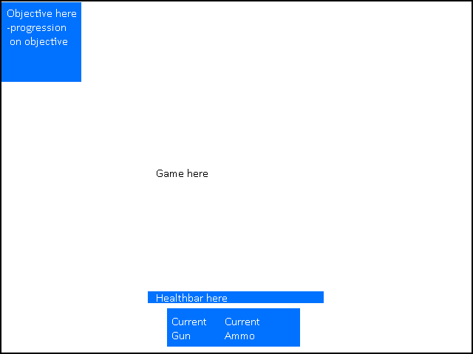

**5. Game World:**

-Modern day(with some little variations)

-Shadows

-Nighttime, color scheme Black, White, and grays.

-Daytime, color scheme Yellow, a few golds, and light gray.

-Urban areas, color scheme matches with Day/Nighttime

-Jungle areas, color scheme is greens and some dark browns.

-Desert areas, color scheme is beige and occasional browns.

-Mood/music of areas depends on what mission it is.

-Player would find enemies, ammo, their target, health packs, and invisibility power ups.

-Each area that you could go to has an objective to kill your target.

-There's not that much ‘story’ in it, it's more open-ended.

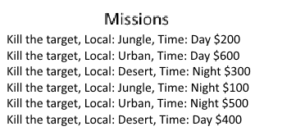

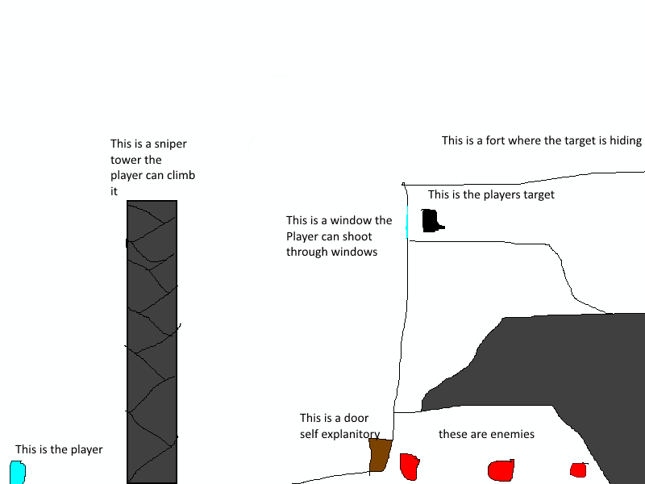

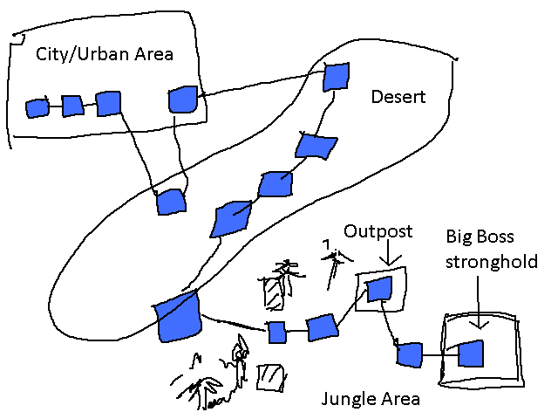

(The blue squares represent levels, player starts in top left)

**6. Game Experience:**

-Thrilling through our scenarios and “How am I supposed to do that?”.

-The player would see the title screen.

-Accomplishment when they complete a mission.

-A triumphant sound when the player completes a mission.

**7. Gameplay Mechanics:**

-Gun system

* Sniper (main weapon)
  + High damage
  + Long range
  + Slow reload (2-3 seconds)
  + Shoots and then re-primes it to shoot (bolt-action)
* Pistol
  + Medium to low damage.
  + medium to close range
  + Medium to fast reload
  + Infinite ammo
  + Can shoot as fast as player can click (semi-auto)
* Additional special weapons (not permanent, occasionally given as reward)
  + Bazooka (big explosions)
  + Machine gun
  + Bazooka machine gun (rapid fire explosives)

-Upgrades

|  |  |  |
| --- | --- | --- |
| **Name** | **Type** | **Effect** |
| Bigger Clip. | Magazine | Gun can carry more bullets. |
| Long range scope. | Scope | Blacks out everything not in aiming direction, but player has vastly increased range. |
| Better red-line scope. | Scope | Increases range slightly. |

-Different bullet types:

|  |  |
| --- | --- |
| **Name** | **Description** |
| Piercing | Bullets will go through walls and will ignore enemy armor. |
| Explosive | Explodes on impact, hurting, if not killing, nearby enemies. Could also start fire.s or destroy some objects. |
| Silenced | Shooting makes no noise, so won’t alert guards. |
| Fire | Bullets will start fires. Good for distractions. |

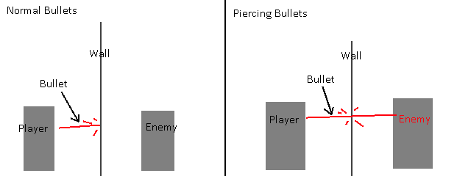

-Sound system

* Shooting a gun will create noise that can alert guards, set off alarms and the like
* Guards can call to others for help if shot, etc
* Explosives can be shot, killing nearby enemies, and also creating lots of noise to distract enemies.

-Between levels player enters a shop where they can:

* Can spend money on upgrades
* Choose new missions from job board
* Save their game
* Practice shooting

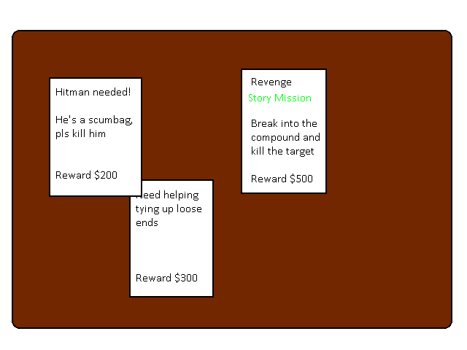

(Job Board, shown above)

-Game switches between various random missions and mandatory story missions.

-Day/night variations:

* This will save development work/time by reusing assets/levels, while still feeling different playing through levels a second time
* During night the player might be able to hide in shadows, there would be different enemy layouts and behavior, ie enemies would need to use flashlights and whatnot

-Economies:

* Bullets are given liberally and can be bought from the shops
* Money drops from enemies and is given as a reward for completing the level
* IE Nothing is super scarce

-Power-ups

|  |  |
| --- | --- |
| **Name** | **Effect** |
| Invisibility | Enemies can’t see you. |
| Power-shield | Extra health. |
| Adrenaline | Increased stamina (heightened aim) |

-Non ai-driven interactable objects:

* Explosive barrels, explode when shot
* Destructible crates

**8. Enemies & Bosses:**

Name Health Weapon Perception

|  |  |  |  |
| --- | --- | --- | --- |
| Infantry | 1 HP | Low damage pistol (10 Damage) | 10 spaces |
| Sniper | Head 1 HP, Body Players HP | Sniper Rifle (50% players health in damage, headshots kill) | Sees player whenever not in cover |
| Armored | 10 HP, Head 2 HP | Shotgun (1 shot kill) or Heavy Machine Gun (1 damage, rate of fire 200 rounds per minute) | Limited due to heavy helmet & visor |
| SMG | 5 HP | SMG (0.5 damage at a rate of 600 rounds per minute) | Wide but short visibility |
| Helicopter (Boss) | 30 HP (Pilot has 5 HP) | Large Rotary Turret(2 damage at 1000 rounds per minutes firing rate) | Can see player unless they’re in cover with a roof |
| Tank/Mech | 10 HP (Has specific weak points, hits on those still only do 1 damage) | Missile Launcher (Player will be pursued while the boss blows up their cover) | Knows general location of player will will fire missiles towards there |

-Bosses

* The helicopter will fly above a small encampment (where the boss stage is set), leaving the player to dart between cover and fire shots whenever they can
* For the tank/mech boss stage the game will become more escape focused as the player must run through exploding terrain. The player will also need to try to blow up the tank by hitting specific weak points on it

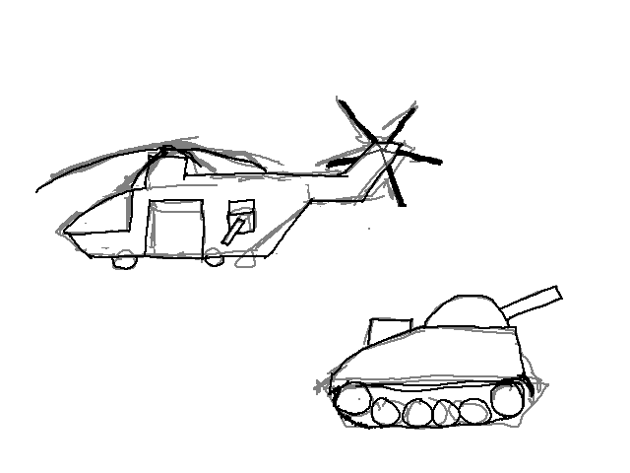

-Enemy AI priority/task system

* Enemies will create task tables for themselves with various priorities
* IE spotting a player will create a task like “shoot” or “chase” with a high priority
* However, each task has a timer, so after a while enemies will, for example, stop chasing the player if they can no longer see them
* Enemies will try to accomplish the highest priority task
* Some tasks when completed/failed will start other tasks (IE chasing player fails so search the area for the player)
* Tasks have additional misc info (where they heard the sound etc)
* Table for an example guard:

|  |  |  |  |
| --- | --- | --- | --- |
| **Name of Task** | **Priority** | **Time left (in frames)** | **Additional information** |
| Chase Player | 50 | 360 | X and Y location of where player was seen. |
| Put out fire | 30 | 600 | X and Y location of the fire. |
| Patrol | 1 | Infinity | Multiple (x, y)’s for where to patrol. |

**9. Game Shell:**

-Title screen

-Choose save file

-Continue

-New game

-Quit

-Pause menu

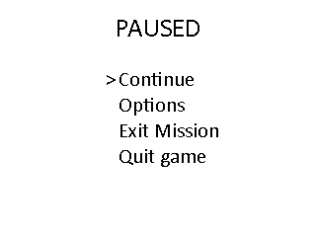

-Level completed screen

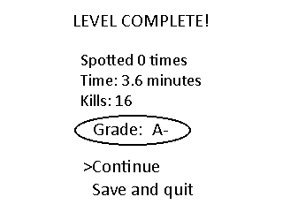

-Death screen

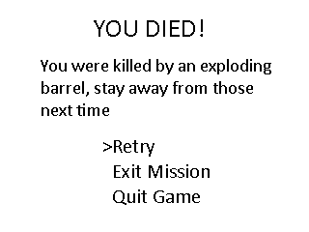

**10. Miscellaneous:**

-Resolution HD (1920×1080 or 1280×720, player can switch from full screen to windowed)

-Token Interaction matrix

|  |  |  |  |  |  |  |
| --- | --- | --- | --- | --- | --- | --- |
|  | **Player Bullets** | **Enemy bullets** | **Player** | **Enemy** | **Barrel** | **Fire** |
| **Player Bullets** | nothing |  |  |  |  |  |
| **Enemy bullets** | nothing | nothing |  |  |  |  |
| **Player** | nothing | Player takes damage.. | Never happens |  |  |  |
| **Enemy** | Enemy takes damage | nothing | Enemy will attack player. | nothing |  |  |
| **Barrel** | Barrel will explode (can start fire | Barrel will explode (can start fire) | nothing | nothing | nothing |  |
| **Fire** | nothing | nothing | Player will take damage. | Enemy will take damage and catch on fire | Barrel will explode (creating a bigger fire) | nothing |

**Beat Chart**

|  |  |  |  |  |  |
| --- | --- | --- | --- | --- | --- |
| **Region** | **Urban** | **Desert** | **Jungle** | **Day (level variation)** | **Night (level variation)** |
| **Location** | City | Desert Base | Jungle Base | All (depends on mission details) | All (depends on mission details) |
| **Objective** | Kill your target | Kill your target | Kill your target | KIll your target | KIll your target |
| **New Enemies** | Simple guard (infantries stats), Snipers (in later levels) | SMG,  Tank boss | Armored infantry,  Helicopter final boss | None | None |
| **New mechanics and hazards** | Innocent civilians that will notify the guards if they see you | You don’t really have any high buildings to snipe from | You can climb walls with vines | You’re easier to see when not in cover | You’re harder to see when out of cover |
| **Gameplay** | This area is more focused on teaching the player the game mechanics | Stealth is recommended but not always needed | If the alarm sounds of enemies will pacifly search for you and shoot to kill if they find you  Stealth is quite difficult | Nothing new | Guards will use flashlights so player must stay in shadows |
| **Color scheme** | Grays and day/night times color schemes thrown in as well | Beige, browns | Greens, dark browns | yellow, golds, light gray. | black, white, dark grays. |

**11. Who did what**

1.Title Page Everyone (Mainly Andrew)

2.Game Story & Flow Andrew / Gavin

3.Character(s) & Controls Kelsey

4.Gameplay Gavin

5.Game World Kelsey

6.Game Experience Kelsey

7.Gameplay Mechanics Gavin

8.Enemies & Bosses Andrew / Gavin

9.Game Shell Gavin

10.Miscellaneous Gavin / Kelsey