# Lab 2: HDFS namenode images

# (DSCI 551, Fall 2022)

## Due: September 23, 2022

## Points: 10

1. [4 points] Create at least two levels of hierarchy (e.g., /user/john) and at least one file under a directory (e.g., /user/john/hello.txt) in your HDFS server. For example,

**ANSWER:**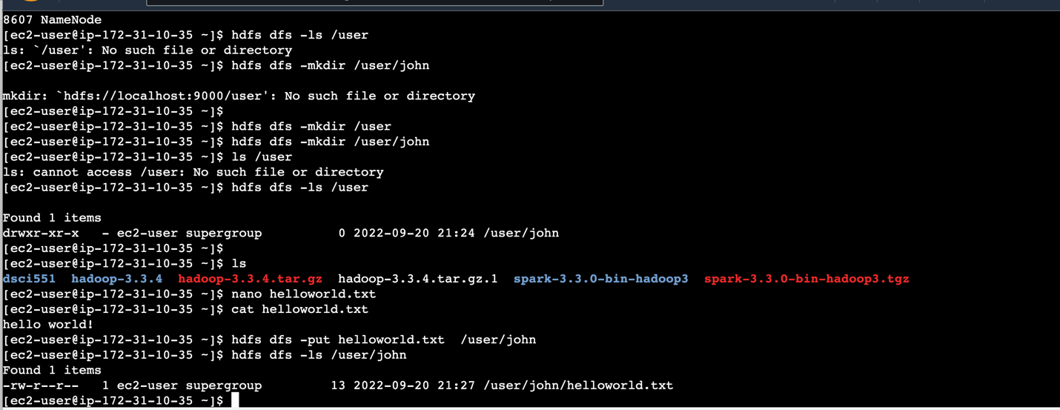

1. [6 points] Use hdfs oiv command to export your HDFS file system image in both XML and TSV (tab-separated value) format. Recall that the images are stored in the /tmp/hadoop-ec2-user/dfs/name/current directory.

Examples:

hdfs oiv -i fsimage_0000000000000000000 -o fsimage160.xml -p XML

hdfs oiv -i fsimage_0000000000000000010 -o fsimage160.tsv -p Delimited

Submission:

1. screenshot for task 1 (similar to the example above)
2. XML file of your HDFS image for task2
3. TSV file of your HDFS image for task2