Pseudocode + Flowchart

* + btnSubmit
    - Declare variables
    - Check to see if all required fields are filled
    - “Parameterize” field values to insert into Fit_User table
    - Check if Username is unique against Fist_User table
    - Insert values and display “New User Added” if successful

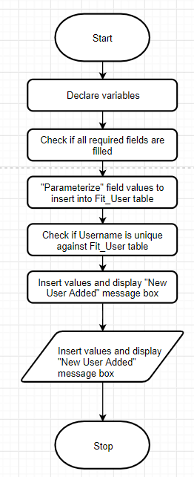

* + btnLogin
    - declare variables
    - check if all required fields are filled
    - “Parameterize field values for selecting from Fit_User table
    - Check if Username and Password exists in Fit_User table
    - Display Login if successful
    - Display Report form

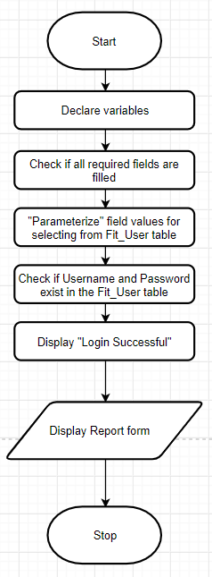

* + frmLogin.btnCancel
    - Exits program

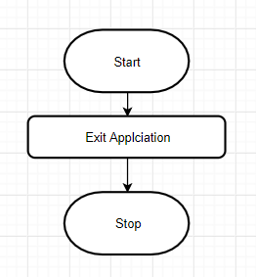

* + frmUserInfo.btnCancel
    - Returns to Login

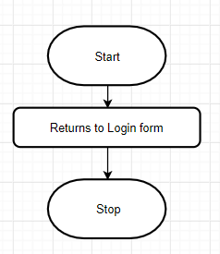

* + btnCalcBMI
    - declare variables
    - convert txtNewWt to a double
    - calculate BMI using BMI formula BMI = (dblNewWeight/(dblHeight^2)) * 703
    - Display BMI in lblNewBMICalc

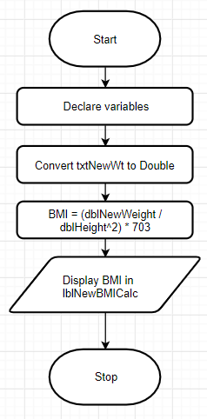

* + btnCalcBF
    - declare variables
    - Check if male or female radio button was selected
      * If Female, convert txtAbdominal, txtNeck, txtHips to Double
        + Calculate body fat percentage based on formula from the web for women

BFP = 163.205×log10(waist+hip-neck) - 97.684×(log10(height)) + 36.76

* + - * If Male, convert txtAbdominal, txtNeck to Double
        + Calculate body fat percentage based on formula from the web for men

86.010×log10(abdomen-neck) - 70.041×log10(height) + 36.76

