# CS 255 System Design Document Template

Drew Pepin

## UML Diagrams

### UML Use Case Diagram

### UML Activity Diagrams

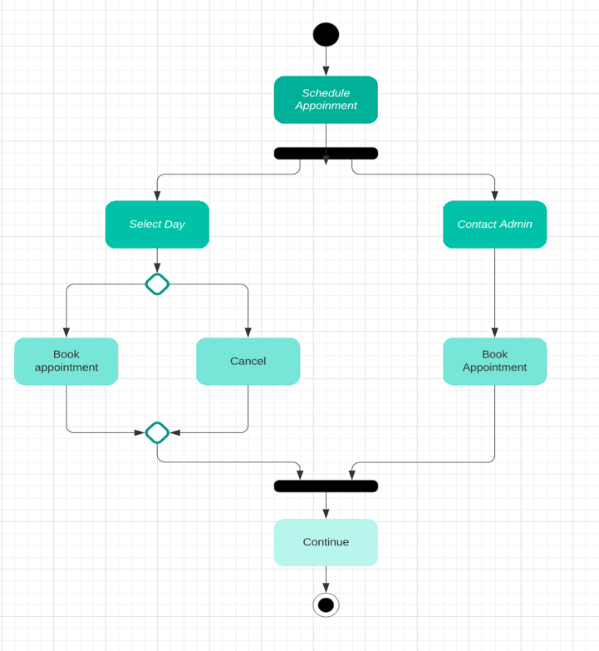

### UML Sequence Diagram

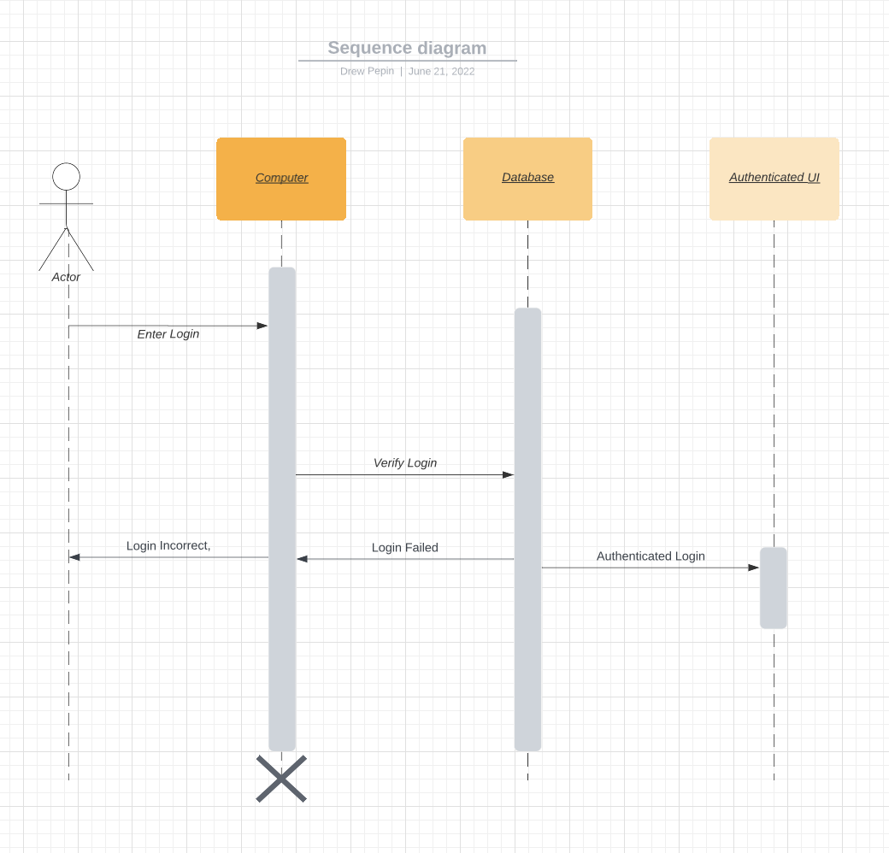

### UML Class Diagram

## Technical Requirements

In order to run this application, you’ll need access to a computer or mobile device that can access the internet. To build this application, you can choose from a few different software options. As long as you can create and manage a backend database to store user info, you can use just about any functioning software. The database is the most important aspect, making sure its secure to manage user logins, as well as authenticating admins on login. You are going to need a software team that can build a front end UI that can handle the required functions, like logging in, managing a schedule, etc. The back end team will be responsible for building the database and ensuring user info is added and secured appropriately on signup and login. The infrastructure will require many services, like user signup, user login, reset password, login validation, schedule appointments, manage appointments, contact instructor.