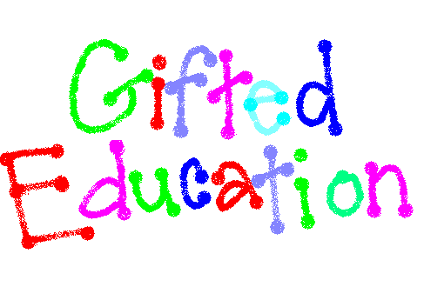

**Ohio Revised**

**Gifted Operating Standards**

**July 2018**

The following outline has been created as a resource for Classroom Teachers and Gifted Intervention Specialists who employ the SOLE process and philosophy to encourage gifted student driven lessons that address. Don’t know SOLE? Check out this link StartSOLE.org

The excerpt below come directly from the Ohio Department of Education’s Gifted Operating Standards (November 2017) 3301-51-15 (D)(8)(b)(i)(a-h). The bulleted points speak directly to the competencies list above them.

**A general education teacher who is designated as the provider of gifted services shall**:

***(i) Receive specialized training in gifted education as documented and monitored by the district on the teacher’s Individual Professional Development Plan (IPDP) or other methods as determined by the department in order to meet the following competencies:***

(a) The ability to differentiate instruction based on a student’s readiness, knowledge and skill level, including using accelerated content, complexity, depth, challenge, creativity and abstractness;

***- SOLE allows the educator to differentiate her/his instruction by implementing a student inquiry method of learning based on a standard driven “Big Question”***

(b) The ability to select, adapt, or create a variety of differentiated curricula that incorporate advanced, conceptually challenging, in-depth, distinctive and complex content;

**- SOLE is differentiated by design. The complexity of the standards driven, teacher created “Big Question” can lead students to explore and discovertopics, concepts and research at a primary grades to collegiate level of understanding.**

(c) The ability to provide an extension or replacement of the general education curricula, to modify the learning process through strategies such as curriculum compacting, and to select alternative assignments and projects based on individual student needs;

**-SOLE can be used as an alternative assignment that can be an extension of a curricular topic, standard or student interest.**

(d) The ability to understand the social and emotional needs of students who are gifted and to address the impact of those needs on student learning;

**-SOLE can provide a teacher selected grouping to not only promote peer interaction, but also allow for students to express their own research discoveries,.**

(g) The ability to select, use, and interpret technically sound formal and informal assessments for the purpose of academic decision making; and

**-SOLE can be used as an informal assessment to drive academic and personal goal setting.**

(h) The ability to participate in the development of the Written Education Plan.

**-SOLE can be written as a way to meet a specific goal or as a way to collect evidence on a student’s Written Education Plan. The goals should align directly with a student's area of identification.**