/// Andrew Souza

/// Comp 210 - Spring 2023

/// Exam 2 -- Problem 1

#include <iostream>

#include "NumberList.h"

using namespace std;

//\*\*\*\*\*\*\*\*\*\*\*\*\*\*\*\*\*\*\*\*\*\*\*\*\*\*\*\*\*\*\*\*\*\*\*\*\*\*\*\*\*\*\*\*\*\*\*\*\*\*

// displayList shows the value \*

// stored in each node of the linked list \*

// pointed to by head. \*

//\*\*\*\*\*\*\*\*\*\*\*\*\*\*\*\*\*\*\*\*\*\*\*\*\*\*\*\*\*\*\*\*\*\*\*\*\*\*\*\*\*\*\*\*\*\*\*\*\*\*

void NumberList::displayList() const

{

int counter = 0;

ListNode\* curr = this->head;

while (curr) {

cout << ++counter << ": " << curr->value << "\n";

curr = curr->next;

}

}

int main() {

NumberList list;

double input = 0.0;

cout << "Enter numbers. Input a negative number to exit.\n";

cin >> input;

while (input >= 0) {

list.appendNode(input);

cin >> input;

}

cout << "You entered:\n";

list.displayList();

cout << endl;

return 0;

}

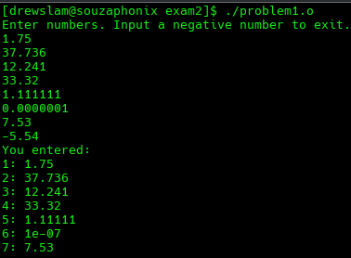

/// Andrew Souza

/// Comp 210 - Spring 2023

/// Exam 2 -- Problem 2

#include <iostream>

#include "NumberList.h"

using namespace std;

//\*\*\*\*\*\*\*\*\*\*\*\*\*\*\*\*\*\*\*\*\*\*\*\*\*\*\*\*\*\*\*\*\*\*\*\*\*\*\*\*\*\*\*\*\*\*\*\*\*\*

// The search function returns the first index \*

// of a given input. If the value is not detected \*

// -1 is returned \*

//\*\*\*\*\*\*\*\*\*\*\*\*\*\*\*\*\*\*\*\*\*\*\*\*\*\*\*\*\*\*\*\*\*\*\*\*\*\*\*\*\*\*\*\*\*\*\*\*\*\*

int NumberList::search(double num) {

int index = 0;

ListNode\* curr = this->head;

while (curr->value != num && curr->next) {

curr = curr->next;

index++;

}

return !curr->next ? -1 : index;

}

int main() {

NumberList list;

double input = 0.0;

cout << "Enter numbers. Input a negative number to exit.\n";

cin >> input;

while (input >= 0) {

list.appendNode(input);

cin >> input;

}

cout << "Enter a value to seach for: ";

cin >> input;

cout << "You searched for: " << input;

cout << "\nPosition: " << list.search(input);

cout << endl;

return 0;

