# Andrew Souza

# Comp-265 -- Spring 2024

# Exam 2 -- Problem 1

# Implement a program which multiplies a user input by 17 using only bit shift

# operations and addition.

# Check to see if your program is correct by using the mult and mflo operators.

# Your program should include a proper and useful prompt for input,

# and print the results in a meaningful manner.

.text

.globl main

main:

# Prompt user for input and take digit input

li $v0, 4

la $a0, prompt

syscall

li $v0, 5

syscall

move $t0, $v0

# Output what user entered

li $v0, 4

la $a0, output

syscall

li $v0, 1

move $a0, $t0

syscall

# Operate on variable

sll $t1, $t0, 4 # Shifts $t0 4 to the left and saves values to $t1

add $t2, $t1, $t0 # Adds $t1 to $t0 and saves value to $t2

li $v0, 4

la $a0, afterShift

syscall

li $v0, 1

move $a0, $t2

syscall

# Test with mult

addi $t3, $t3, 17

mult $t0, $t3

# Exit Program

ori $v0, $zero, 10

syscall

.data

prompt: .asciiz "\nInput your number here: "

output: .asciiz "\nYou input the number "

afterShift: .asciiz "\nYour input * 17 = "







# Andrew Souza

# Comp-265 -- Spring 2024

# Exam 2 -- Problem 2

# Please compute the surface area and volume of a box with

# a base length of a, a base width of b and a height of c.

# Have the user enter in values for each side and display the output.

.text

.globl main

main:

# Prompt user for input and store input

li $v0, 4

la $a0, inputL

syscall

li $v0, 5

syscall

move $t0, $v0

li $v0, 4

la $a0, inputW

syscall

li $v0, 5

syscall

move $t1, $v0

li $v0, 4

la $a0, inputH

syscall

li $v0, 5

syscall

move $t2, $v0

# Operate on user input

# Find volume

# The formula for the volume is: a * b * c

add $s0, $s0, $t0 # Set $s0 to value of $t0

mul $s0, $s0, $t1 # a * b

mul $s0, $s0, $t2 # a * b * c

# Find surface area

# The surface area is: 2 * ((a * b) + (a * c) + (b * c))

addi $s1, $s1, 2

mul $s2, $t0, $t1 # a * b

mul $s3, $t0, $t2 # a * c

mul $s4, $t1, $t2 # b * c

add $s2, $s2, $s3 # (a * b) + (a * c)

add $s2, $s2, $s4 # (a * b) + (a * c) + (b * c)

mul $s1, $s1, $s2 # Above * 2

# Output results

li $v0, 4

la $a0, outputV

syscall

li $v0, 1

move $a0, $s0

syscall

li $v0, 4

la $a0, outputSA

syscall

li $v0, 1

move $a0, $s1

syscall

# Exit program

ori $v0, $zero, 10

syscall

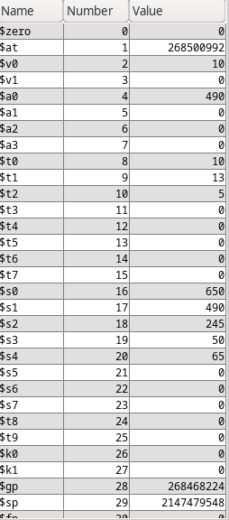.data

inputL: .asciiz "\nInput the length: "

inputW:.asciiz "\nInput the width: "

inputH: .asciiz "\nInput the height: "

outputV: .asciiz "\nThe volume is: "

outputSA: .asciiz "\nThe surface area is: "

