On Heuristic Methods for Deciphering

the Zodiac 340-cipher

Ryan Garlick <garlick@unt.edu>
Visiting Assistant Professor, University of North Texas, Department of Computer Science and Engineering, Denton, TX 76205

and

Jeremy Alleman <jeremya78@yahoo.com>, Allen Arnold <jaa0141@unt.edu>,
Branden Lee <bgl0008@unt.edu>, John Daniel Leon <johndleon@gmail.com>, Joey Liechty <joeyLiechty@gmail.com>, Tanner Oakes <tanneroakes@gmail.com>, Corey Rosemurgy <cpr0011@unt.edu>,
Rutvik Pandya <rutvikpandya@yahoo.com>, Arthur Williams <retekin@gmail.com>,
Russell A. Yermal <yermal@unt.edu>

Abstract
We present several heuristic methods for attempting to decipher the unsolved Zodiac Killer's 340 character cipher. Based on previous communication, the message is possibly a homophonic substitution cipher.

Due to the large number of potential keys, heuristic methods are employed. These algorithms are presented, along with their motivation in relation to the characteristics of the cipher. Results, applications of distributed processing, and notes on future direction are also presented.

Index Terms (See section 12) – Applied Cryptography, Substitution Cipher, Zodiac, Genetic Algorithm, Intelligent Brute Force Algorithm, Random Brute Force Algorithm, Character Frequency Analysis, Natural Language Processing, Distributed Processing
1 Introduction
The Zodiac was a notorious serial murderer from the greater San Francisco area during the 1960’s and 70’s. The Zodiac was confirmed to have seven victims with five left dead, and claimed to have killed dozens more. He is most well remembered for threatening to blow up school buses full of children, skillful manipulation of the media, and of most interest to us, for his taunting of the police and public with letters and ciphers.
On July 31, 1969, less than a month after the Zodiac’s attack on Mike Mageau and his third confirmed murder of Darlene Ferrin, the Zodiac submitted his first cipher. It was sent to the Vallejo Times Herald, the San Francisco Chronicle, and the San Francisco Examiner in three equal parts with no obvious distinction as to which order they were to be read. Along with each part of the cipher were near identical hand-written letters threatening to kill a dozen people in a weekend-long rampage, if his cipher was not printed on the front page of the very next newspaper edition. Each portion of the cipher was eventually published, though not all initially on the front pages and not all on the requested date.
The combined cipher was 17 characters across, and 24 characters long for a total of 408 characters. Although code breakers from the FBI, NSA, CIA, and Naval Intelligence all tried to solve the cipher, it was Donald Harden, a forty one year old high school history teacher, and his wife Betty Harden, who finally cracked it. In addition to some prior knowledge of some basic code breaking techniques, Harden was able to solve the cipher by making a very insightful and very lucky assumption that the coded message began with “I like killing”. Harden also made a number of other basic assumptions as well. Namely that it was a homophonic cipher (one letter being potentially represented by many symbols) and that the message read from left to right and top to bottom like a book.
The Zodiac’s second cipher was received on November 8th, 1969 by the San Francisco Chronicle. The cipher came less than one month after the Zodiac’s fifth and final confirmed murder, of cab driver Paul Stine. Contained in the envelope with the cipher were a greeting card and a bloody piece of Paul Stine’s shirt taken from the scene of his murder. This second cipher was again 17 characters across, but only 20 characters long, resulting in 340 characters total (68 characters less than the previous cipher). In addition, this new 340 cipher had 63 unique symbols, more than the previous. The combination of more unique symbols and a shorter message gave this cipher a much higher degree of difficulty.
Although the Zodiac sent three more ciphers to the news papers, the third and forth are very short and therefore no conclusive analysis can yet be done on them. Also, author of the books Zodiac and Zodiac Unmasked, Robert Graysmith, claimed to have solved the 340 cipher. However, it is our belief that even though his solution is the best to date, it is not a complete, a correct, nor a satisfactory solution. We have worked to solve this cipher once and for all. Upon examination of the problem, one can quickly calculate the total number of possible keys to the cipher. As there are 63 unique symbols to account for the 26 letters of the English alphabet (we are assuming the decoded text is English), there are a total of 63 ²⁶ combinations. This is roughly 6.07 x 10 ⁴⁶ possible keys.
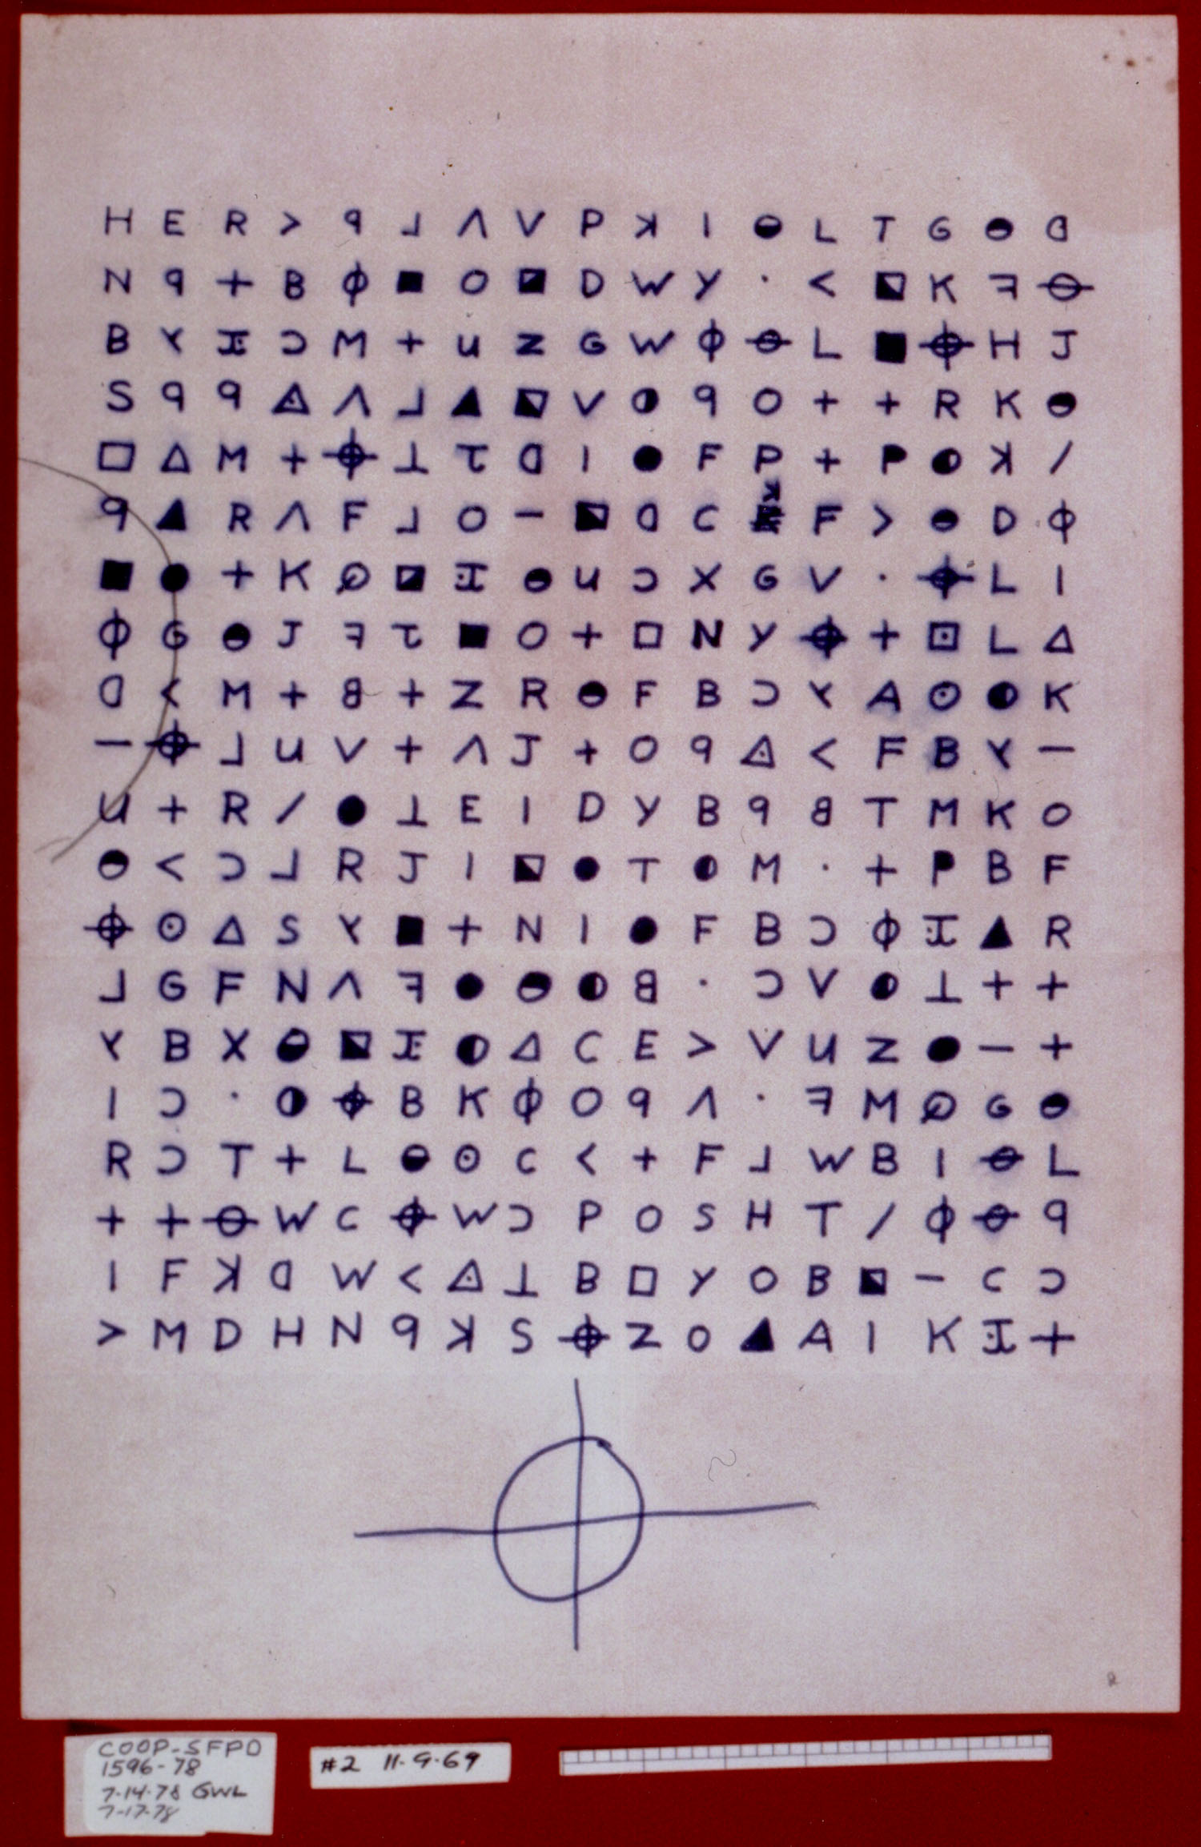
Figure 1
The Zodiac 340-Cipher
2 Previous Efforts
Ciphers of every variation span the gamut of human history and use. Mostly they were used for military and political reasons for the purpose of secrecy. In modern times, they have taken on the guise of a murderer trying to prove his superiority over law enforcement. The Zodiac Killer utilized the homophonic cipher variant to taunt police with his name and vignette, but has also left one best known cipher in his wake. To this day, no credible solution exists, but history has provided many tools to the cryptologist for breaking such codes. These are frequency analysis of symbols and letters, bi- and trigram recognition, and the identification of “cribs.”

Frequency analysis dates back to al-Kindi, an Arabic scholar that used the technique to analyze religious texts to validate the works of Mohammada. Its use states that for any given language, there will be a frequency that each letter will appear. This is an interesting challenge for the Zodiac 340-cipher, as the Zodiac Killer was fond of miss-spelling words in his documents. To have an accurate frequency chart, we took all published correspondence that the Zodiac Killer gave to the newspapers and police^{[2]} and then transcribed these documents to a text-based digital format. This allows us to calculate what the frequency of letters is for his work, and includes other benefits that are discussed below.

This analysis becomes more difficult because of his believed use of a homophonic cipherb. The typical strategy involves taking the frequency percentages, and using a number of symbols equal to the percentage of every letter. For example, the letter “e” in English is used approximately 12% of the time. Thus, twelve different symbols should be used. When properly used, this reduces the frequency of each letter to 1% for the cipher text.

In his previous cipher, the Zodiac Killer used seven symbols for the letter “e” alone. However, many other letters were left with either one or two symbols. This opened up his cipher to be analyzed for bigrams and trigrams that are common to his writing. We mentioned above that we placed his writing into a digital format, which allowed us to analyze the frequency of his letter usage. It also allowed us to find all the common bigrams and trigrams that he used. Many of his bigrams were identified in his original cipher because of his use of words like “kill” and “killing” that used a double “l”, while he only used two symbols to represent the letter “l”. This caused the two symbols for “l” to appear next to each other frequently. By analyzing his previous work, we can tag many of the potential bigrams and trigrams inherent to his writing style, and use it to identify the possible places for words in his 340-cipher.

Finally, from the work of others, we have the wisdom to look for “cribs”, or common words used for a given group or subject, in his works. For the Zodiac Killer, he talks mainly about collecting “slaves” and how he enjoys “killing,” including his misspelling of words like “Christmass” and “Fry” for Friday, are all signatures of his. If we can identify where these words are likely to show up, then we will be farther along in our solving of the 340-cipher.

In our attempt, we also looked at other algorithmic methods to utilize computers to do the majority of the work for us. We reviewed one method in particular, that of Brax Cisco. The method developed by Brax Cisco utilizes a Hillclimber algorithm to enter a solution key for the cipher text that is either developed by guesswork or generated randomly. It then takes the generated solution for the given key and scores it based on a preloaded set of bi-, tri-, tetra-, and pentagraphs common to the English language. If the resulting score is better than the previous best score, then performs a shuffle on the key (exchanging the value of two characters in the key randomly) and then performs another solution and scoring on the new variation of the key. If the new key scores higher, it replaces the older key and runs through the algorithm again by switching another pair and comparing the new key against the saved one.
3 Distributed Processing Implementation

The client is implemented with the feature of sending keys above a constant threshold score value to a dedicated server. The server stores the keys in a database and keeps track of the number of keys sent to it. The keys may then be checked by a human reader to verify correctness in the cipher. The human reader may also see that if the solution is almost correct except for one symbol in the cipher, it is a near-correct solution. The edited or unedited key may be sent back to the server as a solution that is worth looking at. These keys are stored in a separate database which may be looked over at a later date.

4 Linguistic Properties

One of the first things we wanted to do is find the frequencies of the symbols and letters in the 340-cipher to see if maybe there was a pattern to be found. In order to help us find a pattern we decided to try to use something that has already been solved which was Zodiac's 408-cipher. First we gave every symbol in the 408-cipher a unique number to make it easier to read and compute. This will also help when we plug it in to our program to find
the frequencies. Next thing we did was another frequency test to see if there was anything to be found. Since the 408-cipher was a homophonic substitution cipher, we were hoping there would be some similarities between the two ciphers. One pattern we did find was a pattern consistency within his cipher. There would be 5 to 7 symbols that would represent the same letter, and in his writing Zodiac would cycle them repeatedly. For instance, say the letters B, H, T, Y, and / all represent the same letter in the decoded cipher. The encrypted cipher could read something like this: BACGHAZCTPOPYEEV/. After the slash, the encrypted cipher would restart, with B appearing before H, appearing before T, and so on, and Zodiac would continue this pattern with all the other symbols in the cipher.
Unfortunately this pattern does not seem to exist in the 340 cipher. Another direction we took was to make a vocabulary composed of all of his letters and ciphers. We made a program to find the words he used most frequently in his previous writings. This, along with some of the most frequent words
used in the English language, make up our vocabulary, which we use to find out what he could possibly be saying in the 340 cipher.
In considering the linguistic properties of the 340-cipher, we took a thorough analysis of both the 340-cipher and the original, three part 408-cipher. In the 340-cipher, there are 63 unique characters used in the cipher, most of them being Latin characters, Latin characters mirrored, and shapes, such as a circle with a cross (which the Zodiac used as his signature), and circles, square, and triangles with different designs in them. In order to process the individual characters, each symbol was given a two digit number that corresponded to its position in the cipher where it was first used. For example, the first character is 00, the second character 01, and so on. We performed a frequency analysis on the cipher using a custom program (see Figure 2). The results showed that we could not easily use a frequency analysis to break the cipher. Using a separate custom program, we analyzed the n-grams of cipher (where n=2,3,4,5). The results showed that the Zodiac was very good at keeping away from patterns. Very few bi-grams or trigrams were repeated in the cipher. We also used the program to analyze a large body of English text. See the Scoring section to see how the scoring algorithm uses these statistics the score the solutions. Also, a separate program was developed in order to take the body of Zodiac letters and keep statistics of what words were used by the Zodiac, including misspellings, and use this in our dictionary for the client.

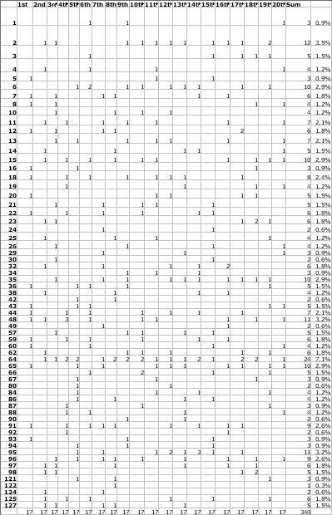
Figure 2
Frequency Analysis of the 340 Cipher

5 Scoring
An automated process for quickly determining if a given key is of interest to us, that is, it appears to be close to a valid solution to the problem, is necessary for the vast amount of possible keys that exist. Our attempt to create such a process resulted in our scoring algorithm which is described below.

The first step towards scoring a key is simply to decode the cipher using the given key. This simply consists of mapping the key’s letter representations of each symbol to each symbol occurrence in the cipher. We assume that the cipher is a homophonic substitution cipher in which each key letter maps directly to its symbol in the cipher and that there can be more than one symbol per letter. This leaves us with a block of English letters which we can now analyze and assign a score to.

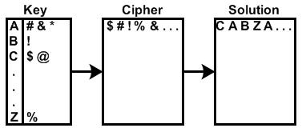

Figure 3
Example of decoding cipher text with key

With our scoring algorithm, we are basically scanning a string of letters and trying to determine if it is what we consider to be readable English text. More specifically however, our routine assigns a score to each key that lets us know how close or far the solution is to our standards for English text. This relative scoring is an important aspect in that it allows us to set a threshold for flagging any good keys that we generate to be looked at. Scoring is also necessary for running algorithms such as the genetic algorithm which needs to know which keys are better than others.

As we read through a block of letters, our scoring algorithm is analyzing and basing the final score on three different aspects of English text: letter frequency, n-graph frequency, and word frequency. Once scores have been determined for each of these individual aspects, they are then combined to create a final score which tells us the key’s relative likeness to our standards for English text. The process for each of these procedures is explained below.

Letter Scoring
The most basic aspect of our scoring algorithm is to analyze the individual frequency of each letter in the English alphabet in the decoded text. We started by generating an average frequency that we could expect for each letter. This was done by analyzing Zodiac and English text files and generating the average frequency for each letter. These generated values are considered to be our average letter frequencies for English text. We then score the decoded text by comparing its letter frequency values with those of our standard values.

A perfect score is given when the frequency of each letter in the text block exactly matches our standard values, and from there, the larger the deviation from the standard the lower the score. Letter frequency is an important aspect to scoring in that it does not reward repetitive text: such as a block that only consists of the word “there” repeated over and over for example.

N-Graph Scoring
The next part of our analysis is to generate a score for the n-graph frequency of the text. Our model for this process is based on the work done by Brax Cisco in his Zodiac 340 hill climber program. N-graph is a term we use to represent all possible letter combinations of length n. The n-graphs we use for our scoring routine are bi-graphs, tri-graphs, tetra-graphs, and penta-graphs. These are letter combinations of two, three, four, and five respectively. For example, the set of all possible bi-graphs is {aa, ab,…, zz}, and so on for all other n-graphs. We used a large sample of English text to generate a list of all n-graphs that occurred and then calculated a frequency for each that is used for n-graph scoring.

Word: KILLING
Bi-Graphs: KI, IL, LL, LI, IN, NG
Tri-Graphs: KIL, ILL, LLI, LIN, ING
Tetra-Graphs: KILL, ILLI, LLIN, LING
Penta-Graphs: KILLI, ILLIN, LLING
Figure 4
Example of breaking text into n-graphs

The model we use for generating an n-graph score is to step through each index of the text block and increment the score based on the frequency of the found n-graphs for each index. The more frequently the given n-graph occurs in English, the larger the increment to the total n-graph score. Using this procedure, we then generated a standard n-graph score for sections of English text of length 340. This was done by breaking up samples of Zodiac and English text into sections of length 340 and then averaging the found n-graph scores for each section (note that procedure this can be scaled to any size problem). From here, we can give decoded keys an n-graph score by comparing its processed n-graph score to our standard score. A perfect score is given to keys with an n-graph score that equals or exceeds our standard, and from there the larger deviation from the standard the lower the score.

N-graph scoring is advantageous to solving our problem in that it rewards the partial formulation of English words: an important aspect to increasing the score of keys that may be close to a possible solution, and to key generation algorithms such as a genetic algorithm which will attempt to complete these partially found words to increase its score. Also, this specifically works well for the Zodiac cipher because the Zodiac killer is known to purposefully misspell certain words. So, even though these misspellings may receive no word score, they would still get an increased score due to their partial completion.

Word Scoring
The third aspect of our scoring system is to determine a word score for our decoded texts. While the basic idea is to search through the text for words, giving texts with more words a higher score, there are many options and variables for doing so and we describe a number of our efforts below.

The first necessity for word scoring is a dictionary for word lookup. There are a wide number of reasonable possibilities for which dictionary to use and each has its own advantages and disadvantages to our particular problem. First and foremost, a large number of Zodiac specific words were chosen and included in every dictionary. This includes common words used by the Zodiac killer and even his known misspellings. These words were also given a higher score value than common words in an attempt to find Zodiac-like solutions. From there, we have tried multiple dictionaries for word scoring: such as the entire English language or the 1000 most commonly used words. Although there are an infinite number of possibilities for this choice, we assume that the best dictionary for solving the problem includes all of the words that the Zodiac has used and a reasonable selection of those he hasn’t used but possibly would.

Another question for generating word scores is how to search through the text. Once again, there is any number of options available for doing so and our best efforts are described here. Our first attempt simply advanced through the text, searching for words starting from each index. This allows the score to be incremented multiple times for each index, which may not produce the desired results. Our most successful attempt also searches from each index, but if it finds a word the index is advanced to the end of the longest found word.

Using the latter procedure, the summation of the lengths of all found words divided by the cipher size leaves us with the percentage of words in the given text. A text that is completely filled with words generates a perfect score and so on.

The word score is perhaps the most important aspect of scoring in that it ties together both the letter frequency and n-graph scores to flag what we hope to find in coherent English text.

Total Score
Once we have generated each of the three individual scores, we then simply tie them all together to create a total score for each text. We have set up our percentages so that texts that approach our standards for English text also approach a score of 100, while texts that appear to be furthest from anything readable generate a score of 0.

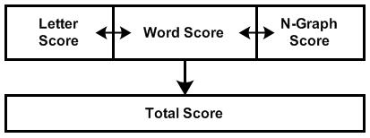
Figure 5
Example of total score generation

One challenge is to determine what weight to assign to each element of the total score. Our efforts have shown improved results when the word score is given the greatest weight of the three, with the n-graph and letter scores weighed slightly less. This gives the best scores to text which have a large amount of words with little repetition and the possibility of some partial or misspelled words.
6 Key Generation Algorithms
IBF
The Intelligent Brute Force or IBF algorithm is a random solution generator for a given poly-alphabetic substitution cipher. It uses parameters provided by an n-gram frequency analysis of English written texts to attempt a more accurate modeling of the English language.
IBF uses six hard-coded constant parameters (2 strings and 4 integers). The two strings represent the names of .txt files containing the n-gram/frequency list, and the target cipher. T (for tokens) represents the sum of all n-gram frequency counts. C (for cipher) represents the size of, or number of symbols in, the target cipher. K (for key) represents the number of unique symbols in the cipher, and subsequently, the size of the key. N (for n-grams) indicates the size, or character length of the n-grams.
IBF begins by initializing the Token[String] array from the text file of n-
gram tokens and integer frequency counts. Each n-gram is then stored in an array of size T and occupies the same number of cells as its respective frequency count.
Next, IBF initializes the Cipher[int] array, from the cipher text file. This text file needs to represent the cipher as a series of integers from 0 to K.
Note: The following procedure should be looped to produce a constant stream of potential solutions (hence the name “Brute Force”). An array Key[char] represents the current solution key and must be initialized to all ‘*’ (asterisk). Until there are no more asterisks in Key[], the following operations will loop. Using a random number between 0 and T-1, a token is selected from the Token[] array. This token then attempts to “fit” in each position of the cipher until it is successful or runs out of space in the cipher.
The conditions of a successful “fit” are as follows:
1.) Each character of the token can only be placed in an empty (‘*’) Key[] position, or
a position occupied by the same letter.
2.) A token must not be placed on
top of the exact same token (this is to avoid stemming repetition). An example is that the token “THE” can be place into positions represented by “***” or “T**” but not into “H**” or “THE”.
Once Key[] is “full” (all ‘*’ have been replaced with characters), the key, or the solution may be outputted, the algorithm may reset the key and find another solution.
Genetic Algorithm
One attempt to intelligently generate good cipher keys is our creation and implementation of a genetic algorithm: more specifically, one with a particular emphasis on solving the Zodiac 340 cipher. A genetic algorithm is a global search heuristic that uses techniques inspired by simple biological evolution to find exact or approximate solutions to search and optimization problems. We implemented our genetic algorithm into a computer application with the intent of finding good cipher keys that may lead us to the solution.
In general, a genetic algorithm has two specific requirements: a genetic representation of the solution, and a fitness function to evaluate the solution. From there, the intent of the genetic algorithm is to slowly evolve the solution from an initial population. This process consists of evolutionary selection, reproduction, and mutation. This process then continues until any one or more of the predetermined halting criteria are reached. For example, these criteria could be reaching a desired fitness score or conducting a maximum number of iterations.
Our genetic organism is represented with a character array representing the unique characters of the given cipher. The scoring algorithm that we used to assign fitness values to each organism is the same as the one described above.

We begin a simulation by filling each array with random letters of the alphabet until we have reached our desired population size. Next, we evaluate our population and assign a fitness score to each member. We then select the individual organisms with the highest fitness score to move on to the next generation. The number of organisms that survive each generation (Sp) is determined by the total population (Tp) and the survival rate (Sr):
Sp = Tp * Sr, where 0 ≤ Sr ≤ 1
Each of the most fit individuals up to this number are selected to pass on to the next generation. The rest are assumed to be unable to adapt to the requirements of the environment and are therefore discarded.
Next, we use the members of the surviving population to breed the next generation of individuals. Our reproduction process randomly assigns members from the surviving population to be the parents of the new offspring.
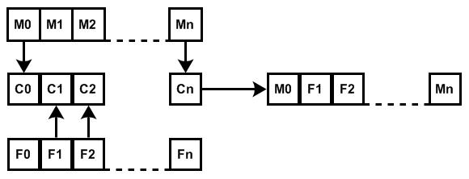
Figure 6
Example of Key Mating Process
To make a child, it is randomly decided if the mother or the father will be a donor. To be a donor for the nth position in the array means that the mother or father will place the character in the nth position in its array in the nth position of the child's array. The reproduction process continues until you have created the desired number of children. Our desired number of children is represented by:
total population - (total population * survival rate) * breed rate
The mutation process will be used to fill out the new population so that it is equal to the size of the starting population. The members kept for reproduction are part of the new population as well as the children created. The number that will be mutated is given by:
total population - (total population * survival rate) * mutate rate
Where the mutate rate = 1 - breed rate
Only the parent members will be mutated. For each mutation a parent member is chosen for mutation. Next a random number of characters are chosen to be changed. Then for each character chosen to be changed a position in the array is seleceted and a letter is randomly chosen to be put in that spot. The same position can be selected mutiple times and a letter may be replaced by the same letter.
Our GA is set to repeat this process until it has gone 100 generations, the default amount generations it is allowed to run, without finding a new best score. Every time it finds a new best score the number of generations passed is reset to zero.
Our GA is set to the Zodiac 340 cipher by defualt but we can set it to solve another cipher by supplying the cipher size, cipher width, cipher height, number of unique characters in the cipher, and a text file location of the cipher.
For fine tuning our GA we can change the survival rate, breed rate, size of total population and number of generations to run. Changing the breed rate will also change the mutate rate as the mutate rate is:
1 - breed rate
The max number of generations our GA is allowed to run is 1000000 and the max size of the population is 10000.
We have successfully implemented our GA but have not found a viable solution to the Zodiac 340 cipher yet. We have come to the conclusion that there is nothing wrong with our GA model and our GA is finding what we have asked it to find according to our fitness function. Therefore we need to make a few changes to fitness function. We have started this process and things are looking better.
Random Brute Force
Originally designed to be the main focus of our distributed processing approach, the Random Brute Force algorithm simply randomly generates 63 letters and plugs them into the solution. Obviously, the Random Algorithm is not nearly as effective as the GA or IBF.

We combined these methods into a single ‘client’ available for download to facilitate distributed processing.

7 Client Details
With our approach, we actually use two clients. The first client, which is available to the public, is the Zodiac Decoder Client. This client can run any of the algorithms, it works on a multi-threaded basis, and whenever one of the algorithms generates a key over a certain threshold, it sends this key to our server, which will be discussed in the next section.
The second client is called the “SuperClient”, or Human Reader. Unlike the main program, only by those who are to review the keys is the Human Reader accessible. The Super Client receives keys from the server and allows the user to view the words found in the current key or edit the current key, if necessary. After reviewing the key, the Human Reader can send the key back to the server. Keys sent by the Human Reader are stored in a separate list of proposed "good keys." The Human Reader can also read keys from text files, in the case that the main client could not send keys to the server. This program is necessary as it allows us to actually see and edit the results of a key and determine if the key creates a believable solution, as opposed to a random string of words or n-graphs.
Optimizing the Client
Of course, crunching such a massive amount of data required quite a bit of optimization. The first thing we needed to optimize was our dictionary for word lookup. We used a hash table class as a base for our dictionary. The hash table gives us the most efficient look up time of constant time, O(1). The dictionary class hashes each word in a text file to a memory location. In the memory location for each word, an integer score for that word is stored. Scores are initially assigned according to word length, but custom scores can be set for specified words. The dictionary serves two similar purposes for our program. First, it provides us in constant time whether or not a combination of characters forms a word, and second, how much weight that word holds.

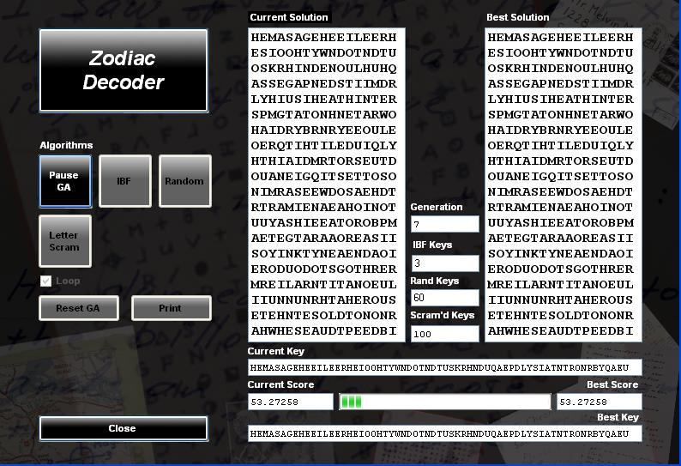
Windows threads were implemented in order to provide smooth functioning of the program as a whole. When a specific algorithm is chosen to run, it is run in a new thread. This allows the operating system control over the hardware intense algorithm. If multiple processors are available, the operating system may choose to move the thread to a less utilized CPU.
Figure 7
A Running Instance of the Zodiac Client
8 Server Properties

Our server has three primary functions. First off, our server receives keys over the defined threshold from the main client, and stores these keys, as well as essential data such as which algorithm generated the key, the number of words in the key-generated solution, the percentage of n-graphs in the solution, and the fit of our generated character frequencies, in our database. Second, the server will send keys generated by the client to a running instance of the Super Client, so the keys may be reviewed by an authorized person. Finally, the server can receive feedback from running Super Clients regarding certain keys.

9 Results
As the tuning process for our Zodiac Decoder program is ongoing, the obvious desired result of a 100% certainly cracked cipher is still far from obtained. As you examine our progress, though, I believe you will realize that our attempt has been one of the most sophisticated to date. The most important result we have collected is that a genetically mutating algorithm is the strongest decrypting process we have utilized. Our work now will deal mainly with fine tuning our scoring methods. Without proper scoring, even the most fit algorithm is useless. While we have come up with a multitude of ideas for the best way to score, we have concluded that a combination of bi-gram, tri-gram, and word frequencies is paramount. We can expect there will be a few key "solving words" that will undoubtedly aid the cipher cracking process. These "words" come mainly from our massive collection of writings confirmed to be from the zodiac killer himself. Being that our efforts include the killer's personal writings as a source lookup dictionary, we can expect to see some of these "solving words" to be the catalyst that will break the decrypting wide open (much in the way that "Ilikekilling" gave a foothold to the first solution). On that note, there have been certain phrases appearing in our key->solution attempts, which is very encouraging - we can only expect to see more and more logical phrases appearing in the future. Ultimately though, our results are not definitive enough to rule out the looming thought that Zodiac made a "junk" cipher merely to infuriate a team of college students, some 30 years after his time.

10 Conclusions and Future Direction
Obviously, our work requires more tweaking, creative inspiration, and hard work before any hard conclusions may be reached. Is the 340-cipher nothing but junk? For the hundreds of hours I have spent towards the problem, I hope not. Now, of course, we have discovered many more directions which we will take while working towards a solution. The cipher may read top-to-bottom, bottom-to-top, even as a spiral, for all we know. The cipher may actually be two distinct ciphers, divided at line 10, which both starts and ends with the symbol “-”. The cipher may even be half a real cipher, and half junk. We will continue to work to examine all possibilities. Our next step is to create a more perfect scoring algorithm. Our plan is to use a Genetic Algorithm to breed a scoring algorithm. We will do this by creating a multitude of properties which may impact the score – the more, the better. We will then randomly generate a large population of different combinations of aspects, wherein each aspect has a different weight to contribute to the score. By running the large population of scoring algorithms against many bodies of English text, we can breed a scoring algorithm which is maximized over as many bodies of text as possible. Such a scoring algorithm will approach an algorithm to determine if a body of text is English or not, and therefore will be able to give us better results as to whether or not we have created a good key, and will be extremely powerful when coupled with our key-generating GA. For now, our strongest conclusion is quite similar to our starting point: we have much to do, and the willpower to do it. We look forward to our future progress, and to eventually discover the truth behind the Zodiac Killer's 340-character cipher.
11 Index
Applied Cryptography: the use of algorithms to decrypt messages.
Substitution Cipher: an encoded message in which symbols transcribe to meaningful symbols.
Zodiac Killer: infamous 1970's serial killer responsible for the cipher we work to solve.
Genetic Algorithm: an algorithm which follows suit to evolution and nature in attempt to breed a desired result.
Intelligent Brute Force Algorithm: an algorithm which uses a brute force approach to place n-graphs in a block of text in a way in which they fit.
Random Brute Force Algorithm: an algorithm which uses a brute force approach to randomly generate a solution.
Character Frequency Analysis: an analysis of the frequencies of all characters in a block of text.
Natural Language Processing: a subfield of artificial intelligence and computational linguistics. It studies the problems of automated generation and understanding of natural human languages. Natural language generation systems convert information from computer databases into normal-sounding human language, and natural language understanding systems convert samples of human language into more formal representations that are easier for computer programs to manipulate. ^{[5]}
Distributed Processing: a computational method in which the computational work required to solve a given problem is distributed between a number of processors.
12 Special Thanks
The authors wish to thank, first and foremost, our talented group of students, we'd also like to thank Kevin Knight, Rada Mihalcea, Brax Cisco, Robert Graysmith, Mr. Chopsticks, the community at www.zodiackiller.com, all of our friends and family who have put up with us while we dedicate ourselves to the cause, Shiner Bock, and the College of Engineering at the University of North Texas.
13 References
- Graysmith, R., “Zodiac”, 1986.
- www.zodiackiller.com
- Brax Cisco
- http://en.wikipedia.org/wiki/Natural_language_processing
as of 11/30/07

a http://www.vectorsite.net/ttcode_01.html#m1 ; as of 11/26/2007
b Since there are 63 unique symbols used in the 340-cipher, his previous use of homophonic substitution ciphers, and the lack of anything that would mark it as any other type of code or cipher, we went on the assumption that this was indeed another homophonic substitution cipher.

