Zodiac Decoder

Reference Manual

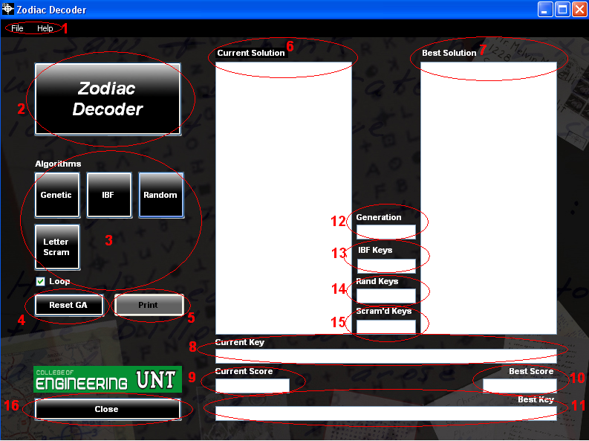

- Menu Bar
  - File
    - Exit
  - Help
    - About
Contains version information
    - Credits
Contains contributor credits
- Logo
Click to view version information. Same as Help → About

- Algorithm selection
  - Genetic
Click to start deciphering using the genetic algorithm. It will run until the button is clicked again. It can then be restarted from its current generation, or reset with the Reset GA button(# 4)
  - IBF – Intelligent Brute Force
Click to start the intelligent brute force decipher algorithm
  - Random
Click to start the random decipher algorithm
  - Letter Scam – Letter Scramble
Click to start the letter scramble decipher algorithm
- Reset Genetic Algorithm
If the genetic algorithm is paused, click to restart from the beginning
- Print
- Current Solution
Displays the current solution being scored in plain text
- Best Solution
Displays the highest scoring solution in plain text
- Current Key
Displays the current key being scored
- Current Score
Displays the score of the current key
- Best Score
Displays the score of the highest key tested
- Best Key
Displays the best key scored
- Generation
Displays the generation of the genetic algorithm
- IBF Keys
Displays the number of keys the Intelligent Brute Force has scored
- Rand Keys
Displays the number of random keys scored
- Scram’d Keys
Displays number of scrambled letter keys scored
- Close
Exit program

Note: To minimize the Zodiac Decoder to the Windows system tray, click the icon in the system tray!
