Cheeze of Insight

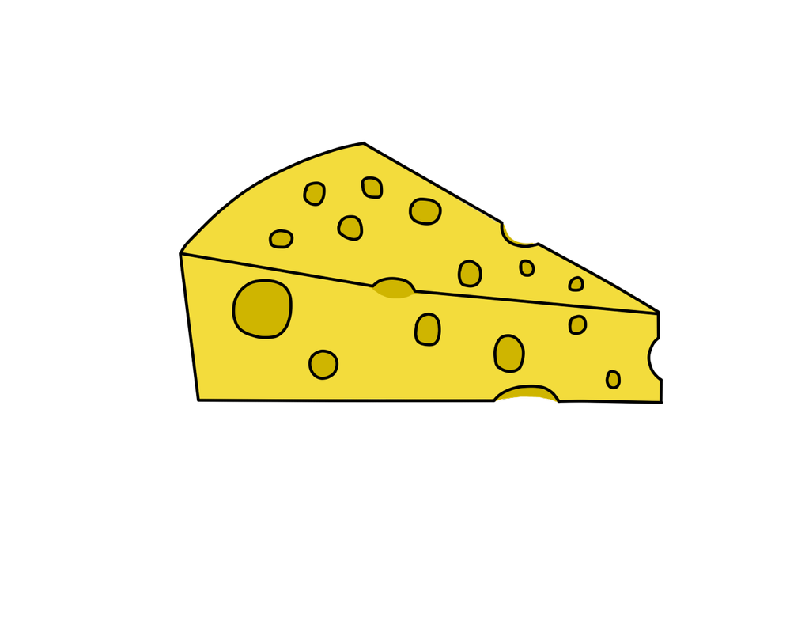
"I’ll so offend to make offense a skill,
Redeeming the time when Cheeze Wizards think least I will." — Shakespearean Wizard

TECHNICAL PROPOSAL: 1.0.1
Published: 8/14/2019
Last Updated:8/30/2019

1 ABSTRACT

As a team built from players of Satoshi’s Treasure we’re uniquely aware of the role statistics can have on gameplay and player psychology. Enter Cheese of Insight. The Cheeze of Insight DApp is a web application and browser extension designed to enrich player psychology in Cheeze Wizards gameplay by providing methods for realistic and test battle predictions, and a module for doing deep analytics of battle history. More specifically, The Cheese of Insight DApp approaches player psychology using a three-pronged method that includes: an Analytics component, a Battle component, and a Prediction Market component.

- Analytics Component:

  - The Analytics Component and its UI, provides players of Cheeze Wizards with a frontend for analyzing individual Wizards and tournament battle history.

- Battle Component:
  - This component is made possible by our modified battle contract that can import specific Mainnet Wizards and import into our own contract deployed on Rinkeby; this allows players to battle replicated versions of their Mainnet Wizards in a test environement against other replicated versions of Mainnet Wizards.

  - The Battle component is included in both Offline and Online component layers.

  - In the Offline Layer, players can play their Wizards in test matches against replicated versions of Mainnet Wizards.

  - When playing a test match, the player invoking the Duel chooses whether they wish to dictate their opponent’s turn commitments, or have the turns dictated instead by an AI player. The AI player we’ve created, analyzes a Wizard’s match history, and attempts to find patterns in that Wizard's battle history. Like a fine cheese, our AI matures with age, so our AI's predictions will become more trustworthy as the tournament progresses.

  - In the Online Layer, analytics collected from tournament battle history is used by our AI to create predictions about outcomes of power level changes in a given day's Dueling window that will be used for the creation of Prediction Markets, as well as provide the data set for our AI player for test Duels.

  - When the tournament enters Phase III, the live Duel predictions created by our AI will be used in to create LONG and SHORT weightings for the Prediction Market component.

  - Since the reliability of our AI's match predictions is in many ways proportional to the data available from a tournament’s match history, we can say our AI begins a tournament “dumb” and ends the tournament “smart”.

- Prediction Market Component:

  - Decentralized prediction markets can be used to generate sets of tokens that represent a financial stake in the outcome of any event.

  - By combining the 0x Protocol with an Augur prediction market (using open source code from Veil—https://github.com/veilco/veil-market-creation), once Phase III of the tournament is reached our platform begins launching prediction markets to speculate on outcomes from each day's Dueling window.

  - Before each Duel window, 2 types of markets will be launched by our platform, providing a total of 10 Augur prediction markets launched daily throughout Phase III of the tournament:

    - Market type #1) 5 separate markets will be created to bet on whether each of the 5 most powerful Wizards will either increase or decrease in power level. If the Wizard's power level does not change, all bets will be returned at their original value.

    - Market type #2) 5 separate markets will be created to bet on whether the 5 most "volatile" Wizards from the previous day's Duel window, will either increase or decrease in power level. If the Wizard's power level does not change, all bets will be returned at their original value. Note, we consider the 5 most "volatile" Wizards to be the 5 Wizards whose power levels fluctuated by the greatest margin in the previous day's Duel history (perhaps one indication of the most active players).

  - Using 0x, the order book for the prediction market is kept offline to limit gas transactions and both LONG and SHORT tokens are merged into a single order book to be transacted on Augur as complete sets.

  - As the Blue Mold begins to show its effects, this Prediction Market will become a place where players who no longer have Wizards in the tournament ("rind-in-the-game") can continue to follow and participate in the game while remaining emotionally invested and incentivized to do so.

"Like a fine cheese, our AI matures with age"

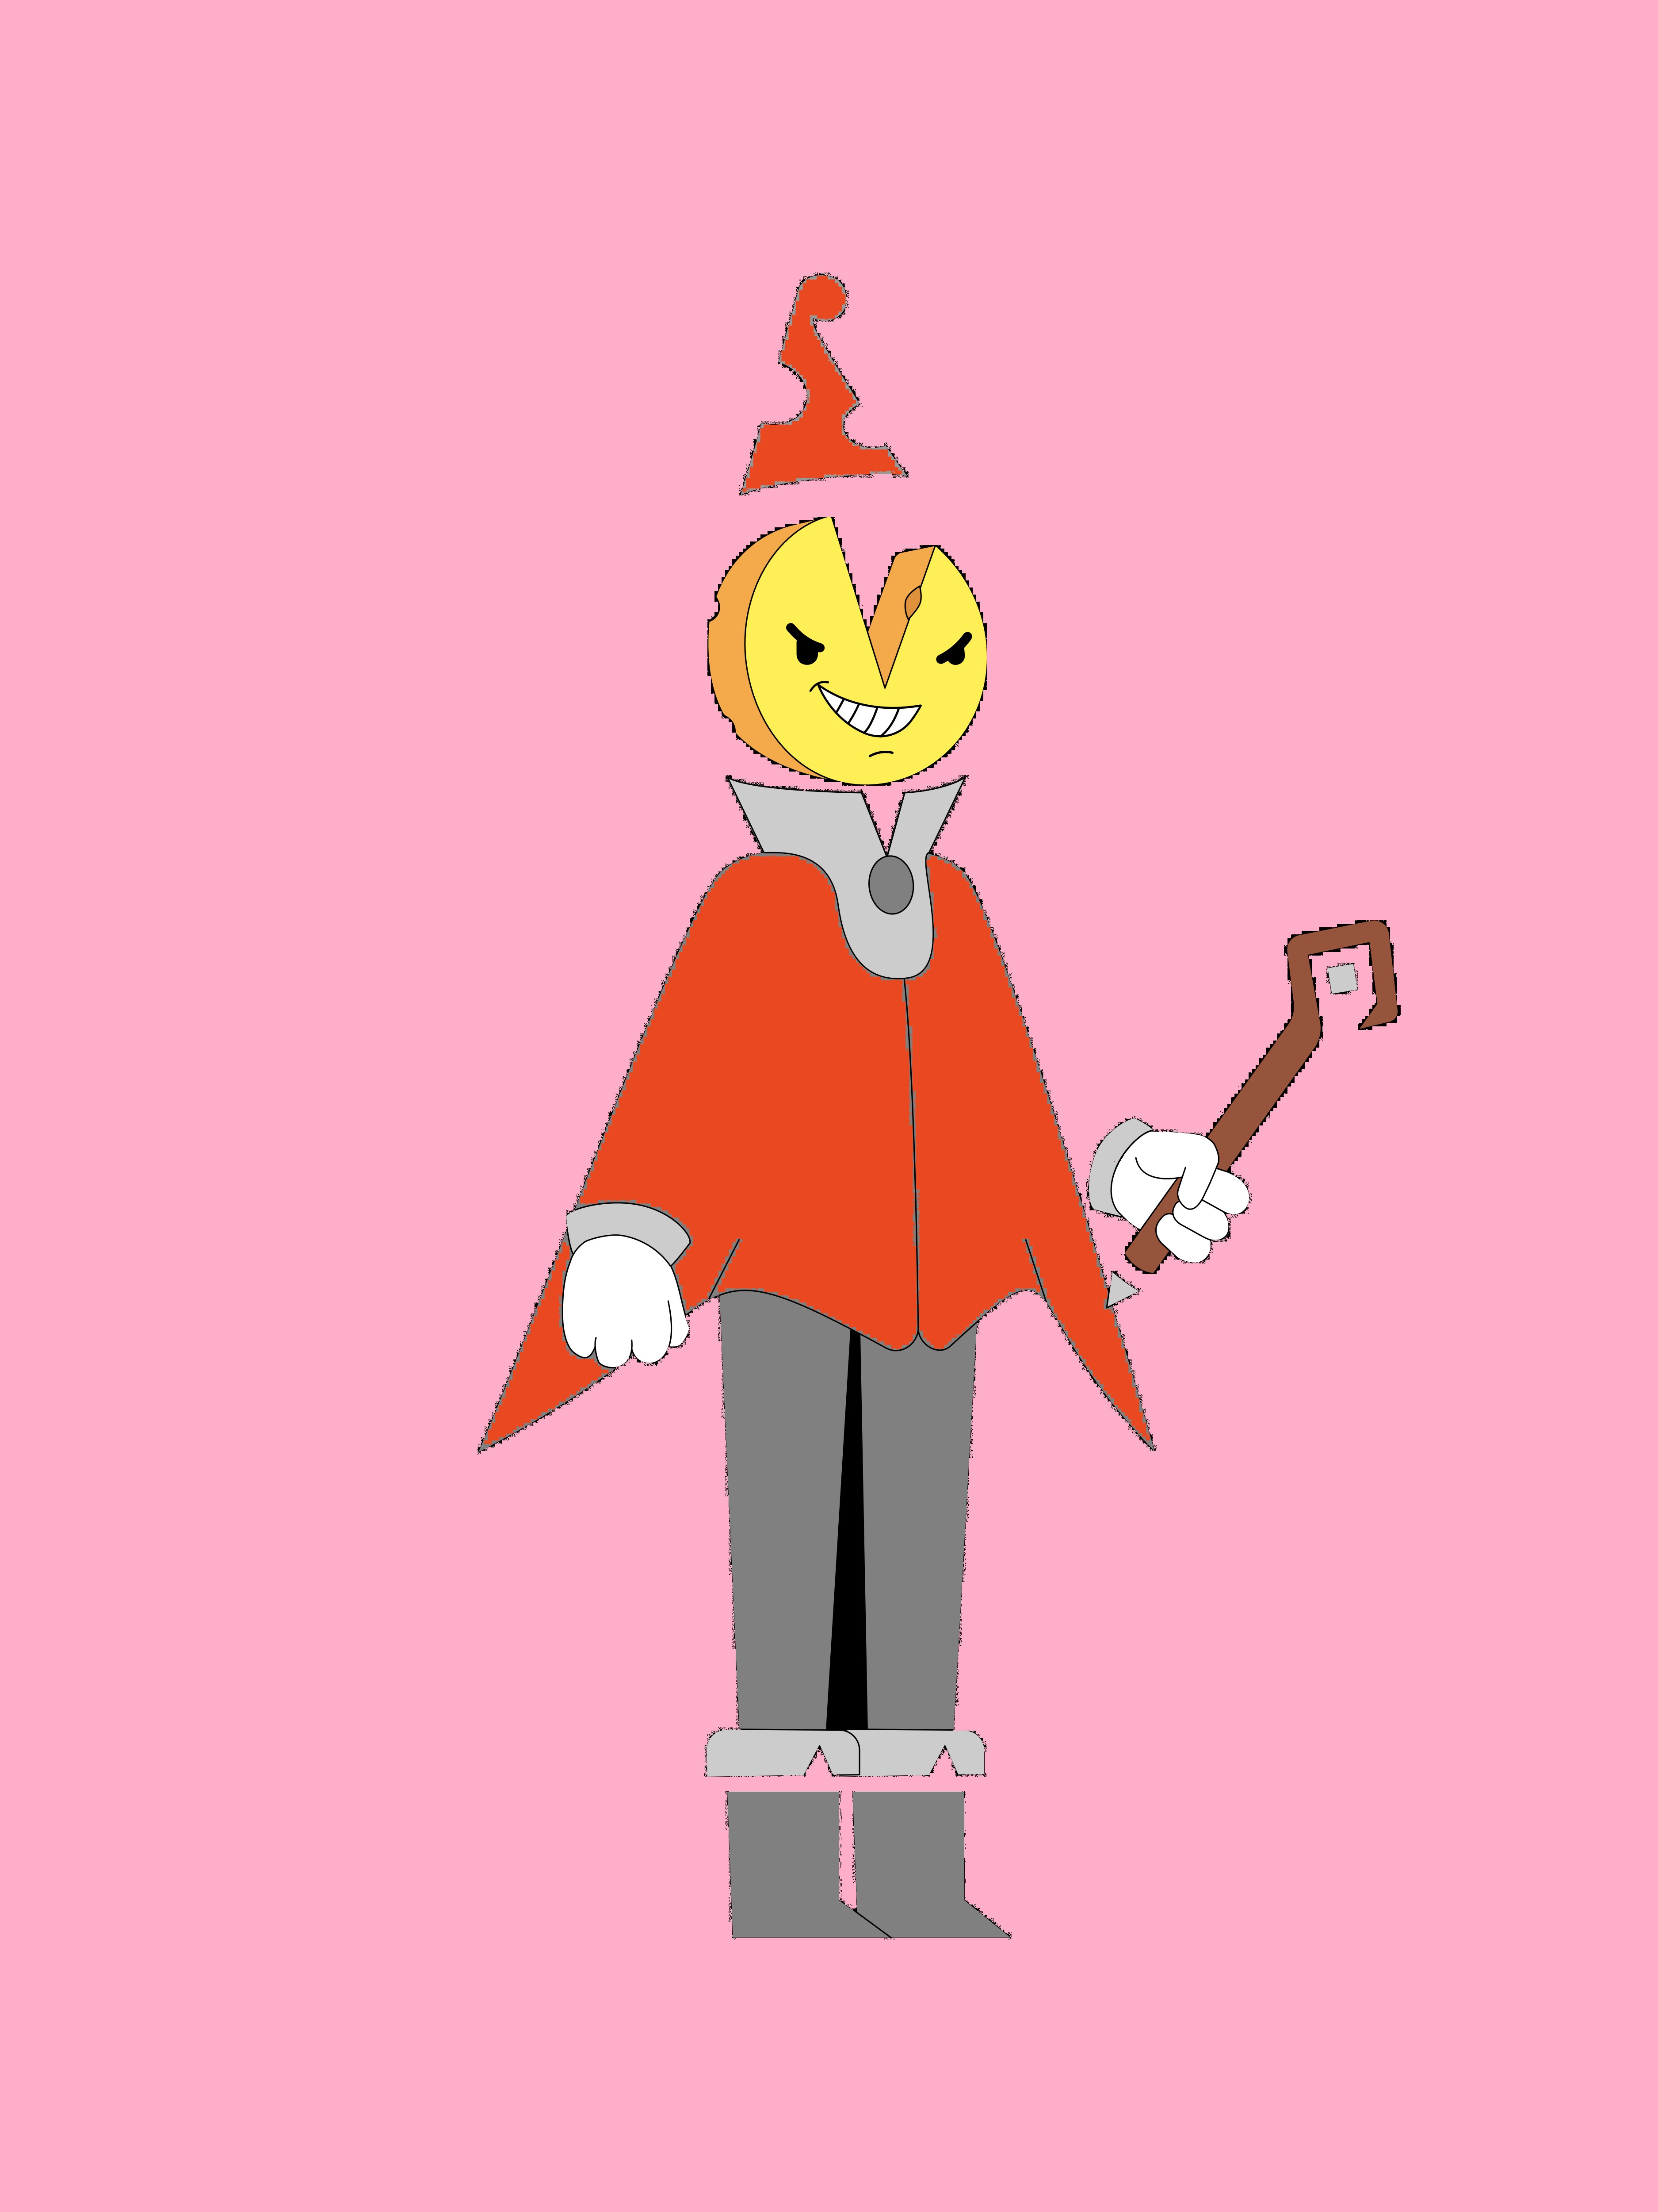

2 TERMINOLOGY

Layers:

The terms "Online" and "Offline" layer" refer to Duel availablity. Components which rely on the Dueling window are part of the "Online" or "Real-Time" tournament integration. However, data and analtyics tools which are usefull outside of the Dueling window (example: test duels using replicated Wizards), are considered to be part of the "offline" layer.

Why Have an Offline Layer?

Creating an environment for participation outside of the Dueling window promotes a healthy player culture. It also gives Wizard summoners the ability to prepare and train their Wizards, and their own psychology, for future battles while getting a feel for the game in a controlled environment.

Betting:

- For the purposes of the Prediction Market component, “bets” can thought of as either LONG or SHORT, and regarding a prediction that some Wizard's power will either increase or decrease during the next Dueling window. Augur prediction markets have two outcome shares and these are unique ERC-20 tokens representing a distinct answer to a market’s question which we can call “LONG” and “SHORT” tokens. LONG and SHORT tokens must be transacted as complete sets that equate to 1 ETH. Example set: 0.2 ETH LONG, 0.8 SHORT).

Given the above, we can take the terms LONG and SHORT to mean as follows.

LONG BETS:

A given Wizard's power is expected to increase in the next Dueling window, or, expecting an increase in value of the LONG token.

SHORT BETS:

A given Wizard's power is expected to decrease in the next Dueling window, or, expecting an increase in value of the SHORT token.

COMPLETE SETS:

A perfect factor of 1 ETH transacted as a pair. Another way to think about this transaction is it is like a sliding scale, between the SHORT and LONG token pairs, that always balances to 1 ETH.

ORDER BOOK:

The “order book” can be thought of as the total transactions of a particular prediction market, for a given Wizard, in reference to a specific day's Dueling window. All bets will be taken by the contract before a Dueling window is available. Bets will then become locked while the Dueling window is active, and the market will expire, and can be reported on, as soon as the the day's Duel window is expired and all transaction resolutions are confirmed.

Since Augur enables you buy and sell complete sets of shares for ETH. By buying and selling complete sets on behalf of the betting user, the Cheeze of Insight smart contract (adapted from Veil https://github.com/veilco/veil-market-creation) merges orders for LONG and SHORT tokens into a single order book. Furthermore, using the 0x Protocol, our contract executes trades on behalf of our user base off-chain, which dramatically reduces the overall gas required to power the prediction market. The on-chain transactions that necessarily need to occur are:

- Initial placement of any LONG or SHORT bet (e.g. the bet)

- Final settlement of the order book after a particular Dueling window has resolved and the market is expired (e.g. the settlement)

3 DEVELOPMENT WORKLIST

Methodolgy:

The suggested workflow (seen below) is designed to optimize modularity and create a development workflow where each component can be worked on individually. There should be a limited amount of interdependence between the various components during the POC stages of development, and developers can work on a component autonomously or in combination with the team.

- Analytics Component:
  - POC Application - ALMOST DONE – Missing Requirements:
    - Connect current POC to Dapper to get “My Wizard” from user's actual wallet. This feature will also ultimately act as a login for the DApp. - DONE
    - Integrate Duel history data of Wizards and test accuracy of metrics using test duels (requires completion of Battle Predictions AI player)
  - Stage 2: convert to browser extension
  - Stage 3: implement design / branding

- Battle Component
  - CONTRACTS POC – ALMOST DONE – Missing Requirements:
    - Re-launch existing tournament and minting contracts with shortened Phases and successfully complete a tournament with 2 Wizards
    - Modify existing contract code to allow for importing of any Mainnet Wizard so that test Duels can be executed by the Offline Layer of the DApp. - DONE
  - Stage 2: Launch 3 simultaneous versions of the contract (either multiple contract addresses, or multiple instances within the same contract address) with a contract instance for each Phase of the tournament. This will be used in our submission to demo how the DApp behaves during each of the 3 Phases of a tournament.
  - AI POC – NOT STARTED. Requirements:
    - In normal Duels (e.g. conducted under conditions where neither Wizard is Ascending) having a higher power level than the opponent does not provide any inherent advantage regarding win / loss of the match. So we can say that Duels are like a glorified game of Rock, Paper, Scissors with the addition of Affinity / Vulnerability stats. The first step in creating our AI will be bootstrap the source code and strategies of this open AI project (https://svilentodorov.xyz/blog/rps) and get it running.
    - Once the base AI source code is confirmed to be running correctly, we'll need to modify the source code to account for Affinity / Vulnerability damage multipliers. At this stage testing can still be done using a fork of the Rock, Paper, Scissors demo page (https://svilentodorov.xyz/rps).
    - Stage 2: Connect the created AI to the smart contract and complete a test Duel and add AI analytics to a Turn Predictor view in the Analytics Component.
- Prediction Market Component
  - POC – NOT STARTED. Requirements:
    - Bootstrap this source code from Veil (https://github.com/veilco/veil-market-creation) and test creating a prediction market, placing bets and settling the order book after the market deadline expires.

4 DELIVERY SCHEDULE

- SUNDAY, AUGUST 18: – GOAL MET
  - Project management documentation (high level overview, delivery schedule, workflow, and tasks distributed to devs)

- SUNDAY, AUGUST 25: – GOAL MET
  - Quasi functional POC's for Analytics Component

- SUNDAY, SEPTEMBER 1: – IN PROGRESS
  - Quasi functional POC for testnet dueling
  - API Duel data included in the application Analytics (Note: since calling the Duels endpoint returns an empty array - use a static JSON file for testing this data. Should be based off copying the API documentation of the return data format)

- SUNDAY, SEPTEMBER 8:
  - Quasi functional POC's for Battle Component AI, and Prediction Market component.

- SUNDAY, SEPTEMBER 15 (CONTEST SUBMISSION DEADLINE):
  - Branding and design finalized and integrated
  - Analtyics, Battles, and Prediction Markets finalized, built and integrated into final DApp (/src folder)
  - 3 fresh contract instances of the tournament contract to be: created, deployed on Rinkeby, and implemented into the DApp (1 contract instance for each tournament phase)
    - (This will be used to demo how the DApp will behave during each separate Phase of the tournament)
  - Final DApp tested
  - Project submission package created (e.g. all product documentation text finalized)
  - Video demo of the DApp created, uploaded to YouTube and link to video added to the final Coinlist submission in the “video” field

5 BRANDING GUIDELINES

Official Cheeze Wizards branding and lore guidelines for 3rd party developers:
https://docs.google.com/presentation/d/1bK8yWTjkhNlM1w0-hfRhaStCeBxY8yEHI3fZGOP0EXo/edit#slide=id.g5e2d0fd546_1_0

Official Cheeze Wizards developer design assets:
https://drive.google.com/drive/folders/1yZTs7epElKYVaDLMrpC6wRE5LdVZXbXT
