It’s a Queer World After All:
Studying The Sims and Sexuality

Professor Mia Consalvo, Ph.D.
School of Telecommunications
213 RTV Building
9 South College Street
Ohio University
Athens, OH 45701

(740) 592-1521
consalvo@ohio.edu

It’s a Queer World After All: Studying The Sims and Sexuality
By Mia Consalvo, Ph.D.
Although Nikki and Roxann couldn’t get married, they bought formal gowns and diamond rings downtown, then threw a party for their Commitment Ceremony. They exchanged rings and kisses, took pictures, and hired a female entertainer to jump out of a cake for their guests. (The Sims: Hot Date)

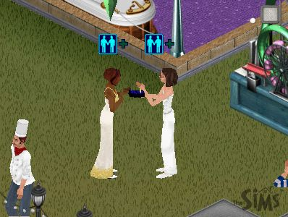
The previous situation and screenshot were created through gameplay with the best selling computer game to date—The Sims. The game was released in 2000 by Electronic Arts/Maxis, and has sold more than 6 million copies (gamezone.com, 2002). Its expansion packs (Livin’ Large; House Party; Hot Date; Vacation; Unleashed) have quickly climbed the sales charts with their releases as well. Additionally, a version of The Sims was released for the PlayStation 2 game console, and The Sims Online debuted in December 2002. A game of electronic dollhouse, The Sims appeals to men and women, kids and adults, in huge numbers. The game’s success is significant in many ways—it is attracting more women players than other games, it is expected to help online gaming go mainstream, and, most importantly for this study, it allows players the chance to create worlds of their own choosing—worlds that can include “Sim” people of varying genders, races and sexual orientations who coexist without homophobia, racism or sexism. Just how is that accomplished? Why is the game so successful? This study seeks answers to those questions.
Computer games have been around for more than 30 years, yet studies that go beyond investigating violence, aggression, and concerns about children’s playing are just now gaining attention. A few scholars in the mid-1990s wrote about games as important cultural texts that should be studied in ways different from mass media texts, but only in the last few years have new theoretical approaches such as ludology (the study of games as spaces to be explored) gained prominence (Aarseth, 1997; Banks, 1998; Fuller & Jenkins, 1995; Murray, 1997). Yet, just as the newer theories help us to understand the unique properties that games bring to mass entertainment, they should not stand alone as they only way to understand games or their place in contemporary culture. Linking those approaches to critical and cultural studies, as well as to the perspectives of queer theory and feminist theory, can lead to greater insights into how games can challenge as well as reproduce ideologies, and into how those particularities are expressed in digital games—which are quite different from television, music, and other forms of popular entertainment.
Ideological studies of games have examined how gender is depicted and expressed in games (mainly through representations of female characters), as well as how games (such as the city-building simulation SimCity) reveal conservative and/or liberal biases (Cassell & Jenkins, 1998; Friedman, 1995). However, one area that has been neglected is the study of sexuality in games—how sexual orientation is presented (or omitted), and how sexuality and sex are programmed, displayed, and played out. While researchers have studied gay visibility in other popular media (Gross, 2001; Tropiano, 2002; Walters, 2001), the study of sexuality in games has been overlooked. From early games such as Donkey Kong and The Legend of Zelda, rudimentary plot lines to establish the goals of the game have been heterosexist in nature. “Rescue the princess” themes, widely recognized as a basic device for motivating action, present a female princess in need of rescue by a male protagonist—Mario, Link, or other male avatars. The rather simple goal of saving the princess to win the game is not remarked upon by researchers, except for its stereotypical treatment of women (see Banks, 1998; Okorafor and Davenport, 2001). But the goal’s “taken-for-granted-ness” in terms of its reliance on heterosexual relationships demands to be made visible and examined in detail.
Examining contemporary games even cursorily reveals such presumptions. Game makers such as Square persist in presenting familiar “rescue the princess/damsel in distress” themes, such as in their top-selling 2000 game Final Fantasy IX. Additionally, “properly normed” characters are predominant, such as male avatar characters who (in cinematic cut-scenes that players do not control) regularly flirt with sexy female characters, and who respond in homophobic fashion if other male characters proposition them. They can be found in “macho” games such as Duke Nukem and more “innocent” games such as the farming simulation series Harvest Moon and the role-playing game Okage: Shadow King, which each feature a 10-year-old boy as the central character. Finally there is the presumption by game marketers of heterosexual (and predominantly male) players. For example, the game magazine Electronic Gaming Monthly, which has a mostly male readership, regularly extols games that provide the best “eye candy” for players—such as Metal Gear Solid 2’s placement of girlie pin-up posters hidden in lockers in the game, or speculation over the (possibly increased) chest size of Tomb Raider’s Lara Croft in the series’ latest installment. And while female characters such as fighters in games like Tekken Tag and Street Fighter are noted for being fierce competitors, their looks are centrally featured in game reviews, while male characters’ skills are mentioned, yet their physical attractiveness is almost never discussed.
Significantly challenging that state of affairs, however, is the best-selling computer game The Sims, which provides little to no heterosexually biased content. Rather than explore how and why sexuality is such a common feature across a number of games, this study instead examines how sexuality and sexual orientation are expressed in The Sims and three of its expansion packs: Livin’ Large, House Party, and Hot Date. The Sims does not follow the heterosexual-male hegemonic mindset, and it is also unlike the majority of games that involve fantastic scenarios, linear narratives, and high-adrenaline action. What features of the game make it so popular then, especially with game players outside the “core market” of young, adult males?
The Sims is a game in which players simulate a neighborhood. Players can build houses and create Sim families composed of multiple individuals (see figure 1). The player controls the Sim characters as they perform mundane daily activities—making friends, working, eating, taking showers, having fun, and getting the proper rest. The creator of the game, Will Wright, has stated that he feels The Sims isn’t actually a game at all, as there is no “winning” or proper end to the game—no princess to win or evil to defeat or high score to post. Instead, he terms his creation a “software toy,” as gameplay is open-ended and the game is more about exploration and creativity than it is about finding some hidden solution.
And because of its insistence on modeling “real life,” the game needs to be studied to determine just how close it comes to achieving that goal. As game critics such as Stephen Poole (2000) have noted, when games attempt to become “too real,” the result can actually become reduced enjoyment in the game (that is why players get multiple lives in most games—if they died too easily and the game ended too soon, their fun would be impeded). How is that concern dealt with in The Sims? More centrally for this paper, how are the real-life aspects of sexuality and sexual orientation addressed? To answer that question, textual and content analyses of the game and its three expansion packs were performed, with attention to the following more specific questions:
- How is the game played, and how (and to what degree) does it approximate real life?
- How are sexual orientation and sexuality treated in the game?
- How does avatar creation work, and how does this creation address issues of diversity of race, gender and sexual orientation?
- How are Sims programmed to interact socially, and what is the role of sexuality in those interactions?
- What role do objects play in Sim interactions, including romantic and sexual interactions?
- What role does money or wealth play in the game?
- Are issues of homophobia present or addressed in the game, and if so, how?
- What is the goal of the game, and how is sexuality a part of that goal?

To answer those questions, a critical, feminist/queer ludological approach was taken to studying The Sims—the game’s interface, its objects, the social interactions between characters and the play spaces provided. For this study, more than 30 characters were created in various combinations of “families,” at least a dozen houses were built, and more than 300 game “days” were played. Analysis of the game’s interface was undertaken, and social interactions were consistently logged. Furthermore, a database of objects was created — including their interaction options and how those options changed (or did not) through gameplay and how those objects possibly facilitated romantic relationships and enabled heterosexual, homosexual, as well as bisexual activities for Sims to experience. The analysis is based on the following theoretical foundations.

Theoretical foundation
To best understand The Sims and how the game functions—as interactive media as well as ideological artifact, we should consider a combination of theories. Ludology theory attempts to understand digital games as spaces of exploration and play—the theory argues that player engagement with the virtual world is more important than any story being told (Juul, 2001). Ludology theory applies very well to The Sims, as there are no “official” storylines to play a part in—players have the option to devise “dramas” for Sims to engage in (will he/she get the boy/girl; etc), but players can alternately focus on building and decorating houses, and experimenting with Sim social interactions. To approach The Sims as a play space for exploration leaves open the possibility that players may or may not use narratives in their gameplay. What is important are the spaces and tools available: the potentialities of the game. In addition to ludology theory, this study relies on critical/cultural and feminist theory by suggesting that popular culture artifacts are significant and important objects of study. As markers of their times—the social, political, cultural and historical products that they are—digital games are well-positioned to allow insight into dominant ideologies as well as to provide the occasional space for challenging those ideologies. Digital games are becoming an important part of culture, and they provide an important site for critical analysis.
As part of a cultural/critical perspective, this analysis also employs queer theory, as it questions the fixity of identities such as “heterosexual” and “gay” or “lesbian.” Queer theorists (as well as some feminist theorists) suggest that we need broader categories for understanding how sexuality is expressed, and how it becomes constituted as part of specific identities. Queer theory is also helpful as it questions all sexual practices and their current classifications—specifically the stability of identity categories as related to sexualities. Queer theory will be useful in understanding how The Sims plays with sexuality and questions sexual orientation as a core aspect of identity. Additionally, queer theory allows us to question what is meant by “sexual orientation,” “homosexual,” and “heterosexual” within the context of Sims gameplay. Specifically, it allows us to understand what it means to create queer Sims. How are “gayness” and/or “queerness” enacted through gameplay? This study explores how The Sims questions (and ultimately destabilizes) identity categories as they pertain to sexuality and sexual orientation.

Playing The Sims
To help people learn to play The Sims, an instruction manual is provided with the software, and a tutorial is built into the game that contains a “sample family” of Bob and Betty Newbie. Yet most information on how to play the game is drawn from the user’s own life experience. Game reviewers have noted the remarkably simple game interface that is used (see figure 2), providing players with controls that are intuitive and easy to use. Each Sim has six status bars that range from completely red (very bad) to completely green (fully satisfied). Each status bar relates to a different need, and are mostly self-explanatory: Bladder; Hygiene; Comfort; Hunger; Energy; Fun; Social; and Room (the rating of how much or how little a Sim likes the room it is in—based mostly on roominess, cleanliness, and decorations). Part of the simplicity is the game’s premise of being drawn from real life—we all presumably know what a full bladder means, and how to resolve that “problem” for an afflicted Sim (direct it to the nearest toilet). And as explained later in more detail, building Sim houses is also fairly self-explanatory. Novice players quickly can move on to running Sims’ lives in microscopic detail.
Although players can tinker continually with household design and appliances, most attention is likely spent on having Sims live their daily lives. That includes everything from getting them prepared and off to work (Sims then disappear from view and can’t be manipulated until they return home), to making sure they have adequate fun and social interaction during their “off hours.” The Sims is very much an electronic dollhouse, and the player decides which characters will talk to whom, when dinner will be served, and how often the bathtub should be scrubbed. As Wright intended, there is no “end” to the game—characters can gain skills such as cooking (so they won’t burn down the house) and logic that will help them in their careers. They can build bigger and better houses. They can have fun and socialize by throwing parties and (in the expansion module The Sims: Hot Date) spending a night on the town. Although players can create multiple Sims, they must play each Sim in turns (Sims are controlled as individuals, not as groups). And when Sim characters are visitors in others’ households, their mood status indicators are not available to monitor. Thus, Sim interactions are easy to learn but tricky to master, and that is where the heart of the game lies.
To interact, a player chooses one Sim to be “active” (the one selected with a green diamond floating over its head—see figure 3), and then clicks on the body of another Sim with the cursor. Above the selected Sim appear options from which the player can then choose (see figure 4). Some interaction options have multiple sub-options as well (see figure 5). The options change over time and with different Sims, depending on each Sim’s mood at the time and his or her relationship with other Sims in the room.
When Sims first interact (they are all strangers to one another at first), they will start with a limited set of interaction options, beginning with “greet,” and after that progressing to options such as “talk,” “joke” and “ask to leave.” The effects of interactions can be monitored in two ways—by watching the plus or minus signs that appear above Sims’ heads during interactions (which indicate positive or negative interactions), and by monitoring their relationship scores (see figures 6 and 7). The multiple interaction options that appear in The Sims: Livin’ Large and House Party are listed in Table 1, and the expanded options offered in Hot Date are listed in Table 2 (note that the lists shown were available after extended gameplay, but even more options might still be available as the game progresses).
Sim relationships are important. They will help each Sim keep his or her “social” score high. Also, as Sims advance in their careers, the game requires them to have some (increasingly higher) number of Sim family friends for further promotions. If a Sim offends other Sims and refuses to make friends, the offending Sim will have no one to call to come over, or alternately, the offended Sims will refuse to visit the offender. Sims with extremely low “social” scores tend to cry incessantly and cannot be motivated to find jobs, study, or clean. Thus, friendship is important to gameplay. A Sim is friendly from the beginning but becomes a “family friend” when the relationship score reaches approximately 50 (the typical maximum is 100). Sim friendships must be maintained through frequent interactions, or the relationship scores will decrease over time, and the Sim friendship will be “lost.”
Sims that have become friends also can become romantically involved by kissing, and at that point, a heart will appear in their relationship scores. Sims’ relationship scores cannot go above 100 (perfect), but can devolve into negative scores. While Sims appear to need friends for sociability and career advancement, they do not “need” to be romantic with any other Sims. They can also be casually romantic without “committing” (proposing or asking to move in) to any particular Sim — or any number of Sims.
Those are the basics of the game, but more details are given in each of the following four analysis sections. Those sections examine how Sim avatars are constructed and the significance of the choices offered; how Sim sociability and sexuality are played out in interactions and how that constructs sexuality in novel ways; how objects mediate interactions by helping or hindering happiness and romance; and, finally, how the emergent nature of gameplay offers more “queer” options for players to confront, and how those options help lead to the success of the game.

Creating Sim Avatars—Gender, Race, and Sexual Orientation
When creating a Sim, a player has many choices to make, including: gender, “shade” (skin color), child or adult, personality traits, and head and body appearances. They can all seem important, and on a surface level they are, as they allow users to create avatars that are highly divergent and more variable than characters in most other digital games currently released. Character/avatar creation is a central component of gameplay in The Sims, and with each new expansion pack, the addition of more “heads” and “bodies” is an important selling point. And unlike other games with avatar creation tools, all Sim possibilities have human features, which gives game players more opportunities to create avatars that either closely resemble themselves, or let them figuratively try on a different-but-realistic “skin” for a while. Because creating simulated people is so central to the game, it is critical to analyze just how gender, race and sexuality coalesce in avatar creation through the options that are offered or are (significantly) absent. In particular, examining race and gender in tandem with sexual orientation makes clear how diversity operates or is absent in The Sims. Thus, rather than focus solely on orientation, and risk reinforcing norms of whiteness, for example, all facets of “identity” are brought up for examination and critique.
To begin, all players must start with the character creation screen. After selecting a “family name” for a Sim family (which can include as many or as few Sims as the player wishes), a screen appears inviting the player to create a Sim by selecting choices from the following options: child/adult; male/female; light/medium/dark shade; various heads and bodies, and personality points (see figure 8).
Although all Sims in a family share the same last name, the family doesn’t necessarily have to have a “father” or any other patriarch. This kind of egalitarian difference is played out continually, as whenever a Sim proposes to another, and receives a “yes;” the proposed-to Sim takes on the family name of the proposer, whether the proposing Sim is male or female (see figures 9 & 10). Likewise, when Sims move in with one another, the Sim moving in takes on the name of the household, regardless of whether their relationship is platonic or romantic. Family names in The Sims seem to hold the significance of “team” names, as Sims, like players, can be traded back and forth multiple times, and take no offense at the change. Each “move” is positive, and Sims left behind don’t seem to care much about the loss. They still can visit their former roommates and spouses, often bearing gifts and goodwill (figure 12). Alternately, the game’s insistence on one common name for Sims living under one roof can recall more conservative ideas about “family” structure and beliefs about proper relationships and the importance of maintaining a common identity rooted in patriarchal culture. However, the lack of a controlling patriarch does moderate this trend.
Most of the creation options involve appearance — gender, skin color, body shape, and facial features. It is interesting to note the The Sims has no “race” option, but rather offers three skin “shades” (light, medium, and dark) that may be read as racially diverse, but have no real impact on gameplay. Although players can certainly make Sims dress and behave according to different cultural norms, the Sims themselves are not inherently cultured according to race. Nor are they inherently cultured according to gender (see figure 11 for an example of a dark-shaded Sim).
Players’ choices for heads show different faces and hairstyles, so players can choose a light female head, for example, that features blonde upswept hair, or electric blue hair in a ponytail. Darker shaded heads feature mostly darker hair choices, although there are a few blonde as well as green-haired dark-shaded female heads. Bodies mainly feature clothing options. Bodies and heads are chosen independently, and the number of available bodies and heads differs in each game and expansion pack. With each expansion pack the number of heads and bodies increases, so players can construct a wider variety of Sims. However, as seen in the following chart detailing the total number of head choices for all four games, there are more heads available in the light shade than in the medium and dark shades for both men and women.

“Head” choices for children (both boys and girls) also diminish as complexion shades darken (for light/medium/dark, girls range from 12, 10, and 9 heads, respectively, while boys’ heads go from 12 to 10 to 8). There are two interpretations of that data. More optimistically, if the three skin hues are read as racial “coding,” with Caucasian, Hispanic/Asian and African-American corresponding to light, medium, and dark, there are more choices available for medium and dark complexions taken together, as indicated below.

That mirrors the growing changes in U.S. population, as whites become a minority population. More pessimism can come from another reading, however. Taking each category separately, more choices are offered to the player creating a “light” shaded Sim. That reading suggests whiteness continues to be a norm, with more choices and more diversity offered to those of light complexion.
The numbers of bodies available lends credence to that more pessimistic view. As mentioned, the bodies available are mainly a way of choosing clothing for a Sim avatar and are chosen independently of heads. Although a few Sims are noticeably overweight (mostly male Sims) or plump (a very few female Sims), none are obese or show any physical impairments. Thus, body selection centers on fashion choices, and most of these fashion choices (and corresponding number of bodies) is the same for each “shade” of Sim.
However, the number of adult male bodies, or fashion choices for male Sims that a player can choose from, noticeably differ in number based on shade. If a player chooses a light shaded male head, 57 bodies/fashions are available; if a medium shaded head is chosen, 48 bodies/fashions can be chosen from; and if the player chooses a dark shaded male head, 49 bodies/fashions are available to choose from. The majority of these body choices (44) are identical for light/medium/dark bodies, but a few vary. Thus, medium and dark shades have a few exclusive fashions of their own (2 medium only and 4 dark only), but there are an additional 12 bodies/fashions are available only for light shaded males. For example, the baseball uniform for the “Llama’s” team and a Robin Hood-style outfit are available only to light shaded male Sims. If a player chooses either one of these bodies first, and then attempts to put a dark shaded head on the body, that body disappears from view—it is coded as for “lights” only.
Although the majority of fashion choices are available to all “shades” of Sim, it is troublesome that the number of bodies available for the darker shades of men should shrink. Why should there be fewer fashion choices for more darkly shaded Sims? (Female bodies do not vary so greatly.) If more darkly shaded Sims are read as “African-American,” the question becomes even more problematic. The numbers of African-Americans playing The Sims is not publicly available data. If they play in fewer numbers, does that lead to less “representation” in the game? Fewer darker “heads” can be interpreted to suggest racism (less interest in these avatars; they all “look alike” anyway) or perhaps the more innocuous (black players are a smaller audience; fewer hairstyles are available for “black” hair), but neither of these options is satisfactory. Combined with a shrinking number of “dark bodies,” charges of racism (even if unintentional) gain stronger footing. Game makers often respond to such criticisms by claiming limited space and time for creation. But choices must always be made about what to include and what to exclude, and it is important to point out where these shortcuts or “trimmings” are, and question the possible reasons for these cuts, and their ideological ramifications.
Given that, head and body options in The Sims suggest greater diversity than most games, but these options also reveal limitations which suggest that while diversity is important, core audiences will drive content, or perhaps unconscious racism will fail to be examined, leaving whiteness/lightness as an uncontested norm.
The head and body options made available for Sim avatar creation, and the juxtapositions they offer for constituting families can lead to conservative, progressive, and transgressive ends, depending on player input. Mixed shade/race relationships and households are just as easy to create as single shade/race households. Likewise, the option to create any sort of household combination offers new ways of defining the term “family” and how it should ultimately look. A “darkly-shaded male gladiator” can cohabitate with a light-shaded, blond male in 50s attire, along with a medium-shaded, active young boy wearing a cape and party hat.
But while Sims’ races or shades have little consequence for gameplay, as there is no racism in the game—no discrimination in education, employment, or individual relationships — gender has a bit more significance, as many but not all body/fashion options are gender specific (female Sims have the option to wear dresses while male Sims do not), and marriage can only occur between male and female Sims. Beyond those different aspects, however, gender differences don’t exist in the game. There are no traditionally masculine or feminine behaviors, or occupations, or activities. All Sims can play with and sing to babies, making baby talk while they do so (see figures 13 and 14). All Sims flirt in the same way. All Sims can enter any profession and advance or fail based on their individual efforts and their personalities.
Although gender and race have some gameplay implications, the two character creation options that are very important for players to consider are whether a Sim is a child or an adult, and how the player distributes personality points for each Sim. Importantly, children do not engage in romantic relationships and cannot hold jobs, limiting their potential interactions with other Sims. Sim children never age, so the decision to make Sim children means acknowledging that they will always be dependent upon other, adult caretaker Sims.
Additionally, all Sims have five personality traits—neat, outgoing, active, nice, playful—that determine how Sims will interact with one another, but those personality traits are not sexualized in any way. These personality points, when distributed across the five categories, are then assigned a corresponding astrological sign that can help players determine which Sims might get along, and which others might be doomed to disagree. These personalities, however, are not gender, race, or sexuality-driven, and stand independent of other Sim creation choices.
More critically, though, and more radically, sexuality is not tied in any way to gender or “sex.” As seen in the Sim character creation screen, there is no button or check off box for sexual orientation—it is not a core part of identity as are gender and shade (neither of which can be changed in gameplay). Sexual orientation and sexuality are highly variable, allowing players to ignore sexuality at the start, decide to have their Sims go one way, and change their minds as the game goes on. So just as any Sim can joke or flirt, male and female Sims can pursue relationships or ignore them. Sims can be nonsexual, or bisexual, homosexual, or heterosexual. But suggesting that Sims can “be” any sexuality (including nonsexual) is somewhat misleading. Sims don’t have “innate” sexuality—either based on a gender/sex or genetics. Sexuality is defined through a Sim’s activity or its lack, and that activity is variable, by design. Sims can have multiple lovers, even multiple, simultaneous marriages. While Sims can get married, there is no divorce. Just as likely, “Michael” can ask “Stewart” to move in with him, then be lured away to marry “Esme.” “Stewart” then can propose to “Bella,” or flirt with “Raj” and see what happens. These situations raise questions about the fixedness of sexuality to identity or sex, and how socially constructed all sexualities might be. “Typical” Western sexuality is left unmoored from almost all conventions—marriage is not forever, or monogamous; heterosexuality is not “innate” or “natural”; Sims can be asexual or promiscuous without prejudice; and neither homosexuality nor bisexuality are displayed as deviant.
The issue of Sim sexuality is taken up in more detail in the next section, but it is important to note here how important it is that choice of sexuality and sexual orientation are left conspicuously absent in Sim character creation. Because the attributes defined during character creation cannot be changed once a Sim is activated, those traits become the (few) fixed “essences” of Sim characters. Locking in gender and shade/race (even if they matter little in later gameplay) makes a statement about their “essentialness” that is critically not made about sexual orientation.

Social Construction of Sim Sexuality—Interactions
Sim sexuality is coded as an activity, rather than as a particular “orientation” that is in any way innate. That leads to trouble from many quarters, as queer Sims challenge both the “nature” argument of “I was born that way” as well as the lesbian/gay identity movements that see sexualities as equal but stable and differentially defined and expressed. Just as bisexuals and queer theory have destabilized the fixity of the categories “gay” and “straight,” Sims question those divisions as well. This section explores how Sim sexuality is constructed —what does it mean for a Sim to be sexual? How is that different from being social? What are the interactions that fall into the category of “sexuality”? And finally, how is that reflected in gameplay options?
To evaluate how Sims deal with social interactions, including friendships and romances, it is important to understand a few elements of gameplay. All Sims have a “social” meter that when fully green means that a Sim is perfectly satisfied with its current sociability. A lower social meter means the Sim is getting lonely, and should engage in some social interactions, such as talking on the telephone with friends, or inviting others over to the house, going downtown, or talking with other members of the household (if there are any). Sims must also negotiate the various relationships they develop, which have two relationship scores—one for daily interactions, and one for lifetime (the two were compiled into one score until the Hot Date upgrade). Those scores can diverge, but do track each other. So, Sims that live together and are lovers can have a very high lifetime score, but may fight one day and have a low daily score.
When Sims are “getting to know each other,” a majority of interaction options are non-sexual, including, among others, variations of “talk,” “joke,” “ask,” and “dance.” Interactions such as “Give Gift,” “Brag,” and “Friendly Hug” are also not defined as sexual—romantic interest does not spring from those interactions. Those interactions help Sims develop and maintain friendships, which require constant maintenance. Importantly, Sims must be friends before romantic feelings can be reciprocated—and only after friendship is established can Sims engage in more intimate (or “sexual”) relations, defined by the game as flirting, kissing, and leaping into each others’ arms romantically. The ultimate “expression” of Sim sexuality is found through use of one object—the “Heart-Shaped Vibromatic Bed.” In that bed, Sims that have a romantic/sexual relationship can “play,” which consists of both Sims disrobing, getting into the bed, and then moving around beneath the covers while making playful noises such as barking (see figure 15). Other than those specific options, however, the majority of Sim interactions revolve around friendly options, listed in the tables at the end of the study.
Queer theory can help in understanding these interactions, as proponents of the theory assert that sexual identities, which ascribe particular sexual interactions, are “historically contingent, socially constructed categories which can and have been assembled differently at different times” (Rudy, 2001). Sexuality in The Sims can be understood as queer in that it challenges what is seen as “normal” for both heterosexual and homosexual identities. Sim sexualities, divorced as they are from stable identities, break our rules for stable “orientations” in important ways. Given that, we can better understand The Sims by refusing to define its version of sexuality using contemporary labels. While not a perfect parallel, (and not meant to function as a one-to-one correspondence) another way to understand the queerness of Sims is to put the homosexual/heterosexual binary aside, and instead consider the Sims as free lovers.
In his book The Invention of Heterosexuality, Jonathan Katz explains that the concept of heterosexuality has been historically variable, and was not even used until the end of the 19th century. When the term was first coined, it referred to a “deviant” person who was sexually interested in members of both sexes (1995). Only over time did it become the concept we recognize today, with its important counterpoint of homosexuality. Katz makes a significant move in exploring heterosexuality as just as much the cultural construction that homosexuality is—including how it is defined and normalized, and how it responds to changing historical conditions.
In his discussion of the creation of the concept of heterosexuality, Katz touches briefly on the Victorian period in the United States, and a small group of “sexual enthusiasts” known as the free lovers. Those individuals “challenged the respectable idea that legal matrimony was necessary to license erotic intercourse of the sexes” (p. 42). Even more importantly, though, was their condemnation of “sensuality detached from romance” (p. 42).
The category of “free lovers” can loosely be mapped on to Sim actions, as it provides a certain amount of historical distance, and allows us to determine how Sims can be read as queer—what is different from our current sexual identity categories, and not just a “both/and” addition as well as how Sims can model constructions of queerness identified in queer theory.
So, Sims can hug, flirt, and kiss passionately, but they must be friendly first. And when sexual interactions are chosen and are successful, a Sim “romance” appears to begin (see figure 16). Sim romances go beyond the bounds of matrimony, even beyond the bounds of gender and race. But Sims will not interact (successfully) in “sexual” ways if they are not familiar enough—defined as “friendly” to begin with, and moving from there to “romantic.” If “Addie” is attempting to seduce “Lola,” she must first talk with her, joke with her, find out which interactions she dislikes and avoid those (such as primping and boasting), give her gifts, cook for her, and engage in fun activities with her. If those interactions are successful, she can then successfully flirt, kiss, and perhaps ask “Lola” to move in. The point is, friendship is necessary for romance, and romance seems to go along with sexual interactions.
But what does it prove to say that Sims might be free lovers? It is a historically situated term, and in its day did not apply to same-sex couples. Yet, the term suggests a way of understanding Sim sexuality and friendships apart from the current hetero/homo identities that are so entrenched in contemporary Western culture. Seeing Sim behavior as based in another context lets us examine them with fresh eyes. Gender is not important for sexuality, but friendship is critical. Race does not play a role in mate selection, but paying attention to (and romancing) a loved one is a necessity. Sims are queer in how sexuality is assigned (or re-assigned), and their interactions are designed to require friendship in concert with sexuality and its expression.
Sim sexuality is variable in another important sense—Sims are polygamous creatures. Sims can marry and move in with other Sims endlessly—there is no lifelong vow, and divorce appears to be automatically granted with the next marriage. As the game manual itself explains, marriage is more of an “event” than a state. When a Sim agrees to marry another Sim, a quickie wedding takes place with each Sim changing into formal wear and then kissing (see figure 17). They then instantly change back into their original clothes, and the accepting Sim is automatically moved into the house. Sims that accept invitations to “move in” do not get any ceremony—they simply appear as part of the household, along with their assets, although the situation is marked by a photograph taken automatically by the game (see figure 18). If the new roommates had previous partners, they will visit the “old” partners, and perhaps even woo them back in the future. Marriage and moving in seem to be about happiness and consolidating resources—there is little permanency found in such living arrangements—and little concern about transience.
Sim sexuality is constructed as both complex and simple. Sexual interactions are just that—interactions—unmoored from gendered identities. Sims engage in queer relationships with ease—they “queer” relationships—flouting fixed sexual identities as well as stable monogamous relationships. Yet Sims do have some standards—like the free lovers of the past, Sims need friendships and romance for their sexual interactions to succeed. Sims may have many lovers, but they will never (happily) kiss a stranger. Sim sexuality thus diverges from hetero-normative practices, and also challenges some identity claims of gay and lesbian groups. It provides a queer picture of how to live life—daring its players to ask how their own interactions and interests compare.

Object mediation—Can money buy love? Or just happiness?
An important part of The Sims, in addition to creating avatars and families, is building houses and furnishing them (as well as building downtowns in Hot Date). As the game begins, a few houses are already built on lots in the Sim neighborhood, with one being populated with the Newbie couple of Betty and Bob. However, players are encouraged to build their own houses in this neighborhood, as well as successive neighborhoods that become available in each expansion pack. To do so, players enter “Build” mode, and have 20,000 Simoleons to build and then furnish the house. House construction includes all it implies—designing a house, building walls and putting in floors, windows, doors, and painting or wall-papering the walls.
Players must furnish houses with the bare essentials of living to start—including beds, refrigerators, toilets, showers, stoves, and the like. After making sure that Sims can keep their status bars fully green, players can slowly fill the houses with telephones, televisions and stereos, artwork, and items for career advancement such as weight benches and bookcases for study. In the game and its three expansion packs taken together, Sims can purchase more than 400 items for use in their homes, each ranging in price from 10 to 15,000 Simoleons. Those objects have been carefully designed to fulfill various Sim needs, and an analysis of a subset can be helpful in understanding the construction and maintenance of Sim sexuality.
The majority of items that can be purchased (63%) are “single use” only, meaning that only one Sim can interact with the object at a time. Examples include toilets to “use” or “clean,” sculptures to “view” and crystal balls to “gaze” at. Approximately 16% of objects have no direct interaction options, such as an artificial plant—no options appear when the item is clicked on, meaning the object is functional in some way, but cannot be manipulated, admired, or played with by Sims. Other objects are indirectly interactive—such as stoves. Players cannot command Sims to “use” stoves—only direct them to “serve a meal” from a refrigerator. Sims will then automatically use the stove to cook the meal, and can start a fire (and possibly die) if their cooking skill levels are not high enough. So, stoves can kill Sims, even if they are not “directly” interactive.
The remaining 21% of objects are directly multi-use, meaning a variable number of Sims can be directed to engage with the object, or “Join” other Sims engaging with the object. Objects then can play a role in Sim socializing, as those objects provide another important site for understanding Sim sociability and the potential for and engagement in romance. Multi-use objects provide many different types of interactions, although all are social (to greater and lesser degrees) and many are “fun” for Sims. Multi-use objects can be restrictive regarding which Sims can join in—but only by limiting interactions to kids or adults only. So, only kids can play on the jungle gym together, and only adults can use the four-person hot tub. Most multi-use objects are open to all Sims however—such as a charades-like parlor game, and pianos to play and listen to.
Although a few single-use objects enable romantic interactions (the telephones, for example, can offer couples a baby to adopt), the majority of romance-enabling objects are multi-use, and are limited to two Sims, at least when a romantic interaction is being directed (romantic activities are always limited to two Sims at a time). A total of 46 objects enable romantic interactions (11% of all objects), and more importantly, all of those objects (and four others—beds that support LGB couples sleeping together, but do not provide romantic interactions) support romantic interactions that are gay, lesbian, bisexual, and heterosexual (see table 3 for list of objects and interactions). For example, objects such as the “Niagara Love Tub” are limited to (any) two Sims, and once Sims are in the tub together, options become “Wash,” “Play,” “Cuddle” and “Kiss.” Sims will default to talking sociably if none of those options are chosen, but if a romantic option is desired, it can be chosen for any combination of Sims. The only limitation is if the two Sims’ relationship scores are not high enough, the “targeted” Sim will reject the advances of the other Sim. But if both Sims are amenable, regardless of gender or race, romantic interactions will occur (see figure 19). Likewise, with the expansion pack Hot Date, couches and loveseats gained new interaction options—starting with “cuddle,” and moving to “kiss,” “embrace,” and “caress.” Those interaction options will surface and occur successfully for any Sim couple that is romantically inclined—gay or straight (see figure 20).
Sexual orientation (or sexuality) of Sims is not fixed, but is instead malleable, as Sims can be directed to “orient” themselves to any other Sim that appears interested. Sims’ romantic activities can make objects queer through use—just as the Sims are made queer through their social interactions. “Love Tubs” and “Love Seats” only recognize “love”—unmarked or unlimited by gender or race. The rules of the game (the codes) are designed to ignore gender in almost all instances, and keep sexual orientation unmarked, unbinding sexuality from specifically sexed bodies. Code could have been written to ensure only “proper” heterosexual interactions with romantic objects, but that did not happen. The code was queered as well—allowing players unparalleled freedom to use objects to further any romantic relationships desired.
But does love come at a price? Must Sims be upper-middle class to enjoy queer objects? Although there are a few higher-end romantic objects to work towards, prices range from 50 to 7,999 Simoleons (the Love Tub costs 7,999—and starting wages for most jobs have a daily wage of 100 to 250 Simoleons (hereafter symbolized as “§”). Most Sims can “afford” to purchase an §85 black-and-white TV to watch and “cuddle” in front of, or a §100 boom box to dance slowly to. And of course objects only mediate interactions—the previously discussed Sim-to-Sim interactions are all free, suggesting that the game does not require money to buy any kind of love.

Can money buy happiness?
Another aspect of the game that can affect sexuality is family income – the more money a family earns, the more high-quality objects they can buy, which raises their comfort levels and improves their moods. Rather than simply reflecting stereotypical materialism, the game more accurately reflects the reality that comfort and happiness are intertwined. For example, in this study one of the test scenarios included a lesbian couple that adopted a baby early in their relationship. They lived in a modest home with low-end furniture and few entertainment options, both of which clearly affected mood – for example, Sims that sleep on more expensive beds regain their energy in less time. Since the couple’s baby could not be left at home unattended, at least one Sim had to miss work each day, without pay. The baby also cried at night, causing the Sims to lose sleep.
The game makes a statement that money and happiness are intertwined. For the poorer Sims, happiness was much harder to achieve. Cheap appliances and furniture meant that needs were harder to fulfill—Sims needed to eat more meals more often to satisfy hunger. The same was true for sleeping and having fun—a cheap bed required more sleep time (or resulted in a tired, grumpy worker) and boom boxes were less fun-fulfilling than hi-fi systems. And if a Sims’s mood was poor, which was significantly more likely to happen with lower-grade objects, she was not promoted at work, wouldn’t study (or find a job if she lost one), had a harder time making friends, and generally was more miserable than her richer neighbors. Sims just “starting out” were more likely to encounter that situation, as were those that had children and couldn’t afford to take off much time from work.
The situation raises interesting questions that parallel those raised by Barbara Ehrenreich in her book Nickel and Dimed: On (Not) Getting By In America. When you’re stuck at the bottom, it’s hard to rise up. My low-income Sims weren’t encumbered by illness, racism, sexism or homophobia, and it was still difficult for them to climb out of the hole. And even if they eventually could, the game’s (quiet) statement remains—that poverty or being poor will wear you down, that it is materially harder to be happy and get ahead when you have less money and fewer resources. Surroundings work against rather than for a “poor” Sim. That is more than a charge of materialism—it is an important statement about basic human requirements, and the importance of the specific starting point, in how or if one (Sim) ultimately gets ahead.
It is important to note that these “humble beginnings” for Sims can be circumvented by easily available “cheat codes” that allow players to instantly add money to their Sims’ accounts. Although I have no hard data about the use of this particular cheat, its widespread circulation on fan web sites suggests it is commonly used. As evidenced on other fan sites, however, some players are determined to not use the cheat, and have their Sims advance the “honest” way—through hard work. Yet, even if players do use the cheat, it is probably used only after encountering the difficulty of meeting Sims’ needs. That suggests the class argument might not be completely lost on these players, determined to “upwardly mobilize” their Sims as quickly as possible.
To conclude this section, then, objects can play an important role in Sim social interactions, allowing Sims to be friendly as well as romantic by utilizing various objects. However, a majority of objects are single use or have no direct use at all, suggesting that objects are less important overall to Sim relationships than Sim-to-Sim interaction. However, all objects that can ‘inspire’ romantic interactions support gay, lesbian, bisexual and heterosexual interactions. Through these interactions, the objects become queer, demonstrating how the code of the game does not restrict players’ actions to the heteronormative—instead creating a space of potentially subversive objects—available for use by all types of couples.

Exploring gameplay—Emergence and Unpredictability
As noted before, The Sims is more than a “text” to be read—more than an ideological artifact to be deconstructed and assessed. Although The Sims has certain ideologies constituted within its gameplay (how can it not? It’s a human creation), it is not necessarily hardwired to follow dominant ideologies. The gameplay itself structures but also leaves free spaces for user interactions as they occur in spontaneous ways.
Games in general are spaces for players to actively explore by “looking around” the game world as a type of virtual tourism, seeking to find hidden or secret options, and trying multiple combinations of actions, with different objects, to satisfy curiosity and see what results. Although Fuller and Jenkins (1995) described those actions, which are forerunners of ludology theory (Aarseth, 1997), as central to platform games such as the Mario and Sonic series, they also apply to The Sims and most other computer games. Players can explore all the objects available for purchase, try to discover events that occur very rarely, or try to have Sims interact with objects or each other in unusual ways. Those options are important for the game’s success, and specific discussion of a few of The Sims’ specific strengths in those areas relates to how the game has become so popular, as well as how the game itself subtly offers all players a queer way to see the world.
A significant feature of The Sims is that each iteration of the game is unique to a player. Players are given complete freedom to design their avatars as they wish (even being allowed to download alternate skins and heads from fan-created Web sites), and the options they are given are broad—not only in skin-shade and gender, but also through heads and bodies that range from old to young, plump to slim, and ultra-trendy or outlandish to the downright dowdy. That should not be overlooked or downplayed—most computer game avatars are alien-like, exotic, or hyper-sexualized (especially the female characters). Sim avatars, on the other hand, challenge contemporary stereotypes of female and male attractiveness through the presence alone of a wide variety of hairstyles and clothing options. And being able to give Sims appearances that range through such options offers more players than ever the chance to create “families that look like them,” as creator Wright imagined.
Additionally, gameplay in The Sims is emergent, meaning that although players can create avatars and set up social interactions, all possible interactions and situations cannot be predicted in advance. Thus, although players can decide that two Sims, say “Mike” and “Mark,” are “just friends,” occasionally when the two interact, the (sexualized) option to “Flirt” might appear, or in addition to a Friendly Hug, a “Romantic Hug” might become an option. Those choices can be unsettling if they are not expected, and can present a dilemma for most players. To the homophobic player, the interaction option will likely be unwelcome, something to quickly ignore or perhaps complain about when describing the game to others. While ignoring the option will usually prevent further sexually charged options from appearing, the option may not disappear for some time—a perpetual reminder that while heterosexuality is considered the norm in U.S. society, it is not the only sexual orientation available. Additionally, the lack of ability to “discipline” the offending Sim (your own Sim!) keeps homophobic expressions from entering the game, keeping the space free for potentially all sexualities to appear.
Likewise, staunchly gay or lesbian players (or gay/lesbian friendly players) may be chagrined (even troubled) to see their proudly gay Sim be given the option to flirt with Mary “Boom Boom” Townie. Although players can create male-only or female-only neighborhoods to try to avoid heterosexual interaction, downtown areas in Hot Date are not so controllable—and ‘Townies” of both genders (and varying sexualities) are always present. So, sexual identities are no more stable for gay Sims than for heterosexual Sims—and even bisexual Sims have to consider the poly-amorous quality of Sims—as they can develop sexual relationships with multiple Sims.
Those properties of emergent gameplay—the different options players are confronted with for their Sims—are evident in other aspects of the game, of course, but sexual orientation is a key variable, as it is such a contested issue in Western society. While the game does not force players to take certain actions, it does poke and prod—teasing players to think about sexual orientation and sexuality, how it is defined and expressed, exploring assumptions, and challenging accepted practices. Although that possibility is not inevitable—players can make all their Sims nonsexual if they choose—it does show how sexuality is being deconstructed, reconfigured, and opened up for questioning, in the most popular computer game to date, no less.

Conclusions
This study has examined the computer game The Sims and three of its expansion packs—Livin’ Large, House Party and Hot Date, to determine how sexuality functions within the game. Analysis of the game has shown that it goes far beyond charges of “window dressing” that are often made about more mainstream media’s treatment of gays, lesbians, and bisexuals (Walters, 2001). While the opening screen of the game and other promotional materials suggest a heterosexually-themed game, the reality is far different. The open-ended nature of the play space gives players freedom to design the Sim characters they desire, and have them engage in whatever social interactions they wish. Avatar creation, while fixing gender and skin shade, leaves sexuality untouched and therefore unmarked. Social interactions between Sims are focused on friendliness and intimacy (in that order) and these interactions are (hardly) touched by gendered concerns, or limited to the “proper” interactions for men and women, women and women, or men and men. With each expansion pack the interaction options have grown into a rich set of tools for creating and maintaining many relationships, of varying types. Additionally, the emergent nature of gameplay nudges all players to consider the queer side (or potential) of their Sims. Although these interruptions are brief, and might be brushed aside, their presence is significant in defining sexuality (within the game) as contingent on activity, rather than fixed to identity.
Finally, the many objects that fill up the game space have their role to play in queering Sim interactions—allowing multiple combinations of Sims to use them to enhance their relationship scores. But while these objects can aid in relationship building, they are not the primary way to do so, leaving the maintenance of relationships largely in the (creative) hands of each player.
Sexual orientation in The Sims is set adrift—detached from identity or essense—it is something one does, rather than what one is. Although players can attempt to create fixed identities or essences for Sim characters, this approach gives players more freedoms to do such things, perhaps helping to add to its popularity. The Sims provides a picture of a queer world—with some limitations (marriage versus moving in) but largely without prejudice or problems. The creators should be congratulated for their conception of a world that mimics our own, but tweaks it, and queers it, in interesting ways.
References
Aarseth, Espen. (1997). Cybertext: Perspectives on Ergodic Literature. Baltimore: The Johns Hopkins University Press.

Banks, John. (1998). “Controlling Gameplay,” M/C: A Journal of Media and Culture 1,no. 5. Accessed online at http://www.uq.edu/au/mc/9812/game.html.

Cassell, Justine & Jenkins, Henry. (1998). From Barbie to Mortal Kombat: Gender and computer games. Cambridge, MA: MIT Press.

Ehrenreich, Barbara. (2001). Nickel and Dimed: On (Not) Getting By in America. New York: Henry Holt & Co.

Friedman, Ted. (1995). “Making Sense of Software: Computer games and Interactive Textuality.” In Steve Jones (Ed.), Cybersociety: Computer-Mediated Communication and Community, Thousand Oaks: Sage (pp. 73-89).

Fuller, Mary and Jenkins, Henry. (1995). “Nintendo and new world travel writing: A dialogue.” In Steve Jones (Ed.), Cybersociety: Computer-mediated communication and community. Thousand Oaks: Sage (pp. 57-72).

Gross, Larry. (2001). Up from Invisibility: Lesbians, Gay Men, and the Media in America. New York: Columbia University Press.

Juul, Jesper. 2001. Games telling stories? Game studies, 1. Accessed online at http://www.gamestudies.org/0101/juul-gts/ (accessed 8/23/01).

Katz, Jonathan. (1995). The Invention of Heterosexuality. New York: Dutton.

Murray, Janet. (1997). Hamlet on the Holodeck Cambridge, MA: The MIT Press.

Nielsen, Joyce McCarl & Kunkel, Charlotte. (2000). Gendered heteronormativity: Empirical illustrations in everyday life. The Sociological Quarterly 41, 2, 283-296.

Okorafor, Nnedimma and Davenport, Lucinda. (2001). “Virtual Women: Replacing the Real.” Paper presented at the annual meeting of the Association for Education in Journalism and Mass Communication, Washington, DC.

Poole, Stephen. (2000). Trigger Happy: The Inner Life of Video Games, London: Fourth Estate.

Rouse, Richard. (2001). Game Design: Theory and Practice. Plano, TX: Wordware Publishing.

Rudy, Kathy. (2000). Queer theory and feminism. Women’s studies, 29, 195-216.

“The Sims Becomes the Best Selling PC Game of All Time.” (2002). Gamezone.com. Accessed at www.gamezone.com/news/03_21_02_01_02PM.htm

Tropiano, Stephen. (2002). The Prime Time Closet: A History of Gays and Lesbians on TV. New York: Applause Theatre & Cinema Books.

Walters, Suzanna Danuta. (2001). All the Rage: The Story of Gay Visibility in America. Chicago: University of Chicago Press.

FIGURES

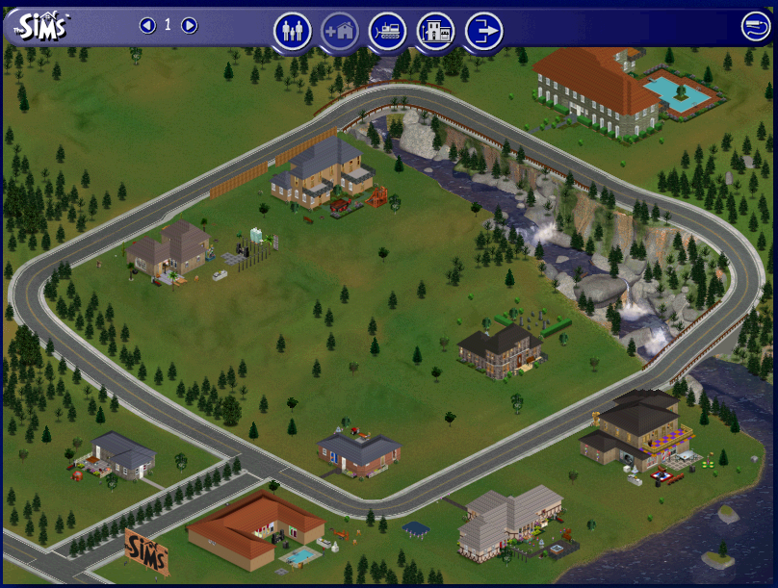
Figure 1: The Sim neighborhood.

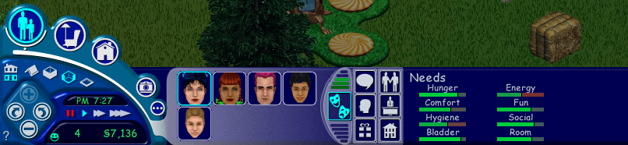
Figure 2: Game interface: for controlling daily lives of Sims in one particular household.

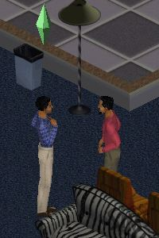

Figure 3: The green diamond indicates which Sim character is being controlled. Sims that are part of the household can be controlled in turn, but guests cannot be controlled while visiting—Sims only can be controlled when they are in their own homes.

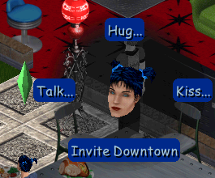

Figure 4: Emma’s current interaction options with Jane include different kinds of Hug, Kiss and Talk (the ellipse indicates there are more options), and Invite Downtown.

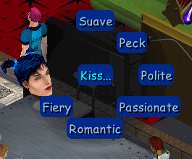

Figure 5: If the Kiss option is chosen, sub-options appear, which are based on this Sim’s feelings toward Jane, and their relationship history. Thus, a “Fiery” kiss will not appear until a relationship is very passionate/romantic.

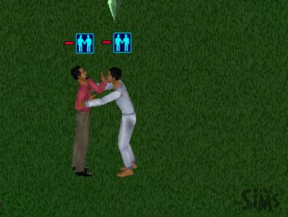
Figure 6: Interaction options can fail if a Sim feels another is being too forward (for example, kissing before the relationship is developed enough), leading to a reduction in the relationship score.

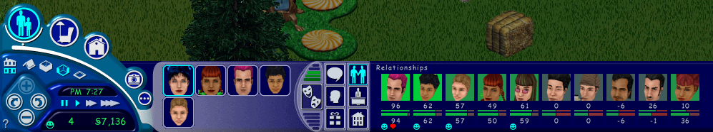

Figure 7: The relationship meter indicates how a Sim is feeling about different characters. Scores can range from –100 to 100. The lower a score, the worse a Sim feels about that particular Sim. A smiley face below a Sim’s picture indicates that the Sim is a family friend—someone that has reach at least 50 on the scale; and a heart indicates someone the Sim is romantically interested in. The two levels of the score are new to Hot Date—with the top score being a daily meter that changes quickly in response to Sims’ moods and things like fights, and the bottom score is the lifetime rating, which changes more slowly.

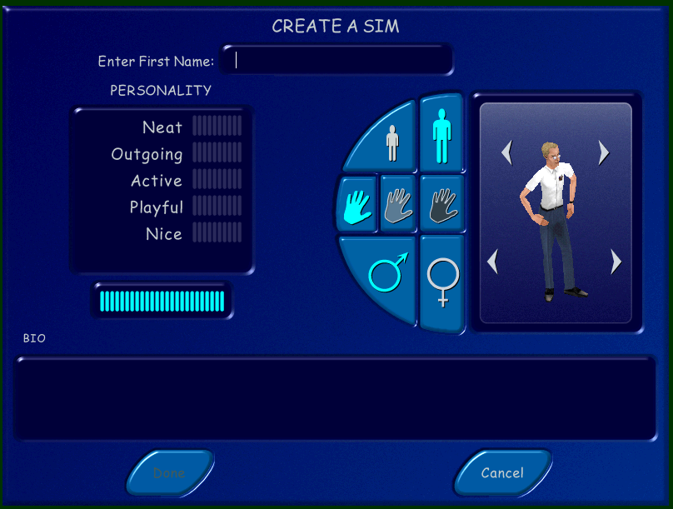

Figure 8: The default character creation screen that appears after players create a “family name.” Note that the first image that always appears (by default) is a white male that appears to be middle-class. However, players can quickly move beyond this default image, choosing from the child/adult buttons on top, the shade buttons in the middle, and the male/female buttons at the bottom. The arrows near the avatar’s head and legs indicate how to rotate between different head and body options. Personality points can also be assigned to the categories of Neat; Outgoing; Active; Playful and Nice. An optional biography of the character also can be written by the player.

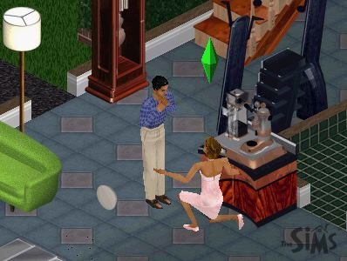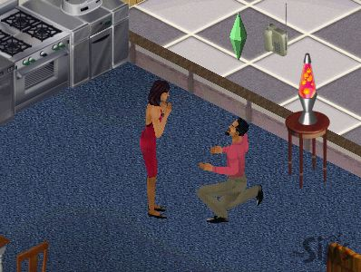

Figures 9 & 10: Male or female Sims can propose to a Sim of the opposite sex, and do so in the same way. If the intended accepts, the player will see him or her try on a ring and admire it. The intended will then move in to the house, and take the name of the proposing Sim—again regardless of gender.

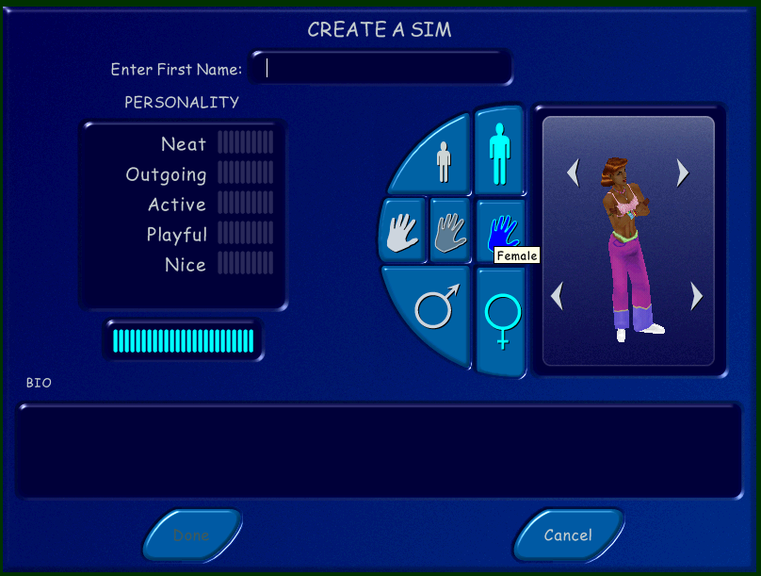

Figure 11: A “dark” shaded female Sim.

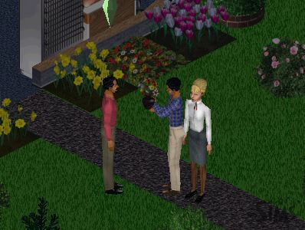

Figure 12: Michael (in the blue plaid shirt) brings flowers to his old roommate/lover Stewart, after moving out to marry Esme.

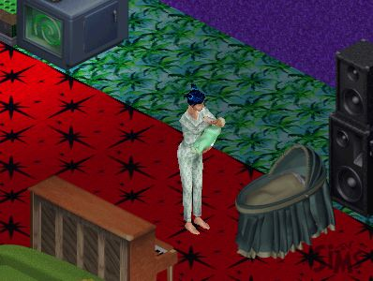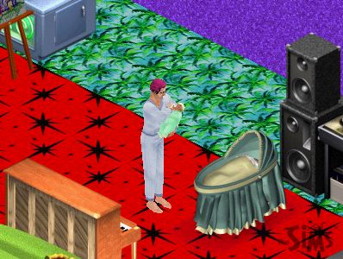

Figures 13 & 14: Emma and Jane (Jane is the man with pink hair) each feed and sing to baby Cara in the same manner.

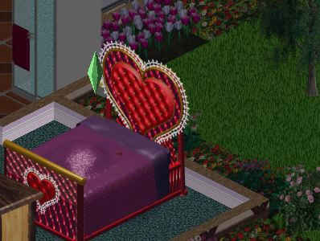

Figure 15: Kleo and Lola “Play” together in the Vibromatic Bed (the only bed with this option).

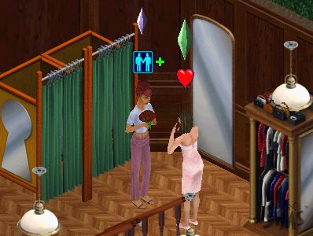

Figure 16: Addie gives Lola red roses, and is now romantically interested in Lola, as indicated by the red heart over her head.

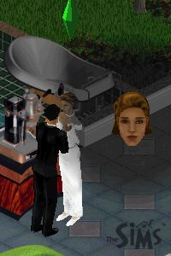

Figure 17: This picture was taken automatically to mark the Sim wedding of Esme and Michael (Esme proposed to Michael, but both wear traditional wedding clothes).

Figure 18: Michael asked Stewart to move in, and Stewart accepted.

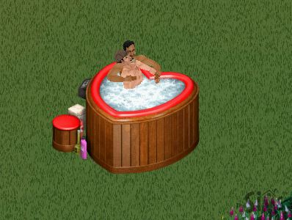

Figure 19: Len and Noel “cuddle” in the Niagara Love Tub. Any two Sims will cuddle in the tub if their relationship score is high enough and they are romantically inclined.

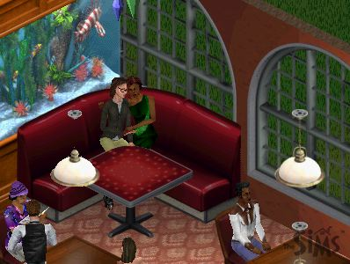

Figure 20: Gay and straight couples can cuddle in loveseats, on couches, and in restaurant booths. Once “cuddled,” they can kiss, caress, and engage in other “romantic” options.

TABLES

Table 1—Interaction Options Available in The Sims, Livin’ Large, & House Party

- Greet
- Talk
- Entertain (juggling)
- Joke
- Tickle
- Flirt
- Hug
- Kiss
- Brag
- Dance
- Apologize
- Admire
- Nag
- Cheer Up
- Ask to Leave
- Give Back Rub
- Give Gift
- Move In
- Propose
- Slap
- Fight

Table 2: Interaction Options Available in Hot Date
- Greet (Includes Wave and Shake Hands to start, then can include more options depending on how familiar Sims are, including Hug, Kiss and others)
- Talk About Interests
- Talk—Gossip
- Ask—How are You?
- Ask—How’s Work?
- Ask—What are You Into?
- Ask—Want to Hang Out?
- Ask—Want to Date?
- Ask—Come Here
- Entertain—Joke
- Entertain—With Puppet
- Entertain—Juggle
- Tickle—Ribs
- Tickle—Extreme
- Flirt—Check Out
- Flirt—Sexy Growl
- Flirt—Growl
- Flirt—Sweet Talk
- Flirt—Back Rub
- Brag—Boast
- Brag—Primp
- Brag—Flex
- Hug—Friendly
- Hug—Intimate
- Hug—Romantic
- Hug—Leap in Arms
- Kiss—Suave
- Kiss—Peck
- Kiss—Polite
- Kiss—Air Kiss
- Kiss—On Cheek
- Kiss—Romantic
- Kiss—Passionate
- Kiss—Fiery
- Dance—Quickly
- Dance—Slow
- Plead—Apologize
- Plead—Grovel
- Insult—Tease
- Insult—Poke
- Join (in some activity)
- Play (for children only)
- Compliment—Admire
- Compliment—Worship
- Proposition—Invite Home
- Proposition—Move In
- Proposition—Propose
- Give Gift (depends on what you have in inventory to choose from)
- Nag—About Friends
- Nag—About House
- Slap
- Slap Fight
- Say Goodbye—(includes Wave; Shake Hands; Hug; and others depending on how friendly or romantic Sims are, including Air Kiss or Passionate Kiss for example)
- Cheer Up—Encourage
- Cheer Up—Comfort
- Join
- Play (children only)

Table 3: Objects that Support Gay, Lesbian, Bisexual, Heterosexual Interactions

- SCTC BR-8 Standard Telephone
- SC7C Cordless Wall Phone

- Monochrome TV
- Revulcanized Eurothane Desk Phone

- "Down Wit Dat" Boom Box
- Recycled Pay Phone

- Trottco 27" Color Television B94U
- Zimantz Component Hi-Fi Stereo

- Wurl 'n' Hurl Retro Jukebox

- Strings Theory Stereo

- Soma Plasma TV

- Turntablitz DJ Booth

- Niagara Love Tub

- Fancy Feet Cake Treat

- Antique Lamp

- PerpetuLux-style Table

- Formi' Table

- Caféfette Café Table

- Bel-Air Dining Booth

- Pleasario Dining Booth

- Contempo Loveseat

- Recycled Couch
- "Psycha" Inflatable Sofa
- "Sky Surfer" Inflatable Sofa
- "Verdette" Inflatable Sofa
- Contempo Couch

- SimSafari Sofa
- Satinistics Loveseat

- Parque Fresco del Aire Bench

- Ur-Bin Park Bench

- Country Class Loveseat
- Pinstripe Loveseat from Zecutime

- Pinstripe Sofa from Zecutime

- Cheap Eazzze Double Sleeper

- Country Class Sofa

- Tropi-Cane Sofa
- Velvet Sofasaurus

- English Garden Swing

- Luxuriare Loveseat

- The Love Seat
- Napoleon Sleigh Bed
- "The Deiter" by Werkbunnst

- Cowch Country Sofa

- Le Grande Guignol Loveseat
- Dolce Tutti Frutti Sofa
- "Red Matter" Sofa from Studio Bakonmi

- Gothic Revival Bench
- Modern Mission Bed
- Antique Four-Poster Bed
- The Vibromatic Heart Bed

These approaches include ludology, narratology, and flow theory. Briefly, ludology is the study of the importance of space and exploration in games, suggesting that players are more concerned with finding objects and visiting new lands than enjoying a story. Narratology takes quite a different approach, suggesting that narratives are important elements of games, and while not fully realized in current games, narratives play a part in helping users find meaning in games. Finally, flow theory investigates the rhythms of gameplay, questioning how “good” games allow players to lose their sense of themselves and time while playing, and how “bad” games interfere with this process. These approaches, as seen in even this brief description, are all quite different, and are at times vigorously debated.

