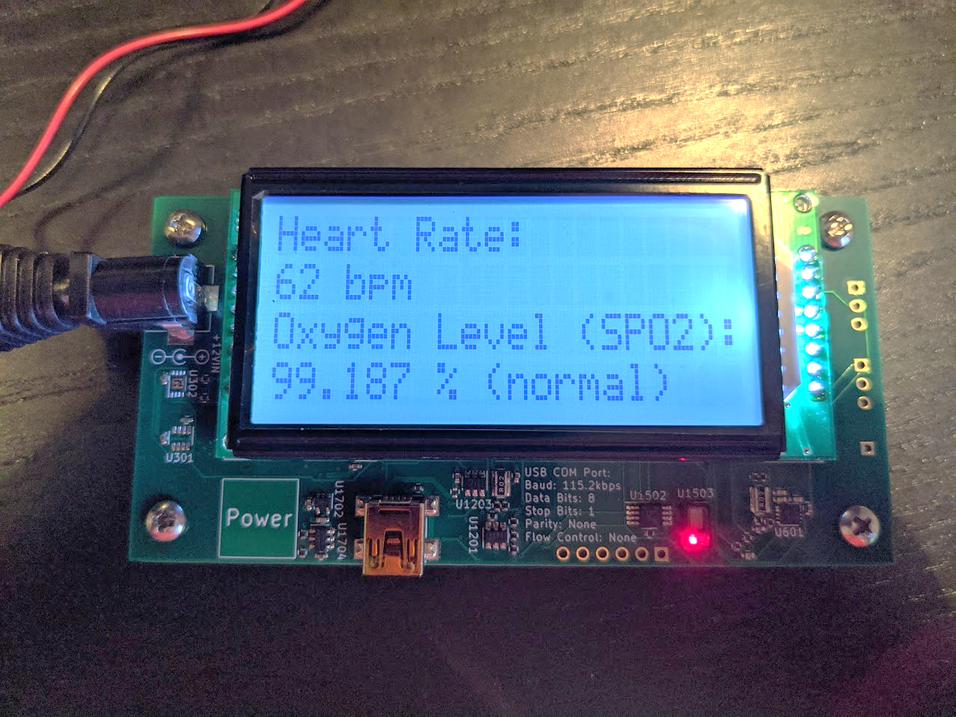

Heartrate

Display

Power

Jack

Oxygen

Saturation

Display

Power

Button

Sensor

A pulse oximeter is a device that measures a user’s heart rate as well as their oxygen saturation. **Heart rate** (pulse) is the measure of the number of beats per minute (bpm) of the user’s heart. **Oxygen saturation** (SPO2), reported in percent, is the measure of how effective the user’s lungs transfer oxygen into their bloodstream when they breathe.

Oxygen saturation is an important metric when someone has contracted COVID-19. In severe COVID cases, a patient’s oxygen levels will decrease. This device will not tell you if you have contracted COVID-19, but it will tell you if you have a severe respiratory infection, and if you should seek treatment. This device is home-made, and is not certified by any regulatory body.

According to the World Health Organization, a **normal** oxygen saturation is between 95% and 100%. A **hypoxic** oxygen saturation is between 90% and 94%. A **dangerous** oxygen saturation is below 90% (From W.H.O. Pulse Oximetry Training Manual).

To use this pulse oximeter:

* Plug the included DC power supply into an AC outlet, and insert the cable into the Power Jack on the pulse oximeter
* Press the Power Button
* The pulse oximeter will display instructions and guidance on measurements
* Lightly rest your right middle finger on the sensor (red light)
  + It may be tempting, but **do not apply pressure on the sensor.** This will constrict your blood vessels, blocking the measurement. Rest your finger very gently
* Your heart rate and oxygen level will be displayed on the screen, updated every five seconds
  + If the pulse oximeter won’t report a measurement, replace your finger on the sensor occasionally