Drew Tomey

SDEV140

Professor Carver

Final Project User’s Manual

Starting the Application

To start the application please locate and open the “TomeyDrewFinalProject.py” in the provided zip folder.

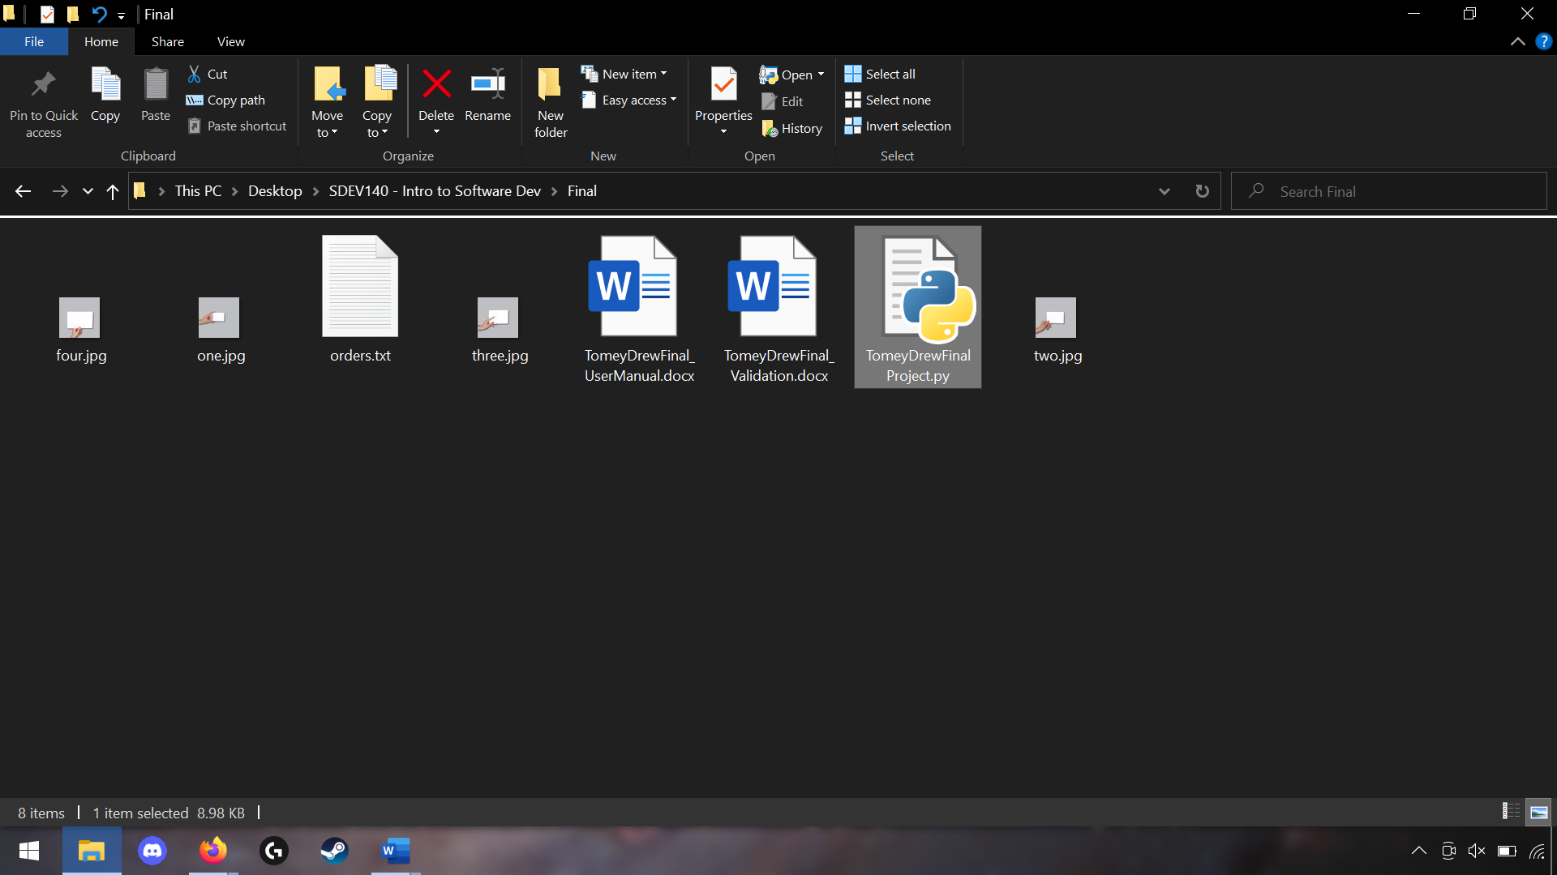

*Important Note: the pillow module must be installed to properly render the GUI.*

Main Window

When opening the GUI, you will see the main window. The layout will look like the one shown below. This is where you will see the prints on the left, the spin boxes in the center, and the totals on the right.

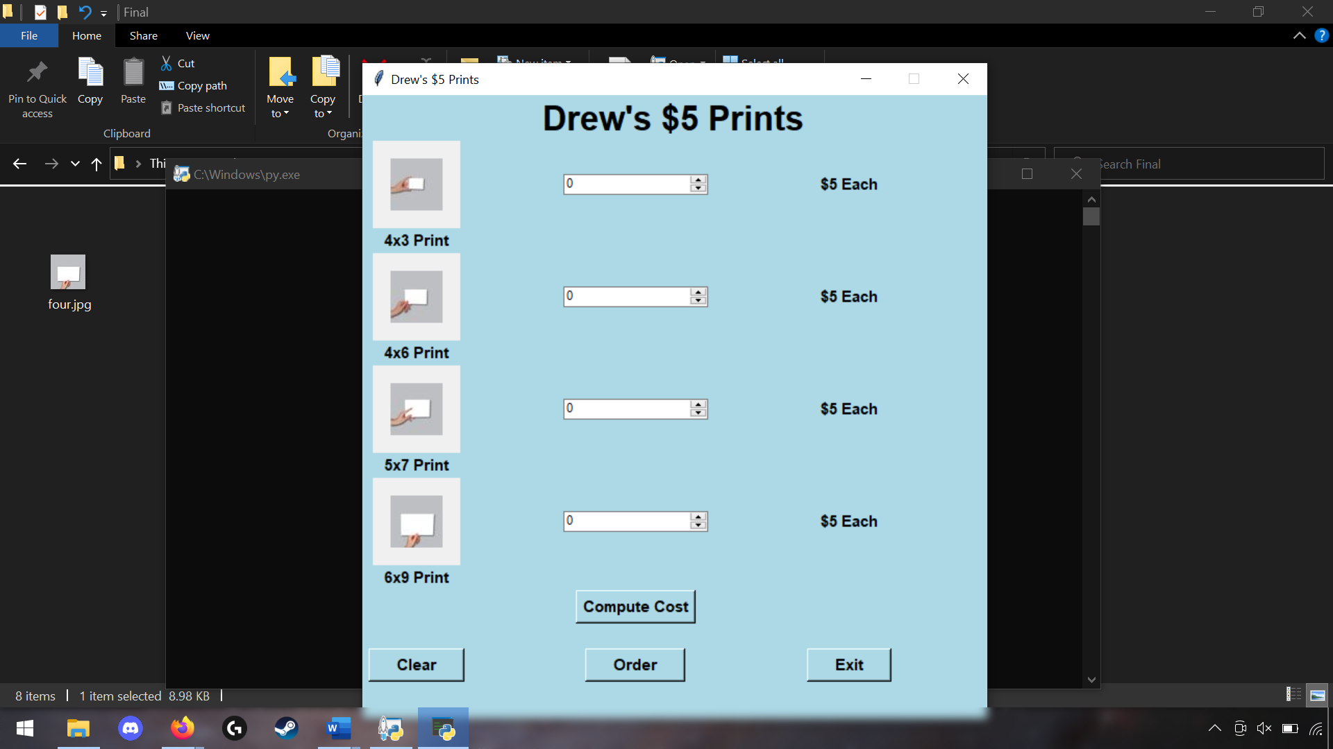

Selection of Prints

To select your prints, please enter the amount for each print in the box to the right of them. At the bottom, you will see four buttons. After you have selected your prints, you can press the compute button to compute the final cost, the clear button to clear the selected prints, the exit button to exit the GUI, and the order button to proceed to the order page.

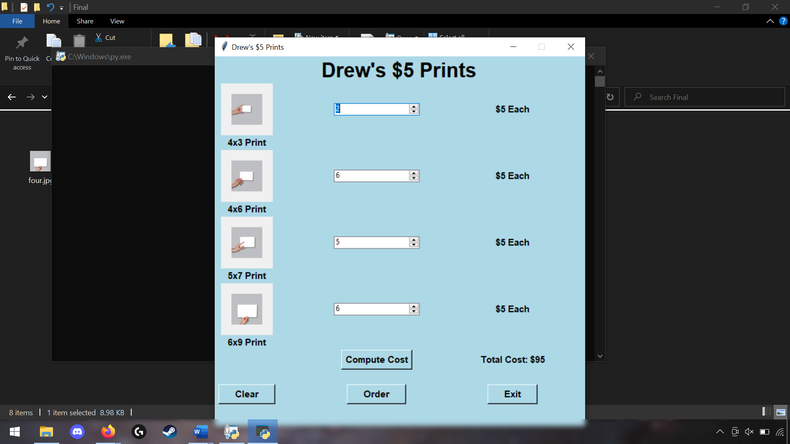

Total Cost

Enter Print Amount

Buttons

Customer Information

Once you decide to place an order, select the “Order” button. This brings up a window that will prompt you to enter your name and e-mail. Once this is entered, select “Confirm Order” and Drew will be in contact with you soon regarding which images you would like printed and payment!

