**Chapter 5**

**I.**        **Multiple Choice**

(1). A ( ) protocol is used to move a packet over an individual link.

A. application-layer B. transport-layer

C. network-layer D. link-layer

(2). Which of the following services cannot be offered by a link-layer protocol? ( )

A. congestion control B. Link Access

C. Error control D. Framing

(3). ( ) protocol serves to coordinate the frame transmissions of the many nodes when multiple nodes share a single broadcast link.

A. ARP B. MAC

C. ICMP D. DNS

(4). Consider CRC error checking approach, the four bit generator G is 1011, and suppose that the data D is 10101010, then the value of R is( ).

A. 010 B. 100

C. 011 D. 110

(5). In the following four descriptions about random access protocol, which one is not correct? ( )

A. In slotted ALOHA, nodes can transmit at random time.

B. CSMA/CD cannot be implemented on a wireless channel.

C. The maximum efficiency of a slotted ALOHA is higher than a pure ALOHA.

D. In CSMA/CD, one node listens to the channel before transmitting.

(6). In the following descriptions about MAC address, which one is not correct? ( )

A. The MAC address is the address of one node’s adapter.

B. No two adapters have the same MAC address.

C. The MAC address doesn’t change no matter where the adapter goes.

D. MAC address has a hierarchical structure.

(7). The ARP protocol can translate ( ) into ( ).

A. host name, IP address B. host name, MAC address

C. IP address, MAC address D. broadcast address, IP address

(8). The value of Preamble field in Ethernet frame structure is ( )

A. 10101010 10101010……10101010 11111111

B. 10101011 10101011……10101011 10101011

C. 10101010 10101010……10101010 10101011

D. 10101010 10101010……10101010 10101010

(9). In CSMA/CD, the adapter waits some time and then returns to sensing the channel. In the following four times, which one is impossible? ( )

A. 0 bit times B. 512 bit times

C. 1024 bit times D. 1028 bit times

(10). Consider the data D is 01110010001, if use even parity checking approach, the parity bit is( ① ), if use odd parity checking approach, the parity bit is( ② ). ( )

A. ① 0 ② 1 B. ① 0 ② 0

C. ① 1 ② 1 D. ① 1 ② 0

(12). In the following four descriptions, which one is not correct? ( )

A. Switches can interconnect different LAN technologies.

B. Hubs can interconnect different LAN technologies.

C. There is no limit to how large a LAN can be when switches are used to interconnect LAN segments.

D. There is restriction on the maximum allowable number of nodes in a collision domain when hubs are used to interconnect LAN segments.

(13). Which of the following devices is not a plug and play device? ( )

A. hub B. router

C. switch D. repeater

(14). Which device has the same collision domain? ( )

A. Hub B. Switch

C. Router D. Bridge

(15). In data link-layer, which protocol is used to share bandwidth? ( )

A. SMTP B. ICMP

C. ARP D. CSMA/CD

(16). When two or more nodes on the LAN segments transmit at the same time, there will be a collision and all of the transmitting nodes well enter exponential back-off, that is all of the LAN segments belong to the same( ).

A. collision domain B. switch

C. bridge D. hub

(17). In the following four descriptions about PPP, which one is not correct? ( )

A. PPP is required to detect and correct errors.

B. PPP is not required to deliver frames to the link receiver in the same order in which they were sent by the link sender.

C. PPP need only operate over links that have a single sender and a single receiver.

D. PPP is not required to provide flow control.

(18). For( ) links that have a single sender at one end of the link and a single receiver at the other end of the link.

A. point-to-point B. broadcast

C. multicast D. all of the above

(19). With( )transmission, the nodes at both ends of a link may transmit packets at the same time.

A. half-duplex B. full-duplex

C. simplex(单工) D. synchronous

(20). Which of the following is wrong? ( )

A. ARP table is configured by a system administrator

B. ARP table is built automatically

C. ARP table is dynamic

D. ARP table maps IP addresses to MAC addresses

(22). Which of the following four descriptions about MAC addresses is wrong? ( )

A. a MAC address is burned into the adapter’s ROM

B. No two adapters have the same address

C. An adapter’s MAC address is dynamic

D. A MAC address is a link-layer address

(23). In the CSMA/CD protocol, what condition on the transmission delay *Ttrans* and the propagation delay *Tprop* has to be satisfied to guarantee that a node always detects a collision?

A. *Ttrans* > *Tprop* B. *Ttrans* > 2*Tprop*

C. *Ttrans* < *Tprop*  D.*Ttrans* < 2*Tprop*

**II.**     **True Or False**

(1). All bit errors can be detected if a packet is sent twice.

(2). The efficiency of unslotted ALOHA is twice that of slotted ALOHA

**III.** **Answer Briefly**

(1). Suppose nodes A, B, and C each attach to the same broadcast LAN (through their adapters). If A sends thousands of IP datagrams to B with each encapsulating frame addressed to the MAC address of B, will C’s adapter process these frames? If so, will C’s adapter pass the IP datagrams in these frames to the network layer C? How would your answers change if A sends frames with the MAC broadcast address?

(2).Assume there is the network as the figure below (fig 1.). Assume that host 111.111.111.111 sends a message that it wants to be received at host 222.222.222.222.

a)   What is the network layer address that it must use on the message? (source ip and destination ip)

b)  What is the link layer address that it must use on the message?

c)   What network layer and link layer addresses must it use if the message is to be received by 111.111.111.112?

d)  How does the node know which link layer address to use?

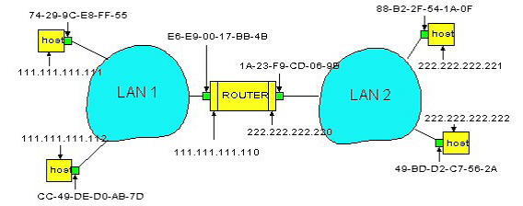

fig 1

(3). As in fig 2. There is new host moves into a network. Thus the new host has to get its IP address from the DHCP server running on the router. Please list the sequence of packets sent or received by the new host until it gets a IP address 192.168.1.4.

a)   Please indicate the source and destination MAC address, the source and destination IP address, and the source and destination port number of each packet.

|  |  |  |  |
| --- | --- | --- | --- |
| *Source MAC* | *Destination MAC* | *Source IP* | *Destination IP* |
|  |  |  |  |
|  |  |  |  |
|  |  |  |  |
|  |  |  |  |

b)  After getting the IP address 192.168.1.4, the local DNS server and the web proxy of the new host is set as 192.168.1.2 and 192.168.1.3, respectively. Now, the user of the new host wants to access an url on the web server [www.scu.edu.cn](http://www.scu.edu.cn). Luckily the DNS cache of local DNS server has cached the RR of [www.scu.edu.cn](http://www.scu.edu.cn). On the other hand, ARP table of all the nodes in fig 3 are empty. Please list the sequence of all the packets sent/received by the new host as well as any other packets sent/received by as other nodes. Please indicate the source and destination MAC address as well as the source and destination IP address of each packets

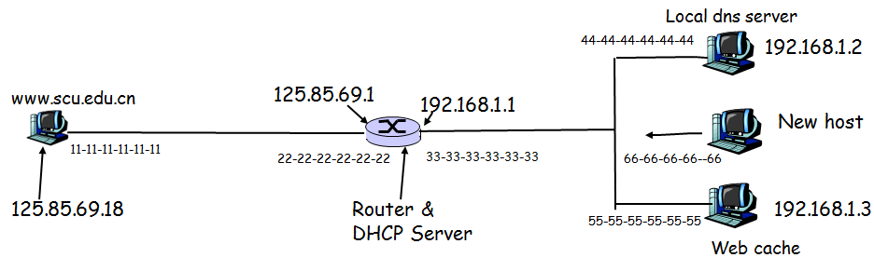

**fig 2**

 (4). Consider the following graph of the network. Suppose Host A will send a datagram to Host B, Host A run TCP client on port 4000, Host B run TCP Server on port 8000. All of ARP tables are up to date. Enumerate all the steps when the SYN segment is sent from host A to host B.

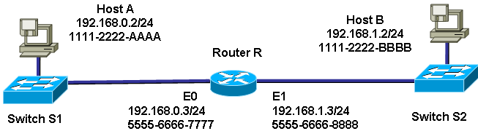

fig 3

(5) Repeat (4), now assuming that the ARP table in the sending host is empty (and the other tables are up to date).

(6) Recall that with the CSMA/CD protocol, the adapter waits K*512 bits times after a collision, where K is drawn randomly. For K = 100, how long does the adapter wait until returning to Step 2 for a 1 Mbps Ethernet? For a 10Mbps Ethernet?

(7)Suppose nodes A and B are on the same 10 Mbps Ethernet bus, and the propagation delay between the two nodes is 225 bit times. Suppose A and B send frames at the same time, the frames collide, and then A and B choose different values of K in the CSMA/CD algorithm. Assuming no other nodes are active, can the retransmissions from A and B collide? For our purposes, it suffices to work out the following example. Suppose A and B begin transmission at t = 0 bit times. They both detect collisions at t = 225 bit times. They finish transmitting a jam signal at t = 225+48=273 bit times. Suppose KA =0 and KB = 1. At what time does B schedule its retransmission? At what time does A begin transmission? (Note :The nodes must wait for an idle channel after returning to Step 2 –see protocol. ) At what time does A’s signal reach B? Does B refrain from transmitting at its scheduled time.

(8) Suppose nodes A and B are on the same 10Mbps Ethernet bus, and the propagation delay between the two nodes is 225 bit times. Suppose node A begins transmitting a frame and, before it finishes, node B begins transmitting a frame. Can A finish transmitting before it detects that B has transmitted? Why or why not? If the answer is yes, then A incorrectly believes that its frame was successfully transmitted without a collision. Hint: Suppose at time t = 0 bit times, A begins to transmitting a frame. In the worst case, A transmits a minimum-sized frame of 512+64 bit times. So A would finish transmitting the frame at t = 512 +64 bit times. Thus, the answer is no, if B’s signal reaches A before bit time t= 512+64 bits. In the worst case, when does B’s signal reach A?

(9)Suppose two nodes, A and B, are attached to opposite ends of a 500 m cable, and that they each have one frame of 1,000 bits (including all headers and preambles) to send to each other. Both nodes attempt to transmit at time t= 0. Suppose there are four repeaters between A and B, each inserting a 20-bit delay. Assume the transmission rate is 100 Mbps, and CSMA/CD with backoff intervals of multiples of 512 bits is used. After the first collision, A draws K =0 and B draws K =1in the exponential backoff protocol. Ignore the jam signal and the 96-bit time delay.

a)   What is the one-way propagation delay (include repeater delays) between A and B in seconds? Assume that the signal propagation speed is 2*108 m/sec .

b)  At what time ( in seconds) is A’s packet completely delivered at B ?

c)   Now suppose that only A has a packet and that the repeaters are replaced with switches. Suppose that each switch has a 20-bit processing delay in addition to a store-and-forward delay. At what time, in seconds ,is A’s packet delivered at B?

(10)Consider the network shown below (figure 3), There are one router, 4 switches, and 11 hosts. Suppose all the switch table on all switches and all the ARP tables on all nodes are empty initially.

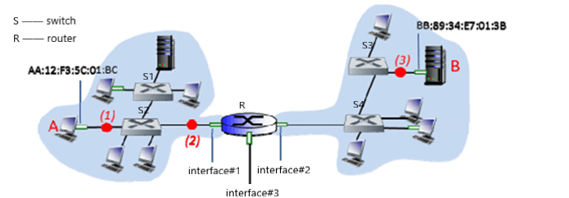

Figure 3

1. Let’s assume that the IP address of R’s interface #1 is 202.115.32.1 and the IP address of R’s interface #2 is 202.115.32.65. Please assign IP address ranges to the subnets containing hosts A and B, and assign IP addresses in these ranges to hosts A and B. Your subnet addressings should use the smallest amount of address space. (4 points)
2. What IP address range can the router advertise to the outside for all of the hosts reachable in these two subnets? (2 points)
3. Consider a datagram being sent from A to B, ARP queries are needed due to the empty ARP table of A. How many of the 11 hosts in the network receive the ARP query sent by A? Explain your answer briefly. (2 points)
4. After completing the ARP query, A can send the datagram to B. How many of the 11 hosts in the network receive the frame containing the datagram sent by A? Explain your answer briefly. (2 points)
5. Consider an IP datagram being sent from A to B using Ethernet as the link layer protocol in all links in the figure above. What are the (i) Ethernet source and destination addresses and (ii) IP source and destination addresses of the IP datagram encapsulated within the Ethernet frame at points (1), (2), and (3) in the above example for a datagram going from A to B (10 points)

Packet at (1)

|  |  |  |  |
| --- | --- | --- | --- |
| *Source MAC* | *Destination MAC* | *Source IP* | *Destination IP* |
|  |  | **A‘s IP** |  |

Packet at (2)

|  |  |  |  |
| --- | --- | --- | --- |
| *Source MAC* | *Destination MAC* | *Source IP* | *Destination IP* |
|  |  |  |  |

Packet at (3)

|  |  |  |  |
| --- | --- | --- | --- |
| *Source MAC* | *Destination MAC* | *Source IP* | *Destination IP* |
|  |  |  | **B‘s IP** |

（11）Consider a campus network as shown in Figure 2, where there two routers R1 and R2, a HUB H1, and a switch S1 that connect 3 Ethernet LANs. The numbers (1,2, or 3) besides the routers indicate their interfaces, and the IP address block (e.g., 128.101.0.0/18) near an Ethernet represents the IP address block assigned to the corresponding Ethernet (thus hosts on the Ethernet). (20 points)

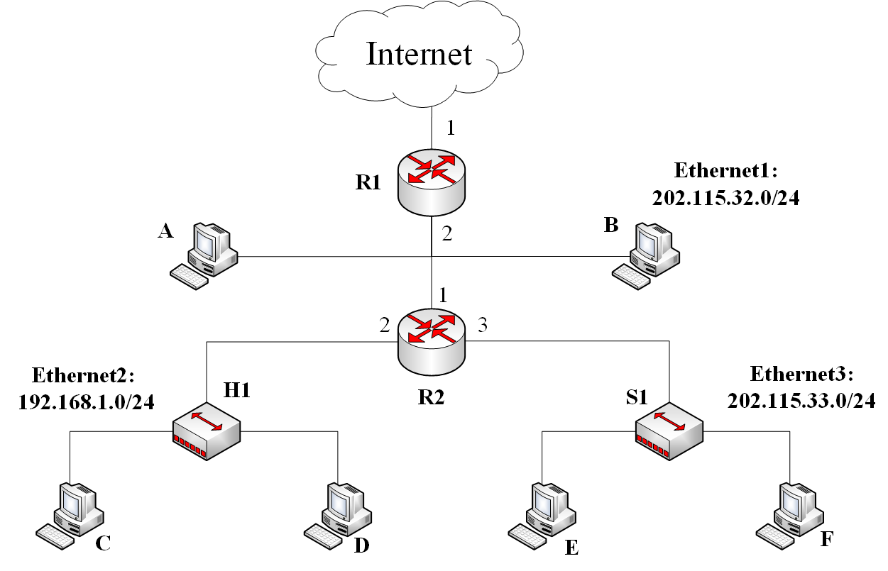

Figure 2.

1. To make sure each host (from A to F) to access the Internet, what services has to be provided by R2? ( 2 points)
2. With route aggregation, whose reachability information is propagated to Internet by R1? ( 2 points)
3. Suppose host E wants to send an IP datagram packet to host F. Host E will send a packet like below. How does host E knows that it can directly forward the packet to host F instead of asking for its default router R2 to help deliver it.(2 points)

*The packet from E to F*

|  |  |  |  |
| --- | --- | --- | --- |
| *Source MAC* | *Destination MAC* | *Source IP* | *Destination IP* |
| *E’s MAC address* | *F’s MAC address* | *E’s IP address* | *F’s IP address* |

1. Will the R2’s interface 3 receive the packet from E to F? Please explain your answer (2 points)
2. If D send a packet to C, will the R2’s interface 2 receive this packet? Please explain your answer (2 points)
3. Now suppose host E want to send an IP datagram to A. Let’s assume the ARP caches of all the hosts in this network is empty while the routers (R1 and R2) has cached all the ARP records needed. List the source and destination’s IP and MAC addresses of all the frames to transfer this IP datagram from E to A.( 6 points)

|  |  |  |  |
| --- | --- | --- | --- |
| *Source MAC* | *Destination MAC* | *Source IP* | *Destination IP* |
|  |  |  |  |
|  |  |  |  |
|  |  |  |  |
|  |  |  |  |
|  |  |  |  |
|  |  |  |  |

1. Now suppose host C want to send an IP datagram to A, what are the source and destination’s IP and MAC addresses in the frame sent by C and what are the source and destination’s IP and MAC addresses in the frame received by A? (4 points)

12. Consider a campus network as shown in Figure 2, where there two routers R1 and R2, a HUB H1, and a switch S1 that connect 3 Ethernet LANs. The numbers (1,2, or 3) besides the routers indicate their interfaces, and the IP address block (e.g., 128.101.0.0/18) near an Ethernet represents the IP address block assigned to the corresponding Ethernet (thus hosts on the Ethernet).

1. To make sure each host (from A to F) to access the Internet, what services has to be provieded by R2? ( 2 points)
2. Suppose host E wants to send an IP datagram packet to host F. Host E will send a packet like below. How does host E knows that it can directly forward the packet to host F instead of asking for its default router R2 to help deliver it.(2 points)

*The packet from E to F*

|  |  |  |  |
| --- | --- | --- | --- |
| *Source MAC* | *Destination MAC* | *Source IP* | *Destination IP* |
| *E’s MAC address* | *F’s MAC address* | *E’s IP address* | *F’s IP address* |

1. Now suppose host E want to send an IP datagram to A. Let’s assume the ARP caches of all the nodes in this network is empty. List the the source and destinations IP and MAC addresses of all the frames to transfer this IP datagram from E to A.( 12 points)
2. Now suppose host C want to send an IP datagram to A, what are the source and destinations IP and MAC addresses in the frame sent by C and what are the source and destinations IP and MAC addresses in the frame received by A? ( 4 points)

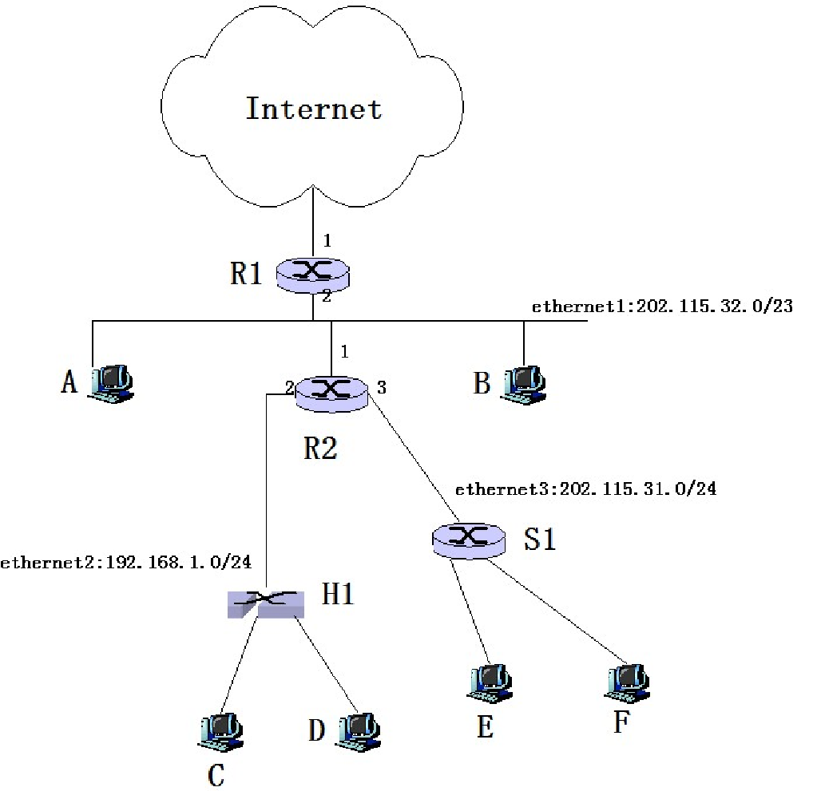

Figure 2