**I. Multiple Choice**

4.1 Which of the following groups run on the top of UDP? _________

A. FTP, ARP, SMTP. B. IMAP, ARP, DNS

C. DNS, RTP, RIP D. DNS, POP3, ICMP

4.2 IP is responsible for _______ communication while TCP is responsible for _______ communication.

A. host-to-host; process-to-process B. process-to-process; host-to-host

C. node-to-node; point-to-point D. point-to-point; node-to-node

4.3 In OSPF network, a _________ belongs to both an area and the backbone.

A. internal router B. area border router

C. boundary router D. backbone router

4.4 Consider a router with the switching fabric based on sharing memory. The memory access speed (read and write) is B packets per second. The overall forwarding throughput is always _______

A. greater than B packets per second

B. greater than B/2 packets per second

C. less than B/2 packets per second

D. less than (√¯B¯)/2 packets per second

4.5 The broadcast address of network 202.115.32.0/23 is_________

A. 202.115.32.255 B. 202.115.33.255

C. 202.115.255.255 D. 202.115.32.0

4.6 Which of the following sub-network masks is illegal? _______.

A. 255.255.32.0 B. 255.255.255.128

C. 255.255.192.0 D. 255.255.254.0

4.7 How many bits are there in IPv6? _________

A. 32 B. 64

C. 128 D. 256

4.8 In BGP, the NEXT-HOP attribute indicates

A. the router interface that begins the next AS

B. the shortest path between two AS

C. the gateway address that has the highest traffic

D. the AS ID of the next AS

4.9 An IP datagram of 1020 bytes (20 byte of IP header plus 1000 bytes of IP payload) arrives at a router and must be forwarded to a link with an MTU of 500 bytes. Thus the router have to fragment the datagram. To the last fragment, the value of offset should be _________

A. 960 B. 1000 C. 100 D.120

4.10 Which of the following protocol doesn’t belong to intra-AS routing protocol? _________

A. RIP B. BGP

C. OSPF D. IRAP

4.11 How does the TTL changed by one each time the datagram is processed by a router? _________

A. decrease B. increase

C. no change D. always 0

4.12 ICMP is used for_________?

A. Reliable data transfer B. Error reporting

C. Flow control D. Congestion control

4.13 If all datagrams arriving at the router from WAN have the same destination IP address, then how does the router know the internal host to which it should forward a given datagram? The trick is to use _________ table at router, and include port numbers as well as IP address in the table entries.

A. routing B. forwarding

C. ARP D. NAT translation

4.14 The standard Tracert program actually sends sets of _________ packets with the same TTL.

A. one B. two

C. three D. four

4.15 The internet’s network layer provides a single service----that is _________.

A. Reliable data transfer B. Flow control

C. Congestion control D. Best-effort-service

4.16 A VC consists of three part, this three parts do not include_________.

A. Path from source to destination

B. VC numbers, one number for each link along path

C. Entries in forwarding tables in routers along path

D. Destination address

4.17 In _________ networking, a series of packet may follow different paths and may arrive out of order?

A. Datagram B. VC

C. TCP D. None of above

4.18 There are three kinds of switch fabric for a router normally, those three switch fabric do not includes_________?

A. Switching via memory

B. Switching via a bus

C. Switching via an Interconnection-Network

D. Packet switching

4.19 _________ means that IPv6 nodes also have a complete IPv4 implementation as well?

A. Dual stack

B. Tunneling

C. Bridge connection

D. Forwarding

4.20 Typically a host is attached directly to one router, the _________ for the host.

A. Default router

B. Source router

C. Destination router

D. Core router

4.21 Which of following about DV is not correct? _________

A. Iterative

B. Synchronous

C. Distributed

D. Self-terminating

4.22 RIP is a kind of _________ algorithm.

A. DV B. LS

C. Both of above D. Neither of A and B

4.23 OSPF is a kind of _________ algorithm.

A. DV B. LS

C. Both of above D. Neither of A and B

4.24 A _________ packet is delivered to only a subset of network nodes.

A. Broadcast B. Multicast

C. Any-cast D. Uni-cast

4.25 In the following four fields, which is in IPV6 header but not in IPV4?_________

A. source address B. destination address

C. version D. flow label

4.26 In the loop of the Dijkstra’s algorithm, for node x, add y to N’, and update the cost of y’s neighbor v, then D(v) is _________.

A. c(x, v) B. min{D(v), D(x)+c(x, v)}

C. min{D(v), D(y)+c(y, v)} D. c(y, v)

**II. True or False**

4.27 BGP exchanges link weights.

4.28 In IP, CRC is introduced for error detection.

4.29 Distance Vector Routing Algorithm is newer and has more flexibility and options than Link State Routing Algorithm.

**III. Answer Briefly**

4.30 Consider the network with 5 routers below, with link cost labeled. Assume that a distance vector algorithm with poisoned reverse is used. Assume that each node initially know only the costs to their neighbors. Assume that the DV algorithm works in a synchronous manner, where all nodes simultaneously receive distance vectors from their neighbors, compute their new distance vectors, and inform their neighbors if their distance vectors have changed.

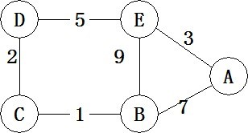

a)    Please show the distance entries at the node E

b)    After the DV algorithm converged, the link cost between node C and node D increases from 2 to 10. Once detecting this change, node C has to update its distance vector and inform its new distance vector to B. What’s this new distance vector C sends to B?

c)    As soon as B received C’s update, B will recalculate its own distance vector. If B has computed a new distance vector, B will inform C this new distance vector. Will B update its distance vector? If so, what’s the new distance vector B will send to C?.

d)    Let’s assume that the network in Figure. 1 is an autonomous system in the Internet with AS number 0. Node A is the BGP gateway of this AS. Is A the only router in this network that runs BGP and DV algorithm simultaneously?

4.31 Consider a subnet with prefix 101.101.101.64/26. Give an example of one IP address (of from xxx.xxx.xxx.xxx) that can be assigned to this network. Suppose an ISP owns the block of addresses of the form 101.101.128/17. Suppose it wants to create four subnets from this block, with each block having the same number of IP addresses. What are the prefixes (of from a.b.c.d/x) for the four subnets?

4.32 Consider the following network. With the indicated link costs, use Dijkstra’s shortest-path algorithm to compute the shortest path from x to all network nodes. Show how the algorithm works by computing a table.

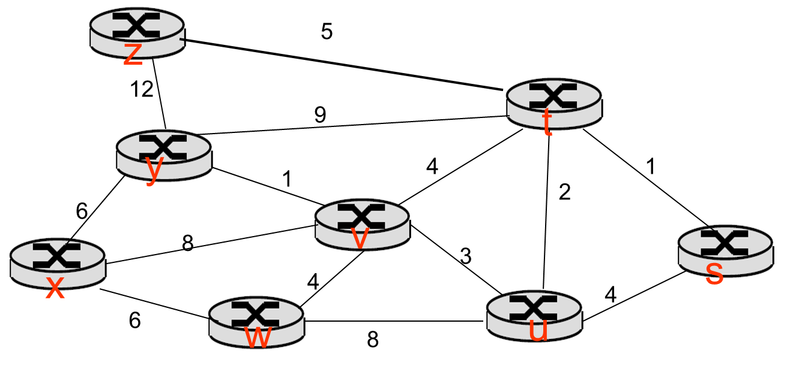

4.33 The fig 1 shows a portion of the internet with four autonomous systems,one of which is shown with four routers, each with its own /16 subnet. Note that each of the other ASs has a /8 subnet.

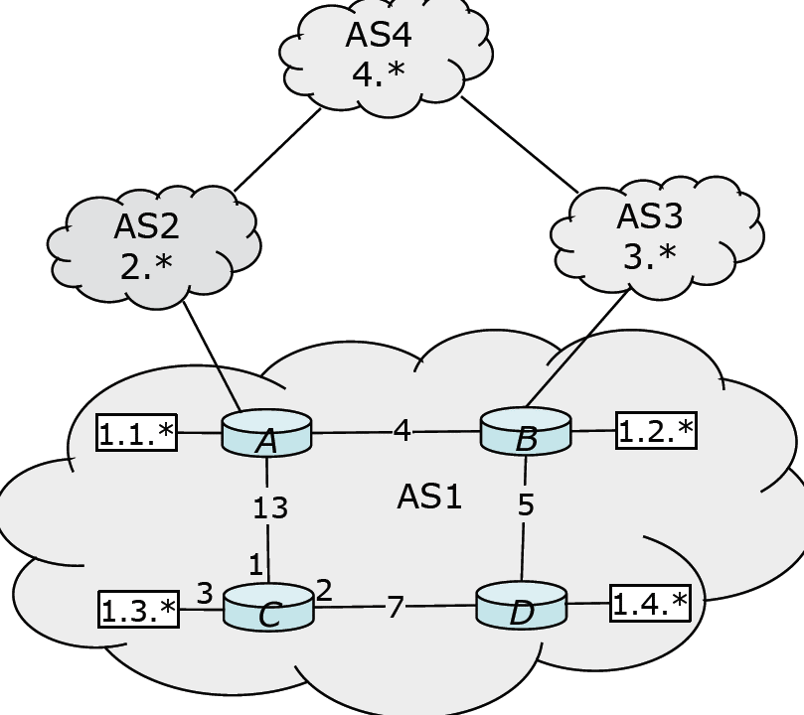

Fig 1

a)    Assume that AS1 uses a LS algorithm as its intra-AS routing algorithm and each node initially knows the costs to each of its neighbors. Show how node C compute the shortest path to all the other nodes

b)    Assume that BGP as the inter-AS routing algorithm among these Ases and there are no policy constraints that must be satisfied. Please complete the forwarding table of node C.

|  |  |
| --- | --- |
| prefix | Output link |
| 1.1.* |  |
| 1.2.* |  |
| 1.3.* |  |
| 1.4.* |  |
| 2.* |  |
| 3.* |  |
| 4.* |  |

c)    Suppose the link joining router B with AS3 fails, which entries would change, and how would they change?

4.34 Answer the following questions for the figure (fig 2.) shown below:

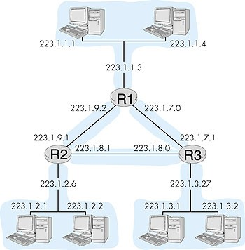

**Fig 2**

a)    Suppose we want to add a new host to the LAN at the top (connected to router R1 via interface 223.1.1.3). What is a valid IP address that can be assigned to this new host?

b)    Suppose we want to the LAN at the top has enough address to support 60 interfaces. Assign the network address to this LAN. Hint: the assignment should take the form *a.b.c.d/x*

4.35 Consider the network scenario shown below, assume the MAC address of the host is 00-15-c5-c1-5e-28, and its IP address is 10.2.128.100 (private address), figure 5-1 is the network topology, and figure 5-2 is the first 80 bytes of the frame which encapsulated the http request message when the host request a web page which is located in a web server somewhere in the Internet, and the frame is presented in hexadecimal(十六进制) and ASCII. Figure 5-3 is the Ethernet frame structure and figure 5-4 is the format of the header of IPv4 datagram.

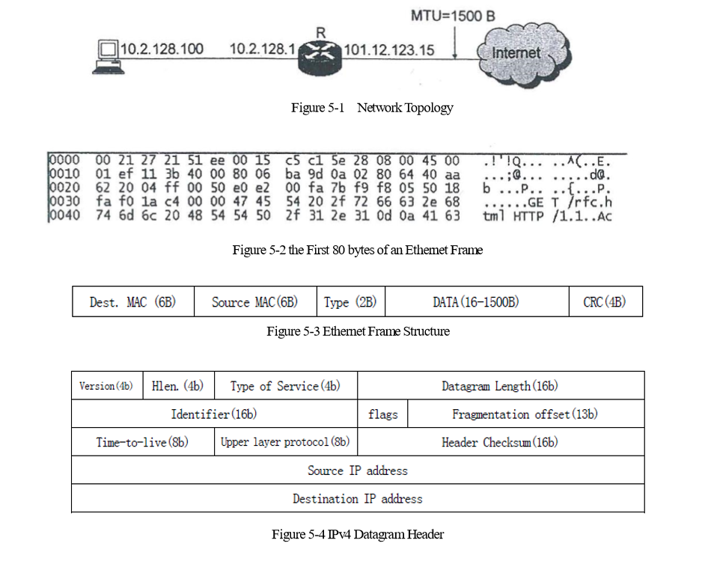

a)    What is the IP address of the web server visited by the host?

b)    Assume HTTP /1.1 uses persistent connections without pipelining, and there are 5 jpeg images referenced in rfc.html, how many RTTs will it take to obtain all the objects from sending the request message?

c)    When router R forwarded the datagram encapsulated in the frame, which fields in the header of the datagram would be updated?

4.36Consider the network scenario shown below. Client C1, servers S1 and S2, and routers R1 through R4 are all part of the same autonomous system (e.g., the SCU network) and are connected to other ASs in the rest of the Internet via router R4.

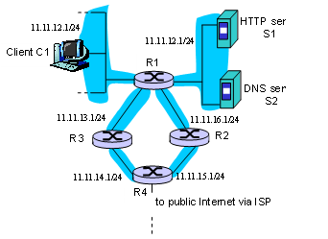

a)    Suppose the user at C1 enters a URL into the browser for a document at S1 and refers to S1 by its name (e.g., S1.cs.scu.edu.cn). The document stored in S1 and returned to the user at C1 contains an embedded URL that is at another site that it outside the autonomous system shown above (e.g., www.remotesite.com). Which of the elements C1, S1, R1 – R4 will make a query to DNS server S2 to resolve the name S1.cs.scu.edu.cn. (3 points)

b)    Which of C1, S1, S2, R1 – R4 must be running the TCP protocol? Explain your answer.(3 points)

c)    Identify the individual networks (in an IP addressing sense) in the figure above. Specify an internet address for one interface in each of the networks (3 points)

d)   Which of C1, S1, S2, R1 – R4 run an intra-domain routing protocol? (3 points)

e)    Which of C1, S1, S2, R1 – R4 run an inter-domain routing protocol? Given your answer in 3), what address prefix is advertised to ASs outside this network?

4.37 Consider the network shown below. Suppose AS3 and AS2 are running OSPF for their intra-AS routing protocol. Suppose AS1 and AS4 are running RIP for their intra-AS routing protocol. Suppose eBGP and iBGP are used for the inter-AS routing protocol. Initially suppose there is no physical link between AS2 and AS4.

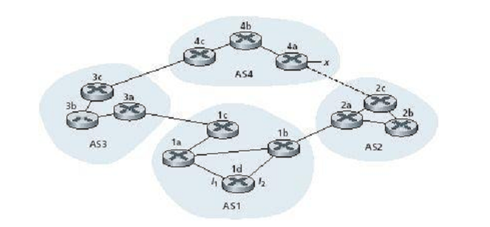

a)    Router 3c learns about prefix x from which routing protocol: OSPF, RIP, eBGP or iBGP?

b)    Router 3a learns about prefix x from which routing protocol?

c)    Router 1c learns about prefix x from which routing protocol?

d)   Router 1d learns about prefix x from which routing protocol?

4.38 Referring to the previous problem, once router 1d learns about x will put an entry (x, *l*) in its forwarding table.

a)    Will *l* be equal to *l*1 or *l*2 for this entry? Explain why in one sentence.

b)    Now suppose that there is a physical link between AS2 and AS4, shown by the dotted line. Suppose router 1d learns that x is accessible via AS2 as well as via AS3. Will *l* be set to *l*1 or *l*2? Explain why in one sentence.

c)    Now suppose there is another AS, called AS5, which lies on the path between AS2 and AS4 (not shown in diagram). Suppose router 1d learns that x is accessible via AS2 AS5 AS4 as well as via AS3 AS4. Will *l* be set to *l*1 or *l*2? Explain why in one sentence.