1. Type the data and write the address

Dummy:

Address of data is: __0x000000010e6f20c0___ (hint: in hex, ox……..)

1. In the address screen: Enter the value of the address of data: 0x_000000010e6f20c0_. You can see the value of on the right hand side.

Write down the first 40 characters.

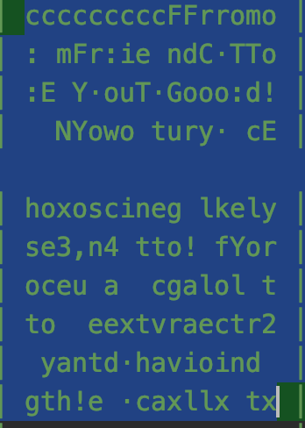

Start value: in decimal in order to produce the above message is ___9___

Stride：3

Write down the address of dummy _0x00007ffeed3d35ec_, you have to set a break point beside key1, F9 and Execute debug so that the program goes through the first few lines

It is an integer: It consists of ____4___ bytes

Write down the value of key1___3_____:

Key2 : 0 x start + 0 x stride ____777______

