**三、stack discipline（本大题共13分）。**

**评阅教师**

**得分**

Consider the following C code and assembly code for two mutually recursive functions:

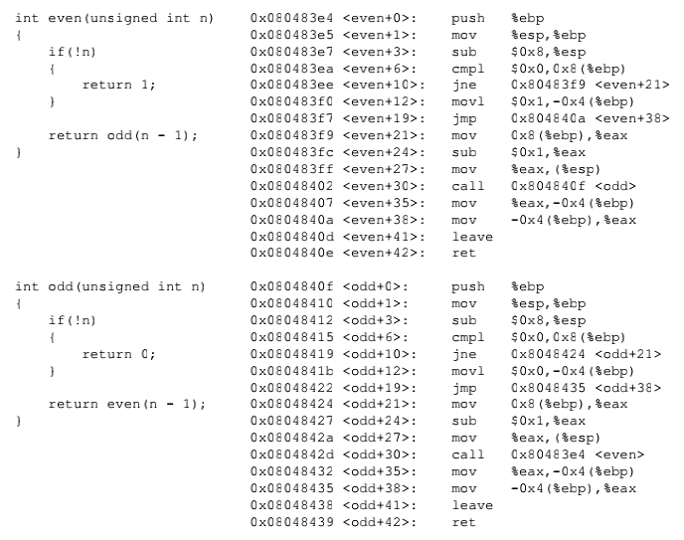

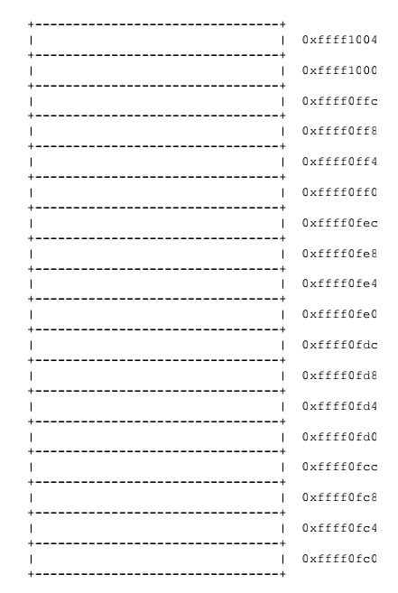Imagine that a program makes the procedure call **even(3)**. Also imagine that prior to the invocation, the value of ESP is 0xffff1000 - that is, 0xffff1000 is the value of ESP immediately before the execution of the **call** instruction.

1. Note the the call even(3) will result in the following function invocations: even(3), odd(2), even(1), and odd(0). Full in the stack diagram with the values that would be present immediately before the execution of the ret instruction for odd(0). Cross out each blank for which there is insufficient information to complete.

2. What are the values of ESP and EBP immediately before the execution of the ret instruction for odd(0)?

ESP= _________________________

EBP=__________________________

如果是你出题呢？