C++ fundamentals and Type conversion
Student ID _______2017141463040__________
Student Name ____朱原昊_________________
Start Time ________________________
Finish Time ________________________

1. Objectives:
To write simple C++ programs covering:
- Understand how a character is stored in memory;
- Understand how an integer is stored in memory;
- Understand array and pointer; and
- Perform conversion from eight bits (character) to eight bytes to be displayed on screen.

2. Type and Format in memory – character, integer, short and float

2.1

Type | Size in byte | Size in bit
Short | 2 | 16
Char | 1 | 8
Short[32] | 64 | 512
Char[64] | 64 | 512

2.2
Type | Size in byte | Size in bit
Int | 4 | 32
Float | 4 | 32
Int[128] | 512 | 4096
Float[16] | 64 | 512

#include<stdio.h>
int main(){
int c;
float s;
int i[128];
float n[16];
printf("%3d \n", sizeof(c));
printf("%3d \n", sizeof(s));
printf("%3d \n", sizeof(i));
printf("%3d \n", sizeof(n));
}

2.3

i: dec=30 oct=36 hex=1e unsigned=30
i: dec=31 oct=37 hex=1f unsigned=31
i: dec=32 oct=40 hex=20 unsigned=32
i: dec=33 oct=41 hex=21 unsigned=33

2.4

Variable | Memory address | Hexadecimal value
a | 0x00007ffee1aa960f | 0x30
i | 0x00007ffee1aa9608 | 0x00000013
j | 0x00007ffee1aa9606 | 0x0012
f | 0x00007ffee1aa9600 | 3fa0000000

3. Array and Pointer

3.1

Address | Type | Value
0x00007ffee0d8d60c | a[0] | 0x30
0x00007ffee0d8d60d | a[1] | 0x31
0x00007ffee0d8d60e | a[2] | 0x32
0x00007ffee0d8d60f | a[3] | 0x00

3.2
#include <stdio.h>
#include <ctype.h>
#include <string.h>
#include <stdlib.h>

int main()
{
char a[11] = "0123456789";
for (int i = 0; i < 14; ++i)
printf("The value of %d is %x in hex %x \n", i, &a[i], a[i]);

}
Write down your explanation (hint: dump the memory location and look at the location of a[11], a[12] and a[13] etc. you then realise why?)
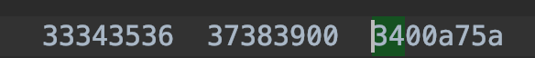
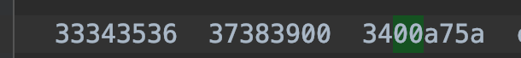
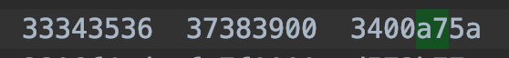
我们打开内存视图可以看到上面的内容，并且 绿色部分分别是a[11]a[12] a[13]的位置，我们可以看到他们的内容与下面我们程序打印出来的转为16进制的数字相符合，所以原因是：每一个内存单元其实都有一个已经存在的值在里面，而不是啥都没有的。但是这个值是不定的，我们在初始化一个大小为n的数组的时候只是将特定一个地方连续的n个单元初始化为零或者我们指定的值，而如果我们越界访问数组元素，则会访问到那些未初始化的地方也就是原来在里面的那些不定的值，而数组的下标访问本质上是基于首地址将在内存中指针增加相应数据类型个单位，于是我们虽然只定义了一个10长度大小的数组，但是却可以访问a[11]等值
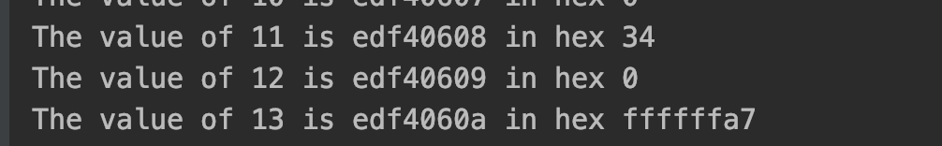

3.3
声明一个大小为11的字符数组并且初始化，然后使用一个指针指向数组的首地址，通过遍历的方式，经过打印指针所指向的地址，打印出数组所有元素的地址以及地址中存放的值转换为16进制的值。

3.4

因为存储一个整形int需要占用四个字节，所以整数数组在遍历时两个整数之间相差四个字节，地址增量是4，而字符只占用一个字节所以地址在增加时只需要增加1就可以到达下一个字符所在的地址。

3.5

#include<iostream>
#include <stdio.h>
#include <ctype.h>
#include <string.h>
#include <stdlib.h>

int main()
{
int a[7] = {12, 21, 31, 41, 51, 61};
int *ptr = &a[0];
for (int i = 0; i <6; ++i,++ptr)
printf("The value of %d is %x in hex %d \n", i, ptr, *ptr);
}

Further discussion

You don’t need answer the following question, just think about it.
void main()
{
char a[4];
char b[3];
char c;

}
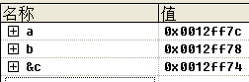

why increment of address is 4 for array b and character c.

