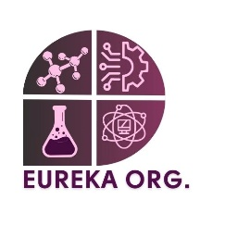**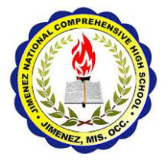Republic of the Philippines**

**Department of Education**

**Region X NORTHERN MINDANAO**

**Division of Misamis Occidental**

**JIMENEZ NATIONAL COMPREHENSIVE HIGH SCHOOL**

**Corrales, Jimenez, Misamis Occidental**

January 22, 2025

Mark Jason Dungog HT- I

Office of the School Principal

Jimenez National Comprehensive High School

Dear Mr. Dungog,

I hope this letter finds you well. On behalf of the Eureka Organization, I am pleased to present to you a proposal for the “**STEM Research and Innovation Workshop 2025**”. The theme for this year’s workshop, Bridging Generation: Continuing the STEM Legacy, underscores the importance of preparing our students for future challenges through innovation and technological advancement.

The workshop will engage students from Grade 7 to Grade 11 in various hands-on STEM projects, fostering critical thinking, creativity, and problem-solving skills. Our objective is to inspire and equip our students with practical knowledge and an interest in STEM fields, which are crucial for their future success and our community’s development.

We propose to have 10 participants from each grade level, with each team guided by a mentor or facilitator throughout the workshop. The details of the workshop are outlined in the attached proposal document for your review and approval.

We believe that this workshop will not only be an educational experience for the participants but will also cultivate a culture of innovation and teamwork within our school.

We kindly seek your approval and support to proceed with this activity. Thank you for considering this initiative, and we look forward to your favorable response.

Sincerely,

NICO ADRIAN P. BALONCIO

Eureka President



**Republic of the Philippines**

**Department of Education**

**Region X NORTHERN MINDANAO**

**Division of Misamis Occidental**

**JIMENEZ NATIONAL COMPREHENSIVE HIGH SCHOOL**

**Corrales, Jimenez, Misamis Occidental**

January 22, 2025

Eleazar L. Tamparong, PSDS, OIC-JIMENEZ

Office of the District Supervisor

Jimenz District

Dear Mr. Tamparong,

I hope this letter finds you well. On behalf of the Eureka Organization, I am pleased to present to you a proposal for the “**STEM Research and Innovation Workshop 2025**”. The theme for this year’s workshop, Bridging Generation: Continuing the STEM Legacy, underscores the importance of preparing our students for future challenges through innovation and technological advancement.

The workshop will engage students from Grade 7 to Grade 11 in various hands-on STEM projects, fostering critical thinking, creativity, and problem-solving skills. Our objective is to inspire and equip our students with practical knowledge and an interest in STEM fields, which are crucial for their future success and our community’s development.

We propose to have 10 participants from each grade level, with each team guided by a mentor or facilitator throughout the workshop. The details of the workshop are outlined in the attached proposal document for your review and approval.

We believe that this workshop will not only be an educational experience for the participants but will also cultivate a culture of innovation and teamwork within our school.

We kindly seek your approval and support to proceed with this activity. Thank you for considering this initiative, and we look forward to your favorable response.

Sincerely,

NICO ADRIAN P. BALONCIO

Eureka President