Federal Grants Review System
Product overview, data inventory, and production architecture
Document status: Synthetic operational artifact for product testing

1. Product summary
The Federal Grants Review System (FGRS) is an internal agency web application used by program-office staff to receive, review, score, and track grant application packages after submission through a separate public intake service. FGRS does not accept direct public connections. The production system identifier is FGRS-PRD.
Attribute | Operational value
Business owner | Dana Holloway, Director, Office of Grants Operations
Technical owner | Riley Chen, Application Platform Manager
Support hours | 06:00-22:00 Eastern, Monday through Friday
Availability objective | 99.9 percent monthly during support hours
Hosting | Agency enterprise cloud, agency-managed production account
Environments | Development, test, and production are separate
Production region | Primary agency east region; backup vault in secondary region

2. Users and business functions
- Program Reviewers view assigned applications, record scores, and enter review notes.
- Program Managers assign work, approve final recommendations, and run reports.
- Records Staff export approved records for transfer to the agency records repository.
- Read-only Auditors can view records and audit history but cannot change case data.
- Application Administrators manage application roles and reference data.
- Platform Administrators maintain the runtime platform through the agency privileged access service.

3. Information handled
Information | Examples | Handling
Grant application records | Narratives, budgets, eligibility documents, scoring results | Agency internal; some records may be pre-decisional
Business contact information | Names, work email, work phone, organization | Limited business contact information
Reviewer information | Agency username, assignments, comments, approvals | Agency internal
Supporting attachments | PDF, DOCX, and XLSX files transferred from the intake service | Stored encrypted; malware-scanned before transfer
Operational records | Audit events, application logs, job status, performance metrics | Restricted to operations and security personnel
The product team treats production confidentiality, integrity, and availability as Moderate. The system is not approved to store classified information, payment card data, protected health information, or applicant bank-account credentials.

4. Production boundary and components
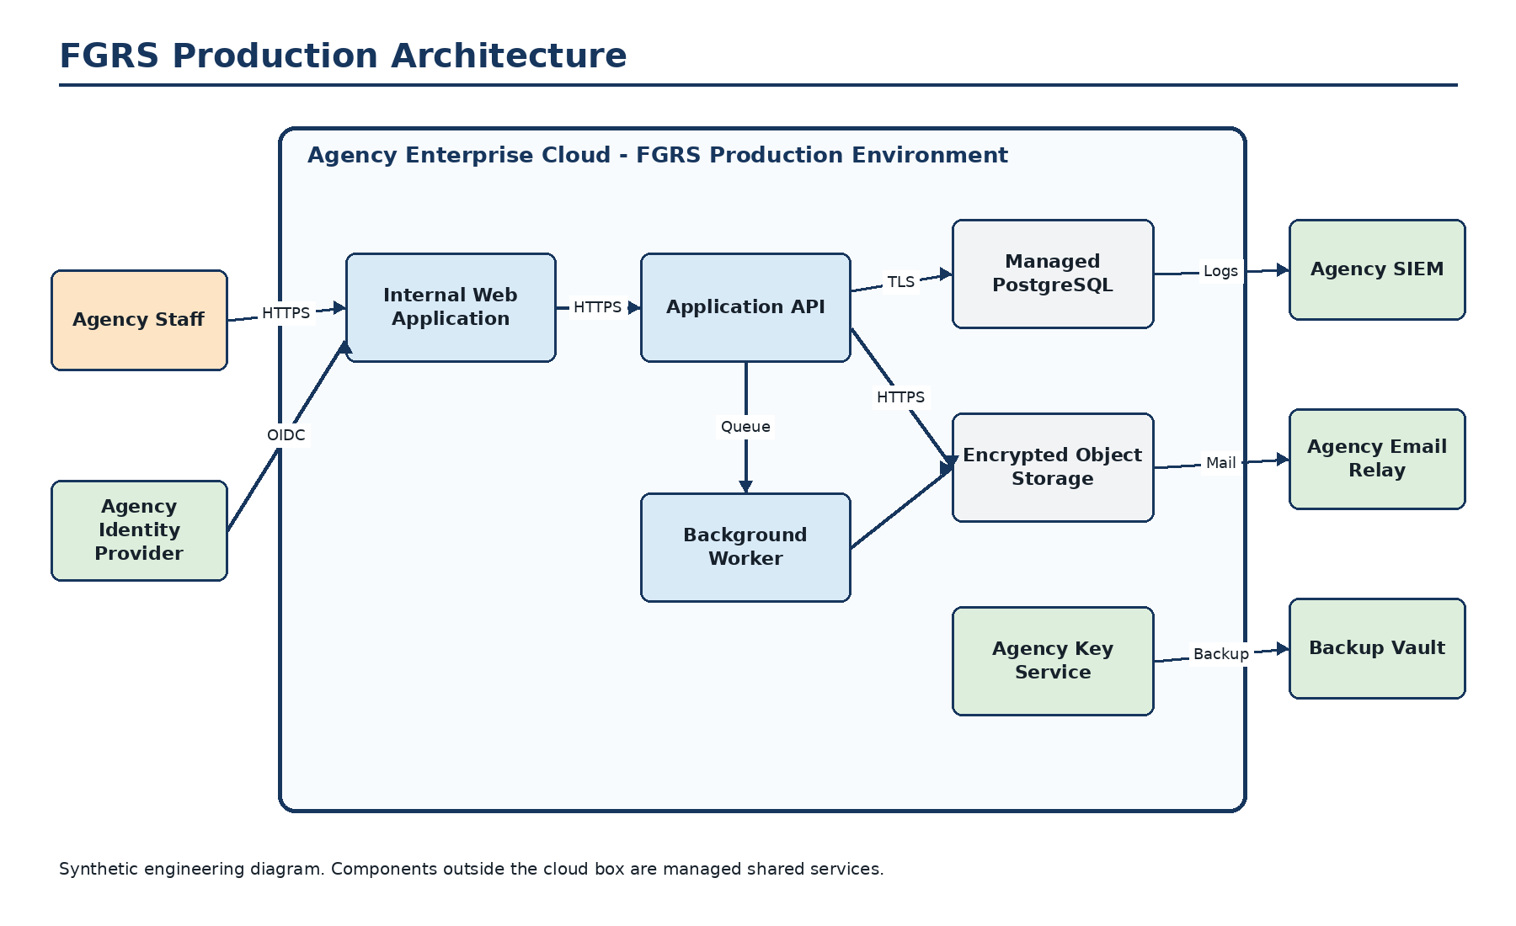
The FGRS production environment includes the internal web application, application API, background worker, managed PostgreSQL database, encrypted object storage, deployment namespace, workload identities, network policies, and application-specific encryption keys. The agency identity provider, SIEM, email relay, vulnerability scanner, privileged access service, and backup vault are shared services operated outside the product environment.

5. Data flow and external services
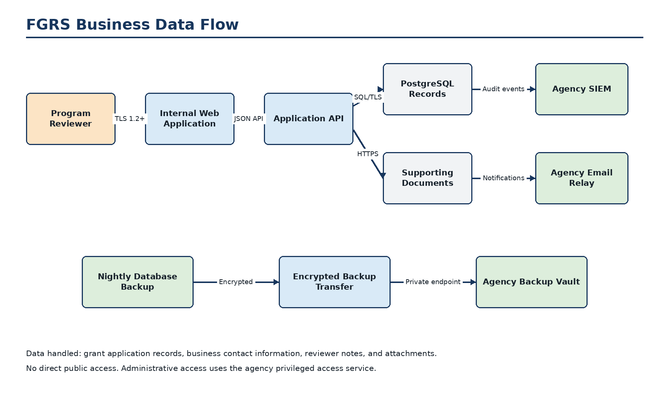
Service | Direction and purpose | Protection
Agency identity provider | Inbound authentication and group claims | OIDC over TLS; phishing-resistant MFA using agency PIV
Public intake service | Inbound transfer of accepted application packages | Mutual TLS, workload identity, schema validation, malware-scan status required
Agency SIEM | Outbound audit and security events | TLS log forwarding through the central collector
Agency email relay | Outbound workflow notifications | Authenticated TLS connection; no attachments are sent
Vulnerability service | Inbound authenticated scanning of approved endpoints | Dedicated scanner identity and private network path
Backup vault | Outbound encrypted database and object backups | Private endpoint and separate agency-managed encryption key

