FGRS Production Operations Guide
Version 3.4 - maintained by the application platform team
Document status: Synthetic operational artifact for product testing

1. Deployment and configuration
Production changes are deployed from the approved source repository through the agency continuous-integration service. Builds create signed container images, scan dependencies and image layers, and publish approved images to the agency registry. Production deployment requires a peer-reviewed change request and approval from the technical owner. Direct interactive changes to running containers are prohibited.
- A standard monthly maintenance window is used for routine platform and application updates.
- Critical remotely exploitable defects are evaluated within one business day and remediated or mitigated within 15 calendar days.
- High-severity defects are remediated within 30 calendar days.
- Infrastructure and application configuration are version-controlled; protected branches require two reviewers.
- Secrets are stored in the agency secret-management service and are not stored in source code, container images, or deployment manifests.
- Production and non-production use separate accounts, networks, databases, keys, and workload identities.

2. Logging and monitoring
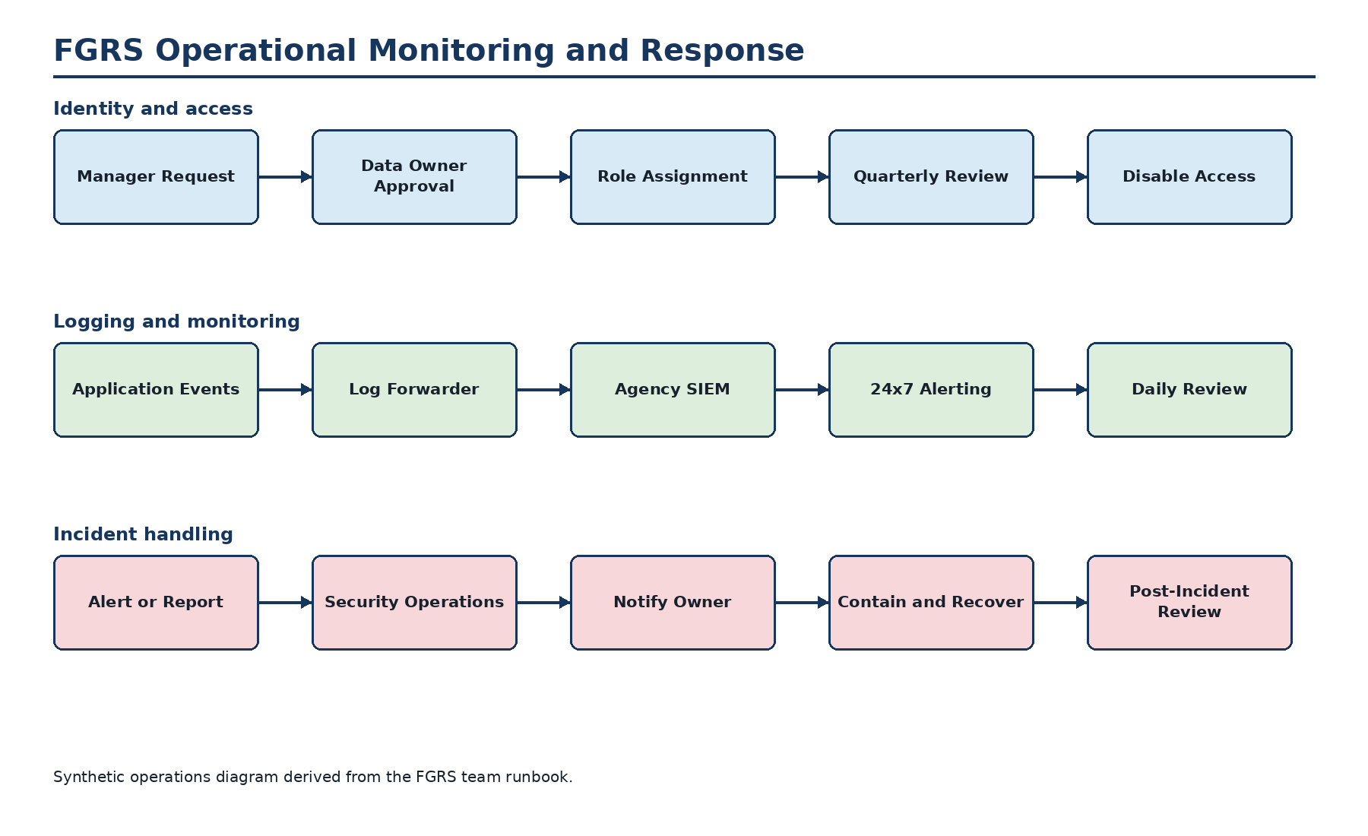
Event source | Recorded details | Operational use
Authentication | Success, failure, user, source, time, session identifier | Brute-force and unusual-access alerting
Authorization | Role changes, denied actions, privileged actions | Access review and misuse detection
Business records | Create, update, assignment, score, approval, export | Accountability and troubleshooting
Platform | Deployment, container restart, health, database connection, job failure | Availability and reliability monitoring
Security tools | Image findings, endpoint findings, dependency findings | Remediation tracking
Application audit events are forwarded to the agency SIEM within five minutes. Security Operations provides 24x7 alerting. The application team reviews service health and failed jobs each business day. Logs remain searchable for 90 days and are archived for one year. Application logs exclude access tokens, passwords, session cookies, full document contents, and sensitive form values.

3. Backup and recovery
- Managed database backups run nightly and transaction logs support point-in-time recovery.
- Object-storage versioning is enabled and deleted objects are retained for 35 days.
- Nightly backups are retained for 35 days; monthly recovery points are retained for one year.
- Backups use a separate agency-managed encryption key and are copied to the secondary-region backup vault.
- The team performs a documented restore test each quarter.
- The recovery objective is eight hours and the maximum acceptable data loss is 24 hours.
- Recovery requires the incident commander or continuity coordinator to authorize failover.

4. Vulnerability and maintenance activities
- Container images and application dependencies are scanned on every build and at least weekly.
- The agency scanning service performs an authenticated infrastructure scan monthly.
- The product team reviews new findings each business day and records remediation owners and due dates in the engineering ticket system.
- Annual application penetration testing is coordinated by the agency security testing team.
- Unsupported software versions are blocked from production deployment by pipeline policy.
- Time is synchronized from the agency time service.

5. Incident and service-event handling
Users report suspected security events through the agency service desk or security hotline. Automated alerts are routed to Security Operations. Security Operations opens the incident record, performs initial triage, and contacts the FGRS technical owner and cybersecurity liaison. The application team preserves relevant logs, isolates affected workloads when directed, rotates exposed credentials, restores trusted images, and validates service health. External reporting and notification are handled under the agency incident-response process. A post-incident review records root cause, corrective actions, and assigned owners.

