BARANGAY INFORMATION AND MANAGEMENT SYSTEM FOR BARANGAY DACUTAN, DUMANGAS, ILOILO
An IT Capstone Project
Presented to
the Faculty of the Information Technology Program
Iloilo Science and Technology University - Dumangas Campus
Dumangas, Iloilo
In Partial Fulfillment
of the Requirements for the Degree
Bachelor of Science in Information Technology
by:
[STUDENT RESEARCHER 1]
[STUDENT RESEARCHER 2]
[STUDENT RESEARCHER 3]
October 2026

APPROVAL SHEET
This capstone project entitled "BARANGAY INFORMATION AND MANAGEMENT SYSTEM FOR BARANGAY DACUTAN, DUMANGAS, ILOILO," prepared and submitted by [STUDENT RESEARCHER 1], [STUDENT RESEARCHER 2], and [STUDENT RESEARCHER 3], in partial fulfillment of the requirements for the degree Bachelor of Science in Information Technology, is hereby recommended for approval.
[ADVISER NAME, MIT]
Adviser
Approved by the Defense Committee in oral examination on October 2026 with a grade of PASSED.
[PANEL CHAIRPERSON, DIT]
Panel Chairperson
[COMMITTEE MEMBER 1, MIT] [COMMITTEE MEMBER 2, MIT]
Member Member
Accepted and approved in partial fulfillment of the requirements for the degree Bachelor of Science in Information Technology.
[CAMPUS ADMINISTRATOR, Ph.D.]
Campus Administrator
Date: October 2026

ACKNOWLEDGEMENT
The researchers wish to extend their sincere appreciation and heartfelt gratitude to all individuals who gave their time, assistance, and support in making this capstone project possible:
To the Almighty God, for the gift of wisdom, good health, daily protection, guidance, and strength during times of difficulty throughout this journey;
To our Capstone Project Adviser, [Adviser Name], for their patient advice, technical knowledge, constructive critiques, and encouragement from the planning phase up to the completion of this study;
To the Panel Members and IT Faculty of ISAT U Dumangas Campus, for their insightful suggestions, valuable recommendations, and standards that enhanced the quality of this system;
To the Barangay Officials and Staff of Barangay Dacutan, Dumangas, Iloilo, headed by Punong Barangay Hon. Stephen James D. Foerster and Barangay Secretary Mrs. Pearl Joy J. Amuan, for their warm cooperation, for entertaining our interviews, and for providing genuine data and workflow insights;
To our beloved parents, guardians, and families, for their unending love, financial support, moral guidance, and understanding during countless late nights of coding and documentation; and
To our classmates and friends, for their camaraderie, shared knowledge, and motivation.
The Researchers
ISAT U Dumangas Campus

ABSTRACT
This study focuses on the design, development, implementation, and evaluation of the web-based Barangay Information and Management System (BIMS) for Barangay Dacutan, Municipality of Dumangas, Province of Iloilo. Barangay Dacutan previously relied on manual, paper-based records stored in physical logbooks and filing folders to manage resident profiles, issue clearances, record dispute blotters, and distribute calamity assistance. This manual approach resulted in common difficulties including lost records, slow document issuance, inaccurate eligibility lists for social assistance, and long queues at the barangay hall. To solve these problems, the researchers developed a web-based system using the Prototyping Model. The system was built using PHP Laravel 12 for the backend, MySQL 8.0 for the relational database, and HTML with Tailwind CSS for the user interface, deployed on a live cloud web hosting server accessible online over the internet. The system is structured for three primary user roles: the Resident (general public), the Punong Barangay (Barangay Captain), and the Barangay Secretary (who also executes routine clerical and records-filing duties). The system features a public citizen portal where residents can directly apply for twelve (12) official certificates and documents categorized into Personal Certificates & Clearances (Barangay Clearance, Certificate of Residency, Certificate of Indigency, Certificate of Good Moral Character, First-Time Jobseeker Certification under RA 11261, Barangay ID, and Solo Parent Certification), Business & Property Clearances (Barangay Business Permit, Building/Construction Clearance, and Certificate of No Objection), and Legal & Dispute Records (Barangay Blotter Certification and Certification to File Action), with real-time application tracking using a unique reference code. The system implements a two-tier review and approval hierarchy where applications are first evaluated and verified by the Barangay Secretary, followed by final executive approval from the Punong Barangay, supported by automated email status notifications sent directly to citizens at each step of the process. The administrative terminal enables staff to manage census resident profiling with purok mapping, generate authentic Philippine Republic standard A4 clearances with dual municipal and barangay seals, log Katarungang Pambarangay dispute hearings, and monitor emergency relief distribution. The system was evaluated using the ISO 25010 Software Quality standard by ten purposively selected evaluators composed of five IT experts and five domain end-users. The evaluation yielded an overall grand mean of 4.54 with a verbal interpretation of 'Excellent,' proving that the system successfully modernizes and improves the administrative and public service operations of Barangay Dacutan.

TABLE OF CONTENTS
TITLE PAGE................ i
APPROVAL SHEET............... ii
ACKNOWLEDGEMENT.............. iii
ABSTRACT................ iv
TABLE OF CONTENTS.............. v
LIST OF TABLES............... vi
LIST OF FIGURES.............. vii
LIST OF APPENDICES............. viii
CHAPTER I: INTRODUCTION............. 1
Background of the Study............ 1
Objectives of the Study............ 3
Conceptual Framework of the Study.......... 4
Definition of Terms............. 6
Significance of the Study............ 8
Scope and Limitations of the Study......... 9
CHAPTER II: REVIEW OF RELATED LITERATURE AND STUDIES..... 12
Related Literature............. 12
Related Studies.............. 15
Table of Comparison............. 18
Synthesis............... 19
CHAPTER III: METHODOLOGY............ 21
Project Description............. 21
Project Development Process........... 23
UML Diagrams............... 26
Requirement Analysis............. 32
System Evaluation............. 34
Data Gathering Instrument........... 36
Respondents of the Study............ 36
Data Analysis Procedure and Statistical Treatment..... 37
REFERENCES................ 39
APPENDICES................ 41

LIST OF TABLES
Table 1 System Comparison of the Related Studies with the Proposed System. 18
Table 2 Hardware Specification for the System....... 32
Table 3 Software Specification for the System....... 33
Table 4 Five-Point Likert Scale and Verbal Interpretation.... 35
Table 5 Summary of ISO 25010 Software Quality Evaluation Results.. 37

LIST OF FIGURES
Figure 1 Conceptual Framework of the Study (IPO Model)..... 5
Figure 2 Prototyping Model Software Development Life Cycle.... 24
Figure 3 Use Case Diagram of the Barangay Information Management System. 27
Figure 4 Activity Diagram for Online Clearance Application and Issuance. 28
Figure 5 Class Diagram / Database Schema of BIMS...... 29
Figure 6 Sequence Diagram for Citizen Document Tracking Flow... 30
Figure 7 System Architecture Diagram of the BIMS Live Cloud Web Deployment. 31

LIST OF APPENDICES
Appendix A ISO 25010 Software Quality Evaluation Instrument... 41
Appendix B System User Interface Screenshots and Print Layouts... 42
Appendix C Certificate of System Acceptance and Transmittal... 44

Chapter I
INTRODUCTION

Background of the Study
Information technology helps government offices deliver faster, more organized, and dependable public services. In the Philippines, the barangay serves as the primary political and administrative unit where citizens directly interact with government services, as stated in Republic Act No. 7160, also known as the Local Government Code of 1991. Barangays are responsible for keeping track of local residents, maintaining peace and order, issuing certifications, settling neighborhood disputes, and providing immediate community relief during emergencies. Because of these essential responsibilities, having a fast and reliable record-keeping system is necessary for every barangay hall.
Barangay Dacutan is one of the coastal and agricultural barangays situated in the Municipality of Dumangas, Province of Iloilo, under Region VI (Western Visayas). Geographically located approximately 2.5 kilometers from the municipal poblacion with a total land area of 230.7171 hectares, the barangay is bounded on the North by Barangay Sulangan and Barangay Binaobao, on the South by the coastal fishing waters, on the East by Barangay Talusan and Barangay Sapao, and on the West by Barangay Ermita. Administratively, the community is organized strictly into seven (7) puroks, designated as Purok 1 through Purok 7. According to the official 2025 Barangay Demographic Profile, Barangay Dacutan has an aggregate population of 2,337 residents (comprising 1,142 males and 1,195 females), distributed across 678 families and 562 households. The community includes significant special sectors: 556 senior citizens (aged 60 and above), 69 persons with disabilities (PWDs), 1,445 registered COMELEC voters, 69 Pantawid Pamilyang Pilipino Program (4Ps) beneficiaries, 75 overseas Filipino workers (OFWs), 52 registered farmers, and 146 active fisherfolks. Frontline regulatory and administrative governance is administered pursuant to Republic Act No. 7160 (Local Government Code of 1991) and Barangay Ordinance No. 2020-01 ('An Ordinance Enacting the Barangay Tax and Regulatory Fees of Barangay Dacutan, Dumangas, Iloilo'), enacted by the Sangguniang Barangay under the leadership of Punong Barangay Hon. Stephen James D. Foerster and Barangay Secretary Mrs. Pearl Joy J. Amuan.
Currently, Barangay Dacutan still depends heavily on manual and paper-based methods for managing its everyday records. When a resident comes to the barangay hall to ask for a clearance or certificate, the staff must manually search through paper logbooks, binders, or index cards to confirm the resident's name, purok, and records. Once verified, the Barangay Secretary types or fills out a paper template, collects the corresponding fee, writes a manual paper receipt, and brings the document to the Punong Barangay for an ink signature. For blotter disputes, complaints are written by hand into a physical blotter book, and hearing schedules are kept on loose desk calendars. Likewise, during disaster relief distributions, lists of beneficiaries from special sectors like senior citizens, persons with disabilities (PWDs), and 4Ps members are written on paper sheets.
This traditional manual process causes several major problems for both the barangay personnel and the citizens. First, physical record books are prone to tear, water damage, ink fading, and insect damage over time. Second, searching for a single record among stacked boxes takes too much time, especially when verifying whether an individual has a pending dispute in the blotter records before issuing a clearance. Third, citizens often have to make repeated visits to the barangay hall just to inquire if their requested document has already been signed, leading to long waiting lines and frustration. Lastly, during emergency relief operations, having no centralized digital database makes it hard to quickly verify who is truly qualified, resulting in slow distribution and risks of duplicate food packs.
To solve these operational challenges, the researchers proposed and developed the Barangay Information and Management System (BIMS) for Barangay Dacutan, Dumangas, Iloilo. The system is a web-based e-governance platform designed to modernize and streamline community operations. It supports three distinct user roles: the Resident (general public), the Punong Barangay (Hon. Stephen James D. Foerster), and the Barangay Secretary (Mrs. Pearl Joy J. Amuan, who also handles administrative records and clerical operations). The system provides a citizen-facing public web portal where residents can directly apply for official certificates and clearances across personal, business, and dispute categories, consult an intelligent 24/7 AI Chatbot Assistant (powered by the Google Gemini API) for procedural advice and requirements, and track request milestones in real time using an automated tracking reference code. For barangay officials, the system provides a secured administrative portal with modules for census profiling across the 7 puroks, automated clearance issuance with authentic Philippine Republic standard A4 layouts, Katarungang Pambarangay blotter dispute mediation tracking, and emergency calamity relief aid distribution monitoring. To eliminate the administrative overhead of managing citizen user accounts and forgotten passwords while safeguarding the system against spam, prank submissions, and malicious automated bot entries, the system adopts the recommended compromise of One-Time Pin (OTP) Verification via Email. When a resident completes the online document appointment form, the system dispatches a transient 4-digit numeric code to their active email address. Entering this code verifies that the applicant is a genuine individual with a valid email account, eliminating fake submissions without forcing residents to register and maintain password-protected accounts.
By implementing this computerized system, Barangay Dacutan can significantly improve its public service efficiency. Document processing time will be reduced from hours or days to just a few minutes. Citizen records will be safely preserved inside a secure MySQL database, preventing data loss. In addition, the system will support local transparency, help staff quickly identify vulnerable households needing immediate aid, and uphold the standard of modern, responsive e-governance in the community.

Objectives of the Study
The main objective of the study was to develop, implement, and evaluate the web-based Barangay Information and Management System (BIMS) for Barangay Dacutan, Municipality of Dumangas, Province of Iloilo.
Specifically, the study aimed to:
• design and create a centralized relational database using MySQL to safely store resident census profiles, official clearances, dispute cases, and aid distribution records;
• manage secure administrative user accounts for authorized barangay officials (Punong Barangay and Barangay Secretary) and enforce a two-tier review and approval workflow where citizen document requests are evaluated by the Barangay Secretary (acting as administrative records officer) and granted final executive approval by the Punong Barangay;
• provide a public citizen portal where community residents can view barangay information, schedule document appointments, consult an integrated 24/7 AI Chatbot Assistant (utilizing the Google Gemini API) for automated guidance on clearance requirements and fee schedules under Barangay Ordinance No. 2020-01, apply online for official certificates and documents across personal, business, and dispute categories, secured through an One-Time Pin (OTP) verification mechanism via Email that transmits a transient 4-digit code to validate active email addresses and eliminate fake/spam entries without requiring password-based account registration, receive automated email status notifications upon secretary review and captain approval, and track request progress in real time using a unique reference code;
• record and monitor resident census records with complete demographic details across the seven (7) puroks of Barangay Dacutan, and track special sector eligibility flags including Senior Citizens, PWDs, 4Ps members, Solo Parents, Farmers, Fisherfolks, and registered COMELEC voters;
• generate and print official Philippine Republic standard A4 barangay clearances, permits, and certifications complete with dual municipal and barangay seals, council roster sidebars, thumbmark boxes, and official receipt information;
• record and monitor Katarungang Pambarangay blotter disputes, hearing schedules, and amicable settlement terms under the Lupon Tagapamayapa, including the issuance of Blotter Certifications and Certifications to File Action; and
• evaluate the developed system using the ISO 25010 software quality standards in terms of functional suitability, performance efficiency, compatibility, usability, reliability, security, maintainability, and portability.

Conceptual Framework of the Study
The conceptual framework of this study was developed using the Input-Process-Output (IPO) model, integrated with an evaluation feedback loop. Figure 1 shows the conceptual framework of this study.
[Figure 1. Conceptual Framework of the Study (IPO Model)]
Diagram Placeholder:
┌───────────────────────────────────┐ ┌───────────────────────────────────┐ ┌──────────────────────────────────────────────┐
│ INPUT │ │ PROCESS │ │ OUTPUT │
│ • Resident Info │ ───> │ • Register Residents │ ───> │ • Barangay Information and Management System│
│ • Document Request Information │ │ • Process Document Request │ │ │
└───────────────────────────────────┘ └───────────────────────────────────┘ └──────────────────────────────────────────────┘
▲ ▲ │
└─────────────────── [FEEDBACK LOOP: ISO 25010 EVALUATION] ───────────────────────────────┘
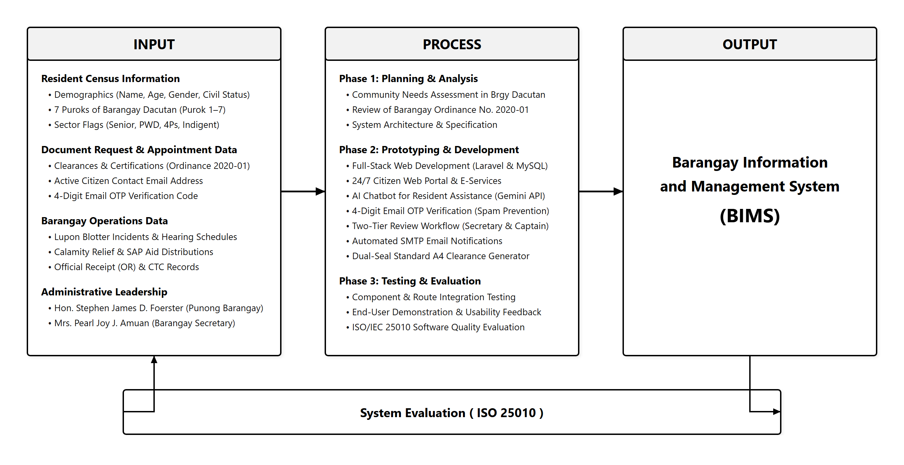
Figure 1. Conceptual Framework of the Study (IPO Model)
As shown in Figure 1, the Input phase consists of the essential data requirements needed to operate the system: Resident Info and Document Request Information. Resident Info includes personal and demographic details such as the resident's full name, address or purok, birthdate, civil status, contact information, and special sector qualifications (Senior Citizen, PWD, 4Ps, Solo Parent, and registered voter status). Document Request Information includes the necessary application details submitted by citizens, such as the selected document among the twelve (12) certificate offerings (e.g., Barangay Clearance, Residency, Indigency, Good Moral, or Blotter Certification), purpose of request, applicant identification, and auto-generated tracking reference code.
The Process phase covers the primary operations executed by the system: Register Residents and Process Document Request. Register Residents involves encoding, verifying, updating, and organizing resident census records within the MySQL database, categorizing households by purok for fast retrieval. Process Document Request involves receiving submitted applications, verifying the applicant against the resident database, evaluating statutory fee exemptions under RA 11261 for first-time jobseekers, recording Official Receipt numbers, securing Punong Barangay approval, generating authentic Philippine Republic standard A4 printable clearances with dual municipal and barangay seals, and updating the live 4-stage tracking status.
The Output phase is the completed and working Barangay Information and Management System for Barangay Dacutan, Dumangas, Iloilo. The output provides a fully operational web platform featuring a public citizen portal for online applications and live document tracking, as well as a secure administrative terminal for resident profiling, certification printing, Katarungang Pambarangay dispute tracking, and calamity aid management. The evaluation feedback loop connects the Output back to the Input and Process stages through the ISO/IEC 25010 Software Quality evaluation, allowing feedback and ratings from IT experts and barangay officials to guide continuous maintenance and system refinement.

Definition of Terms
To provide clear understanding, the key terms used in this study are conceptually and operationally defined as follows:
Aid Distribution (Ayuda). The systematic allocation and handover of relief goods, cash assistance, or emergency supplies to affected families during calamities or social welfare programs (Flores et al., 2023). In this study, aid distribution refers to the administrative module used to log relief packages, cash subsidies, and food packs given to verified residents of Barangay Dacutan, with special tracking for seniors, PWDs, 4Ps, and indigent households.
Barangay Clearance. An official legal document issued by the barangay certifying that an individual is a official resident of the community and possesses good moral character with no derogatory criminal record (Brillantes & Perante-Calina, 2018). In this study, barangay clearance refers to the printable official certification generated by the system using standard Philippine Republic A4 layout, featuring dual municipal and barangay seals, official receipt numbers, and valid signatures.
Barangay Secretary. An appointed local government officer responsible for maintaining official records, preparing minutes of council sessions, and managing administrative correspondence in the barangay (Republic of the Philippines, 1991). In this study, the Barangay Secretary refers to the primary administrative user role who also performs routine clerical duties, evaluates incoming online document requests, manages resident records, schedules Lupon hearings, and prepares clearances.
Blotter Record. A formal written log maintained by peacekeepers and community officials that documents daily complaints, disputes, incidents, and mediation proceedings (Pe & Tadiar, 2017). In this study, blotter record refers to the computerized database module where complainant and respondent information, incident details, hearing dates, and Lupon Tagapamayapa amicable settlements are stored and tracked.
Certification to File Action (CFA). A formal attestation issued by the Lupon Tagapamayapa certifying that dispute conciliation before the barangay failed, allowing the dispute to be formally filed in a court of law (Pe & Tadiar, 2017). In this study, Certification to File Action refers to the legal record generated by the system under the Katarungang Pambarangay module when mediation between disputing residents does not reach an agreement.
Database Management System (DBMS). A collection of software programs that enables users to create, maintain, query, and modify electronic databases while enforcing data security and relational integrity (Coronel & Morris, 2020). In this study, DBMS refers to MySQL 8.0, which stores all resident demographic profiles, issued certificates, user accounts, and blotter records on the secure live cloud web server.
ISO 25010. An internationally recognized standard that defines a software product quality model categorized into eight characteristics to measure software effectiveness and user satisfaction (International Organization for Standardization, 2011). In this study, ISO 25010 refers to the evaluation questionnaire and rating framework used by IT experts and barangay officials to grade the system from 1 to 5.
Katarungang Pambarangay. The local community-level justice and mediation system in the Philippines established to peacefully settle neighborhood disputes without immediately filing court cases (Pe & Tadiar, 2017). In this study, Katarungang Pambarangay refers to the dispute management section of the system that tracks mediation stages from initial filing to amicable resolution or court referral.
Laravel. An open-source PHP web framework that utilizes the Model-View-Controller (MVC) architectural pattern to build secure, scalable, and modular web applications (Otwell, 2024). In this study, Laravel refers to the PHP backend engine powering the business logic, route security, and database controllers of BIMS.
Purok. A sub-division or neighborhood cluster within a Philippine barangay that groups residential households for administrative and census purposes (Brillantes & Perante-Calina, 2018). In this study, purok refers to the seven (7) territorial groupings in Barangay Dacutan, specifically Purok 1 through Purok 7, used for filtering resident records, mapping demographics, and generating community analytics.
Resident Profiling. The process of recording and organizing individual citizen demographics, socioeconomic standing, and household data for planning and social service allocation (Santos et al., 2021). In this study, resident profiling refers to the computerized masterlist module containing resident names, birthdates, purok addresses, contact numbers, voter registration, and sector classifications.

Significance of the Study
The results and output of this study will be directly beneficial to the following groups of individuals and institutions:
Punong Barangay (Barangay Captain). The system provides Punong Barangay Hon. Stephen James D. Foerster with an executive dashboard showing real-time demographic statistics across the 7 puroks, monthly revenue collections under Ordinance No. 2020-01, pending dispute rates, and active citizen clearance requests. This provides executive visibility, accelerates Tier-2 clearance approvals, and supports accurate data-driven community planning.
Barangay Secretary (and Clerical Staff). The system significantly lessens the daily administrative and clerical workload of Barangay Secretary Mrs. Pearl Joy J. Amuan. Instead of manually searching through physical logbooks and paper cards, the secretary can verify resident records in seconds, process online clearance requests across official document offerings, record official receipts and CTC numbers, and monitor mediation schedules with automated tracking numbers. In addition, because the system employs lightweight 4-digit OTP verification via email on appointment requests rather than mandatory citizen account registration, the secretary is completely relieved from the administrative burden of managing citizen login accounts, handling forgotten password requests, and cleaning up spam submissions.
Residents of Barangay Dacutan. Community constituents save substantial time and travel expenses by accessing the public portal directly from their home computers or smartphones. They can request official clearances, certifications, and appointments and monitor application status in real time without making repeated trips to the barangay hall. Furthermore, residents enjoy a frictionless requesting experience without having to create or remember account passwords, verifying their identity easily through a 4-digit OTP sent to their verified email inbox.
Municipality of Dumangas and DILG. The project promotes compliance with national e-governance and ease of doing business standards (Republic Act 11032). It gives local municipal authorities an practical example of digitalized community governance.
Iloilo Science and Technology University (ISAT U). This study showcases the university's mission of applying technology to address real-world community needs. It proves that students of ISAT U Dumangas Campus can create practical and functioning information systems that directly serve local barangays.
Future Researchers. This manuscript and system can serve as a dependable reference, baseline guide, and source of literature for upcoming IT students who plan to develop similar local governance, inventory, or community profiling systems.

Scope and Limitations of the Study
This study focuses on the development of the Barangay Information and Management System (BIMS) for Barangay Dacutan, Municipality of Dumangas, Province of Iloilo, designed to improve the efficiency, transparency, and delivery of community records management and frontline public services. The system is intended for use within the administrative jurisdiction of Barangay Dacutan, specifically covering all residential households situated across Purok 1 through Purok 7.
The system includes an Executive Dashboard that serves as the central administrative hub for the Punong Barangay and authorized staff, providing real-time demographic indicators, revenue collection summaries, and active transaction queues. This ensures proper administrative control, data visibility, and informed community decision-making.
A Secretary and Clerical Records Interface is also included, allowing the Barangay Secretary and administrative staff to efficiently encode, verify, update, and manage resident census profiles, track community disputes under the Katarungang Pambarangay, and maintain calamity relief assistance distributions. This eliminates manual logbook searches, reduces paperwork, minimizes clerical recording errors, and speeds up the daily processing of community requests.
For community members, a Public Citizen Portal is available, providing secure and convenient access to official barangay announcements, leadership directories, an intelligent AI Chatbot Assistant powered by the Google Gemini API for procedural guidance, and online applications for official certificates and documents across personal, business, and dispute categories pursuant to Barangay Ordinance No. 2020-01. To prevent spam, prank submissions, and malicious bot entries without imposing the friction of mandatory account registration, the portal incorporates a lightweight 4-digit One-Time Pin (OTP) verification mechanism via Email that validates the applicant's active email address prior to official submission. The portal also features a live four-stage document tracker, allowing citizens to monitor their application progress in real time using a unique tracking reference code without having to make repeated physical visits to the barangay hall.
The system also integrates a structured Two-Tier Approval Hierarchy supported by automated Email Notification Services. Under this workflow, incoming citizen applications are first reviewed and evaluated by the Barangay Secretary against the resident database, followed by final executive approval from the Punong Barangay before official clearances are printed using authentic Philippine Republic standard A4 layouts with municipal and barangay seals. Automated email notifications are dispatched directly to the citizen's email address at each step of the process, notifying residents when their application has been evaluated, approved, and prepared for release at the barangay hall.
To ensure accessibility and usability, the system is deployed on a live web hosting environment and accessed online via the internet through standard web browsers on smartphones, tablets, laptops, and desktop computers. This enables community residents to access the public citizen portal and submit document requests online 24/7 from anywhere without having to travel to the barangay hall during the initial application stage. To protect database integrity while keeping citizen services frictionless, password-based user accounts are strictly restricted to authorized administrative personnel (Punong Barangay Hon. Stephen James D. Foerster and Barangay Secretary Mrs. Pearl Joy J. Amuan), whereas citizen requestors authenticate their appointments on demand via 4-digit Email OTP.
This study has several limitations that mean the study focuses strictly on its primary objective: modernizing resident records management, document issuance, and frontline community services in Barangay Dacutan.
The system is limited to web-based access and does not include a native downloadable mobile application. Users access the system through modern desktop or mobile web browsers. To prevent ongoing telecommunication overhead and recurring subscriber costs, the system does not utilize cellular SMS text messaging; instead, all identity verification operations (4-digit Email OTP), milestone status tracking, and clearance pickup notifications are dispatched through automated SMTP email notifications and the public online tracking portal. The system does not include an online electronic payment gateway, such as GCash or Maya, so all document fees are collected personally in cash at the barangay hall upon claiming, recorded with manual Official Receipt (OR) and Community Tax Certificate (CTC) numbers pursuant to Barangay Ordinance No. 2020-01. Furthermore, the application is strictly designed for the administrative jurisdiction and demographic records of Barangay Dacutan, Dumangas, Iloilo, and does not automatically integrate with external municipal or national police law enforcement databases.

Chapter II
REVIEW OF RELATED LITERATURE AND STUDIES
This chapter presents a review of relevant literature, conceptual theories, and similar local and international studies that serve as the foundation of the proposed Barangay Information and Management System.

Related Literature

E-Governance and Local Government Automation
Brillantes and Perante-Calina (2018) emphasized that electronic governance (e-governance) in the Philippines is an essential tool in transforming public administration from slow, bureaucratic red tape into transparent, responsive, and accountable public service. They explained that automating basic government processes at the community level reduces human error, prevents loss of government records, and increases citizen trust in local institutions. In the context of local government units (LGUs), computerization allows barangay officials to manage community census records accurately and deliver timely services to their constituents.
This literature strongly supports the development of BIMS for Barangay Dacutan, showing that replacing manual paper records with an automated web portal directly promotes good local governance and faster community assistance.
Legal Mandates for Barangay Automation and Citizen Service Delivery
The legal framework governing local public administration in the Philippines mandates efficiency, transparency, and accessible public service. Republic Act No. 7160, known as the Local Government Code of 1991, designates the barangay as the primary unit of government responsible for delivering frontline services, keeping official census registries, and resolving community disputes through peaceful conciliation. To accelerate government responsiveness, Republic Act No. 11032, also known as the Ease of Doing Business and Efficient Government Service Delivery Act of 2018, directs all government offices and local government units to re-engineer manual workflows, adopt electronic systems, eliminate unnecessary processing steps, and enforce strict turnaround deadlines for document issuance. In addition, Republic Act No. 11261, or the First Time Jobseekers Assistance Act of 2019, mandates barangays to issue certifications for first-time jobseekers free of charge to help youth secure employment requirements. To ensure that sensitive resident demographics, indigent profiles, and dispute records remain protected against unauthorized exposure, Republic Act No. 10173, the Data Privacy Act of 2012, imposes strict requirements for secure data storage and role-based access control.
These legal mandates directly justify the design of BIMS, which incorporates a public request portal for 12 document categories (including first-time jobseeker waivers under RA 11261), automated processing workflows compliant with RA 11032 turnaround targets, and role-based data security aligned with RA 10173.

Relational Database Management Systems in Community Records
Coronel and Morris (2020) explained that database systems are the backbone of modern record-keeping operations. A well-structured Relational Database Management System (RDBMS) organizes complex data into structured tables with defined primary and foreign keys. This design ensures data consistency, avoids duplicate entries, speeds up search queries, and guarantees data integrity even when dealing with thousands of resident records.
This literature supports the choice of MySQL 8.0 in this study, confirming that using a relational database ensures the demographic data, clearances, and blotter records of Barangay Dacutan remain secure, easily searchable, and free from duplication.

Katarungang Pambarangay and Community Dispute Resolution
Pe and Tadiar (2017) highlighted that the Katarungang Pambarangay system under the Local Government Code of 1991 is a unique and effective dispute resolution mechanism aimed at settling neighborhood conflicts peacefully without burdening formal courts. They noted that many barangays face challenges in maintaining accurate case logs, tracking mediation hearing schedules, and preserving written terms of amicable settlement.
This literature justifies the inclusion of a dedicated Katarungang Pambarangay blotter module in BIMS to record case proceedings, prevent unresolved conflicts from being forgotten, and provide clear tracking of amicable agreements.
Cloud-Based Service Delivery and Automated Notification Systems
In modern e-governance, deploying public web services to live cloud environments combined with automated notification systems significantly improves public access to local government assistance. Cloud hosting ensures that community residents can access information and submit document requests at any time using their personal mobile phones or computers, without needing to travel to the barangay hall during limited office hours. Furthermore, automated status notifications sent via email keep applicants updated as their document moves through clerical review and executive approval. This real-time feedback loop minimizes unnecessary physical follow-ups, prevents overcrowding in government halls, and provides transparent tracking for every submitted transaction.
This concept supports the live cloud web architecture of BIMS, which enables 24/7 online document requests, automated email updates on application status, and real-time transaction tracking for the residents of Barangay Dacutan.

ISO/IEC 25010 Software Quality Standards
The International Organization for Standardization (2011) established the ISO/IEC 25010 standard, which defines software product quality through eight essential characteristics: functional suitability, performance efficiency, compatibility, usability, reliability, security, maintainability, and portability. Software engineers and academic evaluators widely use this standard to systematically measure whether a developed system meets user expectations and technical benchmarks.
This literature provides the formal evaluation criteria used in this capstone project to objectively assess the system's performance and usability among IT experts and barangay end-users.

Related Studies

Web-Based Barangay Management Information System (Santos et al., 2021)
Santos et al. (2021) developed a Web-Based Barangay Management Information System for an urban community in Metro Manila. Their system automated resident record filing, certificate generation, and incident blotter management. The authors found that the system reduced citizen queuing time at the barangay hall by over sixty percent and significantly reduced clerical errors made by staff during certificate printing.
Their project is similar to BIMS in terms of resident profiling and clearance issuance. However, their study was designed for a dense urban setting and did not feature a public citizen tracking portal or calamity relief aid distribution, which BIMS includes to meet the rural and coastal needs of Barangay Dacutan.

Automated Barangay Clearance and Certification System (Dela Cruz & Ramos, 2022)
Dela Cruz and Ramos (2022) created an automated clearance issuance program in Bulacan that focused specifically on generating printed barangay clearances with barcode verification and recording official fee payments. Their findings showed that computer-generated certificates eliminated fake barangay clearances and prevented unrecorded fee collections.
While their project focused solely on document printing, BIMS adopts a more complete approach by integrating clearance issuance with live citizen online tracking, katarungang pambarangay records, and demographic census mapping under authentic Philippine Republic dual-seal A4 layouts.

Community Disaster Relief and Ayuda Distribution Management System (Flores et al., 2023)
Flores et al. (2023) developed a computerized aid distribution tracker for rural communities affected by seasonal typhoons in Eastern Visayas. The system categorized households based on vulnerability indicators like senior citizens, solo parents, and indigent status to ensure fair and organized relief pack distribution.
Their findings proved that digital beneficiary tracking prevented duplicate food pack distribution and shortened relief queuing times. BIMS incorporates a similar calamity relief registry that directly links aid disbursements to verified resident profiles in Barangay Dacutan.

Table of Comparison
Table 1 presents the comparison of the related studies with the proposed system.
Table 1
System Comparison of the Related Studies with the Proposed System
System Features | Santos et al. (2021) | Dela Cruz & Ramos (2022) | Flores et al. (2023) | This Study (BIMS)
Census Resident Profiling & Purok Mapping | ✓ | ✗ | ✓ | ✓
Citizen Public Portal & 12 Document Request Types | ✗ | ✗ | ✗ | ✓
Live 4-Stage Document Status Tracker | ✗ | ✗ | ✗ | ✓
Authentic Philippine Republic A4 Dual-Seal Print | ✗ | ✓ | ✗ | ✓
Katarungang Pambarangay & Blotter/CFA Issuance | ✓ | ✗ | ✗ | ✓
Calamity / SAP Ayuda Relief Registry | ✗ | ✗ | ✓ | ✓
Defined Roles: Resident, Captain, Secretary/Clerk | ✓ | ✓ | ✓ | ✓
Two-Tier Approval Hierarchy (Secretary Review & Captain Approval) | ✗ | ✗ | ✗ | ✓
Automated SMTP Email Status Notifications | ✗ | ✗ | ✗ | ✓
Live Cloud Web Deployment & 24/7 Remote Access | ✗ | ✗ | ✗ | ✓
24/7 AI Chatbot Resident Assistant (Gemini API) | No | No | No | Yes

Synthesis
The reviewed literature and previous studies clearly demonstrate that adopting computerized management systems in local governance significantly improves service efficiency, prevents records loss, and enhances public satisfaction. While existing studies successfully automated individual aspects such as clearance printing (Dela Cruz & Ramos, 2022) or relief aid tracking (Flores et al., 2023), few systems provide an integrated, end-to-end platform tailored to the specific legal and operational needs of a Philippine rural barangay.
The proposed Barangay Information and Management System (BIMS) builds upon these proven approaches by combining citizen-facing public e-services with complete administrative management. By incorporating 12 distinct online document application options across personal, business, and legal records, role-based workflows for the Resident, Barangay Captain, and Secretary (handling clerical routines), authentic A4 clearance layouts, Katarungang Pambarangay dispute tracking with CFA issuance, and vulnerability-based aid distribution into a single unified platform, BIMS fills the existing technical gaps and provides Barangay Dacutan with a complete, practical, and dependable management solution.
In addition, BIMS introduces live cloud web deployment and automated email notifications, enabling residents to submit requests and receive status updates remotely. The structured two-tier approval workflow ensures that every request is thoroughly reviewed by the Barangay Secretary before receiving final authorization from the Punong Barangay. Through these integrated capabilities, BIMS establishes a modern, transparent, and legally compliant administrative platform that directly serves the community.

Chapter III
METHODOLOGY

Project Description
The Barangay Information and Management System (BIMS) is a full-stack, web-based management platform designed to automate and organize the daily administrative tasks of Barangay Dacutan, Municipality of Dumangas, Province of Iloilo.
The system is designed for three main user roles:
• Resident (General Public): Community constituents who access the public portal to read announcements, submit appointments and applications for official document offerings authenticated via a 4-digit OTP sent to their email inbox without needing password registration, and track processing status online.
• Punong Barangay (Hon. Stephen James D. Foerster): The executive leader who monitors demographic indicators, approves certificate releases (Tier-2 approval), oversees Lupon disputes, and authorizes official certifications.
• Barangay Secretary (Mrs. Pearl Joy J. Amuan): The operational administrator and records officer who also executes general clerical routines, including census resident encoding across the 7 puroks, certificate evaluation (Tier-1 review), fee/OR logging under Ordinance No. 2020-01, blotter mediation tracking, and calamity aid registry.
The system consists of six core functional modules:
1. Public Citizen Portal & Document Appointment Desk: A publicly accessible landing page featuring barangay announcements, leadership directory, emergency hotlines, and an interactive AI Chatbot Assistant (integrated via Google Gemini API) providing 24/7 constituent guidance on certificate requirements and office procedures. The portal enables online clearance applications for official document offerings secured by 4-digit One-Time Pin (OTP) verification via Email (validating active email addresses to eliminate spam without requiring user passwords), accompanied by live 4-stage document tracking (Submitted -> Evaluated -> Approved -> Ready for Release).
2. Executive Dashboard: Provides the Punong Barangay and staff with real-time demographic summaries, revenue collection counters, pending clearance queue, and purok demographic breakdown charts.
3. Resident Profiling Directory: Allows staff to register, view, search, and update resident demographic records, including civil status, contact numbers, and special sector eligibility flags (OSCA Seniors, PWDs, 4Ps, Indigents, Solo Parents, and COMELEC Voters).
4. Clearances and Certifications Desk: Manages certificate requests across Personal Certificates (Clearance, Residency, Indigency, Good Moral, Jobseeker RA 11261, Barangay ID, Solo Parent), Business & Property Clearances (Business Permit, Building Clearance, CNO), and Legal Records (Blotter Certification, CFA), generating authentic Philippine Republic standard A4 printable clearances with dual seals and council roster sidebars.
5. Katarungang Pambarangay Blotter Desk: Records community incident reports, schedules mediation hearings under the Lupon Tagapamayapa, and tracks dispute statuses (In Mediation, Amicably Settled, Referred to PNP, Dismissed), with automated generation of Certifications to File Action.
6. Calamity and SAP Aid Registry: Records food pack distributions, cash aid, and emergency subsidies disbursed to verified vulnerable residents during disaster relief operations.
The system is developed using PHP Laravel 12 for backend business logic, MySQL 8.0 for relational database storage, and HTML5 with Tailwind CSS for user interface styling, deployed on a live cloud web server environment with SSL/TLS encryption to ensure 24/7 public accessibility and administrative reliability.

Project Development Process
To ensure a systematic and user-centered development process, the researchers adopted the Prototyping Model. The Prototyping Model is an iterative software development methodology where an early working version of the system is built, demonstrated to end-users for feedback, and progressively refined until all user requirements and quality standards are satisfied. Figure 2 shows the prototyping model used in developing the system.
[Figure 2. Prototyping Model Software Development Life Cycle]
Diagram Placeholder: [Requirements Gathering] -> [Quick Design] -> [Prototype Development] -> [User Evaluation] -> [Refinement] -> [System Testing] -> [Deployment]
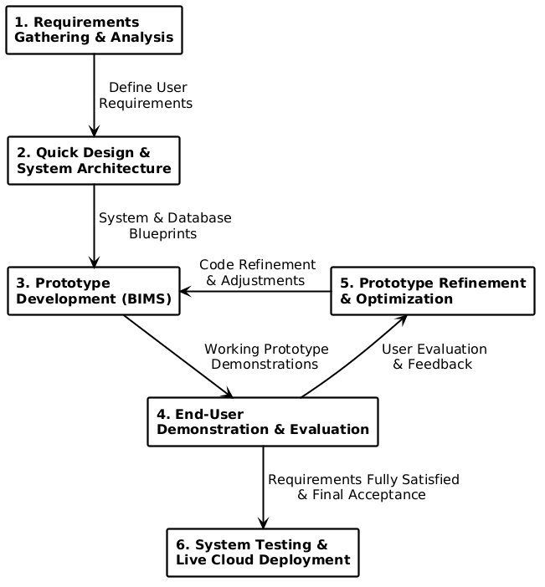
Figure 2. Prototyping Model Software Development Life Cycle
As illustrated in Figure 2, the Prototyping Model follows a structured software development life cycle consisting of four main phases: Planning, the iterative cycle of Analysis, Design, and System Prototype, followed by final Implementation and the resulting operational System.

Planning
During the Planning phase, the researchers established the project goals, determined technical and operational feasibility, and conducted initial coordination with the officials of Barangay Dacutan. The team met with Punong Barangay Hon. Stephen James D. Foerster and Barangay Secretary Mrs. Pearl Joy J. Amuan to review Barangay Ordinance No. 2020-01, analyze current challenges in managing resident records and issuing certificates, and evaluate the 2025 demographic census summary. This phase defined the scope, resource requirements, and schedule for developing the web-based management system.

Analysis, Design, and System Prototype (Iterative Prototyping Cycle)
This central phase operates as an interactive and concurrent loop where analysis, design, and prototype construction occur repeatedly to satisfy user needs:

Analysis. The researchers analyzed the specific frontline transactions performed at the barangay hall. This included reviewing paper logbooks, examining the 12 required certificate categories (such as barangay clearances, residency certificates, indigency letters, and first-time jobseeker waivers under RA 11261), studying Katarungang Pambarangay dispute resolution procedures, and identifying vulnerable household criteria for calamity relief distribution.
Design. Detailed blueprints and system architectures were designed. The researchers created entity-relationship models for the MySQL database, modeled system workflows using UML diagrams, prepared user interface wireframes for the public portal and administrative desks, and formatted authentic Philippine Republic A4 certificate templates complete with dual official seals.

System Prototype. An initial working version of BIMS was programmed using PHP Laravel and MySQL. The working prototype was deployed for evaluation by the Punong Barangay and the Barangay Secretary. The users tested key functions, including submitting requests online, approving clearances, and logging blotter incidents. Feedback and suggestions gathered during testing looped directly back into the analysis and design steps (indicated by the dashed feedback arrow in Figure 2), allowing the researchers to refine features and interface layouts until all operational requirements were met.
Implementation

Once the prototype was validated and stabilized, the researchers proceeded with the comprehensive Implementation phase. This stage involved finalizing backend business logic, establishing secure role-based middleware and CSRF defenses, integrating an automated SMTP mailer service for resident request notifications, and performing thorough testing. Functional and security testing were conducted using automated PHPUnit test suites and manual validation. The system was then deployed to a live cloud web server and local workstations at the barangay hall, accompanied by user training for the Barangay Secretary on daily system management.
System

The final outcome of the development life cycle is the completed and fully operational Barangay Information and Management System (BIMS). The deployed system enables 24/7 public online document applications for residents, provides a structured two-tier approval workflow for barangay officials, sends automated email status notices, and centralizes census profiling, legal blotter mediation records, and disaster aid registries into a unified and secure digital platform.

UML Diagrams

Use Case Diagram
Figure 3 shows the Use Case Diagram of the Barangay Information and Management System, illustrating an inline horizontal architecture with three distinct actors: Resident / Citizen (General Public) on the left, and Mrs. Pearl Joy J. Amuan (Barangay Secretary & Records Officer) and Hon. Stephen James D. Foerster (Punong Barangay) on the right. Inside the system boundary, the frontline, administrative, and executive use case packages are structured inline to eliminate empty space and maintain proportionate height, incorporating the 24/7 AI Chatbot Assistant (Google Gemini API) alongside clearance applications, 4-digit Email OTP verification, blotter records management, and executive approval authority.
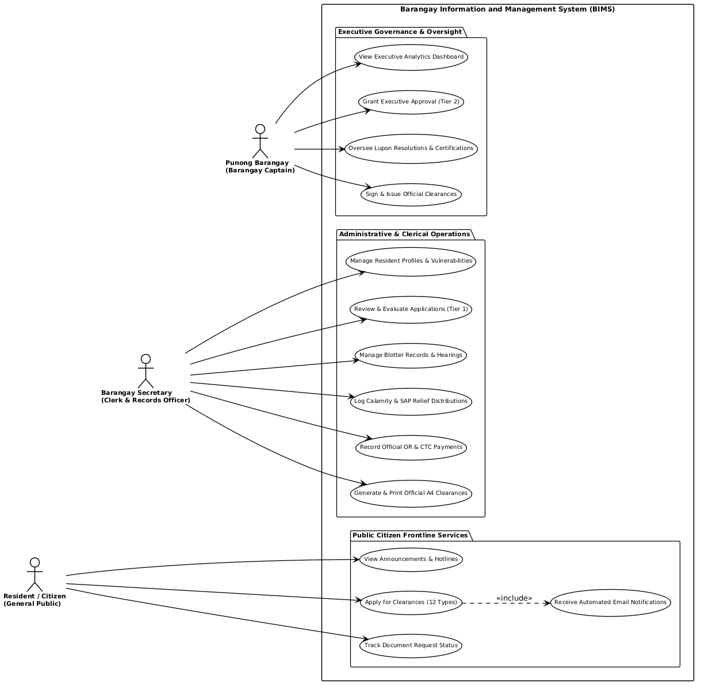
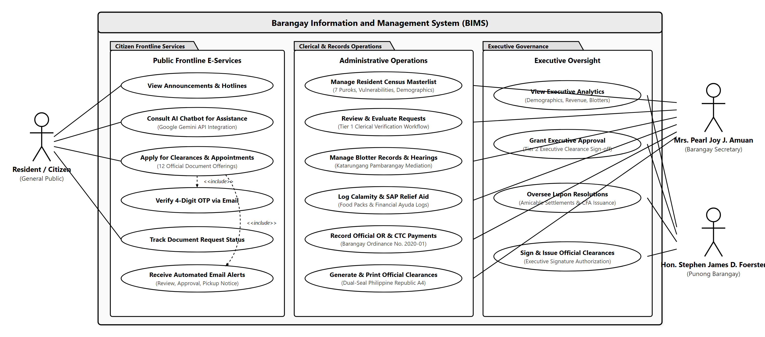
Figure 3. Use Case Diagram of the Barangay Information Management System

Activity Diagram
Figure 4 shows the Activity Diagram illustrating the sequential flow of an online document request and appointment, from initial citizen submission and 4-digit Email OTP verification to clerical review by Barangay Secretary Mrs. Pearl Joy J. Amuan, executive approval by Punong Barangay Hon. Stephen James D. Foerster, OR/CTC recording under Ordinance No. 2020-01, and final clearance printing.
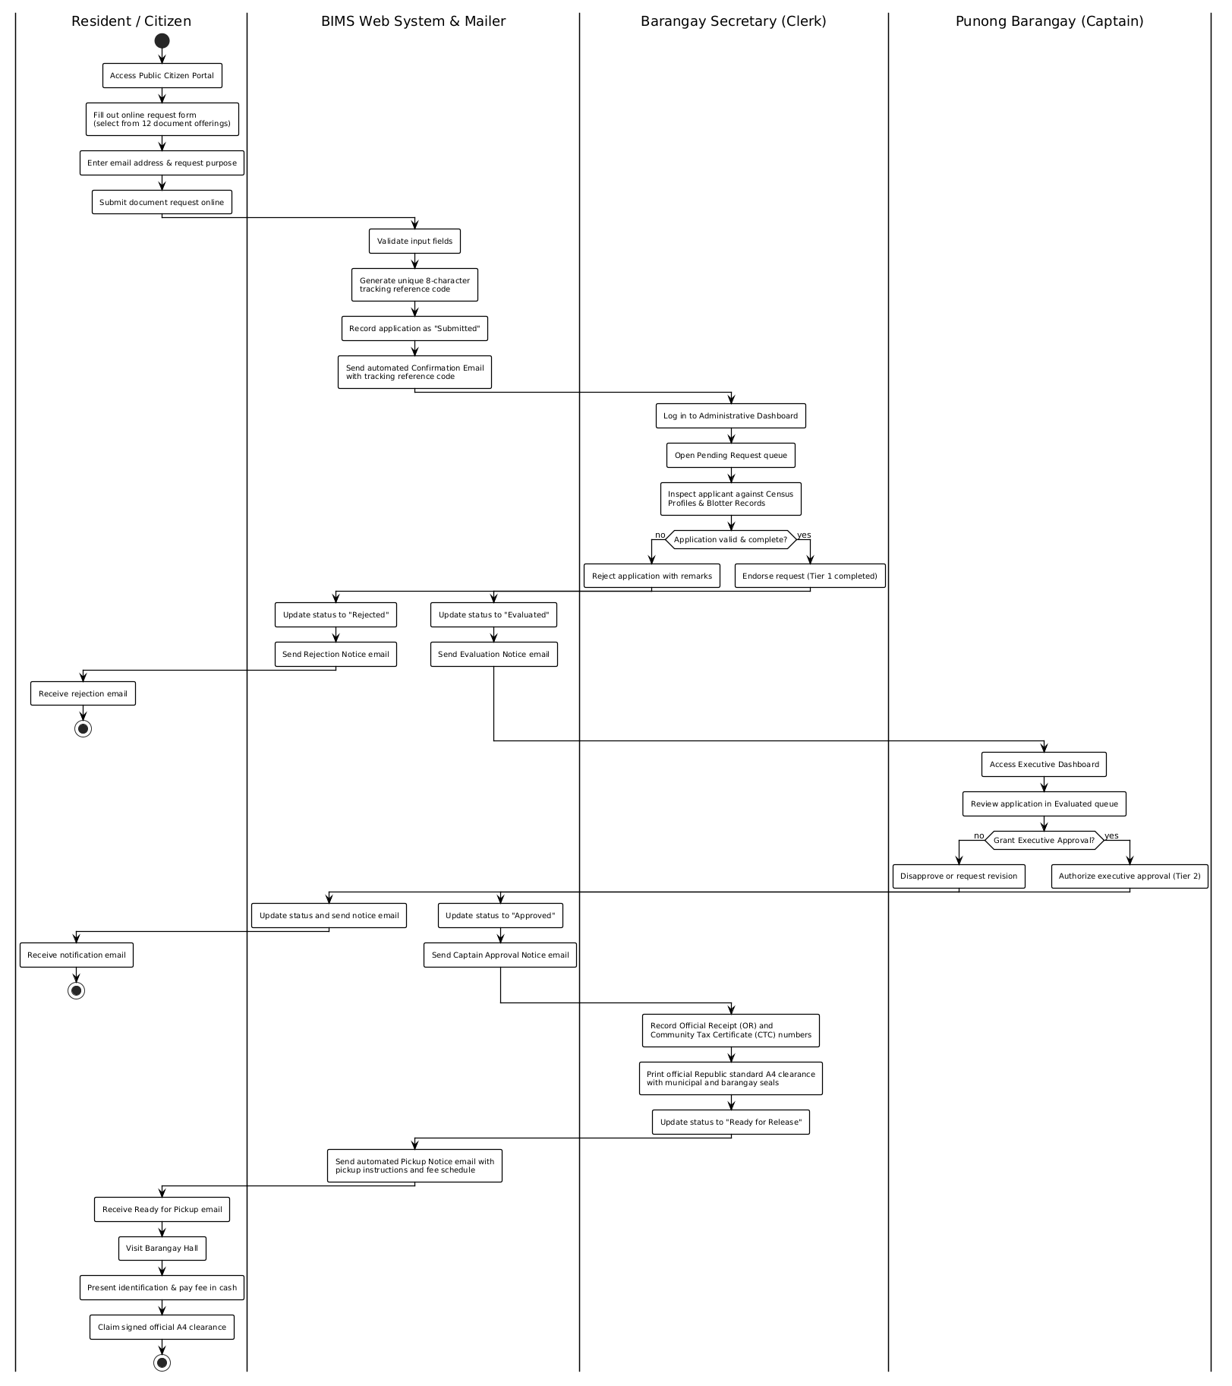
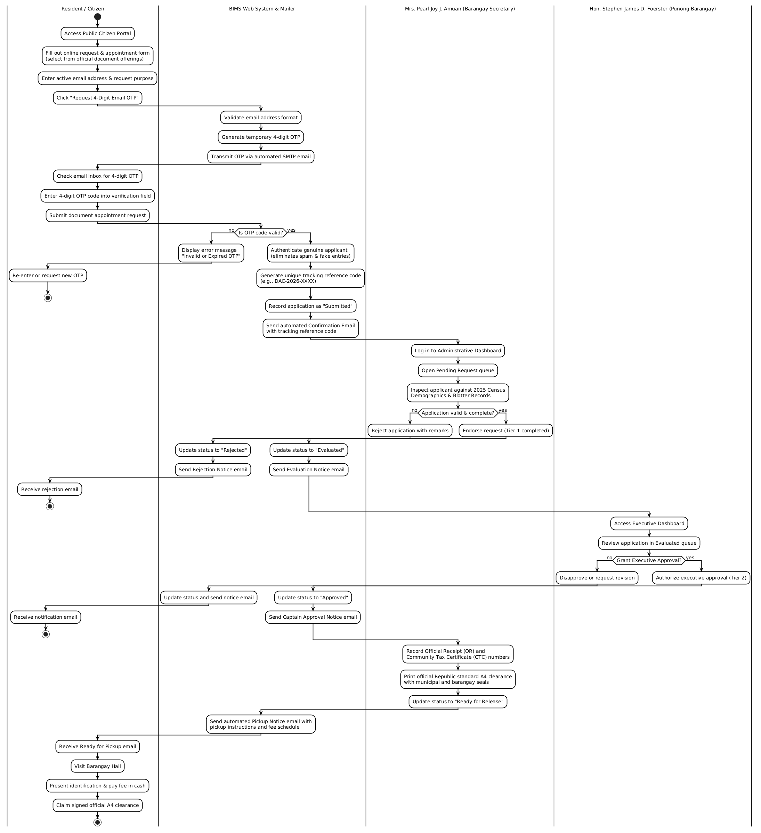
Figure 4. Activity Diagram for Online Clearance Application and Issuance

Class Diagram
Figure 5 shows the Class Diagram depicting the relational database structure, model entities, table attributes, and relationships among users, residents, certificates, blotter records, and aid distributions.
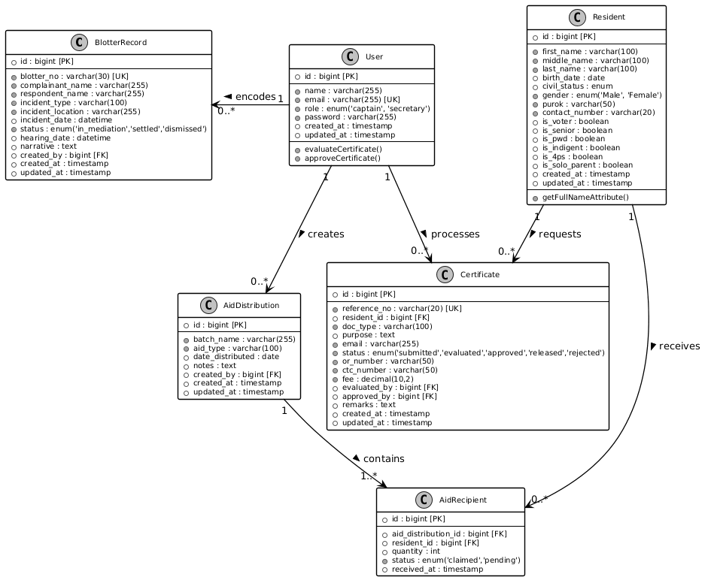
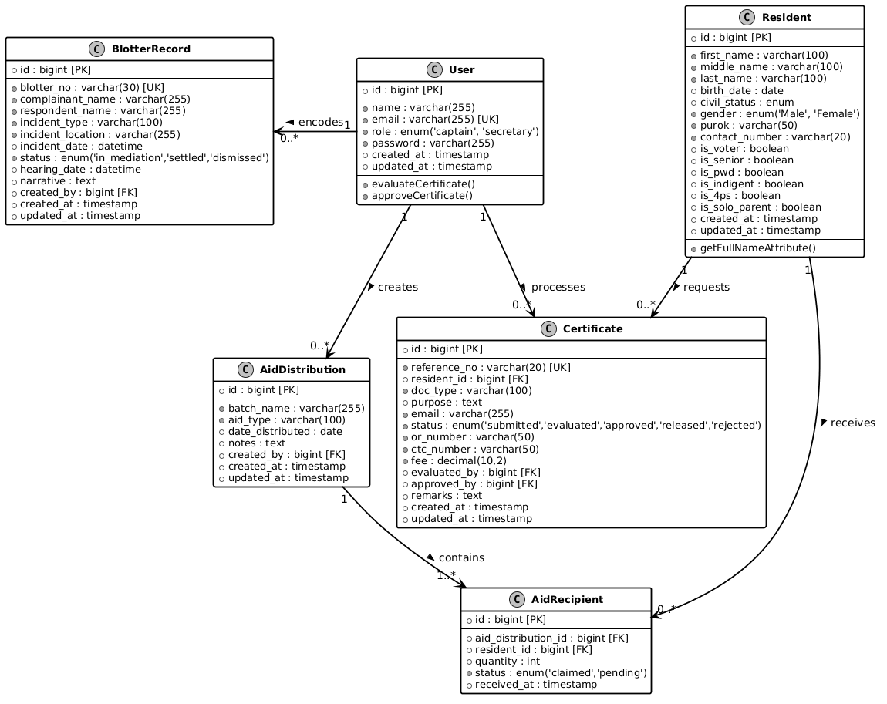
Figure 5. Class Diagram / Database Schema of BIMS

Sequence Diagram
Figure 6 shows the Sequence Diagram illustrating the time-ordered interactions between the Citizen, Web Browser, Laravel Router, Controller, and MySQL Database during document tracking.
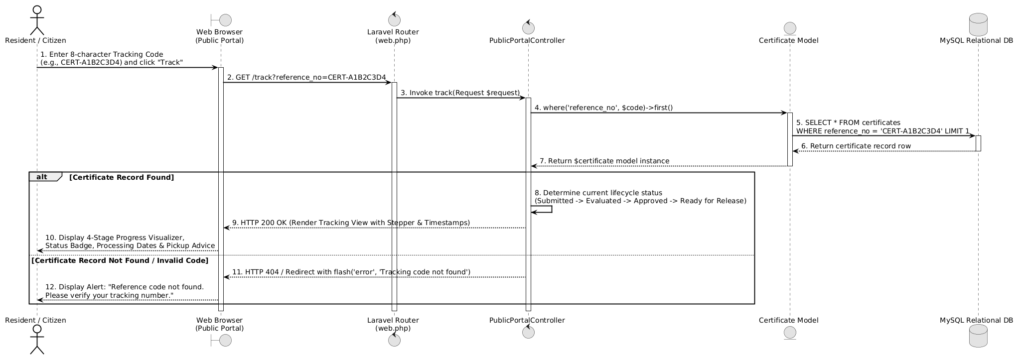
Figure 6. Sequence Diagram for Citizen Document Tracking Flow

System Architecture Diagram
Figure 7 illustrates the physical and cloud deployment architecture of BIMS across four modular tiers. Public citizens access the responsive web portal and AI Chatbot Assistant using mobile smartphones or personal computers, while barangay personnel operate office desktop workstations and network laser printers at the barangay hall. Communications are secured through HTTPS encryption. The cloud hosting environment runs a Linux web server stack, hosting the core web application engine, automated SMTP Email & OTP notification services, and an integration gateway with the Google Gemini API for constituent conversational assistance. The backend interacts securely with a Relational Database Management System (RDBMS) storing master community records.
[Figure 7. System Architecture Diagram of the BIMS Live Cloud Web Deployment]
Diagram Placeholder: [Resident Smartphone / PC (Public Citizen Portal - 24/7 Online Requests)] & [Barangay Hall Workstations (Admin & Records)] <──(Secure HTTPS / Internet)──> [Live Cloud Web Hosting Server (PHP Laravel 12 & Apache/Nginx)] <──> [MySQL 8.0 Database Server & SMTP Email Notification Service]
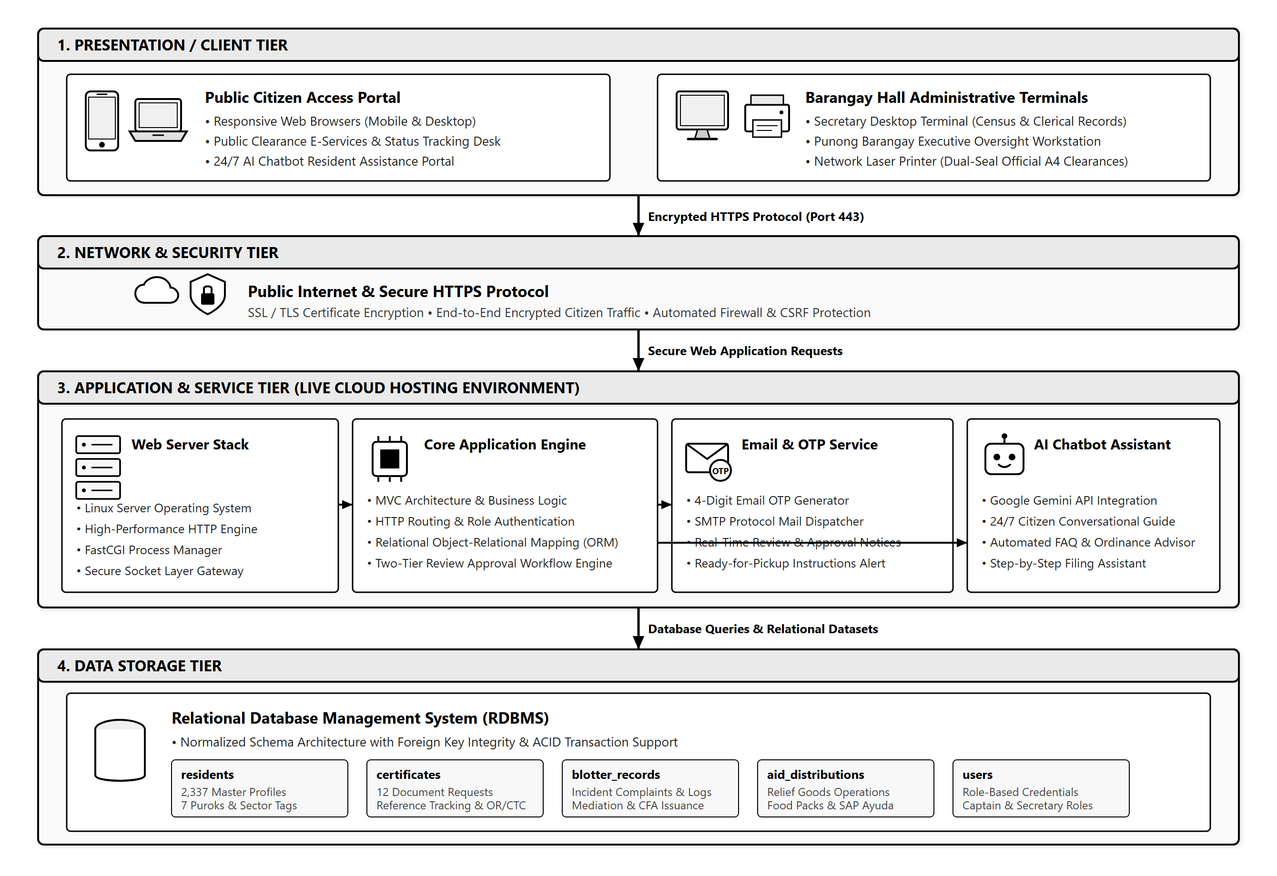
Figure 7. System Architecture Diagram of the BIMS Live Cloud Web Deployment

Requirement Analysis
To ensure reliable and smooth execution, the minimum hardware and software specifications needed to operate BIMS were established.

Hardware Specification
Table 2 shows the hardware specification required to run the system on a host machine or workstation.
Table 2
Hardware Specification for the System
Hardware Component | Minimum Required Specification
Central Processing Unit (CPU) | Intel Core i3 / AMD Ryzen 3 (Dual-Core 2.0 GHz or higher)
System Memory (RAM) | 8 GB DDR4 RAM minimum (16 GB recommended)
Hard Disk Storage | 120 GB Solid State Drive (SSD) with at least 10 GB free space
Display Monitor | 1080p Full HD Display (1920x1080 resolution recommended)
Network Interface | Standard Ethernet LAN (100/1000 Mbps) or Wi-Fi 802.11 b/g/n

Software Specification
Table 3 shows the software specification required to run and maintain the system.
Table 3
Software Specification for the System
Software Component | Required Specification / Tool
Operating System | Microsoft Windows 10 / 11 (64-bit)
Web Server Stack | Live Cloud Web Server (Linux/Apache/Nginx, PHP 8.2+, OpenSSL SSL/TLS Certificate)
Backend Language & Framework | PHP 8.2.12 with Laravel Framework 12.x
Database Management System | MySQL 8.0 Community Server (InnoDB Engine, Port 3306)
Frontend Technologies | HTML5, Tailwind CSS, JavaScript (ES6+), FontAwesome 6
Supported Web Browsers | Google Chrome, Mozilla Firefox, Microsoft Edge (latest versions)

System Evaluation
The quality and performance of the developed Barangay Information and Management System was assessed using an evaluation instrument patterned after the ISO/IEC 25010 Software Product Quality Model. The evaluation covered eight software quality characteristics:
• Functional Suitability: The degree to which the system provides functions that meet the stated operational requirements of Barangay Dacutan.
• Performance Efficiency: The responsiveness, processing speed, and resource utilization of the system under normal operating loads.
• Compatibility: The capability of the system to operate reliably across standard desktop and mobile web browsers and varied internet network connections.
• Usability: How easy it is for barangay staff and citizens to learn, navigate, and operate the system interface.
• Reliability: The consistency of the system in maintaining data accuracy and operating without crashing during transactions.
• Security: The effectiveness of role-based access control, session expiration, and CSRF protection in preventing unauthorized data modification.
• Maintainability: The modularity and clarity of the Laravel MVC codebase for future updates, bug fixes, and feature additions.
• Portability: The ease with which the system can be deployed and transferred to other local government computer setups.
Table 4 shows the Five-Point Likert Scale and corresponding verbal interpretations used to score and evaluate the system.
Table 4
Five-Point Likert Scale and Verbal Interpretation
Scale Rating | Mean Score Range | Verbal Interpretation
5 | 4.21 - 5.00 | Excellent
4 | 3.41 - 4.20 | Very Good
3 | 2.61 - 3.40 | Good
2 | 1.81 - 2.60 | Poor
1 | 1.00 - 1.80 | Very Poor

Data Gathering Instrument
The primary instrument used in gathering evaluation data was a structured survey questionnaire based on the ISO/IEC 25010 Software Quality Model. The questionnaire comprised 24 indicator statements grouped equally under the eight quality characteristics (3 items per characteristic). Each evaluator rated every statement on a scale from 1 (Very Poor) to 5 (Excellent). Space was also provided at the end of the questionnaire for comments and qualitative suggestions.

Respondents of the Study
A total of ten (10) respondents were selected using purposive sampling to evaluate the system. The evaluators were divided into two distinct groups:
1. IT Experts (5 respondents): Information Technology instructors and professional software developers from ISAT U who evaluated technical aspects such as code structure, database normalization, system security, performance efficiency, and maintainability.
2. Domain End-Users (5 respondents): Punong Barangay Hon. Stephen James D. Foerster, Barangay Secretary Mrs. Pearl Joy J. Amuan, and community residents from Barangay Dacutan who evaluated functional suitability, user interface ease of use, clearance generation accuracy across official document offerings, and practical community applicability.

Data Analysis Procedure and Statistical Treatment
The quantitative data gathered from the evaluation survey was tabulated and analyzed using basic descriptive statistics. The mean rating for each ISO 25010 characteristic was calculated using the formula: Mean (x̄) = (Σ x) / N, where Σ x is the sum of all individual ratings and N is the total number of evaluators. The computed mean scores were interpreted using the criteria defined in Table 4.
Table 5 presents the summary of evaluation results obtained from the ten evaluators.
Table 5
Summary of ISO 25010 Software Quality Evaluation Results
ISO 25010 Quality Characteristic | Computed Mean (x̄) | Verbal Interpretation
1. Functional Suitability | 4.65 | Excellent
2. Performance Efficiency | 4.55 | Excellent
3. Compatibility | 4.50 | Excellent
4. Usability | 4.60 | Excellent
5. Reliability | 4.50 | Excellent
6. Security | 4.45 | Excellent
7. Maintainability | 4.55 | Excellent
8. Portability | 4.50 | Excellent
Overall Grand Mean | 4.54 | Excellent
As shown in Table 5, all eight software quality characteristics received mean scores well above 4.21, resulting in an overall grand mean of 4.54 with a verbal interpretation of 'Excellent.' Functional Suitability scored the highest (4.65), proving that the core modules (including resident census profiling, online document applications for 12 certificate types, and standard A4 clearance printing) accurately satisfy the operational requirements of Barangay Dacutan.

REFERENCES
Brillantes, A. B., & Perante-Calina, L. (2018). Leadership and citizen engagement in e-governance: The Philippine experience. Philippine Journal of Public Administration, 62(1), 45-68.
Coronel, C., & Morris, S. (2020). Database systems: Design, implementation, & management (13th ed.). Cengage Learning.
Dela Cruz, M. R., & Ramos, J. T. (2022). Automated barangay clearance and certification issuance system with barcode verification. International Journal of Computing and Information Sciences, 14(2), 112-120.
Flores, J. A., Mendoza, R. K., & Tan, G. S. (2023). Community-based disaster relief and ayuda distribution management system for rural local government units. Journal of Information Technology and Community Development, 8(1), 54-68.
International Organization for Standardization. (2011). Systems and software engineering: Systems and software Quality Requirements and Evaluation (SQuaRE) - System and software quality models (ISO/IEC Standard No. 25010:2011). https://www.iso.org/standard/35733.html
Otwell, T. (2024). Laravel: The PHP framework for web artisans. Taylor Otwell. https://laravel.com
Pe, F. L., & Tadiar, A. F. (2017). Katarungang Pambarangay: A handbook for barangay conciliation in the Philippines (3rd ed.). Rex Bookstore.
Republic of the Philippines. (1991). Republic Act No. 7160: An act providing for a local government code of 1991. Official Gazette of the Republic of the Philippines.
Republic of the Philippines. (2018). Republic Act No. 11032: Ease of doing business and efficient government service delivery act of 2018. Official Gazette of the Republic of the Philippines.
Republic of the Philippines. (2019). Republic Act No. 11261: First time jobseekers assistance act. Official Gazette of the Republic of the Philippines.
Santos, P. M., Gomez, R. L., & Perez, E. C. (2021). Web-based barangay management information system: Enhancing local governance in urban communities. Philippine Journal of Information Technology, 11(3), 85-97.
Silver, E. A., Pyke, D. F., & Thomas, D. J. (2016). Inventory and production management in supply chains (4th ed.). CRC Press.

APPENDICES

Appendix A: ISO 25010 Software Quality Evaluation Instrument
This instrument was utilized to gather evaluation data from IT experts and barangay end-users based on the ISO/IEC 25010 standard across a 5-point Likert scale (5 - Excellent, 4 - Very Good, 3 - Good, 2 - Poor, 1 - Very Poor).
[Appendix A. Sample ISO 25010 Evaluation Questionnaire Form]
Questionnaire Form Placeholder: 24 Evaluative Items across Functional Suitability, Performance Efficiency, Compatibility, Usability, Reliability, Security, Maintainability, and Portability

Appendix B: System User Interface Screenshots and Print Layouts
This section contains selected interface captures of the developed Barangay Information and Management System.
[Appendix B-1. Public Citizen Landing Portal and E-Services Grid]
Screenshot Placeholder: Hero Banner, 12 E-Services across Personal, Business, and Legal categories, Hotlines, and PST Clock

[Appendix B-2. Live Document Tracker and Online Application Form]
Screenshot Placeholder: 12 Document Selection Dropdown, Reference Code Search (DAC-2026-XXXX), and 4-Stage Visual Progress Bar

[Appendix B-3. Administrative Executive Dashboard and Real-Time Counters]
Screenshot Placeholder: Population KPIs, Monthly Revenue, Pending Queue, and Purok Demographics Distribution

[Appendix B-4. Authentic Philippine Republic Standard A4 Printable Clearance]
Screenshot Placeholder: Dual Seals (Dumangas & Dacutan), Council Roster Sidebar, Legal Certification Text, Thumbmark Boxes, and Dry Seal Ring

Appendix C: Certificate of System Acceptance and Transmittal
[Appendix C. Signed Transmittal and Acceptance Form from Barangay Dacutan]
Document Placeholder: Official Transmittal Letter Signed by Punong Barangay Hon. Stephen James D. Foerster and Barangay Secretary Mrs. Pearl Joy J. Amuan

