📓 Storyboard UI Design

Our shiny app will look at networks and patterns, with the network graph as the core visualizations, and other tables and charts as accompanying visualization.

## **Website Look -Netlify**

This would be the prototype of the layout structure with navbar at the top, and sidebar layout at the right side. Codes will be provided as well in panel-tabsets which will support interactivity for Quarto + Shiny visualisations.

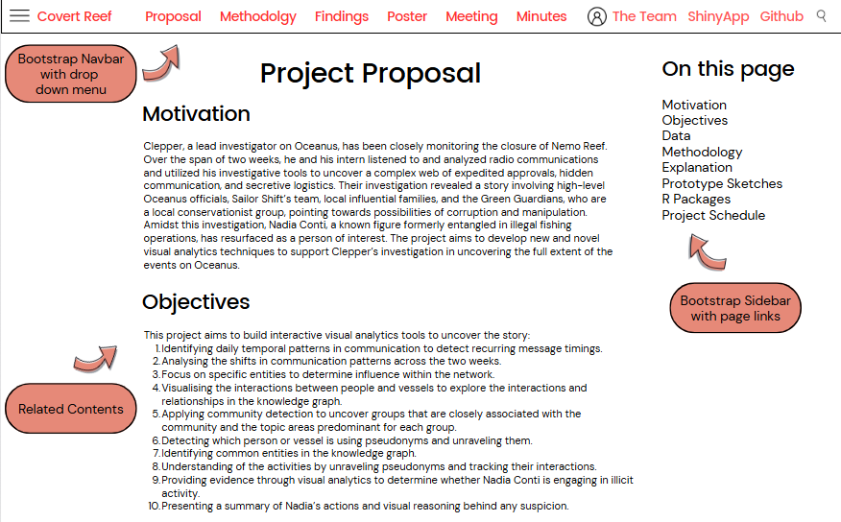

## **Shiny Dashboard for Networks and Visualisations**

**Combination of work:**

We will be using some components from each group member in their Take Home Ex 02. For instance, the Communications, Heatmaps and Discussions from Yang Lu. The Networks, timestamps and discusssions from Jianyi. The Communications, Chord Diagram and Alluvial Diagram from Audrey.

**Principles of usability and interactivity:**

Our shiny compatible visualisations will have timeseries or related interactive shiny compatible subnetworks or visualisations. These may include hovers or other clickable components.

* The *ui.R* script controls the layout and appearance of a shiny app.
  + ui<- fluidPage() which creates a display to adjust to dimensions
  + *titlePanel* and *sidebarLayout* to add to fluidPage. We will create a basic Shiny application with a sidebar.
* The *server.R* script contains the instructions to build the Shiny app.
  + server<- function(input, output) {}
  + We will be using selectInput(), sliderInput(), plotOutput(), etc to assist in the visualisations and interactivity.
* shinyApp(ui=ui, server=server)

## **Prototypes:**

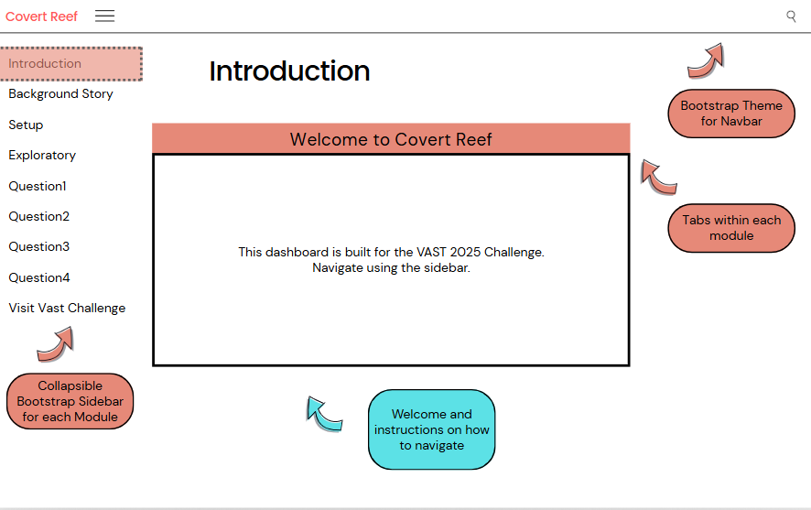

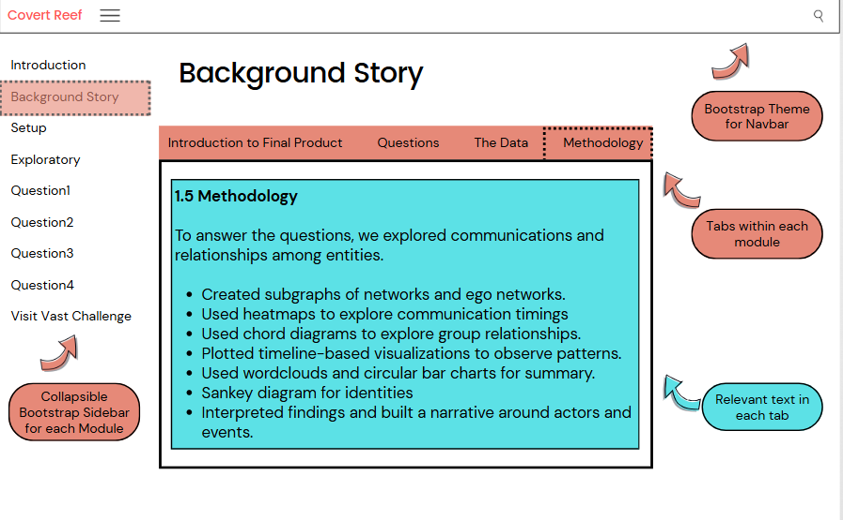

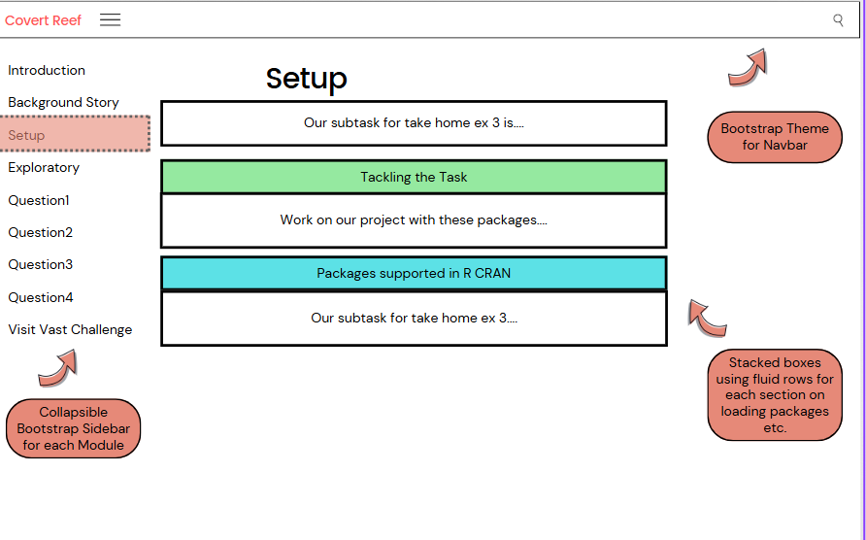

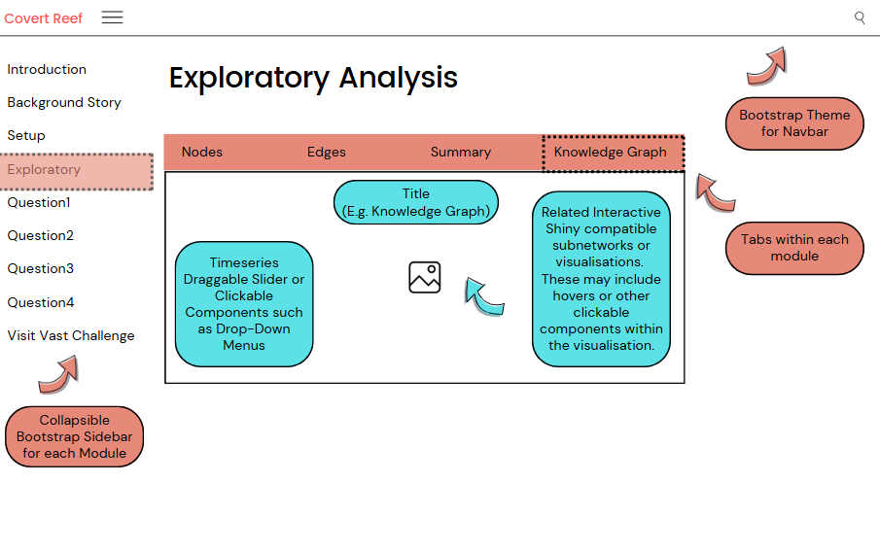

….

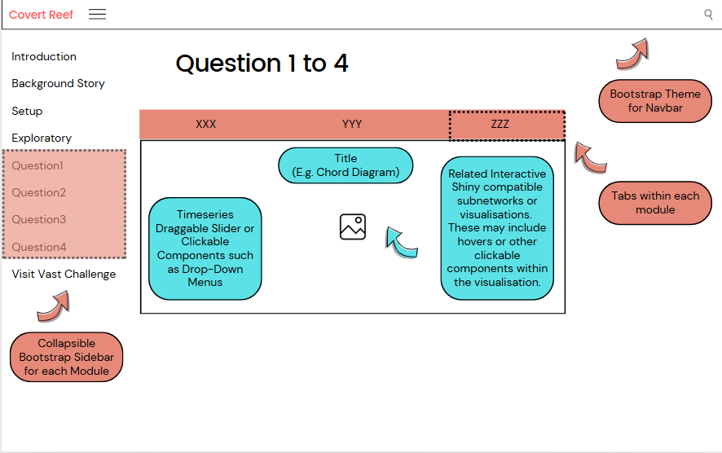

## **Zooming into the Storyboard:**

Some examples of what each module will look like:

## 1. Introduction

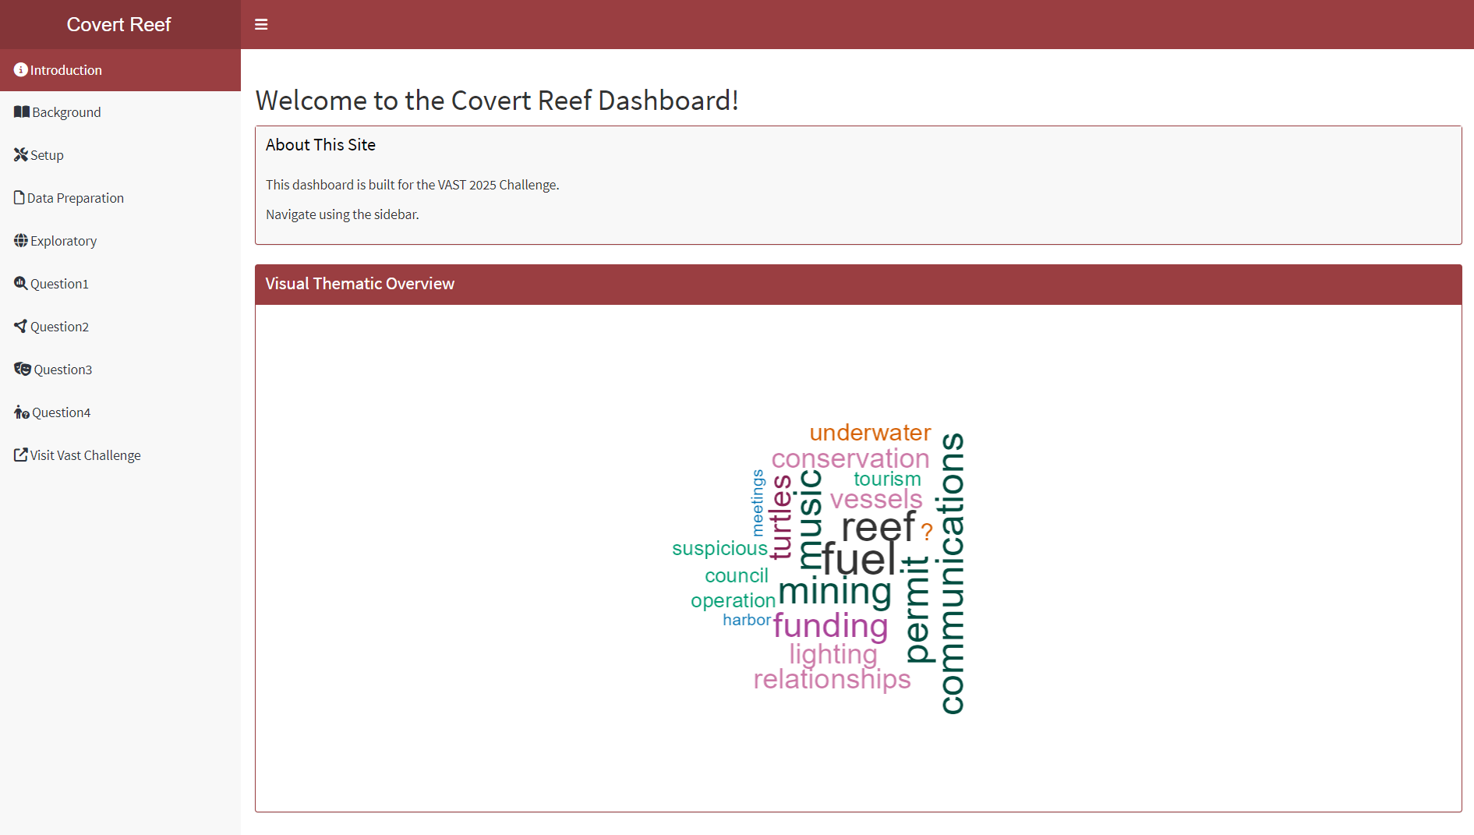

## 2.1 Background- Introduction to Final Product

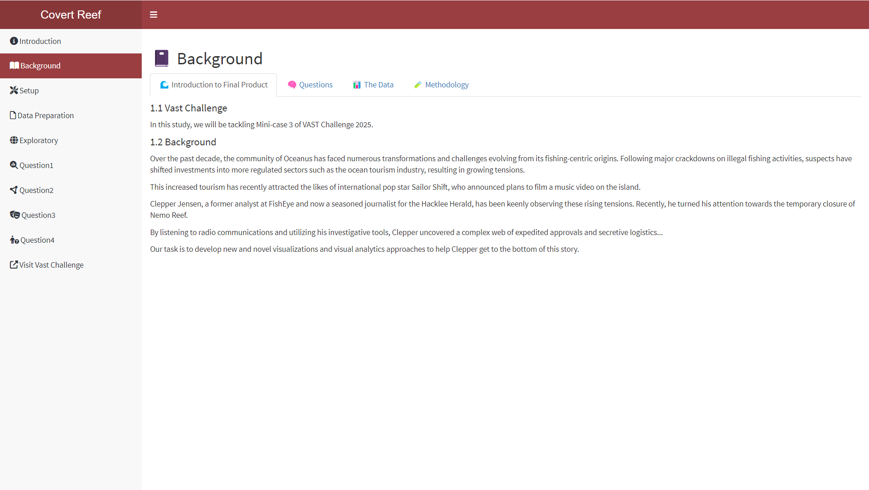

## 2.2 Background- Questions

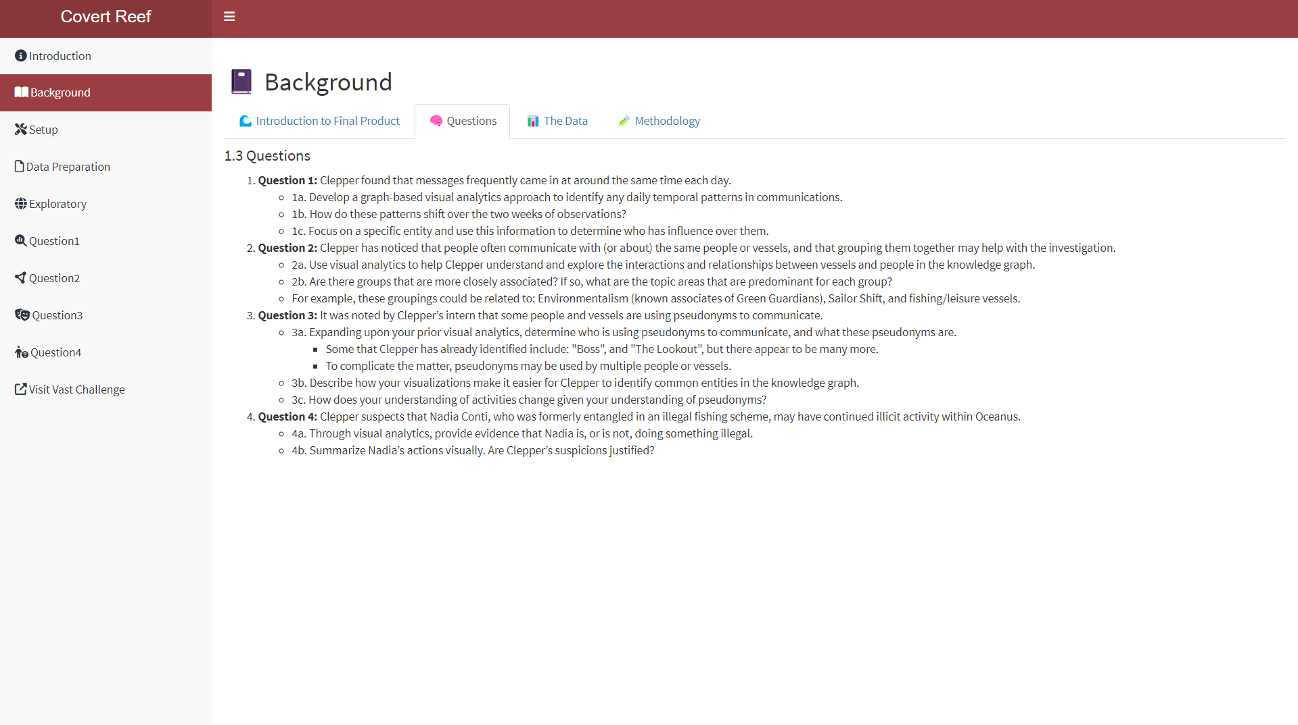

## 2.3 Background- The Data

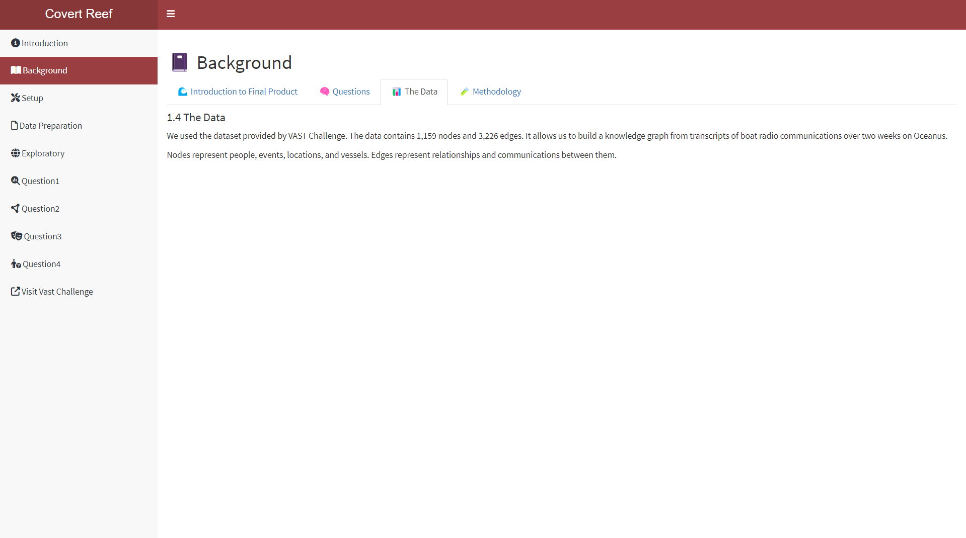

## 2.4 Background- Methodology

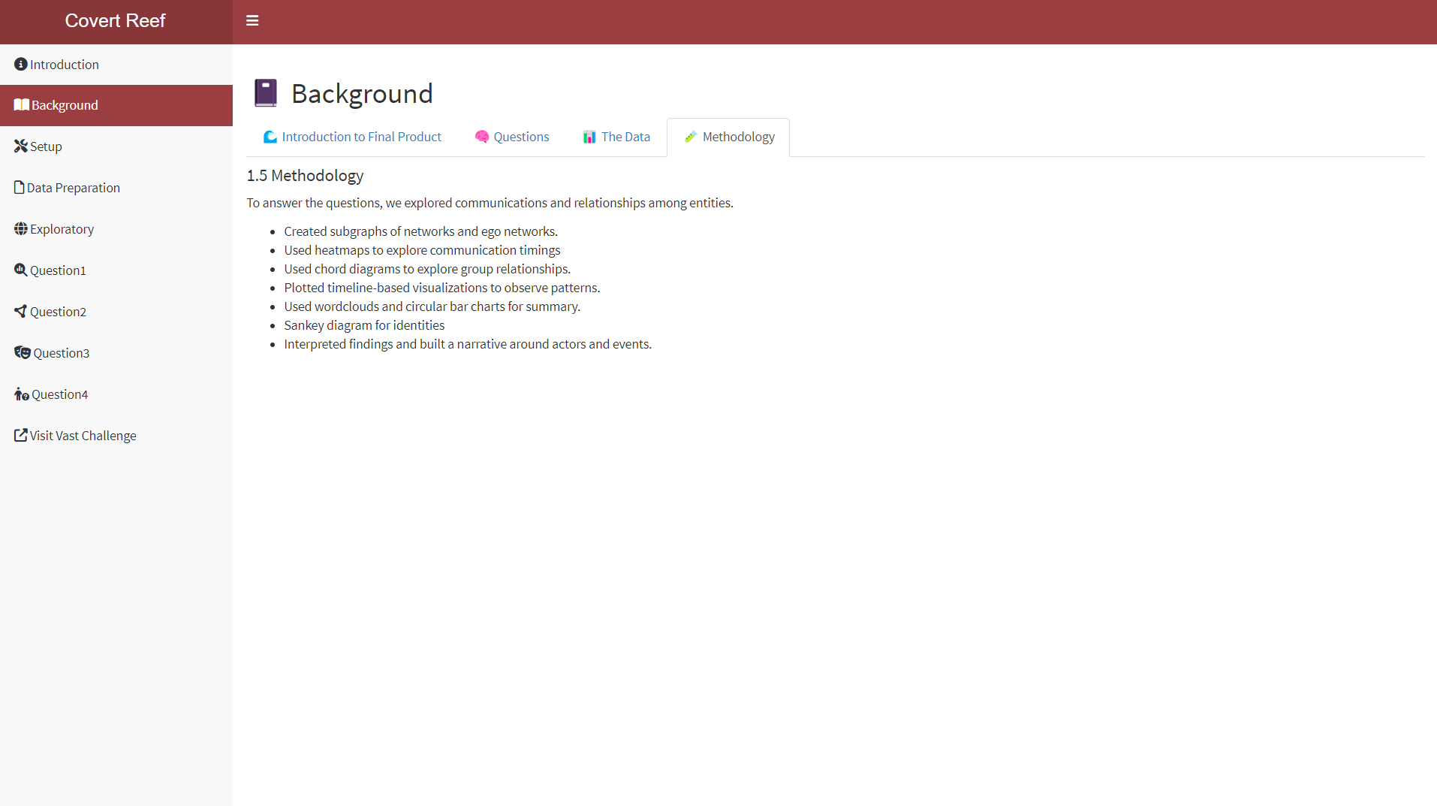

## 3. Setup

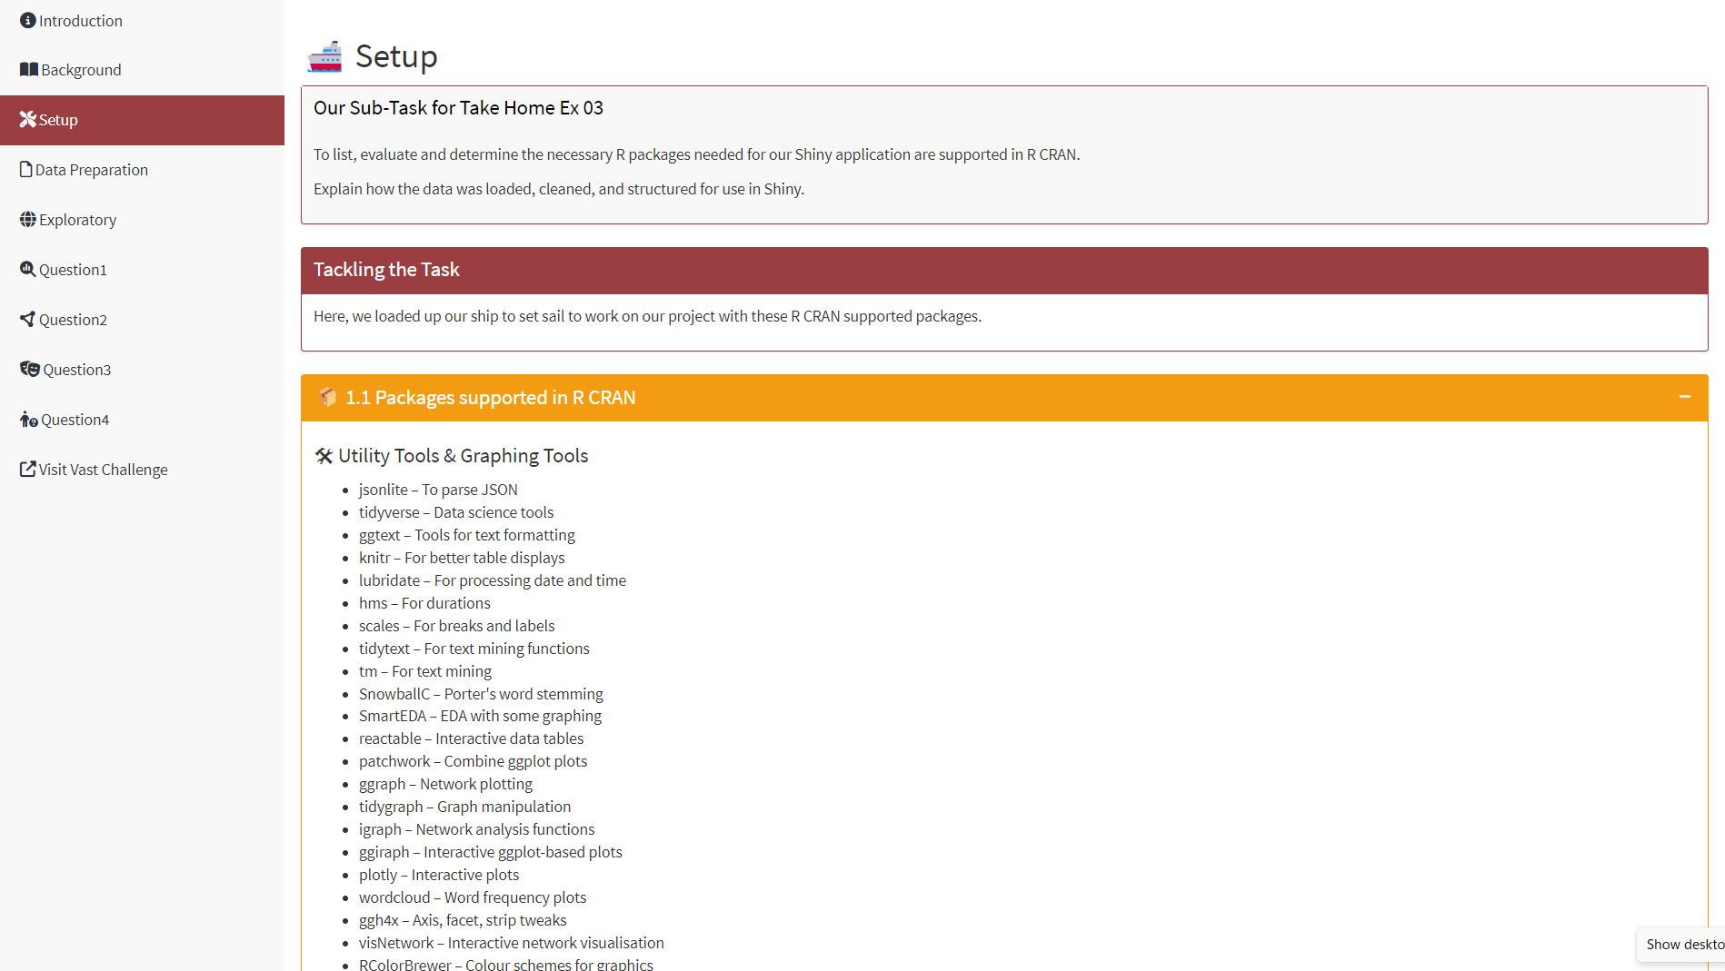

## 4. Data Preparation

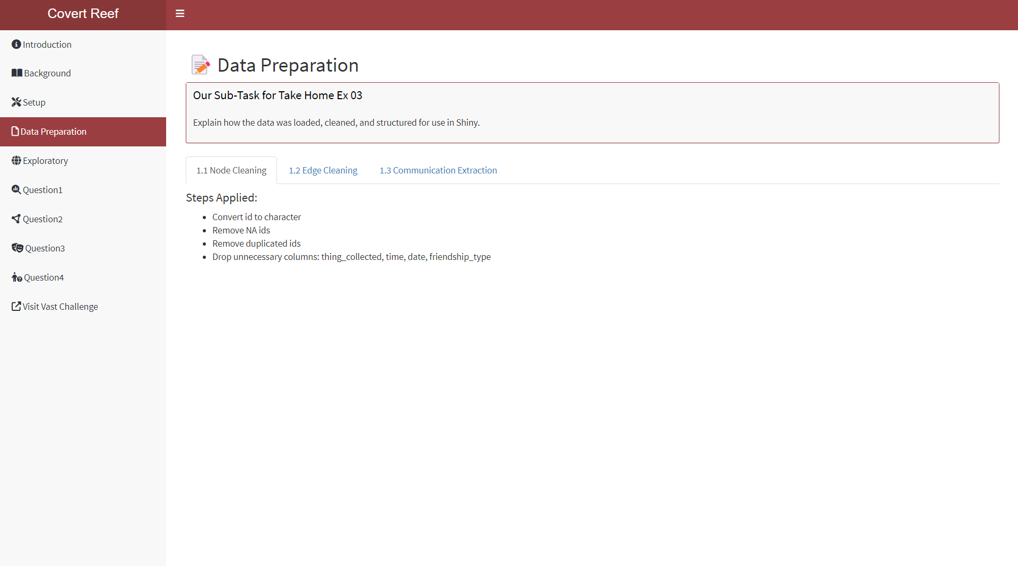

## 5. Exploratory

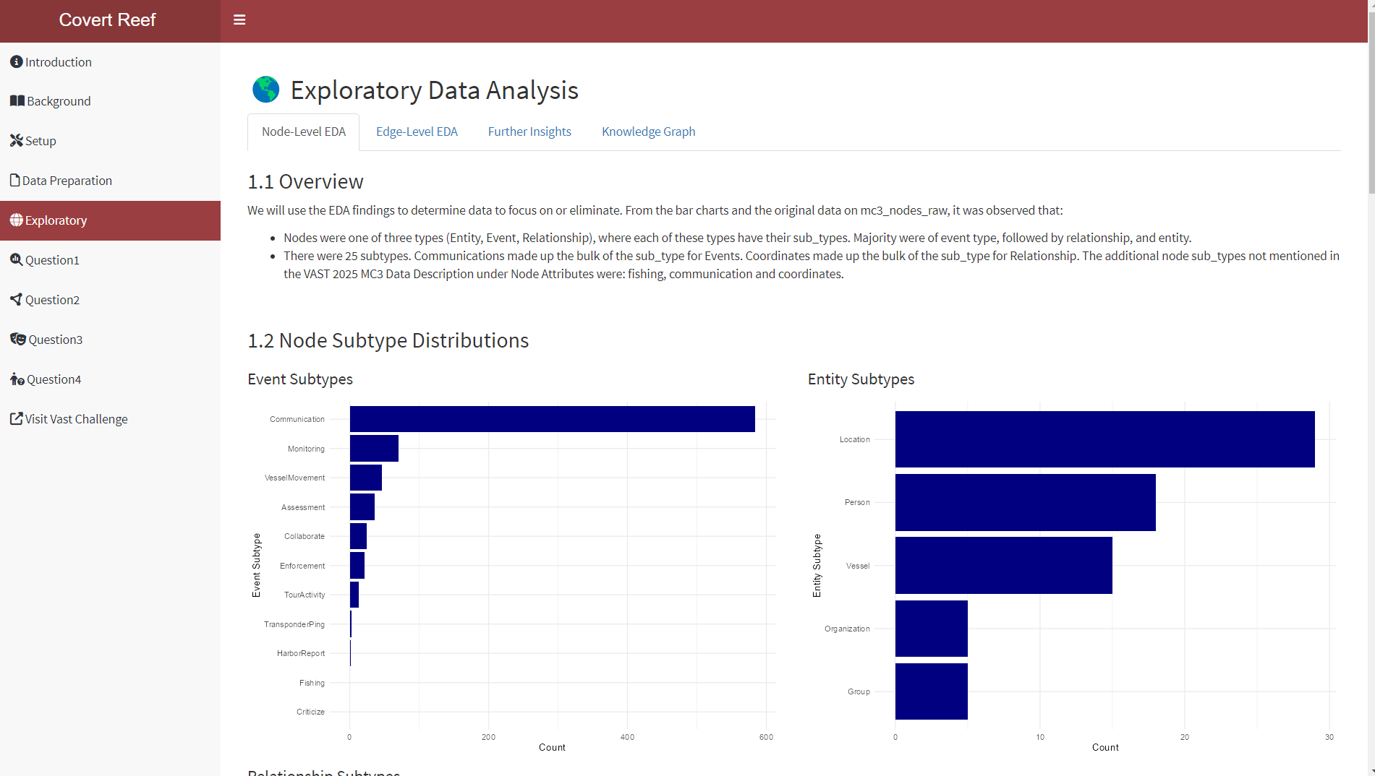

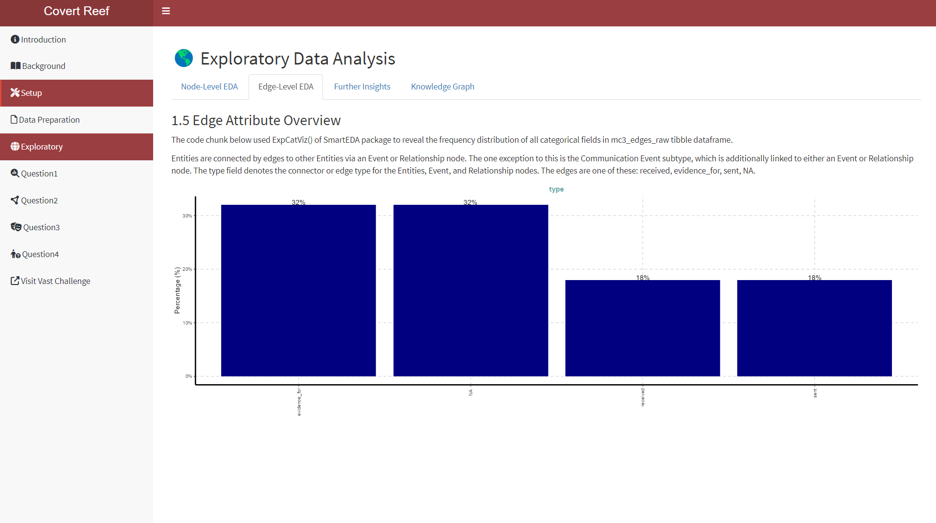

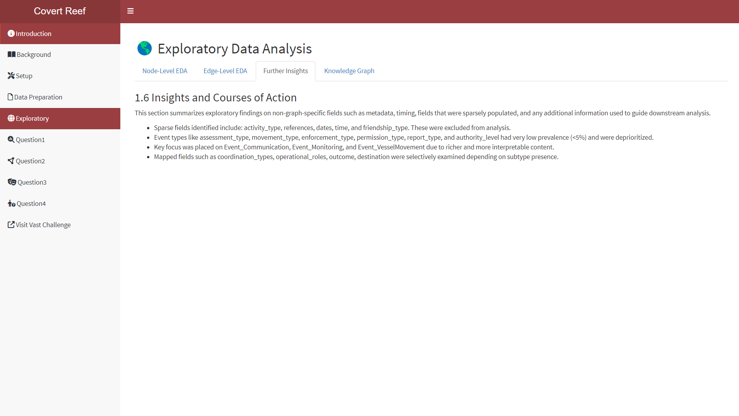

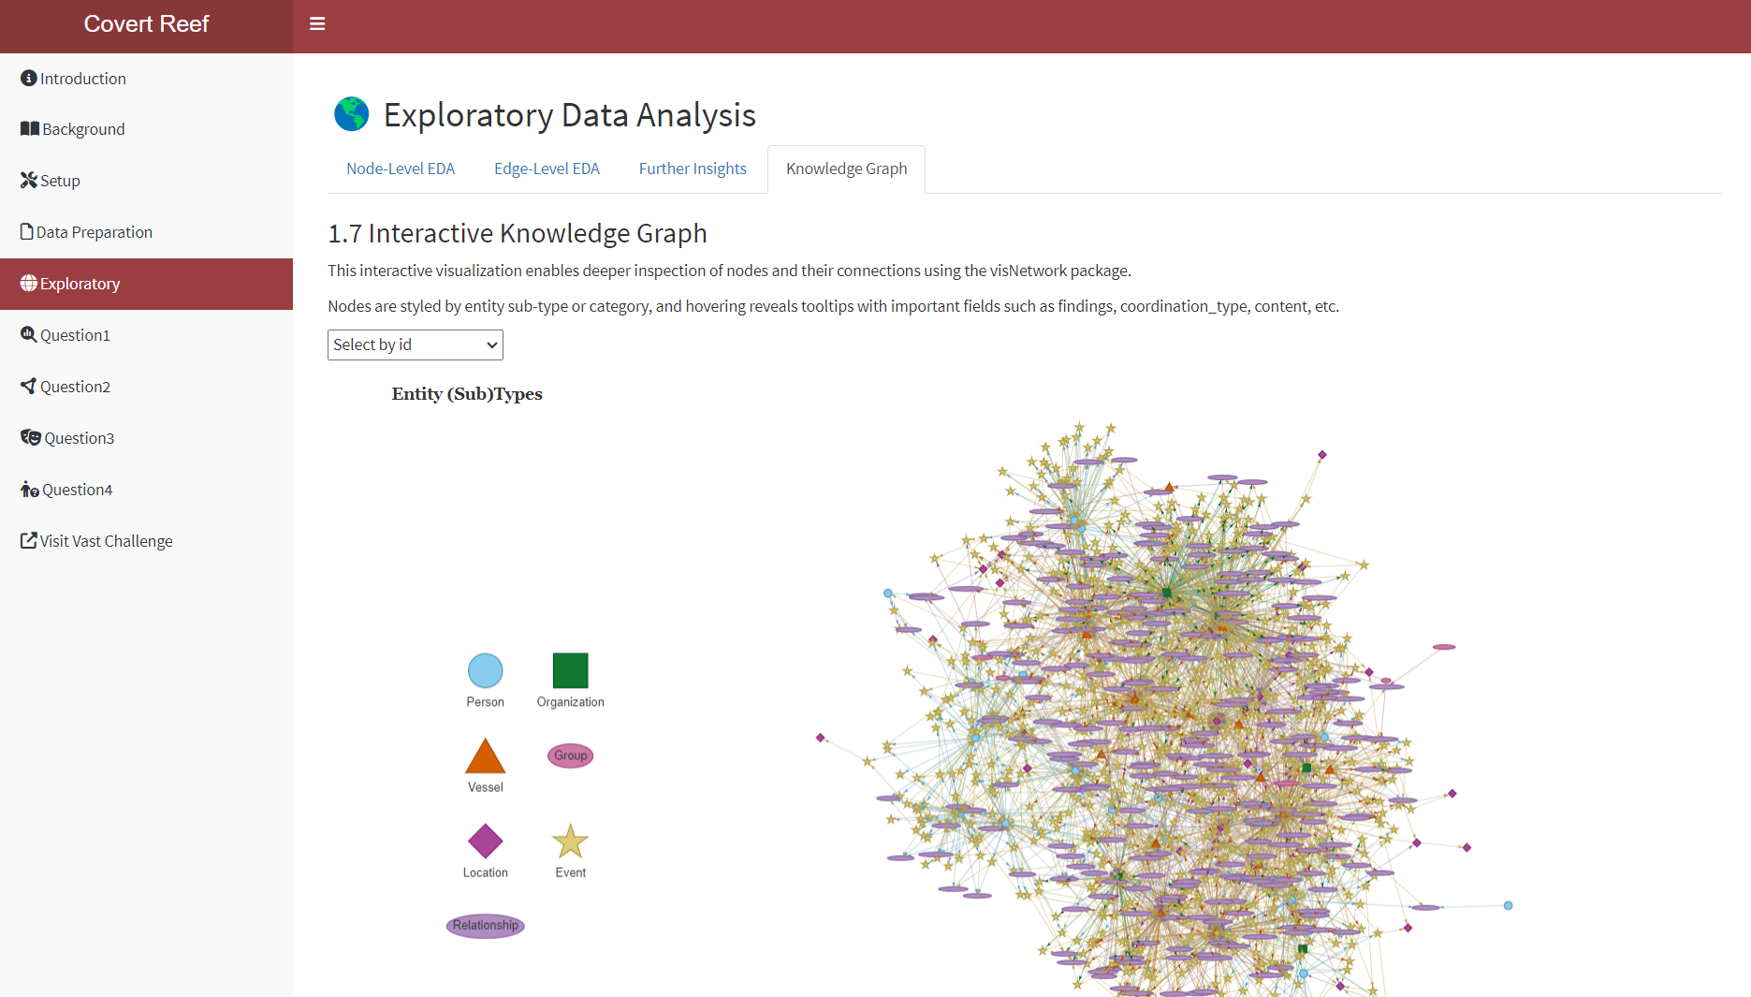

## 6. Question 1

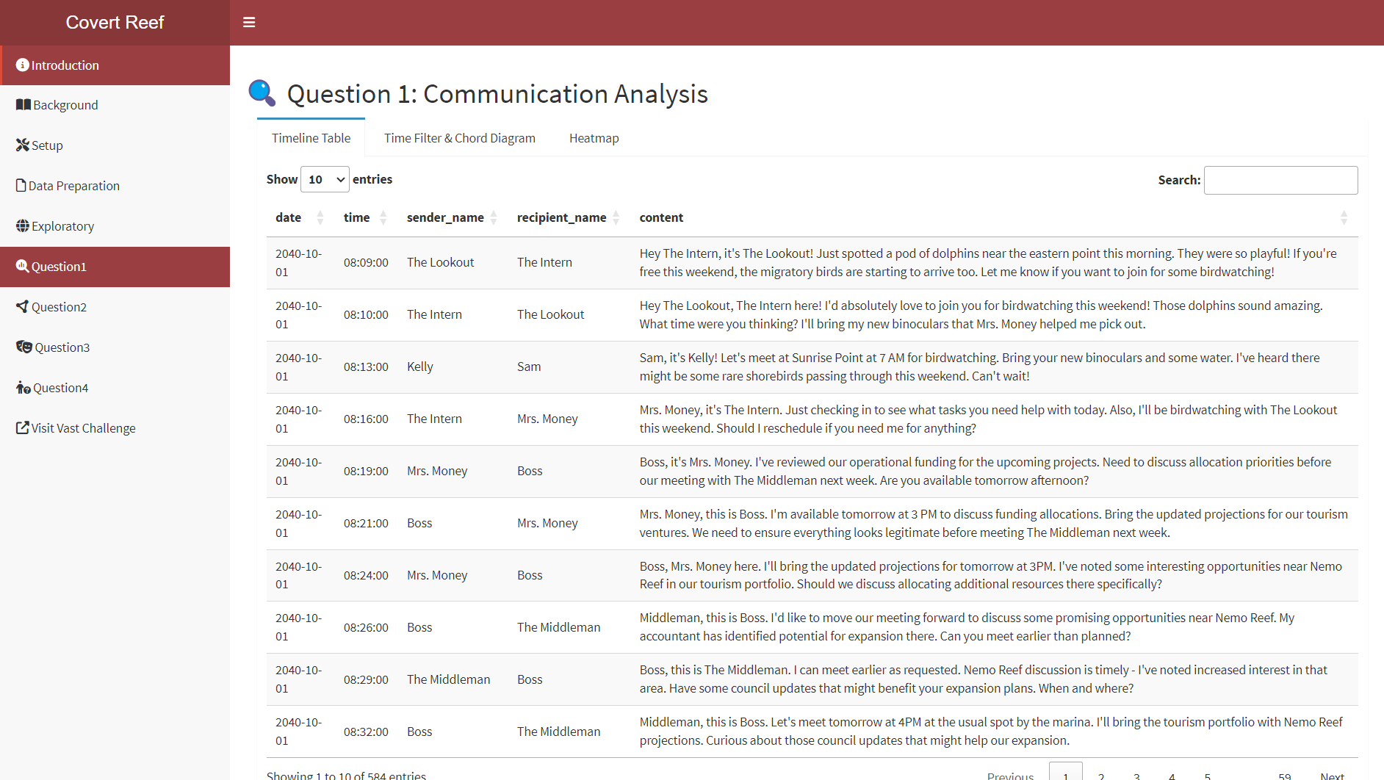

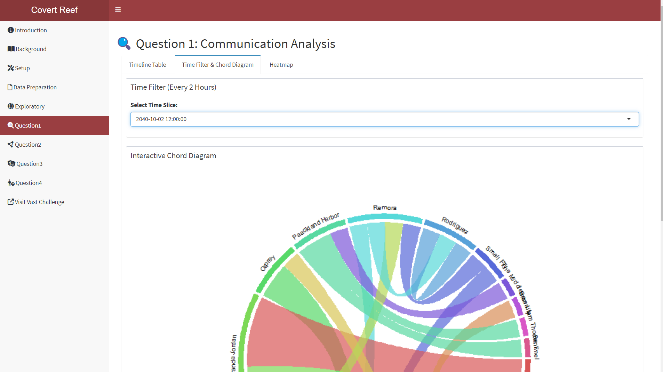

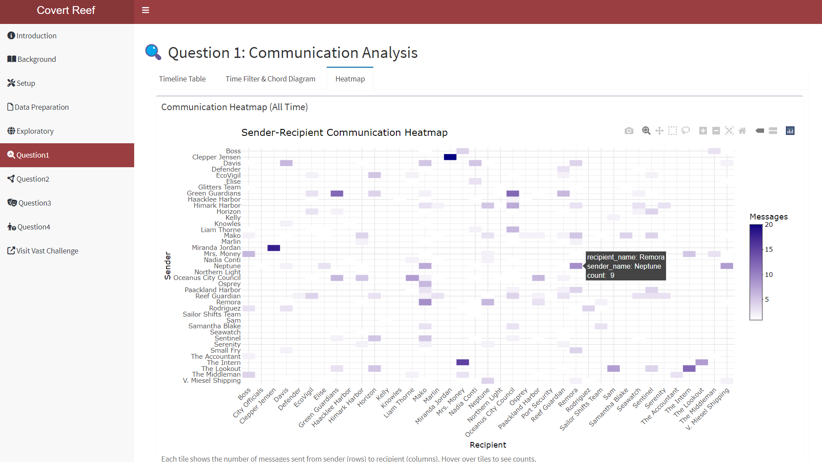

## 7. Question 2

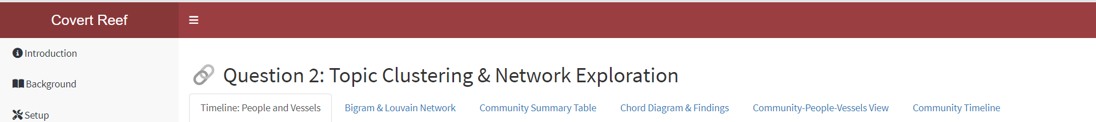

## 8. Question 3

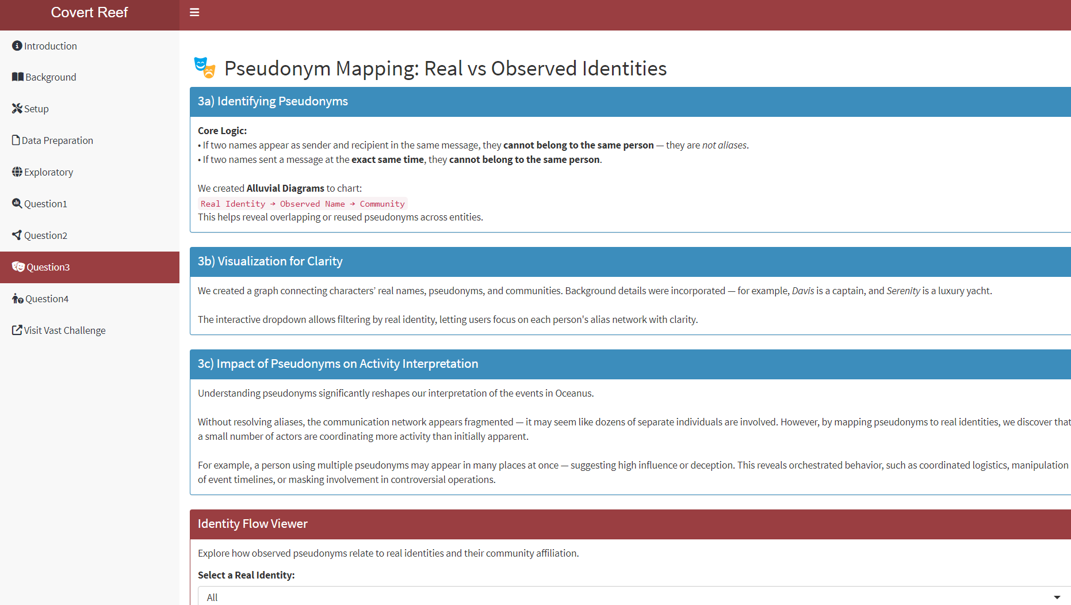

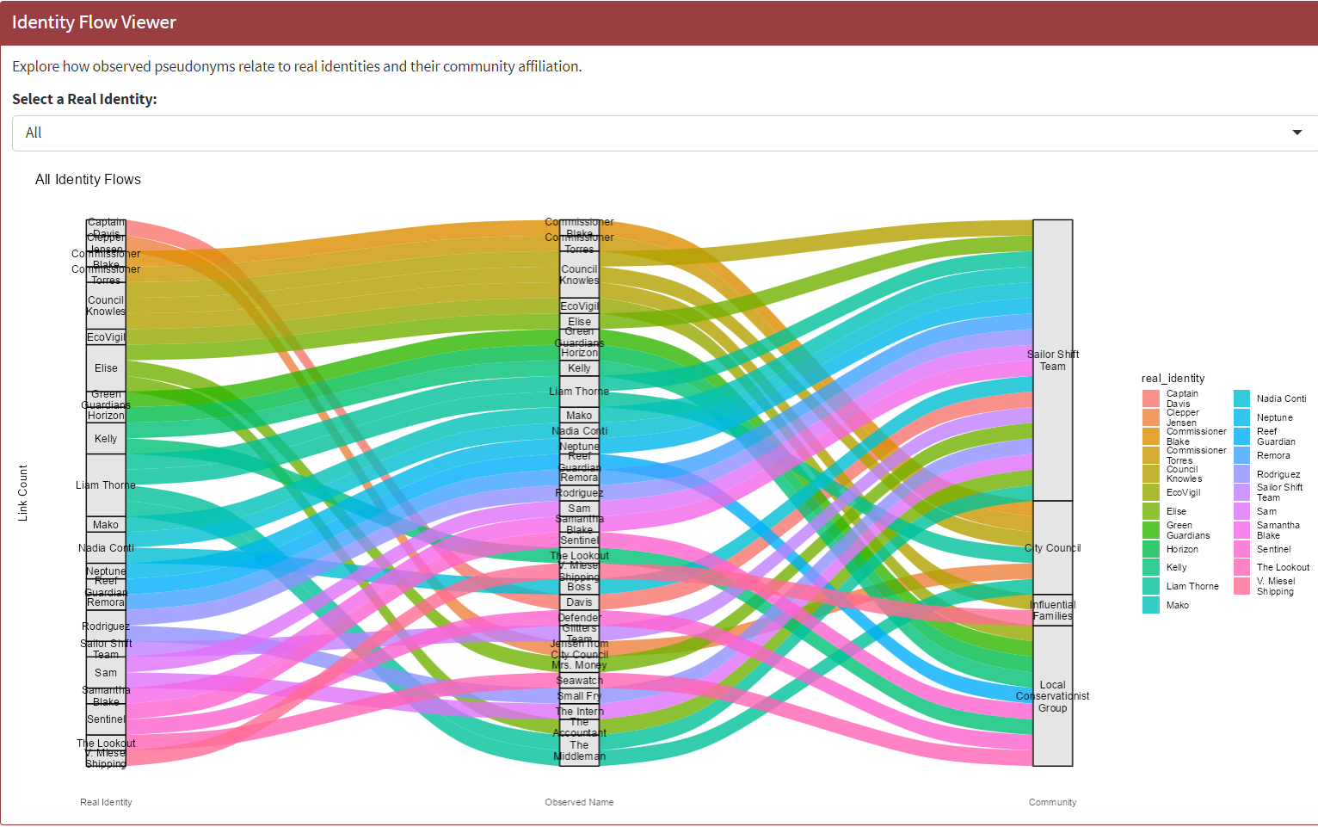

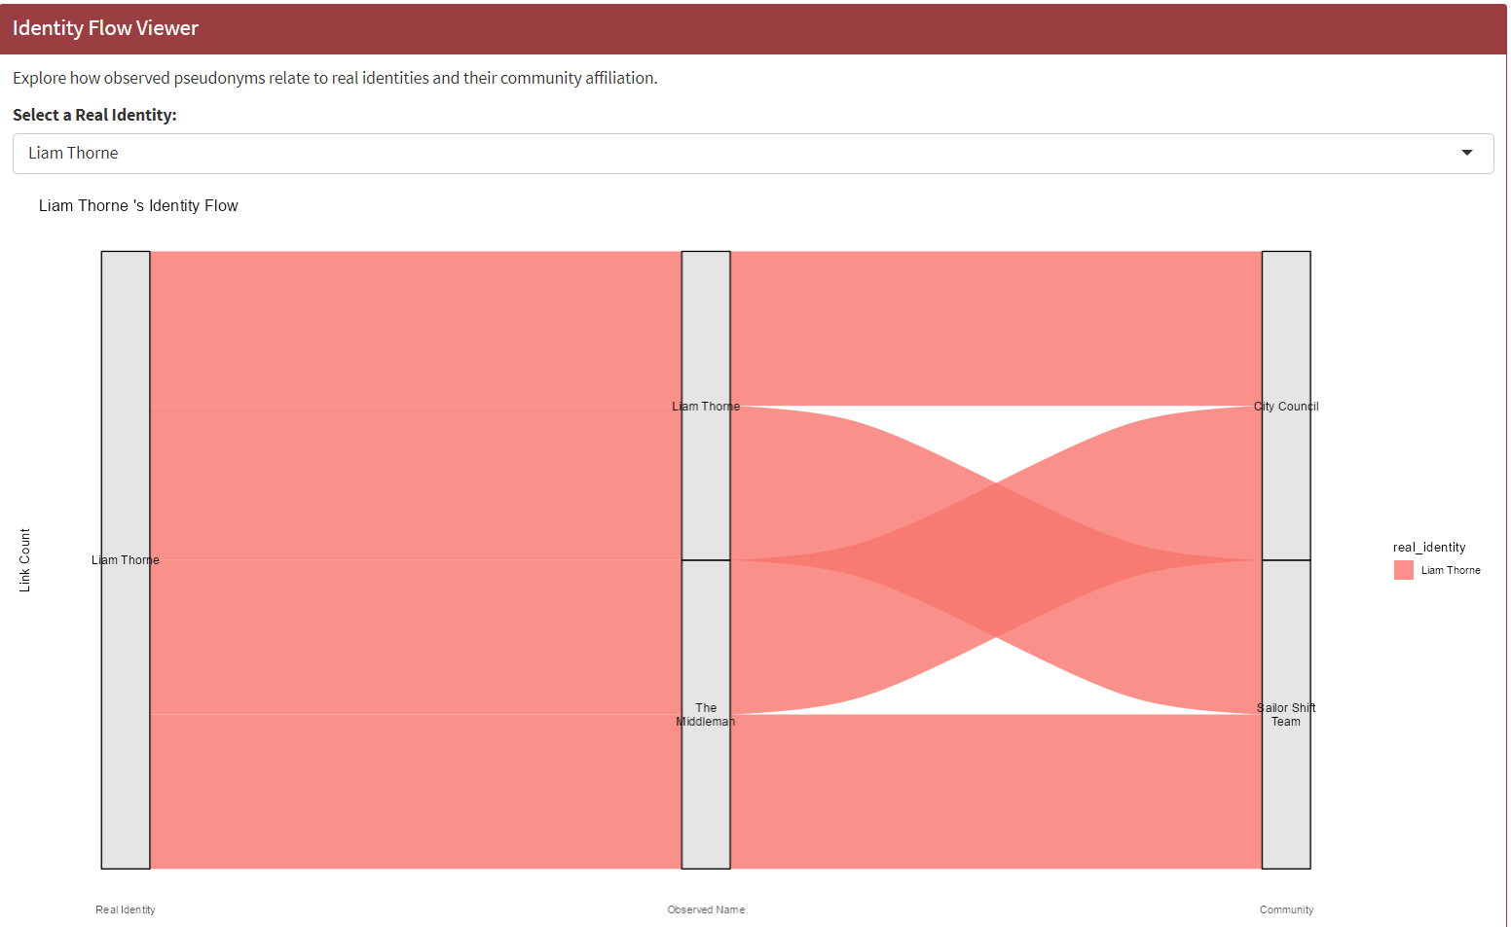

## 9. Question 4

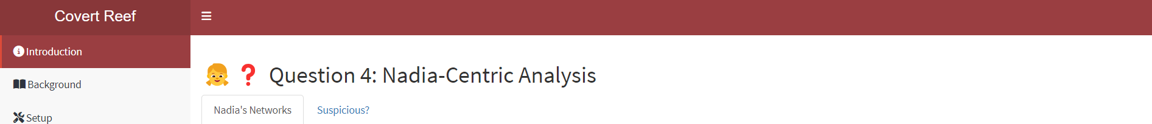

## **Some other Parameters and Outputs:**

## Inputs

The Shiny app will include some of these parts.

### Knowledge graph

As the entire network is very large, containing 1,159 nodes and 3,226 edges, it is not suitable to visualize the entire network. Hence, we will plot with subgraphs and other visualisations.

### Reference Node

For Nadia’s ego network, we require a reference node (Nadia).

### Network depth

In relation to the reference node, this serves to narrow down the network to view. The depth dictates how far from the reference node to network. As Nadia’s networks are at distance 1 or distance 2, we will add an option to toggle whether to render the full network or use the option to render by distance to the reference node.

## Outputs

### Plot area

Shows the network or visual plot. It will be interactive to enable closer inspection of network or visual elements.

These are some prototypes of the webpage and shiny application that we are planning to build for the project. We would like to get to the bottom of the activities brewing at Oceanus such as the Nemo Reef Operation. Hence, enhancing the whole user experience as they follow us along on uncovering the story.

**The users can select inputs such as:**

* Timeseries sliders
* Clickable components
* Hovers
* Drop down menus

**The application will output:**

* Details of communication flows of characters of certain time period
* Names of characters that are related to each other of certain time period

## **Visualisation Pointers:**

* We added shapes and colours to distinguish the Entity nodes (square, circle, triangle, diamond, short oval), relationship node (long oval), and Event-Communication nodes (star).
* We kept the colours distinct from each other and as minimal as possible to be easy on the eyes.
* Faceting was used to create subplots for clarity and differentiation.
* Graph titles, subtitles and legends components were used for graphs.
* Interactivity were used to segment and also as a means to reel the user in.