# Kinect资料

## Kinect定义

### JointType

Ref: <https://msdn.microsoft.com/en-us/library/microsoft.kinect.jointtype.aspx>

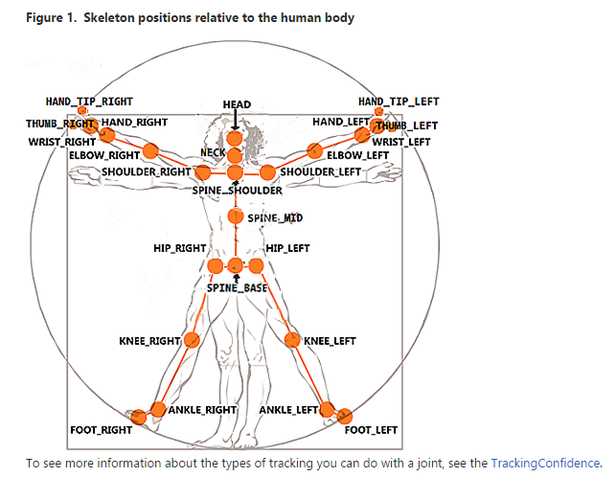

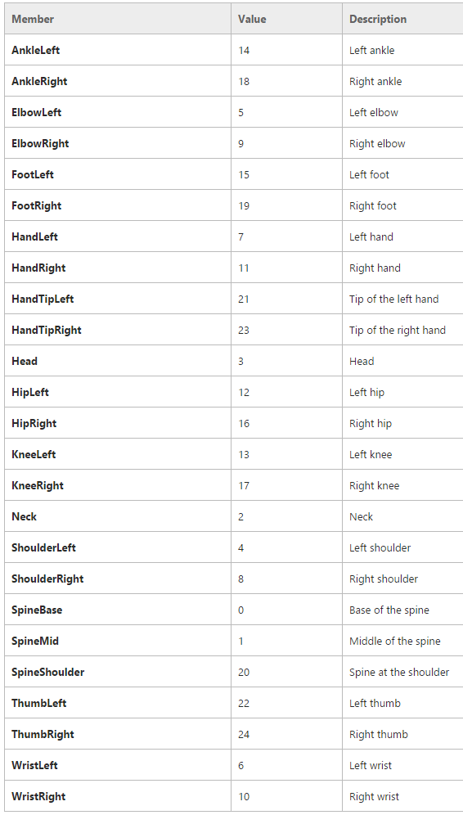

### CameraSpacePoint

<https://msdn.microsoft.com/query/dev12.query?appId=Dev12IDEF1&l=ZH-CN&k=k(Kinect%2FCameraSpacePoint);k(CameraSpacePoint);k(DevLang-C%2B%2B);k(TargetOS-Windows)&rd=true>

Camera space refers to the 3D coordinate system used by Kinect. The coordinate system is defined as follows:

* The origin (x=0, y=0, z=0) is located at the center of the IR sensor on Kinect
* X grows to the sensor’s left
* Y grows up (note that this direction is based on the sensor’s tilt)
* Z grows out in the direction the sensor is facing
* 1 unit = 1 meter

左上前

### （3）DepthSpacePoint

<https://msdn.microsoft.com/query/dev12.query?appId=Dev12IDEF1&l=ZH-CN&k=k(Kinect%2FDepthSpacePoint);k(DepthSpacePoint);k(DevLang-C%2B%2B);k(TargetOS-Windows)&rd=true>

|  |  |
| --- | --- |
| **Name** | **Description** |
| [X](https://msdn.microsoft.com/en-us/library/windowspreview.kinect.depthspacepoint.x.aspx) | The X coordinate of the point, in pixels. |
| [Y](https://msdn.microsoft.com/en-us/library/windowspreview.kinect.depthspacepoint.y.aspx) | The Y coordinate of the point, in pixels. |

## [Remarks](javascript:void(0))

Depth space is the term used to describe a 2D location on the depth image. Think of this as a row/column location of a pixel where x is the column and y is the row. So x=0, y=0 corresponds to the top left corner of the image and x=511, y=423 (width-1, height-1) is the bottom right corner of the image. In some cases, a z value is needed in order to map out of depth space. For these cases, simply sample the depth image at the row/column in question, and use that value (which is depth in millimeters) directly as z.