

Elevate Horizon Connect Requirements Document
Version: 1.3
Assessment Event 2 of 2 – Mobile App Development (Individual Project)

Contents
Elevate Horizon Connect Requirements Document 1
1. Introduction 3
1.1 Purpose of This Document 3
1.2 Audience 3
1.3 Definitions & Abbreviations 3
1.4 Out of Scope 3
2. Project Overview 4
2.1 About the Client 4
2.2 Project Goals 4
2.3 Scope Summary 4
3. Functional Requirements Overview 5
3.1 Functional Requirements 5
3.2 Data Source Requirements 5
4. User Interface (UI) Requirements 7
4.1 Screens & Wireframes 7
4.2 Accessibility & Branding 8
4.3 Responsiveness 8
4.4 Success & Error Message Guidelines 8
4.5 – Supplied UI/UX Wireframes 8
5. Non-Functional Requirements 12
6. Project Setup & Collaboration 13
6.1 GitHub Version Control 13
6.2 Agile Sprint Kick-off & Planning 14
7. Elevate Horizons Style Guide 15
7.1 Colour Scheme 15
7.2 Typography 15
7.3 Images 15
7.4 Corporate logo 16
7.5 Accessibility 16
8. Supplied Remote Data Endpoints 17
9. Assessment Deliverables You must submit the following items as evidence. These align with the marking guide and assessor guide. 18

1. Introduction

1.1 Purpose of This Document
This document specifies the requirements for the Elevate Horizon Connect mobile application to be developed as part of Assessment Event 2 – Individual Project for ICTPRG436, ICTPRG437, and ICTICT449. It defines the scope, features, appearance, and minimum viable product (MVP) requirements, serving as the single source of truth for planning, design, and coding. It aligns with the provided client brief and the current assessment marking and assessor guides, ensuring every requirement has clear, assessable evidence.

1.2 Audience
This document is for student developers undertaking this assessment. It will guide the design and development process and be used to verify completion of functional and non-functional requirements against the marking criteria.

1.3 Definitions & Abbreviations
- MVP – Minimum Viable Product for demonstration and feedback.
- Mock Data /Local Data/Remote Data Endpoint – Data bundled with the app to simulate backend responses.
- Admin (Assumed) – A default administrative role can be set available in mock data to perform management actions (no live authentication in this iteration). It is implied that admin is the default perspective of this version 1 prototype application.

1.4 Out of Scope
- Backend authentication/login, cloud databases, or live server integration.
Push notifications, payments, or calendar syncing.
- App Store/Google Play deployment.

2. Project Overview

2.1 About the Client
Elevate Horizon Connect, a forward-thinking local government body, is developing a digital system to manage and promote its growing portfolio of community engagement activities. The initiative will streamline event coordination and make participation more accessible for both staff and the public. The council fosters health, wellbeing, and social inclusion through programs such as walking clubs, yoga, swimming, trivia nights, board games, music workshops, talent showcases, and movie screenings. With a team of 20 staff and over 50 volunteers annually, the council needs a modern, efficient, and transparent system to manage events and participation.

2.2 Project Goals
- Reduce staff time spent on manual registrations and updates.
- Provide residents with easy access to accurate, up-to-date event information.
- Deliver adjustable accessibility features (text size, dark mode, sound toggle).
- Build an MVP that can later integrate a live data context.

2.3 Scope Summary
The MVP will use React Native with Expo and local/mock data storage. It will:
- Fetch and display event listings (including “Today’s Events”).
- Search/filter events.
- Register for events.
- Adapt layout for mobile portrait and tablet landscape.
- Simulate offline capability by storing latest fetched mock data locally.

3. Functional Requirements Overview

3.1 Functional Requirements
ID | Feature | Description
F1 | View Today’s Events | Display events scheduled for the current day; must update dynamically based on device date.
F2 | Navigation | Provide clear navigation between Home, Events, Event Details, Register, Settings.
F3 | Event Registration | Allow users to register for an event
F4 | Event Search/Filter | Search by keyword and filter by category/date.
F5 | Settings Screen | Change text size, toggle light/dark theme, toggle sound with persistence locally.
F6 | Error/Loading Feedback | Display clear loading/error/success messages across screens.
F7 | Manage Event Listings | Add, update, and delete event listings.
F8 | Responsive & Accessibility | Layouts adapt for phone (portrait) and tablet (landscape) to meet accessibility standards.

3.2 Data Source Requirements
The app must use mock/local data by default. A remote or hosted dataset will be supplied by your teacher/campus. Students must implement loading and error states regardless of the chosen data source. You may adapt the dataset for testing but must maintain the field structure below.
Event Data Fields:
Field | Type | Notes
id | number/string | Unique identifier
title | string | Event title
date | YYYY-MM-DD | Event calendar date
startTime | HH:MM | Start time (24h)
endTime | HH:MM | End time (24h)
location | string | Venue or area
category | string | e.g., Fitness, Social, Music
description | string | Short description
capacity | number | Total spots
spotsRemaining | number | Remaining spots
isCancelled | boolean | Cancellation flag

4. User Interface (UI) Requirements
The app must provide a clear, intuitive interface that works on both mobile phones and tablets. UI designs must align with the Elevate Horizon style guide (Section 7) and be consistent across all screens.
UI Toolkit Requirement
All students may use React Native Paper as the primary 3rd-party UI toolkit. This ensures consistent, accessible styling across the application. Other libraries may be discussed with your teacher, but React Native Paper is the default recommended toolkit. You may choose to opt out of using a toolkit but this must be agreed upon with your teacher.

4.1 Screens & Wireframes
Students will be provided with a set of core Figma wireframes.
Wireframes must:
- Annotate the supplied wireframes to show navigation flow, UI components, and accessibility considerations.
- Create one new wireframe for the Settings screen.
- Include both mobile (portrait) and tablet (landscape) views.
- Submit wireframes as annotated Figma file or PDF export.
Required Screens:
Screen | Purpose | Key Elements / Components
Home | Landing page, brief intro, quick access to events list. | App logo, welcome message, “View Today’s Events” shortcut.
Events List | Browse all events; see key details. | Title, date, time, location, category, spots remaining; filter & search.
Event Details | View details of a selected event. | Title, date/time, location, description, category, capacity, spots remaining, “Register”.
Event Register | Register for an event. | Fields: full name, email; confirm; success/error message.
Settings | Configure display & accessibility preferences. | Text size, theme toggle, sound on/off.
Error/Loading | Generic loading or error state. | Spinner, “Loading…”, error icon, helpful text.

4.2 Accessibility & Branding
- Minimum font size: 13px (or platform equivalent).
- WCAG 2.1 AA colour contrast for text against backgrounds.
- Clear, concise labels for interactive elements (e.g., “Save Event”).
- Follow Elevate Horizon branding and use recognisable icons.
- Tap areas: minimum 44×44px.

4.3 Responsiveness
- Screens must adapt fluidly to device sizes/orientations without breaking layout.
- Portrait vs Landscape: rearrange content for tablet landscape where appropriate.
- No horizontal scrolling unless required by data tables.

4.4 Success & Error Message Guidelines
- Success example: “Registration Successful — you are booked for Morning Yoga.”
- Error example: “Unable to register. Event is full. Please choose another date.”
- Messages must be friendly, specific, and guide the user to resolution.

4.5 – Supplied UI/UX Wireframes
The following UI/UX wireframes are provided as the design baseline for the project:
- Home screen
- Events list
- Event details
- Register screen
- Settings Screen
Students are expected to annotate these designs with navigation arrows, component labels, and accessibility notes. You may use the wireframe tool of your choice provided it is approved OR the primary tool you have used in class.
Additional screens: Students must design a Settings screen with adjustable accessibility options.
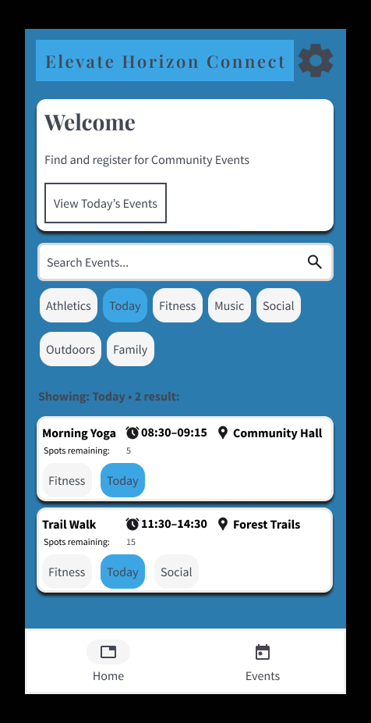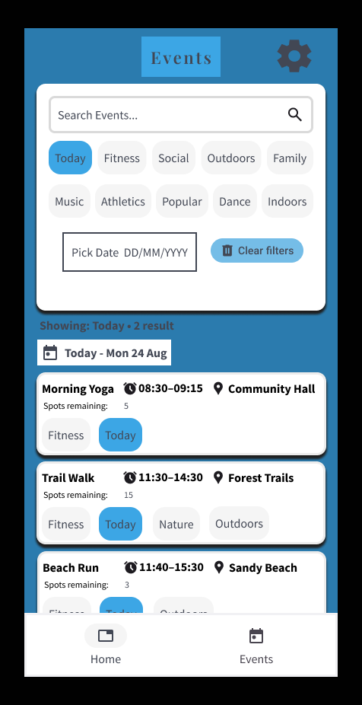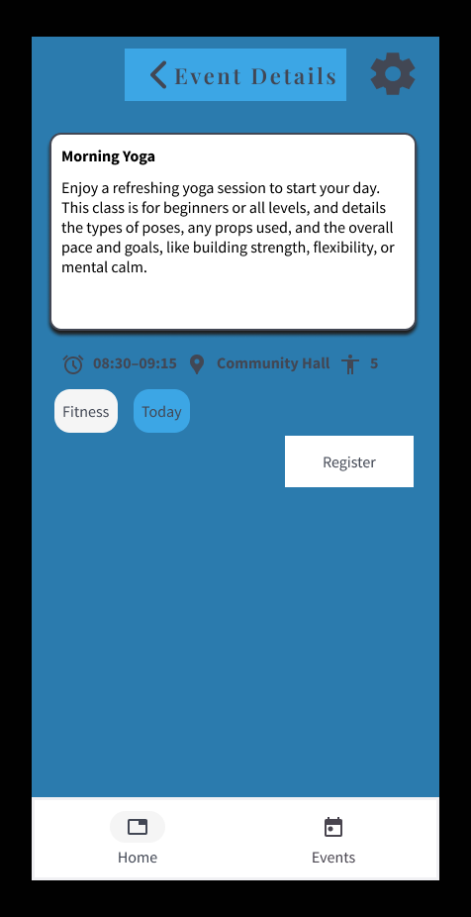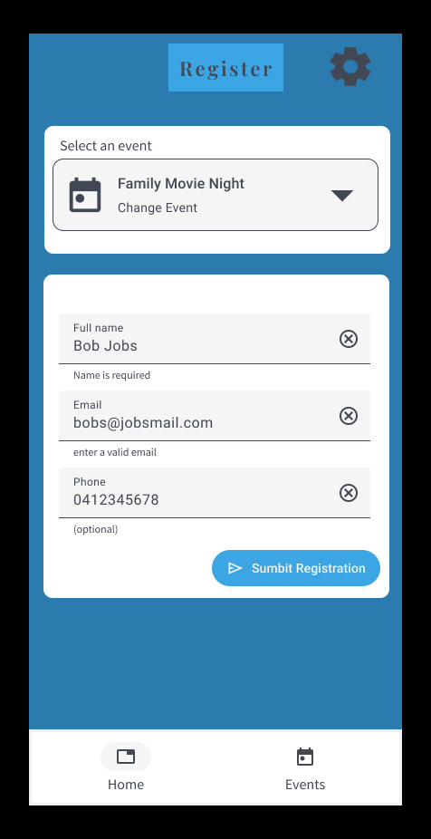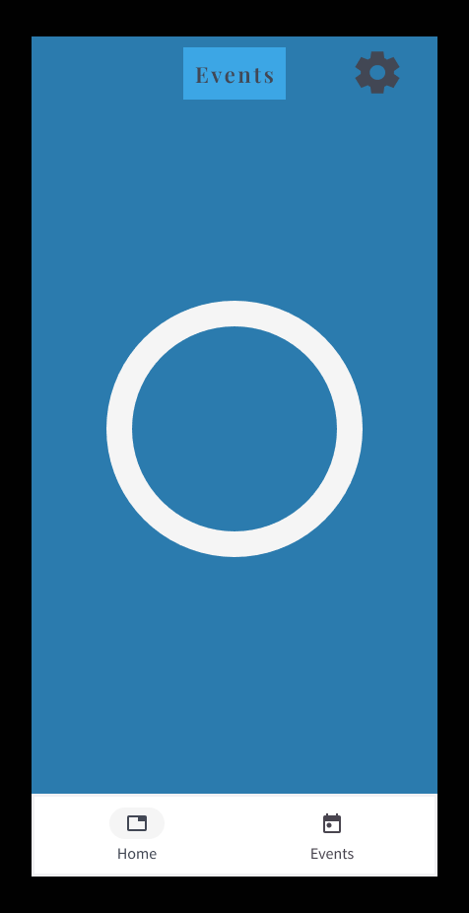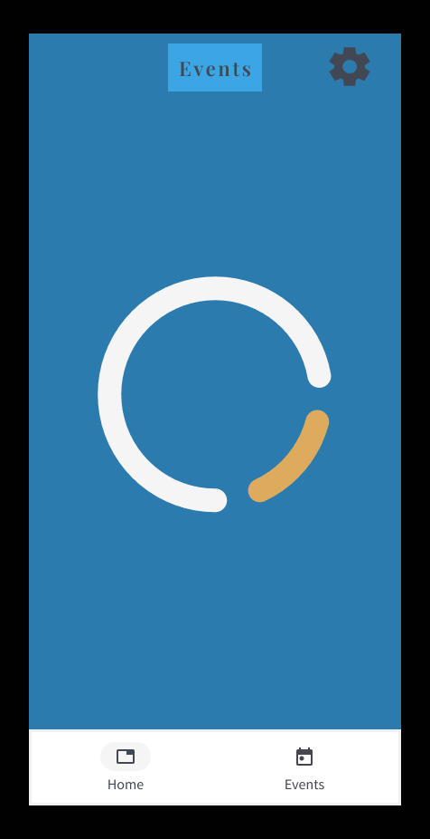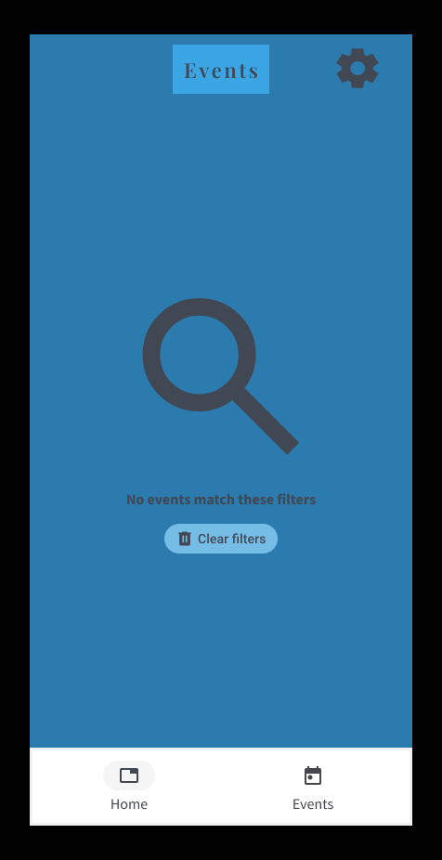

5. Non-Functional Requirements
Category | Requirement
Usability | The application should be intuitive. Navigation and labels are self-explanatory. Clear success/error messages with next steps.
Performance | Each screen loads in less than 3s. Search/filter are less than 1s on 100 events. Must fetch data from remote API in under 3s (under normal classroom Wi-Fi).
Portability | Android and iOS compatibility via Expo and support phone portrait and tablet landscape.
Availability | Changes persist and are visible on next start within the remote data context. Must display error message if API is unavailable. Cache last loaded data for offline run can replace error messages/screens.
Maintainability | Modular, readable code that is consistent in naming/folder structure. There are incremental, meaningful commits (no large “dump” commits).
Security | No live authentication. Store only minimal required data and no hardcoded passwords. Admin is set to default scenario of this application.
Scalability & Future-Proofing | Design to swap local data approach for a backend API with minimal changes. Aim for efficient state management.
Accessibility | Meet WCAG 2.1 AA where feasible and Jakob Nielsen’s 10 heuristics for UI/UX. Allow text size & theme changes and ensure contrast and touch target sizes.

6. Project Setup & Collaboration
The project must be developed in a structured, professional way reflecting real-world practices.
Observation Reminder
Two formal assessor observations will occur during this project:
- Kick-off Meeting (Part 1 Task 1) – observed participation, goals, and scope discussion.
- Final Presentation (Part 5) – observed demonstration of your completed app.
You must attend and participate in both observations as part of assessment evidence.

6.1 GitHub Version Control
Requirement | Details
Repository Creation | Create a personal GitHub repository in Week 1.
Repo Name | Use a descriptive name (e.g., ElevateHorizon_MobileApp_YourName).
Initial Setup | README with project name, purpose, description, tech stack, setup/run instructions.
Folder Structure | Logical structure: /assets (images, flat file formats such as CSVs), /src/components, /src/screens, /src/data, /src/styles.
Branching | Use feature branches; merge into main via pull requests.
Commits | Regular, meaningful commits at least weekly (preferably per feature/task).
Collaboration | Add teacher as collaborator with full access in Week 1.
Evidence | Screenshots/links showing repo creation, initial commit, and collaborator added.

6.2 Agile Sprint Kick-off & Planning
Students must participate in a simulated stand-up meeting at project start to clarify scope and plan work. Submit a short kick-off summary with the initial repo upload, including:
- Client goals and target audience.
- Must-have MVP features.
- Known risks and challenges.
- Timeline/milestones.

7. Elevate Horizons Style Guide

7.1 Colour Scheme
Colour Name | Hex Code | Usage
Sky Blue (Primary) | #3CA6E5 | Primary brand colour; buttons, highlights, links, CTAs.
Charcoal | #424754 | Body text, nav bar background, primary headings.
Light Grey | #F5F5F5 | Backgrounds, card surfaces, dividers.
White | #FFFFFF | Primary content background, contrast areas.
Soft Gold | #DDAB5E | Accent for highlights or special UI elements (use sparingly <10%).
Notes:
- Limit Soft Gold usage to < 10% of UI elements per screen.
- Ensure all text over Sky Blue or Charcoal meets a 4.5:1 contrast ratio.

7.2 Typography
Font | Usage
Georgia | Main headings (H1–H3), splash screen titles.
Calibri (or system sans-serif) | Body text, forms, navigation items.
Font sizes:
- H1: 24–28px.
- H2: 20–22px.
- Body: 14–16px.
- Captions: 12–13px.

7.3 Images
- Use authentic imagery reflecting community events and real locations.
- Avoid over-staged stock photography or busy backgrounds.
- Optimise images for mobile performance (aim < 200KB).

7.4 Corporate logo

Logo usage:
- Use full-colour logo on light backgrounds or reversed white on dark backgrounds.
- Minimum size: 100px wide (mobile), 150px wide (tablet/desktop).
- Maintain aspect ratio; do not distort, crop, or recolour.
- Provide clear space around logo at least the height of the “E” in “Elevate”.
Incorrect usage examples:
- Changing Sky Blue to any other hue.
- Adding drop shadows/outlines not in official logo.
- Placing logo over busy imagery without a solid/blur overlay.

7.5 Accessibility
- Minimum tap target: 44×44px.
- Support dynamic text resizing from OS accessibility settings.
- Avoid relying solely on colour to indicate status — use labels/icons as well.
- Maintain WCAG 2.1 AA compliance for all text and UI contrast.

8. Supplied Remote Data Endpoints
Students will develop using mock/local data by default with early designs using data structures, such as array, for early testing. Remote or hosted API endpoints are provided by your teacher/campus. Regardless of data source, students must implement loading and error handling. An offline fallback option can be simple screens or allocated to errors, and it is not expected that full fallback of cached data is to be built for this application.
Requirements for Students:
- Use fetch with async/await.
- Implement loading states (e.g., spinner, “Loading events…”).
- Implement error states (e.g., “Unable to load events. Please try again later.”).
- You can demonstrate offline fallback with:
  - Simple error screens or messages
  - Or a cached local data fallback.

9. Assessment Deliverables
Students must submit these deliverables progressively at milestones. Each item represents an artifact aligned to your final submission.
Deliverable | Details
1. Student Assessment Overview File | Completed overview document with your details.
2. VCS Repository Setup | GitHub repo link with initial commits, basic folder structure, README.md, and teacher as collaborator.
3. Kick-off Meeting Notes | Completed Collaboration Log including attendees, client goals, risks, navigation flow, and meeting notes.
4. Project Plan | Document including repo link, goals, target audience, MVP features, risks, tech stack, milestones, and initial commit screenshots.
5. Wireframes | Annotated Figma template (core screens) + custom Settings screen. Submitted as PDF export or Figma link.
6. App Build | Expo project with core screens, navigation, settings screen, and mock data integration. This includes final polish, improvements and remote data source integration.
7. VCS Commit History | Clear and professional commit messages showing iterative development.
8. Peer Testing Checklist | Completed checklist, peer feedback notes, improvements documented, screenshots or logs.
9. Final Submission Pack | Final GitHub repo, updated README, screenshots or demo video, completed Final Report Checklist, Reflection, and packaged submission bundle.

Templates & Checklists:
All required templates (Collaboration Log, Project Plan, Wireframe Checklist, Testing Checklist, Final Report Checklist) are included in the App Resources Pack. Students must complete these within the Student Assessment Overview document provided.

