
Student workbook
Cluster Intermediate Web Scripting
TAFE NSW would like to pay our respect and acknowledge Aboriginal and Torres Strait Islander Peoples as the Traditional Custodians of the Land, Rivers and Sea. We acknowledge and pay our respect to Elders, past, present and emerging of all Nations.
Version: 20251204
Date created: 15 September 2025
Date modified: 21 January 2026
For queries contact: Digital, Business and Finance
© TAFE NSW 2025
RTO Provider Number 90003 | CRICOS Provider Code: 00591E
This resource can be found in the TAFE NSW Learning Bank.
The content in this document is copyright © TAFE NSW 2025 and should not be reproduced without the permission of TAFE NSW. Information contained in this document is correct at time of printing: 21 January 2026. For current information please refer to our website or your teacher as appropriate.

Contents
Get started 5
What will I learn? 5
Icon legend 7
Lesson 1: Planning and designing a website 8
Overview 8
Analysing project documents 9
Following web design standards 13
Creating a site map 21
Creating a wireframe 25
Choosing a markup language 30
Developing test plans 34
Working with users and clients 40
Lesson 2: Creating website structure using HTML 45
Overview 45
Setting up your IDE 45
HTML document structure 47
Semantic elements 53
Troubleshooting and validating your HTML 60
Lesson 3: Styling websites using CSS 68
Overview 68
Basic structure of CSS 68
Applying CSS to HTML 76
Understanding the CSS box model 79
Applying floats 81
The display property 82
The position property 91
Applying responsive design with CSS media queries 93
Validating your CSS 95
Lesson 4: Coding in JavaScript 99
Overview 99
Using basic JavaScript syntax 99
Following coding standards and best practices 105
Operators 108
Control structures 113
Data structures 118
Functions 121
Applying data manipulation algorithms 125
Identifying types of errors 130
Debugging your code 133
Lesson 5: Manipulating the HTML DOM using JavaScript 142
Overview 142
HTML DOM 142
Create a simple toggle with JavaScript 147
Responding to events 149
Validating data in forms 155
Three ways to handle JavaScript events 157
Lesson 6: Testing your website 163
Overview 163
Lesson 7: Finalising your website 168
Overview 168
Producing final documentation 168
Achieving user acceptance 169
Answers and feedback 173
Lesson 1 173
Lesson 2 176
Lesson 3 178
Lesson 4 180
Lesson 5 185
Lesson 6 186
Lesson 7 186
References and attributions 187
References 187
Image attributions 187
Appendix: Links 188

Get started

What will I learn?
This workbook covers the units of competency:
- ICTPRG440 Apply introductory programming skills in different languages
- ICTWEB431 Create and style simple markup language documents.
Successfully completing this cluster will give you the skills and knowledge to design and create basic websites using HTML, CSS and JavaScript.
In this workbook, you will learn to:
- review website requirements
- create web page structure using HTML
- style a website using CSS
- use JavaScript to manipulate and search data
- use debugging tools to debug code
- test a website to meet requirements.
Each lesson includes opportunities to check your progress and understanding as well as practice activities that will prepare you for the formal assessments. Answers and feedback for the activities are at the end of this document.
There are 7 lessons to complete within this workbook. They are:
- Planning and designing a website
- Creating website structure using HTML
- Styling websites using CSS
- Coding in JavaScript
- Manipulating the HTML DOM using JavaScript
- Testing your website
- Finalising your website.
If you are using a printed version of this workbook, links and URLs are in a table at the end. Type the URL into your browser to go to the link.

Important note
As you progress through this cluster, you’ll develop the skills and knowledge needed for the assessments. Make sure to complete the practice activities in each lesson as they'll also prepare you for the assessments.
Note: Before starting your learning in this course, make sure that you review the Introduction to Certificate IV in Information Technology (Programming) (docx) resource.

Activity files
Save and unzip the Activity files (zip). You'll need to access these files for some activities.

Icon legend
Table 1: Icons
Icon | Description
 | Practice activity  Complete these learning activities as they will help you to gain the knowledge and skills you need to complete your assessments.
 | Collaboration  Take up opportunities to collaborate with others during your study. This could involve group activities such as mini-projects or discussions where you explore and expand your understanding of the content.
 | Resources  Review resources that will enhance your learning and help you with your assessments.
 | Video  Review video for task demonstrations and to gain a deeper understanding of job roles and concepts. If you are using a printed version, you may need to type the URL into your browser.
 | Self-check  Complete these activities to check your learning progress. They help you identify where you may need to go back and revise your learning. Mark off the tasks you have learned.
 | Assessment task  Complete the relevant assessment tasks soon after you have completed the related lesson.

Lesson 1:
Planning and designing a website

Overview
Every great website starts with a plan. Successful web projects are built on a foundation of clear goals, thoughtful design and collaboration.
Planning and designing a website is where creativity meets strategy. It’s not just about making something look good but about creating a site that works seamlessly for its audience and achieves its purpose.
This process begins with analysing project documents to understand the requirements, then applying established web design standards to ensure usability and accessibility. From there, crafting a clear and intuitive layout sets the stage for a positive user experience. Developing a test plan guarantees reliability across devices and browsers, while ongoing collaboration with the client keeps the vision aligned. Done well, this approach transforms ideas into a functional, engaging digital presence that truly connects with users.
In this lesson, you will learn to:
- review website requirements and other documentation
- follow web design standards
- create diagrams to define the website design
- select a markup language to suit requirements
- develop test plans, including testing approach and test cases
- use active listening and ask questions to work with users and clients.

Analysing project documents
As a web developer, you're probably keen to jump in and start coding when you're tasked with developing a new website. However, before writing a single line of code, you must review and analyse the project documents.
The project documents provide the foundation for understanding what needs to be built, how it should function and the standards it must meet. This will ensure that that the final website aligns with organisational goals, client expectations and industry standards.

Common types of project documents
Here are some types of documents you'll need to review at the beginning of a web project.

Organisational policies and procedures
These outline how work should be conducted within the organisation. They may include:
- branding guidelines (colours, fonts, logos)
- accessibility policies (for example, WCAG compliance)
- security protocols (data protection, password standards)
- workflow and approval processes.
Understanding these ensures your work complies with internal standards and legal obligations. For example, a cybersecurity policy might require HTTPS and secure coding practices.
Hypertext Transfer Protocol (HTTP) is the standard method for transferring data between a web server and a browser, allowing users to view websites. However, HTTP sends data in plain text, meaning it isn't encrypted and can be intercepted by attackers. It also fails to verify the identity of the website, making it unsuitable for sensitive transactions such as payments or personal data.
Hypertext Transfer Protocol Secure (HTTPS) is the secure version of HTTP. It uses SSL/TLS encryption to protect data during transmission and verify the authenticity of the website. Originally, HTTPS was mainly used for banking and payment sites, but modern browsers, such as Chrome, now enforce its use more broadly. For example, Chrome marks HTTP sites as 'Not Secure' and blocks certain features if HTTPS isn't enabled. Today, HTTPS is considered essential for any website, particularly those that handle user information.
Here are some example documents that are used in website development at Gelos:
- Website Development Policy and Procedure (pdf)
- Coding and Testing Guidelines (pdf)
- Software Test Report (docx)
- Style Guide Company (pdf).

User or client requirements
These documents describe what the client expects from the website. They often include:
- business objectives (for example, lead generation, e-commerce)
- target audience and user personas
- functional requirements (forms, search, integrations)
- design preferences (layout, colour schemes, tone).
Analysing these helps you translate abstract ideas into concrete features. Techniques include reviewing requirement documents, conducting stakeholder interviews and creating wireframes or prototypes for refinement and validation.

Industry standards
These include coding best practices, accessibility guidelines and security standards that ensure quality and compliance.

How to interpret complex documents
During a website development project, you'll need to read and interpret different types of complex and technical documents. Here's a 3-stage process that can be used to help you interpret a lengthy, complex document:
- Stage 1: Before reading
  - Skim the table of contents, headings and subheadings.
  - Identify the sections of the document that are relevant to your task.
- Stage 2: During reading
  - Make notes as you read and highlight key phrases and critical information.
  - Pay attention to tables and charts.
  - Map requirements to technical tasks, for example, 'Responsive design' means you need to use CSS media queries.
- Stage 3: After reading
  - Write a brief list of the key points within the document that are relevant to your task.
  - Confirm any assumptions with stakeholders before you begin development.
Resources
Read the webpage The web design process in 7 simple steps, which will give you an insight into the planning process for developing websites.
Practice activity

Activity 1: Interpret organisational documents
Explore the Gelos Website Development Policy and Procedure (pdf) and answer the following question.
- Select 2 W3C standards that websites developed by Gelos must follow.
# | Choices | Answers
 | Web content must be accessible | ☐
 | User interface storyboarding should use low-fidelity wireframes | ☐
 | Website must be device independent | ☐
 | HTML and CSS must be combined for ease of use | ☐
Explore the Gelos Coding and Testing Guidelines (pdf) and answer the following questions.
- Select 3 best practices you are required to use when developing code at Gelos.
# | Choices | Answers
 | For JavaScript, use JSDoc comments | ☐
 | Comment every line of code | ☐
 | Be consistent with naming conventions | ☐
 | Write clear and concise code | ☐
 | Always use the same structure for all coding languages | ☐
- Select 3 items that need to be recorded after testing a website.
# | Choices | Answers
 | Problems found | ☐
 | The actual results | ☐
 | The purpose of the test | ☐
 | The test outcome (pass or fail) | ☐
 | The expected results | ☐
Explore the Gelos Style Guide Company (pdf) and answer the following questions.
- Select the Gelos font style for headings at heading level 3.
# | Choices | Answer
 | Calibri Bold 12 pt Charcoal #424754 | ☐
 | Georgia 18 pt Blue #077A99 | ☐
 | Georgia 22 pt Charcoal #424754 | ☐
 | Calibri Bold 14 pt Black | ☐
- Select 2 rules that apply when using the Gelos logo.
# | Choices | Answers
 | You can't distort the logo | ☐
 | You can change the colour of the logo | ☐
 | Ensure enough white space around the logo | ☐
 | You can move the position of elements in the logo | ☐

Following web design standards
Web design standards provide a common framework that ensures websites are consistent, functional and user-friendly across different devices and browsers. Adhering to these standards is not just about writing clean hypertext markup language (HTML), cascading style sheets (CSS) and JavaScript code; it’s about creating experiences that meet user expectations and comply with best practices. Standards help developers avoid compatibility issues, improve performance and maintain accessibility for all users, including those with disabilities.
Web Standards are developed by the World Wide Web Consortium (W3C). The W3C website is the hub for web standards and includes technical guidelines, educational information and code-checking tools, such as validators, that allow developers to ensure their sites meet required web standards.
The W3C is an international community that sets standards and best practices for web development, including HTML, CSS and JavaScript.
Web design standards are not just technical rules, they shape how users experience a website. Accessibility guidelines, for example, ensure that people of all abilities can interact with content, which is a core principle of modern standards. Similarly, user interface (UI) and user experience (UX) design practices are grounded in these standards to create interfaces that are both visually consistent and easy to navigate.
By following established conventions, developers can deliver websites that are inclusive, intuitive and aligned with best practices, resulting in better usability and compliance across different devices and browsers.
Resources
The Gelos Website Development Policy and Procedure (pdf) summarises the W3C standards that should be applied to any websites created by Gelos.
Collaboration

Activity 2: Discuss accessibility, usability and inclusion
Discuss the following in your class, with colleagues or friends, or write down your thoughts.
Making sure your site is usable and accessible to as many people as possible is important. Accessible and usable sites always guarantee higher search engine rankings.
- What do the terms web accessibility and usability mean to you?
- Who are the different types of web users that you should consider when designing a website?

Designing for accessibility
Web accessibility ensures that a website can be used by as many people as possible, regardless of ability, device, or environment.

Considering diversity of web users
When designing a website, consider the diversity of the users and environments your website must support, such as:
- students and young people
- people from different cultural or language backgrounds
- people with disabilities or age-related impairments
- people using mobile or touch devices
- people with limited or unstable network access
- people using assistive technologies such as screen readers or voice input.

Applying POUR principles
Accessibility is a standard requirement in modern web development and supports inclusion, usability and compliance with W3C’s Web Content Accessibility Guidelines (WCAG) 2.1.
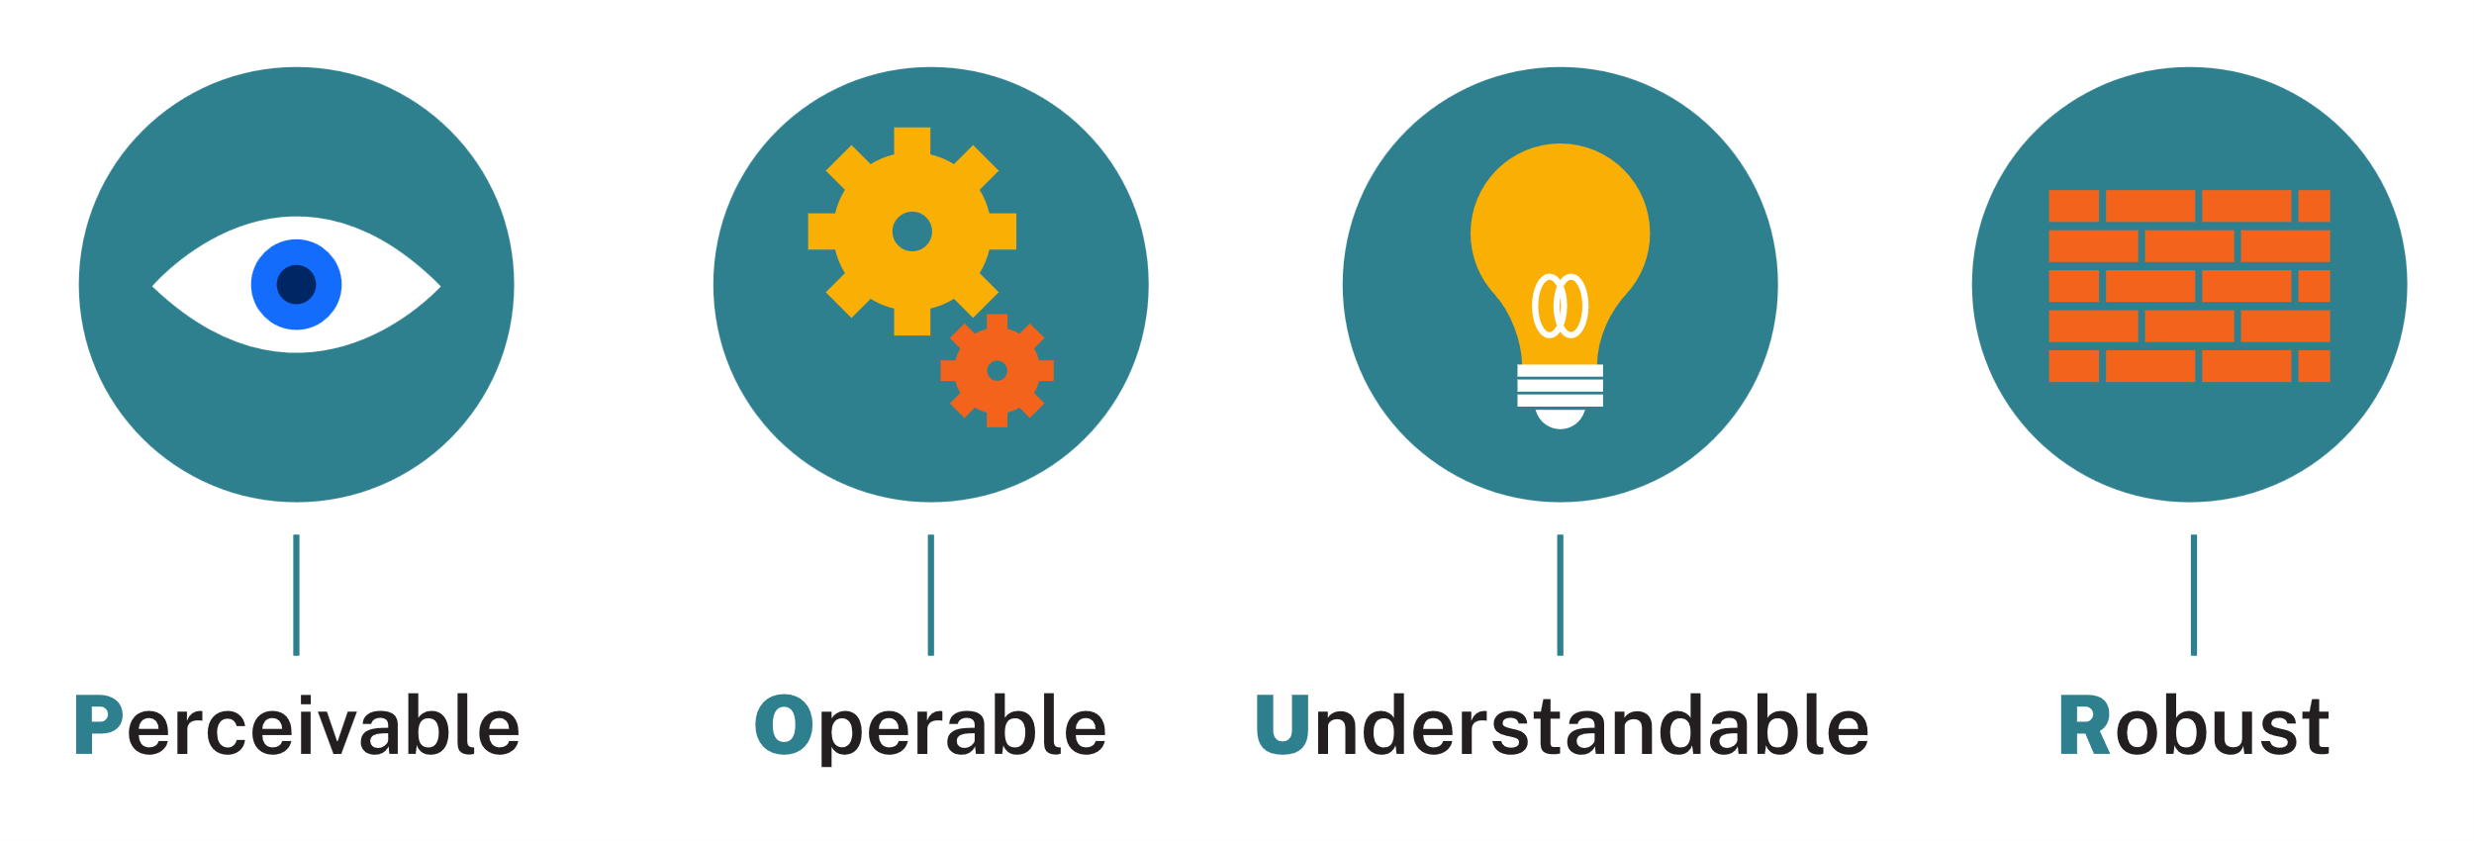
Figure 1: © TAFE NSW 2025
You should follow the WCAG’s 4 guiding principles of accessibility when developing your websites:
- Perceivable: Information and interface elements must be presented in ways users can perceive.
- Operable: Navigation and controls must work with various input methods (keyboard, mouse, or touch).
- Understandable: Content and interaction must be consistent and predictable.
- Robust: The website must work reliably across browsers, devices and assistive technologies, even with slow or unstable connections.

How to apply the POUR principles in your websites
Here’s an overview of how to apply the POUR principles in your websites, which summarises How to Meet WCAG (Quick Reference). You’ll learn how to apply these techniques throughout the learning resource:
- Text alternatives: Provide meaningful alternative (alt) text for images and icons.
- Keyboard navigation: Ensure all links, buttons and forms can be accessed using only the keyboard.
- Colour and contrast: Use colour combinations that meet WCAG contrast ratios, so that all text remains readable.
- Headings and structure: Use semantic HTML for clear content hierarchy and screen reader navigation.
- Forms: Label all input fields clearly and include error messages that explain what went wrong.
- Links and buttons: Use descriptive link text instead of 'click here’ or 'read more.’
- Responsive design: Design layouts that adapt to different screen sizes and orientations.
- Performance: Optimise images and code to improve loading times for users with limited connectivity.
Semantic markup means that elements are used according to their intended purpose.
The tags are used to tell the browser about the content, for example H1 is the most important heading (you’ll learn more about semantic markup as you learn HTML).
Resources
Learn about creating websites that work for everyone at the W3C Web Accessibility Initiative:
- Accessibility, Usability, and Inclusion
- Introduction to Web Accessibility.
You can access tools that check for accessibility for people who are colour blind, like the Colorblind Web Page Filter.

Using browser DevTools for accessibility
Modern browsers, like Microsoft Edge and Chrome, include developer tools (DevTools). These are an essential resource for web developers because they provide powerful, built-in capabilities for inspecting, debugging and optimising websites directly within the browser.
Debugging is the process of finding and fixing errors in programming code. It's an essential part of the development process, helping you identify and resolve errors efficiently.
These tools enable developers to examine HTML and CSS in real-time, modify styles on the fly, and troubleshoot layout issues without altering the source code. Be aware, however, that some DevTools features may be specific to a particular browser.
DevTools also include features for monitoring network activity, analysing performance bottlenecks and debugging JavaScript with breakpoints and console logs. Additionally, they offer insights into accessibility, security and responsive design by simulating different devices and screen sizes.
In this learning resource, you'll be using DevTools in several activities.
The most common web browsers allow you to access DevTools in similar ways:
- Using a function button on your keyboard: F12.
- Using a keyboard shortcut:
  - Ctrl + Shift + I on Windows
  - Cmd + Opt + I on Mac.
- Using the browser menu.
Lighthouse is a tool integrated in DevTools in Microsoft Edge and Chrome that you can use to check your website for accessibility and performance. Access this tool through the Lighthouse tab in DevTools (you may need to first select » for the overflow menu in Chrome or + for More tools in Edge).
Here's an example of a result from checking a website's accessibility in Lighthouse:
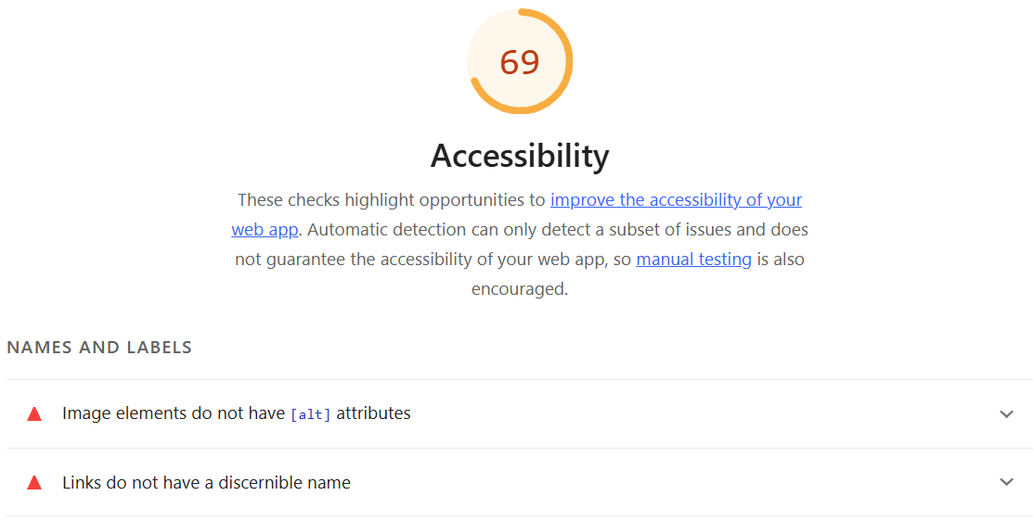
Figure 2: Used with permission from Microsoft
Resources
Access the following resources to learn how to access DevTools and Lighthouse in Microsoft Edge and Chrome:
- Microsoft Edge: Overview of DevTools
- Chrome: Open Chrome DevTools
- Chrome: Introduction to Lighthouse.
Video
The video Lighthouse score and similar (LinkedIn Learning, 3:25 min) demonstrates how to use Lighthouse to assess the accessibility of a website.
LinkedIn Learning videos will open in a new tab within your browser. You can access the full video by logging in with your TAFE NSW username and password. You can access a transcript of the video on the transcript tab within LinkedIn Learning. When you’re finished, simply close the tab and return to your course.
Practice activity

Activity 3: Use browser accessibility tools
Try out some browser accessibility tools on a website. Open the TAFE NSW website in Microsoft Edge or Chrome, then complete the following steps.

Read aloud
- Right-click on the page and select Read aloud (or press Ctrl+Shift+U). You may have to select More tools then Read aloud.
- Listen for missing labels or mis-read content.
- To pause or close the Read aloud tool, right-click the page and select pause or close, or press Ctrl+Shift+U again.

Lighthouse accessibility audit
- Open DevTools and select Lighthouse
- Select Accessibility to review scores and recommendations. Select other options as relevant, then select Analyse page load.

UI vs UX design
UI and UX work together but describe different aspects of a website.
UI refers to the visual and interactive elements a user sees and clicks or taps, such as buttons, colours, menus and typography. It focuses on appearance and layout.
UX refers to how the user feels when navigating and completing tasks on the website. It focuses on usability, clarity and satisfaction.
Good design combines both:
- The UI should look appealing and be consistent with the organisation's brand.
- The UX should make the website intuitive, efficient and enjoyable to use.
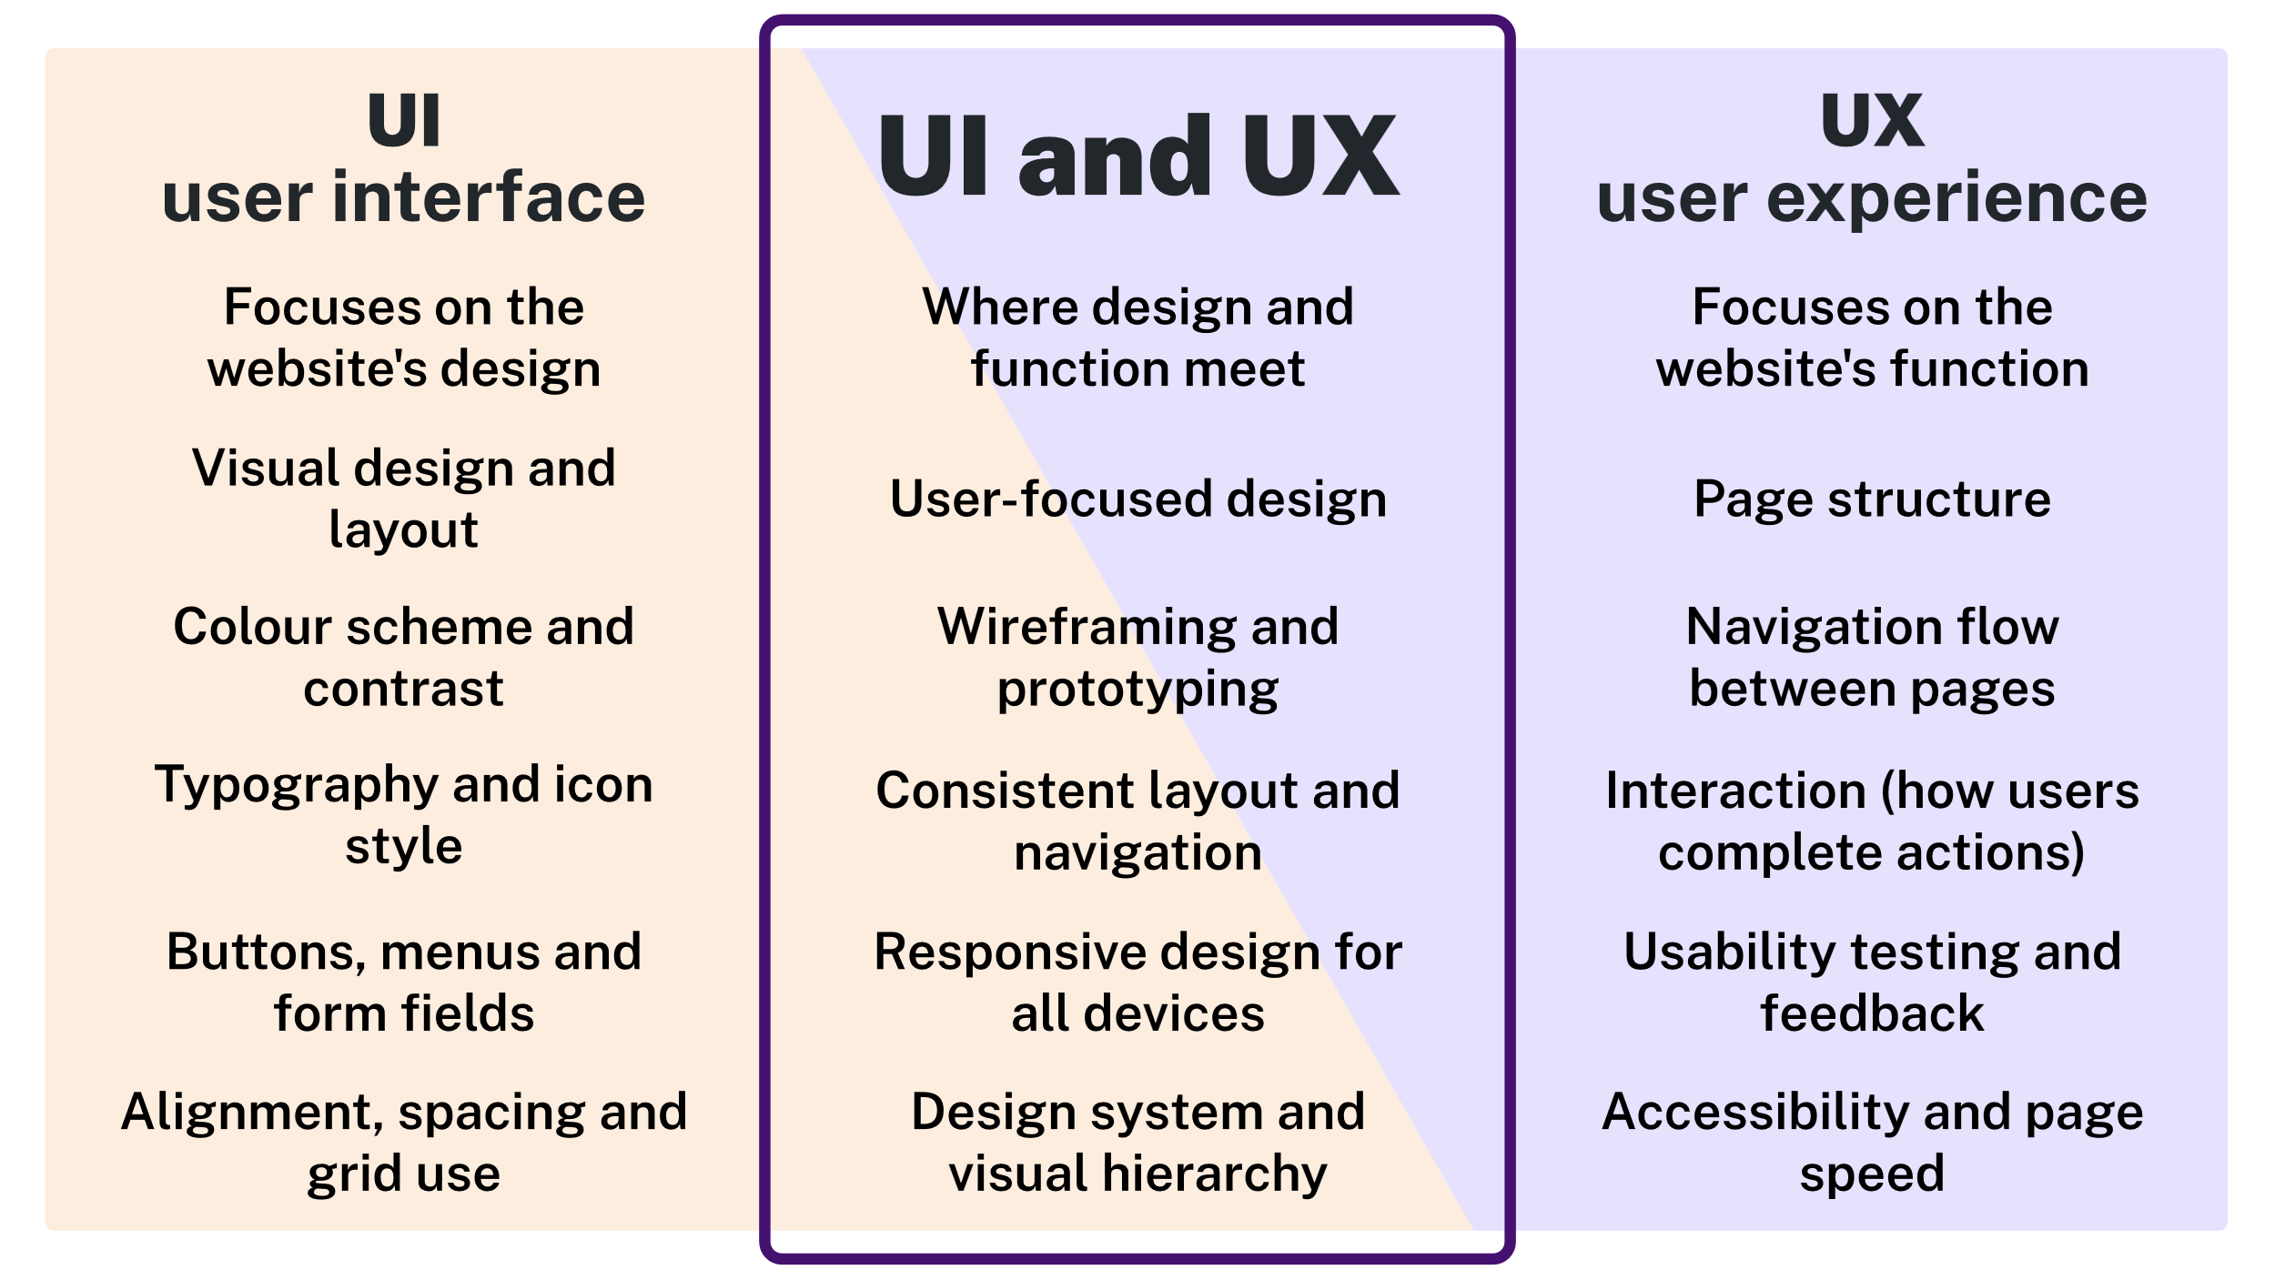
Figure 3: © TAFE NSW 2025
Video
Access the video UI/UX Explained In 8 Minutes (YouTube, 8:17 min) to learn about the differences between UI and UX.

Using colour in web design
Colours in web design can be defined using HTML colour names, hexadecimal (hex) codes, or RGB values. Notice in the Gelos Style Guide Company (pdf) that the colours in the Gelos colour theme have both hex codes and RGB values listed.

HTML colour names
A full list of supported colour names can be found at HTML Color Names.

Hex colours
A hex colour starts with a hash symbol (#) followed by 6 characters, where:
- the first two digits represent Red, the next two Green and the last two Blue
- each pair of hex characters ranges from 00 (none) to FF (full intensity).
For example:
#FF0000 is pure red (255 red, 0 green, 0 blue).
#00FF00 is green, and #0000FF is blue.
#FFFF00 combines red and green for yellow.

RGB colours
RGB values in web design represent colours using a combination of red, green and blue light intensities. Each component is expressed as a number from 0 to 255, where 0 means no intensity and 255 means full intensity.
For example:
rgb(255, 0, 0) gives pure red because red is at full intensity while green and blue are zero.
rgb(0, 255, 0) gives green and rgb(0, 0, 255) gives blue.
Mixing values creates different colors, like rgb(255, 255, 0) for yellow.
Resources
These tools help you select, test and create colour combinations for your website design:
- Adobe Color: You can create colour palettes and explore harmonious colour combinations.
- imagecolorpicker.com: Upload an image and find the exact colour codes from it.
- W3Schools HTML Color Picker: Test and copy hex, RGB, or HSL values.
- Coolors: Automatically generate and adjust colour palettes for web projects.
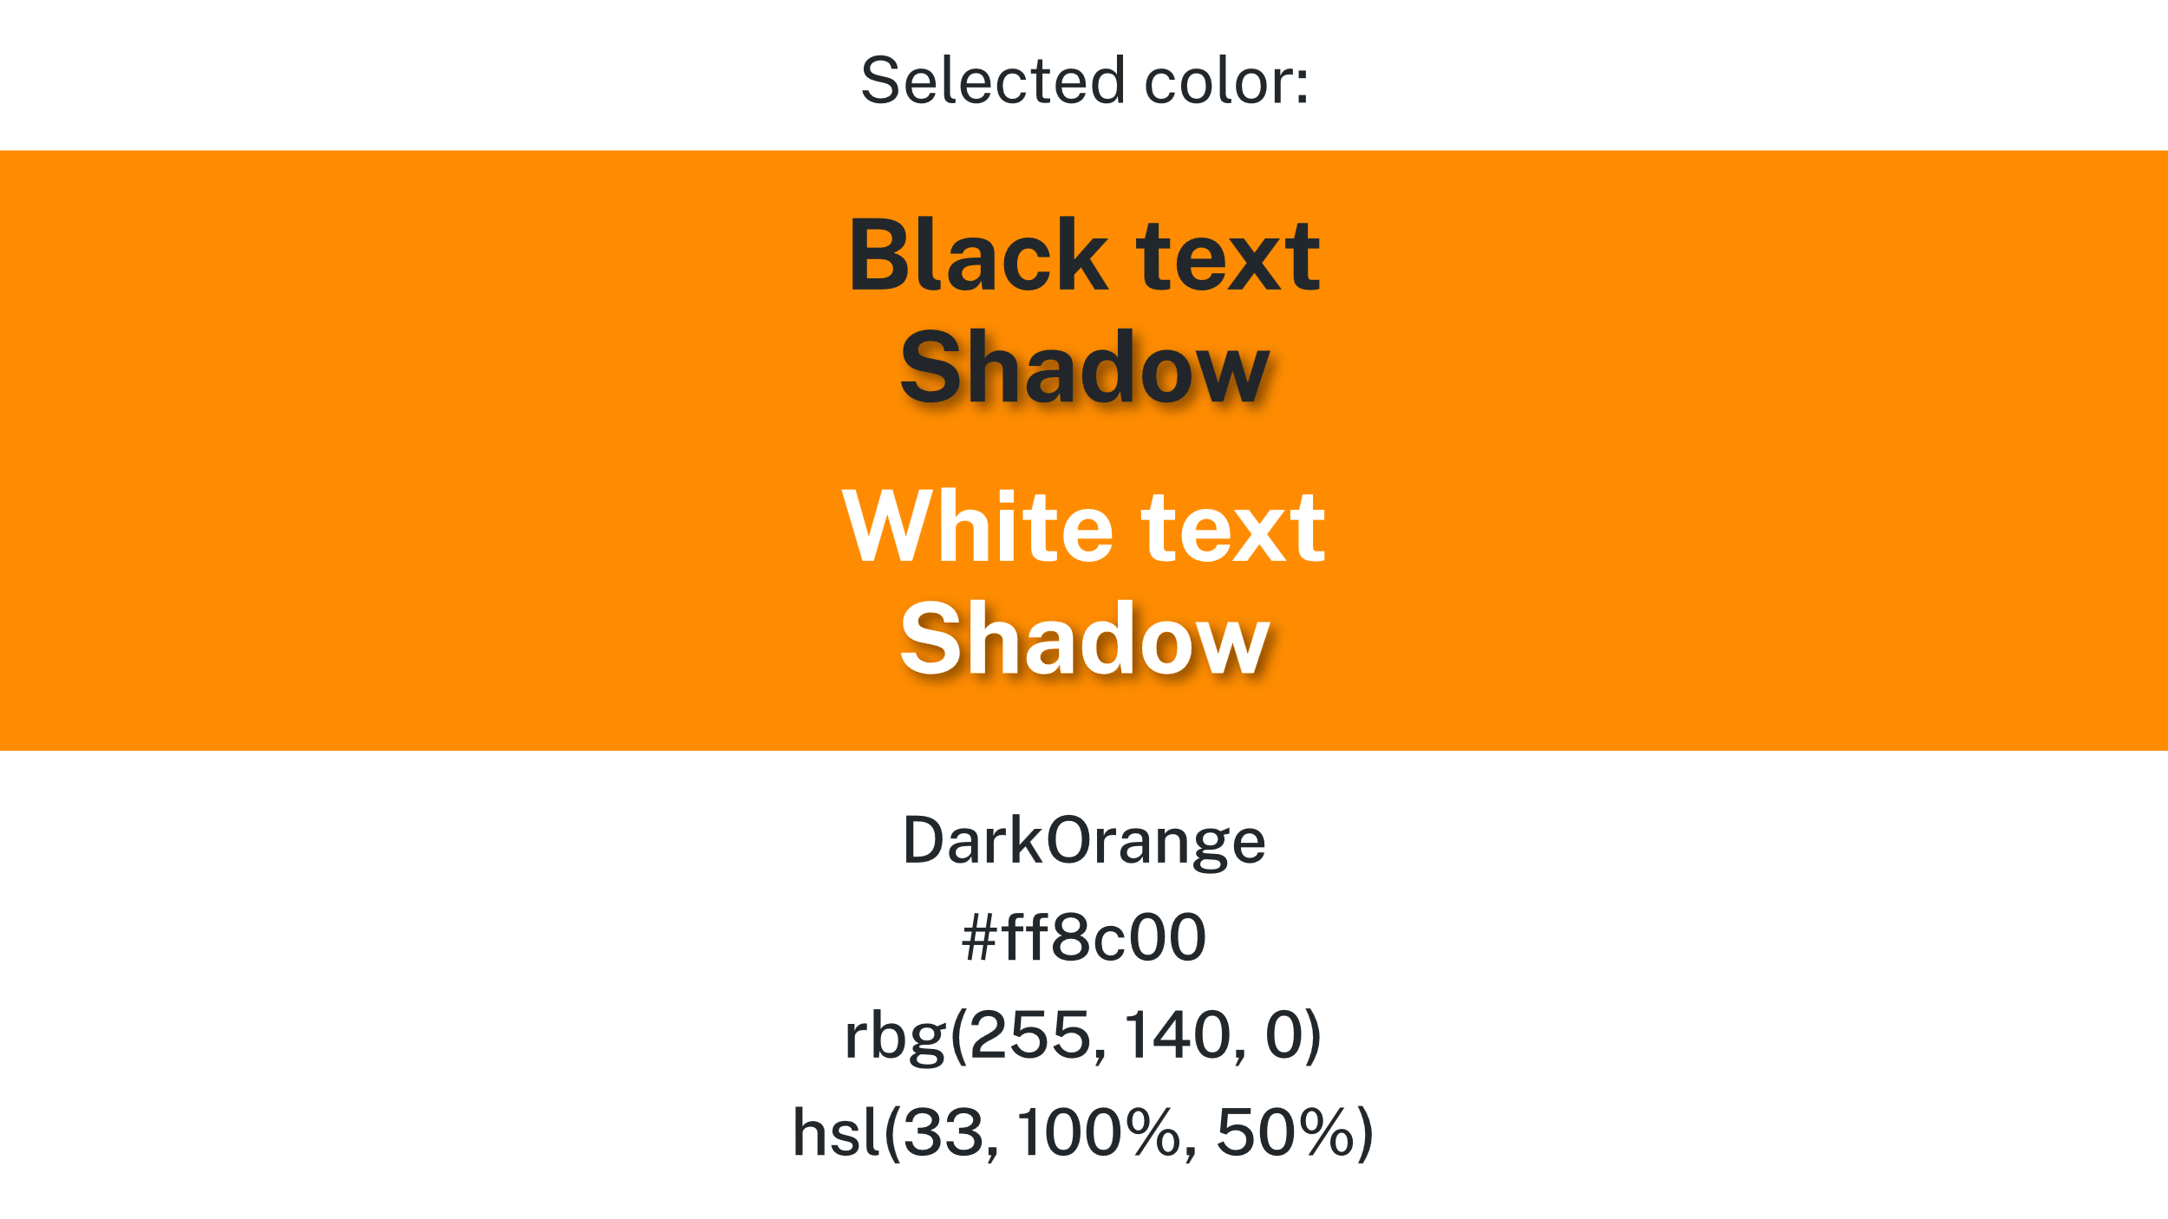
Figure 4: © TAFE NSW 2025

Creating a site map
A sitemap is a diagram that shows how pages in your website connect. It helps plan navigation and structure before building pages.
Note: Don’t confuse this type of sitemap with an XML sitemap you create to help search engines index your website more efficiently.

Hierarchy tiers
Within the sitemap diagram, a hierarchy structure is used and shows where each page fits into this hierarchy.
A hierarchy is where people or things are arranged in order or levels, such as from highest to lowest, or based on importance. Generally, the hierarchy structure has the most important item at the top.

Tier 1: Home page or landing page
- The main entry point of your website.
- Must be named index.html because web servers automatically load this file as the default page.

Tier 2: Website pages
- These are the main sections of the site and appear in the website’s navigation menu.
- Examples include about.html, products.html, services.html and contact.html.

Tier 3+: Linked or subpages
- These are pages linked from Tier 2 pages and provide more detailed content. For example, product1.html and product2.html might be linked from products.html.
- Avoid creating pages that require more than 3 clicks or taps to access from the homepage.
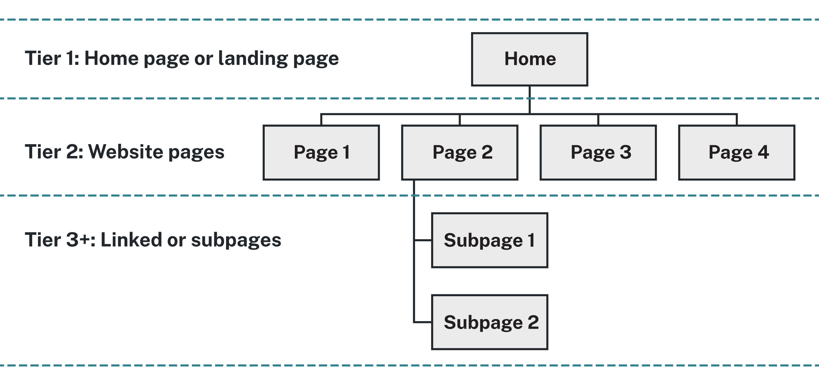
Figure 5: © TAFE NSW 2025
Here's an example of a site map for a business that sells products:
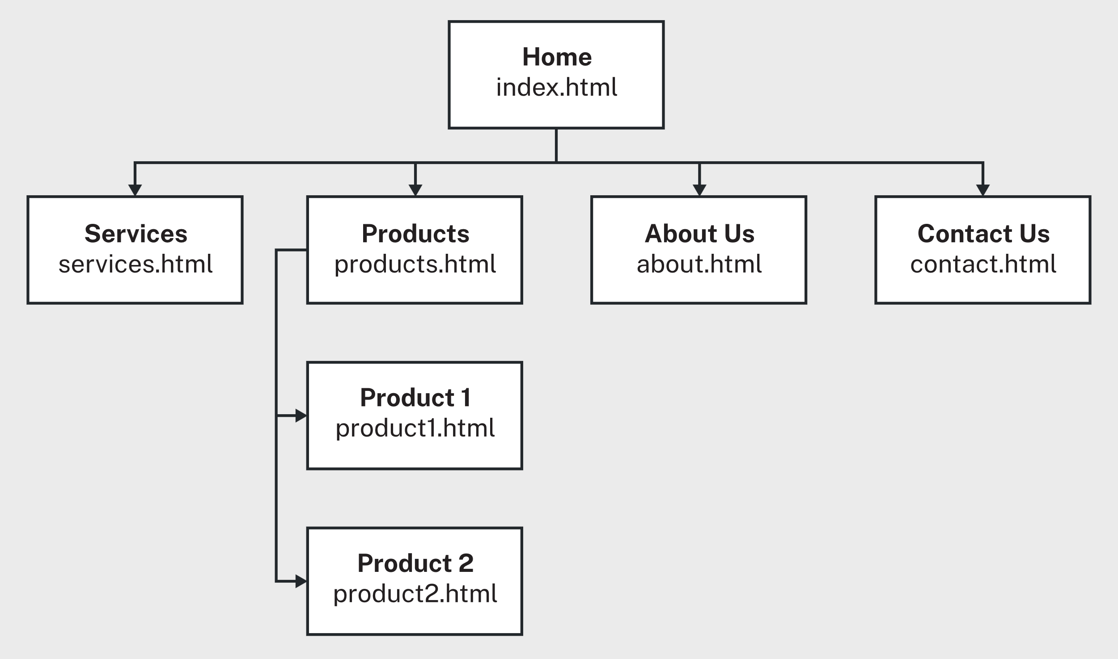
Figure 6: © TAFE NSW 2025

Using digital tools for creating sitemaps
There are many types of digital tools that you can use to create sitemaps. Some tools are free or have free options and some use paid subscriptions.
Some common tools include:
- Lucidchart
- diagrams.net.
Note: You may need to sign up for a free account and log in to use some tools.
Practice activity

Activity 4: Practise using digital tools for creating site maps
Here are some basic instructions for creating sitemaps using Lucidchart and Diagrams.net. Use one or both tools to practise with.

Lucidchart
- Go to Lucidchart → New Document → choose Sitemap Template.
- Drag Page shapes for Home, About, Contact and so on.
- Double-click the shapes to add text.
- Use Connectors to show hierarchy and navigation.
- Export as PNG, SVG, or PDF.

Diagrams.net
- Go to diagrams.net.
- Create boxes for each web page.
- Connect the page boxes with arrows by hovering on the box and selecting an arrow.
- Export to PNG, SVG, or PDF and save the diagrams.net file.

Activity 5: Create a site map for your portfolio
Read the following scenario and complete this activity.

Scenario: Portfolio website
You are completing your internship at Gelos Enterprises as a Web Developer. Your supervisor, Vinh Nguyen, has asked you to design and build your own portfolio website to showcase your skills and experience. This internal project will help you practise planning, designing, coding and testing before working on Gelos client websites.
Website requirements:
- Include 3 main pages: Home, Projects and Contact.
- Apply a responsive layout that looks professional on desktop and mobile.
- Use the Gelos Style Guide Company (pdf) fonts and colours.
- Include a working contact form (to be tested later).
- Follow Gelos Coding and Testing Guidelines (pdf).

Your task
For this task, use a suitable digital tool for creating site maps, such as LucidChart or diagrams.net.
- Create a site map for your Portfolio Website that includes the following:
  - Home page: overview, profile photo, welcome message
  - Projects page: list of web projects, each linking to details
  - Contact page: form, links to social profiles
  - Optional: subpages for each project, for example, 'JavaScript Game’.
- Use arrows or lines to show navigation paths.
Paste a copy of your site map below.

Creating a wireframe
Wireframes are simple sketches showing layout and content areas for each page. They help visualise where elements like text, images and navigation will appear.
Wireframes are useful because they offer a stripped-down, visual experience made up of plain boxes and lines. Generally, they don’t include formatting, styling, or graphic design. If you can draw mostly straight lines, you've got what it takes.
Some of the basic elements you should include in a wireframe are:
- navigation text
- image placeholders with a brief description
- headings, paragraph text and content links
- key features such as logins, forms, maps, or shopping carts.
Here's an example of a wireframe:
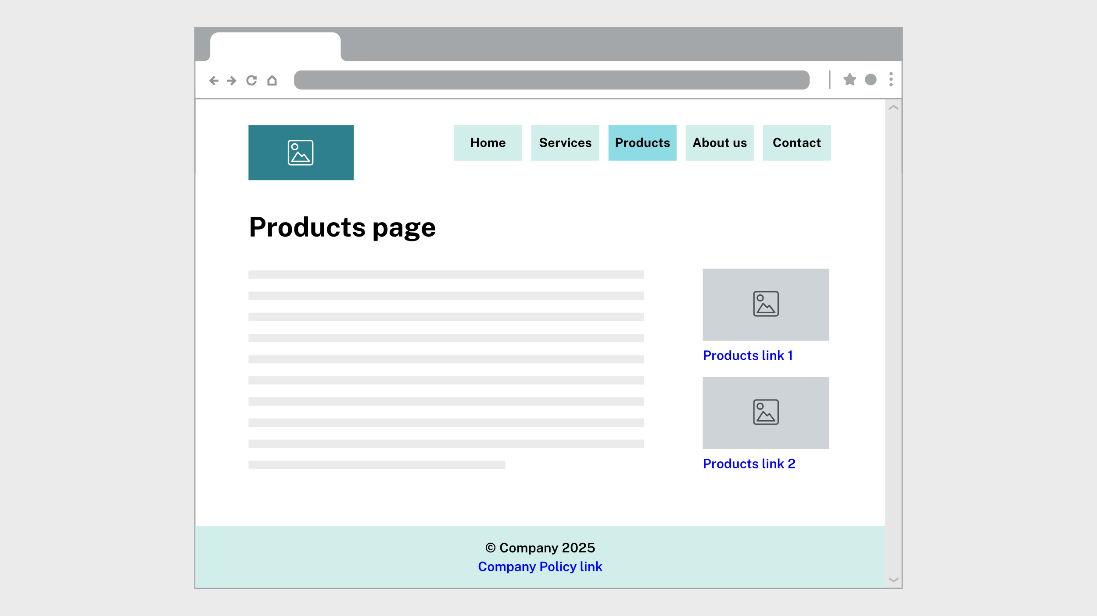
Figure 7: © Getty Images modified under licence

Using digital tools for creating wireframes
There are many types of digital tools that you can use to create wireframes. Some tools are free or have free options and some use paid subscriptions. Some common tools include:
- Figma
- Moqups
- Balsamiq.
Note: You may need to sign up for a free account and log in to use some tools.
Practice activity

Activity 6: Practise using digital tools for wireframes
Read the following basic instructions for creating sitemaps using Figma and Moqups. Use one or both tools to practise with.

Figma
- Go to Figma.
- Login with your TAFE email address.

Method 1
Create a new project:
- Select New Design File from your workspace.
- Rename it with your unit and project name.
Set up frames and grids:
- Press F to create a Frame for each page (for example, Desktop, Tablet, Mobile).
- To enable a grid:
  - Select the frame and in the right-hand sidebar, open the Layout Grid section and select the + icon.
  - Choose Grid, Columns, or Rows depending on your layout plan.
Add and label elements:
- Use R (Rectangle), T (Text), and / Line to create page structure.
- Add short notes for accessibility (for example, Image: beach banner with alt text 'Coastal cleanup').
Create reusable components:
- Select an element (like a button or navigation bar).
- Right-click Create Component.
Components can then be duplicated and reused across frames to ensure consistency.
Prototype navigation:
- Select the Prototype tab (top-right panel).
- Select a button and drag the blue arrow to another frame.
- Choose On click and navigate to under Interaction details.
This allows you to simulate how users move through your website.
Share and export:
- Select the blue Share button in the top-right corner.
- Under Link Sharing, select Anyone with the link can view.
- Use File > Export to download a PDF or PNG.

Method 2
Open a new design file:
- In the left sidebar, select Drafts.
- On the top right, select the Design button; a blank design file opens.
- At the top left, select Untitled and rename it with your unit and project name.
Add frames (pages of your wireframe):
- In the bottom toolbar, select the Frame tool (square icon with a dashed border).
- On the right sidebar, choose:
  - Desktop
  - Tablet
  - Mobile
- Repeat this for each frame you need.
Add a layout grid for aligning assets:
- Click or tap once on a frame to select it.
- In the right-hand sidebar, select Layout guide; the grid will display in the frame.
- Adjust the grid settings in the Layout guide panel:
  - Change the grid type (Grid, Columns, Rows).
  - Update size, count, gutter, or margin as needed.
Add assets to the wireframe to create structure:
- Open the Assets tab in the left sidebar.
- Select Browse team libraries to view available UI kits or organisation libraries.
- If a library contains components you need, enable it and drag items from the Assets panel onto your frame.
- For anything not provided by a library, use the bottom toolbar to add elements manually:
  - Rectangle for sections, placeholders and buttons
  - Text for labels and headings
  - Line for dividers.
Create a reusable component:
- Select the item you want to reuse (for example, a button, navigation bar, header, or footer).
  - In the top of the right sidebar, select Create Component (4 small dots in the shape of a diamond); if you don’t see it, select the ellipsis (…).
- The item will turn purple, indicating it's now a reusable component.
- To reuse the component, click and drag the component from the Assets panel on the left side bar onto your frame.
Wireframe navigation:
- In the right-hand panel, select the Prototype tab.
- Select a button or link area.
- A blue interaction handle appears; drag it to the frame it should navigate to.
- In Interaction details, set:
  - Trigger: On click
  - Action: Navigate to.
- After adding your interactions, go to the top-right corner of Figma and select the Present button (the triangle icon).
To export your wireframes as images
- Go to File > Export in the top left drop down menu.
- Choose PNG or PDF.
- Select Export.

Moqups
- Go to Moqups and select Create New Project.
- Use Stencils for headers, nav bars, cards and forms.
- Add multiple pages and link them with Interactions (right-hand panel).
- Add comments explaining each interaction.
- Export or share using the built-in link feature.
Practice activity

Activity 7: Create a wireframe
Continue with the Scenario: Portfolio website you used in Activity 5: Create a site map.
For this task, use a suitable digital tool for creating wireframes, such as Figma or Moqups.
- Draw wireframes for your 3 main pages.
- Include these key design features:
  - Header: logo and navigation menu
  - Main content: image placeholders, text blocks
  - Footer: contact links or copyright
- Label sections (header, main, footer) to reflect semantic HTML.
- Apply Gelos design principles found in your analysis of the given Gelos Enterprises documentation.
Paste copies of your wireframes below.

Choosing a markup language
The key element in choosing an appropriate markup language is the purpose of the website, which depends on the user requirements. The main markup languages are HTML, XML and XHTML.
A markup language defines markup, or tags, that supplies structural and semantic information about the content of documents.
Programming and markup languages use syntax, which is the set of rules that define how code must be written and structured so the computer can understand it.

HTML
HTML is used to build and display web pages with text, images, video and other content.

Current standard
- HTML Living Standard, maintained by WHATWG.

Advantages
- Supported by all modern browsers
- Continuously updated
- Easy to learn and integrate with CSS and JavaScript
- Open and free to use

Disadvantages
- Static by itself so needs scripting for dynamic features
- Inconsistencies in older browsers may still appear
HTML code sample:
</head>
<body>
<h1>This is a heading</h1>
<p>Document content goes here.....</p>
</body>

XML (extensible markup language)
XML is used to store and share structured data between systems.

Current standard
- Maintained by the W3C.
- To check the current specification, visit Extensible Markup Language (XML) 1.0 (Fifth Edition).

Advantages
- Human readable and machine readable
- Custom tags can be created for specific data types
- Works across different systems and programming languages
- Tags describe data clearly, giving it meaning

Disadvantages
- Uses many tags which can make files large and harder to read
- Needs other tools such as CSS or XSLT for presentation
- Parsing can be slower than formats such as JSON
- Validation through DTD or XSD adds complexity
XML Code Sample (pre-defined tags are not used):
<booking>
<guest>Sarah Lee</guest>
<checkin>2025-10-25</checkin>
<checkout>2025-10-28</checkout>
<room>Deluxe Suite</room>
</booking>

XHTML (extensible hypertext markup language)
XHTML is a stricter XML-based version of HTML that enforces well-formed code.

Current standard
- XHTML 1.0, maintained by the W3C.
- To check the current specification, visit XHTML™ 1.0 The Extensible HyperText Markup Language (Second Edition).

Advantages
- Enforces cleaner and more consistent markup
- Compatible with XML tools

Disadvantages
- Stricter syntax can cause errors if tags are not properly closed
- Offers no practical advantage over modern HTML
Code sample (note XHTML in the DOCTYPE):
<!DOCTYPE html PUBLIC '-//W3C//DTD XHTML 1.1//EN’ 'http://www.w3.org/TR/xhtml11/DTD/xhtml11.dtd’>
<html xmlns='http://www.w3.org/1999/xhtml’>
<head>
<title>Title of document</title>
</head>
<body>
If you’re building a website that displays straightforward information including graphics, some animation and maybe some sound, you would use HTML.
Collaboration

Activity 8: Discuss markup languages to meet requirements
Discuss the following in your class, with colleagues or friends, or write down your thoughts.
Continue with the Scenario: Portfolio website.
- Which markup language do you think would be best to use for this website?
- How does it meet the website requirements?

Developing test plans
Another part of the initial web design process is developing a test plan that includes testing approaches and test cases. These will then need to be refined with the user to ensure that you have included all the ways that the website will be used.
A test plan ensures that your website functions correctly and meets the user requirements before launch. It outlines what will be tested, how testing will be performed and the expected results.

Applying testing approaches
There are several different approaches that can be taken when testing websites. You can use a variety of tools and techniques with each of these testing approaches. It's important to know about these tools and techniques so that you can write effective test cases.
Note: You may need to sign up for a free account and log in to use some tools.

Functionality
This includes checking for broken links, proper error messages and default field values.
Tools and techniques to test functionality include:
- manually selecting links
- manually entering valid and invalid data
- using a broken link checking tool like Deadlink Checker.

Compatibility
Does the website work consistently with different browsers, operating systems and devices (for example, mobiles, printers)? While web standards aim to ensure consistency, they can't guarantee identical behaviour across browsers and devices. Different browsers may run on different rendering engines and have different features, leading to different website behaviour. That's why it's so important to include cross-browser testing in your test plan.
Tools and techniques to test compatibility include:
- manually testing the website in different browsers
- using browser emulators such as:
  - LambdaTest Cross Browser Testing
  - Browserling
- using DevTools in a browser.
Resources
The following resources demonstrate how to use LambdaTest and Browserling for cross browser testing:
- Browserling Tutorial for Beginners
- Cross Browser Testing Quick Demo | How To Perform Cross Browser Testing With LambdaTest (YouTube, 2:16 min).
The following resources explain how to use DevTools in Microsoft Edge and Chrome for compatibility testing:
Microsoft Edge:
- Emulate mobile devices (Device Emulation)
- Emulate dual-screen and foldable devices
- Emulate and test other browsers.
Chrome:
- View a page in Device Mode (LinkedIn Learning, 2:17 min)
- Test a responsive design (LinkedIn Learning, 3:44 min)
- Emulate rendering on other devices (LinkedIn Learning, 4:12 min).
LinkedIn Learning videos will open in a new tab within your browser. You can access the full video by logging in with your TAFE NSW username and password. You can access a transcript of the video on the transcript tab within LinkedIn Learning. When you’re finished, simply close the tab and return to your course.

Usability
This is a type of test that can be carried out by test users who are like the target audience of the website. Things that should be checked include:
- spelling and grammatical errors in content
- content displays correctly, for example, images, tables, charts
- consistency between webpages
- correct navigation with website.

Interface
This is designed to test the interactions between the web server interfaces and the application server interfaces, for example, if the website uses a database.

Security
This includes checking for login bypasses and entry into the website with invalid login details.
Tools to test security include:
- HTTP Observatory (previously known as Mozilla Observatory)
- Sucuri.

Performance and load
This is particularly important for large websites, testing such things as response time, maximum number of users and crash recovery.
Tools to test performance and load include:
- PageSpeed Insights
- Lighthouse (integrated in Microsoft Edge and Chrome DevTools).
Resources
Access the page Lighthouse performance scoring to learn how to use Lighthouse for performance testing in Chrome.
Practice activity

Activity 9: Use testing tools
Try out some testing tools and techniques on a website. Open the TAFE NSW website in Microsoft Edge or Chrome, then complete the following steps.

Manual browser test
- Open the website in at least 2 different browsers (for example, Chrome, Firefox or Safari).
- Verify navigation, layout and functionality work in each.

Online browser emulators
- Go to one of the following sites and enter the website URL:
  - LambdaTest Cross Browser Testing
  - Browserling.
- Select different browsers and options, then review any differences.

Responsive-view in DevTools
- Open DevTools.
- Toggle the device toolbar (Ctrl + Shift + M).
- Select different device presets from the toolbar (for example, iPhone 12 Pro, iPad Air) and confirm the layout adapts without overflow or hidden content.

Analyse performance in Lighthouse
- Open DevTools and select Lighthouse.
- Select Performance (note the other categories you can test).
- Select Analyze page load and review scores and recommendations.

Developing test cases
A test case is a single, written test that checks whether one feature of your website works as expected.
Each test case includes:
- what is being tested (the feature or function)
- how the test will be performed (the steps to take and any data to use)
- what result is expected if the feature works correctly
Using effective test cases should confirm that your website is functional and error-free. They demonstrate to a client that you understand how the website’s functionality should behave in real use.
Here are some things you need to consider when developing your test cases:

Meeting user or client requirements
A set of specifications and requirements for your website should be agreed on between you and your client. Ensure that your test cases including validating the website against the requirements.
These requirements could include:
- the style or formatting of elements, such as text
- style guidelines to fit in with organisation branding
- the positions of elements on the page
- the structure of the page
- web browsers and devices that the web page must work on.

Meeting web standards
Your organisation or the client may specify that websites meet web standards, such as those for accessibility.

How to create a test case
Here's are some steps you can follow to create a test case:
- Identify the feature or requirement to test, for example, 'Navigation links must open the correct pages’. You can use this to create a short name describing the test case, for example, 'Check navigation menu’.
- Decide how to test it, for example, 'Click or tap each navigation link in the menu’.
- Write clear, repeatable steps, including data to be entered (if required), for example:
  - Open the homepage in 2 different browsers (for example, Chrome and Firefox).
  - Click or tap each menu link.
  - Check that the correct page opens each time.
- Describe the expected result, for example, 'Each link opens the correct page without errors’.
Organisations may have their own procedures for testing and documenting those test results so it’s important that you check this with your client.
Here's an example of a test plan with some test cases:
Table 2: Example test plan
Test ID | Test name | Summary | Expected result | Testing schedule (if applicable)
001 | Navigation menu | Check all links in the Navigation menu | Menu links open correct pages | Week 3
002 | Submit contact form correctly | Input all fields in the contact form with correct data and submit | Form sends data successfully | Week 4
003 | Submit contact form incorrect email | Input all fields in the contact form with incorrectly formatted email address and submit | Form displays error message about format of email address | Week 4
Resources
Read Test Cases Example for Web Application (Checklist) from Guru99 to learn about testing approaches and examples of test cases.
Practice activity

Activity 10: Create a test plan
Continue with the Scenario: Portfolio website.
Save the Gelos Software Test Report (docx). Record your test plan in Table 1 – Test Plan in the Planning section of the report, adding rows to the table as required.
- Think about what needs testing on your portfolio website. Consider the following testing approaches:
  - Functionality (for example, links, forms, buttons)
  - Design and layout (for example, alignment, images, responsiveness)
  - Accessibility (for example, keyboard use, colour contrast)
  - Compatibility (for example, browsers, devices).
- Create at least 5 test cases that cover different areas of your website. Include the following for each test case:
  - Test ID: A unique identifier (this could just be a sequential number).
  - Test name: A short, clear title (for example, 'Check Navigation Menu’).
  - Summary: Describe what to test and how (step-by-step).
  - Expected results: Describe what should happen if it works, such as, 'The Projects page opens’ (for a test on checking the Projects link).
  - Testing schedule: When or how often you’ll test (for example, 'Week 6’).

Working with users and clients
As a web developer, you may have to help your user or client understand what they want and how this can be achieved with a website. Effective communication skills help build trust, clarify goals, uncover hidden needs and prevent costly misunderstandings. Whether it’s asking the right questions, listening carefully, or accurately documenting requirements, strong interpersonal skills are just as important as technical knowledge in delivering a successful solution.

Using active listening
Active listening is a technique that improves communication between people. It demonstrates to the person speaking that you're interested and engaged with what they're saying.
The technique involves listening carefully and observing body language or other non-verbal cues, such as tone of voice. It also requires paraphrasing or summarising what the person has said.
A few ways you can use active listening include:
- nodding
- smiling
- occasionally using brief phrases such as okay, right, yes and uh huh
- using a friendly and engaged tone of voice
- making eye contact
- asking open questions
- encouraging the person to continue
- using positive body language, such as leaning towards the speaker.

Asking questions
You can use questions with users and clients to:
- explore possibilities, using what-if (or hypothetical) scenarios
- sort through a lot of information when they don’t get to the point
- clarify what they're saying
- help them plan or work out what to do next
- go deeper into the issue or problem
- confirm information.
When a web designer engages with a client, asking open-ended questions is essential for uncovering deeper insights into their goals, preferences and expectations.
Open questions (those that can't be answered with a simple 'yes' or 'no') encourage clients to share their vision, brand identity and user needs in detail. For example, instead of asking, 'Do you want a modern design?', a designer might ask, 'How would you describe the look and feel you want your website to convey?'. This approach invites the client to articulate their ideas, which helps the designer align the design with the client’s objectives.
Open questions also build trust and collaboration. They show that the designer values the client’s perspective and is committed to creating a tailored solution. Questions like 'What challenges are you hoping the website will solve?' or 'What kind of experience do you want visitors to have?' provide context beyond aesthetics, guiding decisions on functionality, navigation and content strategy. Ultimately, open-ended questioning leads to clearer communication, fewer revisions and a website that truly reflects the client’s vision.
Videos
Access the following videos to learn more skills for communicating with users and clients:
- Initial client discussions (LinkedIn Learning, 10:14 min)
- Active listening (LinkedIn Learning, 4:03 min)
- Ask powerful questions (LinkedIn Learning, 3:29 min).
LinkedIn Learning videos will open in a new tab within your browser. You can access the full video by logging in with your TAFE NSW username and password. You can access a transcript of the video on the transcript tab within LinkedIn Learning. When you’re finished, simply close the tab and return to your course.
Practice activity

Activity 11: Identify and refine work outcomes
Continue with the Scenario: Portfolio website.
Note that in this activity you'll need to discuss your:
- site map from Activity 5: Create a site map
- wireframe from Activity 7: Create a wireframe
- test plan from Activity 10: Create a test plan.
Practise discussing your work outcomes, website design and test plan with your supervisor. You’ll use AI technology to simulate the role of your supervisor.
Note: Using this app is optional. Alternatively, you may choose to practise with a colleague, friend, or family member.

Step 1: Access Pi
You’ll be using the app Pi.ai for this activity. Note that to talk to Pi.ai using your voice, you’ll need to install the Pi, Your Personal AI Assistant app on a mobile device. Follow the steps on the screen to create an account.
Tips:
- You can select different voices for Pi to use.
- You can interact with Pi with or without an account.
- Create an account so your conversation can be saved, enabling you to review and reflect on your communication skills later.

Step 2: Practise discussing
Practise having a discussion with your supervisor (played by Pi) to identify the work outcomes and refine the work you've completed. Make sure that you:
- ask open-ended questions to identify the work outcomes that you need to achieve
- confirm your understanding by paraphrasing and summarising
- use clear and detailed language to discuss and refine:
  - the sitemap and wireframes, including how you have used design principles
  - the test plan.
You may create a script or list some points of discussion before starting the practice if you need to.
Read this prompt to Pi to start the discussion:
Hi Pi, can you help me practise discussing a website I'm developing? You’ll play the role of my supervisor. I’ll ask you questions about the website requirements, discuss the website layout and design, and discuss the test plan I have developed. Please answer as if you’re my supervisor – I need you to help me refine the website design and test plan.
Here's the scenario: I'm an intern at Gelos Enterprises. You've asked me to design and build a portfolio website to showcase my skills and experience, which will help me practise.
The website requirements are to:
- include 3 main pages: Home, Projects and Contact
- apply a responsive layout that looks professional on desktop and mobile
- use the Gelos Style Guide fonts and colours
- include a working contact form
- follow Gelos Coding and Testing Guidelines.
At the end of the conversation, ask Pi for feedback on your communication skills:
Thanks Pi, please give me feedback on my performance, specifically whether I spoke clearly, asked effective open-ended questions and used active listening skills.
Reflect on your communication skills and think about how you could improve. You can repeat this activity as often as you need to.
Self-check

How did you go?
You have completed the lesson: Planning and designing a website. Check the boxes for the tasks you feel confident you can complete.
☐ I can review website requirements and other documentation.
☐ I can follow web design standards.
☐ I can create diagrams to define the website design.
☐ I can select a markup language to suit requirements.
☐ I can develop test plans, including testing approach and test cases.
☐ I can use active listening and ask questions to work with users and clients.
Assessment

Assessment 2 of 2: Project Part 1 and Part 2
As you have completed this lesson, you should be ready to complete Assessment 2 of 2: Project Part 1 and Part 2.
If your assessments are online, go to Assessments in the top menu and access the files.
Note: To access the entire assessment, you must download and save each part separately.

Lesson 2:
Creating website structure using HTML

Overview
HTML is the core language that gives structure and meaning to every webpage. You’ll learn how to use tags and attributes to define text, images and links and how each part of a webpage is organised into sections like the head and body.
Then, you’ll explore semantic elements such as <header>, <nav>, <main> and <footer> that make your code easier to read and help with accessibility and search visibility. You’ll also learn to build navigation menus, add images and create forms to collect information.
Finally, you’ll understand why correct syntax, structure and validation matter. Using the W3C Validator, you’ll check your pages for errors and ensure they meet web standards. These skills will give you a strong foundation for creating well-structured, accessible websites that are ready for styling and interactivity.
In this lesson, you will learn to:
- create web pages according to requirements
- structure web pages using basic HTML elements.

Setting up your IDE
An IDE is an integrated development environment. This is a software application that provides all the tools you need to write, test and debug programs in one place.
Collaboration

Activity 12: Discuss IDEs
Discuss the following in your class, with colleagues or friends, or write down your thoughts.
- Do you know some popular IDEs that are used for programming? What are they?
- Have you used any of these IDEs before? If so, what did you like or find challenging about them?

Installing VS Code
One of the most popular IDEs is Microsoft Visual Studio Code (VS Code), which supports many programming languages and includes built-in tools for editing, debugging and version control.
You are not required to use VS Code to complete the activities, however, this resource will provide references to VS Code tutorials.
To install VS Code, follow these steps:
- Go to Visual Studio Code on Windows.
- Follow the first 3 steps under Installation.
Once installed, open VS Code and add extensions to view your code in a browser:
- Select the Extensions icon.
- Use the Search option to find Live Server, then install.

Add HTML
Create your first HTML page in VS Code:
- Select File > Open Folder.
- In your file system, create a new folder and select it.
- Select the New File icon next to the folder name (or right-click the folder and choose New File).
- Name the file index.html.
- In the html file, enter the following html script tags:
<html>
<head>
<title>My First Web Page</title>
</head>
<body>
<h1>Welcome to My First Web Page</h1>
<p>This is an HTML page I created in VS Code</p>
</body>
</html>
- Right-click the file and select Open with Live Server.
- Save your file File > Save All.
Your default browser will open and display the page. Changes you make in VS Code will auto-reload in the browser.

Using browser DevTools for inspecting elements
You've already used DevTools in a browser to check things like accessibility and performance. DevTools will also help you to inspect and debug your web pages.
To inspect HTML elements:
- Open a website in Microsoft Edge or Chrome and open DevTools.
- Inspect HTML and CSS for the page elements in the Elements panel using one of the following methods:
  - Right-click on any element on the page (for example, the heading) and select Inspect from the context menu.
  - Select the Elements tab and move through the code in the Elements panel.
- Use the Styles pane to tweak CSS and see changes immediately.

HTML document structure
As you previously learned, HTML is a markup language – a high-level set of rules used for describing the content of web pages.
Resources
Read What On Earth Is Semantic Markup? (And Why Should You Learn To Write It) to gain a better understanding of semantic markup.

Elements
HTML includes element types that represent paragraphs, hypertext links, lists, tables and images.
An element has a start tag, content and an end tag. An element’s name appears in the start tag and the end tag.
The coding pattern is as follows:
<tag attribute="value">text content</tag>
- Tags are surrounded by angle brackets. They are generally in lower case but can be a combination of any case.
- The attribute value should be enclosed by quotes. If the value includes a space, then it must be enclosed by quotes.
- A closing tag is generally required (the tag is prefaced by a slash) although some elements are empty (for example, img, br).

Attributes
Elements can have associated properties, called attributes.
HTML Attributes give extra information about an element; they change how the element behaves or looks. Think of them as instructions you give to the browser about that tag.
An attribute has 2 parts:
- Attribute name identifies the property of the element (for example, src, alt, href, id).
- Attribute value defines the value of that property (written in quotes).
Here is an example:
<a href="https://www.tafensw.edu.au">Visit TAFE NSW</a>
In this example:
- href (hypertext reference) is the name of the attribute. It tells the browser where a link should go when someone selects it.
- "https://www.tafensw.edu.au" is the attribute value. It gives the web address of the page to open.

File paths
Attributes can include file paths to other files, such as images or linked pages. A file path tells the browser where to find the file in relation to the HTML document you’re working in.
Use relative paths when linking to files stored within your project folders.
If the file is in the same folder as your HTML file, use the file name only:
src="beach.jpg"
If the file is in a subfolder, include the folder name:
src="images/beach.jpg"
To go up one folder, add ../ before the file name:
src="../beach.jpg"
To go up one folder and into another, combine them:
src="../photos/beach.jpg"
Collaboration

Activity 13: Discuss attributes
Discuss the following in your class, with colleagues or friends, or write down your thoughts.
Think about how the href and src attributes work.
- Can you explain the difference between them?
- When would you use each type?

Rules of HTML
When naming HTML files:
- Make sure you include the suffix .html.
- the home page is always called index.html.
- Use meaningful names for other pages, for example, products.html, not page1.html.
- Never use spaces; instead, run the words together, or use underscores or hyphens, for example, mypage.html, my_page.html.
- Use only lowercase, alphabetic and numeric characters.
When writing HTML:
- HTML is not case sensitive however it’s best to use lowercase only (as recommended by the W3C).
- HTML is only sensitive to a single white space character in content, not multiple spaces, carriage returns or tabs. To add additional white space, you can use &nbsp for each space however be aware that it’s poor practice to layout content using spaces.
- HTML elements must nest (open and close in the correct order), for example:
<center><strong>text to be displayed</strong></center>
- Use US spelling, for example:
  - center, not centre
  - color, not colour.
Resources
Read the HTML Style Guide at W3Schools for the coding conventions and syntax for HTML.
Use the following reference guides for predefined elements and attributes:
- HTML Element Reference
- HTML Attribute Reference.

Main sections of HTML
There are 3 main sections to an HTML file.

DOCTYPE
- This is the Document Type Declaration (DTD).
- Must be the first line in every HTML document.
- It tells the browser which version of HTML the page uses.
- It also allows you to validate the document against that standard.

Head
- This contains information about the page
- The head section tells the browser how to handle and display the page’s content.
- It includes:
  - the title element, which is unique for every page and shown on the browser tab; it also helps with search engine optimisation (SEO)
  - <meta> tags, which define the character set, viewport, author and include a short description of the page
  - <link> tags, which connect external CSS or icons
  - <script> tags, which link external JavaScript files.

Body
- This is the visible content of the page.
- Everything inside the <body> tags displays in the browser window.
- Content should be well-structured and use semantic elements correctly.
- Common semantic elements include:
  - <header> top section (logo or navigation)
  - <main> main content of the page
  - <footer> bottom section (contact details, copyright).
Here's an example of the main sections:
<!DOCTYPE html>
<html>
<head>
<title>My Webpage</title>
<meta>
<link>
<script></script>
</head>
<body>
<header></header>
<main></main>
<footer></footer>
</body>
</html>
Practice activity

Activity 14: Create an HTML template file
Continue with the Scenario: Portfolio website.
Create a reusable HTML template that includes standard structural elements. You can reuse this template for other pages that you create to keep sections consistent.
- Open VS Code or the IDE you're using.
- From the menu, select File > Open Folder > New Folder. Name the folder 'Templates'.
- Click Select Folder to open it in VS Code.
- In the Explorer panel on the left, select New File.
- Type in template.html and press Enter.
- Type the basic structure for an HTML page manually:
  - Type the DOCTYPE declaration on the first line:
<!DOCTYPE html>
  - Add the opening and closing <html> tags. Everything else will go between these tags.
  - Inside the <html> element, add an indent (press the Tab key) to show nested content. Create 2 main sections:
    - <head> for information about the page
    - <body> for visible content
  - Inside the <head> element, add another indent and include the following (add your own page title):
<meta charset='UTF-8'>
<meta name='viewport' content='width=device-width, initial-scale=1.0'>
<title> meaningful page title (for example, 'Template Page') </title>
  - Inside the <body> element, add another indent and include the following semantic elements:
    - <header>
    - <main>
    - <footer>
  - Ensure all tags are opened and closed correctly and indentation clearly shows nesting.
- Select File > Save or press Ctrl+S to save your work.

Semantic elements
Semantic elements describe the purpose of each part of a webpage. They help browsers and screen readers understand the page structure, improving accessibility and how search engines interpret content.
Accessibility: Screen readers use semantic tags to navigate pages more efficiently, for example, jumping to <main>, identifying <nav> as the menu, or moving between <article> and <section>.
SEO: Search engines use semantic tags to understand webpage structure. Correct use of elements like <header>, <main> and <article> helps them index content accurately and display pages more effectively in search results.
Common semantic elements include:
- <header> contains the site name, logo, or top navigation.
- <nav> contains the main navigation links (sometimes found in the header).
- <main> holds the main page content. Inside this, you might include:
  - <section> groups related content.
  - <article> holds standalone content, such as a blog post or news story.
  - <aside> holds related or side content, such as links or ads. Note: This element requires CSS to visually move it to the side.
- <footer> appears at the bottom of a page or section and often includes contact details or copyright information.
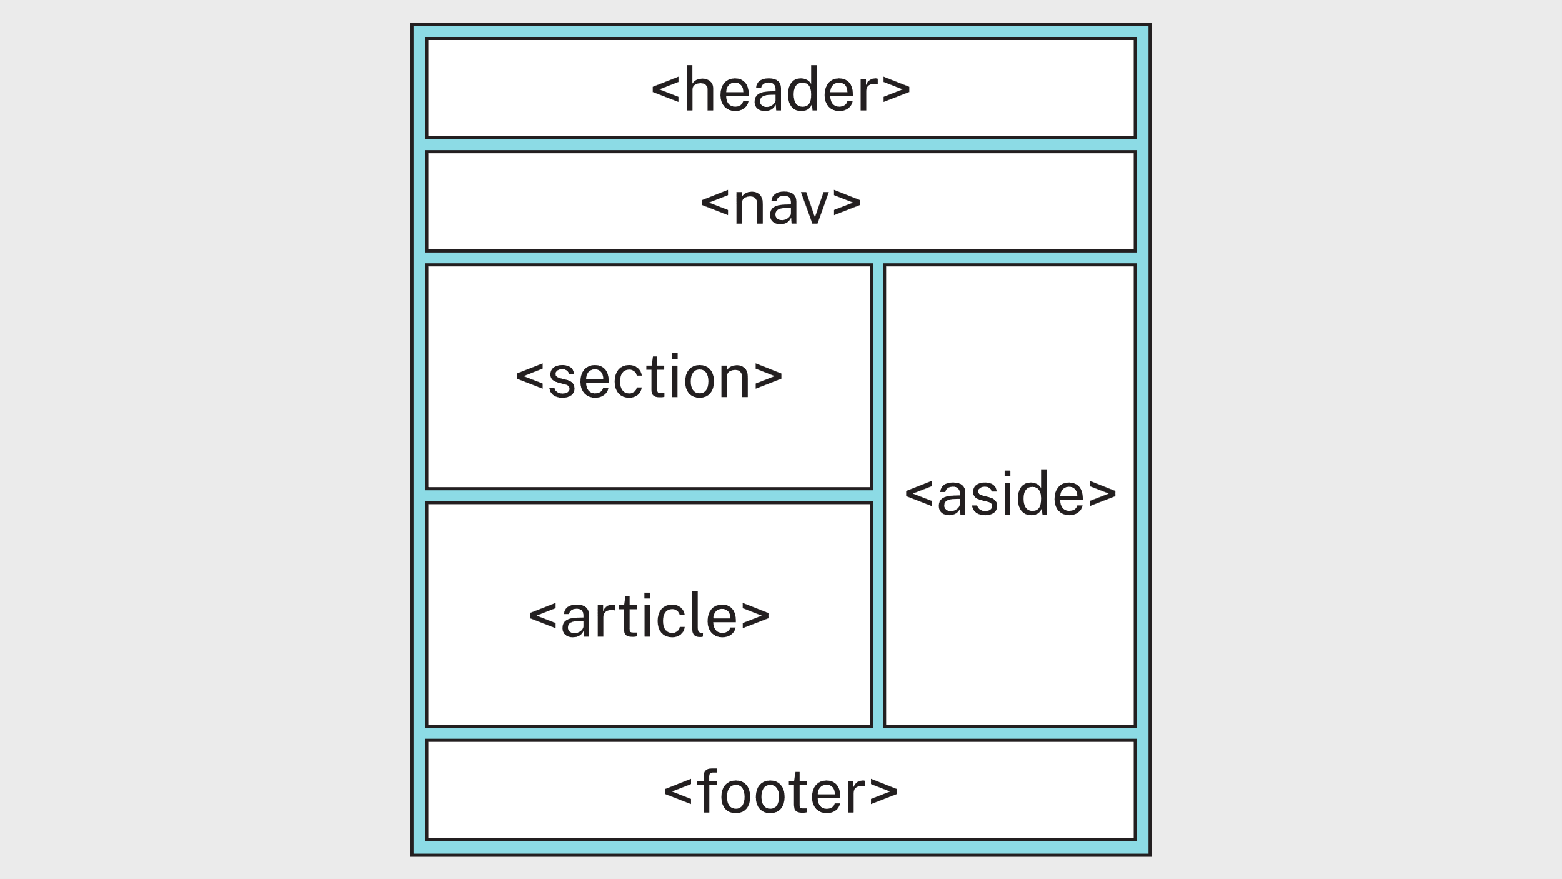
Figure 8: © TAFE NSW 2025
Not all semantic elements need to be used on every page; use only those that suit your layout and content.
Sometimes a semantic element doesn't fit where you need a container to group elements. In these cases, a <div> can be used, but a semantic element should always be used first whenever one is appropriate.
Video
The video Semantic HTML and Accessibility (LinkedIn Learning, 1:50 min) discusses the importance of semantic elements:
LinkedIn Learning videos will open in a new tab within your browser. You can access the full video by logging in with your TAFE NSW username and password. You can access a transcript of the video on the transcript tab within LinkedIn Learning. When you’re finished, simply close the tab and return to your course.

Headings
Headings define the outline of a page, like headings in a report. They help users and search engines understand the structure of your content.
- h1 is the main heading for the page. Use one h1 per page.
- h2 to h6 are subheadings. Use them to show sections and subsections.
Headings are for structure, not style. Don't choose a heading level based on its appearance; use CSS to style headings instead.
For example:
<h1>About Me</h1>
<h2>Skills</h2>
<h3>Front-end Development</h3>
<h3>Back-end Development</h3>
<h2>Experience</h2>
This heading structure creates a clear hierarchy that screen readers and search engines can easily follow.

Hyperlinks
Links connect one page to another page or to a resource. The anchor element <a> uses the href attribute to tell the browser where to go.
For example:
<a href="target.html">Link text</a>
href holds the destination, which could be:
- a placeholder, for example, #
- another page in your site, for example, projects.html
- a section on the same page, for example, #contact. Make sure the element you are linking to has a matching id attribute.
- an external site, for example, https://www.tafensw.edu.au.
While # can be used inside href to create a placeholder link, it's not required. By removing the href attribute, the anchor element becomes a placeholder link.
For example, these 2 statements are equivalent:
<a>Link text</a>
<a href="#">Link text</a>
The link text should be meaningful, for example ‘View project’ rather than ‘Click here’.
For example:
<a href="index.html">Home</a>
<a href="#contact">Skip to contact section</a>
<a href="https://www.tafensw.edu.au">Visit TAFE NSW</a>
Note: The <a> tag is called 'anchor' because it anchors a link to a specific destination.

Navigation
The navigation area, or menu, links main pages from the first and second tier of your sitemap, such as Home and Contact. Navigation is placed inside the <nav> element and built using a list:
- <ul> unordered list (bullets)
- <ol> ordered list (numbers)
- <li> list item
- <a> link (anchor)
<nav>
<ul>
<li><a href="index.html">Home</a></li>
<li><a href="contact.html">Contact</a></li>
</ul>
</nav>
In a browser, this will show a bulleted list of links. Later, CSS can be used to remove the bullets or numbers for a cleaner layout.

Images
Images are added using the <img> tag. This tag is self-closing, so it doesn't need an end tag.
The <img> tag uses attributes to define the image source and description:
- src is the file name or path to the image
- alt is short text shown if the image can't load or be seen (important for accessibility).
<img src="beach.jpg" alt="A sunny beach">
You can also add width and height attributes to set an image's initial display size, which can be scaled by CSS:
<img src="beach.jpg" alt="A sunny beach" width="300" height="200">

Tables
Tables are used to display information in rows and columns, like a spreadsheet.
Each table is built using these elements:
- <table> creates the table.
- <tr> table row.
- <th> table header (bold and centred by default).
- <td> table data (regular cells).
<table>
<tr>
<th>Department</th>
<th>Manager</th>
<th>Contact</th>
</tr>
<tr>
<td>IT Support</td>
<td>Bruce Wayne</td>
<td>0414 123 xxx</td>
</tr>
<tr>
<td>Finance</td>
<td>Robin Hood</td>
<td>robin@batman.com.au</td>
</tr>
<tr>
<td>Human Resources</td>
<td>Clark Kent</td>
<td>clark@superman.com.au</td>
</tr>
</table>
In a browser, this displays a table with 3 columns and 3 rows of data.
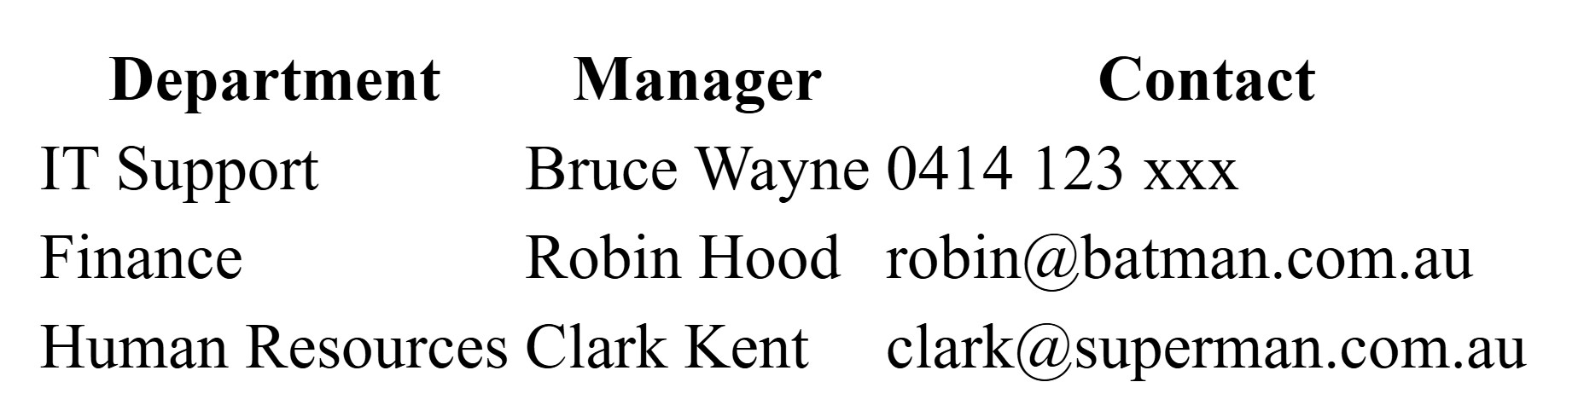
Figure 9: © TAFE NSW 2025

Forms
Forms are used to collect user input, such as names, emails, or feedback. The information entered in a form (by a user) can later be processed by a script written in a language like JavaScript, PHP, or Python.
Forms are created using the following elements:
- <form> wraps the form and includes the action attribute (the file or script that processes the data).
- <label> describes the input field for accessibility.
- <input> creates different input types such as text, email, password, radio, or submit.
- <br> adds a line break between fields.
Note: Ensure the label for attribute matches the input id. In this example, they're both "fname":
<label for="fname">
<input type="text" id="fname" … >
<form action="/action_page.php">
<label for="fname">First name:</label>
<input type="text" id="fname" placeholder="Bruce"><br>

<label for="lname">Last name:</label>
<input type="text" id="lname" placeholder="Wayne"><br>

<input type="submit" value="Submit">
</form>
HTML supports many input types, such as text, email, password, radio, checkbox, number, date and submit. For a list of input types, see HTML Input Types.

Textarea
Use <textarea> when users need to enter longer text, such as comments or feedback.
<label for="message">Message:</label><br>
<textarea id="message" placeholder="Enter message"></textarea>

Dropdown list
Use <select> and <option> to create a dropdown menu for users to choose from:
<label for="course">Choose a course:</label>
<select id="course" name="course">
<option value="web">Web Development</option>
<option value="python">Python Programming</option>
<option value="database">Database Design</option>
</select>

Troubleshooting and validating your HTML
It's important to troubleshoot errors and validate your HTML while building your website.

Troubleshooting errors
Troubleshooting and debugging allows you to catch errors early, preventing broken layouts or malfunctioning features.
Some troubleshooting methods you can use include the following:
- A simple thing to check is your syntax; these errors will generally be picked up by validators.
- To identify problem code, temporarily remove sections of code (html or css) and replace smaller parts of it until the error appears.
- Use the browser's DevTools to make temporary changes to code and check for missing styles and files.
- Clear the browser's cache to remove previous versions that may be stored and prevent conflicts with new code. Different browsers cache differently so this can help ensure that you're testing the same version across browsers.

Validating HTML
Validation checks your HTML code to make sure it follows web standards set by the W3C. It helps find errors such as missing tags, incorrect nesting, or invalid attributes.
Go to the W3C Markup Validation Service site and upload your code using one of the 3 following methods:
- Validate by URI
  - Enter the web address (URL) of your published webpage.
  - The validator will fetch and check the live page.
- Validate by File Upload
  - Upload your saved .html file from your computer.
  - Useful for testing pages before they’re published online.
- Validate by Direct Input
  - Copy and paste your HTML code directly into the text box.
  - Best for testing small sections of code or snippets.
Your aim is to have no errors or warnings, like the following screenshot:
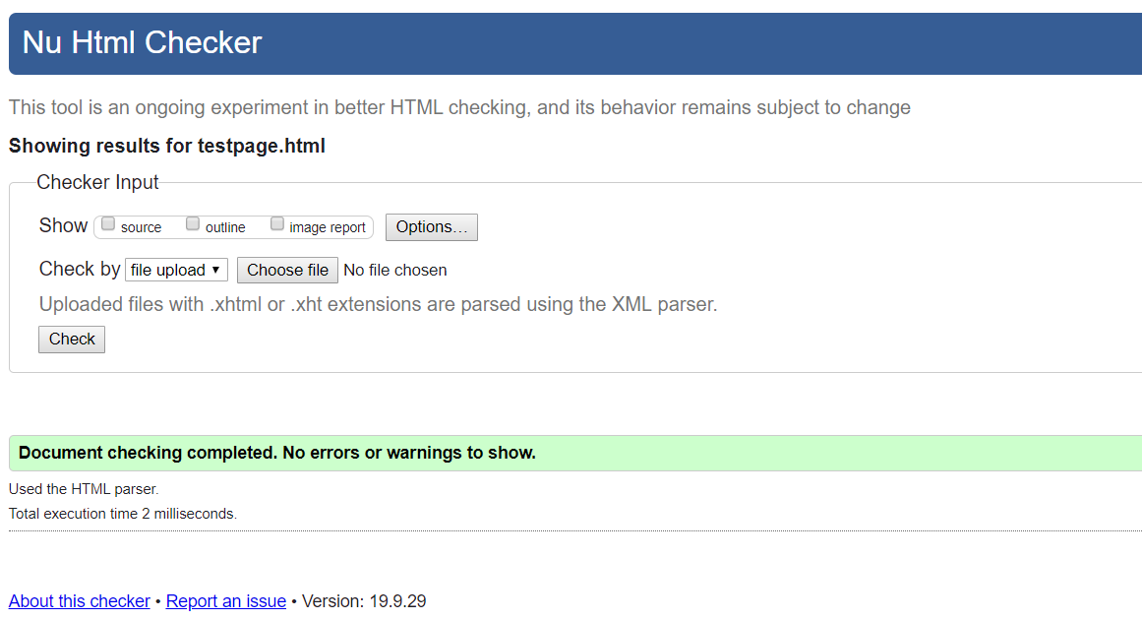
Figure 10: Valid website result
Resources
Read through the webpage Handling common HTML and CSS problems, which is a useful resource for troubleshooting.
Video
The video Debugging HTML (LinkedIn Learning, 3:13 min) demonstrates how to debug your HTML using browser DevTools.
LinkedIn Learning videos will open in a new tab within your browser. You can access the full video by logging in with your TAFE NSW username and password. You can access a transcript of the video on the transcript tab within LinkedIn Learning. When you’re finished, simply close the tab and return to your course.
Practice activity

Activity 15: Build the structure of your portfolio website
Continue with the Scenario: Portfolio website.
Note: You'll need to include some images and a placeholder logo in your portfolio.
For the portfolio images, you can use your own or go to a site like Pexels or Unsplash to find some free images. It's best if the image file size isn't too large, for example, width less than 1,000 pixels or file size less than 150 KB.
For the placeholder logo, you can find one at Logoipsum.

Create your pages
- Open your existing template.html file in VS Code.
- From the menu, select File > Open Folder > New Folder. Name the folder 'Portfolio_Project'.
- Click Select Folder to open it in VS Code.
- Save 3 new copies in your portfolio project folder:
  - index.html – Home page
  - projects.html – Projects page
  - contact.html – Contact page
- Ensure all files are saved in the same folder.
- Ensure all images are stored in the images folder.
Here's an example folder structure:
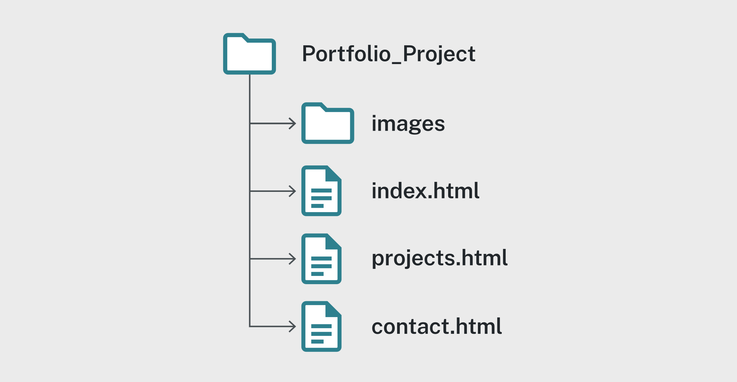
Figure 11: © TAFE NSW 2025

Add common header and navigation
Add the following elements inside the <header> section of your template.html.
- Insert the placeholder logo
  - Save the logo image as 'images/gelos-logo.png’.
  - Use meaningful alt text, for example, 'Gelos Enterprises logo'.
- Add a site title
  - Use a heading element (for example, <h1>My Portfolio</h1>).
- Add a navigation menu
  - Create a <nav> element with an unordered list (<ul>).
  - Add 3 links:
    - Home → index.html
    - Projects → projects.html
    - Contact → contact.html
  - Highlight the current page using an id or class.
- Add a footer placeholder
  - Create a <footer> element with the copyright year and your name, for example, © 2025 Your Name.
- Validate and test in your browser.
  - Ensure all links work.
  - Ensure the logo image displays correctly from the images folder.
Table 3: Tags for Header, Navigation and Footer
Semantics | Open tag | Content | Close tag
Header section | <header> | Holds the logo, title and navigation menu | </header>
Image | <img> | src='images/gelos-logo.png'  alt='Gelos Enterprises logo' | self-closing
Site title | <h1> | My Portfolio | </h1>
Navigation | <nav> | Contains navigation links | </nav>
List (unordered) | <ul> | Holds navigation list items | </ul>
List item | <li> | Each navigation link item | </li>
Link | <a> | Home, Projects, Contact | </a>
Footer | <footer> | Copyright and project note | </footer>

Add home page content (index.html)
Make a copy of the template and save it as index.html.
Add the following elements inside the <main> element:
- Add a major heading such as About Me.
- Add one or 2 paragraphs introducing yourself and your web development skills.
- Add a photo that represents your work (store it in the images folder, for example, images/portfolio-hero.jpg).
- Include:
  - alt text describing the image
  - optional title attribute.
- Save, validate and view in your browser.
Table 4: Tags for Home page content
Semantics | Open tag | Content | Close tag
Major heading | <h1> | About Me | </h1>
Paragraph | <p> | I am a web developer completing my internship at Gelos Enterprises. | </p>
Paragraph | <p> | I enjoy designing and coding responsive websites. | </p>
Image | <img> | src='images/portfolio-hero.jpg' alt='Portfolio image' | (self-closing)

Add projects page content (projects.html)
Make a copy of the template and save it as projects.html.
Inside the <main> element:
- Add a major heading such as Projects.
- Create a table to display placeholder project information.
- Include columns for Project, Type, Year and Link.
- Add 3–5 dummy projects. Each link should point to a placeholder (for example, #) and use meaningful text like View project.
- Validate and test in your browser.
Table 5: Tags for Projects page content
Semantics | Open tag | Content | Close tag
Major heading | <h1> | Projects | </h1>
Paragraph | <p> | Below are examples of my portfolio projects. | </p>
Table | <table> | Defines project information in tabular format | </table>
Table header row | <tr><th> | Project, Type, Year, Link | </th></tr>
Table data row | <tr><td> | Example project information | </td></tr>
Link | <a> | View project | </a>

Add contact page content (contact.html)
Make a copy of the template and save it as contact.html.
Inside the <main> element:
- Add a heading such as Contact Me.
- Add a paragraph explaining how users can reach you.
- Create a form with these fields:
  - Full Name (text input)
  - Email Address (email input)
  - Contact Reason (select with 3–4 options)
  - Message (textarea)
  - Submit button
- Ensure all inputs have a matching <label> with the correct for and id.
- Save and validate your file.
Table 6: Tags for Contact page content
Semantics | Open tag | Content | Close tag
Major heading | <h1> | Contact Me | </h1>
Paragraph | <p> | Please use the form below to send me a message. | </p>
Form | <form> | Holds all input fields and submit button | </form>
Label | <label> | Describes each input field | </label>
Text input | <input type='text'> | Full Name | self-closing
Email input | <input type='email'> | Email Address | self-closing
Select list | <select> | Contact Reason | </select>
Text area | <textarea> | Message | </textarea>
Submit button | <input type='submit'> | Send | (self-closing)

Validate and test
- Validate all pages using the W3C Validator.
- Fix any warnings or errors until each page passes.
- Open each page in a browser and test:
  - all navigation links work
  - all images display correctly from the images folder
  - the form fields are labelled and focusable.
- Ensure each page shares the same header and footer structure.
Self-check

How did you go?
You have completed the lesson: Creating website structure using HTML. Check the boxes for the tasks you feel confident you can complete.
☐ I can create web pages according to requirements.
☐ I can structure web pages using basic HTML elements.
Assessment

Assessment 2 of 2: Project Part 3
As you have completed this lesson, you should be ready to start Assessment 2 of 2: Project Part 3.
If your assessments are online, go to Assessments in the top menu and access the files.
Note: To access the entire assessment, you must download and save each part separately.

Lesson 3:
Styling websites using CSS

Overview
Picture a website stripped down to the essentials, just text and links, functional but lifeless. You can decide whether it feels sleek and modern, warm and inviting, or bold and vibrant. That’s the power of CSS; it’s the design language that transforms structure into style. With CSS, you can shift colours, adjust layouts and create a visual identity that feels entirely different, all without touching the content.
Understanding CSS is essential for transforming basic HTML into a visually engaging and accessible website. These skills will allow you to design layouts that are flexible, readable and consistent across all devices.
In this lesson, you will learn to:
- customise the style and layout of websites using CSS, according to user requirements
- apply consistent styling using CSS across multiple web pages.

Basic structure of CSS
CSS defines how web documents are presented – their style, layout and visual design. The same HTML can look different under different CSS rules or in different devices.
CSS controls visual details such as spacing, indentation, colours and fonts.

Anatomy of a CSS style
A CSS rule defines how HTML elements are styled. It includes:
- the Selector: this identifies which HTML elements to style (for example, p targets all paragraphs)
- the Declaration block: this is enclosed in curly braces { } and it contains one or more declarations separated by semicolons.

Selector
The selector is the HTML element, ID or class you want to style.

HTML element
This can be any HTML element. For example:
h1 {
font-size: 2em;
}

ID
ID selectors must be unique on a page. They're identified as a hash symbol (#) combined with the ID name. ID names can't start with a number. For example:
#blue-heading {
color: blue;
}

Class
A class selector lets you define a style that can be used for multiple elements. It's denoted by a full stop (.) at the beginning of the class name. For example:
.half-width {
width: 50vw;
}

Declaration
Each declaration has a property and a value separated by a colon:
selector {
property: value;
}
CSS properties define which visual aspect of an element is being styled. Each property has a value that sets how it should appear.
For example:
p {
color: blue;
margin: 20px;
}
In this example, color and margin are properties, while blue and 20px are values.

Units
Units define measurements used in CSS values, such as size, spacing and layout. They can be absolute (fixed) or relative (adjust to screen or parent size).
Here are some common units:
Table 7: Common units
Unit | Description
px | Fixed size, does not scale with screen or user settings.
em | Based on the font size of the parent element.
rem | Based on the font size of the root (<html>) element.
% | Based on the size of the parent element.
vw / vh | Based on viewport width or height (1vw = 1% of width, 1vh = 1% of height).
The following image compares CSS font size units:
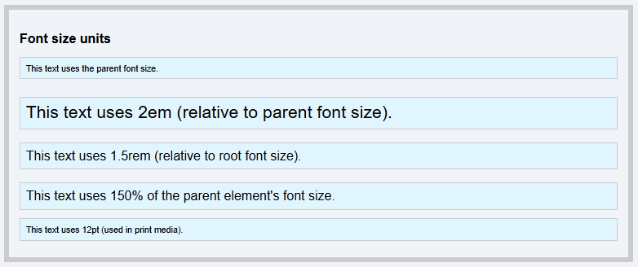
Figure 12: © TAFE NSW 2025
The following image compares CSS element size units:
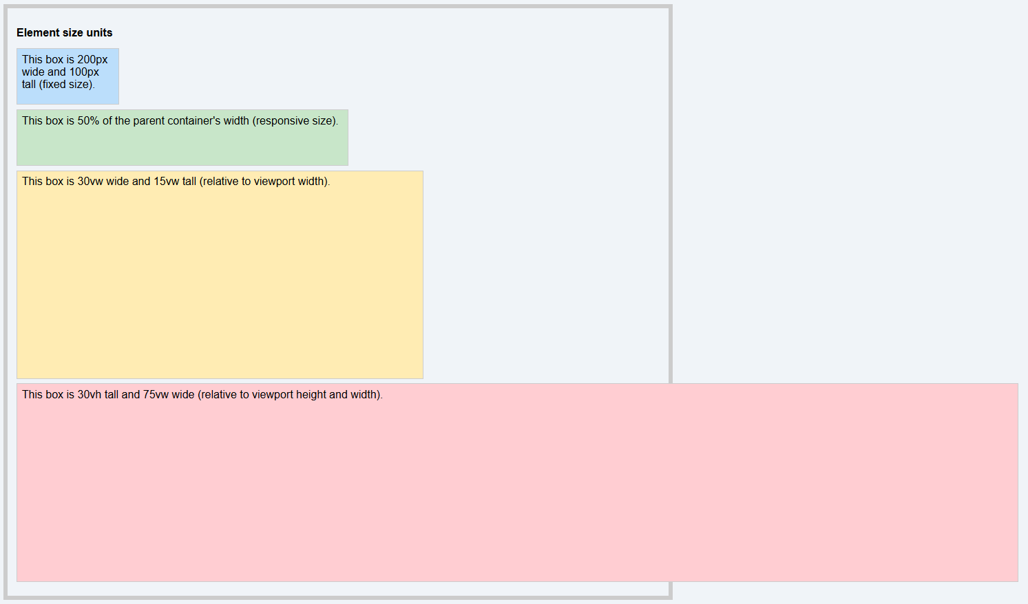
Figure 13: © TAFE NSW 2025
For example:
h1 {
font-size: 2rem;
width: 50vw;
}
Note: When designing responsive layouts, use relative units like %, em, rem, vw and vh instead of fixed px values.

Font hierarchy
A font-family rule often lists several fonts to ensure compatibility across devices.
For example:
body {
font-family: Helvetica, Calibri, Arial, sans-serif;
}
The browser displays the first available font in the list; this list is called a font stack.
If none of the listed fonts are available, the browser uses its default serif font (usually Times New Roman).
Fonts are separated by commas and may appear slightly different in size or spacing depending on the chosen typeface.

Pseudo classes
A pseudo-class defines a special state of an element. It lets you style elements based on user interaction or other conditions.
For example, pseudo-classes can:
- change a link's colour when hovered or visited
- highlight a form field when it gains focus
- apply a style to an element that is the first or last child.
The syntax of pseudo classes is:
selector:pseudo-class {
property: value;
}
The most common pseudo-classes are used on links:
/* unvisited link */
a:link {
color: #FF0000;
}

/* visited link */
a:visited {
color: #00FF00;
}

/* mouse over link */
a:hover {
color: #FF00FF;
}

/* selected (active) link */
a:active {
color: #0000FF;
}
Important: a:hover must come after a:link and a:visited in your CSS to work correctly.

Applying styles to elements
Element selectors, like h1 or p, apply automatically to all matching elements.
IDs and classes work differently from element selectors. IDs and classes must be added manually in HTML.
Remember:
- an ID must be unique on a webpage; it can only be used once on a webpage
- a class is reusable; it can be used on multiple elements on a webpage.
To apply an ID to your html, add id="IDName" to an element (where IDName is the name of the ID), for example:
<h2 id="blue-heading">This is a blue heading</h2>
To apply a class to your html, add class="className" to an element (where className is the name of the class), for example:
<p class="half-width">Here is some sample text</p>
You can apply more than one class to an element by separating each with a space inside the quotes:
<p class="half-width bg-blue">Here is some sample text</p>
Note that the hash (for IDs) and full stop (for classes) in the selector name are only shown in the CSS code. They're not used when applying the styles to your html.

Combinators
Combinators and grouping selectors define how elements are connected or grouped in HTML. Combinators define relationships between elements in HTML, including the following:
Table 8: HTML combinators
Symbol | Name | Example | Description
(space) | Descendant | article p | Targets all <p> elements inside an <article>, no matter how deeply nested.
> | Child | ul > li | Targets <li> elements that are direct children of a <ul>.
+ | Adjacent sibling | h2 + p | Targets the first <p> immediately after an <h2>.
~ | General sibling | h2 ~ p | Targets all <p> elements that appear after an <h2> on the same level.
The comma ( , ) groups multiple selectors so they share the same style rule:
h1, h2, h3 {
color: blue;
}
This applies the same colour to all 3 headings.
Resources
For a list of CSS properties, visit the W3Schools page CSS Reference.
Navigate to the CSS size units demonstration folder (located in the Activity files you saved and unzipped earlier). Open the index.html page and resize the window for a demonstration of how various units react to changes on a webpage.
Practice activity

Activity 16: Practise CSS at W3Schools
Work through the tutorials on the following pages on W3Schools. Use the 'Try it Yourself' examples to modify the code and select 'Run' to see the changes in action.
- CSS Tutorial
- CSS Introduction
- CSS Syntax
- CSS Selectors
- How To Add CSS
- CSS Comments
- CSS Errors.
Note: Bookmark W3Schools as a resource to refer to while building your website.

Applying CSS to HTML
The most common and efficient way to apply CSS to a site is by using an external style sheet. Other methods for applying CSS to HTML include inline and internal CSS.

External CSS
All the rules are stored in a separate text file with a .css suffix and linked to the HTML pages via a <link> tag in the <head> section of the document, for example:
<link rel="stylesheet" href="styles.css">
Here's an example of a style in an external CSS stylesheet:
p {
color: purple;
font-size: 18px;
}
Note: Using external style sheets is best practice for consistent, reusable design.

Inline CSS
By using the style attribute directly on the HTML elements you're trying to style. This is a poor way to apply CSS, as it removes some of its main advantages, such as easier maintenance and smaller file sizes.
<p style="color: blue; font-size: 18px;">This is inline styling.</p>

Internal CSS
Wrapping your CSS in <style> tags on each page. This can work for a single page website but, again, removes its advantages in the same way as inline.
<style>
p { color: green; font-size: 18px; }
</style>
</head>

The cascading order and rule priority
The word cascading in CSS refers to how the browser decides which styles to apply when there are multiple rules that could affect the same element. The 'cascade' is the decision-making process. If a more specific or higher-priority rule exists, it overrides the others. If not, the browser 'falls back' or cascades to the next applicable rule.
A web browser will give priority to style rules in the following order (from highest to lowest):
- Inline style
- Internal style
- External style
- Browser default.
Rules also have different levels of importance (from highest to lowest):
- Importance: The !important declaration is used only when necessary because it overrides all other rules in the file.
- Order of appearance: If 2 rules have the same specificity, the one written last in the .css file wins.
- Specificity: More specific selectors override general ones. Example: .intro overrides p because it targets a smaller group of elements.
Here's an example:
p {
color: blue;
}

.intro {
color: red;
}

p.intro {
color: green;
}

p.intro {
color: purple !important;
}
In this example:
- paragraphs with the class intro will appear purple because it includes !important, which overrides the other classes
- if you remove !important, the color: green rule will apply because it's more specific (by being in p.intro) than .intro or p.
Resources
To learn more about the priority rules of CSS, read the following W3Schools pages:
- How To Add CSS
- CSS The !important Rule
- CSS Specificity.
The CSS Zen Garden website shows how the same HTML file can be displayed differently by only adjusting the CSS.
To explore practical examples and learn new ways to apply your CSS skills, visit the W3schools How To page.
Practice activity

Activity 17: Create a CSS template
Continue with the Scenario: Portfolio website.
In this activity, you will create your first external CSS file and link it to your portfolio pages.
- Open VS Code or the IDE you're using.
- In your Portfolio_Project folder, create a new file named styles.css.
- Save the file in the same location as your HTML pages (index.html, projects.html and contact.html).
- Open each HTML page and link styles.css inside the <head> section.
- Open styles.css and write a style rule for the body element:
  - Add a font-family property with a font stack such as Helvetica, Calibri, Arial, sans-serif.
- Save all files and open each HTML page in your web browser.
- Check that the font on the page is no longer Times New Roman.
  - If you see a sans-serif font (without small decorative lines), your CSS file has been applied successfully.
- If the font hasn't changed, check that the link element in each HTML file correctly references styles.css.
- Validate your HTML files using the W3C Markup Validation Service.
- Validate your styles.css file using the W3C CSS Validation Service.
Collaboration

Activity 18: Compare your website
When you've finished Activity 17: Create a CSS template, compare your page with a website created by another student.
- Do they look the same?
- How can you tell if your CSS file is working correctly?

Understanding the CSS box model
Every HTML element is represented as a rectangular box in the page layout. The CSS Box Model describes how the size of each element is calculated and how it interacts with surrounding elements.
Each box has 4 layers, from the outside in:
- Margin: space outside the element's border
- Border: the outside edge of the element (visible or invisible)
- Padding: space between the content and the border
- Content: the element's actual text, image, or other content.
You can view these layers for any element using your browser's DevTools. In Chrome or Microsoft Edge:
- open DevTools
- select an element on the web page
- locate the visual box model diagram that shows the margin, border, padding and content values in pixels in the Computed tab.
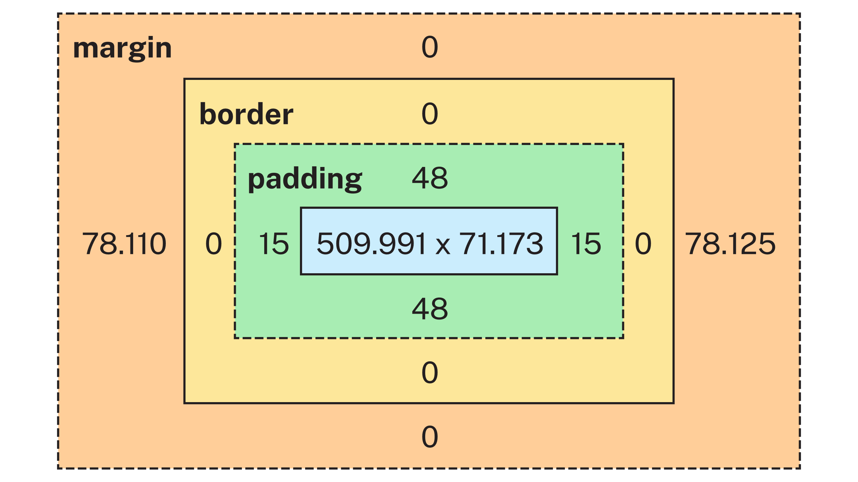
Figure 14: CSS box model with example values © TAFE NSW 2025
Take the following example property values applied to an element:
width: 900px;
padding: 10px;
border: 5px solid #cde;
margin: 10px;
To calculate the total width this element would take up on the page:
= width + left padding + right padding + left border + right border + left margin + right margin
= 900px + 10px + 10px + 5px + 5px + 10px +10px
= 950px.
Resources
To learn more about the CSS properties width, height, margin, padding and border, visit the following W3Schools pages:
- CSS Height, Width and Max-width
- CSS Borders
- CSS Margins
- CSS Padding.
Practice activity

Activity 19: Visualise the box model
In this activity, you will apply scalable CSS units to explore how the box model affects layout and spacing on a responsive webpage.
- Navigate to the Activity_Visualise the box model folder (located in the Activity files you saved and unzipped earlier) and open the styles.css file for editing.
- Add background colours to your elements to make their boundaries visible using the background-color property.
- Apply box model properties using relative or percentage-based units to maintain responsiveness.
- Experiment with the units learned earlier to apply to width, height, margin and so on.
- Open the index.html file and observe the effects in your browser as you resize the window.
  - Width and height adjust to screen size using % and vh (viewport height).
  - Margin and padding scale with font size using rem and em.
  - Border defines the element's outer edge.
- Open DevTools and inspect the element's box model diagram. Observe how each property changes as you resize the window.

Applying floats
The float property lets text and other content wrap around an element, which is like pictures moving within text in a Word document.
When you float an image left or right, the surrounding text adjusts to fill the space next to it.
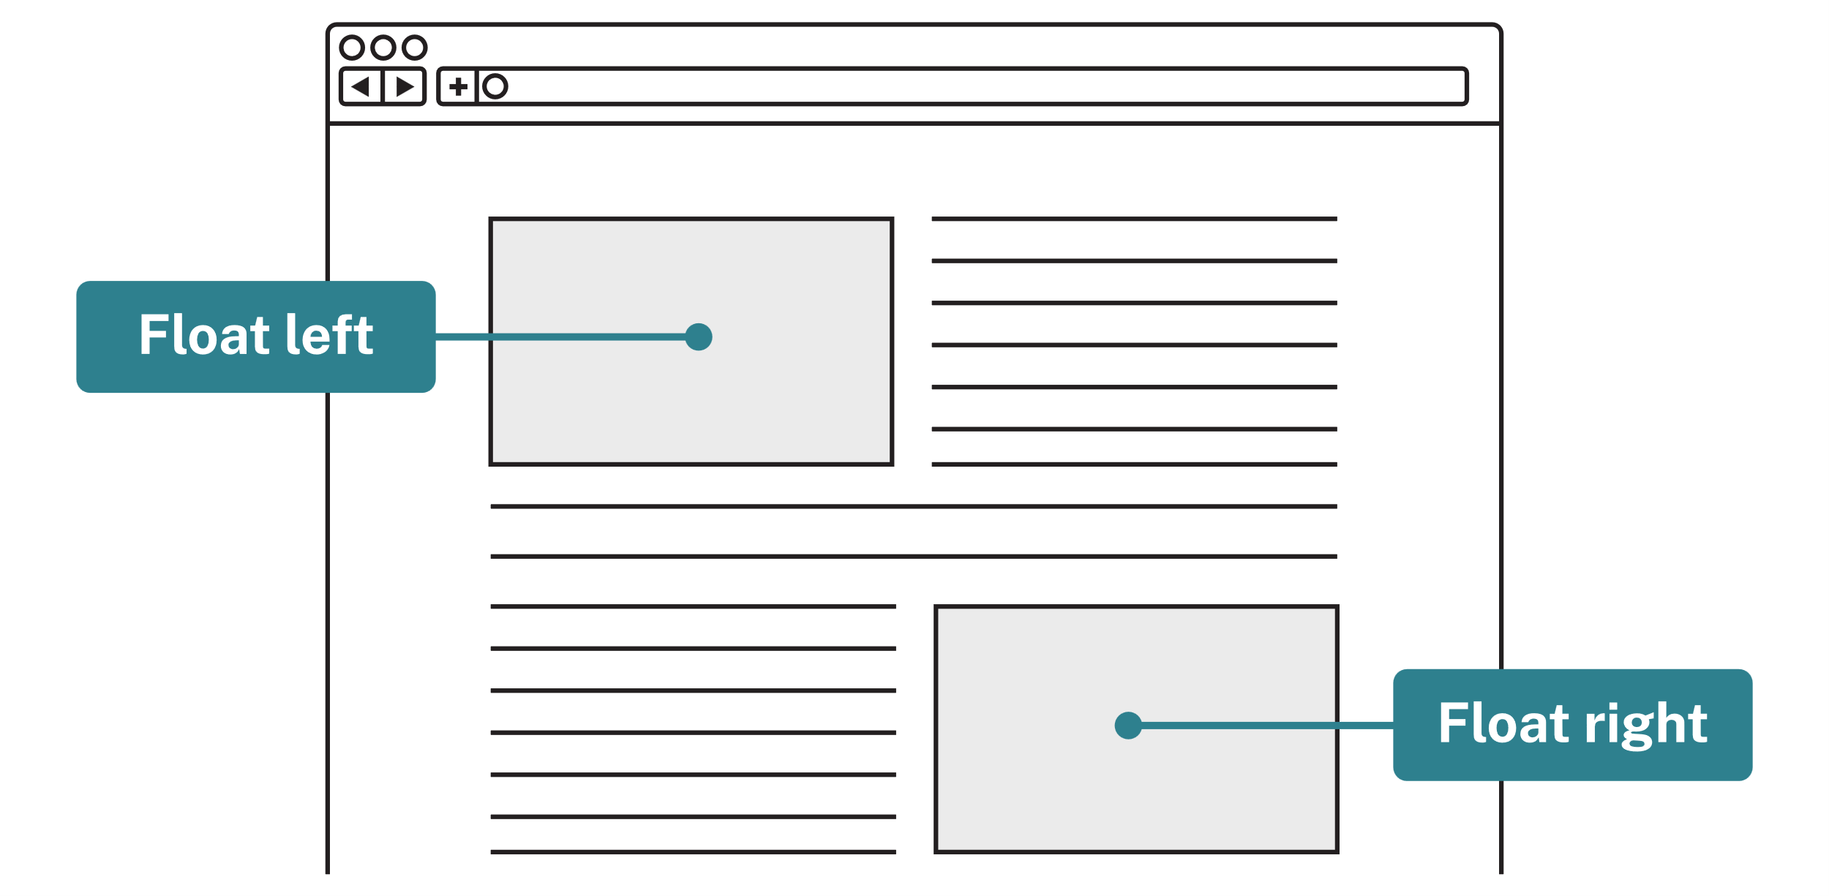
Figure 15: © TAFE NSW 2025
Note: Floats were made for wrapping text around images, not for arranging entire page layouts.
Modern layouts use Flexbox and Grid, which you'll learn about next.
Practice activity

Activity 20: Use floats
In this activity, you'll try out different floats to learn how they work.
- Go to W3Schools CSS Float.
- In the first example, select Try it Yourself.
- In the CSS panel, change the float property on the image to:
  - float: left and observe how the text wraps around the image.
  - float: none and observe how the text moves back below the image.

The display property
The CSS display property defines how an HTML element is displayed on the page, according to its value.
p {
display: value;
}

Block layouts
Block, inline and inline-block are basic layout options.
- block starts on a new line and takes the full width available.
- inline stays on the same line and only takes up the space of its content.
- inline-block stays on the same line but allows width and height to be set.
- none hides the element completely.
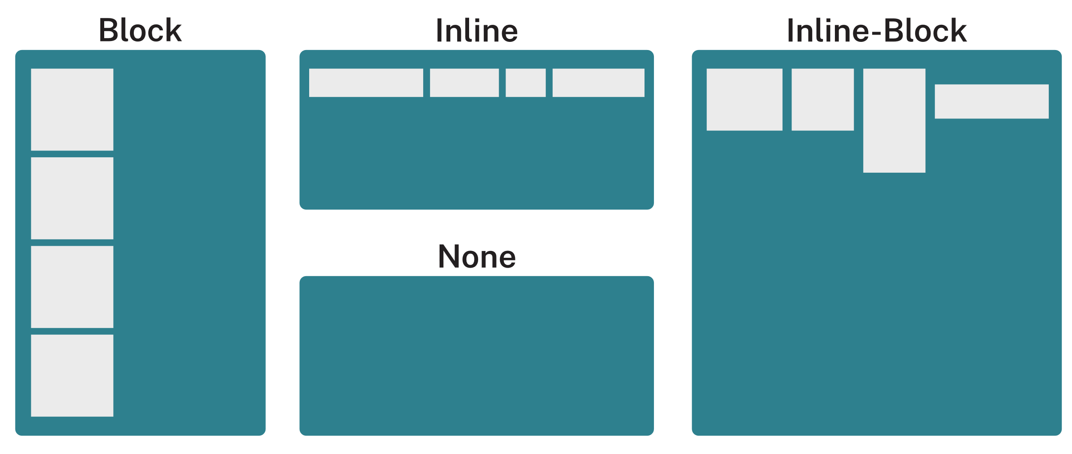
Figure 16: © TAFE NSW 2025
For example:
display: block

Flexbox
CSS Flexbox (Flexible Box Layout) is a CSS layout model that arranges the items inside a container along one direction, either a row or a column.
When you apply the CSS flex property to an HTML element:
- the element becomes a flex container
- its direct children become flex items that adjust automatically to fit the space.
display: flex;
The following table lists the common CSS Flex Container Properties:
Table 9: Flex properties
Property | Description | Values
flex-direction | Sets layout direction | row, column, row-reverse, column-reverse
justify-content | Aligns items along the main axis | flex-start, center, space-between
align-items | Aligns items along the cross axis | flex-start, center, flex-end
flex-wrap | Wraps to a new line when space runs out. | wrap, nowrap
flex-basis | Sets the starting size of a flex item | 35%, 200px
flex | Sets how much space an item takes | 1 for equal space  2 for double the space
The following image illustrates how the flex-direction property works:
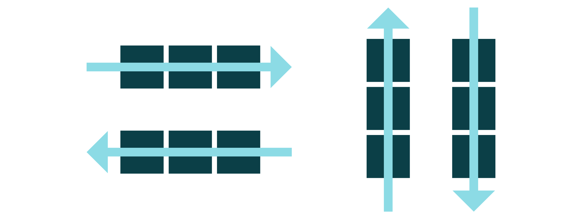
Figure 17: © TAFE NSW 2025

Centred elements
To centre an element, you can use the properties justify-content or align-items.
For example:
.container {
display: flex;
justify-content: center; /* centres horizontally */
align-items: center; /* centres vertically */
}

Two-column layouts
Flexbox can arrange boxes side-by-side and automatically wrap them to the next line when there's not enough space.
Here is some sample code for the HTML and CSS:

HTML
<div class="container">
<div class="box">Box 1</div>
<div class="box">Box 2</div>
<div class="box">Box 3</div>
<div class="box">Box 4</div>
</div>

CSS
.container {
display: flex; /* activates flexbox */
flex-wrap: wrap; /* allows boxes to move to a new row */
}

.box {
flex-basis: 45%; /* two boxes per row with room for spacing */
}
In this example:
- display: flex; arranges the boxes in a row
- flex-wrap: wrap; lets boxes move to a new line when they don't fit
- flex-basis: 45%; makes each box half the container's width (2 per row) with 10% leftover for spacing.
Note: Flexbox is best for one-dimensional layouts (rows or columns). For 2-dimensional layouts, use CSS Grid (in the next section).
Video
Access the video Flexbox Alignment Overview (LinkedIn Learning, 1:39 min) to learn more about the behaviour of the flexbox properties justify-content, align-items, align-content and align-self.
LinkedIn Learning videos will open in a new tab within your browser. You can access the full video by logging in with your TAFE NSW username and password. You can access a transcript of the video on the transcript tab within LinkedIn Learning. When you’re finished, simply close the tab and return to your course.
Practice activity

Activity 21: Convert a float layout to flexbox
In this activity, you'll convert a float layout to a flexbox layout.
- Navigate to the Activity_Convert a float layout to flexbox folder (located in the Activity files you saved and unzipped earlier) and open the styles.css file.
- In the CSS file, remove the float property from the layout.
- Use flexbox to position the elements in the same way as when they were floats.

Grid layout
CSS Grid Layout is a layout system that lets you arrange elements in rows and columns, like a spreadsheet.
It gives precise control over where each item appears on the page.
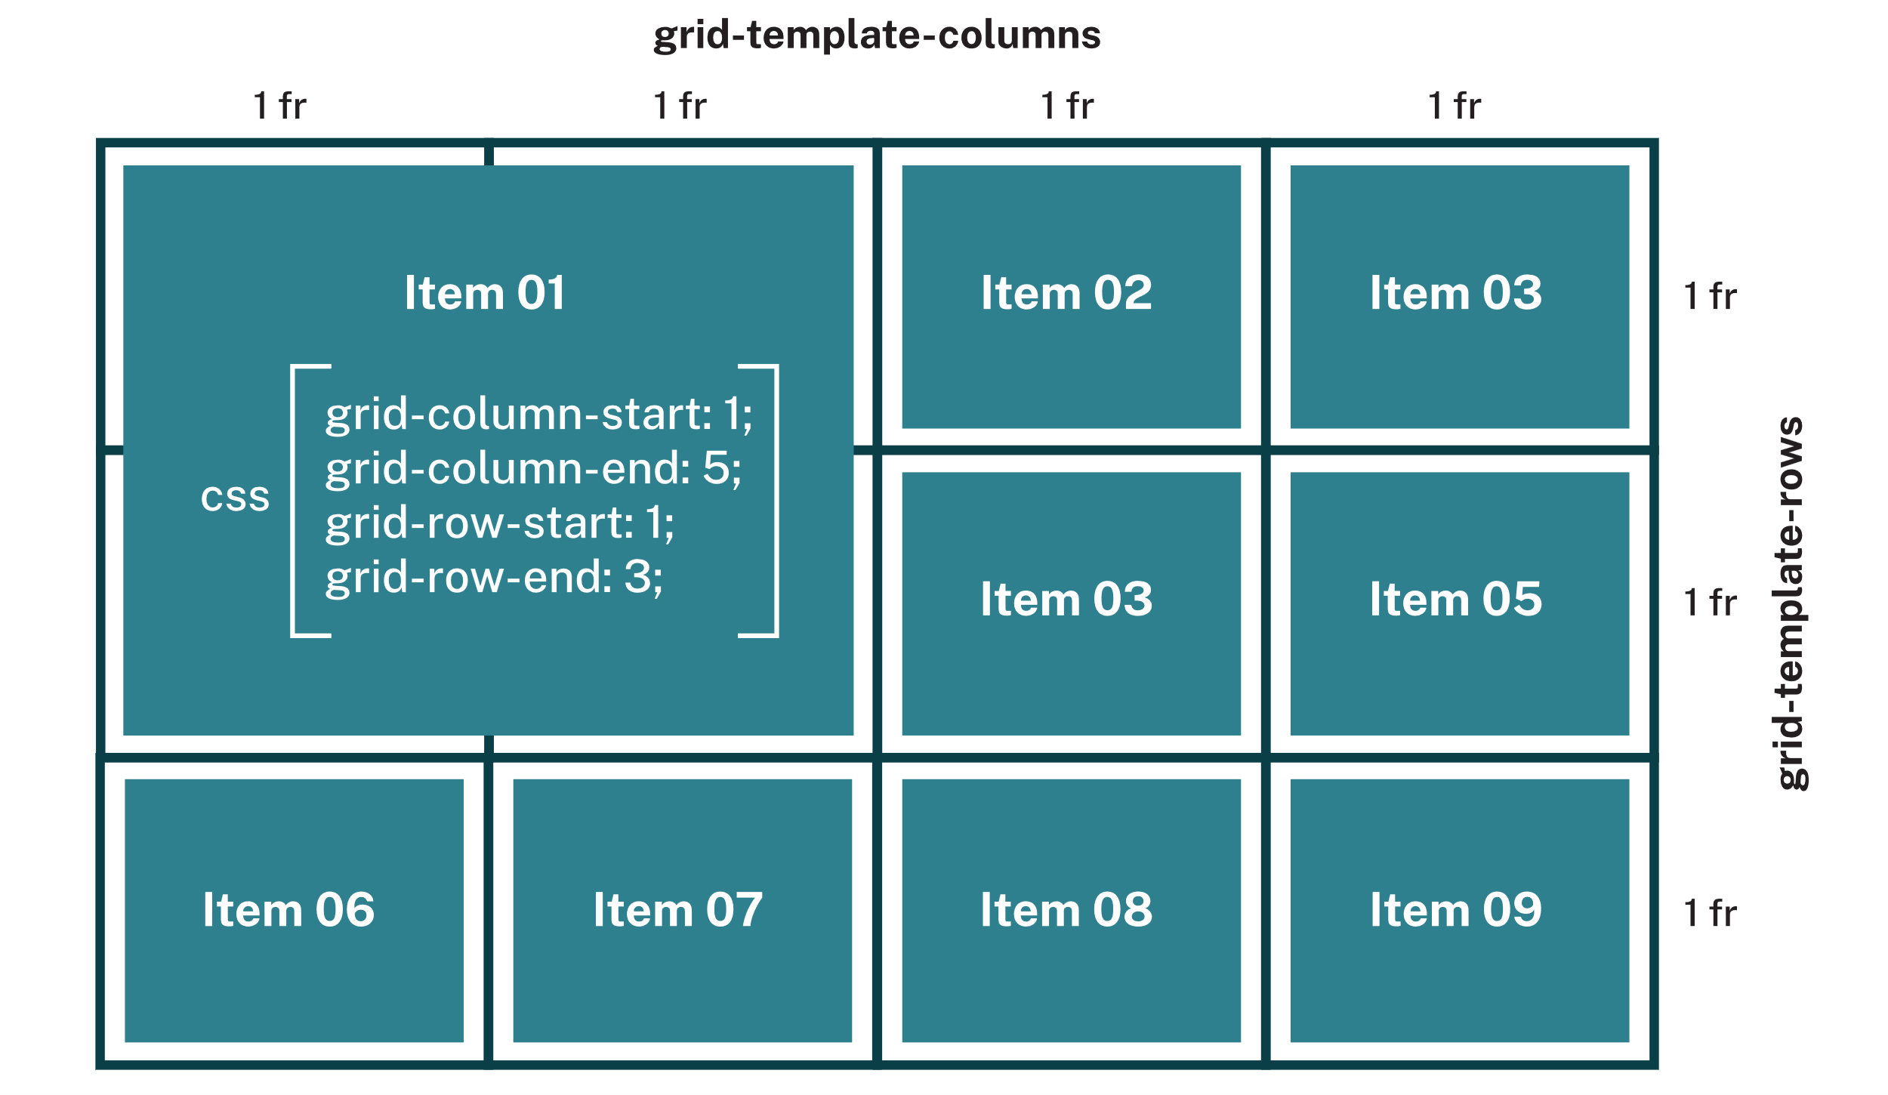
Figure 18: © TAFE NSW 2025
To turn an element into a grid container, use:
display: grid;
Here is some sample code for the CSS:
main {
display: grid;
grid-template-columns: repeat(3, 1fr);
grid-template-rows: repeat(2, 1fr);
}
In this example:
- display: grid; activates grid layout on the container
- grid-template-columns: defines the number and size of columns
- grid-template-rows: defines the number and size of rows.

The fraction unit
The fraction unit (fr) is unique to CSS Grid. It represents a portion of the remaining available space in the grid container.
- 1fr means one fraction of the available space.
- 1fr 2fr divides the space so the second column is twice as wide as the first.
- repeat(3, 1fr) creates 3 equal columns, each taking up one-third of the available space.
Note: Use fr when you want columns or rows to scale automatically with the container size.

Positioning items
Each grid item can be placed anywhere using start and end line properties:
.item1 {
grid-column-start: 1;
grid-column-end: 3;
grid-row-start: 1;
grid-row-end: 2;
}
In this example:
- start in column 1, end before column 3 (so it spans 2 columns)
- start in row 1, end before row 2 (so it spans one row).
Video
Access the video Grid Alignment Overview (LinkedIn Learning, 1:13 min) to learn more about the behaviour of the grid properties justify and align.
LinkedIn Learning videos will open in a new tab within your browser. You can access the full video by logging in with your TAFE NSW username and password. You can access a transcript of the video on the transcript tab within LinkedIn Learning. When you’re finished, simply close the tab and return to your course.
Resources
Refer to the W3Schools CSS Grid Items page to learn about the shorthand notation for positioning items in the grid.
Practice activity

Activity 22: Create a grid rainbow box
In this activity, you'll convert a float layout to a flexbox layout.
- Navigate to the Activity_Create a grid rainbow box folder (located in the Activity files you saved and unzipped earlier) and open the styles.css file.
- Update the CSS file to use a grid layout, so that the index.html page displays like the following image:
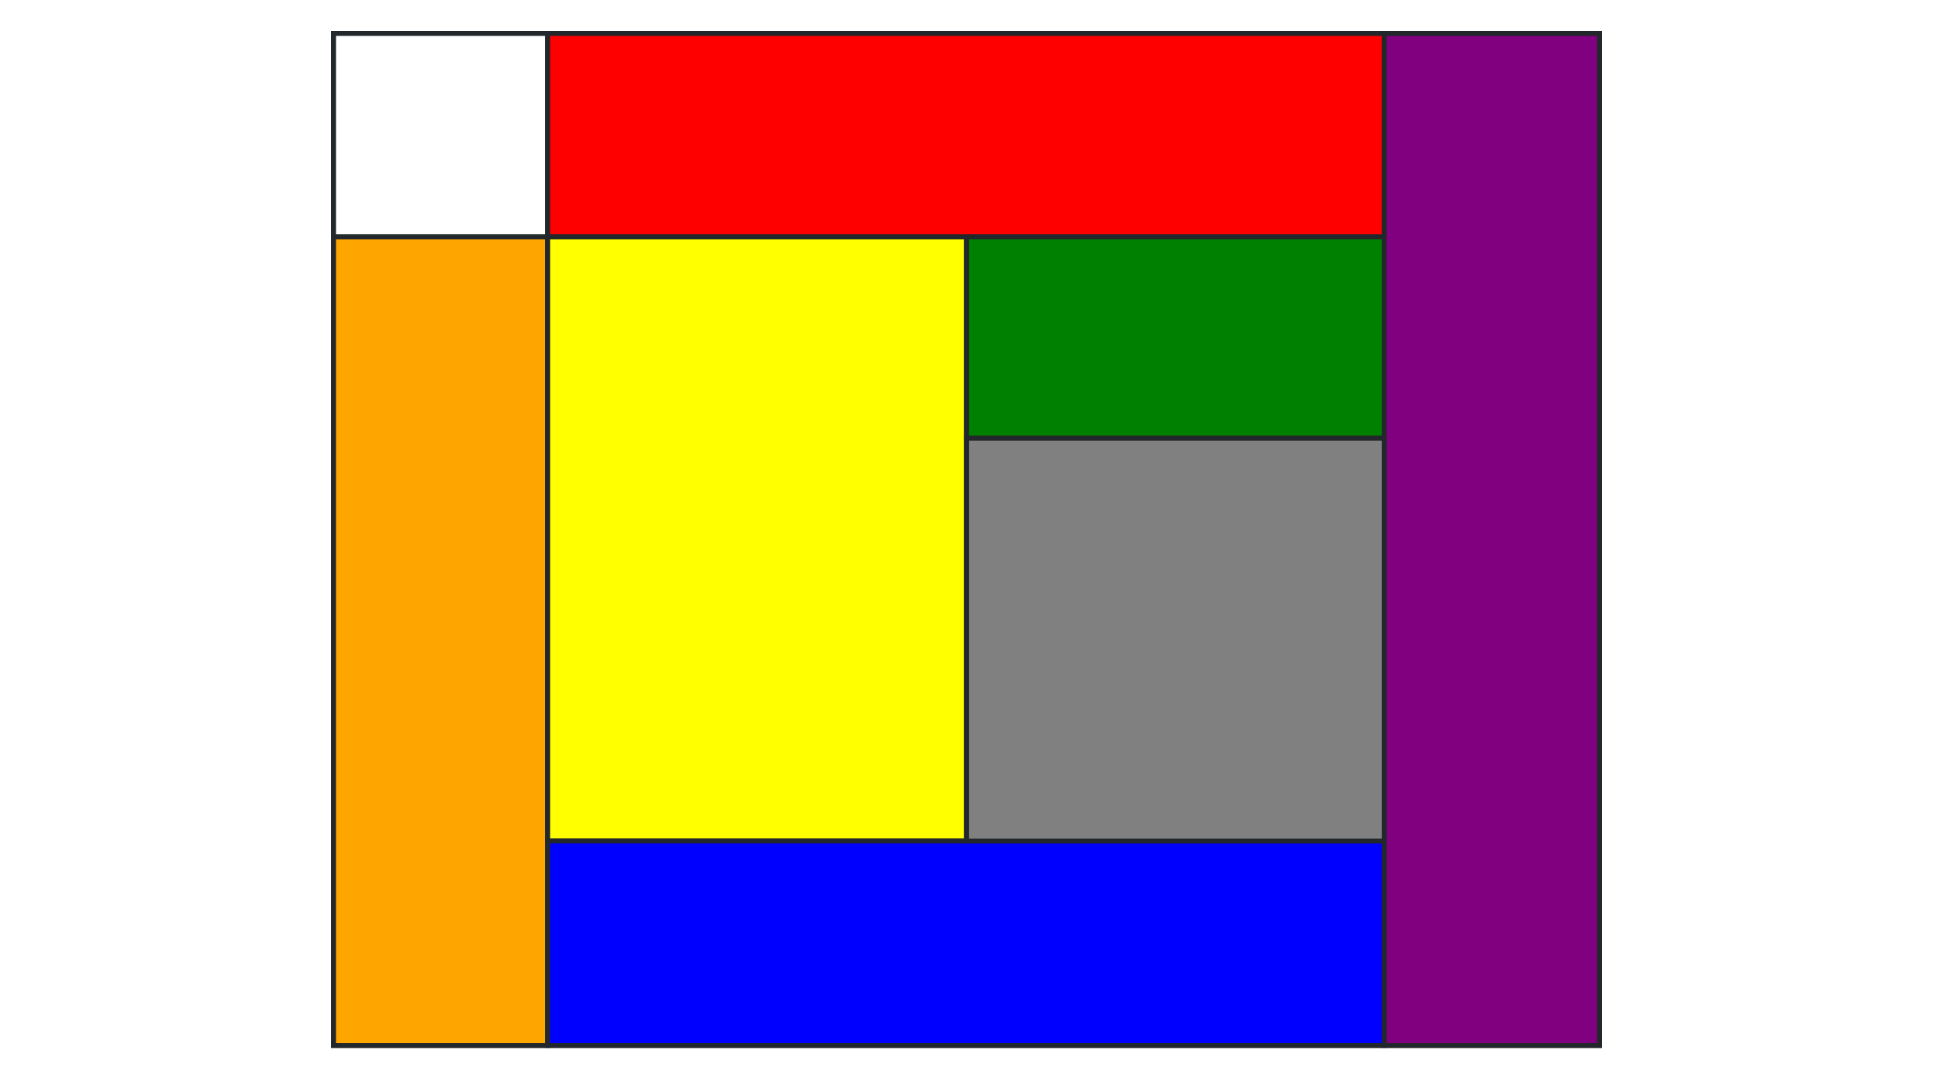
Figure 19: © TAFE NSW 2025

Viewing Flex and Grid containers in DevTools
To reveal Flex containers on a web page:
- Open DevTools in a browser.
- Select the Elements tab.
- Select the Layout tab.
- Check the relevant options under Flexbox overlays.
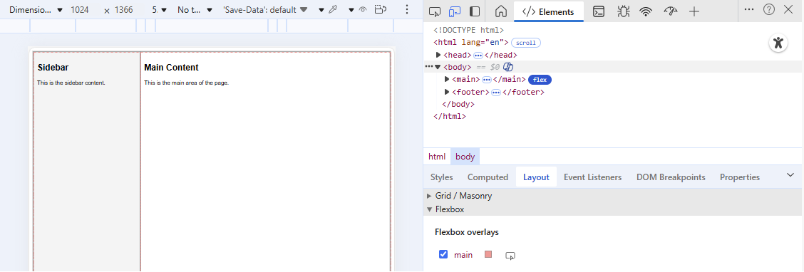
Figure 20: Used with permission from Microsoft
To reveal Grid containers on a web page:
- Open DevTools in a browser.
- Select the Elements tab.
- Select the Layout tab.
- Check the relevant options under Grid / Masonry > Overlay display settings and Grid / Masonry overlays.
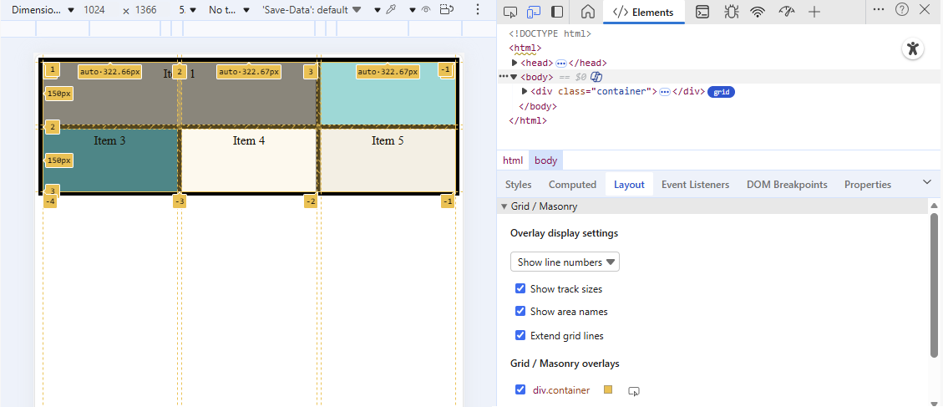
Figure 21: Used with permission from Microsoft
Resources
For a good comparison of the 2 most popular methods for laying out your web pages, spend some time going through the article CSS Grid vs. Flexbox: Which should you use and when?.
Video
To help your understanding of the Flexbox and Grid concept, access the video Grid vs. Flexbox (LinkedIn Learning, 5:31 min) for instructional animated diagrams.
LinkedIn Learning videos will open in a new tab within your browser. You can access the full video by logging in with your TAFE NSW username and password. You can access a transcript of the video on the transcript tab within LinkedIn Learning. When you’re finished, simply close the tab and return to your course.

The position property
The CSS position property defines how an element is placed on a webpage. It determines where an element appears relative to the page, its container, or the user's viewport.

Element stacking order
Something that relates to positioning elements is the z-index property, which controls the stacking order of elements (which one appears in front or behind).
- Elements with a higher z-index appear on top of those with lower values.
- A negative z-index places elements behind others.
Example:
z-index: 1; /* element displayed above */
z-index: -1; /* element displayed behind */
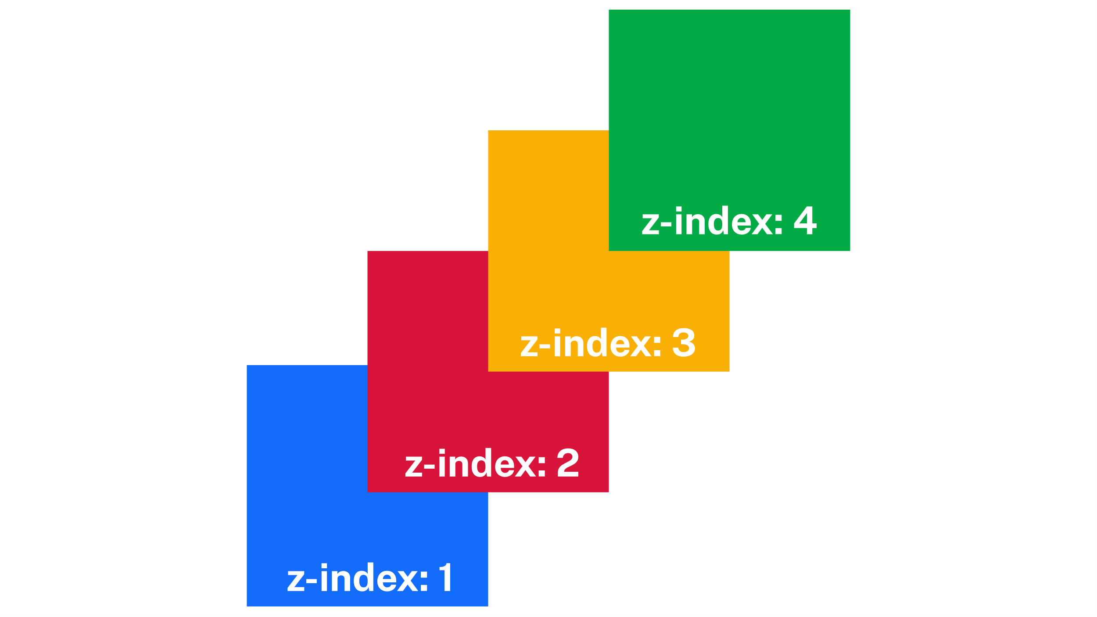
Figure 22: © TAFE NSW 2025

sticky
An element with position: sticky behaves normally until the page scrolls past its trigger point, then it stays fixed in place (usually at the top).
For example:
header {
position: sticky;
top: 0;
}

fixed
A fixed element stays in the same place, even when the page scrolls.
For example:
footer {
position: fixed;
bottom: 0;
}
Video
Access the video The position property (LinkedIn Learning, 5:07 min) to learn about all position property values, including relative and absolute.
LinkedIn Learning videos will open in a new tab within your browser. You can access the full video by logging in with your TAFE NSW username and password. You can access a transcript of the video on the transcript tab within LinkedIn Learning. When you’re finished, simply close the tab and return to your course.

Applying responsive design with CSS media queries
The @media rule is used for responsive design. It allows a webpage to change how it looks depending on the device being used.
Different devices (like phones, tablets, laptops and desktops) have different screen sizes and resolutions, so CSS media queries help make layouts fit each one properly.
For example:
- A desktop might have enough space to show a sidebar and large images.
- A tablet might need smaller fonts and fewer columns.
- A phone might hide side content and stack elements vertically for easier reading.
Here is an example of syntax:
@media screen and (max-width: 600px) {
/* CSS rules go here */
}
In this example:
- screen targets screen-based devices
- (max-width: 600px) applies the styles only when the device screen is 600 pixels wide or smaller, such as most smartphones.

Common uses
To change font size: In the following example, text becomes smaller on smaller screens.
@media screen and (max-width: 600px) {
body {
font-size: 14px;
}
}
To hide an element: In the following example, the sidebar is hidden on mobile screens.
@media screen and (max-width: 600px) {
.sidebar {
display: none;
}
}
Practice activity

Activity 23: Apply responsive design to a webpage
Create a simple webpage that changes colour and layout at different screen widths using @media.
- Create an HTML file with a foundational structure, including <head> and <body> sections.
- Create a style.css file using the following code:
body {
background-color: lightblue;
font-family: Arial, sans-serif;
text-align: centre;
}

/* Tablet */
@media (max-width: 1024px) {
body {
background-color: yellow;
}
}

/* Mobile */
@media (max-width: 600px) {
body {
background-color: coral;
}
}
- Link the style.css file in your HTML page.
- Open your HTML page in a browser.
- Resize the window and observe the background colour change.
- Move the Mobile media query to the top of the CSS file and test what happens. (Hint: Remember the priority order of CSS rules)
- Move the Mobile media query back to its original place and experiment with more media queries using the W3Schools CSS Media Queries - Examples page for ideas.

Validating your CSS
Validation checks your CSS code to make sure it follows web standards set by the W3C. There are 3 methods that can be used to validate your CSS at the W3C CSS Validation Service site:
- Validate by URI
  - Enter the web address (URL) of your published webpage.
  - The validator will fetch and check the live page.
- Validate by File Upload
  - Upload your saved .css file from your computer.
  - Useful for testing pages before they are published online.
- Validate by Direct Input
  - Copy and paste your CSS code directly into the text box.
  - Best for testing small sections of code or snippets.
Your aim is to have no errors or warnings, like the following screen shot:
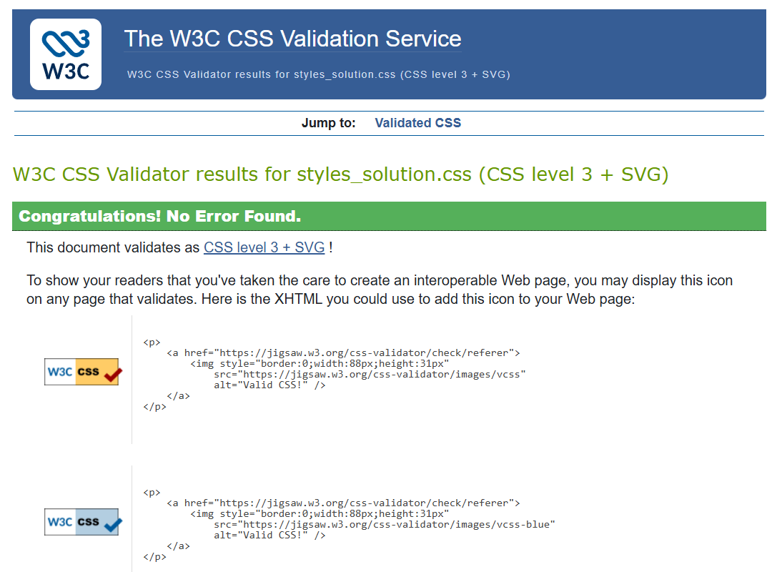
Figure 23
Practice activity

Activity 24: Apply responsive design to your portfolio website
Continue with the Scenario: Portfolio website.
In this activity, you'll make your portfolio website work well on both large and small screens.
You'll use flexbox for layout, a sticky header, a fixed footer and 2 navigation styles – one for computers (a traditional menu) and one for phones (a hamburger icon).
- Choose flexbox, grid or a combination of both to add a layout to your webpages aligning with your wireframes.
- Use the position property to make the header sticky and footer fixed.
- Add a header both a traditional menu and a hamburger icon (the hamburger is just a button for now). For example:
<!-- Traditional menu -->
<nav id="trad-nav">
<ul>
<li><a href="index.html">Home</a></li>
<li><a href="projects.html">Projects</a></li>
<li><a href="contact.html">Contact</a></li>
</ul>
</nav>

<!-- Hamburger icon (no menu yet) -->
<button id="hamburger">&#9776;</button>
Note: When you learn JavaScript, you'll make the hamburger open and close a real menu.
- Show or hide menus with @media rules. Use display: none to show only the menu that suits the screen size, for example:
/* As a default show the traditional menu */
#hamburger {
display: none;
}

/* Hide traditional menu, show hamburger on mobile */
@media (max-width: 768px) {
#trad-nav {
display: none;
}
- Test your layout in a browser:
  - When scrolling, the header should stay at the top and the footer should stay at the bottom.
  - Resize the window and test if the traditional menu is replaced by the hamburger icon.

Self-check

How did you go?
You have completed the lesson: Styling websites using CSS. Check the boxes for the tasks you feel confident you can complete.
☐ I can customise the style and layout of websites using CSS, according to user requirements.
☐ I can apply consistent styling using CSS across multiple web pages.
Assessment

Assessment 1 of 2: Knowledge Part 1
As you have completed this lesson, you should be ready to complete Assessment 1 of 2: Knowledge Part 1.
If your assessments are online, go to Assessments in the top menu and access the files.

Assessment 2 of 2: Project Part 4
As you have completed this lesson, you should be ready to start Assessment 2 of 2: Project Part 4.
If your assessments are online, go to Assessments in the top menu and access the files.
Note: To access the entire assessment, you must download and save each part separately.

Lesson 4:
Coding in JavaScript

Overview
You've already learned how HTML structures content and how CSS controls its appearance. These languages make web pages look organised and professional, but they can't make them interactive.
JavaScript fills this gap by allowing web pages to respond to user actions such as clicking buttons, entering data, or navigating menus. It's the programming language that adds behaviour to web pages.
Did you know?
Despite their similar names, Java and JavaScript are unrelated.
In this topic, you will learn to:
- identify basic JavaScript syntax rules
- use JavaScript data types, operators and expressions
- use sequence, selection and iteration constructs in JavaScript.

Using basic JavaScript syntax
Each programming language has its own syntax that specifies correct use of symbols, keywords and punctuation.
Some rules of syntax in scripting are:
Opening and closing symbols: Symbols (), {}, [], " ", or ' ' must always come in pairs.
For example:
while (condition) { statement();
}
Case sensitivity: Many languages treat uppercase and lowercase letters as different.
For example:
let FirstName;
let firstName;
// two different variables
Comments: Notes for humans, ignored by the computer. Can be single-line or multi-line.
For example:
// one-line comment
/* multi-line comment */
Statement terminators: Some languages use a special character (for example, ;) to end a statement.
For example:
let age = 25;
Whitespace and indentation: Whitespace is often ignored, but some languages use indentation to define code blocks. In all languages, consistent indentation improves readability.
For example:
if (loggedIn) {
console.log("Welcome");
}
Identifiers (naming rules): Names usually start with a letter, _, or $. No spaces or leading numbers are allowed.
For example:
let totalScore = 0;
Quotation marks: Single (' ') and double (" ") quotes both create strings however its best practice to be consistent and use one type. You can use quotes inside a string as long as they're different from the surrounding quotes.
For example:
let a1 = "Their name is O'Hara"
let a2 = "Their name is 'Riley' "
let a3 = 'Their name is "Riley" '

Variables
A variable is a labelled piece of memory used to store data. The label allows the developer to easily find and use the stored data later.

Naming variables
Each variable must have a unique name, called an identifier. Meaningful variable names make your code easier to read, understand and maintain. For example, totalPrice clearly describes the data, while a name like x gives no context.
Use short variable names only for very simple or temporary values.
Variable naming conventions:
- Variable names are case sensitive (y and Y are different).
- They can include letters, digits, underscores (_) and dollar signs ($), but no spaces.
- They cannot start with a number.
- They cannot use reserved words (for example, JavaScript keywords like let or function).

Reserved words
Programming languages have a set of reserved words for specific actions. Since these words have special meaning to the language, you cannot use these words for your purposes, such as for the name of a variable.
The following are some keywords common to many languages:
- if
- then
- else
- while
- for
- return.

Declaring variables
To use a variable, you must first declare it in the script.
const is used for variables that cannot be reassigned.
const PI = 3.14159265359;
let is used for variables that can change.
let x = 0;

Data types
A data type defines the kind of value a variable can hold and how the program can use it.

String
String represents text values. Always use quotes to define a string.
let myName = "Anna";
let searchName = "";

Integer
Integer represents whole numbers without decimals.
let age = 25;
let count = 0;

Float
Float represents numbers with decimal points.
let startTemp = 0.7;
let price = 12.99;

Boolean
Boolean represents logical values: true or false.
let test = false;

Array
Array represents an ordered list of values, enclosed in square brackets [].
let myShapes = ["square","circle","triangle"];
let myOrder = [];

Object
Object represents a collection of related data as key–value pairs, enclosed in curly braces {}. Each key (also called a property) has a value and the value can be any data type.
let myTable = {shape: "round", seating:5, color:"blue"};
let myDetails = {};
Note: In JavaScript, this structure is called an object. It's like a dictionary in languages like Python or a map in some other languages.
Don't confuse it with the term 'object' in languages such as C#, where it refers to any data type instance or class-based object, rather than a key-value structure.

Displaying output from your code
You can use different methods to display output or test your code in JavaScript.
console.log(): Displays messages or variable values in the browser's console (useful for debugging).
let name = "Ava";
console.log(name);
document.write(): Displays text directly on the web page. It's mainly used for quick testing, not in production code.
document.write("I am new text");

Template literals (back ticks)
A template literal is another way to create a string in JavaScript.
Instead of using single (' ') or double (" ") quotes, template literals use backticks (`). The back tick is usually found on the same key as tilde.
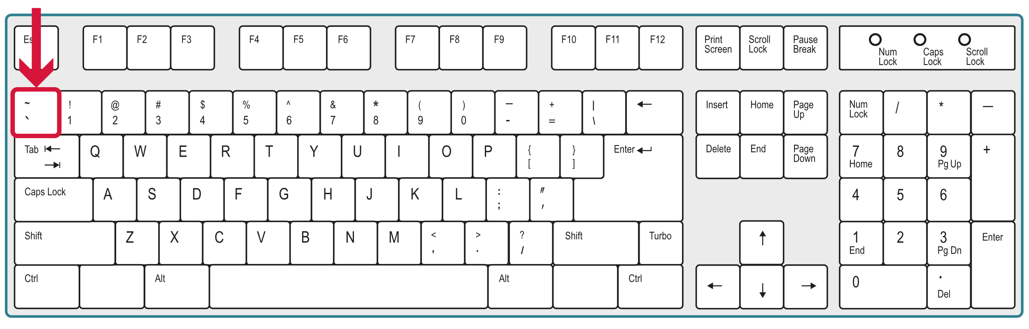
Figure 24: © Getty Images modified under licence
Template literals make it easier to include variables or expressions inside a string without using + for concatenation.
For example: Embed variables using ${variablename}.
const name = 'Jordan';
console.log(`Hello, ${name}!`);
You can also include simple calculations inside ${ }.
const price = 5;
console.log(`Total: $${price * 2}`);

Following coding standards and best practices
Coding standards are agreed rules for how code should be written so that it's clear, consistent and easy to maintain. Following standards helps you and others understand your code and avoid errors.
Some good coding practices include:
- use clear, meaningful names for variables and functions
- keep code lines short and well-spaced
- use indentation to show structure
- write one purpose per function
- reuse code instead of copying it (DRY, or Don't Repeat Yourself)
- avoid too many nested if or loop statements
- add short comments to explain complex sections.

Including comments in your code
Comments are lines of text in the code that are intended for human readers and ignored by the JavaScript interpreter. They explain the purpose and intention of the code.
Some good commenting practices include:
- write comments to explain why something is done, not just what it does
- comment complex logic or unusual conditions
- add short summaries before loops or functions.
You can include either single-line comments or block comments, or both.

Single-line comments
Single-line comments are created in JavaScript by including 2 forward slashes (//). These comments are automatically terminated by the end of line.
For example:
// Function below takes in user’s name
let name = window.prompt("Write your name");
alert("Hello " + name);
You can also place comments at the end of a line:
const DOZEN = 12; // constant

Block comments
Block comments extend over multiple lines, forming a block of text. They generally apply to some (or all) code that follows them.
In JavaScript, the first line in a Block comment starts with /* and the last line ends with */. JavaScript ignores every line in between.
For example:
/* Function below takes in user’s name
Author: Riley Smith
Version: 1.3 */
let name = window.prompt("Write your name");
alert("Hello " + name);

Using JSDoc to add internal documentation
JSDoc is a structured comment format used in JavaScript that documents functions, parameters and return values. It works with IntelliSense in the editor and can generate HTML documentation with the JSDoc tool.
Note: IntelliSense in the editor means the editor, such as VS Code, displays helpful information while you type, based on the comments you wrote in your JSDoc block. This information may include function names, parameter hints and short explanations.
The formatting resembles that of block comments, so be sure not to confuse them.
If you don't already have JSDoc installed, install it:
npm install -g jsdoc
You can use JSDoc to write single-line or multi-line comments.
In JSDoc:
- the first line of the comment starts with /**
- each line in a multi-line comment starts with *; it can include text or JSDoc tags to add more information
- the last line starts with */.
For example:
/**
* [Function comment - description]
* @param {type} name - description
* @returns {type} description
*/
When your code is finished, you'll use JSDoc to generate HTML files of the documentation (you'll learn about this in the last lesson of this resource).
Resources
To learn more about JSDoc, including a list of tags to use, refer to the technical documentation at @use JSDoc.
The Gelos Coding and Testing Guidelines (pdf) outlines the best practices and standards that Gelos expects its coding team to follow.
Practice activity

Activity 25: Read, write and fix JavaScript code
In this activity, you'll practise reading, writing and correcting JavaScript code.
- Copy the following code into the Console in DevTools.
- Follow the instructions inside the code block for each step.
// 1. Read the code
// Task: Run the code below to see the result in your browser console.
let greeting = "Hello";
let user = "Liam";
console.log(`${greeting}, ${user}!`);

// 2. Write the code
// Task: Create 2 variables, one for your name and one for your favourite colour.
// Then use console.log() to display a sentence such as:
// "My name is Ava and my favourite colour is blue."

// Write your code here

// 3. Fix the code
// Task: Uncomment the code and correct all mistakes so it runs correctly.
/*
let Number1 = 10
let number2 = "5";
console.log("The total is: ${Number1 + Number2}");
*/

Operators
An operator is a special symbol that's used to perform operations on operands (values and variables). For example:
2 + 3
Here, + is an addition operator and 2 and 3 are operands.

Assignment operators
With an assignment operator, you can assign a value of the variable on its right-hand side to the variable on its left-hand side; the equal sign (=) is used as the assignment operator.
For example:
let firstNumber = 14;
This code stores the value 14 in the variable named firstNumber.
Note: The variable firstNumber holds the value 14 until you assign a new value to this variable or your program exits.

Arithmetic operators
Arithmetic operators allow you to perform mathematical operations like addition, subtraction, multiplication and exponentiation, as shown in the following table.
Table 10: Arithmetic operators
Operator name | Symbol | Example | Result
Addition | + | a = 1 + 2 | a has value 3
Subtraction | - | a = 8 - 2 | a has value 6
Multiplication | * | a = 4 * 5 | a has value 20
Division | / | a = 4 / 2 | a has value 2
Exponentiation | ** | a = 2 ** 3 | a has value 8
Modulus | % | a = 5 % 2 | a has value 1
Exponentiation refers to raising one number to the power of another, for example, 2³.
Modulus is the number remaining after performing a whole number division.

Compound operators
Compound operators are shorthand formats to increment or decrement a number stored in a variable.
Instead of using the full arithmetic expression, like this:
a = a + 1;
a = a – 1;
You can use increment (++) or decrement (--) operators:
a++;
a--;
Compound operators can also be used with other arithmetic symbols, for example:
a += 5;
a -= 3;
a *= 2;
a /= 4;
Compound operators are useful for loop control variables and repeated assignments.
for (let i = 0; i < 5; i++) {
attendees += names[i] + "<br>";
}

Comparison operators
Comparison operators are used to compare 2 values and return a true or false result. The following table shows the comparison operators used in JavaScript.
Table 11: Comparison of operators
Operator name | Symbol | Example | Result
greater than | > | a > b | True if a is greater than b.
less than | < | a < b | True if a is less than b.
equal to | == | a == b | True if a and b have the same value.
not equal to | != | a != b | True if a and b are not equal.
greater than or equal to | >= | a >= b | True if a is greater than or equal to b.
less than or equal to | <= | a <= b | True if a is less than or equal to b.
Comparison operators are used in if statements or loops to test conditions. For example, to check if an entered password doesn't match the stored one:
if (enteredPassword != storedPassword) {
alert("Wrong password");
}

Logical operators
Logical operators are used when you need to check more than one condition at the same time.
The following table shows logical operators used in JavaScript:
Table 12: Logical operators
Operator | Example | Result
&& | (a && b) == true | If both operands are true, then the condition becomes true.
|| | (a || b) == true | If one operand is true, then the condition becomes true.
! | !(a && b) == true | If both the operands are false, then the condition becomes true.
Examples of logical operators:
AND (&&): both conditions must be true
if (age > 18 && hasID == true) {
console.log("Access granted");
}
OR (||): at least one condition must be true
if (day == "Saturday" || day == "Sunday") {
console.log("It's the weekend!");
}
NOT (!): reverses a true or false value
if (!(score >= 50)) {
console.log("You did not pass");
}
Practice activity

Activity 26: Use operators
Read the question carefully and answer in the space provided.
Suppose you ran the following code, which contains numerous arithmetic operators.
let a = 4;
let b = 3;
let c = a - b;
console.log(c);
let d = c ** b;
console.log(d);
let e = d * a;
console.log(e);
- What would be the output if you ran this code?

For the following code:
let total = (2 + 2) * 4;
console.log(total);
- What would be the output if you ran this code? Why?

Control structures
Programming uses constructs to control the order in which code runs.
The terms construct and control structure are often used interchangeably in programming. A construct can refer to a fundamental building block, and a control structure specifically refers to constructs that control the flow of execution. (BBC, 2025)
The 3 main programming constructs are:
- sequence, which runs code in order, line by line
- selection, which runs code only if certain conditions are true
- iteration, which repeats code while a condition is true.
Each construct controls the order in which instructions are executed, determining what the program does next.

Sequence construct
A sequence is the simplest construct. Each line of code runs in order from top to bottom.
let name = "Ava";
let age = 18;
console.log("Name: " + name);
console.log("Age: " + age);

Selection construct
A selection is used when a program needs to make a decision. It uses conditions to choose which block of code to run.
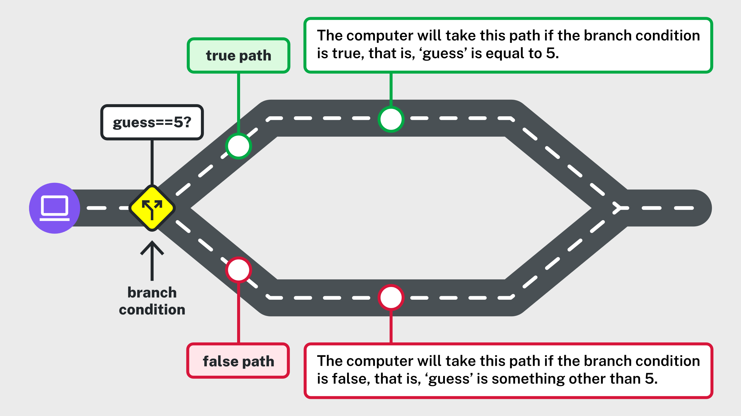
Figure 25: © TAFE NSW 2025

if statement
Runs a block of code only if a condition is true.
if (score >= 50) {
console.log("You passed!");
}

if-else statement
Runs one block if the condition is true, or another if it's false (else).
if (score >= 50) {
console.log("You passed!");
} else {
console.log("Try again!");
}

if-else if-else statement
Checks more than one condition and runs only the first true block, or another if it's false (else).
if (score >= 85) {
console.log("High Distinction");
} else if (score >= 50) {
console.log("Pass");
} else {
console.log("Fail");
}

Ternary operator
A ternary operator is a shorter way to write an if-else statement. It fits simple decisions on one line and has 3 parts:
- condition: what you are testing (for example, score >= 50)
- value if true: what happens if the condition is true
- value if false: what happens if the condition is false.
condition ? valueIfTrue : valueIfFalse
The ? means 'then' – it separates the condition from what happens if it's true.
The : means 'else' – it separates what happens if the condition is false.
For example:
const result = (score >= 50) ? "Pass" : "Fail";
console.log(result);
If the condition (score >= 50) is true, 'Pass' is chosen, otherwise, 'Fail' is chosen.
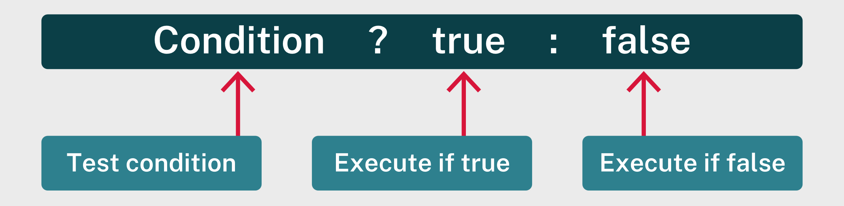
Figure 26: © TAFE NSW 2025

Iteration construct
An iteration repeats a block of code while a condition remains true. This is also called a loop. Common loops are while and for.

While loop
Repeats code while a condition is true. Use this when you don't know how many times the loop should run.
Here is what's happening in the following example:
- The keyword while tells the program to repeat the code inside the braces {} as long as the condition (count <= 3) is true.
- The variable count starts at 1. Each time the loop runs, JavaScript checks whether count is still less than or equal to 3
  - If it is, it runs the code inside the loop and prints the message.
- The statement count++ increases the value of count by one each time, until the condition becomes false and the loop stops.
let count = 1;
while (count <= 3) {
console.log("Count is " + count);
count++;
}

For loop
Repeats code a specific number of times. Use this when you do know how many times the loop should run.
Here is what's happening in the following example:
- The keyword for tells the program to repeat the code a set number of times.
- The statement for (let i = 1; i <= 3; i++) has 3 parts:
  - Initialisation: let i = 1 sets the starting value.
  - Condition: i <= 3 tells the loop to keep running while this is true.
  - Update: i++ increases the value of i by one each time the loop runs.
- Each time the loop runs, JavaScript checks the condition.
- If it's true, the code inside the braces {} runs and prints the message.
- When the condition becomes false, the loop stops.
for (let i = 1; i <= 3; i++) {
console.log("Count is " + i);
}
A simpler way to remember the 3 parts of a for loop is start, stop, step.
For example:
for (let i = 1; i <= 3; i++)
In this example:
- Start: let i = 1 – the loop starts with i equalling 1.
- Stop: i <= 3 – the loop stops when this condition is no longer true.
- Step: i++ – the value of i increases by 1 each time.
Resources
Access the following W3Schools pages to learn more:
- JavaScript Conditionals
- JavaScript Loops.
Practice activity

Activity 27: Predict the count value
Read the following code and answer the questions.
let count = 3
while (count >= 0) {
console.log("Countdown: " + count)
count--
}
- Predict what the console will print and document it in the following table.
Table 13: Predict the count activity
Loop iteration | count before | output shown | count after
- Test your prediction by running the code in the Console in Devtools.

Data structures
A data structure is a collection of data.
Programs often need to work with many related values at once. Because variables alone can't manage more than one piece of data at a time, data is grouped together in a specific format called a data structure.
Common examples of data structures include:
- array: stores a list of items in order
- stack: stores items so the last one added is the first one removed
- queue: stores items so the first one added is the first one removed
- tree: stores data in a branching format
- graph: stores data as connected nodes, showing relationships.

Using arrays
An array is a collection of items stored in contiguous memory locations.
Note: An array is both a data structure and a data type (covered in a previous lesson).
Values of any type can be stored in the same array and its length can be dynamic (it can grow or shrink as much as necessary).
const arr = ['store', 1, 'whatever', 2, 'you want', 3]
Any data type, including arrays, can be stored in an array. A multidimensional array is one that contains other arrays within it.
const arr = [
[1,2,3],
[4,5,6],
[7,8,9],
]

Indexing
Each item is accessible via its index (position number). Indexes start at 0, not 1.
This means:
- index 0 is the first element
- index 1 is the second element
- index 2 is the third element and so on.
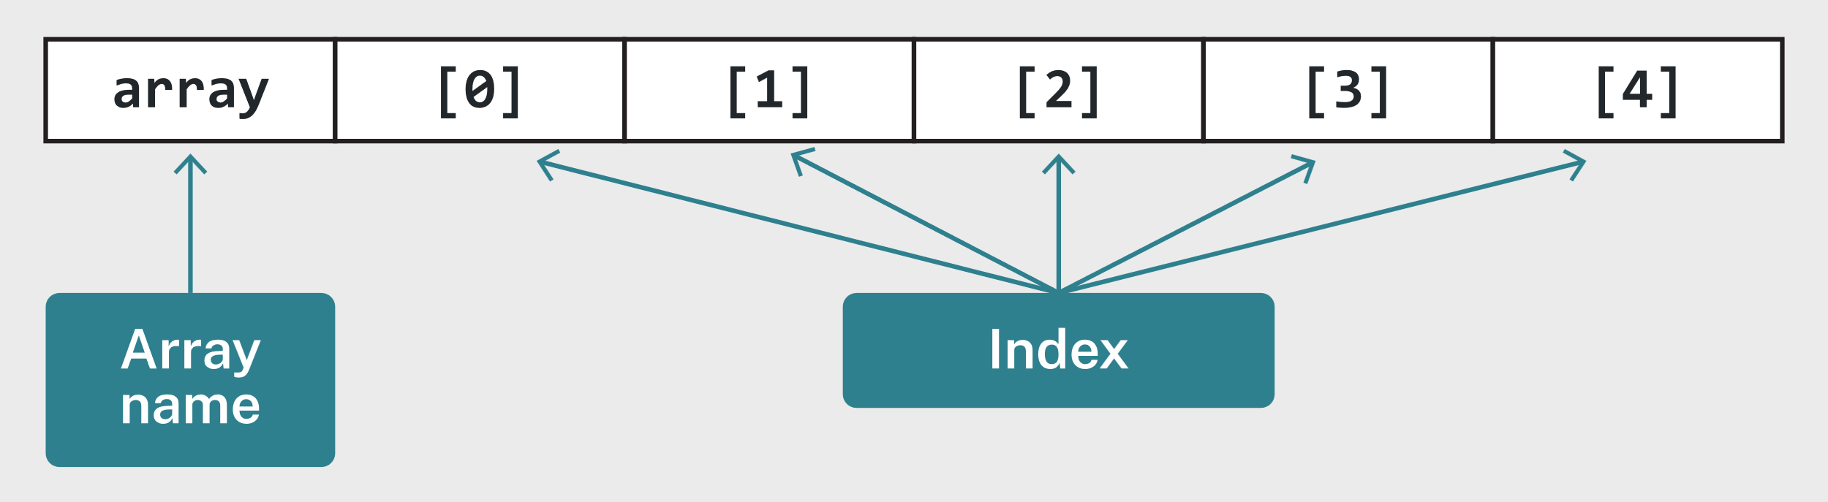
Figure 27: © TAFE NSW 2025
Because arrays always begin at index 0, in the following example you would use the index number 2 to access the 3rd element in a 4-element array:
const arr = ['a', 'b', 'c', 'd']
console.log(arr[2]) // c is printed in the console
Resources
You can find a complete list of methods used to operate arrays at the MDN page Array.
Practice activity

Activity 28: Develop the logic for a mini game
In this activity, you'll develop a simple numbers game.
- Copy the following code.
- Complete the steps in the code to finish the Lucky Draw.
- Run the code in the Console in DevTools to see which numbers win.
// You have 5 random tickets. Lucky number is 7.

let tickets = [3, 7, 1, 7, 4]

// Step 1: Write a for loop that goes through each ticket.
// Step 2: If the number equals 7, print "Winner!"
// Else print "Try again."

Functions
A function is a subprogram – a small, reusable block of code within a larger program. Functions are used to perform specific tasks and reduce repetition.

Defining and calling a function
A function must be defined before it can be called (or run).
To define a function, use the function keyword followed by a name, parentheses () and curly braces { }. The code to be executed is defined inside the curly braces:
function greet() {
console.log("Hello!");
}
To run the function, call it by its name followed by parentheses ():
greet(); // Output: Hello!

Function parameters
A function can accept parameters, which are values that are passed into it when it runs.
function greet(name) {
console.log(`Hello, ${name}!`);
}

greet("Jordan"); // Output: Hello, Jordan!
Parameters make functions reusable because they can work with different inputs.

Return values
Functions can send a result back using the return keyword.
function add(a, b) {
return a + b;
}

const result = add(5, 3);
console.log(result); // Output: 8
When a return statement runs, the function ends and returns that value.

Recursive functions
A recursive function is a function that calls itself. Recursion is often used for tasks like repeating actions, processing lists, or solving mathematical problems.
In this example, countdown() is called within the defined function:
function countdown(number) {
console.log(number);

if (number > 1) {
countdown(number - 1); // the function calls itself (recursion)
}
}

countdown(5);
How it works:
- The function prints the current number.
- It calls itself with a smaller number (number - 1).
- When number is no longer greater than 1, the recursion stops.

Arrow functions
An arrow function is a shorter way to write a function. It uses the arrow symbol (=>) instead of the function keyword. Arrow functions are often used for short, simple tasks.
Differences:
- The function keyword is replaced with a const variable.
- Curly braces { } and the return keyword can be removed if the function has only one line.
- Parentheses ( ) are optional when there is only one parameter.
Example: Basic arrow function with no parameters
const greet = () => {
console.log("Hello!");
};

greet(); // Output: Hello!
Example: With parameters
const greet = (firstName, lastName) => {
console.log(`Hello, ${firstName} ${lastName}!`);
};

greet("Jordan", "Lee"); // Output: Hello, Jordan Lee!
Example: With one parameter
If the function only has one parameter, you can leave out the parentheses ().
const greet = name => {
console.log(`Hello, ${name}!`);
};

greet("Jordan"); // Output: Hello, Jordan!
Example: Returning a value
If the function has a single statement that returns a value, you can omit the curly braces { } and the return keyword.
const add = (a, b) => a + b;

console.log (add(5, 3)); // Output: 8
Practice activity

Activity 29: Convert a function to an arrow function
In this activity, you'll convert a traditional function to an arrow function
- Copy the following code into the Console in DevTools.
- Copy the traditional function and convert it into an arrow function that performs the same task (keep both versions in the code).
- Test both versions to confirm they produce the same result.
// Traditional function
function square(num) {
return num * num;
}

console.log(square(4)); // Expected output: 16

// Step 1: Write your arrow function version below
// Step 2: Name it squareArrow and make sure it behaves the same way.

// Write your code here

console.log(squareArrow(4)); // Expected output: 16
Resources
Exercism's JavaScript Track is a free online learning platform where you can practise JavaScript through short, guided exercises. You can submit your code to receive automated feedback and optional mentor support, as well as view example solutions to learn different approaches to coding problems.
W3Schools also has a useful JavaScript Tutorial.

Applying data manipulation algorithms
An algorithm is a set of step-by-step instructions written in code that performs a specific task or solves a problem.
Algorithms tell the computer how to process data and reach a result, for example, how to find a value, how to add or remove items.
Data manipulation algorithms are used to work with data stored inside a structure. They include the steps a program follows to insert new data, delete existing data, or search for specific data within that structure.
It’s important to know how to code using a standard algorithm, even if a built-in function can do the same thing. Here are some reasons why:
- Deep understanding of logic: Writing code using a standard algorithm helps you understand the underlying steps and data structures involved. This knowledge is critical for debugging, optimising and adapting solutions to unique scenarios.
- Problem-solving skills: Implementing algorithms from scratch strengthens your ability to break down complex problems, which is essential for interviews, competitive programming and real-world development.
- Control and customisation: Built-in functions are convenient but often limited to generic use cases. Knowing the algorithm allows you to customise behaviour, handle edge cases, or improve performance for specific requirements.
- Portability and language independence: Not all languages or environments have the same built-in functions. Understanding the algorithm ensures you can implement it anywhere.
- Efficiency awareness: Writing the algorithm teaches you about time and space complexity, helping you choose the most efficient approach rather than blindly relying on built-in functions.

Sequential search
The most straightforward search is the sequential search, also known as a linear search. This search algorithm applies when the elements are not sorted in any order. It starts with the first element in the list and goes through each element sequentially until it finds a match.
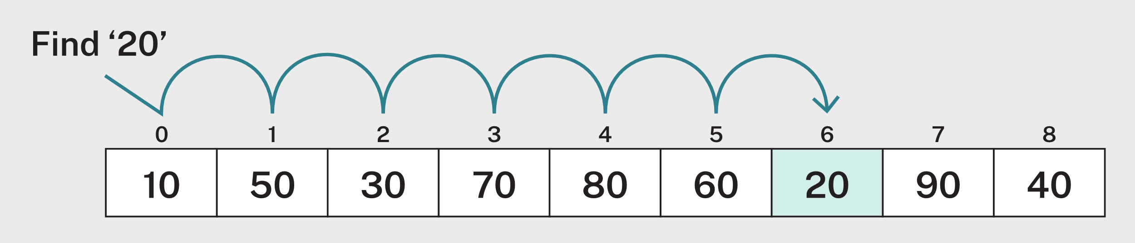
Figure 28: © TAFE NSW 2025
How it works:
- Start at the first element (index 0).
- Compare the current element with the target value.
- If it matches → return the current index.
- If not → move to the next element.
- If the end is reached → return -1 (indicating not found).
For example:
function linearSearch(arr, value) {
for (let i = 0; i < arr.length; i++) {
if (arr[i] === value) {
return i; // found
}
}
return -1; // not found
}

Binary search
Binary search is a sorted array searching algorithm that repeatedly divides the search period in half. The goal behind a binary search is to reduce the time complexity of sorting the array.
Binary search only works on sorted data.
The algorithm needs the data in order so it can decide whether to look in the upper or lower half of the list.
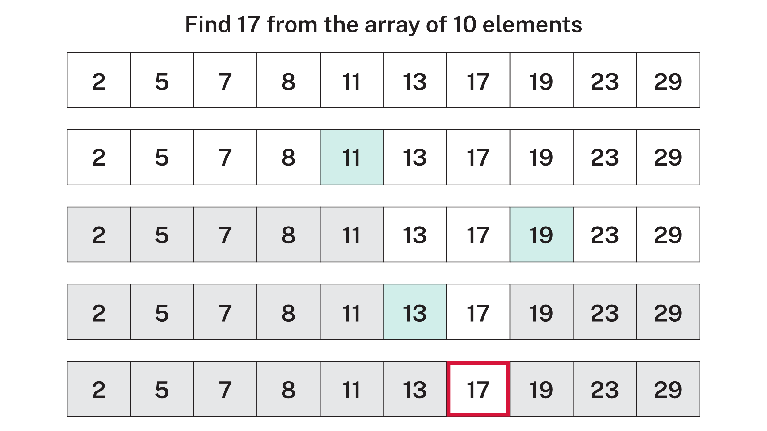
Figure 29: © TAFE NSW 2025
How it works:
- Begin by considering the entire array as the search interval.
- Choose the middle element of the sorted array as the search basis.
- If the value of the search basis equals the search item, return the search basis's position index.
- If the value of the search basis is less than the search item, narrow the search interval to the lower half of the array.
- Otherwise, narrow the search interval to the top half of the array.
- Repeatedly check the search item using the narrowed search interval until you find the value, or the interval is empty.
For example:
function binarySearch(arr, value) {
let low = 0;
let high = arr.length - 1;

while (low <= high) {
let mid = Math.floor((low + high) / 2);
if (arr[mid] === value) {
return mid;
}
if (arr[mid] < value) {
low = mid + 1;
} else {
high = mid - 1;
}
}
return -1; // not found
}

Insertion algorithm for arrays
Insertion is the process of adding elements to the data structure at any location.
The insert operation into a sorted array is complex because you must be aware of the element's position.
How it works:
- Identify the position (index) where the new value should go.
- Shift existing elements from that position onward one place to the right to make space.
- Place the new value at the chosen index.
For example:
function insert(arr, index, value) {
for (let i = arr.length; i > index; i--) {
arr[i] = arr[i - 1];
}
arr[index] = value;
}

Deletion algorithm for arrays
Deletion is the process of removing elements from a data structure. Like the insertion algorithm, this algorithm must use a sorted array.
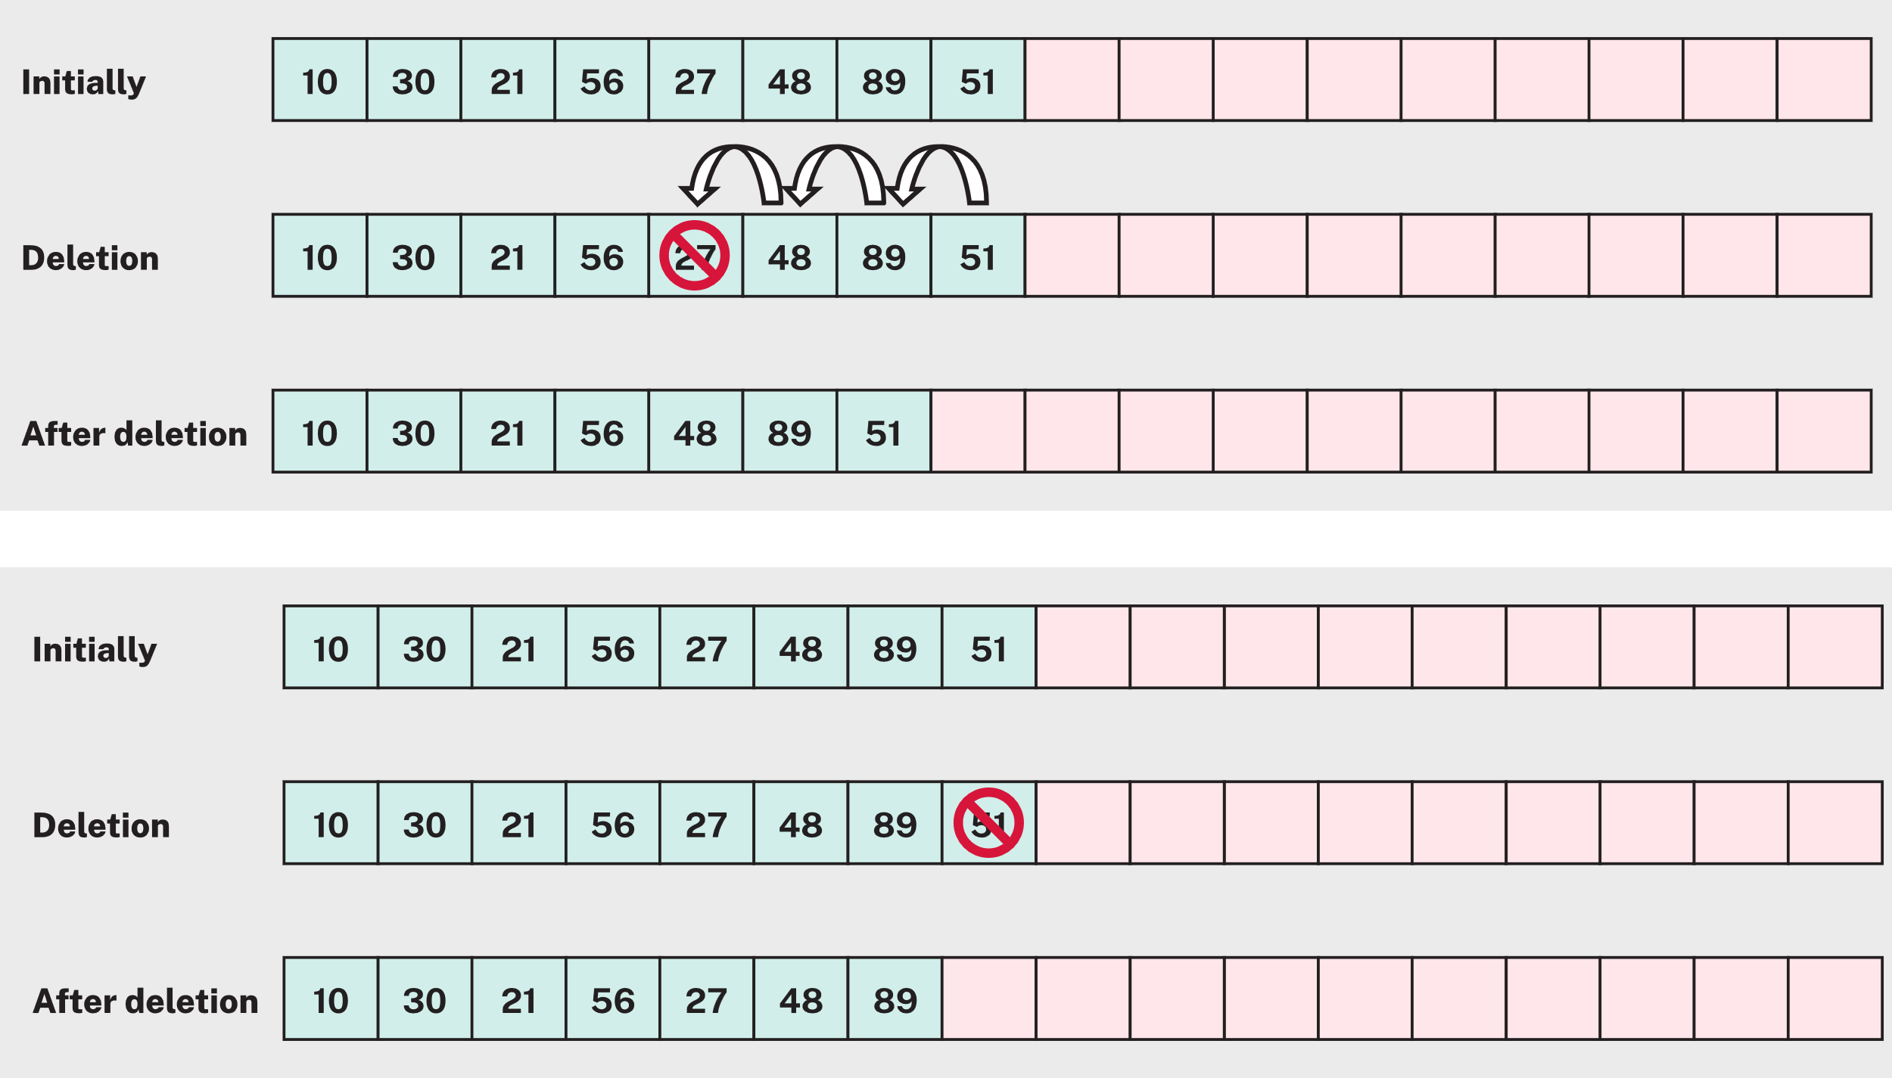
Figure 30: © TAFE NSW 2025
How it works:
- Find the index of the element to remove (using a sequential search).
- Shift each element after that index one place to the left.
- Reduce the length of the array by one (if applicable).
For example:
function remove(arr, index) {
for (let i = index; i < arr.length - 1; i++) {
arr[i] = arr[i + 1];
}
arr.length = arr.length - 1;
}
Resources
Access the Search, Insert, and Delete in an Sorted Array | Array Operations web page to learn about insertion and deletion algorithms for the sorted array.
Review the following W3Schools pages to learn more about these search algorithms:
- DSA Linear Search
- DSA Binary Search.

Identifying types of errors
As you've been learning to code in JavaScript, you've probably seen several errors. When errors occur, a program may not run or may produce incorrect results.
There are 3 main types of errors you'll encounter in JavaScript:
- syntax errors
- runtime errors (exceptions)
- logical errors.

Syntax errors
A syntax error happens when the JavaScript interpreter can't understand the code because of a typing error (typo) or formatting issue. A typo is the most common error you'll encounter.
Other causes are:
- missing brackets or quotes
- incorrect indentation.
For example, this code is missing a closing quotation mark:
alert('Hello + name);
which causes this error:
Uncaught SyntaxError: Invalid or unexpected token

Runtime errors (exceptions)
A runtime error occurs when the code syntax is correct but something goes wrong while the program is running.
For example, in this code the function being called doesn't exist:
window.printme(); // incorrect function name
which causes this error:
Uncaught TypeError: window.printme is not a function
Here are some common runtime errors.

Rangeerror
Thrown when a number is outside an allowable range.
For example, this code:
const arr = [90, 88];
arr.length = 90 ** 99;
causes this error:
RangeError: invalid array length

ReferenceError
Thrown when a variable or item does not exist.
For example, this code:
const cat = 'cat';
cat;
dog;
causes this error:
ReferenceError: dog is not defined

TypeError
Thrown when an operation is performed on the wrong data type.
For example, this code:
let num = 123;
num.toUpperCase();
causes this error:
TypeError: num.toUpperCase is not a function

InternalError
Thrown when the JavaScript engine runs out of memory or exceeds recursion limits.
For example, this code:
function foo() {
foo(); // infinite recursion
}
foo();
causes this error:
InternalError: too much recursion

Logical errors
Logical errors occur when the code runs but produces an incorrect result. There is no error message, only incorrect behaviour.
For example, the following code produces the wrong calculation, although it still runs:
let total = 10;
let discount = 0.1;
let final = total + discount; // should be total - discount

Debugging your code
You usually debug your code before applying formal testing.

Applying debugging methodologies
Debugging methodologies refer to structured approaches for identifying, isolating and fixing errors in software.
Here are some common debugging methodologies.

Inspecting elements
- Use browser DevTools to inspect the DOM and see how JavaScript manipulates elements.
- Check applied styles, event listeners and test changes live.

Isolating the problem
- For complex bugs, comment out or disable sections of code to narrow down the source.
- Test functions or modules individually to confirm which part causes the issue.

Using linters and validators
- Apply tools like ESLint to enforce coding standards and catch syntax or logic errors early.
- Helps maintain clean, consistent code and prevents common mistakes.

Applying step-by-step debugging
- Pause execution and inspect variable states line by line for complex logic.
- This can be used when it's not obvious which statement gets executed first.

Using debugging tools
Both IDEs and modern browsers include debugging tools that you can use to debug your JavaScript. Built-in debuggers can be enabled and disabled, causing them to report errors to the user. You can also use a debugger to set breakpoints (points at which code execution can stop) and examine variables while the code runs.

Applying console logging
The Console in DevTools can be used to view any errors or messages generated by your JavaScript code.
- Use console.log(), console.error() and console.table() to trace variable values, execution flow and data structures.
- Great for quick checks and understanding what your code is doing at runtime.
For example:
<script>
a = 5;
b = 6;
c = a + b;
console.log(c); // displays 11 in the console
</script>
The output appears in the Console panel in DevTools.

Tracing code execution
You can trace the code execution step-by-step to review the logic in detail. This is because it's not always obvious which statement gets executed first.
Breaking is when a program pauses at defined points, allowing you to examine its current state, such as checking variable values or the program's flow.
Breakpoints stop code execution at a specific line, allowing you to inspect how the program is running.

Setting breakpoints with code
Use the debugger; keyword in your code to pause execution at that point.
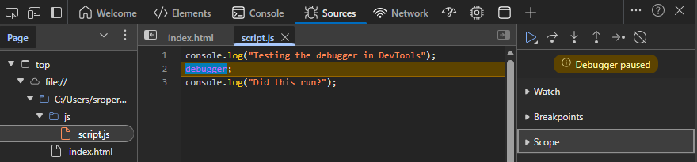
Figure 31: Used with permission from Microsoft
Refresh the page to start the debugger and inspect the variable values when it pauses. The debugger includes tools to navigate through your code and view the variable updates.

Setting breakpoints in the debugging tool
Open the Sources tab in DevTools and select the line number where you want to pause the code.

Starting and inspecting code
To inspect code in DevTools:
- Reload the page to run the script and trigger the debugger.
- When the code pauses, use the Debugger panel in DevTools to:
  - inspect variable values
  - observe the call stack
  - step through code to follow execution.
Here are the actions on the Debugger panel in DevTools:
- Continue (play icon): Resumes script execution.
- Step over (arrow stepping over a dot): Advances the debugger to the next line of code, but it will not move into a function. If there is a function call on the line, it steps over it.
- Step into (arrow pointing downwards): Moves into the function calls on the current line of execution if there are any. If the line contains no function calls, it will move to the next line of code.
- Step out (arrow pointing upwards): Continues execution and exits the current function, then pauses at the next line after the function call.
- Step (arrow pointing right): Steps to the next line of code.
- Deactivate breakpoints (slash through breakpoint icon): Temporarily disables all breakpoints, allowing the script to execute normally without stopping.

Figure 32: © TAFE NSW 2025
Video
To learn more about debugging, you can refer to the video on The JavaScript Console (LinkedIn Learning, 4:12 min)
LinkedIn Learning videos will open in a new tab within your browser. You can access the full video by logging in with your TAFE NSW username and password. You can access a transcript of the video on the transcript tab within LinkedIn Learning. When you’re finished, simply close the tab and return to your course.
Resources
VS Code includes debugging tools for many languages including JavaScript, which you can learn about at Debug code with Visual Studio Code.
Practice activity

Activity 30: Check your knowledge of troubleshooting and debugging
Read each question and select the correct answer.
- You’ve applied new CSS styles to your webpage, but the layout still looks wrong. You want to check which styles are being applied and test quick changes in the browser. Which debugging method should you use?
# | Choices | Answer
 | Using linters and validators | ☐
 | Isolating the problem | ☐
 | Element inspection | ☐
 | Step-by-step debugging | ☐
- Your program is throwing an error, but you have no idea which part of the code is causing it. What is the best approach to narrow down the issue?
# | Choices | Answer
 | Step-by-step debugging | ☐
 | Isolating the problem | ☐
 | Element inspection | ☐
 | Using linters and validators | ☐
- The program runs without crashing, but the output is completely different from what you expected. You suspect a logic error. Which method will help you review the code in detail?
# | Choices | Answer
 | Step-by-step debugging | ☐
 | Element inspection | ☐
 | Using linters and validators | ☐
 | Isolating the problem | ☐
- You’ve finished writing your code and want to make sure it follows proper syntax and coding standards before deployment. Which tool or technique should you use?
# | Choices | Answer
 | Element inspection | ☐
 | Step-by-step debugging | ☐
 | Using linters and validators | ☐
 | Isolating the problem | ☐
- You suspect a syntax error in your CSS file because some styles aren’t applying. Which DevTools feature will help you confirm this?
# | Choices | Answer
 | Network tab | ☐
 | Console tab | ☐
 | Elements panel | ☐
 | Performance tab | ☐
- You’ve updated your CSS file, but the browser still shows the old styles. What should you do first?
# | Choices | Answer
 | Clear the browser cache to force loading the latest files | ☐
 | Restart your computer | ☐
 | Disable JavaScript in the browser | ☐
 | Use DevTools to check if the CSS file is linked correctly | ☐
- After making changes to your JavaScript, the page still behaves as before. What’s the most likely reason?
# | Choices | Answer
 | The browser is caching the old JavaScript file | ☐
 | The HTML file is corrupted | ☐
 | CSS overrides JavaScript | ☐
 | The server is offline | ☐

Activity 31: Add interactivity to your portfolio website
Continue with the Scenario: Portfolio website. Follow these instructions to enhance the Home page of your portfolio site with a short interactive list.
Choose a list for your portfolio home page:
- Pick a list theme, for example:
  - Skills
  - Favourite tools
  - Current learning goals
  - Recent projects.
- Write down about 5–8 items you will include in your list.
Create and link your JavaScript file:
- Create a JavaScript file (for example, home.js) and link it to index.html.
- Create 2 arrays based on your chosen theme, with at least 5 items in each.
Hint: Follow this pattern, but change the values to suit your theme:
const listA = ["item1", "item2", "item3"];
const listB = ["item4", "item5", "item6"];
Write and complete the algorithms in home.js:
- Add the following function headers to your file:
function insertAt(arr, index, value) {
// TODO: complete this function
}

function removeAt(arr, index) {
// TODO: complete this function
}

function linearSearch(arr, value) {
// TODO: complete this function
}

function binarySearch(arr, value) {
// TODO: complete this function
}
- Using the examples in this resource, complete each function so it:
  - insertAt inserts a value at a given index
  - removeAt removes the value at a given index
  - linearSearch searches from start to end
  - binarySearch searches a sorted list.
Test your algorithms:
- In your JavaScript file or browser console:
  - Insert: Use insertAt() to add a new item to one of your arrays and log the updated array. For example:
insertAt(listA, listA.length, "Python"); console.log(listA);
  - Delete: Use removeAt() to remove an item at a chosen index and log the result. For example:
removeAt(listB, 1); console.log(listB);
  - Search: Use linearSearch() to find an item, then sort another array and use binarySearch() on the sorted list. For example:
const result = linearSearch(listA, "CSS"); console.log(result);

Self-check

How did you go?
You have completed the lesson: Coding in JavaScript. Check the boxes for the tasks you feel confident you can complete.
☐ I can identify basic JavaScript syntax rules.
☐ I can use JavaScript data types, operators and expressions.
☐ I can use sequence, selection and iteration constructs in JavaScript.
Assessment

Assessment 2 of 2: Project Part 5
As you have completed this lesson, you should be ready to start Assessment 2 of 2: Project Part 5.
If your assessments are online, go to Assessments in the top menu and access the files.
Note: To access the entire assessment, you must download and save each part separately.

Lesson 5:
Manipulating the HTML DOM using JavaScript

Overview
The HTML Document Object Model (DOM) is the backbone of every web page, acting as a structured map of all its elements. By using JavaScript, developers can dynamically interact with this map, by adding, removing, or modifying content and styles in real time. This ability to manipulate the DOM transforms static pages into interactive experiences, enabling features like live form validation, dynamic content updates and responsive user interfaces.
In this lesson, you will learn to:
- integrate code into a website to process and manipulate data.

HTML DOM
The HTML DOM is a structured representation of a web page. When a page loads, the browser converts the HTML into a tree-like model made up of objects. Each object represents an element, attribute, or piece of text.
JavaScript can use this model to access and change any part of the web page, such as its text, styles, or structure.
The following diagram illustrates an example of how the HTML DOM is constructed:
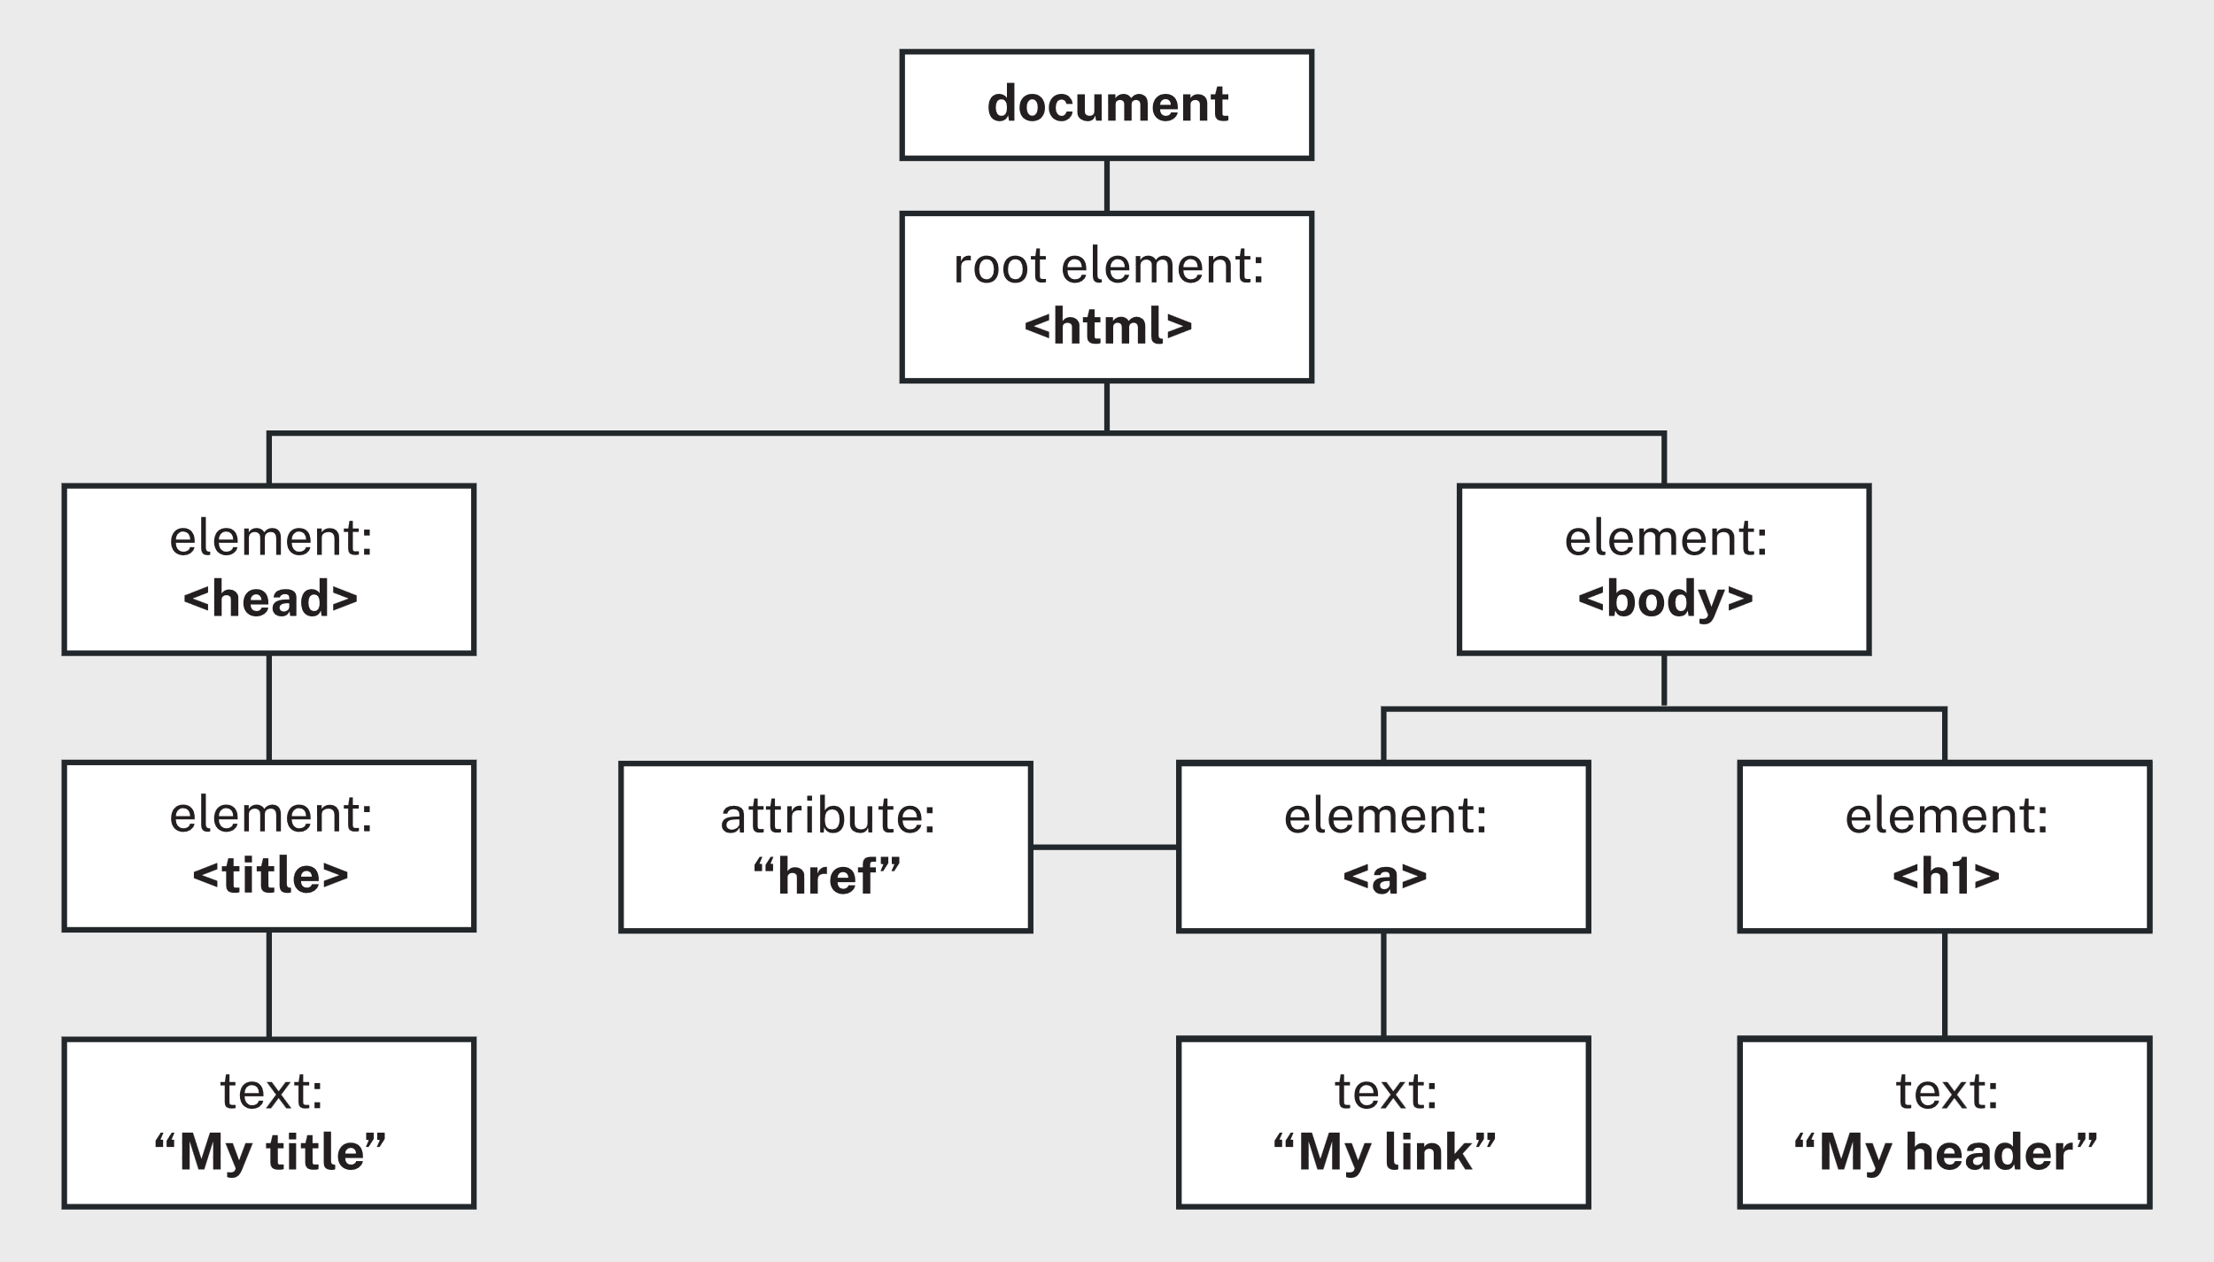
Figure 33: © TAFE NSW 2025
JavaScript can:
- modify any HTML elements on the page
- change HTML attributes, such as src, href, or alt
- update CSS styles applied to elements
- add new HTML elements and attributes
- remove existing HTML elements and attributes
- respond to user interactions and other HTML events.

Why use the DOM?
The DOM exists as a structured representation of an HTML document because directly editing raw HTML strings with JavaScript would be inefficient and prone to errors. The DOM makes this process easier and more efficient for several reasons:
- Live updates: The DOM is 'live.' When JavaScript changes the DOM, those changes are immediately reflected on the webpage. Without the DOM, the entire page would need to reload every time a change occurred.
- Abstraction: The DOM provides an abstract interface for interacting with webpage content. This means developers can manipulate elements without worrying about the underlying HTML syntax.
- Event handling: The DOM includes a built-in system for handling user interactions such as mouse clicks, key presses, or mouse movements. Each element can detect and respond to these events, allowing web pages to become interactive.

Placing the script element
When a web page loads, the browser reads the HTML from top to bottom. If a JavaScript file is placed in the <head> section, the browser will try to run the script before the rest of the page is ready.
At that point, the script might look for elements that haven't been created yet, which causes errors and stops the code from working properly.
There are 2 ways to prevent this issue:
- Use the defer attribute:
<script defer src="script.js"></script>
The defer attribute tells the browser to download the script immediately but only run it after the HTML document has been fully parsed.
In programming, parsing is the process of analysing a string of symbols, like text, code or data, to convert it into a structured, understandable format for a computer.
- Place the <script> element at the end of the <body>:
<body>
<!-- page content here -->
<script src="script.js"></script>
</body>
Placing the script at the bottom ensures all elements are loaded before the script runs.
Both methods allow JavaScript to safely interact with the DOM without errors caused by missing or unloaded elements.

Accessing HTML elements with JavaScript
To work with elements in a webpage, JavaScript needs a way to find them. The DOM provides several methods to locate elements by their id, class, or tag name.
document.getElementById(id)
document.getElementsByClass(class)
document.getElementsByTag(tag name for example, h1)
In the previous example:
- document represents the HTML document within the DOM
- getElementBy methods are used to find HTML elements on the page so you can read or change them.

Example: Accessing an element by ID
Each HTML element can be given an id so it can be identified and changed with JavaScript:
<div id='message'></div>
This id can then be linked to JavaScript using the method:
document.getElementById('message')
Example HTML:
<html>
<head>
<title>A Webpage</title>
<link rel='stylesheet' href='style.css'/>
<script src='script.js'></script>
</head>
<body>
<div id='message'></div>
</body>
</html>
Example JavaScript:
function greetings() {
document.getElementById('message').innerHTML = 'Hi!';
return false;
}

Common properties used with getElementBy methods
Table 14: Common properties used with getElementBy methods
Property | Purpose or description
innerHTML | Gets or sets the HTML content inside an element.
 | document.getElementById("id").innerHTML = "<b>Welcome!</b>";
textContent | Gets or sets the plain text (ignores HTML tags).
 | document.getElementById("id").textContent = "Welcome!";
value | For form fields — gets or sets the user's input or selected value.
 | document.getElementById("name").value = "Shanna";
style | Changes inline CSS for the element.
 | document.getElementsByClass("class").style.backgroundColor = #ADD8EC;
src | For images or scripts — sets the file location.
 | document.getElementById("logo").src = "images/logo.png";
href | For links — sets the URL to navigate to.
 | document.getElementById("link").href = "https://example.com";

Create a simple toggle with JavaScript
A toggle switches an element's state on or off using JavaScript. It works by adding or removing a CSS class when an event (such as a mouse click) occurs.
For example:
element.classList.toggle('active');
This line adds or removes the .active class, depending on its current state. In this example:
- element represents the HTML element being toggled
- classList holds all CSS classes applied to an element
- toggle() adds a class if it isn't present, or removes it if it is.
Practice activity

Activity 32: Apply dark theme toggle
Read the instructions and complete the activity.
- Create a new HTML file and add a button for the dark theme.
  - The button will call a JavaScript function when clicked.
<button type="button" onclick="darkTheme()">Change Theme</button>
- Create a new CSS file and link it to the HTML file.
  - Define 2 styles one for the default theme and one for the dark theme.
- Create a new JavaScript file and link it to the HTML file.
  - Write a function that toggles the dark theme class on the <body> element.
function darkTheme() {
document.body.classList.toggle('dark-theme');
}
- Test your page in your preferred browser.
Practice activity

Activity 33: Apply hamburger menu toggle
Read the instructions and complete the activity.
- Create a new HTML file and add a button and navigation menu:
<button type="button" onclick="toggleMenu()">☰ Menu</button>

<nav id="hamburgerMenu" class="menu">
<a href="#">Home</a>
<a href="#">About</a>
<a href="#">Services</a>
<a href="#">Contact</a>
</nav>
- In your CSS file, hide the menu by default and display it when active.
.menu {
display: none;
flex-direction: column;
}

.menu.open {
display: flex;
}
- In your JavaScript file, add a function to toggle the menu open and closed.
function toggleMenu() {
document.getElementById('hamburgerMenu').classList.toggle('open');
}
- Test the menu in your preferred browser.

Responding to events
An event is something that happens in the browser, such as a user clicking a button, typing on the keyboard, or loading a page. JavaScript allows you to write code to respond to those events.

Event handling
Event handlers allow JavaScript to respond to user actions or browser events. You can attach a JavaScript function to an HTML element so that it runs when a specific event occurs.
Table 15: Common event handlers
Event handler | Description
onchange | Runs when an element's value changes (for example, a form input).
onclick | Runs when the user clicks or taps an element.
onmouseover | Runs when the mouse pointer moves over an element.
onmouseout | Runs when the mouse pointer moves away from an element.
onkeydown | Runs when the user presses a key.
For example:
In HTML: This runs the function myFunction() when the button is clicked.
<button onclick="myFunction()">Click me</button>
In JavaScript: This function runs when the button is clicked and displays a message.
function myFunction() {
alert("Button clicked!");
}

Event listeners
Like event handlers, event listeners also allow JavaScript code to respond to user actions (such as clicks or key presses) or browser events (like when a page finishes loading).
Instead of adding code directly inside HTML tags (for example, onclick="myFunction()"), the preferred way is to attach events in the JavaScript file using:
addEventListener()
The addEventListener() method listens for an event on a specific element and runs a function when that event occurs.
Reasons to use event listeners:
- Separation of concerns: Keeps HTML (structure) and JavaScript (behaviour) separate, making the code easier to read and maintain.
- Scalability: As projects grow, managing multiple inline handlers becomes difficult.
- Multiple event handlers: addEventListener() allows you to attach several actions to the same element.
- Dynamic content: Works better when elements are created or updated dynamically (for example, through JavaScript).
Common event listener names are similar to event handlers, without the word 'on':
Table 16: Common event listeners
Event listener | Description
change | Runs when the value of an input element changes.
click | Runs when the user clicks or taps an element.
mouseover | Runs when the mouse moves over an element.
mouseout | Runs when the mouse leaves an element.
keydown | Runs when a keyboard key is pressed.
load | Runs when the web page finishes loading.
For example:
In HTML:
<button id="myButton">Click me</button>
In JavaScript:
document.getElementById("myButton").addEventListener("click", myFunction);

function myFunction() {
alert("Button clicked!");
}
In the previous example:
- document.getElementById("myButton") finds the button element
- .addEventListener("click", myFunction) listens for a click event and runs myFunction
- myFunction() defines what happens when the button is clicked.

The event object
When an event happens (such as a button click or key press), the browser automatically sends information about that event to your JavaScript code.
This information is stored in an event object, usually called event or e in the code.
The event object contains details about what happened, such as:
- which element triggered the event
- what type of event occurred (for example, click, keydown)
- mouse position, keyboard key and other useful data.
Table 17: Common event properties
Property | Description
event | The object automatically created by the browser that contains information about the event.
event.type | Describes what kind of event occurred (for example, 'click').
event.target | References the DOM element that triggered the event.
event.target.id | Returns the id of the element that triggered the event.
For example:
In the HTML:
<button id="button1">Button 1</button>
<button id="button2">Button 2</button>
In the JavaScript:
document.getElementById("button1").addEventListener("click", showDetails);
document.getElementById("button2").addEventListener("click", showDetails);

function showDetails(event) {
console.log("Event type:", event.type);
console.log("Clicked element ID:", event.target.id);
}
In the previous example, clicking Button 1 or Button 2 logs details about the event to the console.
If Button 1 was clicked and then Button 2 was clicked, the console will display:
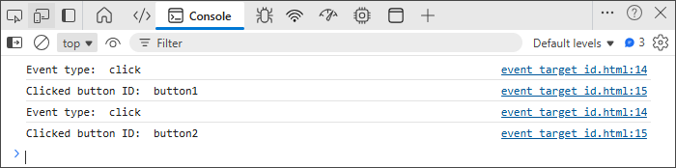
Figure 34: Used with permission from Microsoft
Why it's useful: Using the event object allows one function to handle many elements.
Instead of writing separate functions for each button, you can use event.target to find which one was clicked and respond accordingly.
Practice activity

Activity 34: Develop random hex code colour generator
In this activity, you will create a webpage that uses JavaScript to generate and display random hexadecimal colour codes.
Here are some examples of what your code should output:

Figure 35: © TAFE NSW 2025
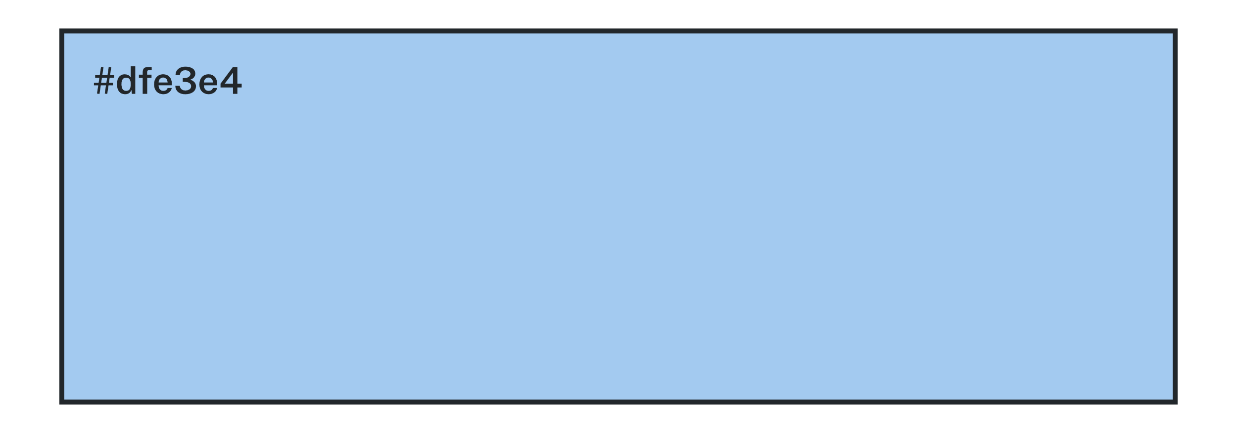
Figure 36: © TAFE NSW 2025
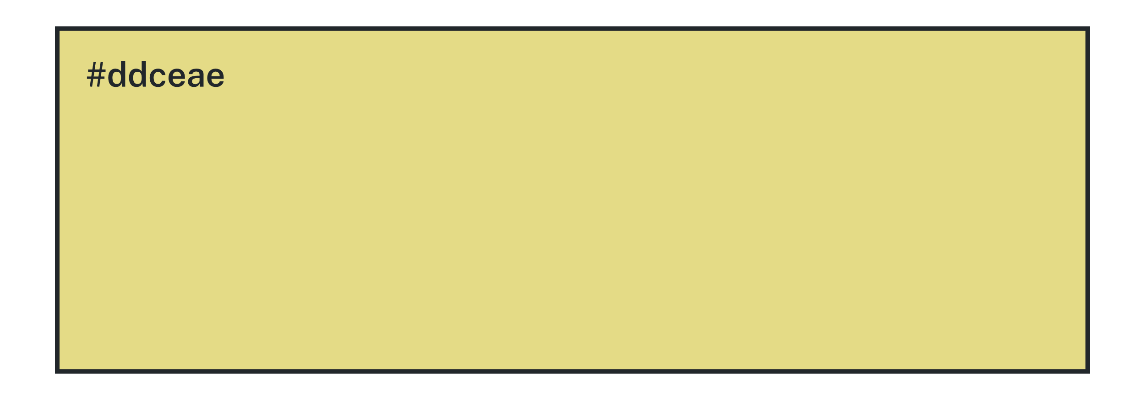
Figure 37: © TAFE NSW 2025
- Create a new JavaScript file called script.js.
  - Inside it, define a function named getRandomHexColor().
  - Add the following lines inside the function body:
// Generate a random number between 0 and 16777215 for hexadecimal
let randomColor = Math.floor(Math.random() * 16777215).toString(16);

// Pad with zeros to ensure it's always 6 characters long
return `#${randomColor.padStart(6, '0')}`;
- Test the function
  - Log the result to the console using console.log(getRandomHexColor());.
  - Each time you refresh, you should see a new colour code appear.
- Create a new HTML file (for example, index.html) and link your JavaScript file
  - Add an element where the colour will display.
- Use the colour code
  - Apply the generated value to the HTML element's style.backgroundColor.
  - Try using a button click or other event to change colours dynamically.
- Create a CSS file
  - Add styling for your box or section (for example, width, height, border). This helps you clearly see the colour changes when testing your JavaScript.
Challenge: Add a few boxes and create your own colour palette generator like Coolors.

Validating data in forms
When you submit a form, the browser automatically tries to send the form data and reloads the page.
However, you often want to check the form data first before it's sent, for example, to make sure a required field isn't blank or an email looks correct. This process is called form validation.

The form submit event
When the submit event occurs, the browser's default action is to send the data and reload the page.
To stop that from happening while you check the input, you use the command:
event.preventDefault();
// or return false
After stopping the default action, you can write code to check if fields are filled in correctly and only continue if the data passes validation.
For example:
In the HTML:
<form id="userForm">
<label for="username">Username:</label>
<input type="text" id="username">
<button type="submit">Submit</button>
</form>

<p id="message"></p>
In the JavaScript:
document.getElementById("userForm").addEventListener("submit", function(event) {
event.preventDefault(); // Stop the form's normal submission

const username = document.getElementById("username").value;

if (username === "") {
document.getElementById("message").innerHTML = "Please enter a username.";
} else {
document.getElementById("message").innerHTML = "Form submitted successfully!";
}
});
In the previous example:
- the submit event occurs when the user clicks or taps the Submit button
- event.preventDefault() stops the page from reloading
- JavaScript checks the value typed into the input box
- if the field is empty, an error message appears
- if it contains text, a success message is shown.

Checking for empty fields
In JavaScript, an empty text box has a value of '' (2 quotation marks with nothing inside). This is called an empty string.
You can check for an empty field using a selection construct, for example:
if (username === "") {
document.getElementById("username-error").textContent = "Username is required.";
isValid = false;
}
In the previous example:
- '' means the input is empty
- the if statement checks if the box has text
- the message changes depending on the result.

Simple email validation
The .includes() method is useful for email validation as it checks whether a string contains certain characters.
For example:
if (email === "" || !email.includes("@") || !email.includes(".")) {
document.getElementById("email-error").textContent = "Valid email is required.";
isValid = false;
}
In the previous example:
- email === "" checks if the field is blank.
- .includes("@") checks if the text contains the @ character.
- .includes(".") checks if it contains a dot.
- ! means not, for example, !email.includes("@") means the email does not include @.

Three ways to handle JavaScript events
Each of the following examples performs the same task – when you hover over a book link, information about that book appears underneath. The only difference is how the event is written.

Using an inline event handler (in HTML)
The function is called directly from the HTML element.
In the HTML:
<h1>Welcome to the Book Shop</h1>

<a id='fantasy' onmouseover='displayInfo(event)' href='#'>Fantasy</a>
<a id='scifi' onmouseover='displayInfo(event)' href='#'>Sci-Fi</a>

<div id='display'></div>
In the JavaScript:
function displayInfo(event) {
let info;

if (event.target.id === 'fantasy') {
info = 'This is a fantasy book.';
} else if (event.target.id === 'scifi') {
info = 'This is a science fiction book.';
}

document.getElementById('display').innerHTML = info;
}
The event is written directly in the HTML tag using onmouseover.

Using an event listener with a named function
The event is added in the JavaScript file using addEventListener() and the function is defined separately.
For example:
In the HTML:
<h1>Welcome to the Book Shop</h1>

<a id="fantasy" href="#">Fantasy</a>
<a id="scifi" href="#">Sci-Fi</a>

<div id="display"></div>
In the JavaScript:
function displayInfo(event) {
let info;

if (event.target.id === "fantasy") {
info = "This is a fantasy book.";
} else if (event.target.id === "scifi") {
info = "This is a science fiction book.";
}

document.getElementById("display").innerHTML = info;
}

document.getElementById("bookDetails").addEventListener("mouseover", displayInfo);
The HTML stays clean and the same function can be reused for other events.

Using an event listener with an anonymous function
Instead of creating a separate named function, the function is written directly inside the event listener.
For example:
In the HTML:
<h1>Welcome to the Book Shop</h1>

<a id="fantasy" href="#">Fantasy</a>
<a id="scifi" href="#">Sci-Fi</a>

<div id="display"></div>
In the JavaScript:
document.getElementById("bookDetails").addEventListener("mouseover", function(event) {
let info;

if (event.target.id === "fantasy") {
info = "This is a fantasy book.";
} else if (event.target.id === "scifi") {
info = "This is a science fiction book.";
}

document.getElementById("display").innerHTML = info;
});
This is called an anonymous function. It has no name and exists only inside the event listener. It's useful when the function will only be used once.
Practice activity

Activity 35: Display skills on your portfolio website
Enhance the Home page by rendering your skills list in the page and wiring buttons to your existing functions:
- insertAt
- removeAt
- linearSearch
- binarySearch.
Steps 1 to 5 show you how to add the insertion algorithm. Then complete step 6 to extend it for Delete and Search.
- Add this section to index.html (Home page). Place your script with defer or before </body>.
<section id="skills-section">
<h2>My Current Skills</h2>

<!-- The skills will appear inside this paragraph -->
<p id="skillsList"></p>

<!-- Simple form for adding a new skill -->
<form id="insertForm">
<input id="skillInput" placeholder="Add a new skill">
<button type="submit">Add Skill</button>
</form>

<!-- Area for messages such as errors or confirmations -->
<p id="message"></p>
</section>
- In home.js, keep your arrays, functions and algorithms that you previously added.
- Get DOM elements with getElementById() and write a render function.
const skillsList = document.getElementById("skillsList");
const insertForm = document.getElementById("insertForm");
const skillInput = document.getElementById("skillInput");
const message = document.getElementById("message");
- Write a render function for displaying the skills array as a list:
function renderSkills() {
// join("<br>") adds a line break between array items.
skillsList.innerHTML = techSkills.join("<br>");
}

// Show the current skills as soon as the page loads
renderSkills();
- Add an event listener to validate and update the element:
insertForm.addEventListener("submit", function(event) {
event.preventDefault();
const newSkill = skillInput.value.trim(); // get value from form

if (newSkill === "") { // Check for empty input
message.textContent = "Please enter a skill.";
return;
}
// Use your algorithm
insertAt(techSkills, techSkills.length, newSkill);

renderSkills(); // Update what's shown on the page
message.textContent = `"${newSkill}" added.`; // Feedback for user
skillInput.value = ""; // Clear the input box
});
- Update your Skills list with the algorithm functionality:
  - Create buttons and inputs for Delete, Search and optionally Sort (A–Z).
  - Use your existing functions removeAt(), linearSearch() and binarySearch() to make each button work.
  - Each button should call its corresponding function, update the array and display the new results using renderSkills().
  - Use the message element to show feedback such as 'Item deleted', 'Found at index 2', or 'Not found'.
Self-check

How did you go?
You have completed the lesson: Manipulating the HTML DOM using JavaScript. Check the boxes for the tasks you feel confident you can complete.
☐ I can integrate code into a website to process and manipulate data.
Assessment

Assessment 2 of 2: Project Part 6
As you have completed this lesson, you should be ready to start Assessment 2 of 2: Project Part 6.
If your assessments are online, go to Assessments in the top menu and access the files.
Note: To access the entire assessment, you must download and save each part separately.

Lesson 6:
Testing your website

Overview
Functional testing should happen throughout the website development process. It’s more effective to test and troubleshoot individual components as they’re added, instead of replicating code and potential errors on to multiple pages.
Once the website is complete, you’ll then need to do a thorough test following a test plan to make sure it meets industry standards and user requirements.
In this lesson, you will learn to:
- test a website following a test plan to confirm it meets specifications
- record test results according to organisational requirements
- correct issues resulting from testing.

Why follow a test plan?
A test plan provides a structured approach to testing. It outlines the following:
- Test cases: Specific scenarios to check, for example, navigation links, form submissions, responsive layout.
- Expected results: What should happen when the test case is executed.
- Actual results: What happens during testing.
Following a test plan helps maintain consistency, ensures all features are tested and makes it easier to identify and fix issues.

Steps to test and record results
Follow these steps to test your website according to the test plan.

Review the test plan
- Access the previously created test plan and understand each test case.
- Confirm the expected outcomes for each scenario.

Perform each test case
- Use different browsers and devices (or simulators) as outlined in the plan.
- Check functionality such as links, forms, media and interactive elements.
- Verify layout and styling across screen sizes.

Record the results
For each test case:
- note whether the actual result matches the expected result
- if there is a discrepancy, describe the issue clearly, for example, 'Image does not resize on mobile view'
- mark the test as Pass or Fail.

Document issues and fixes
- Create a list of failed test cases.
- Suggest or apply fixes, then retest to confirm resolution.
Here is the test plan example from the previous section on developing test plans:
Table 18: Example test plan
Test ID | Test name | Summary | Expected result | Testing schedule (if applicable)
001 | Navigation menu | Check all links in the Navigation menu | Menu links open correct pages | Week 3
002 | Submit contact form correctly | Input all fields in the contact form with correct data and submit | Form sends data successfully | Week 4
003 | Submit contact form incorrect email | Input all fields in the contact form with incorrectly formatted email address and submit | Form displays error message about format of email address | Week 4
Here is an example of a record of the results for those test cases:
Table 19: Example test results
Test ID | Test results | Screenshots of testing or relevant comments | Test outcome  (pass or fail)
001 | All links work except for 'About me' | (screenshot) | Fail
002 | Form submits and displays success message | (screenshot) | Pass
003 | Form displays error message 'Email address is not in a valid format' | (screenshot) | Pass

Best practices when testing websites
- Test on multiple browsers (Chrome, Firefox, Safari, Edge) or browser simulators.
- Use responsive design tools or simulators for mobile and tablet views.
- Validate HTML and CSS after changes to ensure standards compliance.
- Keep detailed notes for future reference or client reporting.
Practice activity

Activity 36: Test your portfolio website
Continue with the Scenario: Portfolio website.
Test your portfolio website using the test plan you created in Activity 10: Create a test plan. Record your results in Table 2 – Test results in the Results section of the report, adding rows to the table as required.
- Copy the Test IDs from Table 1 – Test plan into the Test ID column in Table 2 – Test results.
- Run each test case and record the following:
  - Test results: Describe what happened when you performed the test.
  - Screenshots of testing or relevant comments: Include a screenshot of the test.
  - Test outcome (pass or fail): Indicate whether the test passed or failed according to the expected results.

Self-check

How did you go?
You have completed the lesson: Testing your website. Check the boxes for the tasks you feel confident you can complete.
☐ I can test a website following a test plan to confirm it meets specifications.
☐ I can record test results according to organisational requirements.
☐ I can correct issues resulting from testing.
Assessment

Assessment 2 of 2: Project Part 3-7
As you have completed this lesson, you should be ready to complete Assessment 2 of 2: Project Part 3-7.
If your assessments are online, go to Assessments in the top menu and access the files.
Note: To access the entire assessment, you must download and save each part separately.

Lesson 7:
Finalising your website

Overview
Finalising a website is the last critical stage before launch, ensuring that the product meets agreed requirements and is ready for use. This process involves finalising the test results, making any updates as required, producing complete documentation for ongoing maintenance and obtaining user acceptance on the completed website.
In this lesson, you will learn to:
- document a website using different documentation techniques
- provide documented test results to the user or client
- explain any outstanding issues and corrections to be made
- achieve user acceptance.

Producing final documentation
Providing clear documentation ensures that the client or internal team can manage and maintain the website effectively after launch. There are several techniques that can be used to document your programming.

Test documentation
Before handing over the website, compile and share detailed test results. These should be based on a test plan that was developed at the start of the project. This should outline any outstanding issues and corrective actions that need to be taken.
Presenting these results demonstrates that the site has been validated against the original specifications and helps build confidence in its quality.

Readme files
Code that is distributed or made available for others to use is often accompanied by a ‘readme’ file, which is typically a text or HTML file. The readme file is aimed at the installers and users of the script. Its purpose depends on the nature and complexity of the code being distributed.
For example, readme files may contain:
- version and licence information
- system requirements
- installation and upgrade notes
- operating system information
- location and installation of, or access to, documentation
- new features for upgraded software
- code corrections or bug fixes
- troubleshooting advice.
For simple scripts, a readme file would often contain a usage statement and may include required inputs and a description of the expected output.

Generated documentation
Previously you learned how to add JSDoc comments in your JavaScript code. You can now generate the final documentation in HTML form.
- Run the documentation generator on the command line or terminal using the name of your JavaScript file.
For example:
jsdoc yourFile.js
This command will create a directory named 'out/' in the current working directory and a file called 'index.html', which is the generated documentation.

Achieving user acceptance
The handover process should include a clear explanation of any outstanding issues or limitations identified during testing. Transparency is essential; stakeholders need to understand what works well and what may require future attention. This discussion often includes prioritising issues and agreeing on timelines for fixes or enhancements.
If testing reveals problems that prevent user acceptance, work with stakeholders to agree on corrective actions. These might include minor bug fixes, content updates, or adjustments to functionality. Document these actions and ensure they're completed before final approval or launch.
User acceptance should be obtained in writing. This could be in an email or often approval documents will include a space for a signature. An example of this is the Gelos Software Test Report (docx), which includes a section for approving the software for installation.
Practice activity

Activity 37: Check your knowledge of finalising your website
Read each question and select the correct answers.
- Match the documentation technique to the scenario that best suits it. Indicate the correct letter.
Scenario | Answer | Documentation technique
Including detailed information in the code, which starts with '/**' and end with '*/' |  | - Readme files
Recording whether the website meets client requirements |  | - Inline comments
A piece of information in the code, which starts with '//' |  | - Comment blocks
Providing information to the client about the system, such as operating system requirements installation instructions |  | - Generated documentation
Including multiple lines of information in the code, which start with '/*' and end with '*/' |  | - Test documentation
- Select the 2 best options for achieving user acceptance of a website.
# | Choices | Answers
 | Ask the client to reply with their acceptance in an email | ☐
 | Ask the client to shake hands to indicate acceptance | ☐
 | Ask the client to sign the user acceptance section of the test plan | ☐
 | Ask the client to respond verbally in a meeting | ☐

Self-check

How did you go?
You have completed the lesson: Finalising your website. Check the boxes for the tasks you feel confident you can complete.
☐ I can document a website using documentation techniques.
☐ I can provide documented test results to the user or client.
☐ I can explain any outstanding issues and corrections to be made.
☐ I can achieve user acceptance.
Assessment

Assessment 1 of 2: Knowledge Part 2
As you have completed this lesson, you should be ready to complete Assessment 1 of 2: Knowledge Part 2.
If your assessments are online, go to Assessments in the top menu and access the files.

Assessment 2 of 2: Project Part 8
As you have completed this lesson, you should be ready to complete Assessment 2 of 2: Project Part 8.
If your assessments are online, go to Assessments in the top menu and access the files.
Note: To access the entire assessment, you must download and save each part separately.

Answers and feedback

Lesson 1
Activity 1: Interpret organisational documents
- A, C
- A, C, D
- A, B, D
- B
- A, C
Activity 2: Discuss accessibility, usability and inclusion
Here are some things you may have discussed:
Web accessibility means designing and developing websites so that people with disabilities (such as visual, auditory, motor, or cognitive impairments) can perceive, understand, navigate and interact with the content effectively. It’s about removing barriers and ensuring equal access for everyone.
Usability refers to how easy and efficient a website is for all users to accomplish their goals. A usable site is intuitive, clear and responsive, allowing visitors to find information quickly without frustration. It focuses on user experience, simplicity and functionality.
Different types of web users to consider:
- People with visual impairments (blind, low vision, or colour blindness) who may rely on screen readers or high-contrast settings.
- People with hearing impairments who need captions or transcripts for audio or video content.
- People with motor disabilities who may use keyboard navigation or assistive devices instead of a mouse.
- People with cognitive or learning disabilities who benefit from clear language, consistent layouts and minimal distractions.
- Users with temporary limitations, for example, broken arm, noisy environment.
- Users with slow internet connections or older devices who need lightweight, fast-loading pages.
- Mobile users who access sites on smaller screens and touch interfaces.
- Multilingual users who may need language options or simple wording.
Activity 3: Use browser accessibility tools
How did you go with this activity? Ask your teacher for feedback if needed.
Activity 4: Practise using digital tools for creating site maps
How did you go with this activity? Ask your teacher for feedback if needed.
Activity 5: Create a site map for your portfolio
The site map for your portfolio is very simple, as it only includes 3 pages. Here's an example:
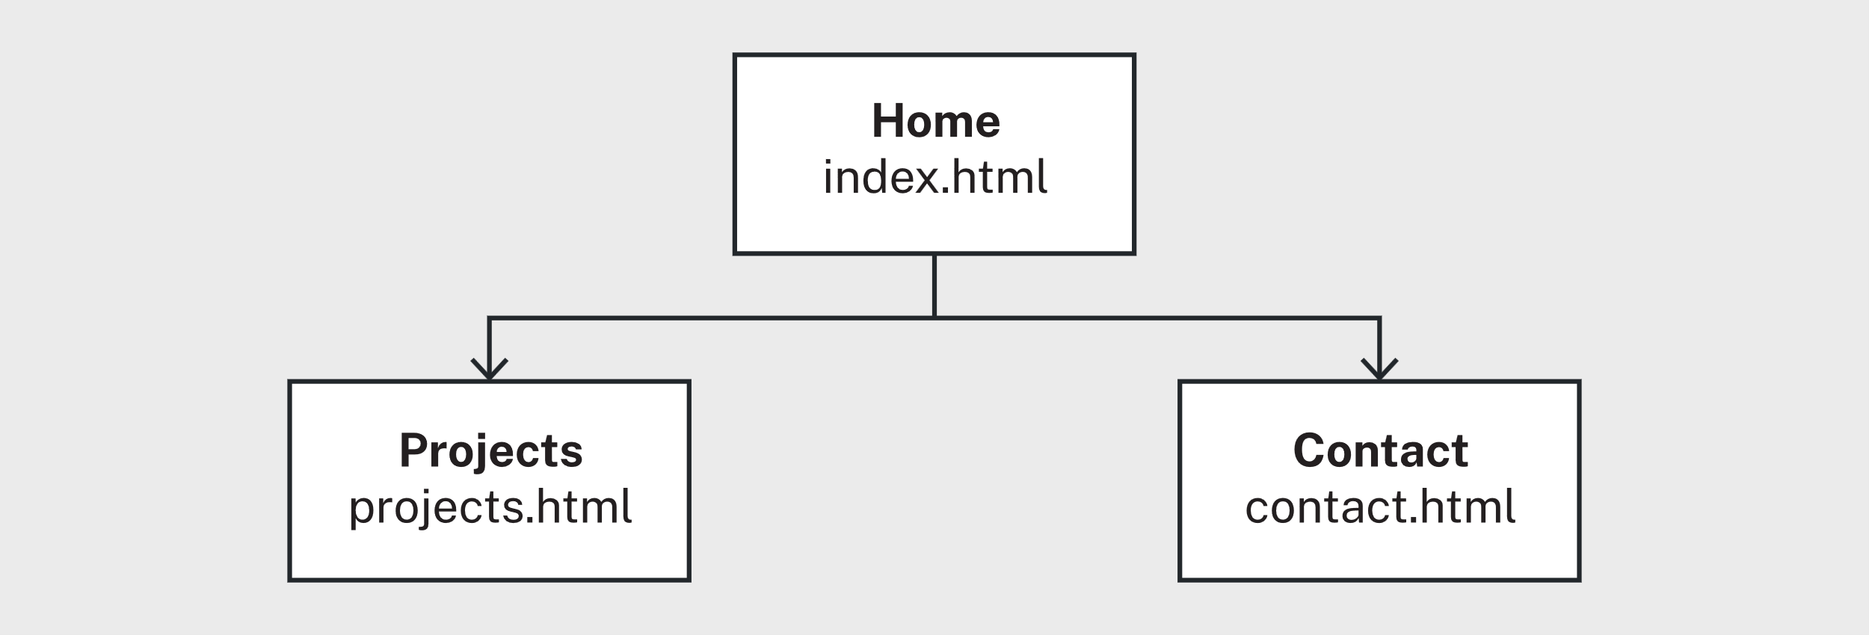
Figure 38: © TAFE NSW 2025
Activity 6: Practise using digital tools for wireframes
How did you go with this activity? Ask your teacher for feedback if needed.
Activity 7: Create a wireframe
Review your wire frames. Did you include:
- Header: logo and navigation menu
- Main content: image placeholders, text blocks
- Footer: contact links or copyright.
Activity 8: Discuss markup languages to meet requirements
Here are some things you may have discussed:
The best markup language for this portfolio website would be HTML. It is the current standard for structuring web content and works seamlessly with CSS and JavaScript to create responsive, interactive websites. HTML also supports semantic elements, which improve accessibility and SEO.
Why it meets the website requirements:
- Responsive layout: HTML works with CSS3 media queries and frameworks like Flexbox or Grid to create layouts that adapt to different screen sizes, ensuring the site looks professional on both desktop and mobile.
- Style guide compliance: HTML allows easy integration of custom fonts and colours specified in the Gelos Style Guide through CSS.
- Working contact form: HTML provides built-in form elements and attributes (like required, email and placeholder) that make creating and validating forms straightforward.
- Accessibility and usability: Semantic tags like <header>, <nav>, <main> and <footer> improve screen reader compatibility and overall user experience.
- Coding and testing guidelines: HTML is widely supported and aligns with modern coding standards, making it easier to follow Gelos’ guidelines.
Activity 9: Use testing tools
How did you go with this activity? Ask your teacher for feedback if needed.
Activity 10: Create a test plan
There are many test cases that you could include. Here's an example, yours may be different:
Table 20: Example test plan answers
Test ID | Test name | Summary | Expected result | Testing schedule (if applicable)
TC-001 | Home page loads correctly | Verify that the Home page displays header, navigation and intro text using Gelos fonts and colors. | Home page loads without errors; all elements visible; styling matches Gelos guide. | Week 2
TC-002 | Navigation links work | Click navigation links (Home, Projects, Contact) and verify correct pages load. | Each link opens correct page without broken links or errors. | Week 3
TC-003 | Projects page displays content | Navigate to Projects page and verify thumbnails, descriptions and links are displayed correctly. | All projects visible, clickable and formatted per Gelos Style Guide. | Week 3
TC-004 | Contact form validation | Enter invalid data (for example, missing email) and submit. Check if validation messages appear. | Form prevents submission; appropriate error messages displayed. | Week 4
TC-005 | Contact form submission | Fill in valid data and submit. Verify successful submission or confirmation message. | Form submits without errors; success message displayed. | Week 4
TC-002 | Responsive layout on mobile | Simulate mobile view and check if layout adjusts properly (menu collapses, text and images resize). | Layout adapts to mobile; no overlapping elements; navigation accessible. | Week 5
Activity 11: Identify and refine work outcomes
It’s important to practise your client communication skills to ensure that you use the right language and practise asking questions. If you used the Pi app, keep practising and change your answers each time according to the feedback you have been given.

Lesson 2
Activity 12: Discuss IDEs
Here are some things you may have discussed.
There are several popular IDEs widely used by developers:
- Visual Studio Code (VS Code): Lightweight, highly customisable and supports many languages through extensions.
- IntelliJ IDEA: Great for Java and other JVM-based languages, with powerful debugging and refactoring tools.
- Eclipse: Commonly used for Java development, with a large plugin ecosystem.
- PyCharm: Designed for Python development, offering excellent code navigation and debugging.
- NetBeans: Another Java-focused IDE, also supports PHP and C++.
- Xcode: Used for iOS and macOS app development.
- Android Studio: Official IDE for Android app development.
Some IDEs you may have used:
Visual Studio Code
- What I liked: It’s fast, lightweight and has a huge library of extensions. The integrated terminal and Git support make workflow smooth.
- Challenges: Sometimes configuring extensions for specific frameworks can be tricky, and performance can slow down with too many plugins.
PyCharm
- What I liked: Excellent for Python projects, with smart code completion and debugging tools.
- Challenges: It can feel heavy and slow to start compared to VS Code and some advanced features require the paid version.
Activity 13: Discuss attributes
Here are some things you may have discussed:
The href attribute is used in HTML to specify the URL of a resource that the user can navigate to, such as a link to another webpage or an external site. It is commonly used in <a> (anchor) tags.
The src attribute, on the other hand, is used to specify the source of an embedded resource that should be displayed or executed within the current page, such as an image, video, or script. It is commonly used in tags like <img>, <script>, and <iframe>.
When to use each:
- Use href when you want to create a hyperlink that takes the user to another page or resource.
- Use src when you want to embed or display content from a source within your page.
Activity 14: Create an HTML template file
Here's an example answer:
<!DOCTYPE html>
<html>
<head>
<meta charset='UTF-8'>
<meta name='viewport' content='width=device-width, initial-scale=1.0'>
<title>This is my portfolio</title>
</head>
<body>
<header>
</header>
<main>
</main>
<footer>
</footer>
</body>
</html>
Activity 15: Build the structure of your portfolio website
Download and unzip the sample answer Portfolio structure (zip) – yours may be different.

Lesson 3
Activity 16: Practise CSS at W3Schools
How did you go with this activity? Ask your teacher for feedback if needed.
Activity 17: Create a CSS template
Sample CSS code:
body {
font-family: Helvetica, Calibri, Arial, sans-serif;
}
Activity 18: Compare your website
Here are some things you may have discussed:
Do they look the same?
- Your pages should look similar because you should be following the Gelos colour scheme and font styles.
- Your pages may look different if you used different colour schemes, fonts and layout styles in your CSS templates.
How can you tell if your CSS file is working correctly?
- If the styles you defined in the CSS file, such as colours, fonts and margins, are applied to the HTML elements, then the CSS is working correctly.
- You can check by inspecting the page in the browser’s developer tools to confirm that the CSS file is linked and the rules are being applied.
- If you make a change in the CSS file (like changing the background colour) and see the update immediately on the page after refreshing, then the CSS is functioning properly.
Activity 19: Visualise the box model
Here is some example CSS, yours may be different:
section {
background-color: lightblue;
background-color: #ADD8E6;
width: 80%;
height: 40vh;
margin: 2rem;
padding: 1em;
border: 2px solid black;
}
Activity 20: Use floats
How did you go with this activity? Ask your teacher for feedback if needed.
Activity 21: Convert a float layout to flexbox
Download and unzip the sample answer Float layout to flexbox (zip). Note that there are multiple ways to achieve the same result using flexbox, here are some examples.
Using Flex-basis:
.container {
display: flex;
}

.item {
flex-basis: 45%;
}
Or using justify-content:
justify-content: space-between;
Or using gap:
display: flex;
align-items: center;
gap: 20px;
Activity 22: Create a grid rainbow box
Download and unzip the sample answer Grid rainbow box (zip) – yours may be different.
Activity 23: Apply responsive design to a webpage
How did you go with this activity? Ask your teacher for feedback if needed.
Activity 24: Apply responsive design to your portfolio website
How did you go with this activity? Ask your teacher for feedback if needed.

Lesson 4
Activity 25: Read, write and fix JavaScript code
Here is some example code, yours may be different:
// 1. Read the code
// Task: Run the code below to see the result in your browser console.
let greeting = "Hello";
let user = "Liam";
console.log(`${greeting}, ${user}!`);

// 2. Write the code
// Task: Create 2 variables, one for your name and one for your favourite colour.
// Then use console.log() to display a sentence such as:
// "My name is Ava and my favourite colour is blue."

// Write your code here
let myName = "Ivy";
let colour = "blue";
console.log(`My name is ${myName} and my favourite colour is ${colour}.`);

// 3. Fix the code
// Task: Uncomment the code and correct all mistakes so it runs correctly.
/*
let Number1 = 10
let number2 = "5";
console.log("The total is: ${Number1 + Number2}");
*/

// Manually convert 5 to an integer or cast it
let number1 = 10;
let number2 = 5;
console.log(`The total is: ${number1 + number2}`);
Activity 26: Use operators
- The values of the variables in the code are calculated as follows:
Calculating c:
- c = a - b (subtract b from a)
- the values of a and b are already known as 4 and 3, so c = 4 - 3
- c = 1.
Calculating d:
- d = c ** b (c to the power of b)
- d = c^{b}
- the values of c and b are already known as 1 and 3, so d = 1³
- d = 1 (1³ is the same as 1 * 1 * 1, which equals 1).
Calculating e:
- e = d * a (multiply d by a)
- the values of d and a are already known as 1 and 4, so e = 4.
- total = 16. The addition is performed first because it's contained in parentheses, which are prioritised before multiplication.
Activity 27: Predict the count value
Table 21: Predict the count activity
Loop iteration | count before | output shown | count after
1 | 3 | Countdown: 3 | 2
2 | 2 | Countdown: 2 | 1
3 | 1 | Countdown: 1 | 0
4 | 0 | Countdown: 0 | -1
The code runs while the condition is greater than or equal to 0, so the loop iterates 4 times.
Did your code work correctly?
Activity 28: Develop the logic for a mini game
Here is some example code, yours may be different:
let tickets = [3, 7, 1, 7, 4];

// Step 1 and 2
for (let i = 0; i < tickets.length; i++) {
if (tickets[i] == 7) {
console.log("Winner!");
} else {
console.log("Try again.");
}
}
Activity 29: Convert a function to an arrow function
Here is some example code, yours may be different:
const squareArrow = (num) => {
return num * num;
};

console.log(squareArrow(4)); // Expected output: 16

// Optional shorter solution:
const squareArrow = num => num * num;
Activity 30: Check your knowledge of troubleshooting and debugging
- C
- B
- A
- C
- C
- D
- A
Activity 31: Add interactivity to your portfolio website
Create and link your JavaScript file:
Two arrays:
const techSkills = ["HTML", "CSS", "JavaScript", "React"];
const softSkills = ["Communication", "Problem Solving", "Teamwork", "Adaptability"];
let isSorted = false;
Write and complete the algorithms in home.js:
function insertAt(arr, index, value) {
for (let i = arr.length; i > index; i--) arr[i] = arr[i - 1];
arr[index] = value;
}

function removeAt(arr, index) {
for (let i = index; i < arr.length - 1; i++) arr[i] = arr[i + 1];
arr.length = arr.length - 1;
}

function linearSearch(arr, value) {
for (let i = 0; i < arr.length; i++) {
if (arr[i] === value) return i;
}
return -1;
}

function binarySearch(arr, value) {
let low = 0;
let high = arr.length - 1;
while (low <= high) {
const mid = Math.floor((low + high) / 2);
if (arr[mid] === value) return mid;
if (arr[mid] < value) low = mid + 1;
else high = mid - 1;
}
return -1;
}
Test your algorithms:
- Test the algorithms using the following test:
  - Insert: Use insertAt() to add a new skill to an array and view the result.
insertAt(techSkills, techSkills.length, "Python");
console.log(techSkills);
  - Delete: Use removeAt() to remove a skill at a chosen index.
removeAt(softSkills, 1);
console.log(softSkills);
  - Search: Use linearSearch() or binarySearch() to find a skill.
linearSearch(techSkills, "CSS"); // works for unsorted lists
binarySearch(techSkills, "HTML"); // works only after sorting (next)
  - Sort (optional): Sort the array to test binary search.
techSkills.sort();

Lesson 5
Activity 32: Apply dark theme toggle
How did you go with this activity? Ask your teacher for feedback if needed.
Activity 33: Apply hamburger menu toggle
How did you go with this activity? Ask your teacher for feedback if needed.
Activity 34: Develop random hex code colour generator
Download and unzip the sample answer Hex code colour generator (zip) – yours may be different.
Activity 35: Display skills on your portfolio website
Download and unzip the sample answer Display skills on portfolio (zip) – yours may be different.

Lesson 6
Activity 36: Test your portfolio website
Answers will vary depending on your test plan and your code. Refer to the table of example test results to see the type of information you should include.

Lesson 7
Activity 37: Check your knowledge of finalising your website
- D, E, B, A, C
- A, C

References and attributions

References
BBC. (2025). The function of structural components of programs - Edexcel. Retrieved November 20, 2025, from BBC: https://www.bbc.co.uk/bitesize/guides/z433rwx/revision/1

Image attributions
Table 22: Image attributions
Title | Creator | Licence | Modified/By
Cover image – Adobe Stock 375315317 | Unknown | © Adobe Stock copied under licence | N/A
Figure 7 – Getty image 1253774851 | Unknown | © Getty Images modified under licence | TAFE NSW
Figure 10 – Screenshot from validator.w3.org | W3C | Copied under s113P, W3C, https://validator.w3.org, accessed 12/12/2025 | N/A
Figure 23 – Screenshot from validator.w3.org | W3C | Copied under s113P, W3C, https://validator.w3.org, accessed 12/12/2025 | N/A
Figure 24 – Getty image 1138858214 | Unknown | © Getty Images modified under licence | TAFE NSW

Appendix: Links
Below is a list of all URLs linked in this workbook.
Table 23: URLs
Link title | URL
@use JSDoc | https://jsdoc.app/
Accessibility, Usability, and Inclusion | https://www.w3.org/WAI/fundamentals/accessibility-usability-inclusion/
Active listening | https://www.linkedin.com/learning/facilitation-skills-for-managers-and-leaders/active-listening?resume=false&u=57684225
Activity files (zip) | https://share.tafensw.edu.au/share/items/2fca9229-cf58-41b2-a256-1a59bd7bd0b1/0/?attachment.uuid=46e9bf33-25be-4488-ac30-263c40e884db
Adobe Color | https://color.adobe.com/
Array | https://developer.mozilla.org/en-US/docs/Web/JavaScript/Reference/Global_Objects/Array
Ask powerful questions | https://www.linkedin.com/learning/facilitation-skills-for-managers-and-leaders/ask-powerful-questions?resume=false&u=57684225
Balsamiq | https://balsamiq.com/
Browserling | https://www.browserling.com/
Browserling Tutorial for Beginners | https://qa.world/browserling-tutorial-for-beginners/
Colorblind Web Page Filter | https://www.toptal.com/designers/colorfilter
Coolors | https://coolors.co/
Cross Browser Testing Quick Demo | How To Perform Cross Browser Testing With LambdaTest | https://www.youtube.com/watch?v=na07BInGXpM
CSS Borders | https://www.w3schools.com/css/css_border.asp
CSS Box Model | https://www.w3schools.com/css/css_boxmodel.asp
CSS Comments | https://www.w3schools.com/css/css_comments.asp
CSS Errors | https://www.w3schools.com/css/css_errors.asp
CSS Flex Container Properties | https://www.w3schools.com/css/css3_flexbox_container.asp
CSS Flexbox (Flexible Box Layout) | https://www.w3schools.com/css/css3_flexbox.asp
CSS Grid Items | https://www.w3schools.com/css/css_grid_item.asp
CSS Grid Layout | https://www.w3schools.com/css/css_grid.asp
CSS Grid vs. Flexbox: Which should you use and when? | https://webdesign.tutsplus.com/articles/flexbox-vs-css-grid-which-should-you-use--cms-30184
CSS Height, Width and Max-width | https://www.w3schools.com/css/css_dimension.asp
CSS Introduction | https://www.w3schools.com/css/css_intro.asp
CSS Margins | https://www.w3schools.com/css/css_margin.asp
CSS Media Queries - Examples | https://www.w3schools.com/css/css3_mediaqueries_ex.asp
CSS Padding | https://www.w3schools.com/css/css_padding.asp
CSS position property | https://www.w3schools.com/cssref/pr_class_position.php
CSS Reference | https://www.w3schools.com/cssref/index.php
CSS Selectors | https://www.w3schools.com/css/css_selectors.asp
CSS Specificity | https://www.w3schools.com/css/css_specificity.asp
CSS Syntax | https://www.w3schools.com/css/css_syntax.asp
CSS The !important Rule | https://www.w3schools.com/css/css_important.asp
CSS Tutorial | https://www.w3schools.com/css/default.asp
CSS Validation Service | https://jigsaw.w3.org/css-validator/
CSS Zen Garden | https://www.csszengarden.com/
Deadlink Checker | https://www.deadlinkchecker.com/
Debug code with Visual Studio Code | https://code.visualstudio.com/docs/debugtest/debugging
Debugging HTML | https://www.linkedin.com/learning/html-for-programmers/debugging-html?resume=false&u=57684225
diagrams.net | https://app.diagrams.net/
Display skills on portfolio (zip) | https://share.tafensw.edu.au/share/items/2fca9229-cf58-41b2-a256-1a59bd7bd0b1/0/?attachment.uuid=4242af62-0e79-4b47-af16-5688b2f93e0a
DSA Binary Search | https://www.w3schools.com/dsa/dsa_algo_binarysearch.php
DSA Linear Search | https://www.w3schools.com/dsa/dsa_algo_linearsearch.php
Emulate and test other browsers | https://learn.microsoft.com/en-us/microsoft-edge/devtools/device-mode/testing-other-browsers
Emulate dual-screen and foldable devices | https://learn.microsoft.com/en-us/microsoft-edge/devtools/device-mode/dual-screen-and-foldables
Emulate mobile devices (Device Emulation) | https://learn.microsoft.com/en-us/microsoft-edge/devtools/device-mode/
Emulate rendering on other devices | https://www.linkedin.com/learning/learning-chrome-web-developer-tools-2/emulate-rendering-on-other-devices?resume=false&u=57684225
ESLint | https://eslint.org/
Extensible Markup Language (XML) 1.0 (Fifth Edition) | https://www.w3.org/TR/xml/
Figma | https://www.figma.com/
Flexbox Alignment Overview | https://www.linkedin.com/learning/responsive-layout/flexbox-alignment-overview?resume=false&u=57684225
Float layout to flexbox (zip) | https://share.tafensw.edu.au/share/items/2fca9229-cf58-41b2-a256-1a59bd7bd0b1/0/?attachment.uuid=27226b97-daa1-4b7c-be90-b983e71429bb
Gelos Coding and Testing Guidelines (pdf) | https://share.tafensw.edu.au/share/items/5b8d7262-59f2-4d6e-b775-7ecae35665a7/0/?attachment.uuid=29fb5c49-ee24-4648-8b96-a26df7a92f61
Gelos Software Test Report (docx) | https://share.tafensw.edu.au/share/items/02285ff1-cfb2-4af4-b402-fdc23bf4bf11/0/?attachment.uuid=074bd9cc-f9e2-46fc-81ad-a43cc32c218e
Gelos Style Guide Company (pdf) | https://share.tafensw.edu.au/share/items/5f1cec7b-1d03-446a-85b7-edb42692c34e/0/?attachment.uuid=7f4fb7d3-3c6e-4e89-ad1b-2443d7e7b2fe
Gelos Website Development Policy and Procedure (pdf) | https://share.tafensw.edu.au/share/items/5f1cec7b-1d03-446a-85b7-edb42692c34e/0/?attachment.uuid=c472c865-44cd-4db0-aa7c-20781257db5a
Grid Alignment Overview | https://www.linkedin.com/learning/responsive-layout/grid-alignment-overview?resume=false&u=57684225
Grid rainbow box (zip) | https://share.tafensw.edu.au/share/items/2fca9229-cf58-41b2-a256-1a59bd7bd0b1/0/?attachment.uuid=67258ac3-a3e9-48cf-8b6c-62695d752443
Grid vs. Flexbox | https://www.linkedin.com/learning/css-combining-grid-and-flexbox/grid-vs-flexbox?u=57684225
Handling common HTML and CSS problems | https://developer.mozilla.org/en-US/docs/Learn/Tools_and_testing/Cross_browser_testing/HTML_and_CSS
Hex code colour generator (zip) | https://share.tafensw.edu.au/share/items/2fca9229-cf58-41b2-a256-1a59bd7bd0b1/0/?attachment.uuid=4a2097a3-5f8e-4f5d-b9cd-f1935fd064c1
How To Add CSS | https://www.w3schools.com/css/css_howto.asp
How to Meet WCAG (Quick Reference) | https://www.w3.org/WAI/WCAG22/quickref/
HTML Attribute Reference | https://www.w3schools.com/tags/ref_attributes.asp
HTML Attributes | https://www.w3schools.com/html/html_attributes.asp
HTML Color Names | https://www.w3schools.com/colors/colors_names.asp
HTML Element Reference | https://www.w3schools.com/tags/
HTML Input Types | https://www.w3schools.com/html/html_form_input_types.asp
HTML Living Standard | https://html.spec.whatwg.org/
HTML Style Guide | https://www.w3schools.com/html/html5_syntax.asp
HTTP Observatory | https://developer.mozilla.org/en-US/observatory
imagecolorpicker.com | https://imagecolorpicker.com/
Initial client discussions | https://www.linkedin.com/learning/freelance-ux-managing-clients/initial-client-discussions?resume=false&u=57684225
Introduction to Certificate IV in Information Technology (Programming) (docx) | https://share.tafensw.edu.au/share/items/7a8103a6-5c74-4ad8-97b5-7f8c35167ce1/0/?attachment.uuid=194c3b8a-01f1-4a63-ad58-e9f1c08251a2
Introduction to Lighthouse | https://developer.chrome.com/docs/lighthouse/overview
Introduction to Web Accessibility | https://www.w3.org/WAI/fundamentals/accessibility-intro/
JavaScript | https://exercism.org/tracks/javascript
JavaScript Conditionals | https://www.w3schools.com/js/js_conditionals.asp
JavaScript Loops | https://www.w3schools.com/js/js_loops.asp
JavaScript Tutorial | https://www.w3schools.com/js/default.asp
LambdaTest Cross Browser Testing | https://www.lambdatest.com/cross-browser-testing
Lighthouse performance scoring | https://developer.chrome.com/docs/lighthouse/performance/performance-scoring
Lighthouse score and similar | https://www.linkedin.com/learning/simplifying-web-development-with-accessibility-best-practices/lighthouse-score-and-similar?resume=false&u=57684225
Logoipsum | https://logoipsum.com/
Lucidchart | https://www.lucidchart.com/pages
Markup Validation Service | https://validator.w3.org/
Moqups | https://moqups.com/
Open Chrome DevTools | https://developer.chrome.com/docs/devtools/open
Overview of DevTools | https://learn.microsoft.com/en-us/microsoft-edge/devtools/overview
PageSpeed Insights | https://developers.google.com/speed/pagespeed/insights/
Pexels | https://www.pexels.com/
Pi.ai | https://pi.ai/onboarding
Portfolio structure (zip) | https://share.tafensw.edu.au/share/items/2fca9229-cf58-41b2-a256-1a59bd7bd0b1/0/?attachment.uuid=d842baf8-2822-4f23-8cf1-3c18d65d09a3
Search, Insert, and Delete in an Sorted Array | Array Operations | https://www.geeksforgeeks.org/dsa/search-insert-and-delete-in-a-sorted-array/
Semantic HTML and Accessibility | https://www.linkedin.com/learning/html-for-programmers/semantic-html-and-accessibility?resume=false&u=57684225
Sucuri | https://sitecheck.sucuri.net/
TAFE NSW | https://www.tafensw.edu.au/
Test a responsive design | https://www.linkedin.com/learning/learning-chrome-web-developer-tools-2/test-a-responsive-design?autoSkip=true&resume=false&u=57684225
Test Cases Example for Web Application (Checklist) | https://www.guru99.com/complete-web-application-testing-checklist.html
The CSS display property | https://www.w3schools.com/css/css_display_visibility.asp
The JavaScript Console | https://www.linkedin.com/learning/web-development-tools-enhance-workflow-and-code-quality/the-javascript-console?u=57684225
The position property | https://www.linkedin.com/learning/css-essential-training-26985268/the-position-property?resume=false&u=57684225
The web design process in 7 simple steps | https://webflow.com/blog/the-web-design-process-in-7-simple-steps
UI/UX Explained In 8 Minutes | https://www.youtube.com/watch?v=ODpB9-MCa5s
Unsplash | https://unsplash.com/
View a page in Device Mode | https://www.linkedin.com/learning/learning-chrome-web-developer-tools-2/view-a-page-in-device-mode?resume=false&u=57684225
Visual Studio Code on Windows | https://code.visualstudio.com/docs/setup/windows
W3C Markup Validation Service | https://validator.w3.org/
W3Schools | https://www.w3schools.com/
W3Schools CSS Float | https://www.w3schools.com/css/css_float.asp
W3schools How To | https://www.w3schools.com/howto/default.asp
W3Schools HTML Color Picker | https://www.w3schools.com/colors/colors_picker.asp
Web Content Accessibility Guidelines (WCAG) 2.1 | https://www.w3.org/TR/WCAG21/
Web Standards | https://www.w3.org/standards/
What On Earth Is Semantic Markup? (And Why Should You Learn To Write It) | https://html.com/semantic-markup/
World Wide Web Consortium | https://www.w3.org/
XHTML™ 1.0 The Extensible HyperText Markup Language (Second Edition) | https://www.w3.org/TR/xhtml1/

