**P5: Candies and Who Likes Them**

Thomas Farid, Brent Peterson

CS 4460

4/18/2019

Overview:

As a team, we decided that the most interesting datasets of the given list were movies and candies. We looked at the movies dataset and found that it did not provide easily accessible questions that a viewer may want to answer by using the vis. When we saw the data for candies, we saw that the individual rows were reviews, with information such as age and location of the reviewer and values from the ordinal set “‘Despair’, ‘Meh’, ‘Joy’” for a set of 47 candies.

Analytic Tasks:

Given the data for the reviewers contained their age, location and their ratings for candies, we decided to make two interconnected visualizations which would help users explore these attributes and their relations to each other.

From what we gathered about the data, the most interesting views were those which showed the relationships between age, location and preference for different candies. We imagined ourselves in the role of the analytic team for a company that manufactures one or more of the candies on the list.

A possible question then becomes, “Does Texas prefer Butterfinger, or Twix?”. By going to the left vis’ search bar you can enter the name you are searching for and it will show you that dot, or the dots that match the search, i.e Hershey’s would show all Hershey’s candies until you specified which one you want to search by. Then you can click the one whose map you want to see, i.e Butterfinger and see that its popularity in Texas is .746 and then clear your search and type in another candy i.e Twix and click the point to see its popularity is .846.

Moreover, we wanted to be able to ask, “What is the candy which has the youngest fan base?”. All you would have to do is look on the left side of the scatterplot and you would soon find candies such as Nerds and Sour patch Kids.

Design Overview

The first vis is a scatterplot which contains each of the individual candies. They are arranged through their values for two attributes: 1. How many people gave that candy a rating of ‘Joy’ on the Y-axis, and 2. The average age of the people who like that candy on the X-axis. This vis provides an easily accessible view of the different levels of popularity of candy for different age groups. Given that it was an average calculation for the x-axis most values are in the middle of the range for the x-values, which makes it easier to see immediately what candies were preferred by younger, older, or all ages of people. Moreover, you can search by a specific name of candy which makes irrelevant points disappear.

The second vis, located to its right, is initially blank, because the user has not yet selected a point in the scatterplot by clicking on it. Once they do, the point clicked becomes green and the second vis loads up as a heatmap of the United States for the popularity of the selected candy across all the states. By passing the mouse over the different states you are given details on demand about what the average review score was [0,1] and how many reviews make up that given state’s response. This was put in to allow for understanding of the context of the data. It discourages conclusions about the data that are not supported or cannot be made.

**Technical Details**

In order to translate from three ordinal values, we decided to assign them the values of 0, for despair, 0.5 for meh and 1 for joy. This made it easy to find the popularity rankings for the map and the joy count for the scatterplot. Values for the popularity in the map come from taking the total score given for a given candy for a state and dividing it by the total number of reviews for that state. The ages for the scatterplot were found using traditional average methods (a + b + c + … /n).

**Screenshots and Descriptions**

* To better understand our vis, we have taken screenshots of key frames.
* Figure 1 shows the description section of the site. Here users are given the basic details of what the site does.

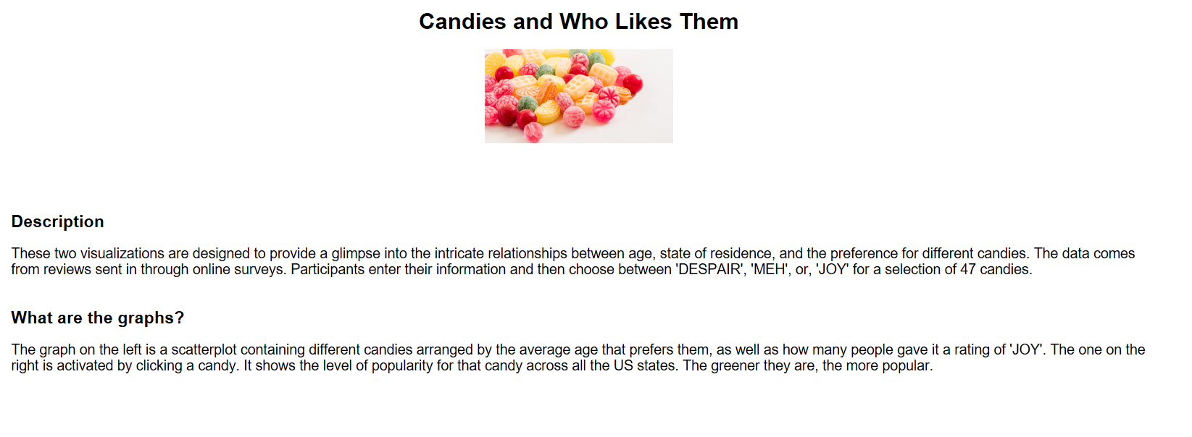

Figure 1 Description Section

* Figure 2 shows the initial data that is loaded – the scatterplot with the candies arranged as described before.

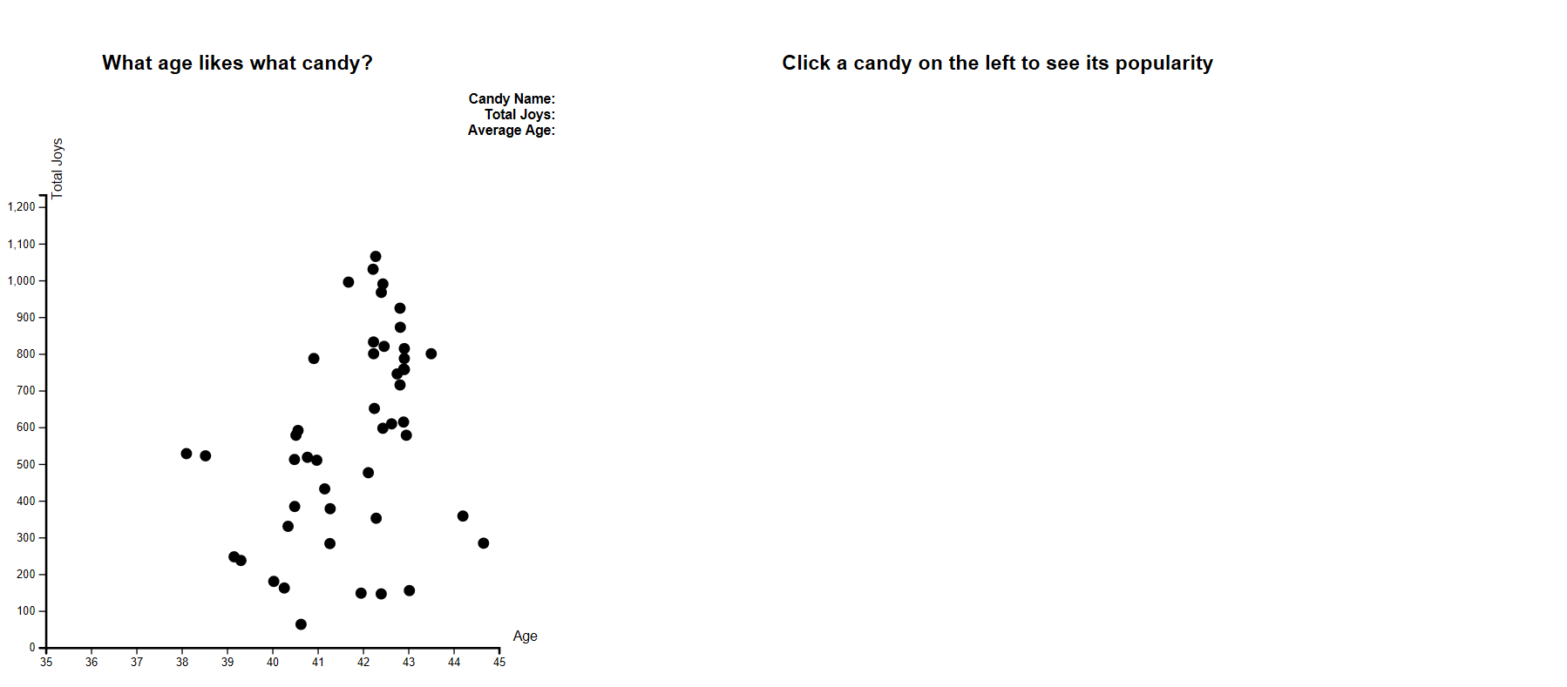

Figure 2 Initial Screen

* Figure 3 shows the mouseover functionality – the dot becomes red and its details appear next to the bold labels at the top right corner.

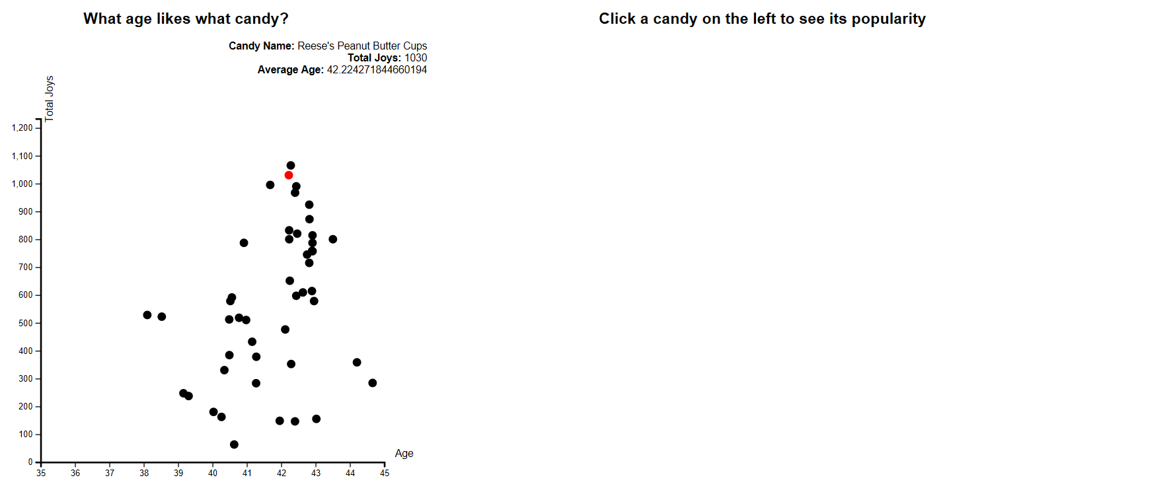

Figure 3 Mouse Over ScatterPlot

* Figure 4 shows the click functionality – the dot becomes green and its heatmap appears.

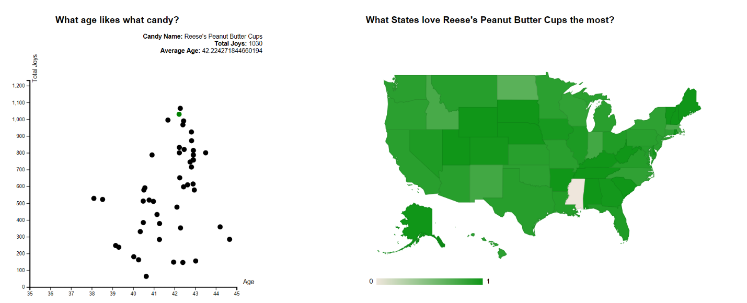

Figure 4 Clicked Candy

* Figure 5 shows the mouseover functionality for the map – a small window appears above the state giving its full name, its popularity value for the clicked candy and how many reviews were used to find that value.

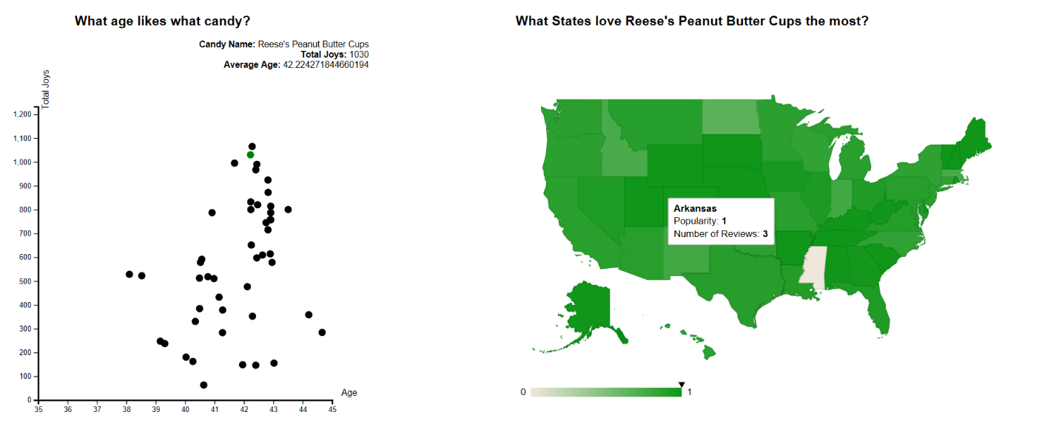

Figure 5 Mouse Over Map

* Figure 6 shows the search functionality for the scatterplot- only the dots that match the search query are shown. Entering nothing or pressing the clear button should clear the search and show all candies.