FISHREG brainstorm on
“Assessment method for not-so-data-poor stocks”

Minutes
Ernesto Jardim
(14/09/2011)

The meeting started at 14:00, there were 9 persons from FISHREG attending. The host, Ernesto Jardim, made a presentation about the subject, followed by a discussion about the future of stock assessment and the implementation of the ideas presented. The presentation and following discussions will are summarized on the next sections.

Presentation

Setting the scene
- DCF 2009 introduced the concept of “concurrent sampling” for metier related variables: “sampling all or a predefined assemblage of species, simultaneously in a vessel's catches or landings” (2008/949/EC, Annex, Chapter I, 1.b)
- Sampling must be performed in order to evaluate the quarterly length distribution of species in the catches, and the quarterly volume of discards (B1.1.1).

Setting the scene in numbers
- Biological parameters (growth & reproduction) are being collected for >250 stocks in waters where European fleets operate.
- Taking the examples of France, Portugal, Spain and Latvia, the number of species sampled for length distributions raised from ~60 to >200 in 2009.

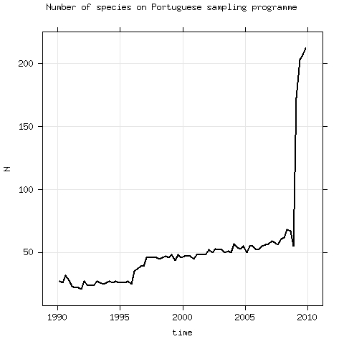
So what
In 2020 fisheries scientists will face the challenge of assessing >250 stocks, caught by several fleets in European EEZ, for each there are information broken by time and space from different sources. The table below describes the sources of information and the expected quality associated with the information provided, as well as regarding the space/time disaggregation.

Table 1 – Quality ad hoc description of information provided in each variable by source (1=fair, 2=good, 3=excellent).
Source | Time | Space | Volume (L,D,C) |  | Effort | Index of abundance
 |  |  | weight | length |  | weight | length
On-auction | 2 | 1 | 3 | 3 | 2 | 1 | 2
On-board | 3 | 3 | 3 | 3 | 3 | 2 | 1
Surveys | 1 | 3 |  | 3 |  | 3 | 3
log-books | 2 | 1 | 1 |  | 2 | 1
VMS | 2 | 3 |  |  | 3 | 2

For most of these stocks biological parameters on growth and reproduction will be a problem. Collecting, processing and conducting research in such a large number of stocks requires human and financial resources that are not available for most fisheries institutes and universities in Europe. Socio-economic information will be available, although there still a long way to overcome the technical problems preventing the integration of such information in stock assessment.

Problem
- These are not data-poor stocks.
- No age data will be available but lots of information on exploitation and abundance will exist !
- It will be impossible to keep the present procedures, which require highly trained analysts working for 2 or 3 month per year, to give advice on exploitation/conservation of 1 species …
- Dealing with the assessment of these stocks will require a change in mindset !

Solution ?!
- Estimate what you know, MSE what you don't and keep it simple !!
- One possible solution is to embed a statistical catch-at-age model on MSE implemented in R/FLR.
The model could be based on length information of landings (L), discards (D) and some kind of abundance index (I), which are converted to age information using a growth model (G), and pooled together with a selectivity/selection pattern model (S) and a stock-recruitment model (R ) to build a statistical catch-at-age model (SCAA).
To test the impact on the advice being given by the sub-models, G, S and R, which are expected to be the most uncertain ones, a Management Strategies Evaluation (MSE) algorithm can be implemented, while the base information, L, D, and I are used for diagnostics.
All the methodology should be driven with the primary objective or providing advice to fisheries management. The major focus should be on the robustness of the advice, not so much on computing intermediate parameters.

Open issues
- Multifleet
- Sexual dimorphism
- Space/time scale
- Weighting of likelihood components
- How to deal with maturity ? External parameter or integrated in the assessment method ?
- ...

Discussion
The discussion focused both on details of the implementation as well as more generic thinking about the future of stock assessment.
There were suggestions about (without any particular order) :
- integrating biomass dynamic models in the SCAA, which could be done by using the outcomes as a starting point for fitting;
- using biological information from similar stocks to set the starting parameters of the model;
- developing the methodology using simulated data sets, to test the outcome and set the boundaries of the methodology;
- considering the possibility of using time series of distinct sizes in each sub-model,
- using Productivity and Susceptibility Analysis (PSA, http://nft.nefsc.noaa.gov/PSA.html), it's possible to compute reference points for many species not currently under assessment. In fact a PSA analysis could be a first step towards expanding the number of species assessed and could be seen as an immediate preliminary step before SCAAs are developed.
and concerns about:
- how multi-species management could be made if interactions between species are not integrated;
- the high computational and statistical burden required, that will still be a problem for assessment of a massive number of stocks;
- the impact on the data collection framework and vice-versa. If some information has no impact on advice its collection may be stopped, which will create an irrecoverable gap on the time series.
The initiative was welcome and it was recognized that there is a potential problem if a large number of stocks are required to be assessed in the future.
Most participants considered the solution presented to be valid and worth to explore. There will be a number of challenges to overcome but there are potential solutions.

Conclusions
A potentially huge problem is expected when the data being collected under the DCF, will have time series long enough to be used in stock assessment, around 2020, and fisheries institutes/scientists will be called to assess these stocks.
The need for such assessments will come not only from stock management requirements, but more broadly from ecosystem management and maritime spatial planning requirements, included in the Integrated Maritime Policy.
The present advisory process is too slow to cope and requires human resources with a very sophisticated background on statistical modeling, which is becoming a limitation on the number of scientists available. It is not foreseen that this system will be able to deliver massive stock assessment in 2020. On the other hand, recent developments on stock assessment are targeting the development of more sophisticated models, which will be more demanding on human resources.
An initiative to develop an assessment method targeting stocks that have a reduced knowledge base on biology and moderate time series on exploitation and abundance, which will be the status of a large number of stocks in the European EEZ, can be the answer to this problem.
FISHREG has the necessary expertises to start the initiative and coordinate the development of the methodology, including its implementation in software (R/FLR). Cooperative work between FISHREG scientists is expected. It is also expected to invite external scientists on short term missions, in order to peer review the progress of the implementation, and cooperate with FISHREG scientists.
In any case, identifying the problem well in advance and triggering the discussion on the scientific community, is a first step to find solutions and avoid being in a difficult situation when the time comes.

