IRT

firdaus

# Prepare Environment

## Load Libraries

library(psych) # For basic psychometrics and scale reliability analysis  
library(foreign) # For reading and writing data in foreign statistical formats  
library(ltm) # To fit 2PL IRT models and other latent trait models

Loading required package: MASS

Loading required package: msm

Loading required package: polycor

Attaching package: 'polycor'

The following object is masked from 'package:psych':  
  
 polyserial

Attaching package: 'ltm'

The following object is masked from 'package:psych':  
  
 factor.scores

library(irtoys) # For IRT utilities

Loading required package: sm

Package 'sm', version 2.2-6.0: type help(sm) for summary information

Attaching package: 'sm'

The following object is masked from 'package:MASS':  
  
 muscle

Attaching package: 'irtoys'

The following object is masked from 'package:psych':  
  
 sim

library(mirt) # Modern IRT package for multi-item response theory

Loading required package: stats4

Loading required package: lattice

Attaching package: 'mirt'

The following object is masked from 'package:ltm':  
  
 Science

library(latticeExtra) # For enhanced plotting in lattice-based plots  
library(tidyverse) # For data manipulation, cleaning, and visualization

── Attaching core tidyverse packages ──────────────────────── tidyverse 2.0.0 ──  
✔ dplyr 1.1.4 ✔ readr 2.1.5  
✔ forcats 1.0.0 ✔ stringr 1.5.1  
✔ ggplot2 4.0.0 ✔ tibble 3.3.0  
✔ lubridate 1.9.4 ✔ tidyr 1.3.1  
✔ purrr 1.1.0

── Conflicts ────────────────────────────────────────── tidyverse_conflicts() ──  
✖ ggplot2::%+%() masks psych::%+%()  
✖ ggplot2::alpha() masks psych::alpha()  
✖ dplyr::filter() masks stats::filter()  
✖ dplyr::lag() masks stats::lag()  
✖ ggplot2::layer() masks latticeExtra::layer()  
✖ dplyr::select() masks MASS::select()  
ℹ Use the conflicted package (<http://conflicted.r-lib.org/>) to force all conflicts to become errors

library(haven) # For importing and exporting SPSS, Stata, and SAS files  
library(writexl) # For exporting data frames to Excel files  
library(readxl) # For reading data from Excel files

## Load Data

data1=read_xlsx("IRT_knowledge_V1.xlsx") ##read data from Excel   
names(data1) # List down variables in the data set

[1] "K1" "K2" "K3" "K4" "K5" "K6" "K7" "K8" "K9" "K10" "K11" "K12"  
[13] "K13" "K14" "K15" "K16" "K17" "K18" "K19" "K20" "K21" "K22" "K23" "K24"  
[25] "K25" "K26" "K27" "K28" "K29" "K30" "K31" "K32" "K33" "K34" "K35" "K36"  
[37] "K37"

dim(data1) # Data set consists of 37 variables and 177 parents

[1] 204 37

### Recode Data

# Define reverse-coded items  
reverse_items <- c("K2", "K3", "K4", "K5", "K8", "K10", "K35")  
  
# Recode  
data2 <- data1 %>%  
 mutate(across(  
 -all_of(reverse_items),   
 ~ case_when(  
 tolower(.) == "ya" ~ 1,  
 tolower(.) == "tidak" ~ 0,  
 tolower(.) == "tidak pasti" ~ 2,  
 TRUE ~ NA_real_  
 )  
 )) %>%  
 mutate(across(  
 all_of(reverse_items),  
 ~ case_when(  
 tolower(.) == "ya" ~ 0,  
 tolower(.) == "tidak" ~ 1,  
 tolower(.) == "tidak pasti" ~ 2,  
 TRUE ~ NA_real_  
 )  
 ))

#Recode 1 = 1 (correct answer), 2 and 0 = 0 (incorrect answer)  
  
data3 <- data2 %>%  
 mutate(across(  
 everything(),  
 ~ case_when(  
 . == 1 ~ 1,  
 . %in% c(0, 2) ~ 0,  
 TRUE ~ NA_real_  
 )  
 ))

# Descriptive Statistics

## Response Frequencies

response.frequencies(data3)

0 1 miss  
K1 0.21078431 0.7892157 0  
K2 0.60784314 0.3921569 0  
K3 0.53921569 0.4607843 0  
K4 0.61764706 0.3823529 0  
K5 0.32352941 0.6764706 0  
K6 0.83823529 0.1617647 0  
K7 0.55882353 0.4411765 0  
K8 0.57352941 0.4264706 0  
K9 0.47549020 0.5245098 0  
K10 0.50490196 0.4950980 0  
K11 0.62254902 0.3774510 0  
K12 0.75980392 0.2401961 0  
K13 0.19117647 0.8088235 0  
K14 0.33823529 0.6617647 0  
K15 0.60294118 0.3970588 0  
K16 0.62254902 0.3774510 0  
K17 0.16666667 0.8333333 0  
K18 0.39705882 0.6029412 0  
K19 0.47058824 0.5294118 0  
K20 0.45098039 0.5490196 0  
K21 0.42647059 0.5735294 0  
K22 0.40196078 0.5980392 0  
K23 0.30392157 0.6960784 0  
K24 0.27941176 0.7205882 0  
K25 0.25490196 0.7450980 0  
K26 0.40686275 0.5931373 0  
K27 0.71078431 0.2892157 0  
K28 0.55392157 0.4460784 0  
K29 0.44117647 0.5588235 0  
K30 0.81372549 0.1862745 0  
K31 0.19607843 0.8039216 0  
K32 0.30392157 0.6960784 0  
K33 0.36764706 0.6323529 0  
K34 0.18627451 0.8137255 0  
K35 0.58333333 0.4166667 0  
K36 0.06862745 0.9313725 0  
K37 0.15686275 0.8431373 0

### Descriptive Statistics

descript(data3)

Descriptive statistics for the 'data3' data-set  
  
Sample:  
 37 items and 204 sample units; 0 missing values  
  
Proportions for each level of response:  
 0 1 logit  
K1 0.2108 0.7892 1.3202  
K2 0.6078 0.3922 -0.4383  
K3 0.5392 0.4608 -0.1572  
K4 0.6176 0.3824 -0.4796  
K5 0.3235 0.6765 0.7376  
K6 0.8382 0.1618 -1.6452  
K7 0.5588 0.4412 -0.2364  
K8 0.5735 0.4265 -0.2963  
K9 0.4755 0.5245 0.0981  
K10 0.5049 0.4951 -0.0196  
K11 0.6225 0.3775 -0.5004  
K12 0.7598 0.2402 -1.1516  
K13 0.1912 0.8088 1.4424  
K14 0.3382 0.6618 0.6712  
K15 0.6029 0.3971 -0.4177  
K16 0.6225 0.3775 -0.5004  
K17 0.1667 0.8333 1.6094  
K18 0.3971 0.6029 0.4177  
K19 0.4706 0.5294 0.1178  
K20 0.4510 0.5490 0.1967  
K21 0.4265 0.5735 0.2963  
K22 0.4020 0.5980 0.3973  
K23 0.3039 0.6961 0.8287  
K24 0.2794 0.7206 0.9474  
K25 0.2549 0.7451 1.0726  
K26 0.4069 0.5931 0.3769  
K27 0.7108 0.2892 -0.8992  
K28 0.5539 0.4461 -0.2165  
K29 0.4412 0.5588 0.2364  
K30 0.8137 0.1863 -1.4744  
K31 0.1961 0.8039 1.4110  
K32 0.3039 0.6961 0.8287  
K33 0.3676 0.6324 0.5423  
K34 0.1863 0.8137 1.4744  
K35 0.5833 0.4167 -0.3365  
K36 0.0686 0.9314 2.6080  
K37 0.1569 0.8431 1.6818  
  
  
Frequencies of total scores:  
 0 1 2 3 4 5 6 7 8 9 10 11 12 13 14 15 16 17 18 19 20 21 22 23 24 25 26 27  
Freq 1 0 1 1 2 1 2 1 4 5 6 5 3 9 4 7 10 4 10 7 8 16 10 8 12 11 5 9  
 28 29 30 31 32 33 34 35 36 37  
Freq 10 6 9 3 3 3 2 1 3 2  
  
  
Point Biserial correlation with Total Score:  
 Included Excluded  
K1 0.3742 0.3274  
K2 0.2793 0.2194  
K3 0.2500 0.1880  
K4 0.3596 0.3028  
K5 0.0997 0.0392  
K6 0.3816 0.3397  
K7 0.2545 0.1928  
K8 0.2645 0.2034  
K9 0.3174 0.2574  
K10 0.3082 0.2478  
K11 0.2970 0.2381  
K12 0.4038 0.3558  
K13 0.4129 0.3693  
K14 0.3313 0.2750  
K15 0.5002 0.4503  
K16 0.4716 0.4205  
K17 0.4539 0.4142  
K18 0.5610 0.5151  
K19 0.6431 0.6027  
K20 0.6762 0.6387  
K21 0.6889 0.6528  
K22 0.6503 0.6112  
K23 0.6857 0.6520  
K24 0.7137 0.6833  
K25 0.6905 0.6591  
K26 0.4828 0.4316  
K27 0.5352 0.4912  
K28 0.4978 0.4469  
K29 0.5478 0.5002  
K30 0.5352 0.4977  
K31 0.6280 0.5953  
K32 0.6193 0.5804  
K33 0.5917 0.5487  
K34 0.3898 0.3457  
K35 0.2232 0.1612  
K36 0.4188 0.3912  
K37 0.4330 0.3935  
  
  
Cronbach's alpha:  
 value  
All Items 0.8935  
Excluding K1 0.8921  
Excluding K2 0.8941  
Excluding K3 0.8948  
Excluding K4 0.8927  
Excluding K5 0.8969  
Excluding K6 0.8919  
Excluding K7 0.8947  
Excluding K8 0.8945  
Excluding K9 0.8936  
Excluding K10 0.8937  
Excluding K11 0.8938  
Excluding K12 0.8917  
Excluding K13 0.8915  
Excluding K14 0.8931  
Excluding K15 0.8901  
Excluding K16 0.8907  
Excluding K17 0.8909  
Excluding K18 0.8890  
Excluding K19 0.8874  
Excluding K20 0.8867  
Excluding K21 0.8865  
Excluding K22 0.8873  
Excluding K23 0.8868  
Excluding K24 0.8864  
Excluding K25 0.8869  
Excluding K26 0.8905  
Excluding K27 0.8895  
Excluding K28 0.8902  
Excluding K29 0.8892  
Excluding K30 0.8897  
Excluding K31 0.8882  
Excluding K32 0.8880  
Excluding K33 0.8884  
Excluding K34 0.8918  
Excluding K35 0.8952  
Excluding K36 0.8917  
Excluding K37 0.8912  
  
  
Pairwise Associations:  
 Item i Item j p.value  
1 2 28 1.000  
2 4 26 1.000  
3 5 22 1.000  
4 5 35 1.000  
5 7 17 1.000  
6 7 19 1.000  
7 7 20 1.000  
8 7 35 1.000  
9 8 35 1.000  
10 10 21 1.000

# Fitting 2PL IRT Model with ltm Package

## Fit 2PL Model (ltm)

irt.data3 <- ltm(data3 ~ z1, IRT.param = TRUE)

## Item Parameter Estimates

# Obtain difficulty and discrimination parameter estimates  
item_parms <- coef(irt.data3)

# Tidy view: Item | a (Discrimination) | b (Difficulty)  
  
item_parms_tbl <- item_parms |>  
 as.data.frame() |>  
 transform(Item = rownames(item_parms),  
 Difficulty = Dffclt,  
 Discrimination = Dscrmn) |>  
 (\(d) d[, c("Item", "Difficulty", "Discrimination")])() |>  
 (\(d) within(d, {   
 Difficulty <- round(Difficulty, 3)  
 Discrimination <- round(Discrimination, 3)  
 }))()  
  
item_parms_tbl

Item Difficulty Discrimination  
K1 K1 -1.426 0.873  
K2 K2 1.275 0.473  
K3 K3 0.719 0.390  
K4 K4 1.094 0.660  
K5 K5 -9.376 0.076  
K6 K6 2.247 0.994  
K7 K7 1.228 0.260  
K8 K8 1.778 0.203  
K9 K9 0.001 0.333  
K10 K10 0.368 0.298  
K11 K11 1.779 0.349  
K12 K12 2.059 0.724  
K13 K13 -1.250 1.135  
K14 K14 -0.559 0.908  
K15 K15 0.676 1.475  
K16 K16 0.800 1.268  
K17 K17 -1.078 1.618  
K18 K18 -0.106 1.362  
K19 K19 0.210 4.683  
K20 K20 0.158 5.578  
K21 K21 0.096 6.871  
K22 K22 0.053 4.676  
K23 K23 -0.163 5.311  
K24 K24 -0.082 16.964  
K25 K25 -0.266 6.626  
K26 K26 -0.159 0.976  
K27 K27 1.073 1.614  
K28 K28 0.531 1.132  
K29 K29 0.050 1.214  
K30 K30 1.382 2.216  
K31 K31 -0.564 3.755  
K32 K32 -0.265 2.718  
K33 K33 -0.113 2.130  
K34 K34 -1.202 1.225  
K35 K35 1.416 0.309  
K36 K36 -1.530 2.379  
K37 K37 -1.220 1.471

## Model Summary

# Includes log-likelihood, AIC/BIC, SEs, and Wald z-values  
summary(irt.data3)

Call:  
ltm(formula = data3 ~ z1, IRT.param = TRUE)  
  
Model Summary:  
 log.Lik AIC BIC  
 -3748.378 7644.756 7890.297  
  
Coefficients:  
 value std.err z.vals  
Dffclt.K1 -1.4264 0.4021 -3.5474  
Dffclt.K2 1.2750 0.4395 2.9011  
Dffclt.K3 0.7195 0.4000 1.7987  
Dffclt.K4 1.0943 0.2948 3.7118  
Dffclt.K5 -9.3762 19.8814 -0.4716  
Dffclt.K6 2.2471 0.4202 5.3475  
Dffclt.K7 1.2275 0.7566 1.6224  
Dffclt.K8 1.7782 1.2819 1.3871  
Dffclt.K9 0.0009 0.4468 0.0021  
Dffclt.K10 0.3675 0.4764 0.7714  
Dffclt.K11 1.7786 0.7647 2.3260  
Dffclt.K12 2.0587 0.4714 4.3673  
Dffclt.K13 -1.2502 0.2985 -4.1882  
Dffclt.K14 -0.5586 0.2302 -2.4270  
Dffclt.K15 0.6763 0.1252 5.4015  
Dffclt.K16 0.7998 0.1486 5.3817  
Dffclt.K17 -1.0782 0.2101 -5.1321  
Dffclt.K18 -0.1062 0.1297 -0.8185  
Dffclt.K19 0.2102 0.0539 3.8974  
Dffclt.K20 0.1584 0.0500 3.1693  
Dffclt.K21 0.0956 0.0422 2.2641  
Dffclt.K22 0.0527 0.0515 1.0217  
Dffclt.K23 -0.1631 0.0568 -2.8727  
Dffclt.K24 -0.0817 0.3221 -0.2537  
Dffclt.K25 -0.2657 0.0658 -4.0389  
Dffclt.K26 -0.1590 0.1747 -0.9101  
Dffclt.K27 1.0730 0.1472 7.2883  
Dffclt.K28 0.5313 0.1449 3.6679  
Dffclt.K29 0.0504 0.1353 0.3729  
Dffclt.K30 1.3822 0.1532 9.0193  
Dffclt.K31 -0.5639 0.0873 -6.4600  
Dffclt.K32 -0.2649 0.0864 -3.0675  
Dffclt.K33 -0.1135 0.0932 -1.2167  
Dffclt.K34 -1.2024 0.2740 -4.3881  
Dffclt.K35 1.4162 0.7078 2.0009  
Dffclt.K36 -1.5304 0.2380 -6.4304  
Dffclt.K37 -1.2203 0.2437 -5.0064  
Dscrmn.K1 0.8727 0.2206 3.9555  
Dscrmn.K2 0.4727 0.1642 2.8785  
Dscrmn.K3 0.3899 0.1564 2.4939  
Dscrmn.K4 0.6598 0.1775 3.7173  
Dscrmn.K5 0.0763 0.1565 0.4879  
Dscrmn.K6 0.9942 0.2469 4.0263  
Dscrmn.K7 0.2602 0.1516 1.7159  
Dscrmn.K8 0.2027 0.1501 1.3505  
Dscrmn.K9 0.3331 0.1547 2.1530  
Dscrmn.K10 0.2983 0.1529 1.9504  
Dscrmn.K11 0.3486 0.1586 2.1979  
Dscrmn.K12 0.7243 0.1992 3.6356  
Dscrmn.K13 1.1346 0.2524 4.4945  
Dscrmn.K14 0.9076 0.2045 4.4370  
Dscrmn.K15 1.4748 0.2662 5.5409  
Dscrmn.K16 1.2676 0.2407 5.2662  
Dscrmn.K17 1.6182 0.3240 4.9951  
Dscrmn.K18 1.3621 0.2489 5.4718  
Dscrmn.K19 4.6826 0.8496 5.5116  
Dscrmn.K20 5.5780 1.2893 4.3264  
Dscrmn.K21 6.8712 1.5567 4.4140  
Dscrmn.K22 4.6763 0.8492 5.5065  
Dscrmn.K23 5.3111 1.1319 4.6924  
Dscrmn.K24 16.9641 66.8082 0.2539  
Dscrmn.K25 6.6261 1.4010 4.7297  
Dscrmn.K26 0.9758 0.2055 4.7490  
Dscrmn.K27 1.6137 0.2974 5.4255  
Dscrmn.K28 1.1320 0.2235 5.0660  
Dscrmn.K29 1.2142 0.2308 5.2616  
Dscrmn.K30 2.2162 0.4249 5.2159  
Dscrmn.K31 3.7552 0.6691 5.6120  
Dscrmn.K32 2.7180 0.4797 5.6656  
Dscrmn.K33 2.1299 0.3664 5.8124  
Dscrmn.K34 1.2254 0.2628 4.6628  
Dscrmn.K35 0.3093 0.1548 1.9986  
Dscrmn.K36 2.3787 0.5652 4.2086  
Dscrmn.K37 1.4710 0.3023 4.8656  
  
Integration:  
method: Gauss-Hermite  
quadrature points: 21   
  
Optimization:  
Convergence: 0   
max(|grad|): 0.088   
quasi-Newton: BFGS

## Items Removal Plan 1

**Selection criteria a > 0.64 (moderate discrimination) (Baker, 2001) ; -3 < b > +3**

K2 - a = 0.47

K3 - a = 0.39

K5 - a = 0.08 , b = -9.3762

K7 - a = 0.26

K8 - a = 0.20

K9 - a = 0.33

K10 - a = 0.30

K11 - a = 0.35

K35 - a = 0.31

### 2PL Model - Remove Items

# Remove the items  
irt_removed_items <- c("K2", "K3", "K5", "K7", "K8", "K9", "K10", "K11","K35")  
  
# Create new dataset with only included items  
data4 <- data3 %>% dplyr::select(-any_of(irt_removed_items))

### Descriptive Statistics

descript(data4)

Descriptive statistics for the 'data4' data-set  
  
Sample:  
 28 items and 204 sample units; 0 missing values  
  
Proportions for each level of response:  
 0 1 logit  
K1 0.2108 0.7892 1.3202  
K4 0.6176 0.3824 -0.4796  
K6 0.8382 0.1618 -1.6452  
K12 0.7598 0.2402 -1.1516  
K13 0.1912 0.8088 1.4424  
K14 0.3382 0.6618 0.6712  
K15 0.6029 0.3971 -0.4177  
K16 0.6225 0.3775 -0.5004  
K17 0.1667 0.8333 1.6094  
K18 0.3971 0.6029 0.4177  
K19 0.4706 0.5294 0.1178  
K20 0.4510 0.5490 0.1967  
K21 0.4265 0.5735 0.2963  
K22 0.4020 0.5980 0.3973  
K23 0.3039 0.6961 0.8287  
K24 0.2794 0.7206 0.9474  
K25 0.2549 0.7451 1.0726  
K26 0.4069 0.5931 0.3769  
K27 0.7108 0.2892 -0.8992  
K28 0.5539 0.4461 -0.2165  
K29 0.4412 0.5588 0.2364  
K30 0.8137 0.1863 -1.4744  
K31 0.1961 0.8039 1.4110  
K32 0.3039 0.6961 0.8287  
K33 0.3676 0.6324 0.5423  
K34 0.1863 0.8137 1.4744  
K36 0.0686 0.9314 2.6080  
K37 0.1569 0.8431 1.6818  
  
  
Frequencies of total scores:  
 0 1 2 3 4 5 6 7 8 9 10 11 12 13 14 15 16 17 18 19 20 21 22 23 24 25 26 27  
Freq 1 2 5 1 3 4 5 5 3 9 7 8 9 6 7 4 12 6 13 12 19 14 6 9 10 8 8 2  
 28  
Freq 6  
  
  
Point Biserial correlation with Total Score:  
 Included Excluded  
K1 0.3532 0.2996  
K4 0.3027 0.2364  
K6 0.3641 0.3162  
K12 0.3249 0.2676  
K13 0.4810 0.4352  
K14 0.4192 0.3599  
K15 0.5729 0.5221  
K16 0.5324 0.4789  
K17 0.5051 0.4630  
K18 0.5301 0.4759  
K19 0.7183 0.6802  
K20 0.7222 0.6847  
K21 0.7320 0.6957  
K22 0.6986 0.6592  
K23 0.7117 0.6762  
K24 0.7545 0.7242  
K25 0.7272 0.6952  
K26 0.4363 0.3757  
K27 0.5602 0.5124  
K28 0.5027 0.4457  
K29 0.5082 0.4516  
K30 0.5437 0.5018  
K31 0.6733 0.6397  
K32 0.6729 0.6337  
K33 0.6404 0.5961  
K34 0.4392 0.3917  
K36 0.4446 0.4143  
K37 0.4745 0.4320  
  
  
Cronbach's alpha:  
 value  
All Items 0.9144  
Excluding K1 0.9145  
Excluding K4 0.9162  
Excluding K6 0.9141  
Excluding K12 0.9151  
Excluding K13 0.9125  
Excluding K14 0.9139  
Excluding K15 0.9111  
Excluding K16 0.9119  
Excluding K17 0.9121  
Excluding K18 0.9120  
Excluding K19 0.9082  
Excluding K20 0.9081  
Excluding K21 0.9079  
Excluding K22 0.9086  
Excluding K23 0.9085  
Excluding K24 0.9077  
Excluding K25 0.9083  
Excluding K26 0.9138  
Excluding K27 0.9113  
Excluding K28 0.9126  
Excluding K29 0.9124  
Excluding K30 0.9115  
Excluding K31 0.9095  
Excluding K32 0.9092  
Excluding K33 0.9098  
Excluding K34 0.9131  
Excluding K36 0.9131  
Excluding K37 0.9126  
  
  
Pairwise Associations:  
 Item i Item j p.value  
1 2 18 1.000  
2 4 5 1.000  
3 1 20 1.000  
4 2 5 0.880  
5 1 19 0.723  
6 18 26 0.704  
7 5 21 0.643  
8 2 27 0.627  
9 4 28 0.593  
10 8 18 0.591

### Refit 2PL Model

irt.data4 <- ltm(data4 ~ z1, IRT.param = TRUE)

### Item Parameter Estimates

# Obtain difficulty and discrimination parameter estimates  
item_parms_refined <- coef(irt.data4)  
  
# Tidy view: Item | a (Discrimination) | b (Difficulty)  
  
item_parms_refined_tbl <- item_parms_refined |>  
 as.data.frame() |>  
 transform(Item = rownames(item_parms_refined),  
 Difficulty = Dffclt,  
 Discrimination = Dscrmn) |>  
 (\(d) d[, c("Item", "Difficulty", "Discrimination")])() |>  
 (\(d) within(d, {   
 Difficulty <- round(Difficulty, 3)  
 Discrimination <- round(Discrimination, 3)  
 }))()  
  
item_parms_refined_tbl

Item Difficulty Discrimination  
K1 K1 -1.480 0.843  
K4 K4 1.154 0.602  
K6 K6 2.271 0.970  
K12 K12 2.161 0.673  
K13 K13 -1.231 1.160  
K14 K14 -0.539 0.941  
K15 K15 0.674 1.488  
K16 K16 0.797 1.273  
K17 K17 -1.096 1.593  
K18 K18 -0.114 1.328  
K19 K19 0.211 4.954  
K20 K20 0.160 5.614  
K21 K21 0.098 6.831  
K22 K22 0.055 4.775  
K23 K23 -0.158 5.427  
K24 K24 -0.064 21.292  
K25 K25 -0.256 6.842  
K26 K26 -0.172 0.946  
K27 K27 1.065 1.645  
K28 K28 0.530 1.135  
K29 K29 0.044 1.176  
K30 K30 1.373 2.253  
K31 K31 -0.565 3.724  
K32 K32 -0.266 2.693  
K33 K33 -0.112 2.141  
K34 K34 -1.209 1.224  
K36 K36 -1.558 2.341  
K37 K37 -1.238 1.452

### Model Summary

# Includes log-likelihood, AIC/BIC, SEs, and Wald z-values  
summary(irt.data4)

Call:  
ltm(formula = data4 ~ z1, IRT.param = TRUE)  
  
Model Summary:  
 log.Lik AIC BIC  
 -2524.426 5160.852 5346.666  
  
Coefficients:  
 value std.err z.vals  
Dffclt.K1 -1.4799 0.4229 -3.4992  
Dffclt.K4 1.1538 0.3317 3.4786  
Dffclt.K6 2.2711 0.4436 5.1200  
Dffclt.K12 2.1606 0.5368 4.0247  
Dffclt.K13 -1.2313 0.2882 -4.2724  
Dffclt.K14 -0.5386 0.2204 -2.4435  
Dffclt.K15 0.6741 0.1236 5.4531  
Dffclt.K16 0.7971 0.1472 5.4150  
Dffclt.K17 -1.0956 0.2146 -5.1060  
Dffclt.K18 -0.1135 0.1332 -0.8523  
Dffclt.K19 0.2106 0.0525 4.0098  
Dffclt.K20 0.1601 0.0494 3.2425  
Dffclt.K21 0.0977 0.0423 2.3111  
Dffclt.K22 0.0551 0.0506 1.0887  
Dffclt.K23 -0.1576 0.0566 -2.7838  
Dffclt.K24 -0.0636 1.0622 -0.0599  
Dffclt.K25 -0.2558 0.0666 -3.8388  
Dffclt.K26 -0.1723 0.1809 -0.9523  
Dffclt.K27 1.0647 0.1441 7.3890  
Dffclt.K28 0.5300 0.1442 3.6763  
Dffclt.K29 0.0441 0.1394 0.3161  
Dffclt.K30 1.3729 0.1500 9.1529  
Dffclt.K31 -0.5648 0.0894 -6.3206  
Dffclt.K32 -0.2658 0.0875 -3.0388  
Dffclt.K33 -0.1116 0.0931 -1.1985  
Dffclt.K34 -1.2086 0.2738 -4.4143  
Dffclt.K36 -1.5580 0.2401 -6.4884  
Dffclt.K37 -1.2383 0.2472 -5.0098  
Dscrmn.K1 0.8428 0.2162 3.8982  
Dscrmn.K4 0.6024 0.1751 3.4413  
Dscrmn.K6 0.9705 0.2510 3.8664  
Dscrmn.K12 0.6734 0.1993 3.3783  
Dscrmn.K13 1.1604 0.2525 4.5955  
Dscrmn.K14 0.9414 0.2061 4.5679  
Dscrmn.K15 1.4881 0.2677 5.5580  
Dscrmn.K16 1.2728 0.2416 5.2673  
Dscrmn.K17 1.5930 0.3185 5.0022  
Dscrmn.K18 1.3282 0.2457 5.4057  
Dscrmn.K19 4.9541 0.9372 5.2863  
Dscrmn.K20 5.6139 1.3086 4.2902  
Dscrmn.K21 6.8311 1.5588 4.3822  
Dscrmn.K22 4.7746 0.9353 5.1048  
Dscrmn.K23 5.4269 1.2230 4.4374  
Dscrmn.K24 21.2922 355.5586 0.0599  
Dscrmn.K25 6.8418 1.5226 4.4934  
Dscrmn.K26 0.9460 0.2026 4.6696  
Dscrmn.K27 1.6446 0.3019 5.4466  
Dscrmn.K28 1.1349 0.2242 5.0619  
Dscrmn.K29 1.1762 0.2269 5.1829  
Dscrmn.K30 2.2529 0.4306 5.2321  
Dscrmn.K31 3.7238 0.6732 5.5313  
Dscrmn.K32 2.6931 0.4726 5.6984  
Dscrmn.K33 2.1406 0.3679 5.8183  
Dscrmn.K34 1.2243 0.2600 4.7088  
Dscrmn.K36 2.3406 0.5444 4.2992  
Dscrmn.K37 1.4516 0.2969 4.8898  
  
Integration:  
method: Gauss-Hermite  
quadrature points: 21   
  
Optimization:  
Convergence: 0   
max(|grad|): 1.6e-05   
quasi-Newton: BFGS

## Graphical Presentation

### Item Characteristic Curves (ICC)

# ICC for All Items  
# Plot ICC for all items  
plot(irt.data4, type = "ICC", legend = TRUE)

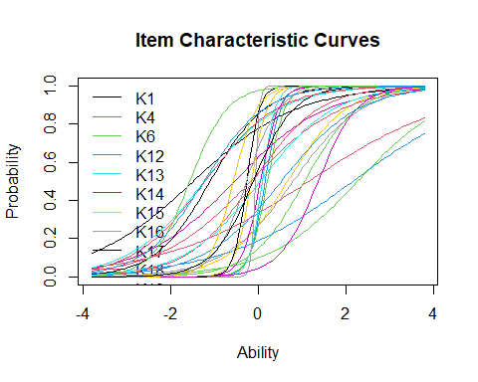

# ICC for Individual Items  
  
# Get total number of items  
ICC_items <- nrow(coef(irt.data4))  
  
# Plot ICC for each item  
for (i in 1:ICC_items) {  
 plot(irt.data4, type = "ICC", legend = TRUE, items = i)  
}

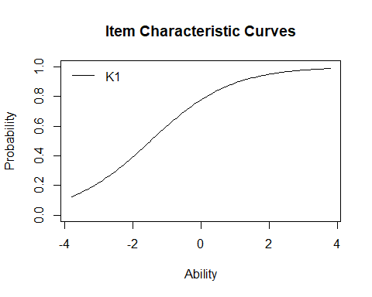

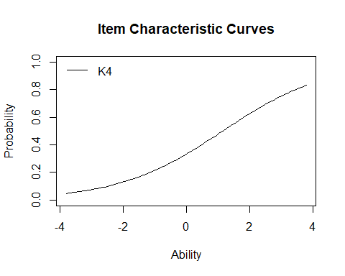

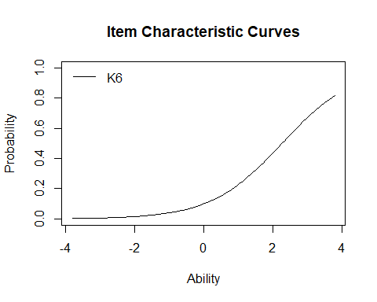

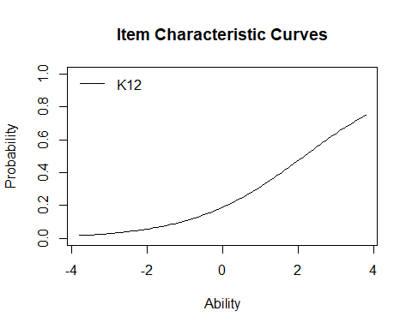

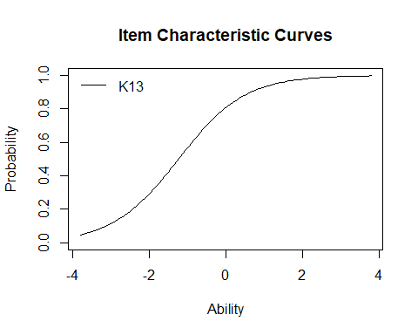

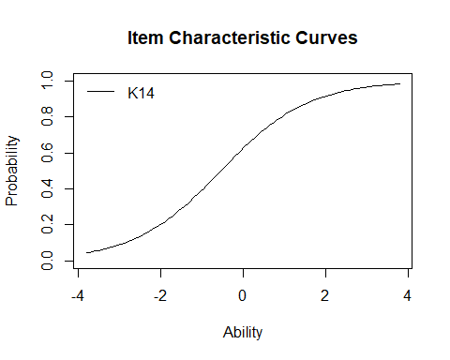

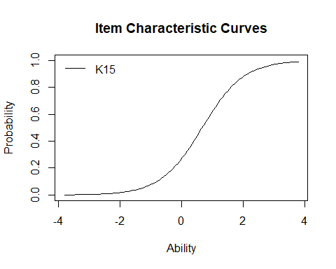

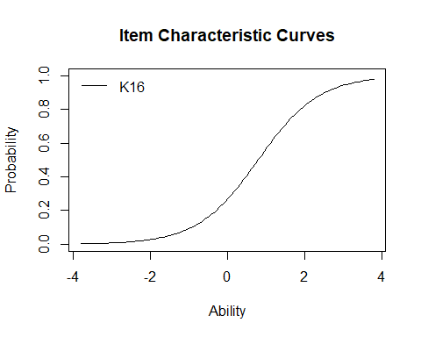

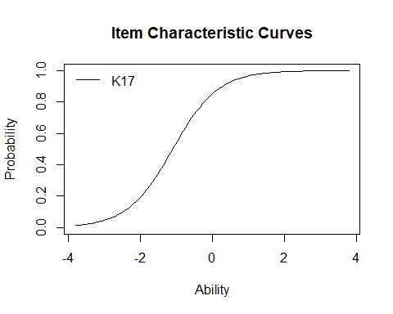

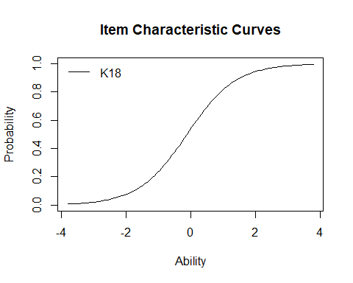

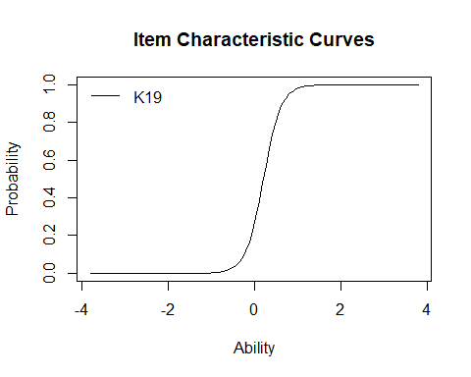

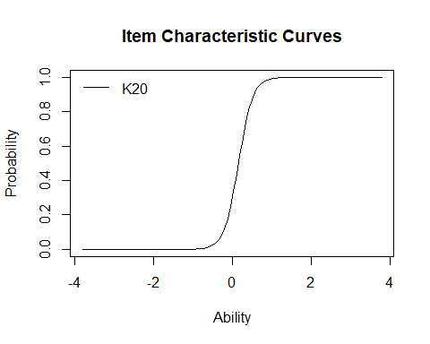

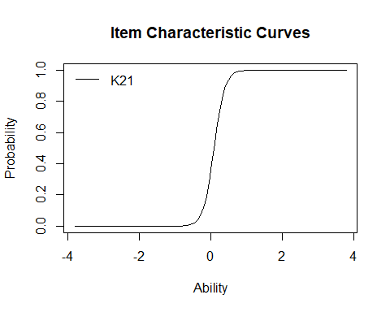

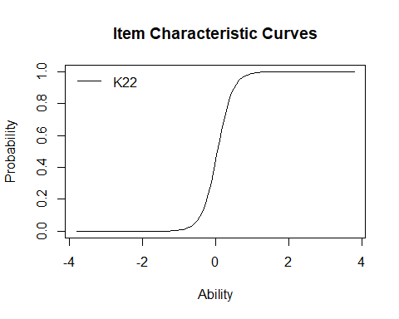

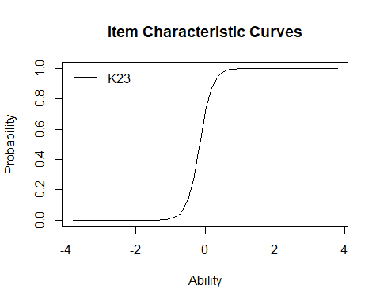

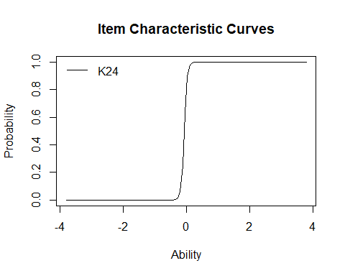

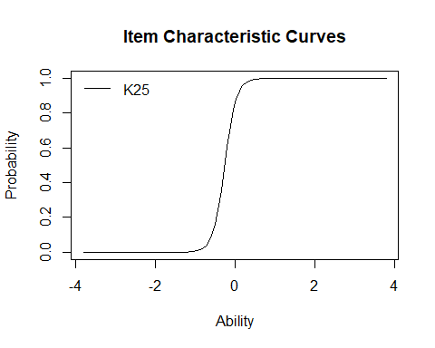

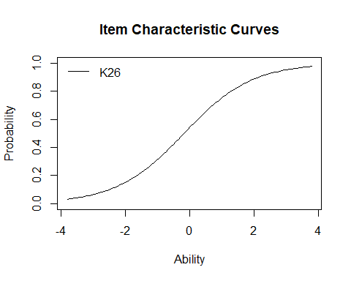

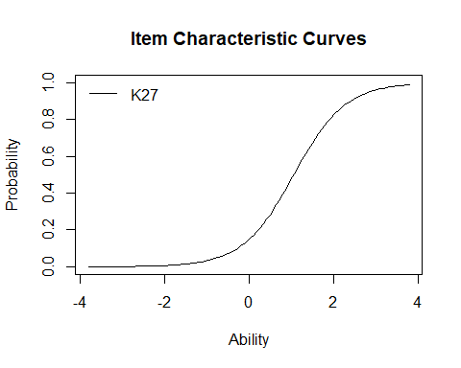

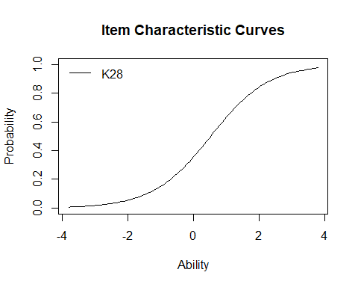

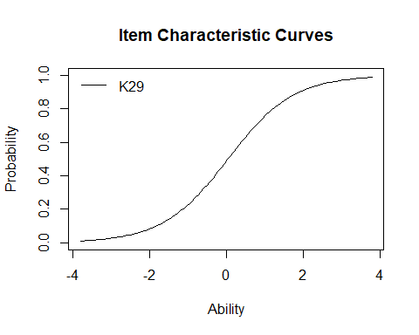

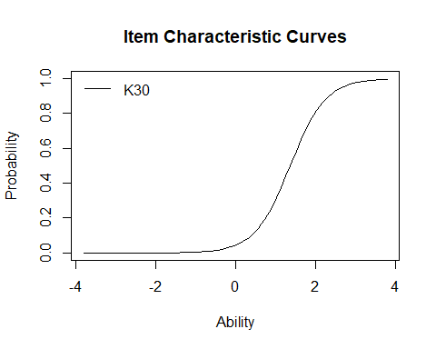

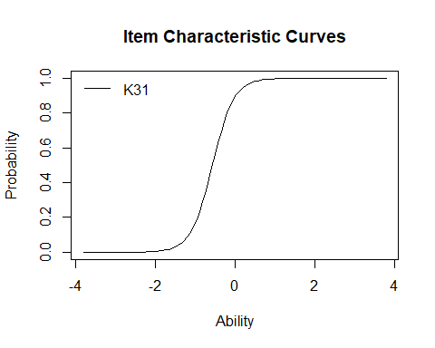

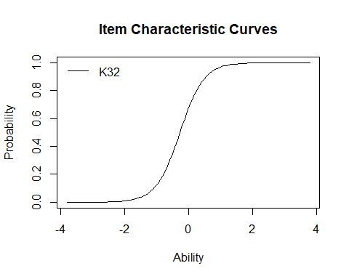

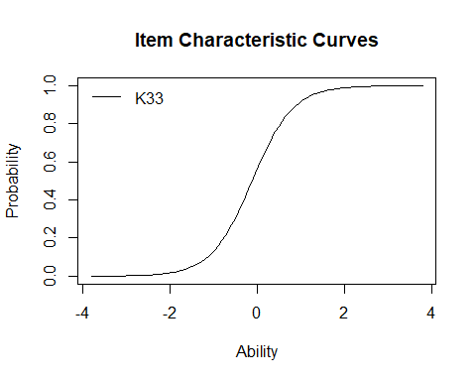

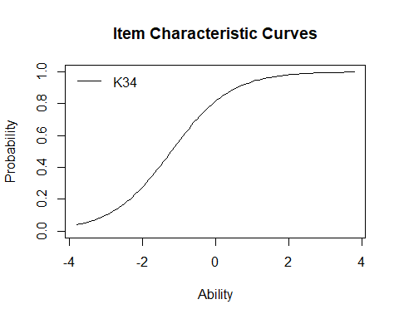

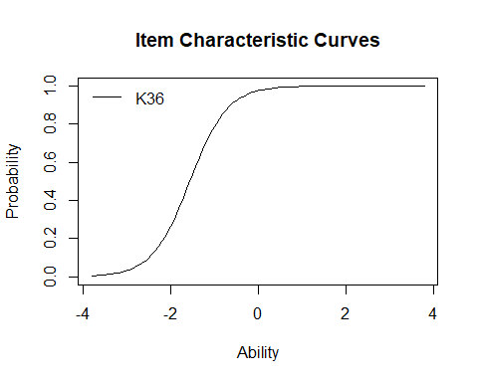

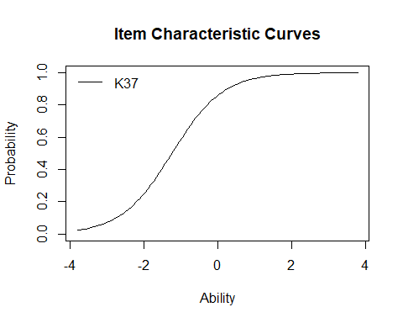

## Goodness-of-Fit Tests

### Item Fit Statistics

item_fit <- item.fit(irt.data4)  
item_fit

Item-Fit Statistics and P-values  
  
Call:  
ltm(formula = data4 ~ z1, IRT.param = TRUE)  
  
Alternative: Items do not fit the model  
Ability Categories: 10  
  
 X^2 Pr(>X^2)  
K1 2.1306 0.9767  
K4 10.1451 0.255  
K6 11.1620 0.1927  
K12 10.8405 0.2109  
K13 20.7712 0.0078  
K14 13.0452 0.1103  
K15 7.2890 0.5058  
K16 7.5638 0.4772  
K17 20.9417 0.0073  
K18 15.6180 0.0482  
K19 10.9301 0.2057  
K20 20.8608 0.0075  
K21 8.9740 0.3445  
K22 15.5933 0.0486  
K23 9.4741 0.3039  
K24 9.2964 0.3179  
K25 7.4241 0.4916  
K26 14.0206 0.0812  
K27 36.0298 <0.0001  
K28 22.1109 0.0047  
K29 18.5971 0.0172  
K30 20.6749 0.0081  
K31 5.7993 0.6697  
K32 11.2550 0.1877  
K33 9.5220 0.3002  
K34 16.9109 0.0311  
K36 12.3999 0.1342  
K37 23.4554 0.0028

### Fit on the Two-Way Margins

margins_output <- margins(irt.data4)  
margins_output

Call:  
ltm(formula = data4 ~ z1, IRT.param = TRUE)  
  
Fit on the Two-Way Margins  
  
Response: (0,0)  
 Item i Item j Obs Exp (O-E)^2/E   
1 12 17 43 77.53 15.38 ***  
2 12 16 47 82.07 14.99 ***  
3 14 16 45 79.51 14.98 ***  
  
Response: (1,0)  
 Item i Item j Obs Exp (O-E)^2/E   
1 7 8 9 34.75 19.09 ***  
2 11 27 4 0.67 16.68 ***  
3 19 20 2 19.34 15.54 ***  
  
Response: (0,1)  
 Item i Item j Obs Exp (O-E)^2/E   
1 7 8 5 32.11 22.89 ***  
2 24 25 5 22.16 13.28 ***  
3 18 21 17 37.10 10.89 ***  
  
Response: (1,1)  
 Item i Item j Obs Exp (O-E)^2/E   
1 7 8 72 32.19 49.23 ***  
2 19 20 57 27.70 31.01 ***  
3 19 22 34 15.83 20.86 ***  
  
'***' denotes a chi-squared residual greater than 3.5

### Person Fit Statistics

person_fit <- person.fit(irt.data4)  
person_fit

Person-Fit Statistics and P-values  
  
Call:  
ltm(formula = data4 ~ z1, IRT.param = TRUE)  
  
Alternative: Inconsistent response pattern under the estimated model  
  
 K1 K4 K6 K12 K13 K14 K15 K16 K17 K18 K19 K20 K21 K22 K23 K24 K25 K26 K27  
1 0 0 0 0 0 0 0 0 0 0 0 0 0 0 0 0 0 0 0  
2 0 0 0 0 0 0 0 0 0 0 0 0 0 0 0 0 0 0 0  
3 0 0 0 0 0 0 0 0 0 0 0 0 0 0 0 0 0 0 0  
4 0 0 0 0 0 0 0 0 0 0 0 0 0 0 0 0 0 1 0  
5 0 0 0 0 0 0 0 0 0 0 0 0 0 0 1 1 1 0 0  
6 0 0 0 0 0 0 0 0 0 1 0 0 0 0 1 0 1 1 0  
7 0 0 0 0 0 0 0 0 1 0 0 0 0 0 0 0 0 0 0  
8 0 0 0 0 0 0 0 0 1 0 0 0 0 0 0 0 0 0 0  
9 0 0 0 0 0 0 0 0 1 0 0 0 0 0 1 1 1 0 0  
10 0 0 0 0 0 0 0 0 1 0 0 0 0 1 1 1 1 1 0  
11 0 0 0 0 0 0 0 0 1 0 0 1 0 0 0 0 0 0 0  
12 0 0 0 0 0 1 0 0 0 0 0 0 0 0 0 0 0 0 0  
13 0 0 0 0 0 1 0 0 1 0 0 0 0 0 0 0 0 1 0  
14 0 0 0 0 1 0 0 0 1 0 0 1 1 1 1 1 0 1 0  
15 0 0 0 0 1 0 0 0 1 1 0 0 0 0 0 0 0 0 0  
16 0 0 0 0 1 0 0 0 1 1 0 0 1 1 1 1 1 1 0  
17 0 0 0 0 1 0 1 1 0 0 0 0 0 0 0 0 0 0 0  
18 0 0 0 0 1 1 0 0 0 0 0 0 0 0 1 1 1 1 0  
19 0 0 0 0 1 1 0 0 0 0 1 0 1 1 1 1 1 1 0  
20 0 0 0 0 1 1 0 0 1 1 0 0 0 0 0 0 0 0 0  
21 0 0 0 0 1 1 0 0 1 1 1 0 1 1 1 1 1 0 1  
22 0 0 0 0 1 1 0 0 1 1 1 1 1 1 1 1 1 1 1  
23 0 0 0 0 1 1 0 1 1 1 1 1 1 1 1 1 1 0 0  
24 0 0 0 0 1 1 1 1 1 0 1 0 0 0 1 1 1 1 1  
25 0 0 0 0 1 1 1 1 1 0 1 1 1 1 1 1 1 0 0  
26 0 0 0 0 1 1 1 1 1 0 1 1 1 1 1 1 1 1 0  
27 0 0 0 0 1 1 1 1 1 1 0 0 0 0 0 0 0 1 1  
28 0 0 0 1 1 0 0 0 1 1 1 1 1 1 1 1 1 1 0  
29 0 0 0 1 1 1 1 0 1 1 0 1 1 1 1 1 1 1 0  
30 0 0 0 1 1 1 1 1 1 0 1 0 0 0 1 1 1 0 1  
31 0 0 0 1 1 1 1 1 1 1 1 1 1 1 1 1 1 1 1  
32 0 0 1 0 1 0 0 0 0 0 0 0 0 0 0 0 0 0 0  
33 0 0 1 0 1 1 1 1 1 0 1 1 1 1 1 1 1 0 0  
34 0 0 1 1 1 1 0 0 1 0 1 1 1 1 1 1 1 1 1  
35 0 1 0 0 0 0 0 0 0 0 1 1 0 0 0 0 0 1 1  
36 0 1 0 0 0 0 0 0 1 0 0 0 0 0 0 0 0 0 0  
37 0 1 0 0 1 0 0 0 1 0 0 0 0 0 1 1 1 0 0  
38 0 1 0 0 1 1 1 1 1 1 0 0 0 0 0 0 0 0 0  
39 0 1 0 0 1 1 1 1 1 1 1 1 1 1 1 1 1 1 1  
40 0 1 0 1 0 0 0 0 1 1 0 0 0 0 1 1 1 0 0  
41 0 1 0 1 0 1 1 1 1 0 1 1 1 1 0 1 0 0 1  
42 0 1 0 1 1 1 1 1 1 1 0 1 1 0 0 1 0 0 1  
43 1 0 0 0 0 0 0 0 0 0 0 0 0 0 0 0 0 0 0  
44 1 0 0 0 0 0 0 0 0 1 1 1 1 1 1 1 1 1 0  
45 1 0 0 0 0 0 0 0 1 0 0 0 0 0 1 1 1 1 0  
46 1 0 0 0 0 0 0 0 1 0 1 1 1 1 1 1 1 1 0  
47 1 0 0 0 0 1 0 0 1 0 0 0 0 0 0 0 0 0 0  
48 1 0 0 0 1 0 0 0 0 0 0 0 0 0 0 0 0 0 0  
49 1 0 0 0 1 0 0 0 0 1 0 0 0 0 0 0 0 1 0  
50 1 0 0 0 1 0 0 0 0 1 0 0 0 0 1 1 1 0 0  
51 1 0 0 0 1 0 0 0 0 1 0 0 1 1 0 0 1 1 0  
52 1 0 0 0 1 0 0 0 0 1 1 1 1 1 1 1 1 1 1  
53 1 0 0 0 1 0 0 0 1 0 0 0 0 0 1 0 1 1 0  
54 1 0 0 0 1 0 0 0 1 0 0 0 0 0 1 1 1 1 0  
55 1 0 0 0 1 0 0 0 1 0 0 0 0 0 1 1 1 1 0  
56 1 0 0 0 1 0 0 0 1 0 1 1 1 1 1 1 1 1 1  
57 1 0 0 0 1 0 0 0 1 1 0 0 0 0 1 1 1 1 1  
58 1 0 0 0 1 0 0 0 1 1 1 1 1 1 0 0 0 1 0  
59 1 0 0 0 1 0 0 0 1 1 1 1 1 1 1 1 1 1 0  
60 1 0 0 0 1 0 0 0 1 1 1 1 1 1 1 1 1 1 0  
61 1 0 0 0 1 0 1 1 1 1 0 0 0 0 1 1 1 0 0  
62 1 0 0 0 1 1 0 0 0 0 0 0 0 0 0 0 0 0 0  
63 1 0 0 0 1 1 0 0 0 0 0 0 0 0 0 0 0 0 0  
64 1 0 0 0 1 1 0 0 0 1 0 0 0 0 0 0 0 1 0  
65 1 0 0 0 1 1 0 0 0 1 1 1 1 1 0 0 0 0 0  
66 1 0 0 0 1 1 0 0 0 1 1 1 1 1 1 1 1 0 0  
67 1 0 0 0 1 1 0 0 1 0 0 0 0 0 0 0 0 0 0  
68 1 0 0 0 1 1 0 0 1 0 0 0 0 0 0 0 0 0 0  
69 1 0 0 0 1 1 0 0 1 0 0 0 0 0 0 0 0 1 0  
70 1 0 0 0 1 1 0 0 1 0 0 0 0 0 0 0 0 1 0  
71 1 0 0 0 1 1 0 0 1 0 0 0 0 1 0 0 0 0 0  
72 1 0 0 0 1 1 0 0 1 0 1 1 1 1 0 0 1 0 0  
73 1 0 0 0 1 1 0 0 1 0 1 1 1 1 1 1 1 0 0  
74 1 0 0 0 1 1 0 0 1 0 1 1 1 1 1 1 1 0 0  
75 1 0 0 0 1 1 0 0 1 1 0 0 0 0 0 0 1 0 0  
76 1 0 0 0 1 1 0 0 1 1 0 0 0 1 0 1 1 1 0  
77 1 0 0 0 1 1 0 0 1 1 0 0 0 1 1 1 1 0 0  
78 1 0 0 0 1 1 0 0 1 1 0 0 1 1 0 0 1 1 0  
79 1 0 0 0 1 1 0 0 1 1 0 0 1 1 1 1 1 0 0  
80 1 0 0 0 1 1 0 0 1 1 1 1 1 1 0 1 1 0 0  
81 1 0 0 0 1 1 0 0 1 1 1 1 1 1 1 0 1 1 0  
82 1 0 0 0 1 1 0 0 1 1 1 1 1 1 1 1 1 0 0  
83 1 0 0 0 1 1 0 0 1 1 1 1 1 1 1 1 1 0 0  
84 1 0 0 0 1 1 0 0 1 1 1 1 1 1 1 1 1 1 0  
85 1 0 0 0 1 1 0 0 1 1 1 1 1 1 1 1 1 1 1  
86 1 0 0 0 1 1 0 1 1 1 0 0 0 0 1 1 1 0 0  
87 1 0 0 0 1 1 0 1 1 1 0 0 0 0 1 1 1 1 1  
88 1 0 0 0 1 1 1 0 1 0 1 1 1 1 1 1 1 0 0  
89 1 0 0 0 1 1 1 0 1 1 0 0 0 0 1 1 1 1 0  
90 1 0 0 0 1 1 1 0 1 1 1 1 1 1 1 1 1 1 0  
91 1 0 0 0 1 1 1 1 1 0 0 0 0 0 1 1 1 1 0  
92 1 0 0 0 1 1 1 1 1 0 0 0 0 0 1 1 1 1 1  
93 1 0 0 0 1 1 1 1 1 0 1 1 1 1 1 1 1 0 0  
94 1 0 0 0 1 1 1 1 1 0 1 1 1 1 1 1 1 1 0  
95 1 0 0 0 1 1 1 1 1 0 1 1 1 1 1 1 1 1 1  
96 1 0 0 0 1 1 1 1 1 1 0 0 0 0 0 0 0 1 0  
97 1 0 0 0 1 1 1 1 1 1 1 0 0 1 0 0 0 0 0  
98 1 0 0 0 1 1 1 1 1 1 1 1 1 1 1 1 1 0 0  
99 1 0 0 0 1 1 1 1 1 1 1 1 1 1 1 1 1 1 0  
100 1 0 0 0 1 1 1 1 1 1 1 1 1 1 1 1 1 1 0  
101 1 0 0 0 1 1 1 1 1 1 1 1 1 1 1 1 1 1 0  
102 1 0 0 0 1 1 1 1 1 1 1 1 1 1 1 1 1 1 0  
103 1 0 0 0 1 1 1 1 1 1 1 1 1 1 1 1 1 1 0  
104 1 0 0 0 1 1 1 1 1 1 1 1 1 1 1 1 1 1 1  
105 1 0 0 0 1 1 1 1 1 1 1 1 1 1 1 1 1 1 1  
106 1 0 0 0 1 1 1 1 1 1 1 1 1 1 1 1 1 1 1  
107 1 0 0 1 0 0 0 0 0 0 0 0 0 0 0 0 0 1 0  
108 1 0 0 1 0 0 0 0 0 1 0 1 0 1 0 0 0 1 0  
109 1 0 0 1 0 0 0 0 1 1 0 0 0 0 0 0 0 1 0  
110 1 0 0 1 0 0 0 0 1 1 1 1 1 1 1 1 1 1 0  
111 1 0 0 1 0 1 0 0 1 1 1 1 1 1 1 1 1 1 1  
112 1 0 0 1 1 0 0 0 0 1 0 0 1 1 1 1 1 1 1  
113 1 0 0 1 1 0 0 0 1 0 0 0 0 0 0 1 1 1 0  
114 1 0 0 1 1 0 0 0 1 1 0 0 0 0 1 1 1 1 0  
115 1 0 0 1 1 0 0 0 1 1 1 1 1 1 1 1 1 1 0  
116 1 0 0 1 1 0 1 1 1 1 1 1 1 1 0 0 1 1 0  
117 1 0 0 1 1 1 0 0 1 0 1 1 1 1 1 1 1 1 0  
118 1 0 0 1 1 1 0 1 1 1 1 0 0 0 1 1 1 0 0  
119 1 0 0 1 1 1 1 1 1 1 0 1 1 1 1 1 1 0 1  
120 1 0 0 1 1 1 1 1 1 1 1 1 1 1 1 1 1 1 1  
121 1 0 1 0 1 1 1 1 1 1 1 1 1 1 1 1 1 1 1  
122 1 0 1 1 1 0 0 0 1 1 0 0 1 1 1 1 1 1 1  
123 1 0 1 1 1 0 0 0 1 1 1 1 1 1 0 1 1 0 0  
124 1 0 1 1 1 1 0 0 1 1 1 1 1 1 1 1 1 0 0  
125 1 1 0 0 0 0 0 0 0 0 0 0 0 0 0 0 0 0 0  
126 1 1 0 0 0 0 0 0 0 0 0 0 0 0 1 1 1 1 0  
127 1 1 0 0 0 0 0 0 1 0 0 0 0 0 0 0 0 1 0  
128 1 1 0 0 0 0 0 0 1 0 1 1 1 1 1 1 1 0 0  
129 1 1 0 0 0 1 0 0 1 0 0 0 0 0 0 0 0 0 0  
130 1 1 0 0 0 1 0 0 1 0 0 0 1 0 0 1 1 0 0  
131 1 1 0 0 1 0 0 0 1 0 0 0 0 0 0 0 0 0 1  
132 1 1 0 0 1 0 0 0 1 0 0 0 0 0 1 1 1 0 0  
133 1 1 0 0 1 0 0 0 1 0 0 0 0 1 0 0 0 0 0  
134 1 1 0 0 1 0 0 0 1 1 1 1 1 1 1 1 1 1 0  
135 1 1 0 0 1 0 0 0 1 1 1 1 1 1 1 1 1 1 1  
136 1 1 0 0 1 1 0 0 0 0 0 0 0 0 0 0 0 1 0  
137 1 1 0 0 1 1 0 0 0 1 0 1 1 1 1 1 1 0 0  
138 1 1 0 0 1 1 0 0 1 0 0 0 0 0 0 0 0 1 0  
139 1 1 0 0 1 1 0 0 1 0 0 0 0 0 1 1 1 0 0  
140 1 1 0 0 1 1 0 0 1 1 0 0 0 0 1 1 1 1 1  
141 1 1 0 0 1 1 0 0 1 1 0 1 1 0 1 1 1 0 1  
142 1 1 0 0 1 1 0 0 1 1 1 1 1 1 1 1 1 1 1  
143 1 1 0 0 1 1 1 1 1 0 0 0 0 0 0 0 0 0 0  
144 1 1 0 0 1 1 1 1 1 0 0 0 0 0 1 1 1 0 0  
145 1 1 0 0 1 1 1 1 1 0 1 1 1 1 0 0 1 0 0  
146 1 1 0 0 1 1 1 1 1 0 1 1 1 1 1 1 1 0 0  
147 1 1 0 0 1 1 1 1 1 0 1 1 1 1 1 1 1 1 1  
148 1 1 0 0 1 1 1 1 1 1 0 0 0 0 0 0 0 0 0  
149 1 1 0 0 1 1 1 1 1 1 1 1 1 1 1 1 1 0 0  
150 1 1 0 0 1 1 1 1 1 1 1 1 1 1 1 1 1 0 0  
151 1 1 0 0 1 1 1 1 1 1 1 1 1 1 1 1 1 1 1  
152 1 1 0 0 1 1 1 1 1 1 1 1 1 1 1 1 1 1 1  
153 1 1 0 1 0 0 0 0 0 1 0 0 0 0 1 1 1 1 0  
154 1 1 0 1 0 0 1 0 1 1 1 1 1 1 1 1 1 1 1  
155 1 1 0 1 1 0 0 0 1 1 1 1 1 1 1 1 1 1 0  
156 1 1 0 1 1 1 0 0 0 1 0 0 0 0 1 1 1 1 0  
157 1 1 0 1 1 1 0 0 1 0 0 0 0 0 0 1 0 0 0  
158 1 1 0 1 1 1 0 0 1 1 0 0 0 0 1 1 1 1 0  
159 1 1 0 1 1 1 0 1 1 1 1 1 1 1 1 1 1 1 0  
160 1 1 0 1 1 1 1 1 1 1 1 1 1 1 1 1 1 1 1  
161 1 1 0 1 1 1 1 1 1 1 1 1 1 1 1 1 1 1 1  
162 1 1 1 0 0 1 0 0 1 0 1 1 1 1 1 1 1 0 0  
163 1 1 1 0 0 1 0 0 1 1 0 1 1 1 1 1 1 1 0  
164 1 1 1 0 1 0 0 0 1 1 0 0 0 0 1 1 1 1 1  
165 1 1 1 0 1 1 0 0 1 1 0 1 0 0 0 0 0 1 1  
166 1 1 1 0 1 1 0 0 1 1 1 1 1 1 1 1 1 1 1  
167 1 1 1 0 1 1 1 0 1 0 1 1 1 1 1 1 1 1 0  
168 1 1 1 0 1 1 1 0 1 1 1 1 1 1 1 1 1 0 0  
169 1 1 1 0 1 1 1 0 1 1 1 1 1 1 1 1 1 1 1  
170 1 1 1 0 1 1 1 1 1 0 1 1 1 1 1 1 1 0 0  
171 1 1 1 0 1 1 1 1 1 1 0 0 0 0 1 1 1 0 0  
172 1 1 1 0 1 1 1 1 1 1 1 1 0 1 1 1 1 1 0  
173 1 1 1 0 1 1 1 1 1 1 1 1 1 1 1 1 1 1 0  
174 1 1 1 0 1 1 1 1 1 1 1 1 1 1 1 1 1 1 1  
175 1 1 1 1 1 0 0 0 1 1 1 1 1 1 1 1 1 1 0  
176 1 1 1 1 1 0 0 0 1 1 1 1 1 1 1 1 1 1 1  
177 1 1 1 1 1 0 1 1 1 1 0 0 1 1 1 1 1 1 0  
178 1 1 1 1 1 1 1 0 1 0 1 1 1 1 1 1 1 0 0  
179 1 1 1 1 1 1 1 1 1 1 0 0 0 0 1 1 1 1 1  
180 1 1 1 1 1 1 1 1 1 1 1 1 1 1 1 1 1 1 0  
181 1 1 1 1 1 1 1 1 1 1 1 1 1 1 1 1 1 1 0  
182 1 1 1 1 1 1 1 1 1 1 1 1 1 1 1 1 1 1 1  
 K28 K29 K30 K31 K32 K33 K34 K36 K37 L0 Lz Pr(<Lz)  
1 0 0 0 0 0 0 0 0 0 -2.1019 1.3045 0.904  
2 0 0 0 0 0 0 1 1 0 -5.1077 1.2157 0.8879  
3 1 0 0 0 1 0 0 0 0 -10.5863 -1.0918 0.1375  
4 0 0 0 0 0 0 0 0 0 -4.4991 0.6760 0.7505  
5 0 0 0 1 1 1 1 1 1 -13.9900 0.3634 0.6418  
6 0 1 0 0 0 0 0 1 0 -16.6779 -1.4925 0.0678  
7 0 0 0 1 1 1 1 1 1 -10.1132 0.8271 0.7959  
8 1 1 0 0 0 0 1 1 1 -9.3717 0.3920 0.6525  
9 0 0 0 1 1 0 1 1 1 -12.4634 0.9926 0.8395  
10 1 1 0 1 1 1 0 1 1 -14.5080 0.0185 0.5074  
11 0 0 0 0 0 0 1 1 1 -12.3027 -0.3413 0.3664  
12 0 0 0 0 0 0 1 1 1 -6.5573 1.0863 0.8613  
13 0 0 0 1 0 0 1 1 1 -8.6289 1.1063 0.8657  
14 1 1 0 1 0 0 0 1 1 -17.2635 -1.1399 0.1272  
15 0 0 0 1 1 1 1 1 1 -9.7148 1.2005 0.885  
16 1 1 0 1 0 0 0 1 1 -14.2753 -0.0174 0.4931  
17 0 0 0 0 0 0 0 0 0 -11.4516 -1.4436 0.0744  
18 0 0 0 1 1 1 1 1 0 -13.7362 0.4520 0.6744  
19 0 1 0 1 1 0 1 1 1 -13.0652 0.2211 0.5875  
20 1 0 0 0 0 0 1 1 1 -9.1622 0.7750 0.7808  
21 1 0 0 1 1 1 1 1 1 -11.7776 0.2883 0.6135  
22 1 0 0 1 1 1 1 1 0 -11.8721 -0.3498 0.3632  
23 0 0 0 1 1 1 1 1 1 -9.4836 0.6823 0.7525  
24 1 1 1 1 1 1 1 1 1 -17.6300 -1.6187 0.0528  
25 0 0 0 1 1 1 1 1 1 -10.5486 0.2626 0.6036  
26 1 1 0 1 1 1 1 1 1 -8.8048 0.4522 0.6744  
27 1 1 0 1 1 1 1 1 1 -16.1083 -0.8128 0.2082  
28 1 1 0 1 1 1 1 1 1 -9.8772 0.2976 0.617  
29 0 1 1 1 1 1 1 1 1 -12.6919 -0.5599 0.2878  
30 1 1 1 1 1 1 1 1 1 -19.3033 -2.2826 0.0112  
31 1 1 1 1 1 1 1 1 1 -6.9923 0.0362 0.5145  
32 0 0 0 0 0 0 0 0 0 -8.1889 -0.5018 0.3079  
33 0 0 0 1 1 1 1 1 0 -14.8134 -1.2704 0.102  
34 1 1 1 1 1 1 1 1 1 -12.3834 -1.5658 0.0587  
35 1 1 0 1 1 1 0 0 0 -27.1154 -5.1984 <0.0001  
36 0 0 0 0 0 0 0 0 0 -6.5015 0.2392 0.5945  
37 0 0 0 1 1 0 1 1 1 -11.7876 1.2515 0.8946  
38 0 0 0 0 0 0 0 1 1 -13.4791 -0.8105 0.2088  
39 1 1 1 1 1 0 1 1 1 -10.2812 -0.8650 0.1935  
40 0 1 0 1 0 0 0 1 0 -18.4378 -1.4512 0.0734  
41 1 1 0 1 0 0 0 0 1 -29.6972 -6.2108 <0.0001  
42 1 1 0 1 1 1 1 1 1 -20.6273 -2.5983 0.0047  
43 0 1 0 0 0 0 1 1 1 -7.2426 0.9799 0.8364  
44 1 1 0 1 1 1 1 1 1 -11.8506 -0.0932 0.4629  
45 0 1 0 1 1 1 0 1 1 -12.4448 0.9532 0.8298  
46 0 1 0 1 1 1 1 1 1 -10.0741 0.6780 0.7511  
47 0 0 0 0 0 0 1 1 1 -6.4408 1.5149 0.9351  
48 1 1 0 0 0 0 1 1 0 -9.1736 0.3140 0.6233  
49 0 1 0 0 0 0 0 0 0 -10.3449 -0.6211 0.2673  
50 0 0 0 1 1 1 1 1 1 -11.2419 1.4415 0.9253  
51 0 1 0 1 0 0 0 1 0 -16.8390 -0.9665 0.1669  
52 1 1 1 1 1 0 1 1 1 -13.7743 -1.2328 0.1088  
53 0 0 0 1 0 0 1 1 0 -10.7451 1.1918 0.8833  
54 0 0 0 1 1 1 0 1 1 -10.9639 1.5545 0.94  
55 1 1 0 1 1 1 1 1 1 -10.1287 1.8159 0.9653  
56 1 0 0 1 1 1 0 1 1 -11.6569 -0.1051 0.4582  
57 1 1 1 1 1 1 1 1 1 -14.5772 -0.1127 0.4551  
58 0 1 0 1 1 1 1 1 1 -15.9250 -0.4197 0.3374  
59 1 0 0 1 1 1 1 1 1 -7.7602 1.2340 0.8914  
60 1 1 0 1 1 1 1 1 1 -7.0598 1.3410 0.91  
61 0 0 0 0 0 0 1 1 1 -14.4602 0.1764 0.57  
62 0 0 0 0 0 0 0 1 0 -6.2080 1.1120 0.8669  
63 0 0 0 0 0 0 0 1 1 -6.3710 1.2962 0.9025  
64 0 0 0 1 1 1 1 1 1 -10.0073 1.1737 0.8797  
65 0 1 0 1 0 0 0 0 0 -24.0451 -3.7665 0.0001  
66 0 1 0 1 0 0 1 1 1 -12.3664 0.2043 0.5809  
67 0 0 0 0 0 0 0 0 0 -6.9606 0.6377 0.7382  
68 0 0 0 0 0 0 1 1 1 -6.1250 1.7955 0.9637  
69 0 0 0 1 0 0 1 1 1 -7.2052 1.8701 0.9693  
70 1 1 0 0 0 0 1 1 1 -9.1029 0.9840 0.8374  
71 0 0 0 1 0 0 1 1 1 -9.4958 1.3177 0.9062  
72 0 0 0 1 1 0 0 1 1 -15.7065 -0.3290 0.3711  
73 0 0 0 0 0 0 1 1 1 -14.0001 -0.1298 0.4484  
74 0 0 0 1 0 1 1 1 1 -10.0675 0.9798 0.8364  
75 0 0 0 1 1 1 1 1 1 -8.8568 2.0216 0.9784  
76 1 1 0 1 1 1 1 1 1 -10.5472 1.6080 0.9461  
77 0 0 0 1 1 1 0 1 1 -10.6438 1.5452 0.9389  
78 1 0 0 1 0 0 0 1 0 -15.5047 -0.3764 0.3533  
79 0 0 0 0 0 0 1 1 1 -12.9105 0.6475 0.7413  
80 0 0 0 0 1 1 1 1 1 -13.5995 -0.0088 0.4965  
81 0 0 0 1 0 0 0 1 0 -17.2123 -0.9563 0.1695  
82 0 0 0 1 1 0 1 1 1 -8.7067 1.2918 0.9018  
83 0 0 0 1 1 1 1 1 1 -7.4535 1.4977 0.9329  
84 0 0 0 1 1 1 1 1 1 -6.7659 1.6322 0.9487  
85 1 1 0 1 1 1 1 1 1 -6.1785 1.3456 0.9108  
86 0 0 0 1 1 0 1 1 1 -10.2518 1.8092 0.9648  
87 1 1 1 1 1 1 1 1 1 -14.8671 -0.3080 0.3791  
88 1 1 0 1 1 1 1 1 1 -7.7620 1.0534 0.8539  
89 0 1 0 0 1 0 1 1 1 -12.2267 1.0370 0.8501  
90 0 1 0 1 1 1 1 1 1 -5.9867 1.5847 0.9435  
91 1 1 0 1 0 0 1 1 1 -12.6085 0.8424 0.8002  
92 1 1 1 1 1 1 1 1 1 -16.0021 -0.7748 0.2192  
93 0 0 0 1 1 1 1 1 1 -8.8054 0.8022 0.7888  
94 1 1 0 1 1 1 1 1 1 -6.8015 1.1226 0.8692  
95 1 1 0 1 1 1 1 1 1 -6.7692 0.8949 0.8146  
96 0 0 0 0 0 0 1 1 1 -11.3805 0.2774 0.6092  
97 0 0 0 0 0 0 1 1 0 -17.6811 -1.6447 0.05  
98 0 0 0 1 1 1 1 1 1 -7.7659 1.0121 0.8442  
99 0 0 0 1 1 1 1 1 0 -9.7560 0.3275 0.6284  
100 0 1 0 1 1 0 1 1 1 -7.9070 0.9607 0.8317  
101 0 1 0 1 1 1 1 1 1 -5.8621 1.4759 0.93  
102 1 0 0 1 1 1 1 1 1 -6.4523 1.2428 0.893  
103 1 1 0 1 1 1 1 1 1 -5.2462 1.5862 0.9437  
104 1 1 0 1 1 1 1 1 1 -4.8177 1.5119 0.9347  
105 1 1 1 1 0 1 1 1 1 -9.2625 -0.3491 0.3635  
106 1 1 1 1 1 1 1 1 1 -3.9451 1.3278 0.9079  
107 0 1 0 0 0 0 1 1 1 -10.3004 -0.0270 0.4892  
108 1 0 0 1 1 1 0 1 0 -20.6055 -2.5722 0.0051  
109 0 0 0 1 0 0 1 1 1 -10.3880 0.6180 0.7317  
110 1 1 0 1 1 1 1 1 0 -12.9296 -0.6003 0.2741  
111 1 1 1 1 1 1 1 1 1 -10.1585 -0.6185 0.2681  
112 1 1 0 1 1 1 1 1 0 -16.4082 -1.1504 0.125  
113 0 1 0 1 1 1 1 1 1 -11.7985 1.2500 0.8944  
114 0 1 0 1 1 1 1 1 1 -10.8123 1.5200 0.9357  
115 0 0 0 1 1 1 1 1 1 -8.8821 0.8748 0.8092  
116 1 1 0 1 1 1 1 1 1 -18.5284 -1.5684 0.0584  
117 1 1 0 1 1 1 0 1 1 -10.2463 0.2685 0.6058  
118 0 0 0 1 1 1 1 0 0 -17.8772 -1.3491 0.0887  
119 1 1 0 1 1 1 1 1 1 -10.8130 -0.1007 0.4599  
120 1 1 0 1 1 1 1 1 1 -5.2178 1.1926 0.8835  
121 1 1 1 1 1 1 1 1 1 -3.9930 0.9863 0.838  
122 1 1 1 1 0 0 0 1 1 -20.5503 -2.8281 0.0023  
123 0 0 0 1 1 1 1 1 1 -14.4649 -0.6552 0.2562  
124 0 1 0 1 1 0 1 1 1 -11.0320 0.0697 0.5278  
125 0 0 0 0 0 0 0 0 0 -5.3231 0.5034 0.6927  
126 0 1 0 1 0 1 1 1 1 -14.0705 0.3230 0.6267  
127 0 1 0 1 0 0 0 1 0 -11.1963 -0.0273 0.4891  
128 0 1 0 1 1 1 1 1 1 -11.0881 0.3362 0.6317  
129 0 0 0 1 0 0 1 1 1 -8.5738 1.1820 0.8814  
130 0 0 0 0 1 1 1 1 1 -14.8604 -0.0071 0.4972  
131 1 0 0 0 0 0 1 1 1 -11.6170 -0.0984 0.4608  
132 0 0 0 1 1 1 1 1 1 -10.3497 1.7865 0.963  
133 0 0 0 0 0 0 1 1 1 -10.8016 0.4429 0.6711  
134 1 1 0 1 1 1 1 1 1 -7.3252 1.1590 0.8768  
135 1 1 0 1 1 1 1 1 1 -7.7061 0.7781 0.7817  
136 1 1 0 1 1 1 0 1 1 -13.1250 -0.0233 0.4907  
137 0 1 0 1 1 0 1 1 1 -11.7885 0.5659 0.7143  
138 0 0 0 1 0 0 1 1 1 -8.2350 1.5267 0.9366  
139 0 0 0 0 0 0 1 1 1 -12.6567 0.9232 0.822  
140 1 1 0 1 1 1 1 1 1 -11.7258 1.0581 0.855  
141 1 1 0 1 1 1 1 1 1 -11.3821 0.5809 0.7194  
142 1 1 1 1 1 1 1 1 1 -6.4460 0.7753 0.7809  
143 0 0 0 0 0 0 1 1 1 -11.3939 0.0966 0.5385  
144 0 0 0 1 1 1 1 1 1 -11.8201 1.1106 0.8666  
145 0 0 0 1 1 1 1 1 1 -16.9352 -0.8696 0.1923  
146 0 0 0 1 1 1 1 1 1 -9.1153 0.6017 0.7263  
147 0 1 0 1 1 1 1 1 1 -7.4899 0.6765 0.7506  
148 0 0 0 0 0 0 1 1 1 -12.0459 -0.0166 0.4934  
149 0 0 0 1 0 1 1 1 1 -10.5160 0.2642 0.6042  
150 0 0 0 1 1 1 1 1 1 -8.0054 0.8351 0.7982  
151 1 1 1 1 1 1 0 1 1 -7.3452 0.0065 0.5026  
152 1 1 1 1 1 1 1 1 1 -3.3401 1.3966 0.9187  
153 1 1 0 0 0 0 1 1 1 -18.2140 -1.3598 0.087  
154 1 1 1 1 1 1 1 1 1 -10.7495 -1.1372 0.1277  
155 0 1 0 1 1 1 1 1 1 -8.5108 0.7709 0.7796  
156 1 0 0 1 1 1 0 1 1 -14.8013 -0.0552 0.478  
157 0 1 0 1 1 1 1 1 1 -13.5938 0.5333 0.7031  
158 0 0 0 1 1 1 1 1 1 -10.9381 1.4604 0.9279  
159 1 1 0 1 1 1 1 1 1 -6.6372 1.0323 0.849  
160 1 1 1 1 1 0 1 1 1 -8.0088 -0.2235 0.4116  
161 1 1 1 1 1 1 1 1 1 -3.1889 1.2272 0.8901  
162 0 1 0 1 1 1 1 1 1 -11.8449 -0.1792 0.4289  
163 0 1 0 1 1 1 1 1 1 -11.7584 0.1675 0.5665  
164 1 1 0 1 1 0 1 1 1 -14.7945 -0.1181 0.453  
165 1 1 0 1 0 0 1 1 1 -17.6861 -1.4111 0.0791  
166 1 1 1 1 1 1 1 1 1 -7.0757 0.2733 0.6077  
167 0 1 1 1 1 1 1 1 1 -9.6672 -0.2933 0.3846  
168 0 0 0 1 1 0 0 1 1 -13.2320 -0.6269 0.2654  
169 1 1 0 1 1 1 1 1 1 -6.2446 0.8206 0.7941  
170 0 0 0 1 1 1 1 1 1 -10.6352 -0.1228 0.4511  
171 0 0 0 1 1 1 1 1 1 -13.7791 0.2646 0.6043  
172 1 1 0 1 1 1 1 1 1 -11.7763 -0.2198 0.413  
173 0 1 0 1 1 1 1 1 1 -7.0146 0.7702 0.7794  
174 1 1 1 1 1 1 1 1 1 -3.1701 1.1279 0.8703  
175 1 1 1 1 1 0 1 1 1 -12.8408 -1.3001 0.0968  
176 0 1 1 1 0 0 1 1 0 -19.2202 -3.0485 0.0011  
177 0 1 0 1 0 1 1 1 1 -15.6861 -0.9692 0.1662  
178 0 0 0 1 1 1 0 1 1 -13.7772 -1.0287 0.1518  
179 1 1 0 1 1 1 1 1 1 -16.9374 -1.2100 0.1131  
180 0 1 1 1 1 1 1 1 1 -7.0040 0.1334 0.5531  
181 1 0 0 1 1 0 1 1 1 -10.9413 -0.5907 0.2773  
182 1 1 1 1 1 1 1 1 1 -2.7252 1.0698 0.8577

## Unidimensionality

set.seed(2025)  
unidimTest(irt.data4) #Take A long time, insert # if want to skip and avoid long time

Warning in optimise(f, interval = c(-maxcor, maxcor)): NA/NaN replaced by  
maximum positive value  
Warning in optimise(f, interval = c(-maxcor, maxcor)): NA/NaN replaced by  
maximum positive value  
Warning in optimise(f, interval = c(-maxcor, maxcor)): NA/NaN replaced by  
maximum positive value

Unidimensionality Check using Modified Parallel Analysis  
  
Call:  
ltm(formula = data4 ~ z1, IRT.param = TRUE)  
  
Matrix of tertachoric correlations  
 K1 K4 K6 K12 K13 K14 K15 K16 K17 K18  
K1 1.0000 0.3928 0.3148 0.1320 0.5059 0.3255 0.1825 0.1469 0.3468 0.4518  
K4 0.3928 1.0000 0.6331 0.2507 0.0433 0.2261 0.3858 0.3139 0.3245 0.1661  
K6 0.3148 0.6331 1.0000 0.4902 0.3832 0.2398 0.3888 0.2308 0.4773 0.3316  
K12 0.1320 0.2507 0.4902 1.0000 0.0214 -0.1444 0.1427 0.1429 0.2160 0.4846  
K13 0.5059 0.0433 0.3832 0.0214 1.0000 0.6660 0.7007 0.7606 0.5424 0.5789  
K14 0.3255 0.2261 0.2398 -0.1444 0.6660 1.0000 0.7623 0.7745 0.5468 0.2252  
K15 0.1825 0.3858 0.3888 0.1427 0.7007 0.7623 1.0000 0.9762 0.7444 0.3013  
K16 0.1469 0.3139 0.2308 0.1429 0.7606 0.7745 0.9762 1.0000 0.7282 0.3529  
K17 0.3468 0.3245 0.4773 0.2160 0.5424 0.5468 0.7444 0.7282 1.0000 0.3172  
K18 0.4518 0.1661 0.3316 0.4846 0.5789 0.2252 0.3013 0.3529 0.3172 1.0000  
K19 0.3259 0.1517 0.3846 0.2008 0.5128 0.4997 0.6328 0.5927 0.5793 0.4284  
K20 0.3594 0.2639 0.4642 0.2442 0.4151 0.4505 0.5965 0.4979 0.5575 0.5022  
K21 0.3617 0.1726 0.4310 0.2808 0.5356 0.4428 0.5497 0.4479 0.5450 0.5584  
K22 0.4047 0.0783 0.4565 0.2361 0.5326 0.4062 0.5311 0.4282 0.5353 0.5628  
K23 0.3136 0.2121 0.4624 0.2789 0.5047 0.2601 0.4998 0.4659 0.5210 0.5196  
K24 0.3249 0.3036 0.5176 0.5095 0.5135 0.3300 0.5254 0.4940 0.6048 0.5057  
K25 0.4635 0.1576 0.4843 0.3465 0.5639 0.2948 0.4741 0.4425 0.5706 0.5902  
K26 0.2759 -0.0087 0.2348 0.4139 0.1877 -0.1414 0.1298 0.0776 0.1082 0.4965  
K27 0.0725 0.3402 0.3435 0.3352 0.4309 0.3632 0.4736 0.4820 0.4527 0.5069  
K28 0.0078 0.1038 0.1641 0.3543 0.2957 0.0944 0.2803 0.3083 0.2609 0.4440  
K29 0.2130 0.2084 0.3416 0.5093 0.0814 -0.0831 0.2481 0.1625 0.0987 0.4122  
K30 0.1337 0.3832 0.5244 0.4499 0.4308 0.3686 0.5640 0.5149 0.5174 0.5107  
K31 0.3073 0.2538 0.5238 0.5265 0.5015 0.2962 0.3774 0.3986 0.5742 0.5170  
K32 0.2278 0.1747 0.3138 0.3293 0.4650 0.3298 0.4634 0.4282 0.4784 0.4583  
K33 0.3087 0.1603 0.1712 0.3029 0.3877 0.2972 0.4935 0.4881 0.5002 0.3650  
K34 0.3850 0.1232 0.1736 0.1304 0.3888 0.4196 0.4559 0.5432 0.5987 0.3579  
K36 0.5792 0.1361 0.2306 0.1801 0.5359 0.4805 0.3828 0.2388 0.7232 0.5003  
K37 0.4313 0.3541 0.2018 0.1154 0.4287 0.5080 0.5003 0.4096 0.7176 0.2208  
 K19 K20 K21 K22 K23 K24 K25 K26 K27 K28  
K1 0.3259 0.3594 0.3617 0.4047 0.3136 0.3249 0.4635 0.2759 0.0725 0.0078  
K4 0.1517 0.2639 0.1726 0.0783 0.2121 0.3036 0.1576 -0.0087 0.3402 0.1038  
K6 0.3846 0.4642 0.4310 0.4565 0.4624 0.5176 0.4843 0.2348 0.3435 0.1641  
K12 0.2008 0.2442 0.2808 0.2361 0.2789 0.5095 0.3465 0.4139 0.3352 0.3543  
K13 0.5128 0.4151 0.5356 0.5326 0.5047 0.5135 0.5639 0.1877 0.4309 0.2957  
K14 0.4997 0.4505 0.4428 0.4062 0.2601 0.3300 0.2948 -0.1414 0.3632 0.0944  
K15 0.6328 0.5965 0.5497 0.5311 0.4998 0.5254 0.4741 0.1298 0.4736 0.2803  
K16 0.5927 0.4979 0.4479 0.4282 0.4659 0.4940 0.4425 0.0776 0.4820 0.3083  
K17 0.5793 0.5575 0.5450 0.5353 0.5210 0.6048 0.5706 0.1082 0.4527 0.2609  
K18 0.4284 0.5022 0.5584 0.5628 0.5196 0.5057 0.5902 0.4965 0.5069 0.4440  
K19 1.0000 0.9707 0.9535 0.9573 0.7310 0.7430 0.7921 0.2797 0.4877 0.3902  
K20 0.9707 1.0000 0.9747 0.9592 0.6793 0.7123 0.6933 0.2996 0.4885 0.4278  
K21 0.9535 0.9747 1.0000 0.9870 0.7417 0.7962 0.8356 0.3028 0.4822 0.3967  
K22 0.9573 0.9592 0.9870 1.0000 0.7046 0.7279 0.7841 0.3378 0.3648 0.3960  
K23 0.7310 0.6793 0.7417 0.7046 1.0000 0.9832 0.9879 0.4691 0.5236 0.4112  
K24 0.7430 0.7123 0.7962 0.7279 0.9832 1.0000 0.9734 0.3543 0.5871 0.4571  
K25 0.7921 0.6933 0.8356 0.7841 0.9879 0.9734 1.0000 0.4410 0.4376 0.3571  
K26 0.2797 0.2996 0.3028 0.3378 0.4691 0.3543 0.4410 1.0000 0.6339 0.7336  
K27 0.4877 0.4885 0.4822 0.3648 0.5236 0.5871 0.4376 0.6339 1.0000 0.9278  
K28 0.3902 0.4278 0.3967 0.3960 0.4112 0.4571 0.3571 0.7336 0.9278 1.0000  
K29 0.3552 0.4357 0.4447 0.3982 0.4936 0.5500 0.4470 0.8035 0.7821 0.7858  
K30 0.6034 0.5293 0.5489 0.5172 0.9842 0.9822 0.9803 0.7777 0.8927 0.7413  
K31 0.7767 0.7943 0.7782 0.7672 0.8178 0.8230 0.8320 0.6168 0.6878 0.4983  
K32 0.7310 0.7059 0.6373 0.5975 0.7605 0.8511 0.8422 0.3736 0.5236 0.4795  
K33 0.6524 0.6383 0.5838 0.5566 0.6877 0.8009 0.7769 0.4017 0.4974 0.4350  
K34 0.4549 0.3980 0.3512 0.2622 0.4834 0.5693 0.5013 0.0720 0.3522 0.1376  
K36 0.3192 0.4397 0.5677 0.5923 0.7833 0.7173 0.8243 0.3960 0.2507 0.3220  
K37 0.3516 0.4302 0.4178 0.3597 0.5210 0.6838 0.5234 0.1029 0.3502 0.3323  
 K29 K30 K31 K32 K33 K34 K36 K37  
K1 0.2130 0.1337 0.3073 0.2278 0.3087 0.3850 0.5792 0.4313  
K4 0.2084 0.3832 0.2538 0.1747 0.1603 0.1232 0.1361 0.3541  
K6 0.3416 0.5244 0.5238 0.3138 0.1712 0.1736 0.2306 0.2018  
K12 0.5093 0.4499 0.5265 0.3293 0.3029 0.1304 0.1801 0.1154  
K13 0.0814 0.4308 0.5015 0.4650 0.3877 0.3888 0.5359 0.4287  
K14 -0.0831 0.3686 0.2962 0.3298 0.2972 0.4196 0.4805 0.5080  
K15 0.2481 0.5640 0.3774 0.4634 0.4935 0.4559 0.3828 0.5003  
K16 0.1625 0.5149 0.3986 0.4282 0.4881 0.5432 0.2388 0.4096  
K17 0.0987 0.5174 0.5742 0.4784 0.5002 0.5987 0.7232 0.7176  
K18 0.4122 0.5107 0.5170 0.4583 0.3650 0.3579 0.5003 0.2208  
K19 0.3552 0.6034 0.7767 0.7310 0.6524 0.4549 0.3192 0.3516  
K20 0.4357 0.5293 0.7943 0.7059 0.6383 0.3980 0.4397 0.4302  
K21 0.4447 0.5489 0.7782 0.6373 0.5838 0.3512 0.5677 0.4178  
K22 0.3982 0.5172 0.7672 0.5975 0.5566 0.2622 0.5923 0.3597  
K23 0.4936 0.9842 0.8178 0.7605 0.6877 0.4834 0.7833 0.5210  
K24 0.5500 0.9822 0.8230 0.8511 0.8009 0.5693 0.7173 0.6838  
K25 0.4470 0.9803 0.8320 0.8422 0.7769 0.5013 0.8243 0.5234  
K26 0.8035 0.7777 0.6168 0.3736 0.4017 0.0720 0.3960 0.1029  
K27 0.7821 0.8927 0.6878 0.5236 0.4974 0.3522 0.2507 0.3502  
K28 0.7858 0.7413 0.4983 0.4795 0.4350 0.1376 0.3220 0.3323  
K29 1.0000 0.9903 0.5685 0.3989 0.3803 0.2383 0.3546 0.3468  
K30 0.9903 1.0000 0.9778 0.5139 0.4134 0.4220 0.9558 0.5005  
K31 0.5685 0.9778 1.0000 0.8931 0.8963 0.3753 0.6756 0.5157  
K32 0.3989 0.5139 0.8931 1.0000 0.9411 0.5231 0.6072 0.6057  
K33 0.3803 0.4134 0.8963 0.9411 1.0000 0.5306 0.6268 0.5512  
K34 0.2383 0.4220 0.3753 0.5231 0.5306 1.0000 0.8841 0.7444  
K36 0.3546 0.9558 0.6756 0.6072 0.6268 0.8841 1.0000 0.9111  
K37 0.3468 0.5005 0.5157 0.6057 0.5512 0.7444 0.9111 1.0000  
  
Alternative hypothesis: the second eigenvalue of the observed data is substantially larger   
 than the second eigenvalue of data under the assumed IRT model  
  
Second eigenvalue in the observed data: 3.3054  
Average of second eigenvalues in Monte Carlo samples: 1.8492  
Monte Carlo samples: 100  
p-value: 0.0099

### Checking Dominant Factor (Essential Unidimensionality)

# Extract the response data from the fitted model  
irt_mat <- as.matrix(irt.data4$X)  
  
# Parallel analysis  
library(psych)  
fa.parallel(irt_mat, fa="fa")

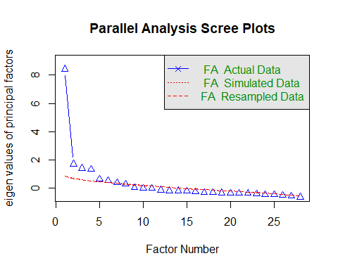

Parallel analysis suggests that the number of factors = 7 and the number of components = NA

# Eigenvalues  
ev <- eigen(cor(irt_mat, use = "pairwise.complete.obs"))$values  
  
# First and second eigenvalues  
first_ev <- ev[1]  
second_ev <- ev[2]  
  
# Ratio  
dominance_ratio <- first_ev / second_ev  
  
# Print  
first_ev

[1] 9.019241

second_ev

[1] 2.511148

dominance_ratio

[1] 3.591681

Parallel analysis suggested up to seven factors, as seven eigenvalues from the actual data exceeded those from randomly simulated data. However, the scree plot demonstrated a sharp drop between the first (9.02) and second (2.51) eigenvalues, yielding a ratio of 3.59. This indicates a single dominant factor underlying item responses, with additional weaker factors. Consistent with the concept of **essential unidimensionality** (Reckase, 1979; Hambleton, Swaminathan, & Rogers, 1991; Embretson & Reise, 2000), the scale was considered suitable for unidimensional IRT modeling despite the presence of minor secondary dimensions.

# Fitting 2PL IRT Model with mirt Package

mirt.data4 = mirt(data4, 1, itemtype = "2PL")

coef(mirt.data4, IRTpars = T, simplify = T)

$items  
 a b g u  
K1 0.852 -1.765 0 1  
K4 0.581 0.884 0 1  
K6 0.916 2.071 0 1  
K12 0.650 1.925 0 1  
K13 1.305 -1.418 0 1  
K14 1.001 -0.805 0 1  
K15 1.575 0.355 0 1  
K16 1.364 0.471 0 1  
K17 1.676 -1.358 0 1  
K18 1.341 -0.420 0 1  
K19 5.913 -0.108 0 1  
K20 5.731 -0.151 0 1  
K21 7.152 -0.205 0 1  
K22 5.401 -0.261 0 1  
K23 4.441 -0.508 0 1  
K24 5.725 -0.549 0 1  
K25 6.123 -0.609 0 1  
K26 0.996 -0.460 0 1  
K27 1.666 0.759 0 1  
K28 1.181 0.219 0 1  
K29 1.197 -0.260 0 1  
K30 2.243 1.088 0 1  
K31 3.934 -0.861 0 1  
K32 2.753 -0.578 0 1  
K33 2.133 -0.428 0 1  
K34 1.243 -1.494 0 1  
K36 2.427 -1.812 0 1  
K37 1.525 -1.494 0 1  
  
$means  
F1   
 0   
  
$cov  
 F1  
F1 1

# Fit 2PL Model (mirt)  
  
mirt.data4 <- mirt(data4, 1, itemtype = "2PL")

## Item Parameter Estimates (mirt)

# Obtain difficulty (b), discrimination (a), guessing (g), upper bound (u)  
mirt_parms <- coef(mirt.data4, IRTpars = TRUE, simplify = TRUE)  
item_parms_refined_mirt <- mirt_parms$items  
  
  
# Tidy view: Item | Discrimination | Difficulty | Guessing Parameter | Upper Bound  
item_parms_refined_tbl_mirt <- item_parms_refined_mirt |>  
 as.data.frame() |>  
 (\(d) {  
 if (!"g" %in% names(d)) d$g <- NA_real_  
 if (!"u" %in% names(d)) d$u <- NA_real_  
 d  
 })() |>  
 transform(  
 Item = rownames(item_parms_refined_mirt),  
 Difficulty = b,  
 Discrimination = a,  
 `Guessing Parameter` = g,  
 `Upper Bound` = u  
 ) |>  
 (\(d) d[, c("Item", "Difficulty", "Discrimination", "Guessing Parameter", "Upper Bound")])() |>  
 (\(d) within(d, {  
 Difficulty <- round(Difficulty, 3)  
 Discrimination <- round(Discrimination, 3)  
 `Guessing Parameter`<- round(`Guessing Parameter`, 3)  
 `Upper Bound` <- round(`Upper Bound`, 3)  
 }))()  
  
item_parms_refined_tbl_mirt

Item Difficulty Discrimination Guessing Parameter Upper Bound  
K1 K1 -1.765 0.852 0 1  
K4 K4 0.884 0.581 0 1  
K6 K6 2.071 0.916 0 1  
K12 K12 1.925 0.650 0 1  
K13 K13 -1.418 1.305 0 1  
K14 K14 -0.805 1.001 0 1  
K15 K15 0.355 1.575 0 1  
K16 K16 0.471 1.364 0 1  
K17 K17 -1.358 1.676 0 1  
K18 K18 -0.420 1.341 0 1  
K19 K19 -0.108 5.913 0 1  
K20 K20 -0.151 5.731 0 1  
K21 K21 -0.205 7.152 0 1  
K22 K22 -0.261 5.401 0 1  
K23 K23 -0.508 4.441 0 1  
K24 K24 -0.549 5.725 0 1  
K25 K25 -0.609 6.123 0 1  
K26 K26 -0.460 0.996 0 1  
K27 K27 0.759 1.666 0 1  
K28 K28 0.219 1.181 0 1  
K29 K29 -0.260 1.197 0 1  
K30 K30 1.088 2.243 0 1  
K31 K31 -0.861 3.934 0 1  
K32 K32 -0.578 2.753 0 1  
K33 K33 -0.428 2.133 0 1  
K34 K34 -1.494 1.243 0 1  
K36 K36 -1.812 2.427 0 1  
K37 K37 -1.494 1.525 0 1

## Test Information

areainfo(mirt.data4, c(-3,3))

LowerBound UpperBound Info TotalInfo Proportion nitems  
 -3 3 70.81756 73.04524 0.9695028 28

## Graphical Presentation

### Item Trace Lines (Item Characteristic Curves)

plot(mirt.data4, type = "trace")

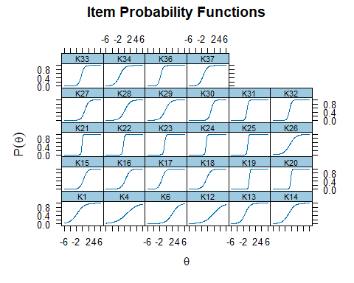

### Item Information Curves

plot(mirt.data4, type = "infotrace")

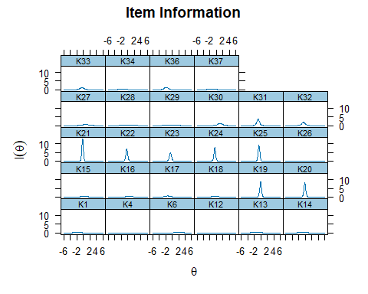

### Test Information Function

plot(mirt.data4, type = "info")

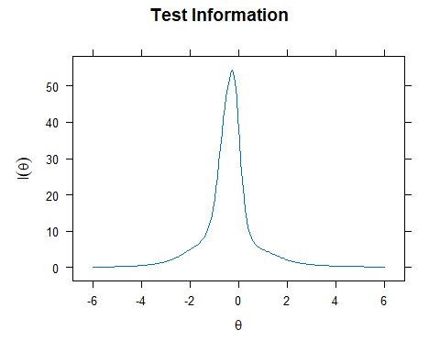

### Test Information and Standard Error

plot(mirt.data4, type = "infoSE")

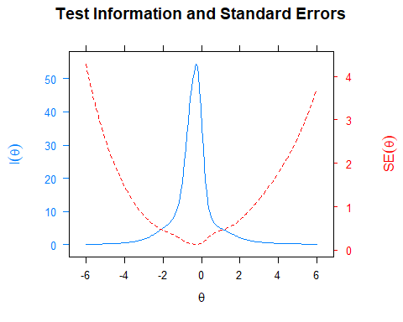

### Expected Total Score

plot(mirt.data4)

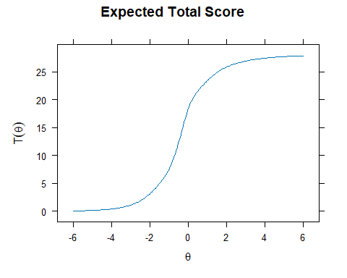

## Goodness-of-Fit Tests

### Overall Model Fit

M2(mirt.data4)

M2 df p RMSEA RMSEA_5 RMSEA_95 SRMSR TLI  
stats 1540.044 350 0 0.1294194 0.1225464 0.1357305 0.1092843 0.8294186  
 CFI  
stats 0.8420542

### Item Fit Statistics

itemfit(mirt.data4)

item S_X2 df.S_X2 RMSEA.S_X2 p.S_X2  
1 K1 10.429 17 0.000 0.885  
2 K4 21.641 19 0.026 0.302  
3 K6 17.900 12 0.049 0.119  
4 K12 16.429 16 0.011 0.423  
5 K13 15.744 16 0.000 0.471  
6 K14 10.805 19 0.000 0.930  
7 K15 14.887 16 0.000 0.533  
8 K16 11.028 15 0.000 0.751  
9 K17 9.621 12 0.000 0.649  
10 K18 14.534 17 0.000 0.629  
11 K19 12.523 7 0.062 0.085  
12 K20 13.132 8 0.056 0.107  
13 K21 21.238 7 0.100 0.003  
14 K22 29.615 9 0.106 0.001  
15 K23 9.146 9 0.009 0.424  
16 K24 4.934 5 0.000 0.424  
17 K25 9.624 6 0.055 0.141  
18 K26 15.317 19 0.000 0.702  
19 K27 17.093 13 0.039 0.195  
20 K28 17.867 17 0.016 0.397  
21 K29 32.279 18 0.063 0.020  
22 K30 10.448 8 0.039 0.235  
23 K31 9.523 7 0.042 0.217  
24 K32 13.525 13 0.014 0.408  
25 K33 16.282 14 0.028 0.296  
26 K34 17.248 15 0.027 0.304  
27 K36 2.863 3 0.000 0.413  
28 K37 13.663 12 0.026 0.323

### Person Fit Statistics

personfit(mirt.data4)

outfit z.outfit infit z.infit Zh  
1 0.57239144 -1.261643121 0.6510220 -1.82161222 1.570936053  
2 0.57239144 -1.261643121 0.6510220 -1.82161222 1.570936053  
3 0.38413376 -0.136450989 0.8180793 -0.55567306 0.644601017  
4 0.58498720 -1.207892524 0.6645092 -1.74075837 1.512731088  
5 1.60431679 0.891662594 0.7857009 -0.85102793 0.306648790  
6 0.45421778 -0.019274249 0.8347868 -0.50244724 0.541241001  
7 0.41664950 -0.315241071 0.7129322 -1.02094904 1.002619420  
8 0.12907099 -1.150413492 0.3810601 -1.76157103 1.258319405  
9 0.90104636 0.074838988 0.9916380 0.05857187 0.006827865  
10 0.93043847 -0.062527436 0.9232533 -0.30836950 0.304192501  
11 0.44276733 -1.590065264 0.5794995 -2.33465013 1.897957711  
12 0.92547468 0.241754852 1.1540746 0.60982950 -0.403785775  
13 0.44181583 -0.107022456 0.8451673 -0.47566637 0.638165079  
14 0.37487505 -0.153255790 0.6759466 -1.18013033 0.992066765  
15 1.12024780 0.395951482 1.2960323 1.22325752 -1.001228482  
16 0.44181583 -0.107022456 0.8451673 -0.47566637 0.638165079  
17 0.62208941 -1.070877775 0.7165991 -1.41450441 1.298278312  
18 3.04393728 1.595905075 0.8752135 -0.32139893 -0.524282455  
19 1.39038748 0.888432234 0.9858294 0.01116633 -0.204175456  
20 1.09234883 0.458440490 1.1111387 0.46961708 -0.399220366  
21 0.62811634 -0.445360974 0.7928105 -0.75325680 0.781552084  
22 1.30429041 0.610183148 1.2159115 0.80292028 -0.840568515  
23 0.49554357 -0.176781588 0.8837372 -0.32668109 0.563587631  
24 1.11315705 0.460973762 1.2568777 1.00343158 -0.902617973  
25 0.50275432 -1.568102279 0.5950355 -2.16563868 1.825756158  
26 1.58377824 1.139016793 0.8994097 -0.36501838 -0.080616255  
27 1.14929439 0.493887834 1.2958773 1.36918339 -1.143699456  
28 0.10528571 -0.876514518 0.4299662 -1.25736177 0.965819440  
29 0.20514745 -0.922902199 0.4795484 -1.94608961 1.422344749  
30 1.05901681 0.279527045 0.9956702 0.04920998 -0.071873429  
31 0.37247178 -0.559680849 0.6341687 -1.38754271 1.258608489  
32 0.64334681 -0.989340382 0.7656014 -1.14066865 1.131114258  
33 1.93827730 1.808562666 1.3872736 1.72099388 -2.090891921  
34 0.44730831 -0.042210125 0.8398748 -0.49477091 0.600313143  
35 0.10528571 -0.876514518 0.4299662 -1.25736177 0.965819440  
36 1.12392797 0.545422232 1.2427778 0.85862723 -0.867398352  
37 0.44181583 -0.107022456 0.8451673 -0.47566637 0.638165079  
38 0.32887391 -0.465135702 0.6657401 -0.65622195 0.627120728  
39 0.29694444 -0.272386282 0.6195315 -1.44121840 1.212154043  
40 0.84011016 0.195018216 1.0115137 0.13548723 0.006496007  
41 0.98653245 0.177115697 0.9563023 -0.08748203 0.055787866  
42 0.27489320 -0.331741643 0.5404062 -1.84686752 1.430182543  
43 0.52604658 -0.095280759 0.9553335 -0.06257416 0.368207668  
44 0.10528571 -0.876514518 0.4299662 -1.25736177 0.965819440  
45 0.92599102 0.255256302 0.9722190 -0.02468584 -0.021051067  
46 0.10528571 -0.876514518 0.4299662 -1.25736177 0.965819440  
47 0.44770483 -0.444819840 1.0969533 0.37764167 -0.051767605  
48 1.38375414 0.676840135 1.4806127 1.56472324 -1.488491077  
49 0.16576582 -1.019239053 0.4678096 -1.53322655 1.194004002  
50 0.23805277 -0.765678372 0.5679622 -1.50434685 1.207523040  
51 0.32776156 -0.223857634 0.6398817 -1.34393819 1.121531995  
52 0.12987427 -0.961745037 0.4720265 -1.21810885 0.996798074  
53 0.20514745 -0.922902199 0.4795484 -1.94608961 1.422344749  
54 0.56603943 -1.251123558 0.6414493 -1.90680287 1.607518008  
55 0.59198622 -1.196356536 0.6615682 -1.74055138 1.504550018  
56 1.04797299 0.497964713 1.5704403 1.79217207 -1.561951384  
57 0.69032442 0.152557155 1.2027913 0.76025111 -0.354665978  
58 1.04374725 0.354118956 1.2997211 1.05832932 -0.832065102  
59 0.87743487 -0.216702970 0.8451716 -0.71182850 0.631825243  
60 0.67395593 0.080488881 1.0132429 0.14156178 0.072327401  
61 1.27500133 0.603260078 1.1804503 0.72806376 -0.720479442  
62 0.16576582 -1.019239053 0.4678096 -1.53322655 1.194004002  
63 0.53154213 -1.384095001 0.6496779 -1.85586005 1.630502722  
64 0.37213658 -0.297119312 0.6511555 -1.29873163 1.133141747  
65 1.22324929 0.554838366 0.9650215 -0.04887877 -0.162494201  
66 0.82539642 -0.151601092 1.0923904 0.47574427 -0.155249837  
67 0.24272568 -0.935145970 0.6092661 -1.25032916 1.082871196  
68 0.12907099 -1.150413492 0.3810601 -1.76157103 1.258319405  
69 0.38486832 -0.376486929 0.8628329 -0.38471197 0.578214222  
70 1.42112632 1.046199669 1.1316647 0.67786111 -0.778203070  
71 0.68796731 0.021383272 1.0579407 0.29404721 0.021555154  
72 0.18364196 -0.922343971 0.6185449 -0.83419347 0.845047273  
73 0.76225912 0.074889769 0.9585710 0.02374180 -0.104385800  
74 0.22668735 -0.356481134 0.4861293 -2.08225821 1.506401636  
75 1.00666115 0.408871378 0.9154241 -0.20817610 0.084091788  
76 0.72212651 0.164098277 1.2766261 0.97513768 -0.625962072  
77 0.67918025 -0.815634650 0.7605508 -1.19203484 1.096636799  
78 1.03904936 0.483417630 1.6510222 1.93666637 -1.787498468  
79 0.49554357 -0.176781588 0.8837372 -0.32668109 0.563587631  
80 0.41191318 -0.101994958 0.7192430 -0.95259716 0.789138814  
81 5.77622382 2.556304280 0.8278537 -0.61759736 -0.376977394  
82 0.53911403 -0.212356807 0.7755284 -0.86639515 0.878161130  
83 0.53348368 -0.715206042 0.7453180 -1.13434568 1.120240268  
84 1.25050136 0.711922539 1.2720127 1.27540489 -1.169482126  
85 1.33601197 0.881816543 1.0104620 0.11938630 -0.301463142  
86 1.76007713 0.984435108 0.9001808 -0.16641928 -0.372147273  
87 0.33781958 -0.624912148 0.7903248 -0.59856882 0.677506777  
88 0.39797406 -0.201629748 0.7151990 -1.01132684 0.959756581  
89 0.70611238 -0.780193695 0.8385263 -0.73297182 0.828259646  
90 0.93621559 0.204781415 1.0241509 0.17923336 -0.143938776  
91 0.49070898 -0.119191178 0.8756199 -0.35763403 0.554418815  
92 1.43998016 0.720067436 1.3747249 1.17580916 -1.406430505  
93 0.96404849 0.022653112 0.9987607 0.06509634 0.002849664  
94 1.13306544 0.446063717 1.1242545 0.64363836 -0.583998003  
95 0.89836753 0.379582700 1.2726453 0.96736357 -0.797471131  
96 0.78766553 0.168969853 0.9956982 0.08054519 0.039202812  
97 0.07684519 -1.077835194 0.2030044 -1.98225393 1.262620072  
98 0.70933058 -0.129020398 0.8728004 -0.38088478 0.447569947  
99 1.17696237 0.484737567 1.0390736 0.23057518 -0.329658722  
100 0.48479887 -1.646282136 0.5982579 -2.14306582 1.841340058  
101 0.85281892 -0.080135070 0.6438510 -1.73669827 1.156319304  
102 2.41528939 1.803191202 1.2435407 0.94242154 -1.399428584  
103 1.66822565 1.531952700 1.3272342 1.49789690 -1.752919060  
104 1.56536468 1.099327552 1.1608916 0.72303460 -0.890476740  
105 0.45499388 -0.463516027 1.0253825 0.18739289 0.069621710  
106 0.73402787 0.109125030 1.0275811 0.19100578 -0.033428015  
107 0.30573534 -0.496933100 0.5610299 -1.80205672 1.452632482  
108 0.49554357 -0.176781588 0.8837372 -0.32668109 0.563587631  
109 0.36016486 -0.500469209 0.7626609 -0.45485732 0.515004312  
110 0.60578871 -1.001574550 0.7595170 -1.19715441 1.156784156  
111 0.55560526 -0.087126111 0.8236760 -0.62245198 0.693231365  
112 1.62158285 1.272291007 1.5572740 2.22602557 -2.281272788  
113 0.78596743 -0.487134443 0.8986975 -0.42899913 0.523383114  
114 0.31752625 -0.377764443 0.6768844 -1.16374154 1.051345125  
115 0.58403262 -1.204868360 0.7130003 -1.44066444 1.354734182  
116 0.46405051 -0.307674161 0.7102608 -1.17303899 1.120250435  
117 0.86841813 0.098929936 0.9484935 -0.13023662 0.130406901  
118 0.66869585 -0.143243157 0.8647001 -0.48430418 0.556263600  
119 0.32389919 -0.488332064 0.5703070 -1.69223161 1.402588909  
120 0.84440984 -0.303183170 0.9501771 -0.17204256 0.288779003  
121 0.51015583 -0.050161076 0.7538717 -0.84557303 0.752776741  
122 0.41747488 -0.174119093 0.7842202 -0.71931425 0.805855289  
123 1.10601511 0.423442234 1.2496026 0.90714332 -0.803286446  
124 0.24272568 -0.935145970 0.6092661 -1.25032916 1.082871196  
125 0.50738063 -0.233509371 0.8493484 -0.46008601 0.644664020  
126 0.61553475 0.001607492 0.9321235 -0.15554728 0.273932502  
127 2.39044580 2.817020728 1.1653658 0.82079812 -1.366228354  
128 0.34064213 -0.168412643 0.7303368 -0.92542536 0.905068166  
129 1.49574096 0.759794277 1.4512561 1.47877529 -1.524384250  
130 1.46068281 0.736310969 1.1551944 0.57518641 -1.017737210  
131 0.43597302 -0.656594906 0.6298175 -1.66325077 1.434359536  
132 0.91051438 -0.124409662 0.9994401 0.06736422 0.065551346  
133 0.44653840 -0.438502938 0.9182377 -0.09653986 0.242031879  
134 1.72342327 1.623266576 1.6617971 2.73345139 -2.938493803  
135 0.27005629 -0.318225567 0.5563717 -1.75235500 1.363481713  
136 0.68021585 0.065658929 1.0939633 0.43280536 -0.054578778  
137 0.57288986 -0.395837031 0.8305780 -0.65386037 0.778249714  
138 0.47435636 -0.614275326 0.7133169 -1.05993570 1.058283002  
139 0.96636110 0.028406429 0.9984766 0.06366651 -0.001400917  
140 0.37213658 -0.297119312 0.6511555 -1.29873163 1.133141747  
141 0.31655203 -0.433149942 0.6296494 -1.42043544 1.224962575  
142 0.60368816 -0.048369640 0.9163689 -0.22069710 0.354696606  
143 1.46882526 1.020224809 1.3995366 1.66531257 -1.648638538  
144 0.58173624 -0.904324174 0.7429777 -1.26450895 1.178144413  
145 0.68620476 -0.847955709 0.7802194 -1.04702899 1.021211143  
146 1.27541090 0.781942677 1.2607513 1.23258656 -1.163345781  
147 0.12568245 -1.052046569 0.4249848 -1.43589527 1.097592295  
148 0.63007183 -0.998904263 0.7585609 -1.18857683 1.146740534  
149 0.62088793 0.148066053 0.9090191 -0.23202332 0.266820348  
150 0.30573534 -0.496933100 0.5610299 -1.80205672 1.452632482  
151 1.18152928 0.526980599 1.1543637 0.60840483 -0.596555212  
152 0.12907099 -1.150413492 0.3810601 -1.76157103 1.258319405  
153 0.35139658 -0.772433953 0.5240514 -2.25712233 1.772207320  
154 0.10528571 -0.876514518 0.4299662 -1.25736177 0.965819440  
155 1.33623542 0.796148830 1.2512331 1.11302067 -1.142925132  
156 2.75891460 3.430842416 1.8613384 3.31101342 -4.318901074  
157 0.44181583 -0.107022456 0.8451673 -0.47566637 0.638165079  
158 1.22227064 0.631957209 1.2855270 1.32120980 -1.181341478  
159 0.32887391 -0.465135702 0.6657401 -0.65622195 0.627120728  
160 0.59675275 -0.120996733 0.9008597 -0.26354990 0.446827971  
161 0.32882837 -0.330835826 0.6855833 -1.14161568 1.055102306  
162 0.36467023 -0.517445577 0.8170278 -0.51520926 0.605364414  
163 2.00067378 1.086652277 1.3021961 1.00202947 -1.534230085  
164 1.09864815 0.455430816 1.4714870 1.53402798 -1.254894320  
165 0.42651627 -0.185817961 0.7624002 -0.80934871 0.843308888  
166 1.37201623 0.987423997 0.9448135 -0.20268312 -0.083158465  
167 0.46252477 -0.270061246 0.7446961 -0.99762407 1.033190595  
168 0.29694444 -0.272386282 0.6195315 -1.44121840 1.212154043  
169 0.72249435 -0.723836774 0.7581004 -1.16996185 1.046791581  
170 1.81657333 1.015258892 0.9779424 0.06818416 -0.494908045  
171 0.82420421 -0.383850944 0.8726272 -0.55767488 0.556298627  
172 0.77769616 -0.049439232 0.9948300 0.07425677 0.125666806  
173 1.38452854 0.971413372 1.1031797 0.54986379 -0.732421825  
174 0.55060439 -1.361679628 0.6423160 -1.86045675 1.615294473  
175 0.75407989 0.088836522 1.1022662 0.44128613 -0.152021373  
176 0.86923304 0.191732488 1.1504885 0.59781047 -0.334819468  
177 0.48431939 -1.638343520 0.5982229 -2.15555067 1.850833426  
178 0.92520391 0.006200902 0.9542291 -0.12834523 0.154296907  
179 0.82743607 -0.176225397 0.8705834 -0.49009327 0.486019894  
180 0.77377657 -0.145794602 1.0057264 0.11061582 0.112297668  
181 0.39616411 -0.303162166 0.7087104 -1.05706446 0.963758435  
182 0.56073631 -0.739289601 0.7664797 -1.05456097 1.061821191  
183 0.79822495 -0.457695929 0.9237900 -0.30012586 0.441036551  
184 1.45418420 0.737999841 0.8176353 -0.40155790 -0.138705998  
185 0.12907099 -1.150413492 0.3810601 -1.76157103 1.258319405  
186 0.28381708 -0.532620666 0.4850542 -2.27159247 1.699693208  
187 1.87324797 1.016051382 1.0175428 0.15633179 -0.456070331  
188 0.64722800 0.185031646 1.2330498 0.83821355 -0.484359681  
189 0.12907099 -1.150413492 0.3810601 -1.76157103 1.258319405  
190 2.05351829 1.115312563 2.0339962 2.89310786 -3.301312823  
191 1.85629508 1.585929500 1.6374695 2.45304053 -2.768192912  
192 1.08587961 0.355407711 1.4327401 1.66858343 -1.354426537  
193 1.16046292 0.518667157 1.3025464 1.39692160 -1.179700887  
194 1.28788539 0.828586520 1.3049285 1.39118451 -1.331573944  
195 0.72044142 -0.632238941 0.8565503 -0.65781454 0.724174186  
196 0.71019212 -0.395795992 0.9157271 -0.26934204 0.447885300  
197 1.10703564 0.404719219 1.1928550 0.92421541 -0.765606493  
198 1.75462913 1.618990953 1.5755873 2.42363208 -2.617336145  
199 0.10528571 -0.876514518 0.4299662 -1.25736177 0.965819440  
200 4.18340035 4.515393257 2.2533465 4.54010479 -6.272560018  
201 3.20488727 3.560669728 2.1284375 4.20760589 -5.675988088  
202 1.41964515 0.986177262 1.1982024 0.94209194 -1.094152736  
203 0.89739338 -0.130989721 1.0224522 0.17670075 0.001812441  
204 1.63618319 0.856209421 1.1797943 0.64690338 -1.055170441

## Reliability Estimates

### Marginal Reliability

marginal_rxx(mirt.data4)

[1] 0.9012828

### Empirical Reliability

theta_se = fscores(mirt.data4, full.scores.SE = TRUE)  
empirical_rxx(theta_se)

F1   
0.9124506