IRT

firdaus

# Prepare Environment

## Load Libraries

library(psych) # For basic psychometrics and scale reliability analysis  
library(foreign) # For reading and writing data in foreign statistical formats  
library(ltm) # To fit 2PL IRT models and other latent trait models

Loading required package: MASS

Loading required package: msm

Loading required package: polycor

Attaching package: 'polycor'

The following object is masked from 'package:psych':  
  
 polyserial

Attaching package: 'ltm'

The following object is masked from 'package:psych':  
  
 factor.scores

library(irtoys) # For IRT utilities

Loading required package: sm

Package 'sm', version 2.2-6.0: type help(sm) for summary information

Attaching package: 'sm'

The following object is masked from 'package:MASS':  
  
 muscle

Attaching package: 'irtoys'

The following object is masked from 'package:psych':  
  
 sim

library(mirt) # Modern IRT package for multi-item response theory

Loading required package: stats4

Loading required package: lattice

Attaching package: 'mirt'

The following object is masked from 'package:ltm':  
  
 Science

library(latticeExtra) # For enhanced plotting in lattice-based plots  
library(tidyverse) # For data manipulation, cleaning, and visualization

── Attaching core tidyverse packages ──────────────────────── tidyverse 2.0.0 ──  
✔ dplyr 1.1.4 ✔ readr 2.1.5  
✔ forcats 1.0.0 ✔ stringr 1.5.1  
✔ ggplot2 4.0.0 ✔ tibble 3.3.0  
✔ lubridate 1.9.4 ✔ tidyr 1.3.1  
✔ purrr 1.1.0

── Conflicts ────────────────────────────────────────── tidyverse_conflicts() ──  
✖ ggplot2::%+%() masks psych::%+%()  
✖ ggplot2::alpha() masks psych::alpha()  
✖ dplyr::filter() masks stats::filter()  
✖ dplyr::lag() masks stats::lag()  
✖ ggplot2::layer() masks latticeExtra::layer()  
✖ dplyr::select() masks MASS::select()  
ℹ Use the conflicted package (<http://conflicted.r-lib.org/>) to force all conflicts to become errors

library(haven) # For importing and exporting SPSS, Stata, and SAS files  
library(writexl) # For exporting data frames to Excel files  
library(readxl) # For reading data from Excel files

## Load Data

data1=read_xlsx("IRT_knowledge_V1.xlsx") ##read data from Excel   
names(data1) # List down variables in the data set

[1] "K1" "K2" "K3" "K4" "K5" "K6" "K7" "K8" "K9" "K10" "K11" "K12"  
[13] "K13" "K14" "K15" "K16" "K17" "K18" "K19" "K20" "K21" "K22" "K23" "K24"  
[25] "K25" "K26" "K27" "K28" "K29" "K30" "K31" "K32" "K33" "K34" "K35" "K36"  
[37] "K37"

dim(data1) # Data set consists of 37 variables and 177 parents

[1] 204 37

### Recode Data

# Define reverse-coded items  
reverse_items <- c("K2", "K3", "K4", "K5", "K8", "K10", "K35")  
  
# Recode  
data2 <- data1 %>%  
 mutate(across(  
 -all_of(reverse_items),   
 ~ case_when(  
 tolower(.) == "ya" ~ 1,  
 tolower(.) == "tidak" ~ 0,  
 tolower(.) == "tidak pasti" ~ 2,  
 TRUE ~ NA_real_  
 )  
 )) %>%  
 mutate(across(  
 all_of(reverse_items),  
 ~ case_when(  
 tolower(.) == "ya" ~ 0,  
 tolower(.) == "tidak" ~ 1,  
 tolower(.) == "tidak pasti" ~ 2,  
 TRUE ~ NA_real_  
 )  
 ))

#Recode 1 = 1 (correct answer), 2 and 0 = 0 (incorrect answer)  
  
data3 <- data2 %>%  
 mutate(across(  
 everything(),  
 ~ case_when(  
 . == 1 ~ 1,  
 . %in% c(0, 2) ~ 0,  
 TRUE ~ NA_real_  
 )  
 ))

# Descriptive Statistics

## Response Frequencies

response.frequencies(data3)

0 1 miss  
K1 0.21078431 0.7892157 0  
K2 0.60784314 0.3921569 0  
K3 0.53921569 0.4607843 0  
K4 0.61764706 0.3823529 0  
K5 0.32352941 0.6764706 0  
K6 0.83823529 0.1617647 0  
K7 0.55882353 0.4411765 0  
K8 0.57352941 0.4264706 0  
K9 0.47549020 0.5245098 0  
K10 0.50490196 0.4950980 0  
K11 0.62254902 0.3774510 0  
K12 0.75980392 0.2401961 0  
K13 0.19117647 0.8088235 0  
K14 0.33823529 0.6617647 0  
K15 0.60294118 0.3970588 0  
K16 0.62254902 0.3774510 0  
K17 0.16666667 0.8333333 0  
K18 0.39705882 0.6029412 0  
K19 0.47058824 0.5294118 0  
K20 0.45098039 0.5490196 0  
K21 0.42647059 0.5735294 0  
K22 0.40196078 0.5980392 0  
K23 0.30392157 0.6960784 0  
K24 0.27941176 0.7205882 0  
K25 0.25490196 0.7450980 0  
K26 0.40686275 0.5931373 0  
K27 0.71078431 0.2892157 0  
K28 0.55392157 0.4460784 0  
K29 0.44117647 0.5588235 0  
K30 0.81372549 0.1862745 0  
K31 0.19607843 0.8039216 0  
K32 0.30392157 0.6960784 0  
K33 0.36764706 0.6323529 0  
K34 0.18627451 0.8137255 0  
K35 0.58333333 0.4166667 0  
K36 0.06862745 0.9313725 0  
K37 0.15686275 0.8431373 0

### Descriptive Statistics

descript(data3)

Descriptive statistics for the 'data3' data-set  
  
Sample:  
 37 items and 204 sample units; 0 missing values  
  
Proportions for each level of response:  
 0 1 logit  
K1 0.2108 0.7892 1.3202  
K2 0.6078 0.3922 -0.4383  
K3 0.5392 0.4608 -0.1572  
K4 0.6176 0.3824 -0.4796  
K5 0.3235 0.6765 0.7376  
K6 0.8382 0.1618 -1.6452  
K7 0.5588 0.4412 -0.2364  
K8 0.5735 0.4265 -0.2963  
K9 0.4755 0.5245 0.0981  
K10 0.5049 0.4951 -0.0196  
K11 0.6225 0.3775 -0.5004  
K12 0.7598 0.2402 -1.1516  
K13 0.1912 0.8088 1.4424  
K14 0.3382 0.6618 0.6712  
K15 0.6029 0.3971 -0.4177  
K16 0.6225 0.3775 -0.5004  
K17 0.1667 0.8333 1.6094  
K18 0.3971 0.6029 0.4177  
K19 0.4706 0.5294 0.1178  
K20 0.4510 0.5490 0.1967  
K21 0.4265 0.5735 0.2963  
K22 0.4020 0.5980 0.3973  
K23 0.3039 0.6961 0.8287  
K24 0.2794 0.7206 0.9474  
K25 0.2549 0.7451 1.0726  
K26 0.4069 0.5931 0.3769  
K27 0.7108 0.2892 -0.8992  
K28 0.5539 0.4461 -0.2165  
K29 0.4412 0.5588 0.2364  
K30 0.8137 0.1863 -1.4744  
K31 0.1961 0.8039 1.4110  
K32 0.3039 0.6961 0.8287  
K33 0.3676 0.6324 0.5423  
K34 0.1863 0.8137 1.4744  
K35 0.5833 0.4167 -0.3365  
K36 0.0686 0.9314 2.6080  
K37 0.1569 0.8431 1.6818  
  
  
Frequencies of total scores:  
 0 1 2 3 4 5 6 7 8 9 10 11 12 13 14 15 16 17 18 19 20 21 22 23 24 25 26 27  
Freq 1 0 1 1 2 1 2 1 4 5 6 5 3 9 4 7 10 4 10 7 8 16 10 8 12 11 5 9  
 28 29 30 31 32 33 34 35 36 37  
Freq 10 6 9 3 3 3 2 1 3 2  
  
  
Point Biserial correlation with Total Score:  
 Included Excluded  
K1 0.3742 0.3274  
K2 0.2793 0.2194  
K3 0.2500 0.1880  
K4 0.3596 0.3028  
K5 0.0997 0.0392  
K6 0.3816 0.3397  
K7 0.2545 0.1928  
K8 0.2645 0.2034  
K9 0.3174 0.2574  
K10 0.3082 0.2478  
K11 0.2970 0.2381  
K12 0.4038 0.3558  
K13 0.4129 0.3693  
K14 0.3313 0.2750  
K15 0.5002 0.4503  
K16 0.4716 0.4205  
K17 0.4539 0.4142  
K18 0.5610 0.5151  
K19 0.6431 0.6027  
K20 0.6762 0.6387  
K21 0.6889 0.6528  
K22 0.6503 0.6112  
K23 0.6857 0.6520  
K24 0.7137 0.6833  
K25 0.6905 0.6591  
K26 0.4828 0.4316  
K27 0.5352 0.4912  
K28 0.4978 0.4469  
K29 0.5478 0.5002  
K30 0.5352 0.4977  
K31 0.6280 0.5953  
K32 0.6193 0.5804  
K33 0.5917 0.5487  
K34 0.3898 0.3457  
K35 0.2232 0.1612  
K36 0.4188 0.3912  
K37 0.4330 0.3935  
  
  
Cronbach's alpha:  
 value  
All Items 0.8935  
Excluding K1 0.8921  
Excluding K2 0.8941  
Excluding K3 0.8948  
Excluding K4 0.8927  
Excluding K5 0.8969  
Excluding K6 0.8919  
Excluding K7 0.8947  
Excluding K8 0.8945  
Excluding K9 0.8936  
Excluding K10 0.8937  
Excluding K11 0.8938  
Excluding K12 0.8917  
Excluding K13 0.8915  
Excluding K14 0.8931  
Excluding K15 0.8901  
Excluding K16 0.8907  
Excluding K17 0.8909  
Excluding K18 0.8890  
Excluding K19 0.8874  
Excluding K20 0.8867  
Excluding K21 0.8865  
Excluding K22 0.8873  
Excluding K23 0.8868  
Excluding K24 0.8864  
Excluding K25 0.8869  
Excluding K26 0.8905  
Excluding K27 0.8895  
Excluding K28 0.8902  
Excluding K29 0.8892  
Excluding K30 0.8897  
Excluding K31 0.8882  
Excluding K32 0.8880  
Excluding K33 0.8884  
Excluding K34 0.8918  
Excluding K35 0.8952  
Excluding K36 0.8917  
Excluding K37 0.8912  
  
  
Pairwise Associations:  
 Item i Item j p.value  
1 2 28 1.000  
2 4 26 1.000  
3 5 22 1.000  
4 5 35 1.000  
5 7 17 1.000  
6 7 19 1.000  
7 7 20 1.000  
8 7 35 1.000  
9 8 35 1.000  
10 10 21 1.000

# Fitting 2PL IRT Model with ltm Package

## Fit 2PL Model (ltm)

irt.data3 <- ltm(data3 ~ z1, IRT.param = TRUE)

## Item Parameter Estimates

# Obtain difficulty and discrimination parameter estimates  
item_parms <- coef(irt.data3)

# Tidy view: Item | a (Discrimination) | b (Difficulty)  
  
item_parms_tbl <- item_parms |>  
 as.data.frame() |>  
 transform(Item = rownames(item_parms),  
 Difficulty = Dffclt,  
 Discrimination = Dscrmn) |>  
 (\(d) d[, c("Item", "Difficulty", "Discrimination")])() |>  
 (\(d) within(d, {   
 Difficulty <- round(Difficulty, 3)  
 Discrimination <- round(Discrimination, 3)  
 }))()  
  
item_parms_tbl

Item Difficulty Discrimination  
K1 K1 -1.426 0.873  
K2 K2 1.275 0.473  
K3 K3 0.719 0.390  
K4 K4 1.094 0.660  
K5 K5 -9.376 0.076  
K6 K6 2.247 0.994  
K7 K7 1.228 0.260  
K8 K8 1.778 0.203  
K9 K9 0.001 0.333  
K10 K10 0.368 0.298  
K11 K11 1.779 0.349  
K12 K12 2.059 0.724  
K13 K13 -1.250 1.135  
K14 K14 -0.559 0.908  
K15 K15 0.676 1.475  
K16 K16 0.800 1.268  
K17 K17 -1.078 1.618  
K18 K18 -0.106 1.362  
K19 K19 0.210 4.683  
K20 K20 0.158 5.578  
K21 K21 0.096 6.871  
K22 K22 0.053 4.676  
K23 K23 -0.163 5.311  
K24 K24 -0.082 16.964  
K25 K25 -0.266 6.626  
K26 K26 -0.159 0.976  
K27 K27 1.073 1.614  
K28 K28 0.531 1.132  
K29 K29 0.050 1.214  
K30 K30 1.382 2.216  
K31 K31 -0.564 3.755  
K32 K32 -0.265 2.718  
K33 K33 -0.113 2.130  
K34 K34 -1.202 1.225  
K35 K35 1.416 0.309  
K36 K36 -1.530 2.379  
K37 K37 -1.220 1.471

## Model Summary

# Includes log-likelihood, AIC/BIC, SEs, and Wald z-values  
summary(irt.data3)

Call:  
ltm(formula = data3 ~ z1, IRT.param = TRUE)  
  
Model Summary:  
 log.Lik AIC BIC  
 -3748.378 7644.756 7890.297  
  
Coefficients:  
 value std.err z.vals  
Dffclt.K1 -1.4264 0.4021 -3.5474  
Dffclt.K2 1.2750 0.4395 2.9011  
Dffclt.K3 0.7195 0.4000 1.7987  
Dffclt.K4 1.0943 0.2948 3.7118  
Dffclt.K5 -9.3762 19.8814 -0.4716  
Dffclt.K6 2.2471 0.4202 5.3475  
Dffclt.K7 1.2275 0.7566 1.6224  
Dffclt.K8 1.7782 1.2819 1.3871  
Dffclt.K9 0.0009 0.4468 0.0021  
Dffclt.K10 0.3675 0.4764 0.7714  
Dffclt.K11 1.7786 0.7647 2.3260  
Dffclt.K12 2.0587 0.4714 4.3673  
Dffclt.K13 -1.2502 0.2985 -4.1882  
Dffclt.K14 -0.5586 0.2302 -2.4270  
Dffclt.K15 0.6763 0.1252 5.4015  
Dffclt.K16 0.7998 0.1486 5.3817  
Dffclt.K17 -1.0782 0.2101 -5.1321  
Dffclt.K18 -0.1062 0.1297 -0.8185  
Dffclt.K19 0.2102 0.0539 3.8974  
Dffclt.K20 0.1584 0.0500 3.1693  
Dffclt.K21 0.0956 0.0422 2.2641  
Dffclt.K22 0.0527 0.0515 1.0217  
Dffclt.K23 -0.1631 0.0568 -2.8727  
Dffclt.K24 -0.0817 0.3221 -0.2537  
Dffclt.K25 -0.2657 0.0658 -4.0389  
Dffclt.K26 -0.1590 0.1747 -0.9101  
Dffclt.K27 1.0730 0.1472 7.2883  
Dffclt.K28 0.5313 0.1449 3.6679  
Dffclt.K29 0.0504 0.1353 0.3729  
Dffclt.K30 1.3822 0.1532 9.0193  
Dffclt.K31 -0.5639 0.0873 -6.4600  
Dffclt.K32 -0.2649 0.0864 -3.0675  
Dffclt.K33 -0.1135 0.0932 -1.2167  
Dffclt.K34 -1.2024 0.2740 -4.3881  
Dffclt.K35 1.4162 0.7078 2.0009  
Dffclt.K36 -1.5304 0.2380 -6.4304  
Dffclt.K37 -1.2203 0.2437 -5.0064  
Dscrmn.K1 0.8727 0.2206 3.9555  
Dscrmn.K2 0.4727 0.1642 2.8785  
Dscrmn.K3 0.3899 0.1564 2.4939  
Dscrmn.K4 0.6598 0.1775 3.7173  
Dscrmn.K5 0.0763 0.1565 0.4879  
Dscrmn.K6 0.9942 0.2469 4.0263  
Dscrmn.K7 0.2602 0.1516 1.7159  
Dscrmn.K8 0.2027 0.1501 1.3505  
Dscrmn.K9 0.3331 0.1547 2.1530  
Dscrmn.K10 0.2983 0.1529 1.9504  
Dscrmn.K11 0.3486 0.1586 2.1979  
Dscrmn.K12 0.7243 0.1992 3.6356  
Dscrmn.K13 1.1346 0.2524 4.4945  
Dscrmn.K14 0.9076 0.2045 4.4370  
Dscrmn.K15 1.4748 0.2662 5.5409  
Dscrmn.K16 1.2676 0.2407 5.2662  
Dscrmn.K17 1.6182 0.3240 4.9951  
Dscrmn.K18 1.3621 0.2489 5.4718  
Dscrmn.K19 4.6826 0.8496 5.5116  
Dscrmn.K20 5.5780 1.2893 4.3264  
Dscrmn.K21 6.8712 1.5567 4.4140  
Dscrmn.K22 4.6763 0.8492 5.5065  
Dscrmn.K23 5.3111 1.1319 4.6924  
Dscrmn.K24 16.9641 66.8082 0.2539  
Dscrmn.K25 6.6261 1.4010 4.7297  
Dscrmn.K26 0.9758 0.2055 4.7490  
Dscrmn.K27 1.6137 0.2974 5.4255  
Dscrmn.K28 1.1320 0.2235 5.0660  
Dscrmn.K29 1.2142 0.2308 5.2616  
Dscrmn.K30 2.2162 0.4249 5.2159  
Dscrmn.K31 3.7552 0.6691 5.6120  
Dscrmn.K32 2.7180 0.4797 5.6656  
Dscrmn.K33 2.1299 0.3664 5.8124  
Dscrmn.K34 1.2254 0.2628 4.6628  
Dscrmn.K35 0.3093 0.1548 1.9986  
Dscrmn.K36 2.3787 0.5652 4.2086  
Dscrmn.K37 1.4710 0.3023 4.8656  
  
Integration:  
method: Gauss-Hermite  
quadrature points: 21   
  
Optimization:  
Convergence: 0   
max(|grad|): 0.088   
quasi-Newton: BFGS

## Items Removal Plan 1

**Selection criteria a > 0.64 (moderate discrimination) (Baker, 2001) ; -3 < b > +3**

K2 - a = 0.47

K3 - a = 0.39

K5 - a = 0.08 , b = -9.3762

K7 - a = 0.26

K8 - a = 0.20

K9 - a = 0.33

K10 - a = 0.30

K11 - a = 0.35

K24 - a = 16.9641 (?Overfitting)

K35 - a = 0.31

### 2PL Model - Remove Items

# Remove the items  
irt_removed_items <- c("K2", "K3", "K5", "K7", "K8", "K9", "K10", "K11","K35","K24")  
  
# Create new dataset with only included items  
data4 <- data3 %>% dplyr::select(-any_of(irt_removed_items))

### Descriptive Statistics

descript(data4)

Descriptive statistics for the 'data4' data-set  
  
Sample:  
 27 items and 204 sample units; 0 missing values  
  
Proportions for each level of response:  
 0 1 logit  
K1 0.2108 0.7892 1.3202  
K4 0.6176 0.3824 -0.4796  
K6 0.8382 0.1618 -1.6452  
K12 0.7598 0.2402 -1.1516  
K13 0.1912 0.8088 1.4424  
K14 0.3382 0.6618 0.6712  
K15 0.6029 0.3971 -0.4177  
K16 0.6225 0.3775 -0.5004  
K17 0.1667 0.8333 1.6094  
K18 0.3971 0.6029 0.4177  
K19 0.4706 0.5294 0.1178  
K20 0.4510 0.5490 0.1967  
K21 0.4265 0.5735 0.2963  
K22 0.4020 0.5980 0.3973  
K23 0.3039 0.6961 0.8287  
K25 0.2549 0.7451 1.0726  
K26 0.4069 0.5931 0.3769  
K27 0.7108 0.2892 -0.8992  
K28 0.5539 0.4461 -0.2165  
K29 0.4412 0.5588 0.2364  
K30 0.8137 0.1863 -1.4744  
K31 0.1961 0.8039 1.4110  
K32 0.3039 0.6961 0.8287  
K33 0.3676 0.6324 0.5423  
K34 0.1863 0.8137 1.4744  
K36 0.0686 0.9314 2.6080  
K37 0.1569 0.8431 1.6818  
  
  
Frequencies of total scores:  
 0 1 2 3 4 5 6 7 8 9 10 11 12 13 14 15 16 17 18 19 20 21 22 23 24 25 26 27  
Freq 1 2 5 1 3 4 5 5 5 8 9 11 8 7 5 9 9 12 13 19 13 7 9 10 8 8 2 6  
  
  
Point Biserial correlation with Total Score:  
 Included Excluded  
K1 0.3583 0.3021  
K4 0.3060 0.2365  
K6 0.3679 0.3176  
K12 0.3244 0.2641  
K13 0.4843 0.4362  
K14 0.4266 0.3647  
K15 0.5811 0.5282  
K16 0.5401 0.4843  
K17 0.5056 0.4613  
K18 0.5350 0.4783  
K19 0.7215 0.6817  
K20 0.7268 0.6877  
K21 0.7317 0.6934  
K22 0.7003 0.6589  
K23 0.6881 0.6482  
K25 0.7066 0.6707  
K26 0.4435 0.3801  
K27 0.5680 0.5182  
K28 0.5095 0.4499  
K29 0.5101 0.4505  
K30 0.5508 0.5072  
K31 0.6681 0.6323  
K32 0.6636 0.6213  
K33 0.6340 0.5867  
K34 0.4376 0.3876  
K36 0.4432 0.4113  
K37 0.4696 0.4246  
  
  
Cronbach's alpha:  
 value  
All Items 0.9077  
Excluding K1 0.9077  
Excluding K4 0.9096  
Excluding K6 0.9073  
Excluding K12 0.9085  
Excluding K13 0.9055  
Excluding K14 0.9070  
Excluding K15 0.9038  
Excluding K16 0.9047  
Excluding K17 0.9051  
Excluding K18 0.9048  
Excluding K19 0.9006  
Excluding K20 0.9005  
Excluding K21 0.9003  
Excluding K22 0.9011  
Excluding K23 0.9015  
Excluding K25 0.9012  
Excluding K26 0.9068  
Excluding K27 0.9040  
Excluding K28 0.9054  
Excluding K29 0.9054  
Excluding K30 0.9043  
Excluding K31 0.9022  
Excluding K32 0.9020  
Excluding K33 0.9026  
Excluding K34 0.9062  
Excluding K36 0.9062  
Excluding K37 0.9057  
  
  
Pairwise Associations:  
 Item i Item j p.value  
1 2 17 1.000  
2 4 5 1.000  
3 1 19 1.000  
4 2 5 0.880  
5 1 18 0.723  
6 17 25 0.704  
7 5 20 0.643  
8 2 26 0.627  
9 4 27 0.593  
10 8 17 0.591

### Refit 2PL Model

irt.data4 <- ltm(data4 ~ z1, IRT.param = TRUE)

### Item Parameter Estimates

# Obtain difficulty and discrimination parameter estimates  
item_parms_refined <- coef(irt.data4)  
  
# Tidy view: Item | a (Discrimination) | b (Difficulty)  
  
item_parms_refined_tbl <- item_parms_refined |>  
 as.data.frame() |>  
 transform(Item = rownames(item_parms_refined),  
 Difficulty = Dffclt,  
 Discrimination = Dscrmn) |>  
 (\(d) d[, c("Item", "Difficulty", "Discrimination")])() |>  
 (\(d) within(d, {   
 Difficulty <- round(Difficulty, 3)  
 Discrimination <- round(Discrimination, 3)  
 }))()  
  
item_parms_refined_tbl

Item Difficulty Discrimination  
K1 K1 -1.516 0.840  
K4 K4 1.242 0.533  
K6 K6 2.324 0.939  
K12 K12 2.289 0.621  
K13 K13 -1.235 1.201  
K14 K14 -0.565 0.936  
K15 K15 0.670 1.508  
K16 K16 0.788 1.300  
K17 K17 -1.166 1.546  
K18 K18 -0.138 1.294  
K19 K19 0.215 6.013  
K20 K20 0.160 6.561  
K21 K21 0.099 7.075  
K22 K22 0.051 5.670  
K23 K23 -0.283 2.875  
K25 K25 -0.394 3.904  
K26 K26 -0.200 0.920  
K27 K27 1.090 1.571  
K28 K28 0.530 1.087  
K29 K29 0.011 1.063  
K30 K30 1.404 2.165  
K31 K31 -0.640 3.489  
K32 K32 -0.311 2.520  
K33 K33 -0.138 2.058  
K34 K34 -1.359 1.102  
K36 K36 -1.708 2.117  
K37 K37 -1.373 1.324

### Model Summary

# Includes log-likelihood, AIC/BIC, SEs, and Wald z-values  
summary(irt.data4)

Call:  
ltm(formula = data4 ~ z1, IRT.param = TRUE)  
  
Model Summary:  
 log.Lik AIC BIC  
 -2476.419 5060.839 5240.017  
  
Coefficients:  
 value std.err z.vals  
Dffclt.K1 -1.5157 0.4169 -3.6361  
Dffclt.K4 1.2418 0.3868 3.2108  
Dffclt.K6 2.3242 0.4602 5.0507  
Dffclt.K12 2.2892 0.6018 3.8037  
Dffclt.K13 -1.2345 0.2731 -4.5200  
Dffclt.K14 -0.5647 0.2238 -2.5238  
Dffclt.K15 0.6699 0.1256 5.3336  
Dffclt.K16 0.7883 0.1472 5.3546  
Dffclt.K17 -1.1663 0.2227 -5.2379  
Dffclt.K18 -0.1382 0.1417 -0.9755  
Dffclt.K19 0.2150 0.0603 3.5667  
Dffclt.K20 0.1600 0.0571 2.8001  
Dffclt.K21 0.0991 0.0501 1.9787  
Dffclt.K22 0.0513 0.0563 0.9121  
Dffclt.K23 -0.2827 0.1000 -2.8258  
Dffclt.K25 -0.3936 0.0992 -3.9665  
Dffclt.K26 -0.2001 0.1893 -1.0573  
Dffclt.K27 1.0903 0.1508 7.2290  
Dffclt.K28 0.5296 0.1532 3.4570  
Dffclt.K29 0.0107 0.1573 0.0679  
Dffclt.K30 1.4037 0.1563 8.9788  
Dffclt.K31 -0.6401 0.1106 -5.7882  
Dffclt.K32 -0.3107 0.1058 -2.9359  
Dffclt.K33 -0.1385 0.1063 -1.3032  
Dffclt.K34 -1.3595 0.3177 -4.2786  
Dffclt.K36 -1.7079 0.2693 -6.3419  
Dffclt.K37 -1.3732 0.2804 -4.8982  
Dscrmn.K1 0.8402 0.2093 4.0135  
Dscrmn.K4 0.5326 0.1664 3.2013  
Dscrmn.K6 0.9389 0.2439 3.8489  
Dscrmn.K12 0.6215 0.1915 3.2446  
Dscrmn.K13 1.2006 0.2516 4.7721  
Dscrmn.K14 0.9360 0.1997 4.6869  
Dscrmn.K15 1.5084 0.2697 5.5918  
Dscrmn.K16 1.3000 0.2434 5.3414  
Dscrmn.K17 1.5463 0.3062 5.0508  
Dscrmn.K18 1.2938 0.2351 5.5031  
Dscrmn.K19 6.0135 1.0683 5.6291  
Dscrmn.K20 6.5612 1.3057 5.0251  
Dscrmn.K21 7.0752 1.5854 4.4628  
Dscrmn.K22 5.6704 1.2451 4.5543  
Dscrmn.K23 2.8749 0.5396 5.3279  
Dscrmn.K25 3.9044 0.8070 4.8379  
Dscrmn.K26 0.9197 0.1952 4.7110  
Dscrmn.K27 1.5705 0.2858 5.4947  
Dscrmn.K28 1.0871 0.2135 5.0915  
Dscrmn.K29 1.0627 0.2102 5.0562  
Dscrmn.K30 2.1649 0.4152 5.2139  
Dscrmn.K31 3.4887 0.6991 4.9903  
Dscrmn.K32 2.5203 0.4525 5.5697  
Dscrmn.K33 2.0583 0.3603 5.7122  
Dscrmn.K34 1.1020 0.2425 4.5449  
Dscrmn.K36 2.1173 0.4878 4.3408  
Dscrmn.K37 1.3244 0.2746 4.8230  
  
Integration:  
method: Gauss-Hermite  
quadrature points: 21   
  
Optimization:  
Convergence: 0   
max(|grad|): 0.0049   
quasi-Newton: BFGS

## Graphical Presentation

### Item Characteristic Curves (ICC)

# ICC for All Items  
# Plot ICC for all items  
plot(irt.data4, type = "ICC", legend = TRUE)

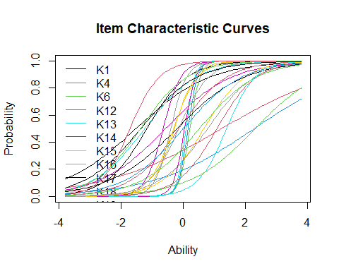

# ICC for Individual Items  
  
# Get total number of items  
ICC_items <- nrow(coef(irt.data4))  
  
# Plot ICC for each item  
for (i in 1:ICC_items) {  
 plot(irt.data4, type = "ICC", legend = TRUE, items = i)  
}

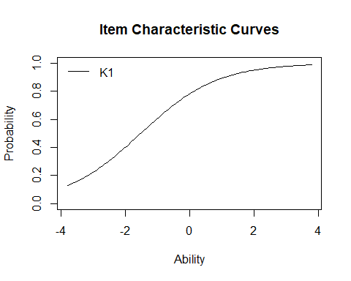

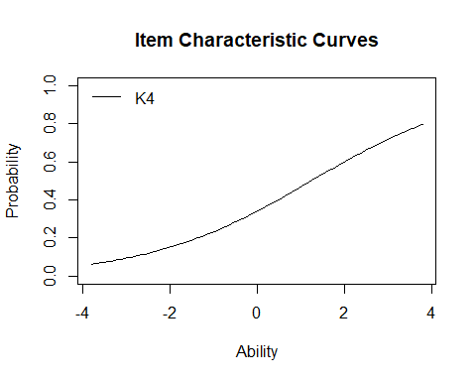

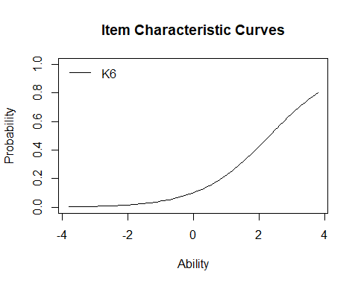

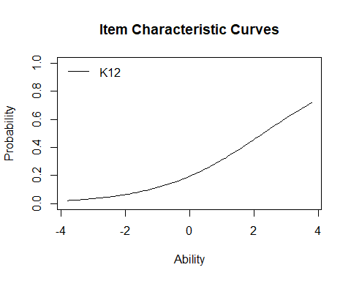

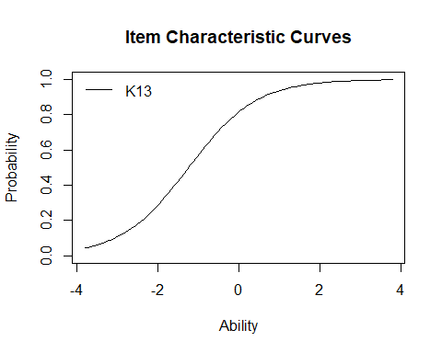

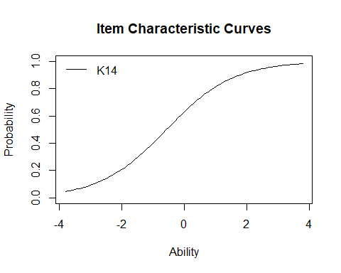

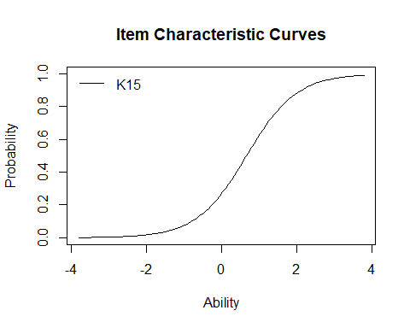

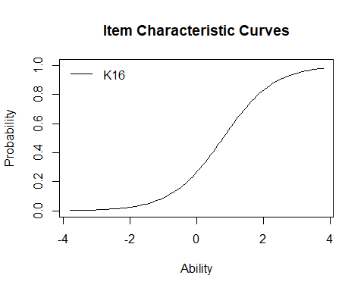

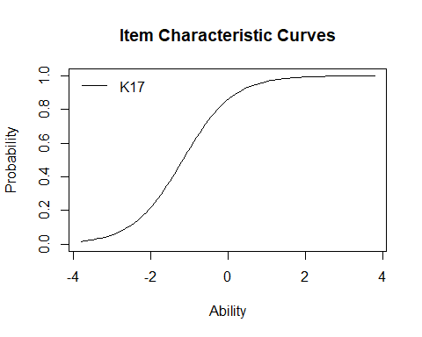

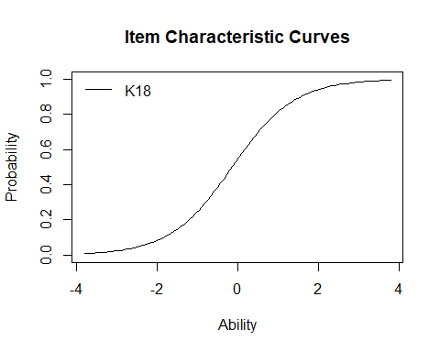

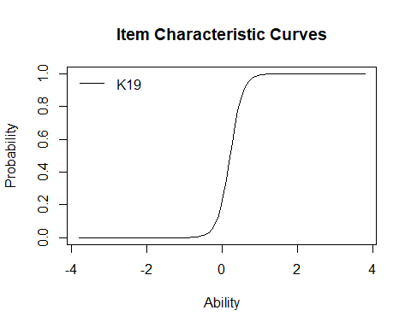

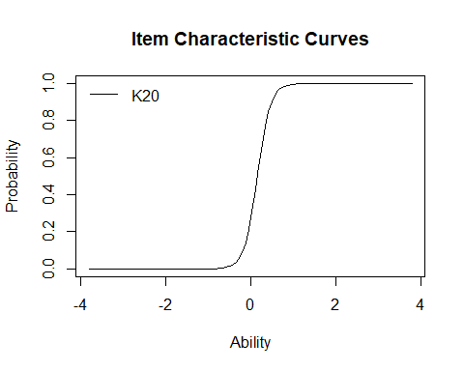

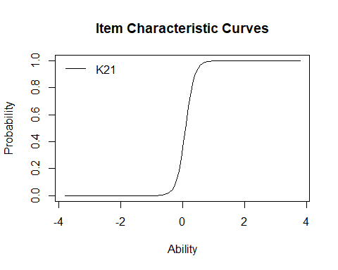

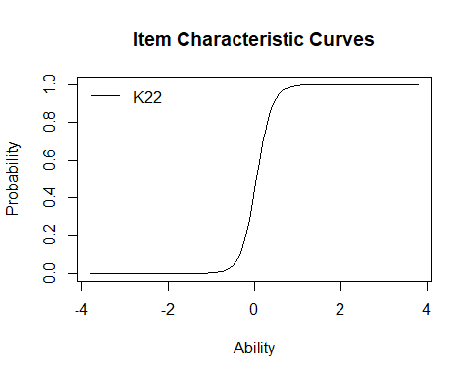

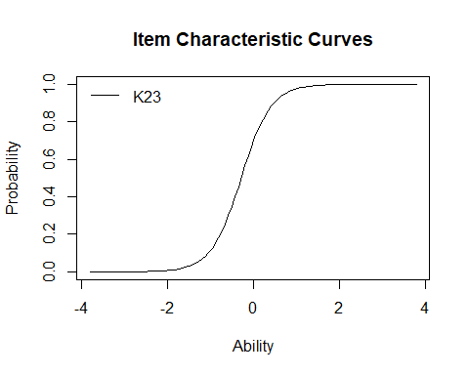

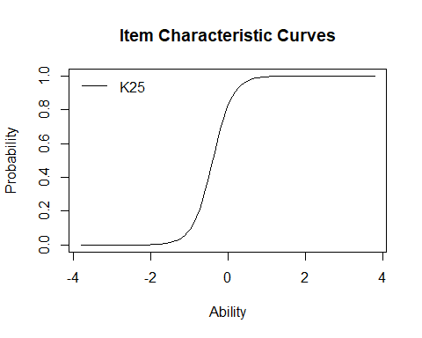

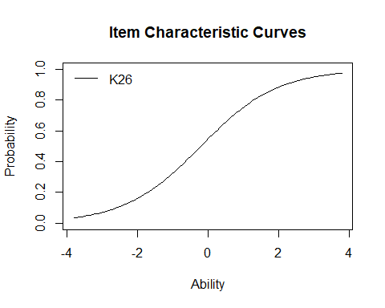

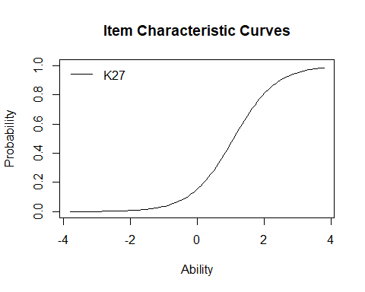

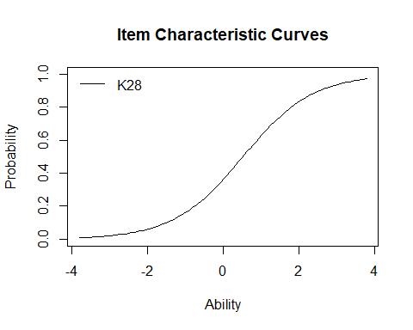

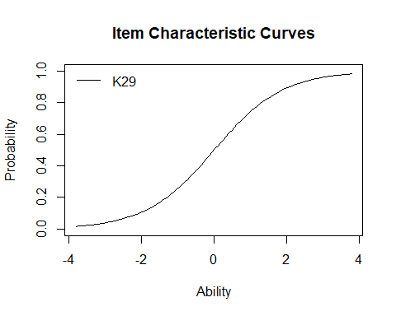

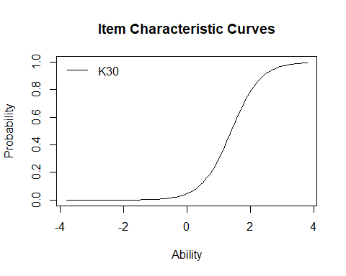

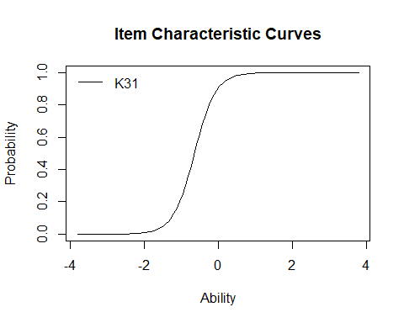

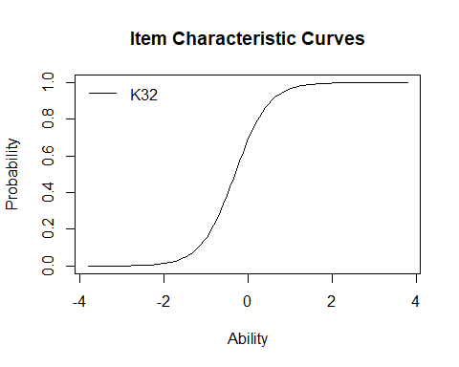

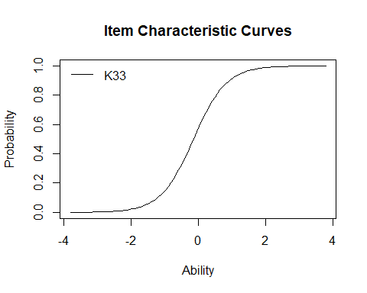

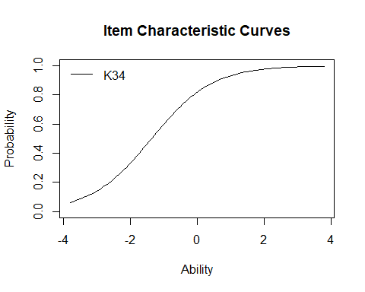

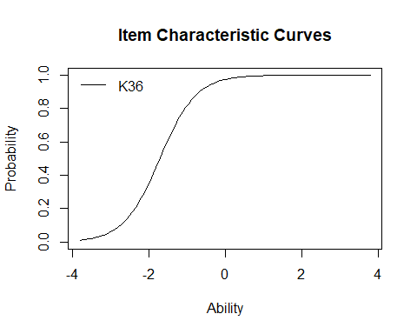

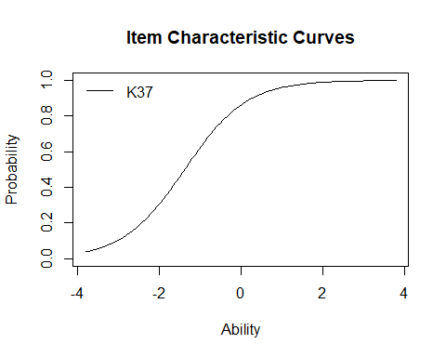

## Goodness-of-Fit Tests

### Item Fit Statistics

item_fit <- item.fit(irt.data4)  
item_fit

Item-Fit Statistics and P-values  
  
Call:  
ltm(formula = data4 ~ z1, IRT.param = TRUE)  
  
Alternative: Items do not fit the model  
Ability Categories: 10  
  
 X^2 Pr(>X^2)  
K1 4.9206 0.766  
K4 15.3684 0.0524  
K6 7.2905 0.5056  
K12 4.2084 0.8378  
K13 11.3718 0.1815  
K14 14.7225 0.0648  
K15 12.7751 0.1198  
K16 13.6769 0.0906  
K17 16.4946 0.0358  
K18 11.3648 0.1819  
K19 3.1158 0.9269  
K20 17.5518 0.0248  
K21 7.7055 0.4628  
K22 9.0532 0.3378  
K23 7.4196 0.4921  
K25 5.7966 0.67  
K26 17.6430 0.0241  
K27 28.2902 0.0004  
K28 24.5023 0.0019  
K29 14.4974 0.0697  
K30 25.8528 0.0011  
K31 7.4821 0.4856  
K32 20.0696 0.0101  
K33 18.4095 0.0184  
K34 9.3176 0.3162  
K36 13.5752 0.0935  
K37 8.5269 0.3838

### Fit on the Two-Way Margins

margins_output <- margins(irt.data4)  
margins_output

Call:  
ltm(formula = data4 ~ z1, IRT.param = TRUE)  
  
Fit on the Two-Way Margins  
  
Response: (0,0)  
 Item i Item j Obs Exp (O-E)^2/E   
1 12 16 43 70.16 10.51 ***  
2 14 23 43 69.90 10.35 ***  
3 14 24 48 74.96 9.70 ***  
  
Response: (1,0)  
 Item i Item j Obs Exp (O-E)^2/E   
1 7 8 9 34.51 18.86 ***  
2 11 26 4 0.63 17.99 ***  
3 18 19 2 19.69 15.90 ***  
  
Response: (0,1)  
 Item i Item j Obs Exp (O-E)^2/E   
1 7 8 5 31.84 22.63 ***  
2 23 24 5 22.51 13.62 ***  
3 17 20 17 38.18 11.75 ***  
  
Response: (1,1)  
 Item i Item j Obs Exp (O-E)^2/E   
1 7 8 72 32.41 48.37 ***  
2 18 19 57 27.32 32.25 ***  
3 18 21 34 15.23 23.14 ***  
  
'***' denotes a chi-squared residual greater than 3.5

### Person Fit Statistics

person_fit <- person.fit(irt.data4)  
person_fit

Person-Fit Statistics and P-values  
  
Call:  
ltm(formula = data4 ~ z1, IRT.param = TRUE)  
  
Alternative: Inconsistent response pattern under the estimated model  
  
 K1 K4 K6 K12 K13 K14 K15 K16 K17 K18 K19 K20 K21 K22 K23 K25 K26 K27 K28  
1 0 0 0 0 0 0 0 0 0 0 0 0 0 0 0 0 0 0 0  
2 0 0 0 0 0 0 0 0 0 0 0 0 0 0 0 0 0 0 0  
3 0 0 0 0 0 0 0 0 0 0 0 0 0 0 0 0 0 0 1  
4 0 0 0 0 0 0 0 0 0 0 0 0 0 0 0 0 1 0 0  
5 0 0 0 0 0 0 0 0 0 0 0 0 0 0 1 1 0 0 0  
6 0 0 0 0 0 0 0 0 0 1 0 0 0 0 1 1 1 0 0  
7 0 0 0 0 0 0 0 0 1 0 0 0 0 0 0 0 0 0 0  
8 0 0 0 0 0 0 0 0 1 0 0 0 0 0 0 0 0 0 1  
9 0 0 0 0 0 0 0 0 1 0 0 0 0 0 1 1 0 0 0  
10 0 0 0 0 0 0 0 0 1 0 0 0 0 1 1 1 1 0 1  
11 0 0 0 0 0 0 0 0 1 0 0 1 0 0 0 0 0 0 0  
12 0 0 0 0 0 1 0 0 0 0 0 0 0 0 0 0 0 0 0  
13 0 0 0 0 0 1 0 0 1 0 0 0 0 0 0 0 1 0 0  
14 0 0 0 0 1 0 0 0 1 0 0 1 1 1 1 0 1 0 1  
15 0 0 0 0 1 0 0 0 1 1 0 0 0 0 0 0 0 0 0  
16 0 0 0 0 1 0 0 0 1 1 0 0 1 1 1 1 1 0 1  
17 0 0 0 0 1 0 1 1 0 0 0 0 0 0 0 0 0 0 0  
18 0 0 0 0 1 1 0 0 0 0 0 0 0 0 1 1 1 0 0  
19 0 0 0 0 1 1 0 0 0 0 1 0 1 1 1 1 1 0 0  
20 0 0 0 0 1 1 0 0 1 1 0 0 0 0 0 0 0 0 1  
21 0 0 0 0 1 1 0 0 1 1 1 0 1 1 1 1 0 1 1  
22 0 0 0 0 1 1 0 0 1 1 1 1 1 1 1 1 1 1 1  
23 0 0 0 0 1 1 0 1 1 1 1 1 1 1 1 1 0 0 0  
24 0 0 0 0 1 1 1 1 1 0 1 0 0 0 1 1 1 1 1  
25 0 0 0 0 1 1 1 1 1 0 1 1 1 1 1 1 0 0 0  
26 0 0 0 0 1 1 1 1 1 0 1 1 1 1 1 1 1 0 1  
27 0 0 0 0 1 1 1 1 1 1 0 0 0 0 0 0 1 1 1  
28 0 0 0 1 1 0 0 0 1 1 1 1 1 1 1 1 1 0 1  
29 0 0 0 1 1 1 1 0 1 1 0 1 1 1 1 1 1 0 0  
30 0 0 0 1 1 1 1 1 1 0 1 0 0 0 1 1 0 1 1  
31 0 0 0 1 1 1 1 1 1 1 1 1 1 1 1 1 1 1 1  
32 0 0 1 0 1 0 0 0 0 0 0 0 0 0 0 0 0 0 0  
33 0 0 1 0 1 1 1 1 1 0 1 1 1 1 1 1 0 0 0  
34 0 0 1 1 1 1 0 0 1 0 1 1 1 1 1 1 1 1 1  
35 0 1 0 0 0 0 0 0 0 0 1 1 0 0 0 0 1 1 1  
36 0 1 0 0 0 0 0 0 1 0 0 0 0 0 0 0 0 0 0  
37 0 1 0 0 1 0 0 0 1 0 0 0 0 0 1 1 0 0 0  
38 0 1 0 0 1 1 1 1 1 1 0 0 0 0 0 0 0 0 0  
39 0 1 0 0 1 1 1 1 1 1 1 1 1 1 1 1 1 1 1  
40 0 1 0 1 0 0 0 0 1 1 0 0 0 0 1 1 0 0 0  
41 0 1 0 1 0 1 1 1 1 0 1 1 1 1 0 0 0 1 1  
42 0 1 0 1 1 1 1 1 1 1 0 1 1 0 0 0 0 1 1  
43 1 0 0 0 0 0 0 0 0 0 0 0 0 0 0 0 0 0 0  
44 1 0 0 0 0 0 0 0 0 1 1 1 1 1 1 1 1 0 1  
45 1 0 0 0 0 0 0 0 1 0 0 0 0 0 1 1 1 0 0  
46 1 0 0 0 0 0 0 0 1 0 1 1 1 1 1 1 1 0 0  
47 1 0 0 0 0 1 0 0 1 0 0 0 0 0 0 0 0 0 0  
48 1 0 0 0 1 0 0 0 0 0 0 0 0 0 0 0 0 0 1  
49 1 0 0 0 1 0 0 0 0 1 0 0 0 0 0 0 1 0 0  
50 1 0 0 0 1 0 0 0 0 1 0 0 0 0 1 1 0 0 0  
51 1 0 0 0 1 0 0 0 0 1 0 0 1 1 0 1 1 0 0  
52 1 0 0 0 1 0 0 0 0 1 1 1 1 1 1 1 1 1 1  
53 1 0 0 0 1 0 0 0 1 0 0 0 0 0 1 1 1 0 0  
54 1 0 0 0 1 0 0 0 1 0 0 0 0 0 1 1 1 0 0  
55 1 0 0 0 1 0 0 0 1 0 0 0 0 0 1 1 1 0 1  
56 1 0 0 0 1 0 0 0 1 0 1 1 1 1 1 1 1 1 1  
57 1 0 0 0 1 0 0 0 1 1 0 0 0 0 1 1 1 1 1  
58 1 0 0 0 1 0 0 0 1 1 1 1 1 1 0 0 1 0 0  
59 1 0 0 0 1 0 0 0 1 1 1 1 1 1 1 1 1 0 1  
60 1 0 0 0 1 0 0 0 1 1 1 1 1 1 1 1 1 0 1  
61 1 0 0 0 1 0 1 1 1 1 0 0 0 0 1 1 0 0 0  
62 1 0 0 0 1 1 0 0 0 0 0 0 0 0 0 0 0 0 0  
63 1 0 0 0 1 1 0 0 0 0 0 0 0 0 0 0 0 0 0  
64 1 0 0 0 1 1 0 0 0 1 0 0 0 0 0 0 1 0 0  
65 1 0 0 0 1 1 0 0 0 1 1 1 1 1 0 0 0 0 0  
66 1 0 0 0 1 1 0 0 0 1 1 1 1 1 1 1 0 0 0  
67 1 0 0 0 1 1 0 0 1 0 0 0 0 0 0 0 0 0 0  
68 1 0 0 0 1 1 0 0 1 0 0 0 0 0 0 0 0 0 0  
69 1 0 0 0 1 1 0 0 1 0 0 0 0 0 0 0 1 0 0  
70 1 0 0 0 1 1 0 0 1 0 0 0 0 0 0 0 1 0 1  
71 1 0 0 0 1 1 0 0 1 0 0 0 0 1 0 0 0 0 0  
72 1 0 0 0 1 1 0 0 1 0 1 1 1 1 0 1 0 0 0  
73 1 0 0 0 1 1 0 0 1 0 1 1 1 1 1 1 0 0 0  
74 1 0 0 0 1 1 0 0 1 0 1 1 1 1 1 1 0 0 0  
75 1 0 0 0 1 1 0 0 1 1 0 0 0 0 0 1 0 0 0  
76 1 0 0 0 1 1 0 0 1 1 0 0 0 1 0 1 1 0 1  
77 1 0 0 0 1 1 0 0 1 1 0 0 0 1 1 1 0 0 0  
78 1 0 0 0 1 1 0 0 1 1 0 0 1 1 0 1 1 0 1  
79 1 0 0 0 1 1 0 0 1 1 0 0 1 1 1 1 0 0 0  
80 1 0 0 0 1 1 0 0 1 1 1 1 1 1 0 1 0 0 0  
81 1 0 0 0 1 1 0 0 1 1 1 1 1 1 1 1 0 0 0  
82 1 0 0 0 1 1 0 0 1 1 1 1 1 1 1 1 0 0 0  
83 1 0 0 0 1 1 0 0 1 1 1 1 1 1 1 1 1 0 0  
84 1 0 0 0 1 1 0 0 1 1 1 1 1 1 1 1 1 0 0  
85 1 0 0 0 1 1 0 0 1 1 1 1 1 1 1 1 1 1 1  
86 1 0 0 0 1 1 0 1 1 1 0 0 0 0 1 1 0 0 0  
87 1 0 0 0 1 1 0 1 1 1 0 0 0 0 1 1 1 1 1  
88 1 0 0 0 1 1 1 0 1 0 1 1 1 1 1 1 0 0 1  
89 1 0 0 0 1 1 1 0 1 1 0 0 0 0 1 1 1 0 0  
90 1 0 0 0 1 1 1 0 1 1 1 1 1 1 1 1 1 0 0  
91 1 0 0 0 1 1 1 1 1 0 0 0 0 0 1 1 1 0 1  
92 1 0 0 0 1 1 1 1 1 0 0 0 0 0 1 1 1 1 1  
93 1 0 0 0 1 1 1 1 1 0 1 1 1 1 1 1 0 0 0  
94 1 0 0 0 1 1 1 1 1 0 1 1 1 1 1 1 1 0 1  
95 1 0 0 0 1 1 1 1 1 0 1 1 1 1 1 1 1 1 1  
96 1 0 0 0 1 1 1 1 1 1 0 0 0 0 0 0 1 0 0  
97 1 0 0 0 1 1 1 1 1 1 1 0 0 1 0 0 0 0 0  
98 1 0 0 0 1 1 1 1 1 1 1 1 1 1 1 1 0 0 0  
99 1 0 0 0 1 1 1 1 1 1 1 1 1 1 1 1 1 0 0  
100 1 0 0 0 1 1 1 1 1 1 1 1 1 1 1 1 1 0 0  
101 1 0 0 0 1 1 1 1 1 1 1 1 1 1 1 1 1 0 0  
102 1 0 0 0 1 1 1 1 1 1 1 1 1 1 1 1 1 0 1  
103 1 0 0 0 1 1 1 1 1 1 1 1 1 1 1 1 1 0 1  
104 1 0 0 0 1 1 1 1 1 1 1 1 1 1 1 1 1 1 1  
105 1 0 0 0 1 1 1 1 1 1 1 1 1 1 1 1 1 1 1  
106 1 0 0 0 1 1 1 1 1 1 1 1 1 1 1 1 1 1 1  
107 1 0 0 1 0 0 0 0 0 0 0 0 0 0 0 0 1 0 0  
108 1 0 0 1 0 0 0 0 0 1 0 1 0 1 0 0 1 0 1  
109 1 0 0 1 0 0 0 0 1 1 0 0 0 0 0 0 1 0 0  
110 1 0 0 1 0 0 0 0 1 1 1 1 1 1 1 1 1 0 1  
111 1 0 0 1 0 1 0 0 1 1 1 1 1 1 1 1 1 1 1  
112 1 0 0 1 1 0 0 0 0 1 0 0 1 1 1 1 1 1 1  
113 1 0 0 1 1 0 0 0 1 0 0 0 0 0 0 1 1 0 0  
114 1 0 0 1 1 0 0 0 1 1 0 0 0 0 1 1 1 0 0  
115 1 0 0 1 1 0 0 0 1 1 1 1 1 1 1 1 1 0 0  
116 1 0 0 1 1 0 1 1 1 1 1 1 1 1 0 1 1 0 1  
117 1 0 0 1 1 1 0 0 1 0 1 1 1 1 1 1 1 0 1  
118 1 0 0 1 1 1 0 1 1 1 1 0 0 0 1 1 0 0 0  
119 1 0 0 1 1 1 1 1 1 1 0 1 1 1 1 1 0 1 1  
120 1 0 0 1 1 1 1 1 1 1 1 1 1 1 1 1 1 1 1  
121 1 0 1 0 1 1 1 1 1 1 1 1 1 1 1 1 1 1 1  
122 1 0 1 1 1 0 0 0 1 1 0 0 1 1 1 1 1 1 1  
123 1 0 1 1 1 0 0 0 1 1 1 1 1 1 0 1 0 0 0  
124 1 0 1 1 1 1 0 0 1 1 1 1 1 1 1 1 0 0 0  
125 1 1 0 0 0 0 0 0 0 0 0 0 0 0 0 0 0 0 0  
126 1 1 0 0 0 0 0 0 0 0 0 0 0 0 1 1 1 0 0  
127 1 1 0 0 0 0 0 0 1 0 0 0 0 0 0 0 1 0 0  
128 1 1 0 0 0 0 0 0 1 0 1 1 1 1 1 1 0 0 0  
129 1 1 0 0 0 1 0 0 1 0 0 0 0 0 0 0 0 0 0  
130 1 1 0 0 0 1 0 0 1 0 0 0 1 0 0 1 0 0 0  
131 1 1 0 0 1 0 0 0 1 0 0 0 0 0 0 0 0 1 1  
132 1 1 0 0 1 0 0 0 1 0 0 0 0 0 1 1 0 0 0  
133 1 1 0 0 1 0 0 0 1 0 0 0 0 1 0 0 0 0 0  
134 1 1 0 0 1 0 0 0 1 1 1 1 1 1 1 1 1 0 1  
135 1 1 0 0 1 0 0 0 1 1 1 1 1 1 1 1 1 1 1  
136 1 1 0 0 1 1 0 0 0 0 0 0 0 0 0 0 1 0 1  
137 1 1 0 0 1 1 0 0 0 1 0 1 1 1 1 1 0 0 0  
138 1 1 0 0 1 1 0 0 1 0 0 0 0 0 0 0 1 0 0  
139 1 1 0 0 1 1 0 0 1 0 0 0 0 0 1 1 0 0 0  
140 1 1 0 0 1 1 0 0 1 1 0 0 0 0 1 1 1 1 1  
141 1 1 0 0 1 1 0 0 1 1 0 1 1 0 1 1 0 1 1  
142 1 1 0 0 1 1 0 0 1 1 1 1 1 1 1 1 1 1 1  
143 1 1 0 0 1 1 1 1 1 0 0 0 0 0 0 0 0 0 0  
144 1 1 0 0 1 1 1 1 1 0 0 0 0 0 1 1 0 0 0  
145 1 1 0 0 1 1 1 1 1 0 1 1 1 1 0 1 0 0 0  
146 1 1 0 0 1 1 1 1 1 0 1 1 1 1 1 1 0 0 0  
147 1 1 0 0 1 1 1 1 1 0 1 1 1 1 1 1 1 1 0  
148 1 1 0 0 1 1 1 1 1 1 0 0 0 0 0 0 0 0 0  
149 1 1 0 0 1 1 1 1 1 1 1 1 1 1 1 1 0 0 0  
150 1 1 0 0 1 1 1 1 1 1 1 1 1 1 1 1 0 0 0  
151 1 1 0 0 1 1 1 1 1 1 1 1 1 1 1 1 1 1 1  
152 1 1 0 0 1 1 1 1 1 1 1 1 1 1 1 1 1 1 1  
153 1 1 0 1 0 0 0 0 0 1 0 0 0 0 1 1 1 0 1  
154 1 1 0 1 0 0 1 0 1 1 1 1 1 1 1 1 1 1 1  
155 1 1 0 1 1 0 0 0 1 1 1 1 1 1 1 1 1 0 0  
156 1 1 0 1 1 1 0 0 0 1 0 0 0 0 1 1 1 0 1  
157 1 1 0 1 1 1 0 0 1 0 0 0 0 0 0 0 0 0 0  
158 1 1 0 1 1 1 0 0 1 1 0 0 0 0 1 1 1 0 0  
159 1 1 0 1 1 1 0 1 1 1 1 1 1 1 1 1 1 0 1  
160 1 1 0 1 1 1 1 1 1 1 1 1 1 1 1 1 1 1 1  
161 1 1 0 1 1 1 1 1 1 1 1 1 1 1 1 1 1 1 1  
162 1 1 1 0 0 1 0 0 1 0 1 1 1 1 1 1 0 0 0  
163 1 1 1 0 0 1 0 0 1 1 0 1 1 1 1 1 1 0 0  
164 1 1 1 0 1 0 0 0 1 1 0 0 0 0 1 1 1 1 1  
165 1 1 1 0 1 1 0 0 1 1 0 1 0 0 0 0 1 1 1  
166 1 1 1 0 1 1 0 0 1 1 1 1 1 1 1 1 1 1 1  
167 1 1 1 0 1 1 1 0 1 0 1 1 1 1 1 1 1 0 0  
168 1 1 1 0 1 1 1 0 1 1 1 1 1 1 1 1 0 0 0  
169 1 1 1 0 1 1 1 0 1 1 1 1 1 1 1 1 1 1 1  
170 1 1 1 0 1 1 1 1 1 0 1 1 1 1 1 1 0 0 0  
171 1 1 1 0 1 1 1 1 1 1 0 0 0 0 1 1 0 0 0  
172 1 1 1 0 1 1 1 1 1 1 1 1 0 1 1 1 1 0 1  
173 1 1 1 0 1 1 1 1 1 1 1 1 1 1 1 1 1 0 0  
174 1 1 1 0 1 1 1 1 1 1 1 1 1 1 1 1 1 1 1  
175 1 1 1 1 1 0 0 0 1 1 1 1 1 1 1 1 1 0 1  
176 1 1 1 1 1 0 0 0 1 1 1 1 1 1 1 1 1 1 0  
177 1 1 1 1 1 0 1 1 1 1 0 0 1 1 1 1 1 0 0  
178 1 1 1 1 1 1 1 0 1 0 1 1 1 1 1 1 0 0 0  
179 1 1 1 1 1 1 1 1 1 1 0 0 0 0 1 1 1 1 1  
180 1 1 1 1 1 1 1 1 1 1 1 1 1 1 1 1 1 0 0  
181 1 1 1 1 1 1 1 1 1 1 1 1 1 1 1 1 1 0 1  
182 1 1 1 1 1 1 1 1 1 1 1 1 1 1 1 1 1 1 1  
 K29 K30 K31 K32 K33 K34 K36 K37 L0 Lz Pr(<Lz)  
1 0 0 0 0 0 0 0 0 -2.2459 1.3406 0.91  
2 0 0 0 0 0 1 1 0 -4.9404 1.2702 0.898  
3 0 0 0 1 0 0 0 0 -10.5886 -0.9929 0.1604  
4 0 0 0 0 0 0 0 0 -4.6553 0.6934 0.756  
5 0 0 1 1 1 1 1 1 -12.3064 0.3408 0.6334  
6 1 0 0 0 0 0 1 0 -14.7805 -1.2331 0.1088  
7 0 0 1 1 1 1 1 1 -10.4111 0.7987 0.7878  
8 1 0 0 0 0 1 1 1 -9.3434 0.4830 0.6855  
9 0 0 1 1 0 1 1 1 -10.6107 1.0013 0.8417  
10 1 0 1 1 1 0 1 1 -14.2719 -0.0812 0.4676  
11 0 0 0 0 0 1 1 1 -13.7618 -0.7563 0.2247  
12 0 0 0 0 0 1 1 1 -6.4688 1.1368 0.8722  
13 0 0 1 0 0 1 1 1 -8.8410 1.1693 0.8789  
14 1 0 1 0 0 0 1 1 -16.9485 -1.1656 0.1219  
15 0 0 1 1 1 1 1 1 -10.0965 1.1031 0.865  
16 1 0 1 0 0 0 1 1 -14.2973 -0.0470 0.4813  
17 0 0 0 0 0 0 0 0 -12.0806 -1.5098 0.0656  
18 0 0 1 1 1 1 1 0 -12.4471 0.3689 0.6439  
19 1 0 1 1 0 1 1 1 -13.2705 0.2067 0.5819  
20 0 0 0 0 0 1 1 1 -9.4779 0.7932 0.7862  
21 0 0 1 1 1 1 1 1 -11.9475 0.3427 0.6341  
22 0 0 1 1 1 1 1 0 -11.8017 -0.3019 0.3814  
23 0 0 1 1 1 1 1 1 -9.4608 0.6846 0.7532  
24 1 1 1 1 1 1 1 1 -17.8407 -1.6096 0.0537  
25 0 0 1 1 1 1 1 1 -10.5298 0.2666 0.6051  
26 1 0 1 1 1 1 1 1 -8.8145 0.4520 0.6744  
27 1 0 1 1 1 1 1 1 -16.0919 -0.9060 0.1825  
28 1 0 1 1 1 1 1 1 -9.9138 0.3180 0.6248  
29 1 1 1 1 1 1 1 1 -12.9876 -0.4683 0.3198  
30 1 1 1 1 1 1 1 1 -19.4987 -2.2866 0.0111  
31 1 1 1 1 1 1 1 1 -7.0489 0.0384 0.5153  
32 0 0 0 0 0 0 0 0 -8.4967 -0.5214 0.3011  
33 0 0 1 1 1 1 1 0 -14.7450 -1.2173 0.1118  
34 1 1 1 1 1 1 1 1 -12.5373 -1.5559 0.0599  
35 1 0 1 1 1 0 0 0 -28.0811 -5.6484 <0.0001  
36 0 0 0 0 0 0 0 0 -6.5188 0.2917 0.6147  
37 0 0 1 1 0 1 1 1 -10.3445 1.1830 0.8816  
38 0 0 0 0 0 0 1 1 -14.0499 -0.9703 0.1659  
39 1 1 1 1 0 1 1 1 -10.3359 -0.8544 0.1965  
40 1 0 1 0 0 0 1 0 -16.0638 -1.3115 0.0948  
41 1 0 1 0 0 0 0 1 -28.8190 -6.1119 <0.0001  
42 1 0 1 1 1 1 1 1 -19.6620 -2.3637 0.009  
43 1 0 0 0 0 1 1 1 -7.1074 1.0652 0.8566  
44 1 0 1 1 1 1 1 1 -11.9429 -0.0832 0.4668  
45 1 0 1 1 1 0 1 1 -11.4320 0.8399 0.7995  
46 1 0 1 1 1 1 1 1 -10.1412 0.6734 0.7496  
47 0 0 0 0 0 1 1 1 -6.5318 1.5587 0.9405  
48 1 0 0 0 0 1 1 0 -9.2482 0.3769 0.6469  
49 1 0 0 0 0 0 0 0 -10.5770 -0.5763 0.2822  
50 0 0 1 1 1 1 1 1 -10.2629 1.3048 0.904  
51 1 0 1 0 0 0 1 0 -16.9137 -1.1668 0.1216  
52 1 1 1 1 0 1 1 1 -13.8229 -1.1837 0.1183  
53 0 0 1 0 0 1 1 0 -9.9376 1.2353 0.8916  
54 0 0 1 1 1 0 1 1 -9.9667 1.4248 0.9229  
55 1 0 1 1 1 1 1 1 -9.5478 1.7308 0.9583  
56 0 0 1 1 1 0 1 1 -11.5895 -0.0626 0.4751  
57 1 1 1 1 1 1 1 1 -14.3263 -0.0646 0.4742  
58 1 0 1 1 1 1 1 1 -12.4676 0.2284 0.5903  
59 0 0 1 1 1 1 1 1 -7.7325 1.2346 0.8915  
60 1 0 1 1 1 1 1 1 -7.0721 1.3373 0.9094  
61 0 0 0 0 0 1 1 1 -12.7749 0.1319 0.5525  
62 0 0 0 0 0 0 1 0 -6.4393 1.0707 0.8579  
63 0 0 0 0 0 0 1 1 -6.5457 1.2877 0.9011  
64 0 0 1 1 1 1 1 1 -10.4183 1.0295 0.8484  
65 1 0 1 0 0 0 0 0 -23.9903 -4.0931 <0.0001  
66 1 0 1 0 0 1 1 1 -12.4266 0.1885 0.5748  
67 0 0 0 0 0 0 0 0 -7.3273 0.5833 0.7201  
68 0 0 0 0 0 1 1 1 -6.3516 1.8409 0.9672  
69 0 0 1 0 0 1 1 1 -7.5766 1.9331 0.9734  
70 1 0 0 0 0 1 1 1 -9.4526 0.9996 0.8413  
71 0 0 1 0 0 1 1 1 -10.5064 1.0137 0.8446  
72 0 0 1 1 0 0 1 1 -13.0084 0.1371 0.5545  
73 0 0 0 0 0 1 1 1 -14.2242 -0.2262 0.4105  
74 0 0 1 0 1 1 1 1 -10.0647 0.9622 0.832  
75 0 0 1 1 1 1 1 1 -8.6605 1.9216 0.9727  
76 1 0 1 1 1 1 1 1 -10.1502 1.6548 0.951  
77 0 0 1 1 1 0 1 1 -10.4363 1.5072 0.9341  
78 0 0 1 0 0 0 1 0 -15.2308 -0.4462 0.3277  
79 0 0 0 0 0 1 1 1 -12.9413 0.4867 0.6868  
80 0 0 0 1 1 1 1 1 -13.0021 0.0710 0.5283  
81 0 0 1 1 0 1 1 1 -8.6817 1.2801 0.8997  
82 0 0 1 1 1 1 1 1 -7.4114 1.4902 0.9319  
83 0 0 1 0 0 0 1 0 -14.0728 -0.3628 0.3584  
84 0 0 1 1 1 1 1 1 -6.7170 1.6251 0.9479  
85 1 0 1 1 1 1 1 1 -6.2222 1.3381 0.9096  
86 0 0 1 1 0 1 1 1 -9.5453 1.6626 0.9518  
87 1 1 1 1 1 1 1 1 -14.7303 -0.2262 0.4105  
88 1 0 1 1 1 1 1 1 -7.7587 1.0518 0.8536  
89 1 0 0 1 0 1 1 1 -11.3711 0.8854 0.812  
90 1 0 1 1 1 1 1 1 -5.9722 1.5776 0.9427  
91 1 0 1 0 0 1 1 1 -12.0262 0.7121 0.7618  
92 1 1 1 1 1 1 1 1 -15.9053 -0.7165 0.2369  
93 0 0 1 1 1 1 1 1 -8.7562 0.8004 0.7883  
94 1 0 1 1 1 1 1 1 -6.7785 1.1243 0.8696  
95 1 0 1 1 1 1 1 1 -6.7520 0.9024 0.8166  
96 0 0 0 0 0 1 1 1 -12.0579 0.0982 0.5391  
97 0 0 0 0 0 1 1 0 -19.1732 -2.1798 0.0146  
98 0 0 1 1 1 1 1 1 -7.6994 1.0130 0.8445  
99 0 0 1 1 1 1 1 0 -9.6249 0.3525 0.6378  
100 1 0 1 1 0 1 1 1 -7.8675 0.9605 0.8316  
101 1 0 1 1 1 1 1 1 -5.8199 1.4798 0.9305  
102 0 0 1 1 1 1 1 1 -6.3597 1.2604 0.8962  
103 1 0 1 1 1 1 1 1 -5.2005 1.5951 0.9447  
104 1 0 1 1 1 1 1 1 -4.7733 1.5213 0.9359  
105 1 1 1 0 1 1 1 1 -9.1258 -0.2949 0.384  
106 1 1 1 1 1 1 1 1 -3.8975 1.3476 0.9111  
107 1 0 0 0 0 1 1 1 -10.2531 0.0711 0.5283  
108 0 0 1 1 1 0 1 0 -21.1737 -2.8821 0.002  
109 0 0 1 0 0 1 1 1 -10.6838 0.6009 0.726  
110 1 0 1 1 1 1 1 0 -12.9438 -0.5536 0.2899  
111 1 1 1 1 1 1 1 1 -10.3920 -0.6478 0.2585  
112 1 0 1 1 1 1 1 0 -16.4577 -1.0616 0.1442  
113 1 0 1 1 1 1 1 1 -10.6973 1.1324 0.8713  
114 1 0 1 1 1 1 1 1 -10.2927 1.4674 0.9289  
115 0 0 1 1 1 1 1 1 -8.8485 0.8886 0.8129  
116 1 0 1 1 1 1 1 1 -10.9543 -0.1881 0.4254  
117 1 0 1 1 1 0 1 1 -10.1800 0.3091 0.6214  
118 0 0 1 1 1 1 0 0 -17.8213 -1.5079 0.0658  
119 1 0 1 1 1 1 1 1 -11.2376 -0.0555 0.4779  
120 1 0 1 1 1 1 1 1 -5.1973 1.2011 0.8852  
121 1 1 1 1 1 1 1 1 -3.9389 1.0187 0.8458  
122 1 1 1 0 0 0 1 1 -20.5661 -2.7493 0.003  
123 0 0 1 1 1 1 1 1 -13.4256 -0.4439 0.3285  
124 1 0 1 1 0 1 1 1 -11.0053 0.1080 0.543  
125 0 0 0 0 0 0 0 0 -5.3828 0.5453 0.7072  
126 1 0 1 0 1 1 1 1 -12.5693 0.2771 0.6091  
127 1 0 1 0 0 0 1 0 -11.3029 0.0235 0.5094  
128 1 0 1 1 1 1 1 1 -11.1612 0.3440 0.6346  
129 0 0 1 0 0 1 1 1 -8.7705 1.2559 0.8954  
130 0 0 0 1 1 1 1 1 -14.2274 -0.2088 0.4173  
131 0 0 0 0 0 1 1 1 -11.8885 -0.1170 0.4534  
132 0 0 1 1 1 1 1 1 -9.4504 1.6593 0.9515  
133 0 0 0 0 0 1 1 1 -12.0165 0.1367 0.5544  
134 1 0 1 1 1 1 1 1 -7.3612 1.1590 0.8768  
135 1 0 1 1 1 1 1 1 -7.7946 0.7728 0.7802  
136 1 0 1 1 1 0 1 1 -13.4591 -0.1992 0.4211  
137 1 0 1 1 0 1 1 1 -11.8874 0.6267 0.7346  
138 0 0 1 0 0 1 1 1 -8.5797 1.5584 0.9404  
139 0 0 0 0 0 1 1 1 -9.9562 1.1461 0.8741  
140 1 0 1 1 1 1 1 1 -11.4269 1.1163 0.8679  
141 1 0 1 1 1 1 1 1 -11.6387 0.6821 0.7524  
142 1 1 1 1 1 1 1 1 -6.6069 0.7458 0.7721  
143 0 0 0 0 0 1 1 1 -11.9480 -0.0183 0.4927  
144 0 0 1 1 1 1 1 1 -11.4187 1.0305 0.8486  
145 0 0 1 1 1 1 1 1 -11.5193 0.0969 0.5386  
146 0 0 1 1 1 1 1 1 -9.0738 0.6089 0.7287  
147 1 0 1 1 1 1 1 1 -7.5033 0.6795 0.7516  
148 0 0 0 0 0 1 1 1 -12.6590 -0.1901 0.4246  
149 0 0 1 0 1 1 1 1 -10.4381 0.2803 0.6104  
150 0 0 1 1 1 1 1 1 -7.9519 0.8427 0.8003  
151 1 1 1 1 1 0 1 1 -7.2112 0.0667 0.5266  
152 1 1 1 1 1 1 1 1 -3.3839 1.3976 0.9189  
153 1 0 0 0 0 1 1 1 -16.0020 -1.2681 0.1024  
154 1 1 1 1 1 1 1 1 -11.0613 -1.1893 0.1172  
155 1 0 1 1 1 1 1 1 -8.5351 0.7865 0.7842  
156 0 0 1 1 1 0 1 1 -14.1792 -0.1239 0.4507  
157 1 0 1 1 1 1 1 1 -11.6506 0.6032 0.7268  
158 0 0 1 1 1 1 1 1 -10.4453 1.4219 0.9225  
159 1 0 1 1 1 1 1 1 -6.6872 1.0283 0.8481  
160 1 1 1 1 0 1 1 1 -8.0553 -0.2133 0.4156  
161 1 1 1 1 1 1 1 1 -3.3022 1.2174 0.8883  
162 1 0 1 1 1 1 1 1 -11.9063 -0.1513 0.4399  
163 1 0 1 1 1 1 1 1 -11.9432 0.2537 0.6001  
164 1 0 1 1 0 1 1 1 -14.3787 -0.1299 0.4483  
165 1 0 1 0 0 1 1 1 -17.9101 -1.5872 0.0562  
166 1 1 1 1 1 1 1 1 -7.2691 0.2424 0.5958  
167 1 1 1 1 1 1 1 1 -9.7146 -0.2810 0.3893  
168 0 0 1 1 0 0 1 1 -13.1431 -0.5735 0.2831  
169 1 0 1 1 1 1 1 1 -6.3257 0.8086 0.7906  
170 0 0 1 1 1 1 1 1 -10.5889 -0.1003 0.4601  
171 0 0 1 1 1 1 1 1 -13.5217 0.2422 0.5957  
172 1 0 1 1 1 1 1 1 -11.8455 -0.1595 0.4366  
173 1 0 1 1 1 1 1 1 -6.9923 0.7827 0.7831  
174 1 1 1 1 1 1 1 1 -3.2300 1.1343 0.8717  
175 1 1 1 1 0 1 1 1 -12.9220 -1.2587 0.1041  
176 1 1 1 0 0 1 1 0 -19.1310 -2.9147 0.0018  
177 1 0 1 0 1 1 1 1 -15.7928 -0.8666 0.1931  
178 0 0 1 1 1 0 1 1 -13.6854 -0.9607 0.1684  
179 1 0 1 1 1 1 1 1 -16.8540 -1.1238 0.1305  
180 1 1 1 1 1 1 1 1 -7.0207 0.1488 0.5592  
181 0 0 1 1 0 1 1 1 -10.8760 -0.5568 0.2888  
182 1 1 1 1 1 1 1 1 -2.8786 1.0557 0.8545

# Checking Assumptions

## Unidimensionality

set.seed(2025)  
#unidimTest(irt.data4) #Take A long time, insert # if want to skip and avoid long time

### Checking Dominant Factor (Essential Unidimensionality)

# Extract the response data from the fitted model  
irt_mat <- as.matrix(irt.data4$X)  
  
# Parallel analysis  
library(psych)  
fa.parallel(irt_mat, fa="fa")

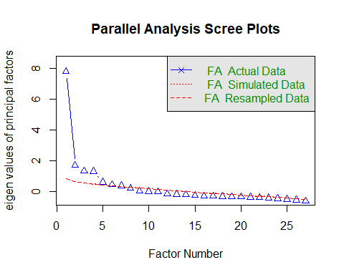

Parallel analysis suggests that the number of factors = 7 and the number of components = NA

# Eigenvalues  
ev <- eigen(cor(irt_mat, use = "pairwise.complete.obs"))$values  
  
# First and second eigenvalues  
first_ev <- ev[1]  
second_ev <- ev[2]  
  
# Ratio  
dominance_ratio <- first_ev / second_ev  
  
# Print  
first_ev

[1] 8.423431

second_ev

[1] 2.509731

dominance_ratio

[1] 3.356309

Parallel analysis suggested up to seven factors, as seven eigenvalues from the actual data exceeded those from randomly simulated data. However, the scree plot demonstrated a sharp drop between the first (9.02) and second (2.51) eigenvalues, yielding a ratio of 3.59. This indicates a single dominant factor underlying item responses, with additional weaker factors. Consistent with the concept of **essential unidimensionality** (Reckase, 1979; Hambleton, Swaminathan, & Rogers, 1991; Embretson & Reise, 2000), the scale was considered suitable for unidimensional IRT modeling despite the presence of minor secondary dimensions.

class(irt.data4)

[1] "ltm"

str(irt.data4, max.level = 1)

List of 14  
 $ coefficients: num [1:27, 1:2] 1.274 -0.661 -2.182 -1.423 1.482 ...  
 ..- attr(*, "dimnames")=List of 2  
 $ log.Lik : num -2476  
 $ convergence : int 0  
 $ hessian : num [1:54, 1:54] 29.894 -0.195 -0.172 -0.167 -0.325 ...  
 $ counts : Named int [1:2] 3 1  
 ..- attr(*, "names")= chr [1:2] "function" "gradient"  
 $ patterns :List of 2  
 $ GH :List of 2  
 $ max.sc : num 0.00487  
 $ ltst :List of 5  
 $ X : tibble [204 × 27] (S3: tbl_df/tbl/data.frame)  
 $ control :List of 6  
 $ IRT.param : logi TRUE  
 $ formula :Class 'formula' language data4 ~ z1  
 .. ..- attr(*, ".Environment")=<environment: R_GlobalEnv>   
 $ call : language ltm(formula = data4 ~ z1, IRT.param = TRUE)  
 - attr(*, "class")= chr "ltm"

## Local Independence

### Yen’s Q3 residual cYen’s Q3 residual correlationsorrelations

# ==========================================  
# Load required package  
# ==========================================  
library(mirt)  
library(mokken)

Loading required package: poLCA

Loading required package: scatterplot3d

Attaching package: 'mokken'

The following object is masked from 'package:dplyr':  
  
 recode

The following object is masked from 'package:psych':  
  
 ICC

# Extract the raw item response matrix from the ltm object  
irt_mat <- as.data.frame(irt.data4$X) # now it's a dataframe  
irt_mat <- as.matrix(irt_mat) # convert to numeric matrix  
  
  
  
# ==========================================  
# 1. Fit a unidimensional 2PL model  
# ==========================================  
  
mod2pl <- mirt(irt_mat, 1, itemtype = "2PL")

Warning: EM cycles terminated after 500 iterations.

mod1pl <- mirt(irt_mat, 1, itemtype = "Rasch")

# ==========================================  
# 2. Assumption: Local Independence  
# ==========================================  
# (a) Yen’s Q3 residual correlations  
# Q3_resid <- resid(mod2pl, type = "Q3")  
# Assumption 2: Local Independence  
Q3_resid <- residuals(mod2pl, type = "Q3")

Q3 summary statistics:  
 Min. 1st Qu. Median Mean 3rd Qu. Max.   
 -0.480 -0.094 -0.025 -0.007 0.055 0.800   
  
 K1 K4 K6 K12 K13 K14 K15 K16 K17 K18  
K1 1.000 0.151 0.052 -0.015 0.170 0.069 -0.065 -0.073 0.012 0.133  
K4 0.151 1.000 0.295 0.077 -0.078 0.046 0.129 0.074 0.081 -0.013  
K6 0.052 0.295 1.000 0.209 0.050 -0.005 0.038 -0.064 0.064 0.026  
K12 -0.015 0.077 0.209 1.000 -0.110 -0.211 -0.070 -0.059 -0.024 0.176  
K13 0.170 -0.078 0.050 -0.110 1.000 0.301 0.203 0.230 0.101 0.160  
K14 0.069 0.046 -0.005 -0.211 0.301 1.000 0.350 0.356 0.170 -0.067  
K15 -0.065 0.129 0.038 -0.070 0.203 0.350 1.000 0.800 0.183 -0.088  
K16 -0.073 0.074 -0.064 -0.059 0.230 0.356 0.800 1.000 0.180 -0.015  
K17 0.012 0.081 0.064 -0.024 0.101 0.170 0.183 0.180 1.000 -0.094  
K18 0.133 -0.013 0.026 0.176 0.160 -0.067 -0.088 -0.015 -0.094 1.000  
K19 -0.083 -0.090 -0.113 -0.114 -0.042 0.066 -0.002 0.079 -0.053 -0.200  
K20 -0.027 0.100 -0.024 -0.066 -0.217 -0.025 -0.075 -0.106 -0.078 -0.078  
K21 -0.004 -0.041 -0.109 -0.038 -0.051 -0.074 -0.205 -0.237 -0.123 0.021  
K22 0.052 -0.162 -0.046 -0.097 -0.050 -0.099 -0.163 -0.206 -0.095 0.006  
K23 -0.052 0.008 0.027 -0.021 -0.031 -0.141 -0.034 -0.020 -0.048 -0.014  
K25 0.083 -0.047 0.013 -0.004 -0.017 -0.137 -0.083 -0.068 -0.025 0.009  
K26 0.042 -0.121 -0.016 0.140 -0.068 -0.285 -0.188 -0.202 -0.149 0.168  
K27 -0.137 0.063 -0.013 0.069 0.029 -0.002 -0.032 0.008 0.008 0.084  
K28 -0.154 -0.068 -0.087 0.104 -0.014 -0.144 -0.114 -0.061 -0.062 0.093  
K29 -0.020 0.022 0.037 0.202 -0.176 -0.273 -0.119 -0.162 -0.194 0.067  
K30 -0.118 0.031 0.109 0.142 0.001 -0.059 -0.043 -0.063 0.003 0.019  
K31 -0.108 0.018 0.040 0.088 -0.104 -0.123 -0.150 -0.091 -0.059 -0.099  
K32 -0.110 -0.023 -0.038 0.030 -0.038 -0.050 -0.043 -0.033 -0.068 -0.049  
K33 -0.018 -0.032 -0.106 0.037 -0.074 -0.062 0.021 0.052 -0.022 -0.095  
K34 0.082 -0.019 -0.026 -0.037 0.025 0.106 0.078 0.139 0.177 0.013  
K36 0.116 -0.044 -0.007 -0.065 -0.001 0.036 -0.025 -0.090 0.122 -0.022  
K37 0.089 0.104 -0.022 -0.060 0.014 0.150 0.085 0.042 0.266 -0.127  
 K19 K20 K21 K22 K23 K25 K26 K27 K28 K29  
K1 -0.083 -0.027 -0.004 0.052 -0.052 0.083 0.042 -0.137 -0.154 -0.020  
K4 -0.090 0.100 -0.041 -0.162 0.008 -0.047 -0.121 0.063 -0.068 0.022  
K6 -0.113 -0.024 -0.109 -0.046 0.027 0.013 -0.016 -0.013 -0.087 0.037  
K12 -0.114 -0.066 -0.038 -0.097 -0.021 -0.004 0.140 0.069 0.104 0.202  
K13 -0.042 -0.217 -0.051 -0.050 -0.031 -0.017 -0.068 0.029 -0.014 -0.176  
K14 0.066 -0.025 -0.074 -0.099 -0.141 -0.137 -0.285 -0.002 -0.144 -0.273  
K15 -0.002 -0.075 -0.205 -0.163 -0.034 -0.083 -0.188 -0.032 -0.114 -0.119  
K16 0.079 -0.106 -0.237 -0.206 -0.020 -0.068 -0.202 0.008 -0.061 -0.162  
K17 -0.053 -0.078 -0.123 -0.095 -0.048 -0.025 -0.149 0.008 -0.062 -0.194  
K18 -0.200 -0.078 0.021 0.006 -0.014 0.009 0.168 0.084 0.093 0.067  
K19 1.000 0.087 -0.270 -0.026 -0.187 -0.181 -0.144 -0.063 -0.105 -0.171  
K20 0.087 1.000 -0.018 -0.027 -0.343 -0.480 -0.111 -0.083 -0.049 -0.045  
K21 -0.270 -0.018 1.000 0.297 -0.243 -0.100 -0.104 -0.141 -0.149 -0.081  
K22 -0.026 -0.027 0.297 1.000 -0.272 -0.226 -0.053 -0.326 -0.144 -0.157  
K23 -0.187 -0.343 -0.243 -0.272 1.000 0.697 0.090 -0.004 -0.030 0.050  
K25 -0.181 -0.480 -0.100 -0.226 0.697 1.000 0.034 -0.126 -0.127 -0.048  
K26 -0.144 -0.111 -0.104 -0.053 0.090 0.034 1.000 0.197 0.390 0.502  
K27 -0.063 -0.083 -0.141 -0.326 -0.004 -0.126 0.197 1.000 0.556 0.325  
K28 -0.105 -0.049 -0.149 -0.144 -0.030 -0.127 0.390 0.556 1.000 0.448  
K29 -0.171 -0.045 -0.081 -0.157 0.050 -0.048 0.502 0.325 0.448 1.000  
K30 -0.043 -0.182 -0.179 -0.189 0.104 0.062 0.176 0.399 0.198 0.243  
K31 -0.119 -0.069 -0.210 -0.180 0.036 -0.055 0.215 0.061 0.035 0.097  
K32 -0.042 -0.098 -0.345 -0.376 0.094 0.174 0.002 0.020 0.058 -0.027  
K33 -0.073 -0.111 -0.299 -0.313 0.037 0.090 0.045 0.036 0.040 -0.017  
K34 -0.032 -0.102 -0.195 -0.250 0.062 0.079 -0.127 0.002 -0.099 -0.040  
K36 -0.342 -0.194 -0.029 0.023 0.147 0.223 0.026 -0.093 -0.040 -0.055  
K37 -0.198 -0.082 -0.137 -0.171 0.037 0.011 -0.127 -0.016 0.012 0.012  
 K30 K31 K32 K33 K34 K36 K37  
K1 -0.118 -0.108 -0.110 -0.018 0.082 0.116 0.089  
K4 0.031 0.018 -0.023 -0.032 -0.019 -0.044 0.104  
K6 0.109 0.040 -0.038 -0.106 -0.026 -0.007 -0.022  
K12 0.142 0.088 0.030 0.037 -0.037 -0.065 -0.060  
K13 0.001 -0.104 -0.038 -0.074 0.025 -0.001 0.014  
K14 -0.059 -0.123 -0.050 -0.062 0.106 0.036 0.150  
K15 -0.043 -0.150 -0.043 0.021 0.078 -0.025 0.085  
K16 -0.063 -0.091 -0.033 0.052 0.139 -0.090 0.042  
K17 0.003 -0.059 -0.068 -0.022 0.177 0.122 0.266  
K18 0.019 -0.099 -0.049 -0.095 0.013 -0.022 -0.127  
K19 -0.043 -0.119 -0.042 -0.073 -0.032 -0.342 -0.198  
K20 -0.182 -0.069 -0.098 -0.111 -0.102 -0.194 -0.082  
K21 -0.179 -0.210 -0.345 -0.299 -0.195 -0.029 -0.137  
K22 -0.189 -0.180 -0.376 -0.313 -0.250 0.023 -0.171  
K23 0.104 0.036 0.094 0.037 0.062 0.147 0.037  
K25 0.062 -0.055 0.174 0.090 0.079 0.223 0.011  
K26 0.176 0.215 0.002 0.045 -0.127 0.026 -0.127  
K27 0.399 0.061 0.020 0.036 0.002 -0.093 -0.016  
K28 0.198 0.035 0.058 0.040 -0.099 -0.040 0.012  
K29 0.243 0.097 -0.027 -0.017 -0.040 -0.055 0.012  
K30 1.000 0.037 -0.035 -0.081 0.007 0.021 0.019  
K31 0.037 1.000 0.269 0.254 -0.121 -0.051 -0.063  
K32 -0.035 0.269 1.000 0.581 0.108 -0.001 0.137  
K33 -0.081 0.254 0.581 1.000 0.116 0.012 0.084  
K34 0.007 -0.121 0.108 0.116 1.000 0.371 0.351  
K36 0.021 -0.051 -0.001 0.012 0.371 1.000 0.388  
K37 0.019 -0.063 0.137 0.084 0.351 0.388 1.000

Q3_resid # inspect residual correlations (Q3 > .20 may indicate local dependence)

K1 K4 K6 K12 K13 K14 K15 K16 K17 K18  
K1 1.000 0.151 0.052 -0.015 0.170 0.069 -0.065 -0.073 0.012 0.133  
K4 0.151 1.000 0.295 0.077 -0.078 0.046 0.129 0.074 0.081 -0.013  
K6 0.052 0.295 1.000 0.209 0.050 -0.005 0.038 -0.064 0.064 0.026  
K12 -0.015 0.077 0.209 1.000 -0.110 -0.211 -0.070 -0.059 -0.024 0.176  
K13 0.170 -0.078 0.050 -0.110 1.000 0.301 0.203 0.230 0.101 0.160  
K14 0.069 0.046 -0.005 -0.211 0.301 1.000 0.350 0.356 0.170 -0.067  
K15 -0.065 0.129 0.038 -0.070 0.203 0.350 1.000 0.800 0.183 -0.088  
K16 -0.073 0.074 -0.064 -0.059 0.230 0.356 0.800 1.000 0.180 -0.015  
K17 0.012 0.081 0.064 -0.024 0.101 0.170 0.183 0.180 1.000 -0.094  
K18 0.133 -0.013 0.026 0.176 0.160 -0.067 -0.088 -0.015 -0.094 1.000  
K19 -0.083 -0.090 -0.113 -0.114 -0.042 0.066 -0.002 0.079 -0.053 -0.200  
K20 -0.027 0.100 -0.024 -0.066 -0.217 -0.025 -0.075 -0.106 -0.078 -0.078  
K21 -0.004 -0.041 -0.109 -0.038 -0.051 -0.074 -0.205 -0.237 -0.123 0.021  
K22 0.052 -0.162 -0.046 -0.097 -0.050 -0.099 -0.163 -0.206 -0.095 0.006  
K23 -0.052 0.008 0.027 -0.021 -0.031 -0.141 -0.034 -0.020 -0.048 -0.014  
K25 0.083 -0.047 0.013 -0.004 -0.017 -0.137 -0.083 -0.068 -0.025 0.009  
K26 0.042 -0.121 -0.016 0.140 -0.068 -0.285 -0.188 -0.202 -0.149 0.168  
K27 -0.137 0.063 -0.013 0.069 0.029 -0.002 -0.032 0.008 0.008 0.084  
K28 -0.154 -0.068 -0.087 0.104 -0.014 -0.144 -0.114 -0.061 -0.062 0.093  
K29 -0.020 0.022 0.037 0.202 -0.176 -0.273 -0.119 -0.162 -0.194 0.067  
K30 -0.118 0.031 0.109 0.142 0.001 -0.059 -0.043 -0.063 0.003 0.019  
K31 -0.108 0.018 0.040 0.088 -0.104 -0.123 -0.150 -0.091 -0.059 -0.099  
K32 -0.110 -0.023 -0.038 0.030 -0.038 -0.050 -0.043 -0.033 -0.068 -0.049  
K33 -0.018 -0.032 -0.106 0.037 -0.074 -0.062 0.021 0.052 -0.022 -0.095  
K34 0.082 -0.019 -0.026 -0.037 0.025 0.106 0.078 0.139 0.177 0.013  
K36 0.116 -0.044 -0.007 -0.065 -0.001 0.036 -0.025 -0.090 0.122 -0.022  
K37 0.089 0.104 -0.022 -0.060 0.014 0.150 0.085 0.042 0.266 -0.127  
 K19 K20 K21 K22 K23 K25 K26 K27 K28 K29  
K1 -0.083 -0.027 -0.004 0.052 -0.052 0.083 0.042 -0.137 -0.154 -0.020  
K4 -0.090 0.100 -0.041 -0.162 0.008 -0.047 -0.121 0.063 -0.068 0.022  
K6 -0.113 -0.024 -0.109 -0.046 0.027 0.013 -0.016 -0.013 -0.087 0.037  
K12 -0.114 -0.066 -0.038 -0.097 -0.021 -0.004 0.140 0.069 0.104 0.202  
K13 -0.042 -0.217 -0.051 -0.050 -0.031 -0.017 -0.068 0.029 -0.014 -0.176  
K14 0.066 -0.025 -0.074 -0.099 -0.141 -0.137 -0.285 -0.002 -0.144 -0.273  
K15 -0.002 -0.075 -0.205 -0.163 -0.034 -0.083 -0.188 -0.032 -0.114 -0.119  
K16 0.079 -0.106 -0.237 -0.206 -0.020 -0.068 -0.202 0.008 -0.061 -0.162  
K17 -0.053 -0.078 -0.123 -0.095 -0.048 -0.025 -0.149 0.008 -0.062 -0.194  
K18 -0.200 -0.078 0.021 0.006 -0.014 0.009 0.168 0.084 0.093 0.067  
K19 1.000 0.087 -0.270 -0.026 -0.187 -0.181 -0.144 -0.063 -0.105 -0.171  
K20 0.087 1.000 -0.018 -0.027 -0.343 -0.480 -0.111 -0.083 -0.049 -0.045  
K21 -0.270 -0.018 1.000 0.297 -0.243 -0.100 -0.104 -0.141 -0.149 -0.081  
K22 -0.026 -0.027 0.297 1.000 -0.272 -0.226 -0.053 -0.326 -0.144 -0.157  
K23 -0.187 -0.343 -0.243 -0.272 1.000 0.697 0.090 -0.004 -0.030 0.050  
K25 -0.181 -0.480 -0.100 -0.226 0.697 1.000 0.034 -0.126 -0.127 -0.048  
K26 -0.144 -0.111 -0.104 -0.053 0.090 0.034 1.000 0.197 0.390 0.502  
K27 -0.063 -0.083 -0.141 -0.326 -0.004 -0.126 0.197 1.000 0.556 0.325  
K28 -0.105 -0.049 -0.149 -0.144 -0.030 -0.127 0.390 0.556 1.000 0.448  
K29 -0.171 -0.045 -0.081 -0.157 0.050 -0.048 0.502 0.325 0.448 1.000  
K30 -0.043 -0.182 -0.179 -0.189 0.104 0.062 0.176 0.399 0.198 0.243  
K31 -0.119 -0.069 -0.210 -0.180 0.036 -0.055 0.215 0.061 0.035 0.097  
K32 -0.042 -0.098 -0.345 -0.376 0.094 0.174 0.002 0.020 0.058 -0.027  
K33 -0.073 -0.111 -0.299 -0.313 0.037 0.090 0.045 0.036 0.040 -0.017  
K34 -0.032 -0.102 -0.195 -0.250 0.062 0.079 -0.127 0.002 -0.099 -0.040  
K36 -0.342 -0.194 -0.029 0.023 0.147 0.223 0.026 -0.093 -0.040 -0.055  
K37 -0.198 -0.082 -0.137 -0.171 0.037 0.011 -0.127 -0.016 0.012 0.012  
 K30 K31 K32 K33 K34 K36 K37  
K1 -0.118 -0.108 -0.110 -0.018 0.082 0.116 0.089  
K4 0.031 0.018 -0.023 -0.032 -0.019 -0.044 0.104  
K6 0.109 0.040 -0.038 -0.106 -0.026 -0.007 -0.022  
K12 0.142 0.088 0.030 0.037 -0.037 -0.065 -0.060  
K13 0.001 -0.104 -0.038 -0.074 0.025 -0.001 0.014  
K14 -0.059 -0.123 -0.050 -0.062 0.106 0.036 0.150  
K15 -0.043 -0.150 -0.043 0.021 0.078 -0.025 0.085  
K16 -0.063 -0.091 -0.033 0.052 0.139 -0.090 0.042  
K17 0.003 -0.059 -0.068 -0.022 0.177 0.122 0.266  
K18 0.019 -0.099 -0.049 -0.095 0.013 -0.022 -0.127  
K19 -0.043 -0.119 -0.042 -0.073 -0.032 -0.342 -0.198  
K20 -0.182 -0.069 -0.098 -0.111 -0.102 -0.194 -0.082  
K21 -0.179 -0.210 -0.345 -0.299 -0.195 -0.029 -0.137  
K22 -0.189 -0.180 -0.376 -0.313 -0.250 0.023 -0.171  
K23 0.104 0.036 0.094 0.037 0.062 0.147 0.037  
K25 0.062 -0.055 0.174 0.090 0.079 0.223 0.011  
K26 0.176 0.215 0.002 0.045 -0.127 0.026 -0.127  
K27 0.399 0.061 0.020 0.036 0.002 -0.093 -0.016  
K28 0.198 0.035 0.058 0.040 -0.099 -0.040 0.012  
K29 0.243 0.097 -0.027 -0.017 -0.040 -0.055 0.012  
K30 1.000 0.037 -0.035 -0.081 0.007 0.021 0.019  
K31 0.037 1.000 0.269 0.254 -0.121 -0.051 -0.063  
K32 -0.035 0.269 1.000 0.581 0.108 -0.001 0.137  
K33 -0.081 0.254 0.581 1.000 0.116 0.012 0.084  
K34 0.007 -0.121 0.108 0.116 1.000 0.371 0.351  
K36 0.021 -0.051 -0.001 0.012 0.371 1.000 0.388  
K37 0.019 -0.063 0.137 0.084 0.351 0.388 1.000

# Chen & Thissen’s LD χ² statistic  
LD_resid <- residuals(mod2pl, type = "LD")

LD matrix (lower triangle) and standardized residual correlations (upper triangle)  
  
Upper triangle summary:  
 Min. 1st Qu. Median Mean 3rd Qu. Max.   
 -0.313 -0.101 -0.041 -0.018 0.052 0.588   
  
 K1 K4 K6 K12 K13 K14 K15 K16 K17 K18 K19  
K1 0.134 0.053 -0.012 0.137 0.055 -0.070 -0.076 0.030 0.104 -0.070  
K4 3.664 0.283 0.081 -0.085 0.035 0.107 0.069 0.058 -0.027 -0.114  
K6 0.584 16.307 0.190 0.055 0.010 0.050 -0.029 0.071 0.031 -0.030  
K12 0.031 1.329 7.370 -0.096 -0.191 -0.057 -0.046 -0.023 0.155 -0.087  
K13 3.843 1.476 0.607 1.894 0.228 0.161 0.192 0.080 0.128 -0.050  
K14 0.612 0.255 0.021 7.463 10.606 0.280 0.296 0.118 -0.068 -0.019  
K15 1.000 2.321 0.503 0.661 5.295 16.005 0.588 0.145 -0.090 -0.037  
K16 1.187 0.964 0.176 0.426 7.488 17.859 70.602 0.148 -0.032 -0.026  
K17 0.187 0.693 1.040 0.105 1.298 2.822 4.286 4.463 -0.069 -0.060  
K18 2.217 0.147 0.194 4.889 3.359 0.940 1.656 0.208 0.981 -0.158  
K19 1.014 2.650 0.180 1.527 0.520 0.077 0.282 0.140 0.734 5.116   
K20 0.495 0.318 0.110 0.687 2.732 0.422 0.928 2.078 1.140 2.081 0.715  
K21 0.533 2.073 0.004 0.271 0.312 0.618 2.642 4.304 1.673 0.763 0.712  
K22 0.142 5.130 0.135 0.789 0.321 1.236 2.923 4.673 1.802 0.561 0.489  
K23 0.768 0.712 0.683 0.321 0.342 3.719 1.363 1.026 0.858 0.456 5.740  
K25 0.960 2.175 1.143 0.853 0.778 3.705 3.202 2.472 1.126 0.832 6.016  
K26 0.156 2.565 0.010 3.812 1.033 13.065 4.409 5.305 3.784 2.934 5.659  
K27 3.572 1.038 0.106 0.664 0.157 0.064 0.043 0.216 0.169 0.557 5.344  
K28 4.354 0.630 0.549 1.780 0.199 3.580 1.345 0.336 1.183 0.622 4.162  
K29 0.147 0.035 0.476 6.919 4.760 11.853 2.016 3.654 5.721 0.242 5.516  
K30 2.285 1.185 2.094 2.224 0.126 0.110 0.191 0.119 0.216 0.171 3.078  
K31 1.478 0.947 1.463 2.746 1.023 3.101 5.737 2.967 1.044 1.167 3.979  
K32 1.598 0.865 0.274 0.345 0.275 1.088 1.208 0.965 0.829 0.635 1.821  
K33 0.130 0.702 1.683 0.165 0.464 0.978 0.157 0.077 0.140 1.546 2.190  
K34 1.143 0.220 0.194 0.191 0.233 1.246 0.543 2.414 3.531 0.040 0.638  
K36 2.427 0.469 0.217 0.201 0.313 0.359 0.640 2.359 2.394 0.088 17.779  
K37 1.357 1.237 0.208 0.488 0.225 2.333 0.518 0.117 6.915 2.038 5.895  
 K20 K21 K22 K23 K25 K26 K27 K28 K29 K30  
K1 -0.049 -0.051 -0.026 -0.061 0.069 0.028 -0.132 -0.146 -0.027 -0.106  
K4 -0.040 -0.101 -0.159 -0.059 -0.103 -0.112 0.071 -0.056 0.013 0.076  
K6 0.023 0.004 0.026 0.058 0.075 0.007 0.023 -0.052 0.048 0.101  
K12 -0.058 -0.036 -0.062 -0.040 0.065 0.137 0.057 0.093 0.184 0.104  
K13 -0.116 -0.039 -0.040 -0.041 0.062 -0.071 0.028 -0.031 -0.153 -0.025  
K14 -0.045 -0.055 -0.078 -0.135 -0.135 -0.253 0.018 -0.132 -0.241 -0.023  
K15 -0.067 -0.114 -0.120 -0.082 -0.125 -0.147 -0.014 -0.081 -0.099 0.031  
K16 -0.101 -0.145 -0.151 -0.071 -0.110 -0.161 0.033 -0.041 -0.134 0.024  
K17 -0.075 -0.091 -0.094 -0.065 -0.074 -0.136 0.029 -0.076 -0.167 0.033  
K18 -0.101 -0.061 -0.052 -0.047 0.064 0.120 0.052 0.055 0.034 0.029  
K19 0.059 -0.059 0.049 -0.168 -0.172 -0.167 -0.162 -0.143 -0.164 -0.123  
K20 0.037 0.038 -0.230 -0.313 -0.153 -0.159 -0.114 -0.104 -0.191  
K21 0.281 0.113 -0.176 -0.138 -0.154 -0.169 -0.141 -0.102 -0.176  
K22 0.299 2.604 -0.201 -0.188 -0.125 -0.254 -0.135 -0.131 -0.189  
K23 10.816 6.332 8.234 0.318 0.040 -0.066 -0.077 -0.040 0.095  
K25 20.021 3.906 7.203 20.571 -0.067 -0.143 -0.133 -0.086 0.090  
K26 4.748 4.855 3.175 0.334 0.915 0.181 0.322 0.405 0.196  
K27 5.177 5.826 13.194 0.899 4.151 6.652 0.429 0.264 0.297  
K28 2.634 4.077 3.691 1.221 3.603 21.195 37.564 0.356 0.191  
K29 2.226 2.138 3.504 0.328 1.503 33.470 14.183 25.848 0.227  
K30 7.453 6.291 7.299 1.824 1.668 7.816 18.045 7.451 10.520   
K31 3.130 5.203 5.056 1.027 1.010 2.867 1.493 0.961 1.150 1.486  
K32 2.959 8.523 10.656 0.603 2.431 0.450 0.408 0.212 0.775 1.078  
K33 2.824 6.528 7.466 0.346 1.782 0.048 0.171 0.054 0.421 2.460  
K34 1.744 3.346 6.691 0.299 0.786 2.941 0.098 2.217 0.457 0.117  
K36 7.677 2.148 1.430 1.314 2.080 0.060 2.944 0.528 0.322 0.304  
K37 2.855 3.624 5.786 0.368 1.049 2.962 0.347 0.098 0.066 0.218  
 K31 K32 K33 K34 K36 K37  
K1 -0.085 -0.088 -0.025 0.075 0.109 0.082  
K4 -0.068 -0.065 -0.059 -0.033 -0.048 0.078  
K6 0.085 -0.037 -0.091 -0.031 -0.033 -0.032  
K12 0.116 0.041 0.028 -0.031 -0.031 -0.049  
K13 -0.071 -0.037 -0.048 0.034 0.039 0.033  
K14 -0.123 -0.073 -0.069 0.078 0.042 0.107  
K15 -0.168 -0.077 -0.028 0.052 -0.056 0.050  
K16 -0.121 -0.069 0.019 0.109 -0.108 0.024  
K17 -0.072 -0.064 -0.026 0.132 0.108 0.184  
K18 -0.076 -0.056 -0.087 0.014 0.021 -0.100  
K19 -0.140 -0.094 -0.104 -0.056 -0.295 -0.170  
K20 -0.124 -0.120 -0.118 -0.092 -0.194 -0.118  
K21 -0.160 -0.204 -0.179 -0.128 -0.103 -0.133  
K22 -0.157 -0.229 -0.191 -0.181 -0.084 -0.168  
K23 0.071 0.054 0.041 -0.038 0.080 -0.042  
K25 -0.070 0.109 0.093 -0.062 0.101 -0.072  
K26 0.119 -0.047 0.015 -0.120 0.017 -0.121  
K27 0.086 -0.045 -0.029 -0.022 -0.120 -0.041  
K28 -0.069 0.032 -0.016 -0.104 -0.051 -0.022  
K29 0.075 -0.062 -0.045 -0.047 -0.040 -0.018  
K30 0.085 -0.073 -0.110 0.024 0.039 0.033  
K31 0.169 0.195 -0.099 -0.066 -0.073  
K32 5.793 0.353 0.052 -0.033 0.067  
K33 7.729 25.415 0.071 0.034 0.051  
K34 1.984 0.556 1.038 0.248 0.254  
K36 0.884 0.217 0.232 12.558 0.253  
K37 1.096 0.911 0.533 13.137 13.053

LD_resid # values > 10 indicate local dependence

K1 K4 K6 K12 K13 K14 K15 K16 K17 K18 K19  
K1 NA 0.134 0.053 -0.012 0.137 0.055 -0.070 -0.076 0.030 0.104 -0.070  
K4 3.664 NA 0.283 0.081 -0.085 0.035 0.107 0.069 0.058 -0.027 -0.114  
K6 0.584 16.307 NA 0.190 0.055 0.010 0.050 -0.029 0.071 0.031 -0.030  
K12 0.031 1.329 7.370 NA -0.096 -0.191 -0.057 -0.046 -0.023 0.155 -0.087  
K13 3.843 1.476 0.607 1.894 NA 0.228 0.161 0.192 0.080 0.128 -0.050  
K14 0.612 0.255 0.021 7.463 10.606 NA 0.280 0.296 0.118 -0.068 -0.019  
K15 1.000 2.321 0.503 0.661 5.295 16.005 NA 0.588 0.145 -0.090 -0.037  
K16 1.187 0.964 0.176 0.426 7.488 17.859 70.602 NA 0.148 -0.032 -0.026  
K17 0.187 0.693 1.040 0.105 1.298 2.822 4.286 4.463 NA -0.069 -0.060  
K18 2.217 0.147 0.194 4.889 3.359 0.940 1.656 0.208 0.981 NA -0.158  
K19 1.014 2.650 0.180 1.527 0.520 0.077 0.282 0.140 0.734 5.116 NA  
K20 0.495 0.318 0.110 0.687 2.732 0.422 0.928 2.078 1.140 2.081 0.715  
K21 0.533 2.073 0.004 0.271 0.312 0.618 2.642 4.304 1.673 0.763 0.712  
K22 0.142 5.130 0.135 0.789 0.321 1.236 2.923 4.673 1.802 0.561 0.489  
K23 0.768 0.712 0.683 0.321 0.342 3.719 1.363 1.026 0.858 0.456 5.740  
K25 0.960 2.175 1.143 0.853 0.778 3.705 3.202 2.472 1.126 0.832 6.016  
K26 0.156 2.565 0.010 3.812 1.033 13.065 4.409 5.305 3.784 2.934 5.659  
K27 3.572 1.038 0.106 0.664 0.157 0.064 0.043 0.216 0.169 0.557 5.344  
K28 4.354 0.630 0.549 1.780 0.199 3.580 1.345 0.336 1.183 0.622 4.162  
K29 0.147 0.035 0.476 6.919 4.760 11.853 2.016 3.654 5.721 0.242 5.516  
K30 2.285 1.185 2.094 2.224 0.126 0.110 0.191 0.119 0.216 0.171 3.078  
K31 1.478 0.947 1.463 2.746 1.023 3.101 5.737 2.967 1.044 1.167 3.979  
K32 1.598 0.865 0.274 0.345 0.275 1.088 1.208 0.965 0.829 0.635 1.821  
K33 0.130 0.702 1.683 0.165 0.464 0.978 0.157 0.077 0.140 1.546 2.190  
K34 1.143 0.220 0.194 0.191 0.233 1.246 0.543 2.414 3.531 0.040 0.638  
K36 2.427 0.469 0.217 0.201 0.313 0.359 0.640 2.359 2.394 0.088 17.779  
K37 1.357 1.237 0.208 0.488 0.225 2.333 0.518 0.117 6.915 2.038 5.895  
 K20 K21 K22 K23 K25 K26 K27 K28 K29 K30  
K1 -0.049 -0.051 -0.026 -0.061 0.069 0.028 -0.132 -0.146 -0.027 -0.106  
K4 -0.040 -0.101 -0.159 -0.059 -0.103 -0.112 0.071 -0.056 0.013 0.076  
K6 0.023 0.004 0.026 0.058 0.075 0.007 0.023 -0.052 0.048 0.101  
K12 -0.058 -0.036 -0.062 -0.040 0.065 0.137 0.057 0.093 0.184 0.104  
K13 -0.116 -0.039 -0.040 -0.041 0.062 -0.071 0.028 -0.031 -0.153 -0.025  
K14 -0.045 -0.055 -0.078 -0.135 -0.135 -0.253 0.018 -0.132 -0.241 -0.023  
K15 -0.067 -0.114 -0.120 -0.082 -0.125 -0.147 -0.014 -0.081 -0.099 0.031  
K16 -0.101 -0.145 -0.151 -0.071 -0.110 -0.161 0.033 -0.041 -0.134 0.024  
K17 -0.075 -0.091 -0.094 -0.065 -0.074 -0.136 0.029 -0.076 -0.167 0.033  
K18 -0.101 -0.061 -0.052 -0.047 0.064 0.120 0.052 0.055 0.034 0.029  
K19 0.059 -0.059 0.049 -0.168 -0.172 -0.167 -0.162 -0.143 -0.164 -0.123  
K20 NA 0.037 0.038 -0.230 -0.313 -0.153 -0.159 -0.114 -0.104 -0.191  
K21 0.281 NA 0.113 -0.176 -0.138 -0.154 -0.169 -0.141 -0.102 -0.176  
K22 0.299 2.604 NA -0.201 -0.188 -0.125 -0.254 -0.135 -0.131 -0.189  
K23 10.816 6.332 8.234 NA 0.318 0.040 -0.066 -0.077 -0.040 0.095  
K25 20.021 3.906 7.203 20.571 NA -0.067 -0.143 -0.133 -0.086 0.090  
K26 4.748 4.855 3.175 0.334 0.915 NA 0.181 0.322 0.405 0.196  
K27 5.177 5.826 13.194 0.899 4.151 6.652 NA 0.429 0.264 0.297  
K28 2.634 4.077 3.691 1.221 3.603 21.195 37.564 NA 0.356 0.191  
K29 2.226 2.138 3.504 0.328 1.503 33.470 14.183 25.848 NA 0.227  
K30 7.453 6.291 7.299 1.824 1.668 7.816 18.045 7.451 10.520 NA  
K31 3.130 5.203 5.056 1.027 1.010 2.867 1.493 0.961 1.150 1.486  
K32 2.959 8.523 10.656 0.603 2.431 0.450 0.408 0.212 0.775 1.078  
K33 2.824 6.528 7.466 0.346 1.782 0.048 0.171 0.054 0.421 2.460  
K34 1.744 3.346 6.691 0.299 0.786 2.941 0.098 2.217 0.457 0.117  
K36 7.677 2.148 1.430 1.314 2.080 0.060 2.944 0.528 0.322 0.304  
K37 2.855 3.624 5.786 0.368 1.049 2.962 0.347 0.098 0.066 0.218  
 K31 K32 K33 K34 K36 K37  
K1 -0.085 -0.088 -0.025 0.075 0.109 0.082  
K4 -0.068 -0.065 -0.059 -0.033 -0.048 0.078  
K6 0.085 -0.037 -0.091 -0.031 -0.033 -0.032  
K12 0.116 0.041 0.028 -0.031 -0.031 -0.049  
K13 -0.071 -0.037 -0.048 0.034 0.039 0.033  
K14 -0.123 -0.073 -0.069 0.078 0.042 0.107  
K15 -0.168 -0.077 -0.028 0.052 -0.056 0.050  
K16 -0.121 -0.069 0.019 0.109 -0.108 0.024  
K17 -0.072 -0.064 -0.026 0.132 0.108 0.184  
K18 -0.076 -0.056 -0.087 0.014 0.021 -0.100  
K19 -0.140 -0.094 -0.104 -0.056 -0.295 -0.170  
K20 -0.124 -0.120 -0.118 -0.092 -0.194 -0.118  
K21 -0.160 -0.204 -0.179 -0.128 -0.103 -0.133  
K22 -0.157 -0.229 -0.191 -0.181 -0.084 -0.168  
K23 0.071 0.054 0.041 -0.038 0.080 -0.042  
K25 -0.070 0.109 0.093 -0.062 0.101 -0.072  
K26 0.119 -0.047 0.015 -0.120 0.017 -0.121  
K27 0.086 -0.045 -0.029 -0.022 -0.120 -0.041  
K28 -0.069 0.032 -0.016 -0.104 -0.051 -0.022  
K29 0.075 -0.062 -0.045 -0.047 -0.040 -0.018  
K30 0.085 -0.073 -0.110 0.024 0.039 0.033  
K31 NA 0.169 0.195 -0.099 -0.066 -0.073  
K32 5.793 NA 0.353 0.052 -0.033 0.067  
K33 7.729 25.415 NA 0.071 0.034 0.051  
K34 1.984 0.556 1.038 NA 0.248 0.254  
K36 0.884 0.217 0.232 12.558 NA 0.253  
K37 1.096 0.911 0.533 13.137 13.053 NA

## Monotonicity

# ==========================================  
# 3. Assumption: Monotonicity  
# ==========================================  
  
# (a) Plot Item Characteristic Curves (ICCs) to visually check monotonicity  
plot(mod2pl, type = "trace") # S-shaped, increasing curves are expected

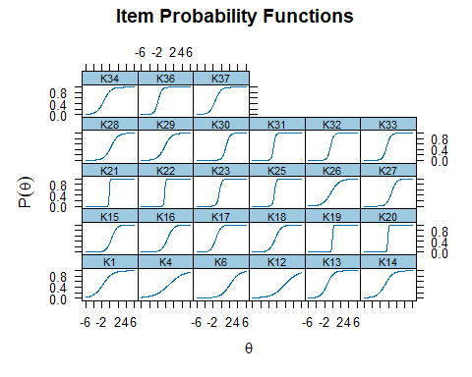

# (b) Optional: Use Mokken scale analysis for monotonicity check  
  
# Run monotonicity check  
check.monotonicity(irt_mat) # flags items with non-monotonic patterns

$results  
$results[[1]]  
$results[[1]][[1]]  
[1] "K1"  
  
$results[[1]][[2]]  
 Group Lo Score Hi Score N F 0 F 1 Mean P(X >=1)  
[1,] 1 0 12 73 25 48 0.6575342 0.6575342  
[2,] 2 13 26 131 18 113 0.8625954 0.8625954  
  
$results[[1]][[3]]  
 #ac #vi #vi/#ac maxvi sum sum/#ac zmax group group #zsig  
P(X >=1) 1 0 0 0 0 0 0 0 0 0  
Total 1 0 0 0 0 0 0 0 0 0  
  
$results[[1]][[4]]  
[1] "Minsize = 68 Minvi = 0.03"  
  
  
$results[[2]]  
$results[[2]][[1]]  
[1] "K4"  
  
$results[[2]][[2]]  
 Group Lo Score Hi Score N F 0 F 1 Mean P(X >=1)  
[1,] 1 0 12 68 48 20 0.2941176 0.2941176  
[2,] 2 13 26 136 78 58 0.4264706 0.4264706  
  
$results[[2]][[3]]  
 #ac #vi #vi/#ac maxvi sum sum/#ac zmax group group #zsig  
P(X >=1) 1 0 0 0 0 0 0 0 0 0  
Total 1 0 0 0 0 0 0 0 0 0  
  
$results[[2]][[4]]  
[1] "Minsize = 68 Minvi = 0.03"  
  
  
$results[[3]]  
$results[[3]][[1]]  
[1] "K6"  
  
$results[[3]][[2]]  
 Group Lo Score Hi Score N F 0 F 1 Mean P(X >=1)  
[1,] 1 0 13 74 73 1 0.01351351 0.01351351  
[2,] 2 14 26 130 98 32 0.24615385 0.24615385  
  
$results[[3]][[3]]  
 #ac #vi #vi/#ac maxvi sum sum/#ac zmax group group #zsig  
P(X >=1) 1 0 0 0 0 0 0 0 0 0  
Total 1 0 0 0 0 0 0 0 0 0  
  
$results[[3]][[4]]  
[1] "Minsize = 68 Minvi = 0.03"  
  
  
$results[[4]]  
$results[[4]][[1]]  
[1] "K12"  
  
$results[[4]][[2]]  
 Group Lo Score Hi Score N F 0 F 1 Mean P(X >=1)  
[1,] 1 0 12 69 62 7 0.1014493 0.1014493  
[2,] 2 13 26 135 93 42 0.3111111 0.3111111  
  
$results[[4]][[3]]  
 #ac #vi #vi/#ac maxvi sum sum/#ac zmax group group #zsig  
P(X >=1) 1 0 0 0 0 0 0 0 0 0  
Total 1 0 0 0 0 0 0 0 0 0  
  
$results[[4]][[4]]  
[1] "Minsize = 68 Minvi = 0.03"  
  
  
$results[[5]]  
$results[[5]][[1]]  
[1] "K13"  
  
$results[[5]][[2]]  
 Group Lo Score Hi Score N F 0 F 1 Mean P(X >=1)  
[1,] 1 0 12 74 30 44 0.5945946 0.5945946  
[2,] 2 13 26 130 9 121 0.9307692 0.9307692  
  
$results[[5]][[3]]  
 #ac #vi #vi/#ac maxvi sum sum/#ac zmax group group #zsig  
P(X >=1) 1 0 0 0 0 0 0 0 0 0  
Total 1 0 0 0 0 0 0 0 0 0  
  
$results[[5]][[4]]  
[1] "Minsize = 68 Minvi = 0.03"  
  
  
$results[[6]]  
$results[[6]][[1]]  
[1] "K14"  
  
$results[[6]][[2]]  
 Group Lo Score Hi Score N F 0 F 1 Mean P(X >=1)  
[1,] 1 0 12 72 39 33 0.4583333 0.4583333  
[2,] 2 13 26 132 30 102 0.7727273 0.7727273  
  
$results[[6]][[3]]  
 #ac #vi #vi/#ac maxvi sum sum/#ac zmax group group #zsig  
P(X >=1) 1 0 0 0 0 0 0 0 0 0  
Total 1 0 0 0 0 0 0 0 0 0  
  
$results[[6]][[4]]  
[1] "Minsize = 68 Minvi = 0.03"  
  
  
$results[[7]]  
$results[[7]][[1]]  
[1] "K15"  
  
$results[[7]][[2]]  
 Group Lo Score Hi Score N F 0 F 1 Mean P(X >=1)  
[1,] 1 0 13 75 67 8 0.1066667 0.1066667  
[2,] 2 14 26 129 56 73 0.5658915 0.5658915  
  
$results[[7]][[3]]  
 #ac #vi #vi/#ac maxvi sum sum/#ac zmax group group #zsig  
P(X >=1) 1 0 0 0 0 0 0 0 0 0  
Total 1 0 0 0 0 0 0 0 0 0  
  
$results[[7]][[4]]  
[1] "Minsize = 68 Minvi = 0.03"  
  
  
$results[[8]]  
$results[[8]][[1]]  
[1] "K16"  
  
$results[[8]][[2]]  
 Group Lo Score Hi Score N F 0 F 1 Mean P(X >=1)  
[1,] 1 0 12 68 60 8 0.1176471 0.1176471  
[2,] 2 13 26 136 67 69 0.5073529 0.5073529  
  
$results[[8]][[3]]  
 #ac #vi #vi/#ac maxvi sum sum/#ac zmax group group #zsig  
P(X >=1) 1 0 0 0 0 0 0 0 0 0  
Total 1 0 0 0 0 0 0 0 0 0  
  
$results[[8]][[4]]  
[1] "Minsize = 68 Minvi = 0.03"  
  
  
$results[[9]]  
$results[[9]][[1]]  
[1] "K17"  
  
$results[[9]][[2]]  
 Group Lo Score Hi Score N F 0 F 1 Mean P(X >=1)  
[1,] 1 0 12 74 27 47 0.6351351 0.6351351  
[2,] 2 13 26 130 7 123 0.9461538 0.9461538  
  
$results[[9]][[3]]  
 #ac #vi #vi/#ac maxvi sum sum/#ac zmax group group #zsig  
P(X >=1) 1 0 0 0 0 0 0 0 0 0  
Total 1 0 0 0 0 0 0 0 0 0  
  
$results[[9]][[4]]  
[1] "Minsize = 68 Minvi = 0.03"  
  
  
$results[[10]]  
$results[[10]][[1]]  
[1] "K18"  
  
$results[[10]][[2]]  
 Group Lo Score Hi Score N F 0 F 1 Mean P(X >=1)  
[1,] 1 0 12 70 47 23 0.3285714 0.3285714  
[2,] 2 13 26 134 34 100 0.7462687 0.7462687  
  
$results[[10]][[3]]  
 #ac #vi #vi/#ac maxvi sum sum/#ac zmax group group #zsig  
P(X >=1) 1 0 0 0 0 0 0 0 0 0  
Total 1 0 0 0 0 0 0 0 0 0  
  
$results[[10]][[4]]  
[1] "Minsize = 68 Minvi = 0.03"  
  
  
$results[[11]]  
$results[[11]][[1]]  
[1] "K19"  
  
$results[[11]][[2]]  
 Group Lo Score Hi Score N F 0 F 1 Mean P(X >=1)  
[1,] 1 0 12 69 64 5 0.07246377 0.07246377  
[2,] 2 13 26 135 32 103 0.76296296 0.76296296  
  
$results[[11]][[3]]  
 #ac #vi #vi/#ac maxvi sum sum/#ac zmax group group #zsig  
P(X >=1) 1 0 0 0 0 0 0 0 0 0  
Total 1 0 0 0 0 0 0 0 0 0  
  
$results[[11]][[4]]  
[1] "Minsize = 68 Minvi = 0.03"  
  
  
$results[[12]]  
$results[[12]][[1]]  
[1] "K20"  
  
$results[[12]][[2]]  
 Group Lo Score Hi Score N F 0 F 1 Mean P(X >=1)  
[1,] 1 0 12 69 62 7 0.1014493 0.1014493  
[2,] 2 13 26 135 30 105 0.7777778 0.7777778  
  
$results[[12]][[3]]  
 #ac #vi #vi/#ac maxvi sum sum/#ac zmax group group #zsig  
P(X >=1) 1 0 0 0 0 0 0 0 0 0  
Total 1 0 0 0 0 0 0 0 0 0  
  
$results[[12]][[4]]  
[1] "Minsize = 68 Minvi = 0.03"  
  
  
$results[[13]]  
$results[[13]][[1]]  
[1] "K21"  
  
$results[[13]][[2]]  
 Group Lo Score Hi Score N F 0 F 1 Mean P(X >=1)  
[1,] 1 0 12 70 61 9 0.1285714 0.1285714  
[2,] 2 13 26 134 26 108 0.8059701 0.8059701  
  
$results[[13]][[3]]  
 #ac #vi #vi/#ac maxvi sum sum/#ac zmax group group #zsig  
P(X >=1) 1 0 0 0 0 0 0 0 0 0  
Total 1 0 0 0 0 0 0 0 0 0  
  
$results[[13]][[4]]  
[1] "Minsize = 68 Minvi = 0.03"  
  
  
$results[[14]]  
$results[[14]][[1]]  
[1] "K22"  
  
$results[[14]][[2]]  
 Group Lo Score Hi Score N F 0 F 1 Mean P(X >=1)  
[1,] 1 0 12 71 57 14 0.1971831 0.1971831  
[2,] 2 13 26 133 25 108 0.8120301 0.8120301  
  
$results[[14]][[3]]  
 #ac #vi #vi/#ac maxvi sum sum/#ac zmax group group #zsig  
P(X >=1) 1 0 0 0 0 0 0 0 0 0  
Total 1 0 0 0 0 0 0 0 0 0  
  
$results[[14]][[4]]  
[1] "Minsize = 68 Minvi = 0.03"  
  
  
$results[[15]]  
$results[[15]][[1]]  
[1] "K23"  
  
$results[[15]][[2]]  
 Group Lo Score Hi Score N F 0 F 1 Mean P(X >=1)  
[1,] 1 0 12 71 49 22 0.3098592 0.3098592  
[2,] 2 13 26 133 13 120 0.9022556 0.9022556  
  
$results[[15]][[3]]  
 #ac #vi #vi/#ac maxvi sum sum/#ac zmax group group #zsig  
P(X >=1) 1 0 0 0 0 0 0 0 0 0  
Total 1 0 0 0 0 0 0 0 0 0  
  
$results[[15]][[4]]  
[1] "Minsize = 68 Minvi = 0.03"  
  
  
$results[[16]]  
$results[[16]][[1]]  
[1] "K25"  
  
$results[[16]][[2]]  
 Group Lo Score Hi Score N F 0 F 1 Mean P(X >=1)  
[1,] 1 0 12 73 46 27 0.3698630 0.3698630  
[2,] 2 13 26 131 6 125 0.9541985 0.9541985  
  
$results[[16]][[3]]  
 #ac #vi #vi/#ac maxvi sum sum/#ac zmax group group #zsig  
P(X >=1) 1 0 0 0 0 0 0 0 0 0  
Total 1 0 0 0 0 0 0 0 0 0  
  
$results[[16]][[4]]  
[1] "Minsize = 68 Minvi = 0.03"  
  
  
$results[[17]]  
$results[[17]][[1]]  
[1] "K26"  
  
$results[[17]][[2]]  
 Group Lo Score Hi Score N F 0 F 1 Mean P(X >=1)  
[1,] 1 0 12 69 41 28 0.4057971 0.4057971  
[2,] 2 13 26 135 42 93 0.6888889 0.6888889  
  
$results[[17]][[3]]  
 #ac #vi #vi/#ac maxvi sum sum/#ac zmax group group #zsig  
P(X >=1) 1 0 0 0 0 0 0 0 0 0  
Total 1 0 0 0 0 0 0 0 0 0  
  
$results[[17]][[4]]  
[1] "Minsize = 68 Minvi = 0.03"  
  
  
$results[[18]]  
$results[[18]][[1]]  
[1] "K27"  
  
$results[[18]][[2]]  
 Group Lo Score Hi Score N F 0 F 1 Mean P(X >=1)  
[1,] 1 0 13 74 72 2 0.02702703 0.02702703  
[2,] 2 14 26 130 73 57 0.43846154 0.43846154  
  
$results[[18]][[3]]  
 #ac #vi #vi/#ac maxvi sum sum/#ac zmax group group #zsig  
P(X >=1) 1 0 0 0 0 0 0 0 0 0  
Total 1 0 0 0 0 0 0 0 0 0  
  
$results[[18]][[4]]  
[1] "Minsize = 68 Minvi = 0.03"  
  
  
$results[[19]]  
$results[[19]][[1]]  
[1] "K28"  
  
$results[[19]][[2]]  
 Group Lo Score Hi Score N F 0 F 1 Mean P(X >=1)  
[1,] 1 0 12 68 54 14 0.2058824 0.2058824  
[2,] 2 13 26 136 59 77 0.5661765 0.5661765  
  
$results[[19]][[3]]  
 #ac #vi #vi/#ac maxvi sum sum/#ac zmax group group #zsig  
P(X >=1) 1 0 0 0 0 0 0 0 0 0  
Total 1 0 0 0 0 0 0 0 0 0  
  
$results[[19]][[4]]  
[1] "Minsize = 68 Minvi = 0.03"  
  
  
$results[[20]]  
$results[[20]][[1]]  
[1] "K29"  
  
$results[[20]][[2]]  
 Group Lo Score Hi Score N F 0 F 1 Mean P(X >=1)  
[1,] 1 0 12 70 49 21 0.3000000 0.3000000  
[2,] 2 13 26 134 41 93 0.6940299 0.6940299  
  
$results[[20]][[3]]  
 #ac #vi #vi/#ac maxvi sum sum/#ac zmax group group #zsig  
P(X >=1) 1 0 0 0 0 0 0 0 0 0  
Total 1 0 0 0 0 0 0 0 0 0  
  
$results[[20]][[4]]  
[1] "Minsize = 68 Minvi = 0.03"  
  
  
$results[[21]]  
$results[[21]][[1]]  
[1] "K30"  
  
$results[[21]][[2]]  
 Group Lo Score Hi Score N F 0 F 1 Mean P(X >=1)  
[1,] 1 0 13 74 74 0 0.0000000 0.0000000  
[2,] 2 14 26 130 92 38 0.2923077 0.2923077  
  
$results[[21]][[3]]  
 #ac #vi #vi/#ac maxvi sum sum/#ac zmax group group #zsig  
P(X >=1) 0 0 NaN 0 0 NaN 0 0 0 0  
Total 0 0 NaN 0 0 NaN 0 0 0 0  
  
$results[[21]][[4]]  
[1] "Minsize = 68 Minvi = 0.03"  
  
  
$results[[22]]  
$results[[22]][[1]]  
[1] "K31"  
  
$results[[22]][[2]]  
 Group Lo Score Hi Score N F 0 F 1 Mean P(X >=1)  
[1,] 1 0 12 73 37 36 0.4931507 0.4931507  
[2,] 2 13 26 131 3 128 0.9770992 0.9770992  
  
$results[[22]][[3]]  
 #ac #vi #vi/#ac maxvi sum sum/#ac zmax group group #zsig  
P(X >=1) 1 0 0 0 0 0 0 0 0 0  
Total 1 0 0 0 0 0 0 0 0 0  
  
$results[[22]][[4]]  
[1] "Minsize = 68 Minvi = 0.03"  
  
  
$results[[23]]  
$results[[23]][[1]]  
[1] "K32"  
  
$results[[23]][[2]]  
 Group Lo Score Hi Score N F 0 F 1 Mean P(X >=1)  
[1,] 1 0 12 72 49 23 0.3194444 0.3194444  
[2,] 2 13 26 132 13 119 0.9015152 0.9015152  
  
$results[[23]][[3]]  
 #ac #vi #vi/#ac maxvi sum sum/#ac zmax group group #zsig  
P(X >=1) 1 0 0 0 0 0 0 0 0 0  
Total 1 0 0 0 0 0 0 0 0 0  
  
$results[[23]][[4]]  
[1] "Minsize = 68 Minvi = 0.03"  
  
  
$results[[24]]  
$results[[24]][[1]]  
[1] "K33"  
  
$results[[24]][[2]]  
 Group Lo Score Hi Score N F 0 F 1 Mean P(X >=1)  
[1,] 1 0 12 70 51 19 0.2714286 0.2714286  
[2,] 2 13 26 134 24 110 0.8208955 0.8208955  
  
$results[[24]][[3]]  
 #ac #vi #vi/#ac maxvi sum sum/#ac zmax group group #zsig  
P(X >=1) 1 0 0 0 0 0 0 0 0 0  
Total 1 0 0 0 0 0 0 0 0 0  
  
$results[[24]][[4]]  
[1] "Minsize = 68 Minvi = 0.03"  
  
  
$results[[25]]  
$results[[25]][[1]]  
[1] "K34"  
  
$results[[25]][[2]]  
 Group Lo Score Hi Score N F 0 F 1 Mean P(X >=1)  
[1,] 1 0 12 71 26 45 0.6338028 0.6338028  
[2,] 2 13 26 133 12 121 0.9097744 0.9097744  
  
$results[[25]][[3]]  
 #ac #vi #vi/#ac maxvi sum sum/#ac zmax group group #zsig  
P(X >=1) 1 0 0 0 0 0 0 0 0 0  
Total 1 0 0 0 0 0 0 0 0 0  
  
$results[[25]][[4]]  
[1] "Minsize = 68 Minvi = 0.03"  
  
  
$results[[26]]  
$results[[26]][[1]]  
[1] "K36"  
  
$results[[26]][[2]]  
 Group Lo Score Hi Score N F 0 F 1 Mean P(X >=1)  
[1,] 1 0 12 74 12 62 0.8378378 0.8378378  
[2,] 2 13 26 130 2 128 0.9846154 0.9846154  
  
$results[[26]][[3]]  
 #ac #vi #vi/#ac maxvi sum sum/#ac zmax group group #zsig  
P(X >=1) 1 0 0 0 0 0 0 0 0 0  
Total 1 0 0 0 0 0 0 0 0 0  
  
$results[[26]][[4]]  
[1] "Minsize = 68 Minvi = 0.03"  
  
  
$results[[27]]  
$results[[27]][[1]]  
[1] "K37"  
  
$results[[27]][[2]]  
 Group Lo Score Hi Score N F 0 F 1 Mean P(X >=1)  
[1,] 1 0 12 74 24 50 0.6756757 0.6756757  
[2,] 2 13 26 130 8 122 0.9384615 0.9384615  
  
$results[[27]][[3]]  
 #ac #vi #vi/#ac maxvi sum sum/#ac zmax group group #zsig  
P(X >=1) 1 0 0 0 0 0 0 0 0 0  
Total 1 0 0 0 0 0 0 0 0 0  
  
$results[[27]][[4]]  
[1] "Minsize = 68 Minvi = 0.03"  
  
  
  
$I.labels  
 [1] "K1" "K4" "K6" "K12" "K13" "K14" "K15" "K16" "K17" "K18" "K19" "K20"  
[13] "K21" "K22" "K23" "K25" "K26" "K27" "K28" "K29" "K30" "K31" "K32" "K33"  
[25] "K34" "K36" "K37"  
  
$Hi  
 K1 K4 K6 K12 K13 K14 K15 K16   
0.2764982 0.2156167 0.4446250 0.3025641 0.4084400 0.2915036 0.4642901 0.4362880   
 K17 K18 K19 K20 K21 K22 K23 K25   
0.4596081 0.3686416 0.5317350 0.5285261 0.5271176 0.5004022 0.5197159 0.5669049   
 K26 K27 K28 K29 K30 K31 K32 K33   
0.2947985 0.5330675 0.3818424 0.3506838 0.6504665 0.5797645 0.4991323 0.4540330   
 K34 K36 K37   
0.3679740 0.6575401 0.4375481   
  
$m  
[1] 2  
  
$X  
 K1 K4 K6 K12 K13 K14 K15 K16 K17 K18 K19 K20 K21 K22 K23 K25 K26 K27 K28  
 [1,] 1 0 0 1 1 0 0 0 1 1 0 0 0 0 1 1 1 0 0  
 [2,] 1 0 0 1 1 0 0 0 1 1 0 0 0 0 1 1 1 0 0  
 [3,] 1 1 1 0 1 1 1 1 1 1 1 1 1 1 1 1 1 0 0  
 [4,] 1 1 0 1 1 1 0 0 1 1 0 0 0 0 1 1 1 0 0  
 [5,] 1 1 0 0 1 0 0 0 1 0 0 0 0 1 0 0 0 0 0  
 [6,] 1 1 0 0 1 1 1 1 1 0 1 1 1 1 1 1 1 1 0  
 [7,] 1 0 0 0 1 0 0 0 1 1 1 1 1 1 1 1 1 0 1  
 [8,] 1 1 0 0 1 1 1 1 1 1 1 1 1 1 1 1 1 1 1  
 [9,] 1 1 1 0 0 1 0 0 1 1 0 1 1 1 1 1 1 0 0  
 [10,] 1 1 1 0 1 1 1 1 1 1 0 0 0 0 1 1 0 0 0  
 [11,] 1 0 0 0 1 1 0 0 1 1 0 0 0 0 0 1 0 0 0  
 [12,] 1 1 1 0 0 1 0 0 1 0 1 1 1 1 1 1 0 0 0  
 [13,] 1 1 0 0 1 1 1 1 1 1 1 1 1 1 1 1 0 0 0  
 [14,] 1 0 0 0 1 1 1 1 1 0 1 1 1 1 1 1 1 0 1  
 [15,] 1 1 1 1 1 0 1 1 1 1 0 0 1 1 1 1 1 0 0  
 [16,] 1 1 0 0 1 1 1 1 1 1 1 1 1 1 1 1 0 0 0  
 [17,] 1 0 0 1 1 0 0 0 1 0 0 0 0 0 0 1 1 0 0  
 [18,] 1 0 0 0 1 1 1 1 1 1 1 1 1 1 1 1 1 1 1  
 [19,] 1 0 0 0 1 1 0 0 1 0 1 1 1 1 1 1 0 0 0  
 [20,] 1 0 0 1 1 1 1 1 1 1 0 1 1 1 1 1 0 1 1  
 [21,] 1 0 0 0 1 1 0 0 1 0 1 1 1 1 1 1 0 0 0  
 [22,] 1 0 0 1 0 0 0 0 1 1 1 1 1 1 1 1 1 0 1  
 [23,] 1 0 0 0 1 1 1 1 1 0 1 1 1 1 1 1 0 0 0  
 [24,] 0 1 0 0 1 1 1 1 1 1 0 0 0 0 0 0 0 0 0  
 [25,] 1 0 0 0 1 1 0 1 1 1 0 0 0 0 1 1 0 0 0  
 [26,] 1 0 0 0 1 1 0 0 1 1 1 1 1 1 0 1 0 0 0  
 [27,] 1 1 0 1 0 0 0 0 0 1 0 0 0 0 1 1 1 0 1  
 [28,] 1 1 1 1 1 1 1 1 1 1 1 1 1 1 1 1 1 1 1  
 [29,] 1 0 0 0 1 1 1 1 1 1 1 1 1 1 1 1 1 1 1  
 [30,] 1 1 1 0 1 0 0 0 1 1 0 0 0 0 1 1 1 1 1  
 [31,] 1 0 0 0 1 1 0 0 1 1 1 1 1 1 1 1 0 0 0  
 [32,] 1 1 0 0 1 1 1 1 1 0 0 0 0 0 1 1 0 0 0  
 [33,] 1 0 0 0 1 1 1 1 1 1 1 0 0 1 0 0 0 0 0  
 [34,] 1 1 0 0 1 0 0 0 1 1 1 1 1 1 1 1 1 1 1  
 [35,] 1 1 1 1 1 1 1 1 1 1 1 1 1 1 1 1 1 1 1  
 [36,] 1 0 0 1 0 1 0 0 1 1 1 1 1 1 1 1 1 1 1  
 [37,] 1 1 0 0 1 1 1 1 1 1 1 1 1 1 1 1 0 0 0  
 [38,] 0 0 0 0 0 0 0 0 0 0 0 0 0 0 0 0 1 0 0  
 [39,] 1 0 0 0 1 1 0 0 1 1 1 1 1 1 1 1 1 1 1  
 [40,] 1 1 0 0 1 1 1 1 1 1 1 1 1 1 1 1 0 0 0  
 [41,] 1 0 0 0 1 1 0 0 0 1 1 1 1 1 1 1 0 0 0  
 [42,] 1 0 0 0 1 1 1 0 1 1 1 1 1 1 1 1 1 0 0  
 [43,] 1 1 0 0 1 1 1 1 1 0 1 1 1 1 1 1 0 0 0  
 [44,] 1 1 1 1 1 1 1 1 1 1 1 1 1 1 1 1 1 1 1  
 [45,] 1 1 0 0 1 1 1 1 1 0 0 0 0 0 0 0 0 0 0  
 [46,] 1 1 1 1 1 1 1 1 1 1 1 1 1 1 1 1 1 1 1  
 [47,] 1 1 1 1 1 1 1 1 1 1 1 1 1 1 1 1 1 0 0  
 [48,] 0 0 1 0 1 1 1 1 1 0 1 1 1 1 1 1 0 0 0  
 [49,] 1 0 0 0 1 1 1 1 1 1 1 1 1 1 1 1 1 1 1  
 [50,] 0 0 0 0 0 0 0 0 0 0 0 0 0 0 0 0 0 0 0  
 [51,] 1 0 0 0 1 1 1 1 1 1 1 1 1 1 1 1 1 0 1  
 [52,] 1 1 1 0 1 1 1 1 1 1 1 1 1 1 1 1 1 1 1  
 [53,] 1 0 0 0 1 1 1 1 1 1 1 1 1 1 1 1 1 1 1  
 [54,] 1 0 0 0 1 1 0 0 1 1 0 0 0 1 1 1 0 0 0  
 [55,] 1 0 0 0 1 0 0 0 0 1 0 0 0 0 1 1 0 0 0  
 [56,] 1 1 1 1 1 0 0 0 1 1 1 1 1 1 1 1 1 0 1  
 [57,] 1 1 1 0 1 1 1 1 1 0 1 1 1 1 1 1 0 0 0  
 [58,] 1 1 1 0 1 1 1 0 1 1 1 1 1 1 1 1 0 0 0  
 [59,] 1 0 0 0 1 1 0 0 1 1 0 0 1 1 1 1 0 0 0  
 [60,] 0 0 0 1 1 0 0 0 1 1 1 1 1 1 1 1 1 0 1  
 [61,] 1 0 1 1 1 0 0 0 1 1 1 1 1 1 0 1 0 0 0  
 [62,] 1 0 0 0 1 1 1 1 1 1 1 1 1 1 1 1 1 1 1  
 [63,] 1 0 0 0 1 1 0 0 1 1 0 0 0 1 0 1 1 0 1  
 [64,] 1 0 0 0 1 0 0 0 1 1 1 1 1 1 1 1 1 0 1  
 [65,] 1 1 0 0 1 0 0 0 1 0 0 0 0 0 0 0 0 1 1  
 [66,] 1 1 0 0 1 1 0 0 0 0 0 0 0 0 0 0 1 0 1  
 [67,] 1 0 0 1 1 1 1 1 1 1 1 1 1 1 1 1 1 1 1  
 [68,] 1 1 0 0 1 1 1 1 1 1 1 1 1 1 1 1 1 1 1  
 [69,] 1 0 0 0 1 1 0 0 1 0 0 0 0 0 0 0 0 0 0  
 [70,] 1 0 0 0 1 1 1 1 1 0 0 0 0 0 1 1 1 1 1  
 [71,] 0 0 0 0 1 1 1 1 1 0 1 1 1 1 1 1 0 0 0  
 [72,] 1 0 1 0 1 1 1 1 1 1 1 1 1 1 1 1 1 1 1  
 [73,] 0 0 0 1 1 1 1 1 1 1 1 1 1 1 1 1 1 1 1  
 [74,] 1 0 0 0 1 1 1 1 1 1 1 1 1 1 1 1 1 0 1  
 [75,] 1 0 0 0 1 1 1 1 1 1 1 1 1 1 1 1 1 0 0  
 [76,] 1 0 0 0 1 0 0 0 0 1 0 0 0 0 0 0 1 0 0  
 [77,] 1 1 0 0 1 1 0 0 1 1 0 0 0 0 1 1 1 1 1  
 [78,] 0 0 1 1 1 1 0 0 1 0 1 1 1 1 1 1 1 1 1  
 [79,] 1 0 0 0 1 1 1 1 1 0 1 1 1 1 1 1 0 0 0  
 [80,] 1 0 0 0 1 1 1 1 1 0 1 1 1 1 1 1 1 1 1  
 [81,] 0 0 0 0 0 0 0 0 1 0 0 1 0 0 0 0 0 0 0  
 [82,] 1 0 0 0 1 1 0 0 1 0 0 0 0 0 0 0 1 0 1  
 [83,] 0 0 0 0 1 0 0 0 1 1 0 0 0 0 0 0 0 0 0  
 [84,] 0 0 0 0 1 1 1 1 1 1 0 0 0 0 0 0 1 1 1  
 [85,] 1 0 0 0 1 1 0 1 1 1 0 0 0 0 1 1 1 1 1  
 [86,] 1 1 0 1 1 1 1 1 1 1 1 1 1 1 1 1 1 1 1  
 [87,] 1 1 1 0 1 1 1 0 1 1 1 1 1 1 1 1 1 1 1  
 [88,] 1 1 0 0 1 0 0 0 1 1 1 1 1 1 1 1 1 0 1  
 [89,] 1 0 0 0 1 1 1 1 1 0 0 0 0 0 1 1 1 0 1  
 [90,] 1 1 0 0 1 1 1 1 1 1 0 0 0 0 0 0 0 0 0  
 [91,] 1 1 0 1 1 0 0 0 1 1 1 1 1 1 1 1 1 0 0  
 [92,] 1 1 0 1 0 0 1 0 1 1 1 1 1 1 1 1 1 1 1  
 [93,] 1 1 0 0 0 1 0 0 1 0 0 0 1 0 0 1 0 0 0  
 [94,] 1 0 0 0 1 1 0 0 1 0 1 1 1 1 0 1 0 0 0  
 [95,] 1 1 1 1 1 1 1 1 1 1 1 1 1 1 1 1 1 0 1  
 [96,] 1 0 0 1 1 1 0 0 1 0 1 1 1 1 1 1 1 0 1  
 [97,] 0 0 0 0 0 0 0 0 0 0 0 0 0 0 0 0 0 0 0  
 [98,] 1 0 0 0 0 0 0 0 1 0 1 1 1 1 1 1 1 0 0  
 [99,] 1 0 0 0 0 0 0 0 0 1 1 1 1 1 1 1 1 0 1  
[100,] 1 1 0 0 1 0 0 0 1 0 0 0 0 0 1 1 0 0 0  
[101,] 1 0 0 0 1 1 0 0 1 0 0 0 0 1 0 0 0 0 0  
[102,] 1 0 0 1 1 0 1 1 1 1 1 1 1 1 0 1 1 0 1  
[103,] 1 1 1 0 1 1 0 0 1 1 0 1 0 0 0 0 1 1 1  
[104,] 1 1 0 0 1 1 1 1 1 0 1 1 1 1 0 1 0 0 0  
[105,] 1 1 1 0 1 1 0 0 1 1 1 1 1 1 1 1 1 1 1  
[106,] 1 0 0 1 0 0 0 0 0 0 0 0 0 0 0 0 1 0 0  
[107,] 1 0 0 0 0 1 0 0 1 0 0 0 0 0 0 0 0 0 0  
[108,] 1 0 0 0 1 1 1 1 1 0 1 1 1 1 1 1 0 0 0  
[109,] 1 1 0 0 0 0 0 0 0 0 0 0 0 0 0 0 0 0 0  
[110,] 1 1 0 0 1 1 0 0 1 0 0 0 0 0 1 1 0 0 0  
[111,] 0 0 0 0 1 1 0 0 1 1 0 0 0 0 0 0 0 0 1  
[112,] 0 0 0 1 1 1 1 1 1 0 1 0 0 0 1 1 0 1 1  
[113,] 0 0 0 0 0 0 0 0 0 0 0 0 0 0 1 1 0 0 0  
[114,] 1 0 0 0 1 1 0 0 0 0 0 0 0 0 0 0 0 0 0  
[115,] 0 1 0 0 1 0 0 0 1 0 0 0 0 0 1 1 0 0 0  
[116,] 1 1 0 0 0 1 0 0 1 0 0 0 0 0 0 0 0 0 0  
[117,] 1 0 0 0 1 1 1 1 1 1 0 0 0 0 0 0 1 0 0  
[118,] 1 0 0 1 0 0 0 0 1 1 0 0 0 0 0 0 1 0 0  
[119,] 1 0 0 0 1 1 0 0 1 1 1 1 1 1 1 1 1 0 0  
[120,] 1 0 0 0 1 0 1 1 1 1 0 0 0 0 1 1 0 0 0  
[121,] 1 0 0 0 1 1 1 1 1 1 1 1 1 1 1 1 1 0 0  
[122,] 1 0 0 0 1 1 1 1 1 1 1 1 1 1 1 1 0 0 0  
[123,] 0 0 0 1 1 1 1 0 1 1 0 1 1 1 1 1 1 0 0  
[124,] 1 0 0 1 1 1 1 1 1 1 1 1 1 1 1 1 1 1 1  
[125,] 1 0 0 1 1 0 0 0 1 1 1 1 1 1 1 1 1 0 0  
[126,] 1 0 0 0 1 0 0 0 0 0 0 0 0 0 0 0 0 0 1  
[127,] 1 0 0 1 1 1 0 1 1 1 1 0 0 0 1 1 0 0 0  
[128,] 1 1 0 1 1 1 0 1 1 1 1 1 1 1 1 1 1 0 1  
[129,] 1 0 0 0 1 0 0 0 0 1 1 1 1 1 1 1 1 1 1  
[130,] 0 1 0 0 1 1 1 1 1 1 1 1 1 1 1 1 1 1 1  
[131,] 1 1 0 0 1 1 0 0 1 0 0 0 0 0 0 0 1 0 0  
[132,] 0 0 0 0 0 0 0 0 1 0 0 0 0 1 1 1 1 0 1  
[133,] 0 1 0 0 0 0 0 0 1 0 0 0 0 0 0 0 0 0 0  
[134,] 1 0 0 1 0 0 0 0 0 1 0 1 0 1 0 0 1 0 1  
[135,] 1 0 0 0 1 1 1 1 1 1 1 1 1 1 1 1 1 0 0  
[136,] 1 1 0 0 0 0 0 0 1 0 0 0 0 0 0 0 1 0 0  
[137,] 0 0 0 0 0 0 0 0 1 0 0 0 0 0 0 0 0 0 0  
[138,] 1 0 0 0 1 1 0 0 1 1 1 1 1 1 1 1 0 0 0  
[139,] 1 1 0 1 1 1 0 0 0 1 0 0 0 0 1 1 1 0 1  
[140,] 1 0 0 0 1 0 0 0 1 1 1 1 1 1 1 1 1 0 1  
[141,] 1 0 0 0 1 1 0 0 0 0 0 0 0 0 0 0 0 0 0  
[142,] 0 0 0 0 0 0 0 0 1 0 0 0 0 0 0 0 0 0 1  
[143,] 0 0 0 0 1 1 1 1 1 0 1 0 0 0 1 1 1 1 1  
[144,] 1 0 0 0 1 0 0 0 1 0 0 0 0 0 1 1 1 0 0  
[145,] 1 0 0 0 0 0 0 0 1 0 0 0 0 0 1 1 1 0 0  
[146,] 0 0 0 0 1 0 0 0 1 0 0 1 1 1 1 0 1 0 1  
[147,] 1 1 0 1 1 1 1 1 1 1 1 1 1 1 1 1 1 1 1  
[148,] 0 0 0 0 0 0 0 0 1 0 0 0 0 0 1 1 0 0 0  
[149,] 0 0 0 0 1 1 1 1 1 0 1 1 1 1 1 1 1 0 1  
[150,] 1 0 0 0 0 1 0 0 1 0 0 0 0 0 0 0 0 0 0  
[151,] 0 0 0 0 1 1 0 0 1 1 1 1 1 1 1 1 1 1 1  
[152,] 1 1 0 0 1 1 1 1 1 1 1 1 1 1 1 1 1 1 1  
[153,] 1 0 0 0 1 1 0 0 1 0 0 0 0 0 0 0 1 0 0  
[154,] 1 1 1 1 1 1 1 1 1 1 1 1 1 1 1 1 1 1 1  
[155,] 1 0 0 1 1 0 0 0 0 1 0 0 1 1 1 1 1 1 1  
[156,] 1 0 0 0 1 1 0 0 0 1 1 1 1 1 0 0 0 0 0  
[157,] 1 1 0 0 1 1 1 1 1 1 1 1 1 1 1 1 0 0 0  
[158,] 1 1 1 1 1 1 1 1 1 1 0 0 0 0 1 1 1 1 1  
[159,] 0 0 0 0 0 0 0 0 0 0 0 0 0 0 0 0 1 0 0  
[160,] 0 0 0 0 1 1 0 1 1 1 1 1 1 1 1 1 0 0 0  
[161,] 0 0 0 0 0 1 0 0 0 0 0 0 0 0 0 0 0 0 0  
[162,] 1 1 0 0 1 1 0 0 1 1 1 1 1 1 1 1 1 1 1  
[163,] 0 0 0 0 1 0 1 1 0 0 0 0 0 0 0 0 0 0 0  
[164,] 1 1 1 1 1 1 1 0 1 0 1 1 1 1 1 1 0 0 0  
[165,] 1 0 0 0 1 1 1 0 1 0 1 1 1 1 1 1 0 0 1  
[166,] 1 0 0 0 1 0 0 0 1 1 0 0 0 0 1 1 1 1 1  
[167,] 0 0 0 0 0 1 0 0 1 0 0 0 0 0 0 0 1 0 0  
[168,] 1 0 0 0 1 1 0 0 1 1 1 1 1 1 1 1 1 1 1  
[169,] 1 0 0 0 1 1 1 0 1 1 0 0 0 0 1 1 1 0 0  
[170,] 0 0 1 0 1 0 0 0 0 0 0 0 0 0 0 0 0 0 0  
[171,] 0 0 0 0 1 1 0 0 0 0 0 0 0 0 1 1 1 0 0  
[172,] 1 1 0 0 0 0 0 0 1 0 1 1 1 1 1 1 0 0 0  
[173,] 1 0 0 0 1 0 0 0 1 1 1 1 1 1 0 0 1 0 0  
[174,] 1 0 0 0 1 0 0 0 1 0 0 0 0 0 1 1 1 0 0  
[175,] 1 0 1 1 1 1 0 0 1 1 1 1 1 1 1 1 0 0 0  
[176,] 1 0 0 0 1 0 0 0 1 0 1 1 1 1 1 1 1 1 1  
[177,] 1 0 0 0 1 0 0 0 1 0 0 0 0 0 1 1 1 0 1  
[178,] 0 0 0 0 1 1 0 0 0 0 1 0 1 1 1 1 1 0 0  
[179,] 1 1 0 0 1 1 0 0 0 1 0 1 1 1 1 1 0 0 0  
[180,] 0 0 0 0 1 1 0 0 1 1 1 0 1 1 1 1 0 1 1  
[181,] 1 0 0 0 0 0 0 0 0 0 0 0 0 0 0 0 0 0 0  
[182,] 1 0 0 0 1 1 0 0 0 1 0 0 0 0 0 0 1 0 0  
[183,] 1 1 0 0 0 0 0 0 0 0 0 0 0 0 1 1 1 0 0  
[184,] 1 1 0 0 1 1 1 1 1 1 1 1 1 1 1 1 1 1 1  
[185,] 1 1 0 0 1 1 1 1 1 1 1 1 1 1 1 1 1 1 1  
[186,] 1 0 0 0 1 1 0 0 1 0 0 0 0 0 0 0 0 0 0  
[187,] 1 1 1 0 1 1 1 1 1 1 1 1 0 1 1 1 1 0 1  
[188,] 1 1 1 0 1 1 1 0 1 0 1 1 1 1 1 1 1 0 0  
[189,] 1 1 0 0 1 1 1 1 1 1 1 1 1 1 1 1 1 1 1  
[190,] 1 1 1 1 1 0 0 0 1 1 1 1 1 1 1 1 1 1 0  
[191,] 1 0 1 1 1 0 0 0 1 1 0 0 1 1 1 1 1 1 1  
[192,] 0 0 0 0 0 0 0 0 0 1 0 0 0 0 1 1 1 0 0  
[193,] 0 1 0 1 0 0 0 0 1 1 0 0 0 0 1 1 0 0 0  
[194,] 1 0 0 0 1 0 0 0 0 1 0 0 1 1 0 1 1 0 0  
[195,] 1 1 0 1 1 1 0 0 1 0 0 0 0 0 0 0 0 0 0  
[196,] 1 1 0 0 1 1 0 0 1 1 0 1 1 0 1 1 0 1 1  
[197,] 1 0 0 0 1 1 0 0 1 1 0 0 1 1 0 1 1 0 1  
[198,] 0 1 0 1 1 1 1 1 1 1 0 1 1 0 0 0 0 1 1  
[199,] 1 1 1 1 1 1 1 1 1 1 1 1 1 1 1 1 1 1 1  
[200,] 0 1 0 1 0 1 1 1 1 0 1 1 1 1 0 0 0 1 1  
[201,] 0 1 0 0 0 0 0 0 0 0 1 1 0 0 0 0 1 1 1  
[202,] 1 0 0 0 1 1 0 0 1 1 1 1 1 1 1 1 1 0 0  
[203,] 0 0 0 0 1 0 0 0 1 1 0 0 1 1 1 1 1 0 1  
[204,] 0 0 0 0 0 0 0 0 0 0 0 0 0 0 0 0 0 0 1  
 K29 K30 K31 K32 K33 K34 K36 K37  
 [1,] 1 0 1 1 1 1 1 1  
 [2,] 1 0 1 1 1 1 1 1  
 [3,] 1 0 1 1 1 1 1 1  
 [4,] 0 0 1 1 1 1 1 1  
 [5,] 0 0 0 0 0 1 1 1  
 [6,] 1 0 1 1 1 1 1 1  
 [7,] 0 0 1 1 1 1 1 1  
 [8,] 1 1 1 1 1 1 1 1  
 [9,] 1 0 1 1 1 1 1 1  
 [10,] 0 0 1 1 1 1 1 1  
 [11,] 0 0 1 1 1 1 1 1  
 [12,] 1 0 1 1 1 1 1 1  
 [13,] 0 0 1 1 1 1 1 1  
 [14,] 1 0 1 1 1 1 1 1  
 [15,] 1 0 1 0 1 1 1 1  
 [16,] 0 0 1 1 1 1 1 1  
 [17,] 1 0 1 1 1 1 1 1  
 [18,] 1 1 1 0 1 1 1 1  
 [19,] 0 0 0 0 0 1 1 1  
 [20,] 1 0 1 1 1 1 1 1  
 [21,] 0 0 1 0 1 1 1 1  
 [22,] 1 0 1 1 1 1 1 0  
 [23,] 0 0 1 1 1 1 1 1  
 [24,] 0 0 0 0 0 0 1 1  
 [25,] 0 0 1 1 0 1 1 1  
 [26,] 0 0 0 1 1 1 1 1  
 [27,] 1 0 0 0 0 1 1 1  
 [28,] 1 1 1 1 1 1 1 1  
 [29,] 1 0 1 1 1 1 1 1  
 [30,] 1 0 1 1 0 1 1 1  
 [31,] 0 0 1 1 1 1 1 1  
 [32,] 0 0 1 1 1 1 1 1  
 [33,] 0 0 0 0 0 1 1 0  
 [34,] 1 0 1 1 1 1 1 1  
 [35,] 1 1 1 1 1 1 1 1  
 [36,] 1 1 1 1 1 1 1 1  
 [37,] 0 0 1 1 1 1 1 1  
 [38,] 0 0 0 0 0 0 0 0  
 [39,] 1 0 1 1 1 1 1 1  
 [40,] 0 0 1 0 1 1 1 1  
 [41,] 1 0 1 0 0 1 1 1  
 [42,] 1 0 1 1 1 1 1 1  
 [43,] 0 0 1 1 1 1 1 1  
 [44,] 1 1 1 1 1 1 1 1  
 [45,] 0 0 0 0 0 1 1 1  
 [46,] 1 1 1 1 1 1 1 1  
 [47,] 1 1 1 1 1 1 1 1  
 [48,] 0 0 1 1 1 1 1 0  
 [49,] 1 1 1 1 1 1 1 1  
 [50,] 0 0 0 0 0 1 1 0  
 [51,] 0 0 1 1 1 1 1 1  
 [52,] 1 1 1 1 1 1 1 1  
 [53,] 1 0 1 1 1 1 1 1  
 [54,] 0 0 1 1 1 0 1 1  
 [55,] 0 0 1 1 1 1 1 1  
 [56,] 1 1 1 1 0 1 1 1  
 [57,] 0 0 1 1 1 1 1 1  
 [58,] 0 0 1 1 0 0 1 1  
 [59,] 0 0 0 0 0 1 1 1  
 [60,] 1 0 1 1 1 1 1 1  
 [61,] 0 0 1 1 1 1 1 1  
 [62,] 1 1 1 1 1 1 1 1  
 [63,] 1 0 1 1 1 1 1 1  
 [64,] 1 0 1 1 1 1 1 1  
 [65,] 0 0 0 0 0 1 1 1  
 [66,] 1 0 1 1 1 0 1 1  
 [67,] 1 0 1 1 1 1 1 1  
 [68,] 1 1 1 1 1 1 1 1  
 [69,] 0 0 0 0 0 0 0 0  
 [70,] 1 1 1 1 1 1 1 1  
 [71,] 0 0 1 1 1 1 1 1  
 [72,] 1 1 1 1 1 1 1 1  
 [73,] 1 1 1 1 1 1 1 1  
 [74,] 1 0 1 1 1 1 1 1  
 [75,] 0 0 1 1 1 1 1 0  
 [76,] 1 0 0 0 0 0 0 0  
 [77,] 1 0 1 1 1 1 1 1  
 [78,] 1 1 1 1 1 1 1 1  
 [79,] 0 0 1 1 1 1 1 1  
 [80,] 1 0 1 1 1 1 1 1  
 [81,] 0 0 0 0 0 1 1 1  
 [82,] 1 0 0 0 0 1 1 1  
 [83,] 0 0 1 1 1 1 1 1  
 [84,] 1 0 1 1 1 1 1 1  
 [85,] 1 1 1 1 1 1 1 1  
 [86,] 1 1 1 1 0 1 1 1  
 [87,] 1 0 1 1 1 1 1 1  
 [88,] 1 0 1 1 1 1 1 1  
 [89,] 1 0 1 0 0 1 1 1  
 [90,] 0 0 0 0 0 1 1 1  
 [91,] 1 0 1 1 1 1 1 1  
 [92,] 1 1 1 1 1 1 1 1  
 [93,] 0 0 0 1 1 1 1 1  
 [94,] 0 0 1 1 0 0 1 1  
 [95,] 0 0 1 1 0 1 1 1  
 [96,] 1 0 1 1 1 0 1 1  
 [97,] 0 0 0 0 0 0 0 0  
 [98,] 1 0 1 1 1 1 1 1  
 [99,] 1 0 1 1 1 1 1 1  
[100,] 0 0 1 1 1 1 1 1  
[101,] 0 0 1 0 0 1 1 1  
[102,] 1 0 1 1 1 1 1 1  
[103,] 1 0 1 0 0 1 1 1  
[104,] 0 0 1 1 1 1 1 1  
[105,] 1 1 1 1 1 1 1 1  
[106,] 1 0 0 0 0 1 1 1  
[107,] 0 0 0 0 0 1 1 1  
[108,] 0 0 1 1 1 1 1 1  
[109,] 0 0 0 0 0 0 0 0  
[110,] 0 0 0 0 0 1 1 1  
[111,] 0 0 0 0 0 1 1 1  
[112,] 1 1 1 1 1 1 1 1  
[113,] 0 0 1 1 1 1 1 1  
[114,] 0 0 0 0 0 0 1 0  
[115,] 0 0 1 1 0 1 1 1  
[116,] 0 0 1 0 0 1 1 1  
[117,] 0 0 0 0 0 1 1 1  
[118,] 0 0 1 0 0 1 1 1  
[119,] 0 0 1 1 1 1 1 1  
[120,] 0 0 0 0 0 1 1 1  
[121,] 1 0 1 1 0 1 1 1  
[122,] 0 0 1 1 1 1 1 1  
[123,] 1 1 1 1 1 1 1 1  
[124,] 1 0 1 1 1 1 1 1  
[125,] 0 0 1 1 1 1 1 1  
[126,] 1 0 0 0 0 1 1 0  
[127,] 0 0 1 1 1 1 0 0  
[128,] 1 0 1 1 1 1 1 1  
[129,] 1 1 1 1 0 1 1 1  
[130,] 1 1 1 1 0 1 1 1  
[131,] 0 0 1 0 0 1 1 1  
[132,] 1 0 1 1 1 0 1 1  
[133,] 0 0 0 0 0 0 0 0  
[134,] 0 0 1 1 1 0 1 0  
[135,] 1 0 1 1 1 1 1 1  
[136,] 1 0 1 0 0 0 1 0  
[137,] 0 0 1 1 1 1 1 1  
[138,] 0 0 1 1 0 1 1 1  
[139,] 0 0 1 1 1 0 1 1  
[140,] 1 0 1 1 1 1 1 1  
[141,] 0 0 0 0 0 0 1 1  
[142,] 1 0 0 0 0 1 1 1  
[143,] 1 1 1 1 1 1 1 1  
[144,] 0 0 1 0 0 1 1 0  
[145,] 1 0 1 1 1 0 1 1  
[146,] 1 0 1 0 0 0 1 1  
[147,] 1 1 1 1 1 1 1 1  
[148,] 0 0 1 1 0 1 1 1  
[149,] 1 0 1 1 1 1 1 1  
[150,] 0 0 0 0 0 1 1 1  
[151,] 0 0 1 1 1 1 1 0  
[152,] 1 1 1 1 1 1 1 1  
[153,] 0 0 1 0 0 1 1 1  
[154,] 1 1 1 1 1 1 1 1  
[155,] 1 0 1 1 1 1 1 0  
[156,] 1 0 1 0 0 0 0 0  
[157,] 0 0 1 1 1 1 1 1  
[158,] 1 0 1 1 1 1 1 1  
[159,] 0 0 0 0 0 0 0 0  
[160,] 0 0 1 1 1 1 1 1  
[161,] 0 0 0 0 0 1 1 1  
[162,] 1 1 1 1 1 1 1 1  
[163,] 0 0 0 0 0 0 0 0  
[164,] 0 0 1 1 1 0 1 1  
[165,] 1 0 1 1 1 1 1 1  
[166,] 1 1 1 1 1 1 1 1  
[167,] 0 0 1 0 0 1 1 1  
[168,] 1 0 1 1 1 1 1 1  
[169,] 1 0 0 1 0 1 1 1  
[170,] 0 0 0 0 0 0 0 0  
[171,] 0 0 1 1 1 1 1 0  
[172,] 1 0 1 1 1 1 1 1  
[173,] 1 0 1 1 1 1 1 1  
[174,] 0 0 1 1 1 0 1 1  
[175,] 1 0 1 1 0 1 1 1  
[176,] 0 0 1 1 1 0 1 1  
[177,] 1 0 1 1 1 1 1 1  
[178,] 1 0 1 1 0 1 1 1  
[179,] 1 0 1 1 0 1 1 1  
[180,] 0 0 1 1 1 1 1 1  
[181,] 1 0 0 0 0 1 1 1  
[182,] 0 0 1 1 1 1 1 1  
[183,] 1 0 1 0 1 1 1 1  
[184,] 1 1 1 1 1 0 1 1  
[185,] 1 1 1 1 1 1 1 1  
[186,] 0 0 0 0 0 1 1 1  
[187,] 1 0 1 1 1 1 1 1  
[188,] 1 1 1 1 1 1 1 1  
[189,] 1 1 1 1 1 1 1 1  
[190,] 1 1 1 0 0 1 1 0  
[191,] 1 1 1 0 0 0 1 1  
[192,] 1 0 0 0 0 0 1 0  
[193,] 1 0 1 0 0 0 1 0  
[194,] 1 0 1 0 0 0 1 0  
[195,] 1 0 1 1 1 1 1 1  
[196,] 1 0 1 1 1 1 1 1  
[197,] 0 0 1 0 0 0 1 0  
[198,] 1 0 1 1 1 1 1 1  
[199,] 1 1 1 1 1 1 1 1  
[200,] 1 0 1 0 0 0 0 1  
[201,] 1 0 1 1 1 0 0 0  
[202,] 0 0 1 0 0 0 1 0  
[203,] 1 0 1 0 0 0 1 1  
[204,] 0 0 0 1 0 0 0 0  
  
attr(,"class")  
[1] "monotonicity.class"

## Model Fitness

### Global fit statistics

# ==========================================  
# 4. Assumption: Model Fit  
# ==========================================  
# (a) Global fit statistics (M2, RMSEA, SRMSR)  
M2(mod2pl) # RMSEA < 0.08 and SRMSR < 0.05 = good fit

M2 df p RMSEA RMSEA_5 RMSEA_95 SRMSR TLI CFI  
stats 1295.559 324 0 0.1215386 0.1143697 0.1281896 0.1107436 0.8387448 0.851149

### Item-level fit

# (b) Item-level fit (S-X² or G² statistics)  
itemfit_stats <- itemfit(mod2pl)  
itemfit_stats # significant misfit items should be reviewed

item S_X2 df.S_X2 RMSEA.S_X2 p.S_X2  
1 K1 11.970 18 0.000 0.849  
2 K4 24.900 19 0.039 0.164  
3 K6 19.540 12 0.056 0.076  
4 K12 16.999 16 0.018 0.386  
5 K13 17.768 16 0.023 0.338  
6 K14 8.226 18 0.000 0.975  
7 K15 13.625 15 0.000 0.554  
8 K16 9.260 15 0.000 0.864  
9 K17 13.202 13 0.009 0.432  
10 K18 18.775 17 0.023 0.342  
11 K19 25.800 5 0.143 0.000  
12 K20 20.065 6 0.107 0.003  
13 K21 29.530 4 0.177 0.000  
14 K22 38.942 6 0.164 0.000  
15 K23 8.013 11 0.000 0.712  
16 K25 5.544 7 0.000 0.594  
17 K26 19.194 18 0.018 0.380  
18 K27 15.104 12 0.036 0.236  
19 K28 23.698 16 0.049 0.096  
20 K29 25.531 18 0.045 0.111  
21 K30 10.893 8 0.042 0.208  
22 K31 9.587 7 0.043 0.213  
23 K32 10.418 13 0.000 0.659  
24 K33 13.726 13 0.017 0.393  
25 K34 14.995 16 0.000 0.525  
26 K36 5.159 5 0.013 0.397  
27 K37 12.242 15 0.000 0.661

### Compare 1PL vs 2PL with likelihood ratio test

# (c) Compare 1PL vs 2PL with likelihood ratio test  
# Fit 1PL and 2PL models  
mod1pl <- mirt(irt_mat, 1, itemtype = "Rasch")

mod2pl <- mirt(irt_mat, 1, itemtype = "2PL")

Warning: EM cycles terminated after 500 iterations.

# Likelihood ratio test: does 2PL fit better than Rasch?  
anova(mod1pl, mod2pl)

AIC SABIC HQ BIC logLik X2 df p  
mod1pl 5257.663 5261.858 5295.245 5350.57 -2600.831   
mod2pl 5035.831 5043.922 5108.312 5215.01 -2463.916 273.832 26 0

# Fitting 2PL IRT Model with mirt Package

mirt.data4 = mirt(data4, 1, itemtype = "2PL")

Warning: EM cycles terminated after 500 iterations.

coef(mirt.data4, IRTpars = T, simplify = T)

$items  
 a b g u  
K1 0.869 -1.723 0 1  
K4 0.570 0.913 0 1  
K6 0.891 2.127 0 1  
K12 0.632 1.984 0 1  
K13 1.318 -1.393 0 1  
K14 1.017 -0.781 0 1  
K15 1.584 0.366 0 1  
K16 1.373 0.481 0 1  
K17 1.658 -1.349 0 1  
K18 1.369 -0.399 0 1  
K19 8.186 -0.093 0 1  
K20 8.433 -0.133 0 1  
K21 11.814 -0.183 0 1  
K22 8.124 -0.233 0 1  
K23 3.204 -0.528 0 1  
K25 4.287 -0.623 0 1  
K26 0.997 -0.444 0 1  
K27 1.659 0.771 0 1  
K28 1.185 0.231 0 1  
K29 1.170 -0.249 0 1  
K30 2.167 1.113 0 1  
K31 3.845 -0.840 0 1  
K32 2.549 -0.573 0 1  
K33 2.036 -0.418 0 1  
K34 1.171 -1.540 0 1  
K36 2.248 -1.855 0 1  
K37 1.440 -1.529 0 1  
  
$means  
F1   
 0   
  
$cov  
 F1  
F1 1

# Fit 2PL Model (mirt)  
  
mirt.data4 <- mirt(data4, 1, itemtype = "2PL")

Warning: EM cycles terminated after 500 iterations.

## Item Parameter Estimates (mirt)

# Obtain difficulty (b), discrimination (a), guessing (g), upper bound (u)  
mirt_parms <- coef(mirt.data4, IRTpars = TRUE, simplify = TRUE)  
item_parms_refined_mirt <- mirt_parms$items  
  
  
# Tidy view: Item | Discrimination | Difficulty | Guessing Parameter | Upper Bound  
item_parms_refined_tbl_mirt <- item_parms_refined_mirt |>  
 as.data.frame() |>  
 (\(d) {  
 if (!"g" %in% names(d)) d$g <- NA_real_  
 if (!"u" %in% names(d)) d$u <- NA_real_  
 d  
 })() |>  
 transform(  
 Item = rownames(item_parms_refined_mirt),  
 Difficulty = b,  
 Discrimination = a,  
 `Guessing Parameter` = g,  
 `Upper Bound` = u  
 ) |>  
 (\(d) d[, c("Item", "Difficulty", "Discrimination", "Guessing Parameter", "Upper Bound")])() |>  
 (\(d) within(d, {  
 Difficulty <- round(Difficulty, 3)  
 Discrimination <- round(Discrimination, 3)  
 `Guessing Parameter`<- round(`Guessing Parameter`, 3)  
 `Upper Bound` <- round(`Upper Bound`, 3)  
 }))()  
  
item_parms_refined_tbl_mirt

Item Difficulty Discrimination Guessing Parameter Upper Bound  
K1 K1 -1.723 0.869 0 1  
K4 K4 0.913 0.570 0 1  
K6 K6 2.127 0.891 0 1  
K12 K12 1.984 0.632 0 1  
K13 K13 -1.393 1.318 0 1  
K14 K14 -0.781 1.017 0 1  
K15 K15 0.366 1.584 0 1  
K16 K16 0.481 1.373 0 1  
K17 K17 -1.349 1.658 0 1  
K18 K18 -0.399 1.369 0 1  
K19 K19 -0.093 8.186 0 1  
K20 K20 -0.133 8.433 0 1  
K21 K21 -0.183 11.814 0 1  
K22 K22 -0.233 8.124 0 1  
K23 K23 -0.528 3.204 0 1  
K25 K25 -0.623 4.287 0 1  
K26 K26 -0.444 0.997 0 1  
K27 K27 0.771 1.659 0 1  
K28 K28 0.231 1.185 0 1  
K29 K29 -0.249 1.170 0 1  
K30 K30 1.113 2.167 0 1  
K31 K31 -0.840 3.845 0 1  
K32 K32 -0.573 2.549 0 1  
K33 K33 -0.418 2.036 0 1  
K34 K34 -1.540 1.171 0 1  
K36 K36 -1.855 2.248 0 1  
K37 K37 -1.529 1.440 0 1

## Test Information

areainfo(mirt.data4, c(-3,3))

LowerBound UpperBound Info TotalInfo Proportion nitems  
 -3 3 73.49848 75.79422 0.9697109 27

## Graphical Presentation

### Item Trace Lines (Item Characteristic Curves)

plot(mirt.data4, type = "trace")



### Item Information Curves

plot(mirt.data4, type = "infotrace")

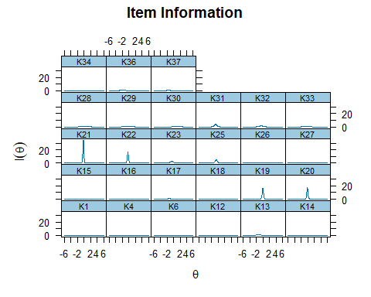

### Test Information Function

plot(mirt.data4, type = "info")

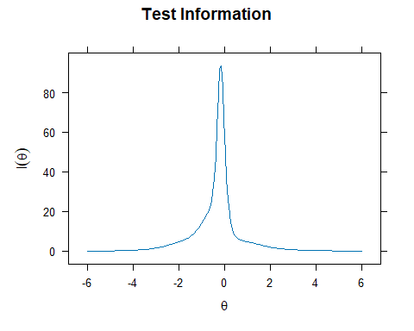

### Test Information and Standard Error

plot(mirt.data4, type = "infoSE")

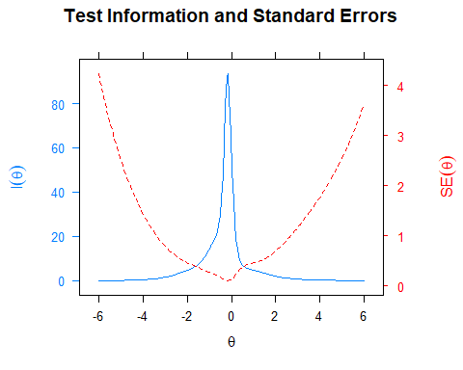

### Expected Total Score

plot(mirt.data4)

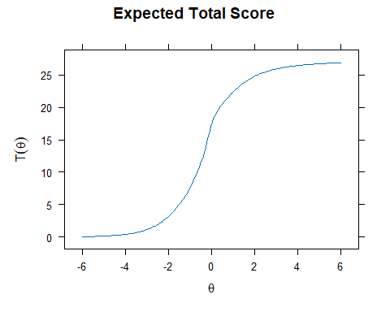

## Goodness-of-Fit Tests

### Overall Model Fit

M2(mirt.data4)

M2 df p RMSEA RMSEA_5 RMSEA_95 SRMSR TLI CFI  
stats 1295.559 324 0 0.1215386 0.1143697 0.1281896 0.1107436 0.8387448 0.851149

### Item Fit Statistics

itemfit(mirt.data4)

item S_X2 df.S_X2 RMSEA.S_X2 p.S_X2  
1 K1 11.970 18 0.000 0.849  
2 K4 24.900 19 0.039 0.164  
3 K6 19.540 12 0.056 0.076  
4 K12 16.999 16 0.018 0.386  
5 K13 17.768 16 0.023 0.338  
6 K14 8.226 18 0.000 0.975  
7 K15 13.625 15 0.000 0.554  
8 K16 9.260 15 0.000 0.864  
9 K17 13.202 13 0.009 0.432  
10 K18 18.775 17 0.023 0.342  
11 K19 25.800 5 0.143 0.000  
12 K20 20.065 6 0.107 0.003  
13 K21 29.530 4 0.177 0.000  
14 K22 38.942 6 0.164 0.000  
15 K23 8.013 11 0.000 0.712  
16 K25 5.544 7 0.000 0.594  
17 K26 19.194 18 0.018 0.380  
18 K27 15.104 12 0.036 0.236  
19 K28 23.698 16 0.049 0.096  
20 K29 25.531 18 0.045 0.111  
21 K30 10.893 8 0.042 0.208  
22 K31 9.587 7 0.043 0.213  
23 K32 10.418 13 0.000 0.659  
24 K33 13.726 13 0.017 0.393  
25 K34 14.995 16 0.000 0.525  
26 K36 5.159 5 0.013 0.397  
27 K37 12.242 15 0.000 0.661

### Person Fit Statistics

personfit(mirt.data4)

outfit z.outfit infit z.infit Zh  
1 0.57209776 -1.179938339 0.6773825 -1.518653318 1.356204674  
2 0.57209776 -1.179938339 0.6773825 -1.518653318 1.356204674  
3 0.40016550 -0.395341971 0.8115395 -0.577037604 0.664079425  
4 0.58693697 -1.136651570 0.6891093 -1.453578165 1.309498812  
5 2.29654632 1.342584269 0.8890041 -0.475210438 -0.217236172  
6 0.47415018 -0.177674459 0.8288165 -0.524235974 0.558885539  
7 0.42598778 -0.384462884 0.7129412 -1.039454982 1.006945655  
8 0.13323115 -0.935041478 0.3785329 -1.765441472 1.258841171  
9 0.92540096 0.033427025 0.9761949 -0.001669705 0.056079552  
10 0.96325368 0.025486025 0.9419940 -0.185843669 0.198965962  
11 0.40932352 -1.442619721 0.5572452 -2.319804484 1.849532980  
12 0.94861240 0.244031625 1.1634589 0.644632365 -0.447753929  
13 0.45408005 -0.085613591 0.8379505 -0.510652222 0.661665338  
14 0.39003589 -0.128751581 0.6707152 -1.206823295 1.019715691  
15 1.13457166 0.442916262 1.2435752 1.068202032 -0.885039019  
16 0.45408005 -0.085613591 0.8379505 -0.510652222 0.661665338  
17 0.61407489 -0.804976645 0.7612924 -1.094456238 1.038936235  
18 2.54135282 1.445714656 0.8647300 -0.348324390 -0.390129250  
19 1.49823508 1.088919463 1.0036017 0.096237634 -0.284449112  
20 1.10139204 0.395095597 1.1307359 0.539146766 -0.423658244  
21 0.62189419 -0.542507503 0.8105386 -0.647980869 0.727268634  
22 1.29203190 0.598217728 1.2311393 0.857246884 -0.884868261  
23 0.50767863 -0.240849840 0.8834503 -0.335886801 0.560057644  
24 1.13842541 0.446197515 1.2364486 0.993400345 -1.019393950  
25 0.50097522 -1.334492522 0.6276397 -1.820862050 1.550434044  
26 1.65279833 1.249554000 0.9080170 -0.278954691 -0.081076430  
27 1.09885207 0.391288283 1.3917140 1.729125577 -1.424989194  
28 0.11270854 -0.825682124 0.4441657 -1.214633635 0.953775981  
29 0.21128669 -0.908266925 0.4740542 -1.946405925 1.428756688  
30 1.09966332 0.381170994 1.0267391 0.192268380 -0.193245084  
31 0.37864924 -0.602701685 0.6362188 -1.394383473 1.252970828  
32 0.65473883 -0.894155522 0.7957482 -0.884730373 0.932430388  
33 1.64909904 1.532071102 1.5556111 2.155269613 -2.320561043  
34 0.46440016 -0.014136967 0.8337207 -0.521964678 0.621398840  
35 0.11270854 -0.825682124 0.4441657 -1.214633635 0.953775981  
36 1.16094523 0.499660040 1.2331290 0.829328607 -0.840591799  
37 0.45408005 -0.085613591 0.8379505 -0.510652222 0.661665338  
38 0.34972545 -0.230900096 0.6712294 -0.654601747 0.623016359  
39 0.30827202 -0.256224004 0.6134410 -1.473383816 1.246928378  
40 0.79884561 0.130710221 1.0191384 0.161463495 0.006332417  
41 1.00191706 0.188035371 0.9804915 0.017038221 -0.003368797  
42 0.28428368 -0.300672382 0.5351842 -1.891989307 1.473072267  
43 0.54004948 -0.148487917 0.9530790 -0.074616536 0.365668456  
44 0.11270854 -0.825682124 0.4441657 -1.214633635 0.953775981  
45 0.93837301 0.252878035 0.9622161 -0.084790355 -0.046610102  
46 0.11270854 -0.825682124 0.4441657 -1.214633635 0.953775981  
47 0.46767673 -0.313596405 1.1013540 0.388762391 -0.047029769  
48 1.37717896 0.672481034 1.4982953 1.628359753 -1.548129498  
49 0.17056955 -0.906124119 0.4635994 -1.541060321 1.197411153  
50 0.23758659 -0.797193723 0.5489063 -1.543328396 1.228998944  
51 0.33669857 -0.222290420 0.6311500 -1.385967416 1.162213534  
52 0.13585408 -0.873061717 0.4749644 -1.208610559 0.994852969  
53 0.21128669 -0.908266925 0.4740542 -1.946405925 1.428756688  
54 0.57567148 -1.240599834 0.6592877 -1.688403208 1.480447565  
55 0.56805298 -0.954073152 0.7116024 -1.365651850 1.229181531  
56 1.04832765 0.501953049 1.5520060 1.751282656 -1.540702572  
57 0.71255865 0.171837110 1.1944864 0.741044331 -0.365262904  
58 1.04452922 0.345645582 1.3155818 1.112614071 -0.873209144  
59 0.94763257 -0.018087592 0.8668720 -0.598572149 0.496243850  
60 0.69556019 0.044193131 1.0118608 0.135977911 0.055685336  
61 1.08161241 0.339176537 1.2349526 0.878591132 -0.694709440  
62 0.17056955 -0.906124119 0.4635994 -1.541060321 1.197411153  
63 0.52245658 -1.456044258 0.6450363 -1.806000600 1.616087098  
64 0.38308408 -0.364713242 0.6485375 -1.332899508 1.155065992  
65 1.22742246 0.532123625 0.9467987 -0.139167478 -0.165948247  
66 0.83523564 0.055655600 1.1153145 0.597678266 -0.285802128  
67 0.25050665 -0.724465913 0.6057716 -1.245585814 1.086895534  
68 0.13323115 -0.935041478 0.3785329 -1.765441472 1.258841171  
69 0.41537748 -0.579799216 0.8808854 -0.311813480 0.545060751  
70 1.55132228 1.401695317 1.0895892 0.475279671 -0.717569238  
71 0.70601931 0.027014177 1.0644224 0.317594556 -0.011860328  
72 0.19040727 -0.768217081 0.6175355 -0.835572867 0.848760351  
73 0.80891858 0.149581587 0.9584556 0.023709407 -0.100767303  
74 0.23496519 -0.676451770 0.4802532 -2.104084869 1.531393273  
75 0.96998819 0.355634040 0.9135269 -0.220973182 0.100062667  
76 0.76539090 -0.010606399 1.2790593 0.971908597 -0.618950160  
77 0.70220966 -0.773832484 0.7612008 -1.089113633 1.016892701  
78 1.08217423 0.432650713 1.6367440 1.902394609 -1.764420798  
79 0.50767863 -0.240849840 0.8834503 -0.335886801 0.560057644  
80 0.43156583 -0.343903264 0.7135003 -0.970642970 0.805270610  
81 12.10521394 4.046924765 0.8989397 -0.398400106 -1.112519829  
82 0.55515331 -0.236149160 0.7635531 -1.013108599 0.966340315  
83 0.53524899 -0.303282181 0.7568217 -1.190474249 1.127980618  
84 1.15857869 0.502199707 1.2748711 1.186154686 -0.996039209  
85 1.45664339 1.206993841 0.9722093 -0.057507530 -0.243659760  
86 1.62587763 0.856240698 0.9004301 -0.159882105 -0.303052566  
87 0.35206594 -0.565470921 0.7885359 -0.597046802 0.685138934  
88 0.41100404 -0.213210092 0.7117812 -1.041573978 0.981098143  
89 0.71550939 -0.649771526 0.8859150 -0.443133730 0.597472310  
90 0.94000142 0.278096040 1.0264884 0.191919120 -0.225393705  
91 0.50685950 -0.171350711 0.8718451 -0.380235091 0.558944929  
92 1.49357030 0.765097760 1.3729635 1.168710249 -1.380521867  
93 1.14169282 0.481521637 1.0845855 0.436218662 -0.425855981  
94 0.91713055 -0.008867605 1.0149150 0.143286388 -0.008337747  
95 0.89160362 0.366772632 1.2586604 0.925816769 -0.758151820  
96 0.78474985 0.116635268 0.9980787 0.087289851 0.030150138  
97 0.08112888 -0.931520966 0.2053474 -2.002194685 1.272762299  
98 0.72508945 -0.172008542 0.8866902 -0.326572585 0.402672776  
99 1.18775378 0.489584707 1.0558995 0.288772395 -0.379159664  
100 0.47313795 -1.351386718 0.6335406 -1.803498677 1.567059417  
101 0.90272707 0.021808354 0.7706831 -1.084133409 0.752317255  
102 1.30605853 0.631152683 1.0845009 0.385019036 -0.503941067  
103 1.50353262 1.271664741 1.3833954 1.576271508 -1.667308771  
104 0.91530526 0.147447880 1.0941570 0.418544801 -0.202967949  
105 0.47571253 -0.284420922 1.0275856 0.193832938 0.077849701  
106 0.75505904 -0.180433378 1.0002815 0.093372373 0.027320350  
107 0.31998638 -1.190333890 0.5500791 -1.857359619 1.521232726  
108 0.50767863 -0.240849840 0.8834503 -0.335886801 0.560057644  
109 0.37702231 -0.276668547 0.7764069 -0.426792155 0.505289009  
110 0.54052759 -0.294841772 0.7608517 -1.168739036 1.109904568  
111 0.58036723 -0.418097991 0.8074834 -0.734491322 0.757307869  
112 1.76256667 1.744943419 1.4800724 2.114508652 -2.334855564  
113 0.73974224 -0.224961288 0.9683073 -0.078966272 0.276954976  
114 0.33941782 -0.767097769 0.6864118 -1.098242258 1.028848054  
115 0.56359873 -0.769889159 0.7589546 -1.138807006 1.099990953  
116 0.48295050 -0.381459798 0.7015263 -1.321690588 1.220452528  
117 0.86938776 0.225916206 0.9564040 -0.126480515 0.071604045  
118 0.68627322 -0.032380169 0.8612344 -0.567427542 0.567602481  
119 0.32988432 -0.562966992 0.5686791 -1.728724728 1.418005079  
120 0.82494989 -0.053207903 1.0066981 0.102340892 0.051247765  
121 0.50476571 -0.054454943 0.7482944 -0.881703299 0.790878574  
122 0.42819831 -0.177320264 0.7782712 -0.755385799 0.829251447  
123 1.16755297 0.460792432 1.2180087 0.824327010 -0.757914505  
124 0.25050665 -0.724465913 0.6057716 -1.245585814 1.086895534  
125 0.51976684 -0.227755067 0.8515827 -0.460172403 0.632428990  
126 0.64457006 -0.362278305 0.9153143 -0.217062506 0.315875406  
127 2.26024262 2.654807432 1.2174554 0.990373813 -1.520491788  
128 0.35502970 -0.349771411 0.7246609 -0.947324658 0.926625938  
129 1.48640473 0.751683041 1.4440254 1.477224741 -1.544523156  
130 1.42227247 0.708233029 1.1497885 0.555448712 -0.944823561  
131 0.45029427 -0.293263875 0.6337893 -1.845136666 1.541879769  
132 0.93372581 -0.058880321 1.0482360 0.286779252 -0.100912332  
133 0.46579169 -0.237331062 0.9252369 -0.077938897 0.242831923  
134 1.70755467 1.698065443 1.6929932 2.635501312 -2.901652573  
135 0.28001616 -0.312999360 0.5502733 -1.785761697 1.400684060  
136 0.70905013 -0.190933770 1.0709447 0.358645338 -0.056459800  
137 0.57744758 -0.126640278 0.8246011 -0.768847075 0.830814172  
138 0.47655254 -0.715587817 0.7232682 -1.004607505 1.019528832  
139 0.95909545 0.030452063 1.0710211 0.379656669 -0.208767822  
140 0.38308408 -0.364713242 0.6485375 -1.332899508 1.155065992  
141 0.33493465 -0.949427546 0.6280845 -1.407612715 1.240529118  
142 0.62726296 -0.438016075 0.8902249 -0.323778876 0.419042088  
143 1.60088580 1.444319028 1.3296008 1.526800797 -1.659412599  
144 0.55205643 -0.445657707 0.7369842 -1.304009849 1.168774729  
145 0.66472966 -0.664467101 0.8432819 -0.667741638 0.749742656  
146 1.26520499 0.747905825 1.2462954 1.165445372 -1.123115063  
147 0.13118433 -0.927347151 0.4271244 -1.426565703 1.095032326  
148 0.59225741 -0.476031073 0.8014334 -0.933062723 0.937346624  
149 0.64415853 0.166342997 0.9040819 -0.253481950 0.273945477  
150 0.31998638 -1.190333890 0.5500791 -1.857359619 1.521232726  
151 1.15879643 0.490486627 1.1589378 0.629648018 -0.620298982  
152 0.13323115 -0.935041478 0.3785329 -1.765441472 1.258841171  
153 0.36630162 -0.508236033 0.5274796 -2.494437865 1.932971552  
154 0.11270854 -0.825682124 0.4441657 -1.214633635 0.953775981  
155 1.33409810 0.867296050 1.2164524 1.000183642 -1.065781545  
156 3.53495610 4.046209578 1.6897165 2.796119049 -3.997763305  
157 0.45408005 -0.085613591 0.8379505 -0.510652222 0.661665338  
158 1.29790566 0.857603451 1.2374591 1.110941562 -1.121530873  
159 0.34972545 -0.230900096 0.6712294 -0.654601747 0.623016359  
160 0.61166296 -0.114820542 0.9060540 -0.249825198 0.423521563  
161 0.33809425 -0.769568485 0.6693583 -1.187486548 1.090742442  
162 0.38032396 -0.520988238 0.8159943 -0.515171188 0.617102888  
163 2.12517326 1.246435563 1.3105812 1.017431091 -1.517728469  
164 1.10667622 0.441897847 1.4763664 1.567875881 -1.302293682  
165 0.43913277 -0.236175598 0.7596281 -0.835044489 0.858575840  
166 1.47260282 1.238300088 0.9338282 -0.229611681 -0.096745057  
167 0.48308617 -0.460013452 0.7334688 -1.132252213 1.123014222  
168 0.30827202 -0.256224004 0.6134410 -1.473383816 1.246928378  
169 0.68221043 -0.648653357 0.8192398 -0.783638342 0.794130196  
170 1.81562904 0.964160824 0.9917241 0.103972954 -0.481640889  
171 0.78332287 -0.267631915 0.9507933 -0.155927548 0.286300779  
172 0.79594406 -0.081538427 1.0129212 0.139260250 0.073475250  
173 1.26379437 0.641063227 0.9084321 -0.270894172 0.041781065  
174 0.53182170 -1.080305699 0.6865666 -1.505815838 1.343031353  
175 0.76356282 0.097195032 1.1059873 0.457055121 -0.173670585  
176 0.87118362 0.181222084 1.1609334 0.636314266 -0.367888476  
177 0.47870274 -1.514175706 0.6249153 -1.824313336 1.608868969  
178 0.95085224 0.031634388 0.9559400 -0.115748205 0.144600484  
179 0.83756405 -0.222048938 0.8650957 -0.501984870 0.511300998  
180 0.81641286 -0.205615443 0.9888856 0.045185721 0.144479309  
181 0.40735945 -0.765906305 0.6897061 -1.123716295 1.019626170  
182 0.56626980 -0.309017749 0.7794844 -1.065708740 1.028967175  
183 0.76442212 -0.256430931 0.9981263 0.063404645 0.178462415  
184 1.35297946 0.651967909 0.8157014 -0.398750582 -0.075115222  
185 0.13323115 -0.935041478 0.3785329 -1.765441472 1.258841171  
186 0.29943740 -1.298462559 0.4768076 -2.360949127 1.808116854  
187 1.80827904 1.309053216 1.0411076 0.239373939 -0.488304530  
188 0.67515345 0.069437949 1.2193139 0.797475019 -0.461226979  
189 0.13323115 -0.935041478 0.3785329 -1.765441472 1.258841171  
190 1.98868588 1.095774521 2.0493877 2.965899165 -3.357420923  
191 1.88600582 1.830488236 1.5795424 2.318033206 -2.693965297  
192 1.00125230 0.319865699 1.4060256 1.617183407 -1.340248324  
193 1.11884506 0.417678067 1.3988867 1.757254265 -1.480509823  
194 1.28500150 0.830057744 1.2834316 1.281635045 -1.243704129  
195 0.70401428 -0.268984220 0.8894227 -0.469075012 0.546805388  
196 0.75460573 -0.460769325 0.8912774 -0.404164427 0.523978759  
197 1.07077374 0.309581954 1.1104363 0.581090362 -0.470013030  
198 1.56669419 1.327236332 1.5619516 2.327095752 -2.418498376  
199 0.11270854 -0.825682124 0.4441657 -1.214633635 0.953775981  
200 4.44436692 4.438693850 2.3042070 4.111918669 -5.852019317  
201 3.29841849 4.007494198 2.2423630 4.146865169 -5.712329310  
202 1.17292557 0.487252246 1.1146788 0.506522382 -0.505070225  
203 0.92274721 -0.077108035 1.0202037 0.166279587 -0.018916225  
204 1.55064203 0.811549178 1.1767469 0.628571957 -0.957831818

## Reliability Estimates

### Marginal Reliability

marginal_rxx(mirt.data4)

[1] 0.8962959

### Empirical Reliability

theta_se = fscores(mirt.data4, full.scores.SE = TRUE)  
empirical_rxx(theta_se)

F1   
0.9099955