Lab 3 - Comparing two means

Furtado Jr., O.

10/5/2021

**Other Formats**: [PDF](ds1.pdf) | [Word](ds1.docx)

## Learning objectives

1. calculate measures of central tendency and variability in jamovi
2. differentiate between descriptive and inferential statistics
3. create and interpret histograms and boxplots
4. understand characteristics of normal and non-normal distributions

## Data set

We will use a modified version of the NFL Combine data set. You will need to download the csv data file and open it with jamovi.

[Click here](./datasets/data-labs.csv) to download the data set for this lab.

Note that you will be required to create filters[1] when completing some of the required analysis for this assignment.

Position key

| Position ID | Name |
| --- | --- |
| 1 | Cornerback |
| 2 | Defensive lineman |
| 3 | Safety |
| 4 | Linebacker |
| 5 | Offensive lineman |
| 6 | Running back |
| 7 | Wide receiver |

## Problem 1

Suppose a researcher working for the NFL Combine Data Collection Team wanted to find whether players of two different positions would differ on their bench press scores (bpress). The field positions considered for this study were: 1= Cornerback; 2= Defensive Lineman. The scores were recorded as the number of repetitions @ 225 lbs. **Run an analysis to learn if differences exist between these two positions on the bench press variable.**

### Question 1

**Filter**: create a filter for position so that only Wide Receivers and Safety are included in this analysis.

Calculate the mean, standard deviation, n, skewness, kurtosis, and shapiro-wilk test. Ensure to provide the Descriptives Table as part of this question.

DESCRIPTIVES  
  
 Descriptives   
 ───────────────────────────────────────────────────────   
 position bpress   
 ───────────────────────────────────────────────────────   
 N Cornerback 15   
 Defensive lineman 32   
 Mean Cornerback 16.86667   
 Defensive lineman 28.15625   
 Standard deviation Cornerback 3.044120   
 Defensive lineman 5.941160   
 ───────────────────────────────────────────────────────

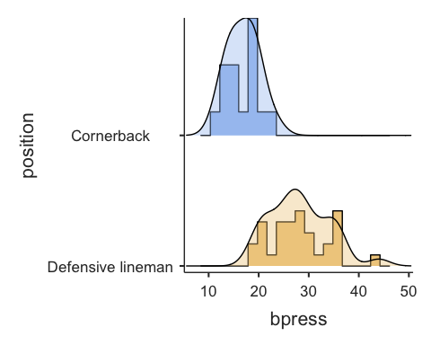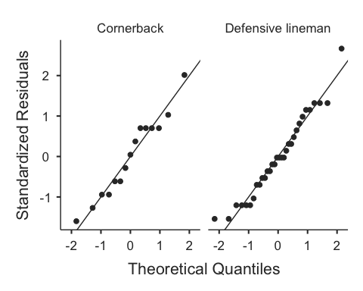

Question 2

## Question 2

**Filter**: turn off all filters before proceeding!

Considering the nature of both dependent variables used in Question 1 and assuming the distribution of scores for both variables are **approximating normality**, which measure of central tendency should be reported (mean, mode, or median)? Explain.

## Question 3

In question 1, you calculated the measures of central tendency and variability, which fall under the category of descriptive statistics. Discuss the difference between **descriptive statistics** and **inferential statistics**. More complete answers will receive more points.

## Question 4

**Filter**: create a filter to Position so that only Quarterbacks (QB) are included in this analysis.

Using the variable BroadJumpin, calculate the range, standard deviation and the IQR for Quarterbacks (QB) ONLY.

## Question 5

**Filter**: turn off all filters before proceeding!

In Question 1, you were asked to calculate the standard deviation of height (inches) and weight (lbs). Suppose you want to compare the standard deviations of height and weight. How the two standard deviations compare?

## Question 6

When calculating the sample variance and standard deviation, jamovi uses N - 1 in the denominator (see below). In your own words, explain why N - 1 is used instead of N.

Standard Deviation equation for the sample:

$$σ=\sqrt{\frac{∑{\left(x-μ\right)}^{2}}{N-1}}$$

Variance equation for the sample:

$$s^{2}=\frac{∑{\left(x-\overset{‾}{x}\right)}^{2}}{N-1}$$

## Question 7

The variance and the standard deviation are the two most common measures of variability reported in research manuscripts. Let’s say the manuscript you submitted for publication was returned by the editor. The editor-in-chief has asked you to report either the variance OR the standard deviation. Which one would you pick and why?

## Question 8

**Filter**: create a filter to Status so that **only** Year 2 is included in this analysis.

The variable “Status” refers to players who were either tested during the first or second year. Run an analysis to calculate the mean, and standard deviation for the variable Shuttle.

## Question 9

Create a histogram for the variable Shuttle and add the density line to it.

Provide the histogram create by jamovi below and state whether the distribution of scores for Shuttle appears to be deviating or approximating normality. In this particular case, disregard other sources of normality (skewness, kurtosis, QQ-plots, Shapiro-Wilk test, etc.).

## Question 10

Create a boxplot for Shuttle. Did the creation of the boxplot reveal any outliers? Explain.

# License

This work is licensed under a Creative Commons Attribution-NonCommercial-NoDerivatives 4.0 International License.

1. Creating filters in jamovi: <https://youtu.be/pij0KlFhITw>