Final Review

Table of contents

## 1 Overview

1. [**t-test**](https://drfurtado.github.io/randomstats/posts/04012023-ttest/): The t-test is a statistical test used to compare the means of two groups. It helps determine whether there is a significant difference between the means of the two groups.
   * One-samples t-test: used when there is one group that needs to be compared to population value.
   * Independent samples t-test: used when the two groups being compared are independent (e.g., comparing the mean strength of two different groups of athletes)
   * Paired samples t-test: used when the two groups being compared are dependent or related (e.g., comparing the mean strength of the same group of athletes before and after a training program)
2. [**One-way ANOVA**](https://drfurtado.github.io/randomstats/posts/04082023-one-way-anova/): One-way Analysis of Variance (ANOVA) is used to compare the means of three or more groups. It tests the null hypothesis that all group means are equal. If the p-value is less than the chosen significance level, the null hypothesis can be rejected, indicating that there is a significant difference between at least two of the groups.
3. [**Repeated measures ANOVA**](https://drfurtado.github.io/randomstats/posts/04152023-r_anova/): Repeated measures ANOVA is used to analyze data when the same participants are measured multiple times under different conditions or at different time points. This test takes into account the within-subject variability and is useful in determining whether there is a significant effect of the different conditions or time points on the dependent variable.
4. [**Between**](https://drfurtado.github.io/randomstats/posts/04222023-fanova-bb/) **and** [**within**](https://drfurtado.github.io/randomstats/posts/04282023-fanova-ww/) **subjects ANOVA**: This type of ANOVA is used when there are both between-subjects factors and within-subjects factors in an experiment. It allows you to analyze the main effects and interactions of these factors on the dependent variable.
5. **Nonparametric tests**: Nonparametric tests are used when the assumptions of parametric tests (e.g., normality, equal variances) are not met. Examples of nonparametric tests that can be used as alternatives to the tests above include:
   * Mann-Whitney U test: a nonparametric alternative to the independent samples t-test
   * Wilcoxon signed-rank test: a nonparametric alternative to the paired samples t-test
   * Kruskal-Wallis H test: a nonparametric alternative to the one-way ANOVA
   * Friedman test: a nonparametric alternative to the repeated measures ANOVA

## 2 Datasets

### 2.1 Dataset 1

[Download](review-data1.csv)

Brief description of the dataset:

* The dataset contains information on 30 individuals.
* Each individual’s record includes their ID, age, gender, “before” and “after” scores for a stretching intervention, and reaction time.
* The age of the individuals ranges from 20 to 49 years old.
* There are 15 male and 15 female individuals in the dataset.

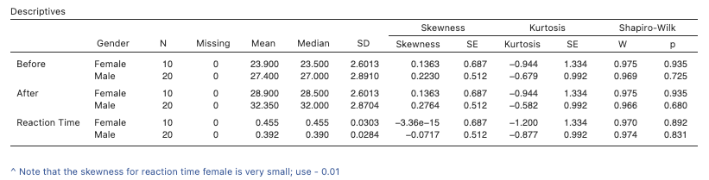

### 2.2 Dataset 2

[Download](review-data2.csv)

Brief description of the dataset:

* The dataset contains information on 24 individuals.
* Outcome variable: sit-up test (repetitions)
* Each individual’s record includes their ID, gender, age group, condition, and scores on three time measures (pre, mid, and posttest).
* The age groups are categorized as young (8-10) and old (11-13)
* The conditions are labeled as A, B, and C.

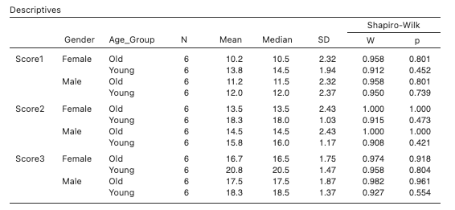

## 3 Research questions

Find below a list of research questions along with corresponding database links. To answer each question, perform the appropriate statistical procedure using the relevant database.

|  |
| --- |
| For all research questions below, test the hypothesis using $α$ = .05 and two-tailed tests. |

### 3.1 Research question 1

Using database 1, run the appropriate test to answer the research question below:

Is there a difference in flexibility (**before**) among college athletes compared to a population mean flexibility score of 35?

Provide the following:

1. the independent and dependent variables and specify the level (nominal, ordinal, continuous)
2. the and the hypotheses
3. whether any assumptions were violated (state none, if all assumptions were confirmed)
   1. *Disregard the assumption of test of independence since a random technique was not used*
4. the test used to answer the research question
   1. *Consider the nature of the dependent variable and the result of the Shapiro-Will test*
5. if the assumption of normality does not apply (or was violated), what test should be used instead?
6. the test decision (reject or fail to reject the ) + explanation
   1. use the p-value and the test statistic value to explain your decision
7. conclusion in one paragraph (does not have to be in APA style)
8. information on the meaningfulness of the result (effect size)
9. jamovi output (Name the output Research Question 1)
   1. test’s main table
   2. any assumption check tables
   3. descriptives table
   4. descriptives plot

Do not close jamovi; continue on to answer Research Question 2

### 3.2 Research Question 2

Using database 1, run the appropriate test to answer the research question below:

Is there a difference in reaction time between male and female athletes?

Provide the following:

1. the independent and dependent variables and specify the level (nominal, ordinal, continuous)
2. the and the hypotheses
3. whether any assumptions were violated (state none, if all assumptions were confirmed)
   1. *Disregard the assumption of test of independence since a random technique was not used*
4. the test used to answer the research question
   1. *Consider the nature of the dependent variable and the result of the Shapiro-Will test*
5. if the assumption of normality does not apply (or was violated), what test should be used instead?
6. the test decision (reject or fail to reject the ) + explanation
   1. use the p-value and the test statistic value to explain your decision
7. conclusion in one paragraph (does not have to be in APA style)
8. information on the meaningfulness of the result (effect size)
9. jamovi output (Name the output Research Question 2)
   1. test’s main table
   2. any assumption check tables
   3. descriptives table
   4. descriptives plot

Do not close jamovi; continue on to answer Research Question 3

### 3.3 Research Question 3

Using database 1, run the appropriate test to answer the research question below:

Does a resistance training program lead to increased strength in middle-aged adults?

Provide the following:

1. the independent and dependent variables and specify the level (nominal, ordinal, continuous)
2. the and the hypotheses
3. whether any assumptions were violated (state none, if all assumptions were confirmed)
   1. *Disregard the assumption of test of independence since a random technique was not used*
4. the test used to answer the research question
   1. *Consider the nature of the dependent variable and the result of the Shapiro-Will test*
5. if the assumption of normality does not apply (or was violated), what test should be used instead?
6. the test decision (reject or fail to reject the ) + explanation
   1. use the p-value and the test statistic value to explain your decision
7. conclusion in one paragraph (does not have to be in APA style)
8. information on the meaningfulness of the result (effect size)
9. jamovi output (Name the output Research Question 3)
   1. test’s main table
   2. any assumption check tables
   3. descriptives table
   4. descriptives plot

### 3.4 Research Question 4

Using database 2, run the appropriate test to answer the research question below:

Is there a significant interaction between age group and condition on sit-up scores (Score1)?

**Provide the following:**

1. the independent and dependent variables and specify the level (nominal, ordinal, continuous)
2. the and the hypotheses
3. whether any assumptions were violated (state none, if all assumptions were confirmed)
   1. *Disregard the assumption of test of independence since a random technique was not used*
4. the test used to answer the research question 1. *Consider the nature of the dependent variable and the result of the Shapiro-Will test*
5. if the assumption of normality does not apply (or was violated), what test should be used instead?
6. the test decision (reject or fail to reject the ) + explanation
   1. use the p-value and the test statistic value to explain your decision
7. conclusion in one paragraph (does not have to be in APA style)
8. information on the meaningfulness of the result (effect size)
9. jamovi output (Name the output Research Question 4)
   1. test’s main table
   2. any assumption check tables
   3. any post-hoc table
   4. descriptives table
   5. descriptives plot

### 3.5 Research Question 5

Using database 2, run the appropriate test to answer the research question below:

Is there a significant difference in scores across time (pre, mid, posttest)?

**Provide the following:**

1. the independent and dependent variables and specify the level (nominal, ordinal, continuous)
2. the and the hypotheses
3. whether any assumptions were violated (state none, if all assumptions were confirmed)
   1. *Disregard the assumption of test of independence since a random technique was not used*
4. the test used to answer the research question
   1. *Consider the nature of the dependent variable and the result of the Shapiro-Will test*
5. if the assumption of normality does not apply (or was violated), what test should be used instead?
6. the test decision (reject or fail to reject the ) + explanation
   1. use the p-value and the test statistic value to explain your decision
7. conclusion in one paragraph (does not have to be in APA style)
8. information on the meaningfulness of the result (effect size)
9. jamovi output (Name the output Research Question 5)
   1. test’s main table
   2. any assumption check tables
   3. any post-hoc table
   4. descriptives table
   5. descriptives plot

### 3.6 Research Question 6

Using database 2, run the appropriate test to answer the research question below:

Is there a significant difference in scores (Scores3) across the three conditions (A, B, and C)?

**Provide the following:**

1. the independent and dependent variables and specify the level (nominal, ordinal, continuous)
2. the and the hypotheses
3. whether any assumptions were violated (state none, if all assumptions were confirmed)
   1. *Disregard the assumption of test of independence since a random technique was not used*
4. the test used to answer the research question
   1. *Consider the nature of the dependent variable and the result of the Shapiro-Will test*
5. if the assumption of normality does not apply (or was violated), what test should be used instead?
6. the test decision (reject or fail to reject the ) + explanation
   1. use the p-value and the test statistic value to explain your decision
7. conclusion in one paragraph (does not have to be in APA style)
8. information on the meaningfulness of the result (effect size)
9. jamovi output (Name the output Research Question 6)
   1. test’s main table
   2. any assumption check tables
   3. any post-hoc table
   4. descriptives table
   5. descriptives plot