# Using Quarto to Generate Documents in APA Style (7th Edition)

Ana Fulano1, Blanca Zutano1, Carina Mengano2,3, and Dolorita Perengano4

1Clinical Psychology Program, Department of Psychology, Ana and Blanca’s University

2Carina’s Primary Affiliation

3Carina’s Secondary Affiliation

4Buffalo, NY

# Author Note

Ana Fulano  http://orcid.org/0000-0000-0000-0001

Blanca Zutano  http://orcid.org/0000-0000-0000-0002

Carina Mengano  http://orcid.org/0000-0000-0000-0003

Dolorita Perengano  http://orcid.org/0000-0000-0000-0004

Author roles were classified using the Contributor Role Taxonomy (CRediT; https://credit.niso.org/) as follows: *Ana Fulano***:** conceptualization and writing – original draft. *Blanca Zutano***:** project administration and formal analysis. *Carina Mengano***:** formal analysis and writing – original draft. *Dolorita Perengano***:** writing – original draft, methodology, and formal analysis

Correspondence concerning this article should be addressed to Ana Fulano, Clinical Psychology Program, Department of Psychology, Ana and Blanca’s University, 1234 Capital St., Albany, NY 12084-1234, Email: sm@example.org

# Abstract

This document is a template demonstrating the apaquarto format.

*Keywords*: keyword1, keyword2, keyword3

# Using Quarto to Generate Documents in APA Style (7th Edition)

This is my introductory paragraph. The title will be placed above it automatically. *Do not start with an introductory heading* (e.g., “Introduction”). The title acts as your Level 1 heading for the introduction.

Details about writing headings with markdown in APA style are [here](https://wjschne.github.io/apaquarto/writing.html#headings-in-apa-style).

## Displaying Figures

A reference label for a figure must have the prefix fig-, and in a code chunk, the caption must be set with fig-cap. Captions are in [title case](https://apastyle.apa.org/style-grammar-guidelines/capitalization/title-case).

To refer to any figure or table, use the @ symbol followed by the reference label (e.g., Figure 1).

## Imported Graphics

One way to import an existing graphic as a figure is to use knitr::include_graphics in a code chunk. For example, Figure 2 is an imported image. Note that in apaquarto-pdf documents, we can specify that that a figure or table should span both columns when in journal mode by setting the apa-twocolumn chunk option to true. For other formats, this distinction does not matter.

Figure graphics can be imported directly with Markdown:

## Displaying Tables

We can make a table the same way as a figure. Generating a table that conforms to APA format in all document formats can be tricky. When the table is simple, the kable function from knitr works well. Feel free to experiment with different methods, but I have found that David Gohel’s [flextable](https://davidgohel.github.io/flextable/) to be the best option when I need something more complex.

To refer to this table in text, use the @ symbol followed by the reference label like so: As seen in Table 1, the first few numbers and letters of the alphabet are displayed.

In Table 2, there is an example of a plain markdown table with a note below it.

What if you want the tables and figures to be at the end of the document? In the .pdf format, you can set the floatsintext option to false. For .html and .docx documents, there is not yet an automatic way to put tables and figures at the end. You can, of course, just put them all at the end, in order. The reference labels will work no matter where they are in the text.

## Citations

See [here](https://quarto.org/docs/authoring/footnotes-and-citations.html) for instructions on setting up citations and references.

A parenthetical citation requires square brackets (Cameron & Trivedi, 2013). This reference was in my bibliography file. An in-text citation is done like so: Cameron and Trivedi (2013).

See [here](https://wjschne.github.io/apaquarto/writing.html#references) for explanations, examples, and citation features exclusive to apaquarto like masked citations (citations masked for peer review) and possessive citations (e.g., “Schneider and McGrew’s (2012) idea seemed reasonable at the time.”)

## Masking Author Identity for Peer Review

Setting mask to true will remove author names, affiliations, and correspondence from the title page. Any references listed in the masked-citations field will be masked as well. See [here](https://wjschne.github.io/apaquarto/writing.html#masked-citations-for-anonymous-peer-review) for more information.

## Hypotheses, Aims, and Objectives

The last paragraph of the introduction usually states the specific hypotheses of the study, often in a way that links them to the research design.

# Method

General remarks on method. This paragraph is optional.

Not all papers require each of these sections. Edit them as needed. Consult the [Journal Article Reporting Standards](https://apastyle.apa.org/jars) for what is needed for your type of article.

## Participants

Who are they? How were they recruited? Report criteria for participant inclusion and exclusion. Perhaps some basic demographic stats are in order. A table is a great way to avoid repetition in statistical reporting.

## Measures

This section can also be titled **Materials** or **Apparatus**. Whatever tools, equipment, or measurement devices used in the study should be described.

### Measure A

Describe Measure A.

### Measure B

Describe Measure B.

## Procedure

What did participants do?

How are the data going to be analyzed?

# Results

## Descriptive Statistics

Here we describe the basic characteristics of our primary variables.

# Discussion

Describe results in non-statistical terms.

## Limitations and Future Directions

Every study has limitations. Based on this study, some additional steps might include…

## Conclusion

Let’s sum this up.

# References

Cameron, A. C., & Trivedi, P. K. (2013). *Regression analysis of count data* (2nd ed.). Cambridge University Press. <https://doi.org/10.1017/CBO9781139013567>

Schneider, W. J., & McGrew, K. S. (2012). *The Cattell-Horn-Carroll model of intelligence.*

# Appendix

If there are multiple appendices, label them with level 1 headings as Appendix A, Appendix B, and so forth.

Table 1

The Table Caption

| Numbers | Letters |
| --- | --- |
| 1 | A |
| 2 | B |
| 3 | C |
| 4 | D |

*Note*. The note below the table.

Table 2

Table Caption of a Markdown Table

| Default | Left | Right | Center |
| --- | --- | --- | --- |
| 12 | 12 | 12 | 12 |
| 123 | 123 | 123 | 123 |
| 1 | 1 | 1 | 1 |

*Note*. This is a note below the markdown table.

Figure 1

The Figure Caption

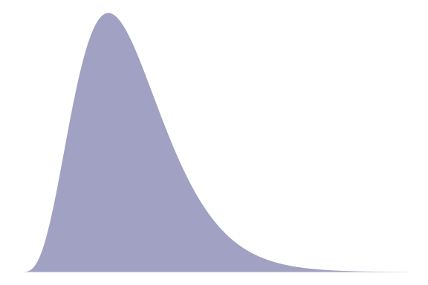

*Note*. This is the note below the figure.

Figure 2

An Imported Graphic

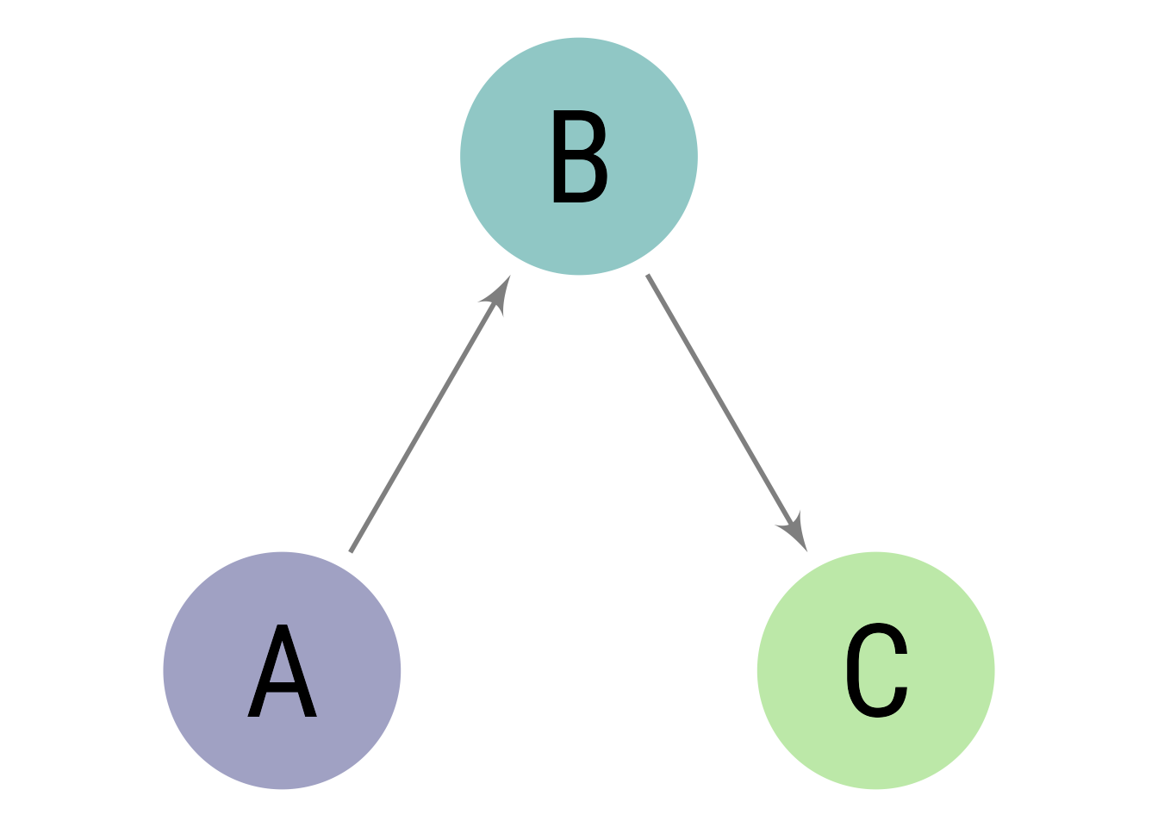

*Note*. A note below the figure

Figure 3

Another Way to Import Graphics



*Note*. A note below the figure